**Performance of PMKISAN scheme in India with special reference to Tamil Nadu – An insight into distribution**

**ABSTRACT**

PMKISAN scheme an income support scheme implemented by Government of India to help farmers at the time of cultivation for purchase of agricultural inputs. Cash transfer programme has positive impact on increasing the consumption pattern, nutritional status and eliminating rural poverty. The study analysed the performance and progress of state under PMKISAN scheme and also to estimate the proportion of income to the total annual income of the households. The results indicate that large share of beneficiary belong to Uttar Pradesh (20.82 percent), followed by Maharashtra (8.98 percent) and Madhya Pradesh (7.08 percent) and in case of Tamil Nadu districts like Villupuram, Tiruvannamalai, Salem and Cuddalore have the highest beneficiary. The lowest share was observed in states like Goa, Lakshadweep and Puducherry etc., The reason for lesser registration of beneficiary might be due to problems with land documents of farmers i.e., mismatching of names. The results also found that it has positive impact on redistribution of income to small and marginal farmers where the income share to their annual income is higher in all the districts of Tamil Nadu. Digitization of land records and other information would help increase the number of beneficiary among the states which has lesser share of beneficiary.

**Keywords: PMKISAN, cash transfer, universal basic income**

**Introduction**

Agriculture plays a major role in the economic growth of developing countries like India. With increase in global population and demand for food supply, agricultural land is under pressure to meet global demand through increasing productivity. With reduction in agricultural land area, adoption of modern technologies, tools and high yielding varieties are at greater need to increase productivity which also require huge capital investment by the farmers. In India, about 146 million rural households have operational land holdings and 86.08 percent of farmers have marginal and small land holdings (Agricultural census, 2015) whose income is less than the poverty line. About 57.8 percent of rural households depend on agriculture as the primary source of income (Situation Assessment Survey, NSO 2021). With slow pace of structural transformation in agricultural sector, the income level of the rural households is lesser and there exists a wider gap between income of rural and urban households. Policy makers and government institutions are involved in boosting the rural economy by implementing various schemes and subsidy programmes to the farmers. Some of the predominant schemes are Pradhan Mantri Krishi Sinchai Yojana (PMKSY), Paramparagat Krishi Vikas Yojana (PKVY), Pradhan Mantri Fasal Bima Yojana (PMFBY), National Mission for Sustainable Agriculture (NMSA) and Pradhan Mantri Kisan Samman Nidhi Yojana (PMKISAN). The total budget allocation by the Government of India during 2021-22 to the Ministry of Agriculture and Farmers welfare (MoAFW) was Rs. 1,31,531 crore which is 14 percent higher when compared to previous year budget. Among the total budget around, 76 percent of the budget is proposed for PM-KISAN, PMFBY and interest subsidy on short-term credit. PMFBY was implemented to provide insurance coverage and financial support to the farmers in the event of crop failure due to natural calamities. The scheme was compulsory for loanee farmers but made optional from kharif 2020 and voluntary for non-loanee farmers (Tiwari *et al.* 2020). PM-KISAN is a direct cash transfer scheme initiated to increase the livelihood status of small and marginal farmers. It aims at providing social security to all small and marginal farmers in the country through supplementing the financial needs of the farmers in procuring various inputs like seeds, fertilisers etc., and also to protect from the usurious moneylenders for meeting such expenses. This would provide liquidity to the farm households to meet their expenditure and it helps in boosting demand in rural economy. A sum of Rs. 6000 is given in three intervals in a year before the crop seasons (Kharif, rabi and summer) and are credited through Direct Benefit Transfer (DBT) mode. So far 7 instalments have been released and 3.76 crore (33 percent of registered) farmers received all the 7 instalments and 10.69 crore (93 percent of registered) farmers received at least one instalment. Over 12 crore registered farmers have been benefiting from this scheme. The Government spending towards this scheme has increased in successive years. Since, implementation the budget has increased from Rs. 20,000 crores in 2018-19 to Rs. 65,000 crores during 2021-22 which is 49 percent of the total budget allotted to MoAFW. A number of similar schemes has been formulated by many state governments, initially by Telangana state called the Rythu Bandhu scheme where Rs. 8000 is provided to farm households in two instalments to supplement income of the farmers. Large number of studies (Taaffe *et al*. 2017, Kusuma *et al.* 2017, Chioda *et al*. 2016, Aizer *et al*. 2016) discusses the effectiveness of cash transfer programmes and indicates that there is a positive effect of the programmes on increasing the consumption level, education, nutritional status etc. The successive rate of programme also depend on the condition or environment under which it is provided and it also depends on the traceability of the whether it has reached the beneficiary or not. Hence, this study focuses on analysing the progress and performance of PM-Kisan scheme in districts of Tamil Nadu as well as the share of PM-Kisan scheme in total annual income of the households.

**Methodology**

The present study is based on the secondary data, the state wise number of beneficiary registered and government expenditure on PM-Kisan scheme was compiled from http://www.pmkisan.gov.in. The data pertaining to operational holdings was collected from agriculture census (2011) and the household income of farmers was compiled from the Situation Assessment Survey (2019). The performance of states and districts of Tamil Nadu was studied in terms of proportion of beneficiary to the potential beneficiary i.e., number of operational holdings in each state and district. The income share from the scheme has also been studied for each district. Since the proportion of income for each land holding category is different, the income share from the scheme has been studied separately for each land holding category.

**Results and Discussion**

**State wise progress of PMKISAN**

The state wise number of beneficiaries registered under the PM-Kisan scheme is presented in table 1. The total number of farmers registered under the scheme as on 30th March, 2022 is 125 million beneficiaries. The highest number of beneficiary is registered in Uttar Pradesh 26.11 lakhs (20.82 percent), followed by Maharashtra 11.27 lakhs (8.98 percent), Madhya Pradesh 8.88 lakhs (7.08 percent), Bihar 8.35 lakhs (6.66 percent), Rajasthan 7.82 lakhs (6.24 percent), Gujarat 6.42 lakhs (5.12 percent), Andhra Pradesh 5.65 lakhs (4.51 percent), Karnataka 5.07 lakhs (4.05 percent), West Bengal 4.82 lakhs (3.84 percent) and Tamil Nadu 4.75 lakhs (3.79 percent). Among the major states Haryana (1.56 percent), Jammu and Kashmir (0.97 percent), Himachal Pradesh (0.79 percent) and Uttarakhand (0.74 percent) ranks lowest with less than 20 lakhs of beneficiary registration. The union territories and small states like Goa (0.01 percent), Lakshadweep (0.00 percent), Delhi (0.01 percent), Puducherry (0.01 percent) and Chandigarh 90.00 percent) have less than 20,000 beneficiary.

**Performance of states with respect to PMKISAN**

The performance of states were estimated using the operational land holding data taken from agriculture census 2015-16 and the data for 2020-2021 was projected by epolate function in STATA using the agriculture census data from 1995-96 to 2015-16. The Ministry of Agriculture & Farmers Welfare also considers the state wise operational land holding to identify the number of farmers to be covered under the scheme. Hence, Operational land holdings is considered as a proxy for the identifying the potential beneficiary.

The results indicate that the states like Manipur (317.47 percent), Mizoram (214.06 percent), Punjab (206.17 percent), Andhra Pradesh (146 percent), Andaman and Nicobar Island (142.81 percent), Haryana (119.42 percent), Assam (115.35 percent) and other states like Gujarat, Uttarakhand and Uttar Pradesh has a greater number of beneficiary than the potential beneficiary (operational land holding). Many of the North Eastern States like Manipur has community-based land ownership, it might not be possible to assess the quantum of Land holder farmers. Similarly, many of the land holding is owned jointly in many of the states where the families having land under joint ownership is also considered to be owner of the land and is permitted to avail the benefit (Kavitha *et al.* 2020). States like Assam, Punjab and Haryana have more beneficiary than potential, it may be due to faulty identification of beneficiaries for which the states are reverifying the list. But this may be also due to reverse tenancy i.e., small and marginal lease out lands to large farmers. The states like Nagaland (96.73 percent), Himachal Pradesh (95.46 percent), Rajasthan (92.93 percent), Chhattisgarh (90.36 percent), Jammu and Kashmir (87.56 percent) have more than 85 percent of potential beneficiaries. The states like Goa (16.09 percent), Sikkim (19.52 percent), Lakshadweep (26.86 percent) and Puducherry (32.47 percent) account for less than 40 percent of potential beneficiaries. The reason for less beneficiary may be due to states that have not completely digitised the land records, document problems, farmers themselves have not enrolled for the scheme and in some of the north eastern states identification of beneficiary itself has been a major problem due to community based ownership. In Kerala more than 40,000 farmers could not receive fourth instalment due to mismatch in the documents (Aadhar card and PMKISAN portal).

**Table 1. State wise Percentage share of total beneficiary in PM-KISAN over land holding (as on 02nd April, 2022)**

|  |  |  |  |  |
| --- | --- | --- | --- | --- |
| **State** | **Total No. of Beneficiaries** | **Percentage to total no. of beneficiary** | **Total No. of Operational land holdings** | **Beneficiary over operational holdings (%)** |
| Andaman and Nicobar Islands | 17287 | 0.01 | 12105 | 142.81 |
| Andhra Pradesh | 5654077 | 4.51 | 3872720 | 146.00 |
| Arunachal Pradesh | 97320 | 0.08 | 117208 | 83.03 |
| Assam | 3187456 | 2.54 | 2763199 | 115.35 |
| Bihar | 8358711 | 6.66 | 16634395 | 50.25 |
| Chandigarh | 465 | 0.00 | 782 | 59.46 |
| Chhattisgarh | 3862781 | 3.08 | 4275064 | 90.36 |
| Delhi | 17164 | 0.01 | 21187 | 81.01 |
| Goa | 11439 | 0.01 | 71106 | 16.09 |
| Gujarat | 6422871 | 5.12 | 5755642 | 111.59 |
| Haryana | 1956924 | 1.56 | 1638719 | 119.42 |
| Himachal Pradesh | 986004 | 0.79 | 1032853 | 95.46 |
| Jammu And Kashmir | 1211475 | 0.97 | 1383621 | 87.56 |
| Karnataka | 5077565 | 4.05 | 9529289 | 53.28 |
| Kerala | 3690226 | 2.94 | 8336203 | 44.27 |
| Lakshadweep | 2619 | 0.00 | 9749 | 26.86 |
| Madhya Pradesh | 8881953 | 7.08 | 11133893 | 79.77 |
| Maharashtra | 11271344 | 8.98 | 16871913 | 66.81 |
| Manipur | 477316 | 0.38 | 150348 | 317.47 |
| Meghalaya | 198351 | 0.16 | 255233 | 77.71 |
| Mizoram | 187664 | 0.15 | 87668 | 214.06 |
| Nagaland | 207628 | 0.17 | 214653 | 96.73 |
| Odisha | 3760292 | 3.00 | 5064234 | 74.25 |
| Puducherry | 11186 | 0.01 | 34452 | 32.47 |
| Punjab | 2341709 | 1.87 | 1132872 | 206.71 |
| Rajasthan | 7825342 | 6.24 | 8420796 | 92.93 |
| Sikkim | 13298 | 0.01 | 68136 | 19.52 |
| Tamil Nadu | 4752765 | 3.79 | 7757670 | 61.27 |
| Tripura | 242270 | 0.19 | 567909 | 42.66 |
| Uttar Pradesh | 26118219 | 20.82 | 24317794 | 107.40 |
| Uttarakhand | 932094 | 0.74 | 849960 | 109.66 |
| West Bengal | 4822697 | 3.84 | 7362117 | 65.51 |

Data source: http://pmkisan.gov.in; http://agcensus.dacnet.nic.in/

Authors Calculation

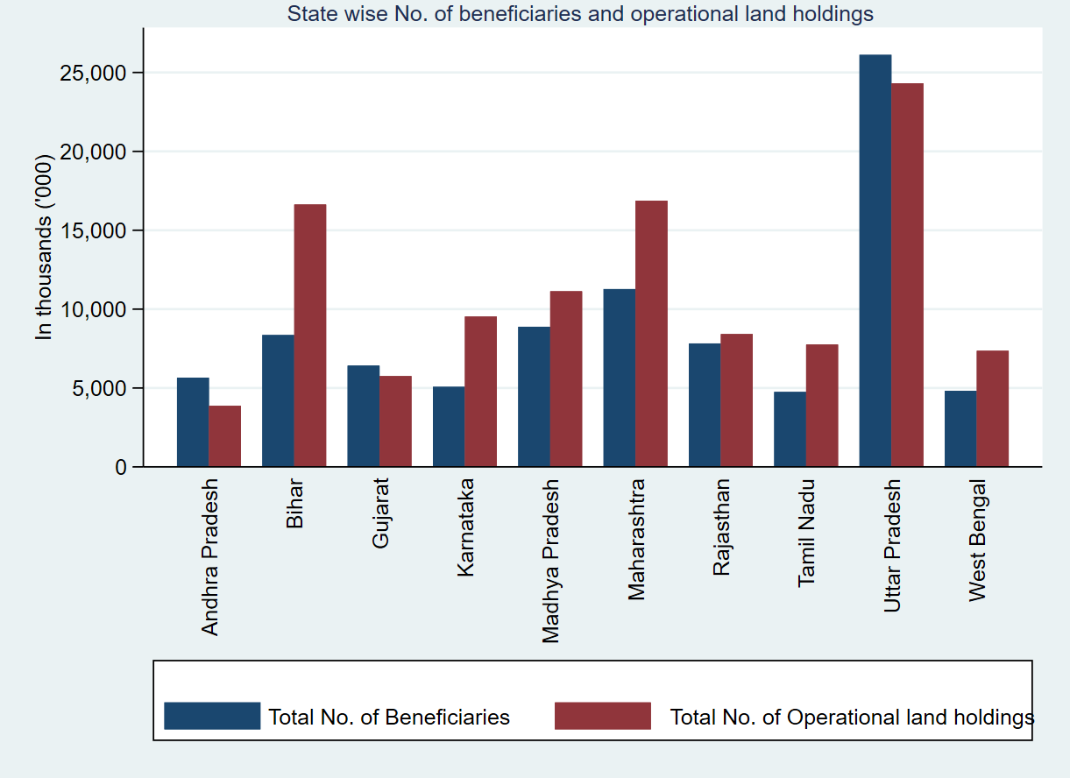

**Fig 1. Top 10 states with highest number of beneficiary**

Source: authors calculation

**District wise progress of PMKISAN in Tamil Nadu**

In Tamil Nadu, the total number of beneficiary registered in the scheme is around 4.75 lakhs. District wise total number of beneficiary registered in PM-Kisan scheme is shown in table 2. It is observed that highest number of beneficiary were registered in Villupuram district 5.27 lakhs (11.10 percent), followed by Tiruvannamalai 4.04 lakhs (8.51 percent), Salem 2.79 lakhs (5.88 percent), Cuddalore 2.65 lakhs (5.59 percent), Vellore 2.54 lakhs (5.36 percent), Dharmapuri 2.17 lakhs (4.57 percent). The lowest number of beneficiary registered in the scheme was estimated and districts like Thoothukudi, Perambalur, Thiruvarur, Nagapattinam, Nilgiris and Theni has less than 2 percent share in total number of beneficiaries registered for availing the benefit.

**Performance of districts in Tamil Nadu with respect to PMKISAN**

The district wise performance of PMKISAN scheme in Tamil Nadu was estimated by percentage analysis of registered beneficiary and potential beneficiary and is presented in table 2. The districts like Pudukkottai (99.98 percent), Tiruvallur (97.38 percent), Kancheepuram (95.4 percent), Sivagangai (90.06 percent), Tiruvannamalai (89.79 percent) has more than 85 percent of registered beneficiary when compared to the potential beneficiaries. Some of the districts like Pudukkottai, Tiruvallur and Kancheepuram has large number of joint holding ownership (Agriculture Census, 2015) which could be the reason for higher beneficiaries since identification itself is a major problem. More than half of the districts in Tamil Nadu fall under the range of 50 to 85 percent indicating that two third of farmers have registered under the scheme. Only two districts Theni (39.68 percent) and Tirunelveli (36.05 percent) has less than 40 percentage of beneficiary registered for the scheme.

The percentageshare of cash transfer in total annual income of household was calculated. The data pertaining to average annual income of agricultural households was compiled from the Situation Assessment Survey (2019). District wise annual income was estimated for each landholding category and the percentage share of cash transfer to annual income was presented in table 3. The results indicate that the share of cash transfer to annual income was higher for marginal and small landholding farmer than semi-medium and medium class farmers as shown in fig 2. Similar results were found (Kavitha *et al.* 2021) where state wise income share has been estimated. Districts like Tirupur (16.76 percent), Tiruvannamalai (15.44 percent), Dindigul (15.26 percent), Perambalur (14.43 percent) and Vellore (13.74 percent) has the highest percentage share of cash transfer to total annual income indicating that the income level of the household is lesser compared to other districts of Tamil Nadu. Similarly, districts like Thanjavur (9.26 percent), Tiruvallur (8.74 percent), Coimbatore (8.46) and Thiruvarur (6.82 percent) has lesser share to the total income of the households.

**Table 2. District wise Percentage share of total beneficiary in PM-KISAN over land holding in Tamil Nadu (as on 02nd April, 2022)**

|  |  |  |  |  |
| --- | --- | --- | --- | --- |
| **District** | **Total No. of Beneficiaries** | **Percentage to total no. of beneficiary** | **Total No. of Operational land holdings** | **Beneficiary over operational holdings (%)** |
| Ariyalur | 111892 | 2.35 | 175125 | 63.89 |
| Coimbatore | 66975 | 1.41 | 128377 | 52.17 |
| Cuddalore | 265905 | 5.59 | 347476 | 76.52 |
| Dharmapuri | 217215 | 4.57 | 374124 | 58.06 |
| Dindigul | 138943 | 2.92 | 300733 | 46.20 |
| Erode | 100178 | 2.11 | 194388 | 51.54 |
| Kancheepuram | 190784 | 4.01 | 199987 | 95.40 |
| Kanyakumari | 213101 | 4.48 | 517678 | 41.16 |
| Karur | 77546 | 1.63 | 113797 | 68.14 |
| Krishnagiri | 172337 | 3.63 | 368689 | 46.74 |
| Madurai | 140158 | 2.95 | 228158 | 61.43 |
| Nagapattinam | 60740 | 1.28 | 115160 | 52.74 |
| Namakal | 92885 | 1.95 | 204402 | 45.44 |
| Perambalur | 76908 | 1.62 | 173055 | 44.44 |
| Pudukkottai | 139964 | 2.94 | 139998 | 99.98 |
| Ramanathapuram | 123323 | 2.59 | 277254 | 44.48 |
| Salem | 279533 | 5.88 | 344691 | 81.10 |
| Sivagangai | 111208 | 2.34 | 123484 | 90.06 |
| Thanjavur | 127147 | 2.68 | 267984 | 47.45 |
| The Nilgiris | 50000 | 1.05 | 101881 | 49.08 |
| Theni | 48521 | 1.02 | 122284 | 39.68 |
| Thriuvarur | 61956 | 1.30 | 119831 | 51.70 |
| Trichy | 162671 | 3.42 | 309066 | 52.63 |
| Tirunelveli | 108938 | 2.29 | 302203 | 36.05 |
| Tiruppur | 96999 | 2.04 | 174706 | 55.52 |
| Tiruvallur | 158629 | 3.34 | 162895 | 99.98 |
| Tiruvannamalai | 404421 | 8.51 | 450413 | 89.79 |
| Tuticorin | 82668 | 1.74 | 157277 | 52.56 |
| Vellore | 254530 | 5.36 | 363501 | 70.02 |
| Villupuram | 527325 | 11.10 | 790519 | 66.71 |
| Virudhunagar | 89265 | 1.88 | 159169 | 56.08 |

Data source: http://pmkisan.gov.in; http://agcensus.dacnet.nic.in/

Authors Calculation

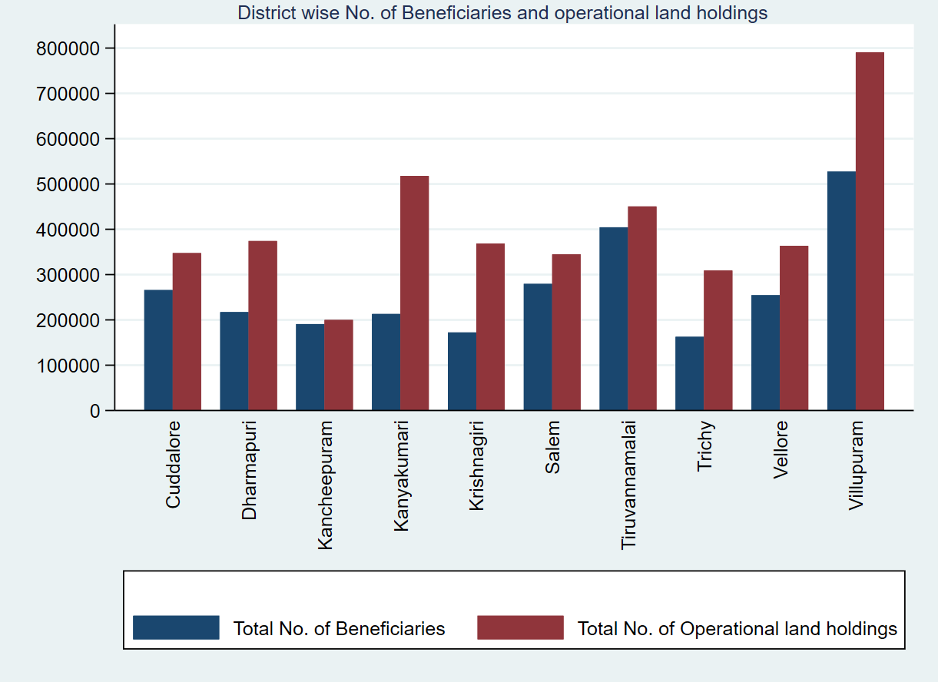**Fig 2. Top 10 district with highest number of beneficiary**

Source: authors calculation

**Table 3. District wise share of PMKISAN in annual income of household**

|  |  |  |  |  |  |  |  |  |
| --- | --- | --- | --- | --- | --- | --- | --- | --- |
| **District** | **Annual Income of household** | | | | **% of total income** | | | |
| **Marginal** | **Small** | **Semi-Medium** | **Medium** | **Marginal** | **Small** | **Semi-Medium** | **Medium** |
| Thiruvallur | 68624 | 72289 | 61763 | 320000 | 8.74 | 8.3 | 9.71 | 1.88 |
| Kancheepuram | 60233 | 70929 | 56539 | 73456 | 9.96 | 8.46 | 10.61 | 8.17 |
| Vellore | 43674 | 55049 | 46933 | 59325 | 13.74 | 10.9 | 12.78 | 10.11 |
| Tiruvannamalai | 38870 | 50359 | 45120 | 53658 | 15.44 | 11.91 | 13.3 | 11.18 |
| Viluppuram | 49290 | 30030 | 76827 | 142778 | 12.17 | 19.98 | 7.81 | 4.2 |
| Salem | 47171 | 66762 | 67562 | 70321 | 12.72 | 8.99 | 8.88 | 8.53 |
| Namakkal | 55953 | 65280 | 98499 | 158335 | 10.72 | 9.19 | 6.09 | 3.79 |
| Perambalur | 41594 | 56938 | 65660 | 68520 | 14.43 | 10.54 | 9.14 | 8.76 |
| The Nilgiris | 49218 | 57550 | 63723 | 65675 | 12.19 | 10.43 | 9.42 | 9.14 |
| Dindigul | 39313 | 52844 | 44216 | 68000 | 15.26 | 11.35 | 13.57 | 8.82 |
| Karur | 55832 | 69607 | 57509 | 94160 | 10.75 | 8.62 | 10.43 | 6.37 |
| Trichy | 52517 | 76029 | 70876 | 77830 | 11.42 | 7.89 | 8.47 | 7.71 |
| Erode | 44643 | 40717 | 42084 | 69750 | 13.44 | 14.74 | 14.26 | 8.6 |
| Ariyalur | 45479 | 27450 | 48288 | 51100 | 13.19 | 21.86 | 12.43 | 11.74 |
| Cuddalore | 50488 | 53179 | 74899 | 156889 | 11.88 | 11.28 | 8.01 | 3.82 |
| Nagapattinam | 73910 | 139532 | 114457 | 145980 | 8.12 | 4.3 | 5.24 | 4.11 |
| Thiruvarur | 88022 | 40800 | 82200 | 189833 | 6.82 | 14.71 | 7.3 | 3.16 |
| Thanjavur | 64803 | 56491 | 57198 | 105710 | 9.26 | 10.62 | 10.49 | 5.68 |
| Pudukkottai | 47786 | 42936 | 50806 | 74245 | 12.56 | 13.97 | 11.81 | 8.28 |
| Sivagangai | 62686 | 76673 | 102646 | 118057 | 9.57 | 7.83 | 5.85 | 5.08 |
| Madurai | 43680 | 41408 | 68044 | 96688 | 13.74 | 14.49 | 8.82 | 6.21 |
| Theni | 54973 | 59780 | 62154 | 114250 | 10.91 | 10.04 | 9.65 | 5.25 |
| Virudhunagar | 51230 | 75078 | 93671 | 93758 | 11.71 | 7.99 | 6.41 | 6.4 |
| Ramanathapuram | 45939 | 48122 | 62104 | 63630 | 13.06 | 12.47 | 9.66 | 9.73 |
| Thoothukudi | 48701 | 46386 | 68000 | 59300 | 12.32 | 12.93 | 8.82 | 10.12 |
| Tirunelveli | 48280 | 34204 | 45031 | 70500 | 12.43 | 17.54 | 13.32 | 8.51 |
| Kanniyakumari | 51283 | 126000 | 237333 | 198000 | 11.7 | 4.76 | 2.53 | 3.03 |
| Dharmapuri | 55348 | 37622 | 55833 | 76961 | 10.84 | 15.95 | 10.75 | 7.8 |
| Krishnagiri | 45875 | 49318 | 56853 | 68835 | 13.08 | 12.17 | 10.55 | 8.72 |
| Coimbatore | 70912 | 77825 | 82456 | 120120 | 8.46 | 7.71 | 7.28 | 5 |
| Tiruppur | 35791 | 79288 | 86685 | 92215 | 16.76 | 7.57 | 6.92 | 6.51 |

Source: authors calculation

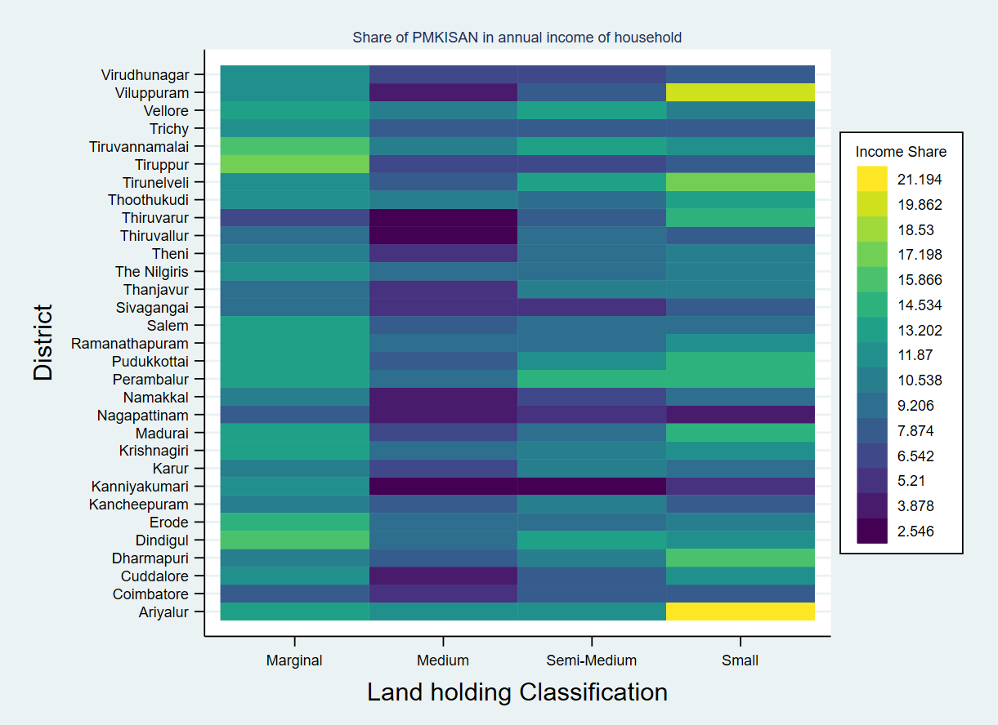

**Fig 3. Share of PMKISAN in Annual income of the farm household**

Source: authors calculation

**Conclusion**

PM-KISAN direct cash transfer scheme implemented by the Government of India to provide income support to the farmers at the time of crop production in three intervals to ease the liquidity constraints in procuring the agricultural inputs. The scheme is provided invariably to all the farmers. The total registered beneficiary under this scheme has been increasing largely over the years. The states like Uttar Pradesh, Maharashtra, Madhya Pradesh, Bihar, Tamil Nadu has the highest share of beneficiary where the agriculture has been carried out performantly. Whereas in Tamil Nadu, districts like Villupuram, Tiruvannamalai, Salem, Cuddalore has highest beneficiary rather than agriculture based districts like Thanjavur, Thiruvarur etc., The state wise performance indicate that states like Manipur, Mizoram has more beneficiary than potential beneficiary which may be due to community based, joint ownership based landholding which is difficult to assess the quantum of land holding. The another important aspects is lowest number of beneficiary which may be due to farmers facing problems with their land documents. In Tamil Nadu, about two third of farmers have registered and availed at least one instalment expect in districts like Theni and Tirunelveli where the total beneficiary is less than 40 percent to total registered beneficiary. The scheme has important impact on redistribution of income to small and marginal farmers where the income share to the their annual income is higher in all the districts. It is therefore suggested that states with less beneficiary can be concentrated to increase the beneficiary through digitization of land records and other related documents. This would reduce the mismatching of documents and also help in easy identification of beneficiaries in many states.

**Acknowledgements**

I thank Indian Council of Social Science Research for providing financial assistance for the research work under ICSSR Centrally Administered Full-Term Doctoral Fellowship.

**Reference**

Aizer, A., Eli, S., Ferrie, J., & Lleras-Muney, A. 2016. The long-run impact of cash transfers to poor families. *The American Economic Review*, **106(4):** 935-971. *http://doi: 10.1257/aer.20140529.*

Chioda, L., De Mello, J. M., & Soares, R. R. (2016). Spillovers from conditional cash transfer programs: Bolsa Família and crime in urban Brazil. *Economics of Education Review*, **54**: 306-320. *https://doi.org/10.1016/j.econedurev.2015.04.005*

GoI (2019), Agricultural Census 2015-16: All India Report on Number and Area of Operational Holdings, Agricultural Census Division, Ministry of Agriculture and Farmers Welfare, Government of India.

Kavitha H N, Pramod Kumar, Anbukkani P, Burman R R, Venkatesh P, G.K. Jha and   
Prakash, P. 2020. Performance of universal basic income programme in India: A case of PM-KISAN Scheme. *Indian Journal of Extension Education* **56(3):**1-8*. doi:*[*10.5958/2454-552X.2020.00001.8*](https://doi.org/10.5958/2454-552X.2020.00001.8)

Kavitha H N, Pramod Kumar, Anbukkani P, Burman R R, and Prakash, P. 2020. Evaluation of PM Kisan vis-à-vis State Government Schemes. *Economic and Political Weekly* **56(34)**:13-17.

Kusuma, D., McConnell, M., Berman, P., & Cohen, J. 2017. The impact of household and community cash transfers on children's food consumption in Indonesia. *Preventive Medicine*, **100:** 152-158. *https://doi.org/10.1016/j.ypmed.2017.04.020*

NSO (2021), “Situation Assessment of Agricultural Households and Landholdings of Households in Rural India,” NSS 77th Round, Ministry of Statistics and Programme Implementation, Government of India.

Taaffe, Jessica E., Andrew F. Longosz, and David Wilson.2017. "The impact of cash transfers on livelihoods, education, health and HIV–what's the evidence?." *Development Policy Review,* **00:**1-19. *https://doi.org/10.1111/dpr.12253*

Tiwari, Rajesh, Khem Chand, and Bimal Anjum. 2020. Crop Insurance in India: A Review of Pradhan Mantri Fasal Bima Yojana (PMFBY). *FIIB Business Review,* **9:** 249–55. *https://doi.org/10.1177/2319714520966084*

Kavitha H N, Pramod Kumar, Anbukkani P, Burman R R and

Prakash P. 2021. Income support schemes: Evaluation of PM

KISAN vis-à-vis State government schemes, Economic and

Political Weekly 56(34): 13–17.

Kavitha H N, Pramod Kumar, Anbukkani P, Burman R R and

Prakash P. 2021. Income support schemes: Evaluation of PM

KISAN vis-à-vis State government schemes, Economic and

Political Weekly 56(34): 13–17.

Kavitha H N, Pramod Kumar, Anbukkani P, Burman R R and

Prakash P. 2021. Income support schemes: Evaluation of PM

KISAN vis-à-vis State government schemes, Economic and

Political Weekly 56(34): 13–17