**Abstract**

Little millet, a minor cereal cultivated in semi-arid regions of India, is renowned for its nutraceutical properties. The endophytic plant growth-promoting bacterial (PGPB) communities help crop plants increase growth and health, endure stress tolerance, and enhance nutrient availability. Seed biotiztion with these endophytic PGPBs can facilitate the host plant to develop a defense against pathogens and challenging environments. Thus the present study aimed to biotize the little millet seeds (var. ATL1) with PGPBs, *viz*., *Bacillus albus* LRS2, *Alcaligenes faecalis* LSB6, *Bacillus amyloliquefaciens* LAS10 and *Bacillus velezensis* LLB10 and to evaluate their efficiency by developing as a consortia of these strains for improved plant growth and development. The seeds were biotized with all the strains individually and as SynCom to evaluate their plant growth attributes *in vitro* and *in vivo*. The results showed significant differences in vegetative growth parameters and yield attributes compared with the control over SynCom biotized seeds. During the panicle initiation stage (27 DAS), the shoot length (59.2, cm), root length (13.9 cm), total plant biomass (1.46 g), number of productive tillers plant-1 (5), panicle length (13.2 cm) and 1000 grain weight (5.12 g), grain yield plant-1 (28.45 g), straw yield (36.21 g) registered more in SynCom biotized plants compared to non-biotized plant maintained as control. Thus, the present study confirmed that the inoculation of little millet seeds with the SynCom of indigenous strains could promote plant growth and productivity. Further, the inoculant can be recommended as a novel bio-inoculant for enhancing crop health and sustainable production in little millet.

**Keywords: *SynCom; Biotization; Little Millet; Plant growth; Yield***

**Introduction**

Little millet (*Panicum sumatranse* L*.*) is a highly nutritious crop known for its rich content of nutraceutical components, including phenols, tannins, and phytates, as well as a variety of essential macro and micro-nutrients (Pradeep et al., 2011). It comprises protein (7.70 to 16.50 %), fat (2.45 to 9.04 %), carbohydrates (62.50 to 76.30 %), and dietary fiber (15.90 to 18.10 %) (Patil et al., 2015). Furthermore, it contains elevated levels of minerals like iron, magnesium, and zinc (Itagi et al., 2003). Despite its nutritional superiority and favorable comparison to staple cereals, the utilization of little millet is limited due to the increased production and availability of preferred cereals (Patil et al., 2015). Further, little millet is the least studied crop among millets, and unaware of the detailed mechanism of their limited production (Johnson et al., 2019).

The plant growth-promoting abilities of plant growth-promoting bacteria (PGPB) and beneficial endophytes have been reported earlier in diverse plants (White et al., 2019). They can elicit plant growth either directly or indirectly in the plants, through the mechanisms of induced systemic resistance, indole acetic acid (IAA) production, transporting nutrients from the soil into the plants, production of 1-Aminocyclopropane carboxylate deaminase (ACCd) enzyme, phosphate solubilization, siderophore production, hydrogen cyanide (HCN) and enhancing the ability of plants to withstand stress. Their growth-promoting effects vary from one organism to another and strain to strain (Pattnaik et al., 2019; Compant et al., 2010). Plants in natural ecosystems maintain symbiotic relationships with these endophytic microbes, which promote growth and protect against biotic and abiotic stressors (Verma et al., 2018). Due to the diverse functions of endophytic microbes, it is evidenced that they have the potential to substantially decrease the reliance on agrochemicals and aid in sustainable agricultural production.

The composition of the microbiome in plant roots can vary significantly from that in the rhizosphere, highlighting the role of plants in shaping the microbial communities that inhabit their roots (Gottel et al., 2011). The research conducted on the potential of root endophytes as plant inoculants enhances plant growth (Thakore et al., 2006). Simultaneously, seed endophytes in various crop plants play a significant role in promoting plant growth and development (Rahman et al., 2018). Leaf and their apoplast are a niche for beneficial microbes that help in plant health and stress resilience (Fatima et al., 2022). Biotizing the seeds with these beneficial organisms from various regions of a single plant facilitates the successful colonization of microbes throughout the host plant for effective application (Glick 2015). However, there has been a growing interest in microbial consortia application instead of using individual inoculants to promote plant growth and health (Bradacova et al., 2019). Positive interactions between rhizobacteria help in colonization and associative means of combatting environmental adversities. Utilizing a combination of two or more PGPBs can result in enhanced plant growth, stress resistance, and pathogen control. To substantiate this assertion, research studies have demonstrated that the co-inoculation of PGPBs leads to enhanced plant growth (Shanmugam et al., 2013; Wang et al., 2012; Berendsen et al., 2018). In our earlier experiments, we have isolated and identified the endophytic drought-tolerant bacteria from seed, root, leaf, and apoplastic fluid of little millet plants namely *Alcaligenes faecalis* LSB6, *Bacillus albus* LRS2, *Bacillus velenzensis* LAB10, and *Bacillus amyloliquefaceins* LAS10, respectively which play a potential role in plant growth promotion and enhanced drought stress tolerance (Unpublished). In the present study, a consortium of these endophytic PGPBs was developed and evaluated for its potential to enhance plant growth and yield attributes of little millet plants. The findings of this study would aid in developing a novel microbial consortium for improving little millet production.

**Materials and Methods**

**Bacterial strains and culture conditions**

PGPB strains *viz*.,  *Bacillus albus* LRS2, *Alcaligenes faecalis* LSB6, *Bacillus amyloliquefaceins* LAS10, *Bacillus velezensis* LLB10, isolated from the various parts of little millet cultivar (var. ATL1) used in this study was obtained from Biocatalysts Laboratory, Department of Agricultural Microbiology, Tamil Nadu Agricultural University, Coimbatore. All the strains were grown in Luria bertani (LB) broth, and incubated at 28 ± 2 ºC.

**Inoculum preparation and seed treatment**

The plant growth promotion ability of all the strains individually and in consortia was evaluated *in vitro* and carried over to a pot culture experiment. Surface disinfection of little millet seeds was carried out with 5 min soaking in mercuric chloride followed by 70% ethanol for 2 min and followed by repeated rinsing with sterile water (Olanrewaju *et al*., 2019). The pure cultures of *Bacillus albus* LRS2, *Alcaligenes faecalis* LSB6, *Bacillus amyloliquefaceins* LAS10, and *Bacillus velezensis* LLB10 were inoculated in LB broth overnight at ambient room temperature. The cells were collected through centrifugation at a speed of 6000 rpm for 5 min and subsequently diluted to achieve a final concentration of 108 colony-forming units (CFU) mL−1 using sterile 0.1 M Phosphate buffer at a pH of 7.2 (Petrillo et al., 2022). A consortium comprising four strains was established by combining them in even proportions, with each strain being blended at a 1:1:1:1 ratio. One milliliter of the respective bacterial strains was pooled and thoroughly mixed to create synthetic bacterial communities (Pandey et al., 2007). The surface-sterilized seeds were biotized with bacterial suspension for 1 h, air-dried, and placed on sterile Whatman filter paper No.1 (Soumiya *et al*., 2021). The seeds biotized with phosphate buffer served as control. Bacterial inoculants were treated in a single and a consortium. The biotized seeds were placed on a sterile filter paper in Petri dishes (9 cm) flooded with sterile distilled water. Further, for every treatment, three replicates were maintained with 10 seeds for each treatment (Narayanasamy et al., 2020). The seeds were incubated for five days in a plant growth chamber with a relative humidity of 60% at 28 °C for 12 h of light (200 moles m-2s-1). Plant growth attributes *viz*., root length, shoot length, and germination percentage of little millet due to biotization were analyzed.

**Pot culture experiment**

Little millet seeds (var. ATL1) utilized for this study were collected from the Department of Millets, Tamil Nadu Agricultural University, Coimbatore. The seeds were sown and consistently irrigated under a 12-hour light cycle, with temperatures varying between 25 to 29 ºC and a relative humidity of 72–76% in the glasshouse, Department of Genetics and Breeding, Tamil Nadu Agricultural University, Coimbatore. Four replications for each treatment were maintained. Morphological, yield, and yield components were recorded. The experiments were conducted two times to verify the consistency and reliability of the obtained results.

The treatment details are as follows:

Variety: ATL1

T1 : Control

T2: Seed biotization with *B. albus* LRS2

T3: Seed biotization with *Alcaligenes faecalis* LSB6

T4: Seed biotization with *B. amyloliquefaceins* LAS10

T5 : Seed biotization with *B. velezensis* LLB10

T6: Seed biotization with consortia (T2+T3+T4+T5)

Replication: 4

Design: Completely Randomized Design (CRD).

Samples were collected during the panicle initiation stage (28 DAS) at 5-day intervals up to the flowering stage.

**Plant growth attributes**

**Morphological characters**

The effects of the microbial inoculation on morphological characteristics in little millet *viz*., root length, shoot length, and germination percentage of little millet due to inoculation at the panicle initiation stage (28 DAS) were assessed.

The germination percentage for *in vitro* plate germination assays was recorded at 3-day intervals of up to 5 days. Seeds were considered as germinated when the radicle protrusion was a minimum of 2 mm in length. The germination of little millet seeds concerning different treatments was recorded on day 7 and expressed as germination percentage. The vigor index of the seedlings was calculated using the following formula proposed by Abdul-Baki and Anderson (1973).

Vigor Index = (Shoot length + Root length) x Germination percentage

On the 28th day after sowing, seedlings from each replication were carefully removed at random. The length of the shoot was assessed by measuring from the collar region to the tip of the longest leaf and recorded in centimeters (cm). The plants were removed with great care to minimize any potential harm to the roots. The length from the base of the shoot to the tip of the longest root was measured, and the average was calculated for three plants within each replication, expressed in centimeters (cm).

**Yield components**

For each treatment, three hills were chosen at the onset of panicle initiation, and labeled, and the number of tillers producing panicles per hill was counted, with the average value subsequently recorded. Total straw and grain yield were recorded and expressed in grams. One thousand filled grains were sampled from each plant weighed at 14 percent moisture content and expressed in g.

**Statistical analysis**

The dataset was subjected to a two-way analysis of variance and means were separated by Duncan’s multiple range test (DMRT) at 0.05 level of probability using statistical software SPSS version 20.0. Graph pad prism 8 was used for the construction of graphs.

**Result and Discussion**

**Plant growth promotion of PGPB on little millet under *in vitro***

The utilization of Plant Growth-Promoting Bacteria (PGPB) in both plant growth promotion, abiotic stress tolerance, and disease control have been reported in numerous studies (Adjanohoun et al., 2011). In the soil, these microbes coexist and thrive, with their survival and cohabitation determined by their compatibility and adaptability to the environment. These characteristics have inspired researchers to explore the concept of co-inoculation. The utilization of consortia organisms for plant growth promotion has been assessed across a range of different crop varieties (Kumar et al., 2016). The SynCom methodology holds potential as a technology that integrates the principles of microbial ecology and genetics (Toju et al., 2020). Traditionally, beneficial microbes are chosen through in vitro screening for particular taxa exhibiting one or more Plant Growth-Promoting (PGP) traits, such as nitrogen fixation, phosphorus solubilization, and the production of growth-regulating hormones. However, their evaluation is often limited to controlled environmental conditions (Choi et al., 2021). A SynCom presents a compelling alternative to address the challenges linked to traditional inoculants. It has the capacity to integrate diverse microbial communities, partially emulating the functional environment of these microorganisms (Kaminsky et al., 2019).The PGPB strains LRS2, LSB6, LAS10, and LLB10 and the consortia of these strains were assessed for their prospective role in seed germination and plant growth promotion under *in vitro* conditions. Biotization of little millet seeds with these PGPBs elevated the germination compared to the non-biotized control seeds. Biotized seeds considerably promoted seed germination. Seed germination started after 72 h, irrespective of all treatments (Table 1). However, biotized seeds visualized earlier germination when compared to control seeds. Among the treatments, individual-treated seeds and consortia treated showed on par seed germination percentage with cent percent, whereas control seeds registered 92 % seed germination after 72 h. Further, control seeds registered full germination only after 3 DAS (Table 1). The *in vitro* assessment of strains over consortia yielded the highest germination percentage and earlier germination (72 h) in consortia than in individual and control treatments. The seed vigor index of consortia yielded a 43.4 % increase over control. The individual strains showed a range of 31.9% to 37.81 % higher vigor index than the control.IAA plays a role in root elongation, and its interaction with ethylene contributes to the plant's defense mechanisms. Initial studies showed that all the strains were able to produce IAA, siderophore, nutrient solubilization, and ACCd activity (unpublished data). In brief, the current findings focus on the perspectives regarding the plant growth-promoting capabilities of SynCom when compared to individual strains. The microbial interactions among the strains impact the consortia inoculants mechanisms. In the present study, the SynCom of four strains (LRS2, LSB6, LAS10, LLB10) recorded a positive and better performance in all plant growth and morphological attributes than individual treatment and control.

**3.2.Effect of PGPB consortia seed biotization on morphological attributes of little millet under pot culture**

Seed biotization notably influenced the shoot length and root length as observed on 28 DAS during the panicle initiation stage (Figure 1). Among the treatments, seeds biotized with T6 showed increased shoot length (35.5%) and root length (44.3%) over control seedlings, on the 28th day of sampling (Figure 1a, Figure 1b) followed by T3 with elevated shoot length (15.7%) and root length (17.8%) over control on 0th day. The shoot length and root length of little millet were recorded on consecutive 5-day intervals at the tillering to the panicle initiation stage. On the 5th and 10th day from the 28th day of sample collection showed a range of 44.6- 54.7% increased root length activity in T6 over control respectively. The least values for shoot and root length were recorded in T1 (Control). The increased root length in T6 than control plants might be due to the IAA production from all the plant growth-promoting microbes. The seed vigor index was found to be higher in biotized plants when compared to the control. T6 recorded a higher seed vigor index (43.4%) followed by T3 (32.1%) which is higher when compared to the control. At 27 DAS, maximum root length (54.7%), and shoot length (42.12%), were recorded by the consortia treatments than individual inoculated seeds. The earlier results reported that PGPB can release bioactive molecules that can directly or indirectly increase plant growth (Olanrewaju et al., 2017). Furthermore, an increase in root length due to inoculation with bacterial consortium was also reported in the study of Akhtar et al., (2018). Besides, IAA produced by the PGPBs plays a crucial role in promoting root elongation (Di et al., 2016). Microbial activity impacts on the biomass of plants (Rana et al., 2011). In our study, consortia treatment (T6) showed a significant difference in plant biomass over control which may be due to the production of phytohormones (Kurepin et al., 2014).

**3.3.Yield attributes of biotized little millet crop in pot culture**

**3.3.1.Number of productive tillers and panicle length**

The number of productive tillers was found to be higher in T6 (5.3) followed by T2 (2.41) and T4 (2.41) treatments of individual treated seeds. The lowest number of productive tillers was recorded in T1 followed by T5 (Figure 2a). However, all the PGPB biotized strains produced an increased number of tillers over control. The inoculation effect was also visualized with an increase in tillers and panicle length compared to the control. Panicle length was found to be increased in T6 (31.06%) biotized plants when compared to control plants (Figure 2b) followed by T2 (10.7%) over control. Several studies reported that consortia inoculation of bacterial cultures showed a significant correlation between grain yield with the number of tillers, panicle length, and number of grains per panicle (Khaliq et al., 2004; Dhurai et al., 2016). The SynCom (T6) treated plants reported an elevated number of productive tillers (5.3), panicle length (30.06%), and 1000 grain weight (49.7%) and these results are in line with the earlier reports of Khaliq et al., (2004) and Dhurai et al., (2016),. The panicle length and 1000 grain weight have a direct effect on grain yield (Reddy et al., 2013).

**Total biomass**

Seed biotization (T2- T6) increased the total biomass of the crop plant in the range of 67.7 to 9.6 % over control (T1). Among the treatments, the total biomass of biotized little millet plants was found to be increased in T6 (67.7%) followed by T2 (41.97%) over control. Among the biotized seeds, SynCom-treated seeds (T6) recorded the highest biomass content (1.46 g) when compared to individual strains (0.52 – 0.81g) (Figure 2c). In general PGPB inoculated seeds improve total biomass of plant crop. Earlier reports evidenced that PGPB helped in increase leaf biomass and pod biomass by 23.97% when compared to the control treatment in the trial (Lally et al., 2017). et al., reported that pea plants that were cultivated from seeds treated with a microbial consortia exhibited a notable decrease in susceptibility to diseases and there was a substantial improvement in both yield and overall biomass (Jain et al., 2015).

**Grain and straw yield**

SynCom biotized little millet seeds recorded the highest yield attributes than the control. Biotized seeds showed increased grain yield in the range of 39.8-18.2% over control. Among them, T6 visualized the highest grain yield (39.2%), followed by T5 (33.3%). Simultaneously, the straw yield was also found to be increased in biotized seeds (19.05 – 6.1%) when compared to non-biotized seeds. Among the treatments, T6 recorded the highest straw yield of 36.21 g plant-1 followed by T4 (32.7 g plant-1). T6 recorded the highest 1000-grain weight (5.12 g) among the biotized seeds followed by T2 (3.21 g) which is 49.7% and 40.4% higher, compared to control respectively (Figure 2d, Figure 2e, Figure 2f). Though the individual strains showed an increased grain and straw yield than the control, consortia-treated seeds recorded higher grain (28.45 g plant-1) and straw yield (36.21 g plant-1) than the individual strains which are 39.2 and 19.05% higher than control, respectively. In addition, Vijayabharathi et al., (2018) reported that *Streptomyces* consortium increased chickpea growth. Kumar et al., (2021) reported that the consortia-treated (tetra-inoculants) wheat seeds showed a significantly higher grain yield of 40.09% and straw yield of 42.64 % over control which supports our present study. Shahzad et al., (2017), reported that consortium-treated wheat seeds visualized increased grain yield, straw yield, and 1000 grain weight when compared to the control.

**Conclusion**

Consortia envisaged a prominent effect on plant growth performance viz., increased shoot length, root length, and yield attributes over control. The plant growth-promoting traits might be due to the auxin, phytohormone production, and nutrient uptake by the potential four strains. The results obtained from this study were encouraging, thereby supporting the use of SynCom as an environmentally friendly method to enhance plant performance. However, further analysis is necessary to refine this approach for potential commercial use in the agro-industrial sector. Further, field trials may ultimately result in the development of an effective and innovative bioinoculant consortium for improving the fitness of little millet crops, ultimately leading to increased crop productivity.

**Ethics approval and consent to participate**

Not applicable**.**

**Originality and plagiarism**

Authors ensured that the manuscript was written entirely as original works and that the work and/or words of others have been appropriately cited.

**Consent for publication**

NA

**Competing interest**

All authors declared no conflicting interests.

**Availability of data and material**

All data generated or analyzed during this study are included in this published article.

**Funding**

This study was supported by the Ministry of Human Resource Development, Government of India through MHRD-FAST-CoE (F.No.5–6/2013-TSVII) sanctioned to SU.

**Author’s contributions**

SU-Conceptualization, supervision, funding acquisition, project administration, validation, review, and editing; MR- Writing an original draft, conducting experiments, data curation, and formal analysis. SN- supervision, software analysis, validation, review, and editing.

**Acknowledgement**

This study was supported by the Ministry of Human Resource Development, Government of India through MHRD-FAST-CoE (F.No.5–6/2013-TSVII) sanctioned to SU.

**References**

Abdul‐Baki, A. A., & Anderson, J. D. (1973). Vigor determination in soybean seed by multiple criteria 1. *Crop science*, *13*(6), 630-633.

Adjanohoun, A., Allagbe, M., Noumavo, P. A., Gotoechan-Hodonou, H., Sikirou, R., Dossa, K. K., ... & Baba-Moussa, L. (2011). Effects of plant growth promoting rhizobacteria on field grown maize. *Journal of Animal & Plant Sciences*, *11*(3), 1457-1465.

Akhtar, N., Naveed, M., Khalid, M., Ahmad, N., Rizwan, M., & Siddique, S. (2018). Effect of bacterial consortia on growth and yield of maize grown in Fusarium infested soil. *Soil & Environment*, *37*(1).

Argaw, A. (2012). Evaluation of co-inoculation of Bradyrhizobium japonicum and Phosphate solubilizing Pseudomonas spp. effect on soybean (Glycine max L. Merr.) in Assossa Area. *Journal of Agricultural Science and Technology*, *14*(1), 213-224.

Berendsen, R. L., Vismans, G., Yu, K., Song, Y., de Jonge, R., Burgman, W. P., ... & Pieterse, C. M. (2018). Disease-induced assemblage of a plant-beneficial bacterial consortium. *The ISME journal*, *12*(6), 1496-1507.

Bradáčová, K., Florea, A. S., Bar-Tal, A., Minz, D., Yermiyahu, U., Shawahna, R., ... & Poşta, G. (2019). Microbial consortia versus single-strain inoculants: an advantage in PGPM-assisted tomato production?. Agronomy, 9(2), 105.

Choi, K., Khan, R., & Lee, S. W. (2021). Dissection of plant microbiota and plant-microbiome interactions. *Journal of Microbiology*, *59*, 281-291.

Compant, S., Clément, C., & Sessitsch, A. (2010). Plant growth-promoting bacteria in the rhizo-and endosphere of plants: their role, colonization, mechanisms involved and prospects for utilization. *Soil Biology and Biochemistry*, *42*(5), 669-678.

Dhurai SY, Reddy DM, Ravi S .Correlation and path analysis for yield and quality characters in rice (*Oryza sativa* L.). Rice Genomics Genet 7 (2016):1–6

Di, D. W., Zhang, C., Luo, P., An, C. W., & Guo, G. Q. (2016). The biosynthesis of auxin: how many paths truly lead to IAA?. *Plant growth regulation*, *78*, 275-285.

Fatima, T., Sharma, S., Bano, A., Srivastava, D., Verma, I., & Singh, P. C. (2022). Microbial Endophytes: A Hidden Plant Resident, Application and Their Role in Abiotic Stress Management in Plants. *Journal of Ecophysiology and Occupational Health*, 127-140.

Glick, B. R. (2015). *Beneficial plant-bacterial interactions* (p. 383). Heidelberg: Springer.

Gottel, N. R., Castro, H. F., Kerley, M., Yang, Z., Pelletier, D. A., Podar, M., ... & Schadt, C. W. (2011). Distinct microbial communities within the endosphere and rhizosphere of Populus deltoides roots across contrasting soil types. *Applied and environmental microbiology*, *77*(17), 5934-5944.

Itagi, S., Naik, R., & Yenagi, N. (2013). Versatile little millet therapeutic mix for diabetic and non diabetics. *Asian Journal of Science and Technology*, *4*(10), 33-35.

Jain, A., Singh, A., Singh, S., & Singh, H. B. (2015). Biological management of Sclerotinia sclerotiorum in pea using plant growth promoting microbial consortium. *Journal of basic microbiology*, *55*(8), 961-972.

Johnson, M., Deshpande, S., Vetriventhan, M., Upadhyaya, H. D., & Wallace, J. G. (2019). Genome‐wide population structure analyses of three minor millets: Kodo millet, little millet, and proso millet. *The Plant Genome*, *12*(3), 190021.

Kaminsky, L. M., Trexler, R. V., Malik, R. J., Hockett, K. L., & Bell, T. H. (2019). The inherent conflicts in developing soil microbial inoculants. *Trends in Biotechnology*, *37*(2), 140-151.

Khaliq, I. H. S. A. N., Parveen, N. A. J. M. A., & Chowdhry, M. A. (2004). Correlation and path coefficient analyses in bread wheat. *Int. J. Agric. Biol*, *6*(4), 633-635.

Kumar, A., Maurya, B. R., & Raghuwanshi, R. (2021). The microbial consortium of indigenous rhizobacteria improving plant health, yield and nutrient content in wheat (Triticum aestivum). *Journal of Plant Nutrition*, *44*(13), 1942-1956.

Pandey, P. (2016). Bacteria consortium optimization improves nutrient uptake, nodulation, disease suppression and growth of the common bean (Phaseolus vulgaris) in both pot and field studies.

Kurepin, L. V., Zaman, M., & Pharis, R. P. (2014). Phytohormonal basis for the plant growth promoting action of naturally occurring biostimulators. *Journal of the Science of Food and Agriculture*, *94*(9), 1715-1722.

Lally, R. D., Galbally, P., Moreira, A. S., Spink, J., Ryan, D., Germaine, K. J., & Dowling, D. N. (2017). Application of endophytic Pseudomonas fluorescens and a bacterial consortium to Brassica napus can increase plant height and biomass under greenhouse and field conditions. *Frontiers in Plant Science*, *8*, 2193.

Narayanasamy, S., Thangappan, S., & Uthandi, S. (2020). Plant growth-promoting Bacillus sp. cahoots moisture stress alleviation in rice genotypes by triggering antioxidant defense system. *Microbiological Research*, *239*, 126518.

Olanrewaju, O. S., Glick, B. R., & Babalola, O. O. (2017). Mechanisms of action of plant growth promoting bacteria. *World Journal of Microbiology and Biotechnology*, *33*, 1-16.

Olanrewaju, O. S., & Babalola, O. O. (2019). Bacterial consortium for improved maize (Zea mays L.) production. *Microorganisms*, *7*(11), 519.

Pandey, P., & Maheshwari, D. K. (2007). Two-species microbial consortium for growth promotion of Cajanus cajan. *Current science*, 1137-1142.

Patil, K. B., Chimmad, B. V., & Itagi, S. (2015). Glycemic index and quality evaluation of little millet (Panicum miliare) flakes with enhanced shelf life. *Journal of food science and technology*, *52*, 6078-6082.

Pattnaik, S., Mohapatra, B., Kumar, U., Pattnaik, M., & Samantaray, D. (2019). Microbe-mediated plant growth promotion: a mechanistic overview on cultivable plant growth-promoting members. *Biofertilizers for sustainable agriculture and environment*, 435-463.

Petrillo, C., Vitale, E., Ambrosino, P., Arena, C., & Isticato, R. (2022). Plant growth-promoting bacterial consortia as a strategy to alleviate drought stress in Spinacia oleracea. *Microorganisms*, *10*(9), 1798.

Pradeep, S. R., & Guha, M. (2011). Effect of processing methods on the nutraceutical and antioxidant properties of little millet (Panicum sumatrense) extracts. *Food chemistry*, *126*(4), 1643-1647.

Rana, Anuj, Baljeet Saharan, Lata Nain, Radha Prasanna, and Yashbir S. Shivay. "Enhancing micronutrient uptake and yield of wheat through bacterial PGPR consortia." *Soil Science and Plant Nutrition* 58, no. 5 (2012): 573-582.

Reddy, G. E., Suresh, B. G., Sravan, T., & Reddy, P. A. (2013). Interrelationship and cause-effect analysis of rice genotypes in north east plain zone. *The Bioscan*, *8*(4), 1141-1144.

Rehman, A., Farooq, M., Naveed, M., Nawaz, A., & Shahzad, B. (2018). Seed priming of Zn with endophytic bacteria improves the productivity and grain biofortification of bread wheat. *European Journal of Agronomy*, *94*, 98-107.

Shahzad, S., Khan, M. Y., Zahir, Z. A., Asghar, H. N., & Chaudhry, U. K. (2017). Comparative effectiveness of different carriers to improve the efficacy of bacterial consortium for enhancing wheat production under salt affected field conditions. *Pak. J. Bot*, *49*(4), 1523-1530.

Shanmugam, V., Thakur, H., Kaur, J., Gupta, S., Rajkumar, S., & Dohroo, N. P. (2013). Genetic diversity of Fusarium spp. inciting rhizome rot of ginger and its management by PGPR consortium in the western Himalayas. *Biological control*, *66*(1), 1-7.

Soumya, P. R., Sharma, S., Meena, M. K., & Pandey, R. (2021). Response of diverse bread wheat genotypes in terms of root architectural traits at seedling stage in response to low phosphorus stress. *Plant Physiology Reports*, *26*, 152-161.

Thakore, Y. (2006). The biopesticide market for global agricultural use. *Industrial Biotechnology*, *2*(3), 194-208.

Toju, H., Abe, M. S., Ishii, C., Hori, Y., Fujita, H., & Fukuda, S. (2020). Scoring species for synthetic community design: network analyses of functional core microbiomes. *Frontiers in microbiology*, *11*, 1361.

Verma, S. K., & White, J. F. (2018). Indigenous endophytic seed bacteria promote seedling development and defend against fungal disease in browntop millet (Urochloa ramosa L.). *Journal of applied microbiology*, *124*(3), 764-778.

Vijayabharathi, R., Gopalakrishnan, S., Sathya, A., Vasanth Kumar, M., Srinivas, V., & Mamta, S. (2018). Streptomyces sp. as plant growth-promoters and host-plant resistance inducers against Botrytis cinerea in chickpea. *Biocontrol Science and Technology*, *28*(12), 1140-1163.

Wang, C. J., Yang, W., Wang, C., Gu, C., Niu, D. D., Liu, H. X., ... & Guo, J. H. (2012). Induction of drought tolerance in cucumber plants by a consortium of three plant growth-promoting rhizobacterium strains. *Plos one*, *7*(12), e52565.

White, J. F., Torres, M. S., Verma, S. K., Elmore, M. T., Kowalski, K. P., & Kingsley, K. L. (2019). Evidence for widespread microbivory of endophytic bacteria in roots of vascular plants through oxidative degradation in root cell periplasmic spaces. In *PGPR amelioration in sustainable agriculture* (pp. 167-193). Woodhead Publishing.

**Table 1. Plant growth attributes of biotized little millet seeds over control under *in vitro***

|  |  |  |  |
| --- | --- | --- | --- |
| **Treatments** | **Germination percentage** | **Vigour index (%)** | **Fresh weight (mg/plant)** |
| T1 | 92 ± 0.91 | 114.91±1.09e | 227.42 ± 0.99b |
| T2 | 100 ± 0.72 | 2380 ± 1.27b | 302.31±1.09b |
| T3 | 100 ± 0.84 | 1800.01 ± 2.01c | 291.09 ± 0.72c |
| T4 | 100 ± 0.85 | 1491.32 ±1.43bc | 299.42 ± 1.04bc |
| T5 | 100 ± 0.29 | 1729.5 ± 1.86bc | 282.31 ± 1.12c |
| T6 | 100 ± 0.31 | 2612.31 ± 1.91a | 324.51 ± 1.37a |

Values are means of standard errors (n = 5) and values followed by the same letter in each column are significantly different from each other on the observation day as determined by DMRT (p ≤ 0.05). T1- Absolute control, T2- LRS2, T3- LSB6, T4- LAS10, T5- LLB10, T6- SynCom

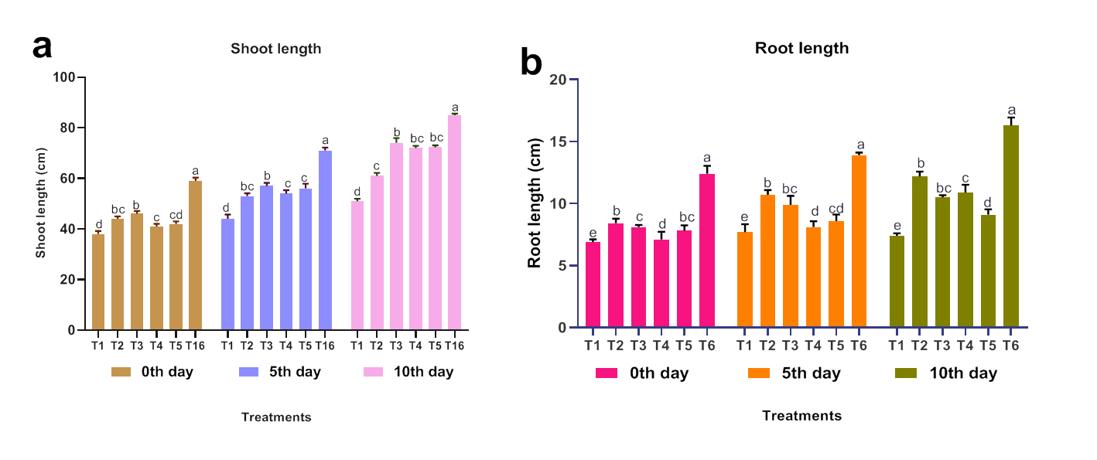

**Figure 1.** Effect of SynCom biotization on plant growth promoting attributes of little millet plant. **a.** Shoot length. **b**. Root length. Values are means of standard errors (n = 5) and values followed by the same letter in each column are significantly different from each other on the observation day as determined by DMRT (p ≤ 0.05). T1- Absolute control, T2- LRS2, T3- LSB6, T4- LAS10, T5- LLB10, T6- SynCom

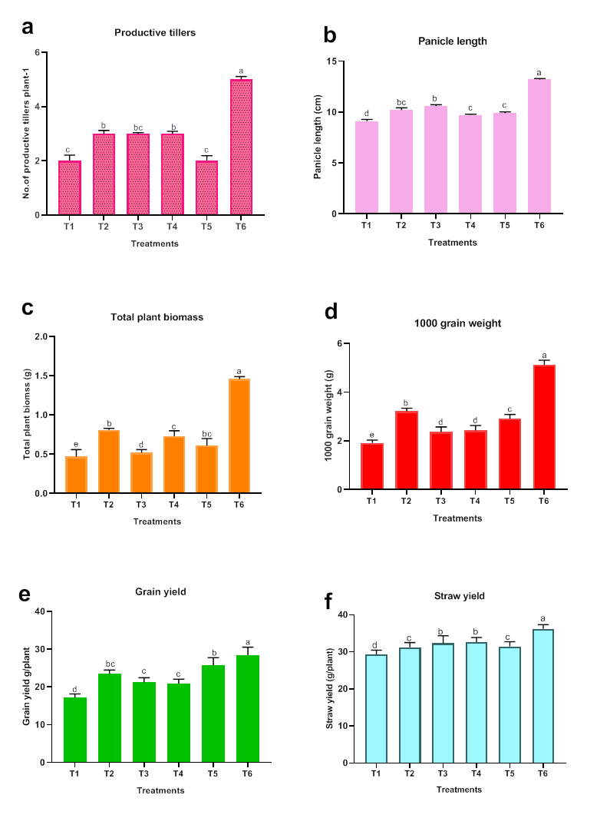

**Figure 2.** Impact of SynCom biotized seed on yield attributes of little millet plant. **a.** Productive tillers. **b.** Panicle length. **c.** Total biomass **d.** 1000-grain weight. **e**. Grain yield. **f.** Straw yield. Values are means of standard errors (n = 5) and values followed by the same letter in each column are significantly different from each other on the observation day as determined by DMRT (p ≤ 0.05). T1- Absolute control, T2- LRS2, T3- LSB6, T4- LAS10, T5- LLB10, T6- Consortium