Effect of Human urine on soil properties and yield of Finger millet and Brinjal crops
Dr.G.Sridevi
Assistant Professor (SS & AC) , Agricultural College & Research Institute (AC & RI),
Tamil Nadu Agricultural University, Coimbatore-3, Tamil Nadu , India
Corresponding author email: smathareddy@gmail.com
Abstract
The introduction of Human urine created opportunities for safer sanitation and recycling of human excreta, as fertilizers, in rural and peri-urban areas. Field experiments were conducted at the University farm on Finger millet and brinjal crops as the test crops in succession for 2 consecutive years in the same field. Different treatment combinations tried include human urine, with and without gypsum, cattle urine Farm yard manure (FYM), chemical fertilizers and control. The fertilizer value of human urine was assessed and supplied to the crops based on the nutrient content. The results revealed that yield of two crops were significantly highest in treatment receiving human urine + FYM followed by human urine alone. Generally the results showed that human urine performed well than the commercially available chemical fertilizers (urea) applied as a source of N for crops and does not pose any significant hygienic threats and leave any significant flavor in food products.
Keywords: Cattle urine; Farmyard manure; Fertilizers; Human urine and Yield
Introduction
In agriculture, when food is produced, the nutrients and trace elements are taken up from the soil and built into biological material. On harvesting, crops or when meat is produced, these elements are taken from the fields and in most cases circulated on the farm. However some of the food is transported into the urban community, where a lot of it is eaten and some of it is disposed of as biodegradable solid waste. Due to the one-way flow of food from the farms into the city, a deficit of those elements not occurring in surplus amounts will occur. These elements have to be compensated for in some manner. In the agriculture of today, mineral fertilizers of fossil origin often do this. Due to the decreasing reserves of fossil resources, nutrients have to be circulated between the city and the farms if we are to have a sustainable development of society. In this regard an attempt was made to use human urine for agricultural purpose. Human wastes are a widely used resource in many parts of the world. The guidelines concentrate on the following three practices, which are the most common: use of wastewater for crop irrigation; use of excreta for soil fertilization and soil structure improvement; use of wastewater and excreta in aquaculture.
The use of urine as a source of nutrients or fertilizer has been tested, gaining popularity and accepted partially in Finland, South Africa, Israel, Sweden and China (Pradhan et al.,2009; Winker et al., 2010). Human urine contains all the essential nutrients required by the plants. The fertilizer value of pure urine is similar to NPK fertilizers. Still due to awareness and non-technical aspects are often neglected both by scientists and by developers of new technologies. One of the best options is to utilize human urine as liquid fertilizer which has appreciable quantities of nutrient elements required by plants but is being wasted.
Human urine and cattle urine, which contains appreciable quantity of nitrogen (N), phosphorus (P) and potassium (K). The nitrogen in human urine mainly consists of ammonium and has 85-100% of the plant availability of the nitrogen in chemical fertilizers (Jonsson et al.,2004). The phosphorus in urine is mainly in the form of phosphate ions and is as available to plants as soluble phosphorus fertilisers.
The use of human urine in agriculture is not possible with the present system of sewage disposal mechanisms. Eco-friendly design of toilet called ‘ECOSAN’ (Urine diverting toilets) is being currently used for this studies which helpin source separation of human urine and faecal matter in a hygienic way. The standardprocedure and protocol of using human urine in crop production is not well documented in India. By keeping all these points, the present study was carried out with the main objective to assess the nutritive value of human urine with and without gypsum on Finger millet and brinjal crops .
Materials and Methods
Experimental Site and Soil Characteristics
Field experiments were conducted for two years at the main research station ofUniversity of Agricultural Sciences, GKVK, Bangalore which is located in the eastern dry zone of Karnataka and the site. Initial characteristics of the experimental site was presented in Table 1. The soils of the experimental fields were analyzed for their physico-chemical properties are presented in Table 2 along with the site characteristics.
Table 1. Characteristics of the experimental study area
Experimental study area | Research farm, University of Agricultural Science, GKVK, Bangalore
Latitude/Longitude | 12° 58’ North latitude, 77° 35’ East longitude
Mean annual maximum Temperature (ºC) | 28.0
Mean annual minimumTemperature (ºC) | 20.8
Major soils | Lateritic soils
crop | Finger Millet and Brinjal

Table 2. Initial Characteristics of the experimental soil
Soil series | Vijayapur
USDA Taxonomical class | Oxichaplustalf
Texture | Sandy clay loam
pH | 5.97
EC (dSm-1) | 0.14
Organic carbon (%) | 1.45
Available N ( kg ha⁻¹) | 347.8
Available P( kg ha⁻¹) | 41.62
Available K ( kg ha⁻¹) | 283.8

Nutrient composition of urine and cow urine
The nutrient composition of urine of differs from country to country and is basically based on diet. The composition of cow urine and FYM may also vary. Hence these were analyzed.the chemical composition for human urine was 0.30, 0.17, 0.18 per cent ,N, P₂O₅ and K₂O, respectively and cow urine had 0.25, 0.12 and 0.16 per cent N, P2O5and K2O, respectively
Crop details
A Finger millet –Brinjal crop used as at test crops for record the performance of human urine and cattle urine the crop production. The experiment was laid out with a set of nine different treatments in randomized block design with three replications (Table 3). The recommended dose of fertilizers (RDF) for test variety of Finger millet (100:50:50kg of NPK ha⁻¹ ) and Brinjal is (125:100:50kgof NPK ha⁻¹ , respectively as per the Karnataka package of practice hand book. The required quantity of N, P and K were applied in the form of urea, single supe rphosphate and muriate of potash, cow urine and human urine as per the treatments. In treatments, N was given based on the nitrogen content in human urine, cow urine and FYM (Tables 4). Balance of P and K were supplied through chemical fertilizers, Phosphorus through single super phosphate and Potassium through muriate of potash. The urine was applied in rose can for uniform soil application. Basal application of urine was done before sowing the seeds to supply 40% of nitrogen and the balance 60% N was supplied through human urine/cattle urine (two split dose was) given before fifty per cent of flowering. The balanced recommended dose of P&K was applied to the plots at the time of sowing. Gypsum was used as an amendment. The gypsum requirement was calculated based on the solubility of gypsum, field capacity of the soil and quantity of human urine. To attain hundred per cent saturation, two grams of gypsum per litre of human urine was used. The total quantity of gypsum per plot was calculated based on the amount of human urine to be added for each plot. All the cultural and management practices were followed uniformly to all plots as per the package of practices in both the crops. The growth and yield parameters were recorded by adopting standard procedures.
Table 3. Treatment details
Treatment | Details
T₁ | Rec. N -Human urine @ 40% basal + 60 % in 3 splits without gypsum
T₂ | Rec. N -Human urine @ 40% basal + 60 % in 3 splits with gypsum
T₃ | Rec. N -Cow urine @ 40% basal + 60 % in 3 splits without gypsum
T₄ | Rec. N -Cow urine @ 40% basal + 60 % in 3 splits with gypsum
T₅ | 40% Rec. N through FYM basal+ 60% thro' HU
T₆ | 40% Rec. N through CF basal + 60% thro' HU
T₇ | 40% Rec. N through FYM basal+ 60% thro' CU
T₈ | 40% Rec. N through CF basal + 60% thro' CU
T₉ | Absolute control

Table 4. Recommendation of Human urine and cow urine for finger millet and Brinjal crops
Crop |  | Plants/ha | RDF | Human urine  (lit/ha) | Urine required /plant (lit) | Cow Urine required  (lit/ha) | No. of Splits
Finger millet | (I) | 3,33,333 | 100:50:50 | 33,333 | 0.10 | 50000 | 5-6
Brinjal | (I) | 37,037 | 125:100:50 | 41,667 | 1.125 | 62500 | 3-4
Soil analysis
To assess the influence of urine on the agronomic performance, soil fertility and nutrient balance, representative soil samples were taken from each treatment plot. Samples were taken from the cultivated soil layer (upper 15 cm), using a single auger and combining 12 samples evenly distributed over the field to one composite sample. The samples were air dried, crushed and gravel and other particles of more than 2 mm were removed with a sieve. The samples were analysed in the soil laboratory of Department of Soil Science and Agricultural Chemistry, University of Agricultural Sciences, for the parameters listed in Table 5.
Table 5. Soil parameters and analytical methods.
Parameter | Method | Reference
Texture (sand, silt, clay) | Hydrometer | Day (1965)
pH | 1: 2.5 Soil water suspension | Jackson (1973)
EC (dsm⁻¹) | 1: 2.5 Soil water suspension | Jackson (1973)
Organic Carbon (%) | Wet Digestion | Walkley and Black (1934)
Available Nitrogen (kg ha⁻¹) | Alkaline Permanganate method | Subbiah and Asija (1956)
Available Phsophorus (kg ha⁻¹) | Bray method | Bray and Kurtz (1945)
Available Potassium (kg ha⁻¹) | Ammonium acetate extractable K | Standford and English (1949)
Statistical analysis
Statistical analyses of the data were carried out according to randomized block design. The experimental data of two years were subjected to statistical scrutiny as per methods suggested by Gomez and Gomez (1984).All the parameters were subjected to analysis of variance (ANOVA) and the data were analyzed for its statistical significance. Fisher’s Least Significant Difference (LSD) was used to test the significant differences between the means, at probability level P≤0.05using the ANOVA (Analysis of Variance). The non-significant treatment differences were denoted as NS.
Results and Discussion
Soil properties
The pH and EC of the soil were significantly affected by different treatments tried. In the first crop of Finger millet , higher pH (7.02) was noticed in treatment (T₅-40% Rec. N through FYM basal+ 60% through HU).During second year after the harvest of Brinjal also the same treatment recorded higher pH (6.64). The higher EC value was noticed in human urine alone treatment T₁(0.30 dSm-1) when compared to control. This is attributed due to the presence of higher quantity of salts in human urine which in turn depends upon diet .During second year also, the soil properties were found to be congenial for plant growth. The EC of the soil was significantly affected by different treatments. Application of human urine has increased the EC of soil slightly. The higher EC value (0.32 dSm⁻¹) was noticed in human urine alone treatment (T₁) when compared to control. Similar results of increase in EC of soil with application of human urine were reported by Mnkeni Pearson, (2008). However, all these values are below the permissible limits and hence it might have turned beneficial for plant growth. This might be due to presence of higher quantity of salts in human urine which might have contributed for the increase in values (Table 6)
Table 6. Effect of Human urine on pH, EC (dSm⁻¹) and organic carbon content (%) of soil at harvest stages of Finger millet and Brinjal crop
[Treatments | Crop I | Crop II | Crop I | Crop II | Crop I | Crop II
[Treatments | pH |  | EC (dSm⁻¹) |  | Organic carbon (%)
T₁- Rec. N -Human urine @ 40% basal + 60 % in 3 splits without gypsum | 6.43 | 6.32 | 0.30 | 0.32 | 1.66 | 1.58
T₂- Rec. N -Human urine @ 40% basal + 60 % in 3 splits with gypsum | 6.38 | 6.33 | 0.29 | 0.30 | 1.75 | 1.60
T₃- Rec. N -Cow urine @ 40% basal + 60 % in 3 splits without gypsum | 6.16 | 6.08 | 0.18 | 0.19 | 1.62 | 1.56
T₄- Rec. N -Cow urine @ 40% basal + 60 % in 3 splits with gypsum | 6.31 | 6.10 | 0.20 | 0.21 | 1.63 | 1.57
T₅- 40% Rec. N through FYM basal+ 60% thro' HU | 7.02 | 6.64 | 0.19 | 0.19 | 1.83 | 1.76
T₆- 40% Rec. N through CF basal + 60% thro' HU | 6.44 | 6.04 | 0.16 | 0.16 | 1.51 | 1.49
T₇- 40% Rec. N through FYM basal+ 60% thro' CU | 6.80 | 6.34 | 0.18 | 0.19 | 1.53 | 1.48
T₈- 40% Rec. N through CF basal + 60% thro' CU | 6.69 | 6.23 | 0.16 | 0.17 | 1.24 | 1.26
T₉- Absolute control | 6.70 | 5.91 | 0.15 | 0.15 | 0.99 | 0.98
SEm + | 0.05 | 0.15 | 0.15 | 0.16 | 0.03 | 0.02
CD(P =0.05) | 0.16 | 0.44 | 0.46 | 0.47 | 0.08 | 0.06

The organic carbon content was found to increase significantly among the treatments. The treatments which received FYM plus human urine were found to register higher values of organic carbon at harvest stage of crop compared to chemical fertilizers and cow urine treatments. The highest organic carbon content (1.83 per cent) was registered in treatment T5 which received 40% RDF. N through FYM basal+ 60% through human urine (Table 6) . Similar trend of results were observed after the harvest of Second crop brinjal crop (1.76 per cent).
Soil Available nutrients
The higher mean of soil available nitrogen (520.6 and 402.8 kg ha-1), phosphorus (56.44 and 49.5 kg ha-1) potassium content (616.37 and 349.23 kg ha-1) and available sulphur status (25.83 mg kg⁻¹ and 24.1 mg kg⁻¹ ) of soil was observed in treatment T5 which received 40% RDF. N through FYM basal + 60% through human urine (Table 7 & Fig 1). The possible reasons might be good release of nutrients from the sources and their positive interaction. Human urine is a soluble liquid fertilizer, which mean that nitrogen is more rapidly available and effective even in dry season. The post-harvest soil analysis revealed that plots receiving direct urine application had almost three times higher phosphorus content than the control plots. Nitrogen and potassium content was also higher, which might suggest a residual build-up of these nutrients in the soil following urine application (Sridevi et al., 2019).
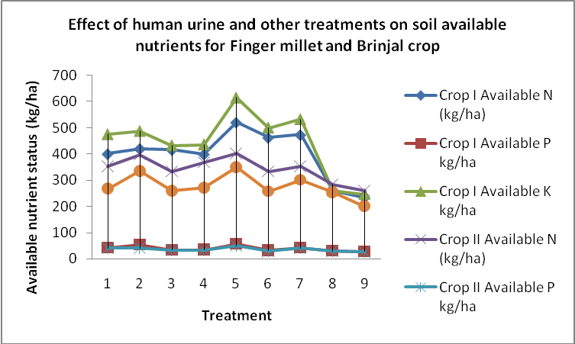

Fig1. Effect of human urine and other treatments on soil available nutrients for
Finger Millet & Brinjal crop.

The highest sodium content was observed in the treatment (0.27 meq100 gm⁻¹) recorded in RDN through human urine (T₁) when compared to other treatments . the reasons might be human urine contain more soluble salts (Table 7).
Table 7. Effect of Human urine on Sodium and available sulphur status of soil at harvest stages of Finger millet and Brinjal crop
Treatments | Crop I (Finger Millet) |  | Crop II Brinjal
Treatments | Sodium  meq/  100 gm | Sulphur  (mgkg⁻¹) | Sodium  meq/  100 gm | Sulphur  (mgkg⁻¹)
T₁- Rec. N -Human urine @ 40% basal + 60 % in 3 splits without gypsum | 0.27 | 17.83 | 0.36 | 16.6
T₂- Rec. N -Human urine @ 40% basal + 60 % in 3 splits with gypsum | 0.25 | 23.50 | 0.32 | 18.9
T₃- Rec. N -Cow urine @ 40% basal + 60 % in 3 splits without gypsum | 0.25 | 20.83 | 0.26 | 14.7
T₄- Rec. N -Cow urine @ 40% basal + 60 % in 3 splits with gypsum | 0.21 | 22.00 | 0.24 | 16.3
T₅- 40% Rec. N through FYM basal+ 60% thro' HU | 0.23 | 25.83 | 0.25 | 24.1
T₆- 40% Rec. N through CF basal + 60% thro' HU | 0.22 | 18.17 | 0.28 | 18.9
T₇- 40% Rec. N through FYM basal+ 60% thro' CU | 0.25 | 23.00 | 0.27 | 20.5
T₈- 40% Rec. N through CF basal + 60% thro' CU | 0.24 | 17.00 | 0.27 | 18.6
T₉- Absolute control | 0.22 | 16.33 | 0.25 | 15.0
SEm + | 0.008 | 2.10 | 0.03 | 2.22
CD (P =0.05) | 0.023 | 6.30 | 0.08 | 6.66

Crop yields
Higher Finger millet grain yield was observed in treatment T₅ (4.01 t ha-1) which received40% RDF. N through FYM basal+ 60% through human urine when compared to other treatments (Fig 2). The lower value (2.21 t ha⁻¹) was recorded in absolute control (T₉). In the second crop (Brinjal ) also, T₅ treatment registered higher yield (33.6 t ha-1) compared to absolute control (9.2 t ha⁻¹ ).similar results were reported by Sridevi et al., 2019.
Conclusion
A research effort was undertaken to explore the possibility of using the human urine as a fertilizer resource for the cultivation of crops. The present study revealed that the human urine can be used as fertilizer. Combined application of FYM + human urine was found to be beneficial in increasing the crop yield and improving soil fertility status as compared to chemical fertilizers. Based on the data, it can be concluded that it can used as a fertilizers source . however it needs further research for proper handling of these fertilizers.
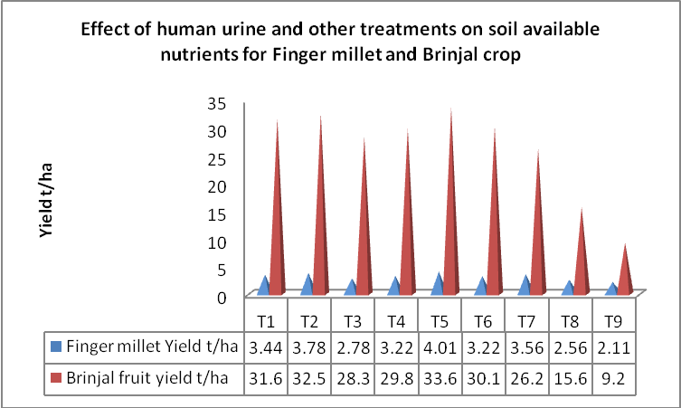

Fig 2. Effect of human urine and other treatments on crop Yield (t ha⁻¹) for Finger Millet & Brinjal crop.

References
Bray, R.H., Kurtz, L.T., 1945. Determination of total, organic and available forms of phosphorus in soils. Soil Sci. 59, 39-45.
Day, P.R., 1965. Particle fractionation and particle-size analysis. In: Black, C.A. (ed.), Methods of Soil Analysis, Part 1, Physical and Mineralogical Properties. Madison WI: SSSA and ASA, pp. 549-567.
Gomez, K.A., Gomez, A.A., 1984. Statistical procedures for agricultural research. John Wiley and Sons,New York
Jackson, M.L., 1973. Soil Chemical Analysis. Prentice Hall of India Pvt. Ltd., New Delhi, 75p
Jonsson, H., Stintzing, R., Vinneras, B., Saomon, E., 2004. Guidelines on use of urine and feces in cropproduction. Report 2004-2, Ecosan res., Stockholm Environment institute, Stockholm, Sweden.
Mnkeni Pearson, N.S., 2008. Evaluation of human urine as a source of nutrients for selected vegetablesand maize under tunnel house conditions in the Eastern Cape, South Africa Waste Mangt and Res.26 (2), 132-139.
Pradhan, S.K., Nerg, A., Sjoblom, A., Holopainen, J.K., Heinonen-Tanski, H., 2007. Use of human urinefertilizer in cultivation of cabbage (Brassica oleracea)-impacts on chemical, microbial and flavorquality. J. Agric. Food Chem. 55, 8657-63.
G. Sridevi , C.A. Srinivasamurthy and U.Surendran 2016. Influence of human urine combined with farm yard manureand chemical fertilizers on french bean and maize cropping sequence in lateritic soils of Karnataka, India International Journal of Plant Production 10(3): 335-346
Stanford, S.L., English, L., 1949. Use of flame photometer in rapid soil tests of K and Ca. Agron. J.41, 446-497.
Winker, M., Clemens, J., Reich, M., Gulyas, H., Otterpohl, R., 2010. Ryegrass uptake of carba mazepine and ibuprofen applied by urine fertilization. Sci. Total Environ. 408, 1902-8.

