**SEMIOCHEMICALS AND ITS IMPORTANCE IN SILKWORM *Bombyx mori* L.**

**V.Vasanth1, E. Arasakumar2, Nandha Kumar. R3, Moulidharshan. R4 and Krishnamoorthi. S5**

**Forest College and Research Institute, Mettupalayam, 641 301, Tamil Nadu, India**

**\*Corresponding author:** [veervasa001@gmail.com](mailto:veervasa001@gmail.com)

**ABSTRACT**

Chemicals play an important role in communication and also essential for survival of insects, which enable them to appraise immediate environment through modification of their behavior. Info chemicals are organic compounds used by insects to convey specific chemical messages that modify behavior or physiology. Bombykol the pheromone used by the female silkworm moth to attract a male for mate was first identified and synthesized by Adolf Butenant. Sex pheromone signals are received by receptors present in male antennae. These signals are transmitted first to the olfactory processing center, the antennal lobe and then are processed further in the higher centers of lateral protocerebrum and mushroom body to elicit orientation behavior towards females. Bombykol is synthesized *de novo* within pheromone gland cell from acetyl-CoA via conventional long chain fatty acid synthesis. After adult emergence the stored fatty acid is cleaved and converted to bombykol in response to pheromone biosynthesis activating neuropeptide. The pheromone binding proteins are small, soluble proteins that are synthesized by accessory cells of trichogen or tormogen into the sensillum lymph by their ability to bind to pheromone compound and showed a predominant expression pattern in male antennae of silkmoth. Artificial application of serotonin to the male silkworm modified the neuronal response at antennal lobe in the behavior level as a modulation of pheromone sensitivity. Thus this pheromone is responsible for male attraction through the specific receptors. The identified female silkmoth pheromone sensed in olfactory studies towards male moth.

**Keywords:** *Bombyx mori, Bombykol, Circadian rhythm, Pheromone dispersal,* Lateral *protocerebrum.*

**Introduction**

Chemical communication plays an important and essential role in the survival of insects, which enable them to appraise immediate environment through modification of their behavior. Semiochemicals are organic compounds used by insects to convey specific chemical messages that modify behavior or physiology. The term semiochemical is derived from the Greek word “semeon” which means sign or signal. Insects use semiochemicals to locate mate, host, or food source, avoid competition, escape natural enemies, and overcome natural defense systems of their hosts. Semiochemicals have the advantage of being used to communicate message over relatively long distances compared with other insect means of communication such as touch. Semiochemicals have different molecular weights depending on carbon chain. They are biologically active at very low concentration in the environment, thus their chemical characterization is complicated.

Olfactory information plays pivotal roles in many aspects of an animal’s life including foraging, prey detection, finding hosts, and mating. Animals can extract adequate information from the numerous odorants in their surroundings to respond in the appropriate behavioral manner. Clarification of the mechanisms by which animals detect olfactory information, process it in the brain, and finally translate it into the appropriate behavioral responses is of critical importance in neuroscience. The insect brain provides an excellent model system for deciphering the neural mechanisms underlying olfactory driven behavior for two reasons. For one, it consists of far fewer neurons (105–106) than the mammalian brain, which allows the examination of the whole brain as a system. In addition, despite of such small brain, insects exhibit stereotypic innate behaviors in response to specific environmental stimuli such as sex pheromones and CO2 showing robust and relatively straightforward input-output relationships. The sex pheromone and its associated pheromone source searching behavior is one of the best examples of these relationships.

**Classification of semiochemicals**

Semiochemicals are classified based on their effect or function and this should be taken into account because the same molecule could act as a pheromone for one insect species and as a

kairomone or allomone for another species. Semiochemicals are divided into two broad groups:

pheromones that mediate interactions among individuals of the same species (intraspecific reactions) and allelochemicals that mediate interactions among individuals of different species (interspecific interactions). According to the behavioral response, pheromones are further subdivided into primer pheromones that have long-term physiological changes and releaser pheromones that elicit short-term or immediate behavioral response. Allelochemicals are divided

into kairomones that mediate interactions favoring the recipient, allomones, on the other hand, favor the emitter. Synomones favoring both the emitter and the recipient, and apneumones, which are substances, produced by nonliving material that elicit behavioral response favorable to the receiving organism but harmful to a second organism found on the nonliving material. Schematic diagram showing the classification of semiochemicals is shown in Figure.

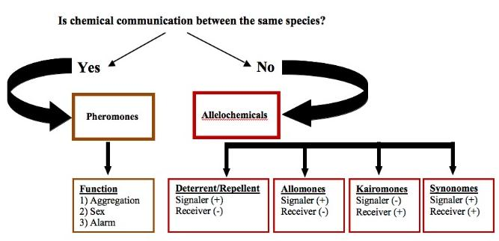

**Schematic diagram showing the classification of semiochemicals**

**In pursuit of Bombykol**

Chemical messenger molecules which organisms emit to communicate with other organisms, usually of the same species. Systematic study of chemical communications began in the 1870s when French entomologist Jean Henri Fabre (1823–1915) showed for the first time that smell, not sight or sound, was the sense which guided male moths in their search of the female.In a series of experiments at his home at Sérignan in southern France, Fabre removed the antennae of male giant emperor moths and found that without these the males could not find the female. Putting the female in a closed box had a similar effect. However, he also noticed that surrounding the female with saucers of smelly substances such as naphthalene or sodium sulfide did not affect the male moth’s ability to locate his mate. Fabre went on to show that the male was attracted to an empty cage occupied by the female the previous night, as if she had left a love bait for him. However, it would take another 80 years for the fi rst pheromone – bombykol (*E*-10- *Z*-12-hexadecadien-1-ol, *1*) – to be isolated from the female silkworm moth *Bombyx mori* and synthesised.

**Adolph Butenandt**

Adolph Butenandt (1903–95) was one of the greatest German organic chemists. Born in Lehe, near Bremerhaven, he studied chemistry and biology at the Universities of Marburg and Gottingen where he started work on sex hormones. In 1933 he moved to the Danzig Institute of Technology to become professor of chemistry and in 1936 moved again to Berlin–Dahlem to head the Kaiser Wilhlem Institute of Technology. By this time Butenandt had identifi ed sex hormones oestrone (1929), androsterone (1931) and progesterone (1934) and for this work he shared the 1939 Nobel prize in chemistry with Leopold Ruzicka. In the early 1940s Butenandt started a project to identify and synthesise the biologically active molecule for mediating sex attraction between female and male silkworm moths. He carefully selected the *B. mori* species for the study because at the time the silkworms were used as the source of silk for the large European silk industry, which provided Butenandt with a ready source of thousands of silkworms for the initial investigation (Cotton, 2009).

**Bombykol’s chemical structure**

The successful purification of the pheromone had taken Butenandt and his coworkers nearly 20 years but identifying its structure would take the team just one year. Butenandt determined the molecular formula of bombykol as C16 H30 O by chemical analysis. Using the relatively new technique of infrared spectroscopy, the team established the presence of an alcohol group, while other infrared absorptions indicated the presence of conjugated double bonds (as did the uv spectrum). Catalytic hydrogenation of bombykol resulted in the formation of cetyl alcohol, CH3(CH2)15OH, the identity of which Butenandt confirmed by mixing with an authentic sample, and showing that the melting point was unaffected. He then esterified bombykol using 4’-nitroazobenzene-4-carboxylic acid and determined the position of the double bonds in the ester by oxidative degradation using KMnO4 (Scheme 1), which resulted in the formation of ethane-1,2-dioic acid (oxalic acid), butanoic acid, and the 4’-nitroazobenzene-4-carboxylic acid ester of hydroxydecanoic acid (identified as its methyl ester). Finally, in 1959 the Germans confirmed the identity of the molecule by synthesising it themselves. Since the molecule contains two double bonds, each capable of adopting the *E*- or *Z*-configuration, there are four possible isomers. Butenandt’s team prepared all four, and showed that one isomer was at least a thousand million times more biologically active than the other three.

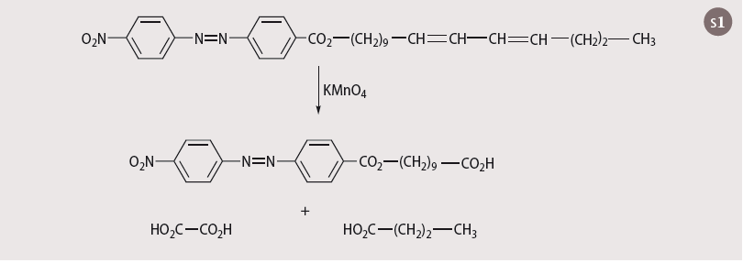

**Female sex pheromone and male responses in the subfamily Bombycinae**

|  |  |  |  |  |  |  |
| --- | --- | --- | --- | --- | --- | --- |
| **Male antennal response (Behavioural effect)** | | | | | | |
| **Species** | **Sex pheromone** | **Bombykol** | | **Bombykal** | **Bombykyl acetate** | |
| *B. mori* | Bombykol | + (attractant) | | + (antagonist) | + (antagonist) | |
| *B. mandarina* | Bombykal | + (attractant) | | + (antagonist) | + (antagonist) | |
| *Rondotia menciana* | Bombykyl acetate | - | | + | + (attractant) | |
| *Trilocha varians* | Bombykol and Bombykyl acetate (1:2.3) | - | | + (attractant) | + (attractant) | |
| + Responded; - Not responded | | | (Takaai *et al.,* 2012) | | |

**Flutter dance of adult male silkworm**

To locate the attractant molecules the team developed bioassays. Butenandt had observed that when the male moth is in the presence of the pheromone, it beats its wings rapidly in what is known as a ‘flutter dance’. He exploited this behaviour in the bioassay design which exposed male moths to extract solutions of differing concentrations to find out the least concentrated solution required to produced the response.

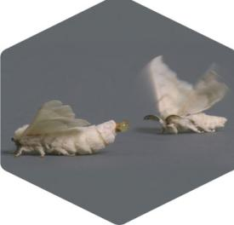 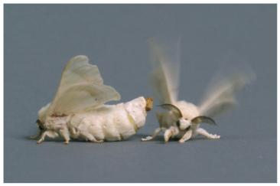

As the team purified the solutions by fractionations that concentrated the attractant so the mass of material needed to make the male ‘flutter’ decreased. Eventually Butenandt and his colleagues found that a concentration of 10–12 micrograms of bombykol per millilitre of solvent would produce a flutter dance in 50 per cent of a sample of male moths. By 1956 the project was in its final phase as the team set to identifying the pheromone molecule. However, Butenandt faced a setback. Following the success of synthetic fibres developed during World War II the European silk industry had collapsed and Butenandt’s supply of starting material had dried up. So the team had to order half a million female moths from Japan, which after two years of painstaking extractions and separations yielded 6.4 mg of pure bombykol.

**Morphology of pheromone gland in *B. mori***

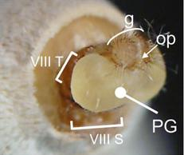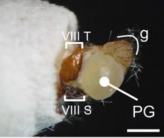

**B**

**A**

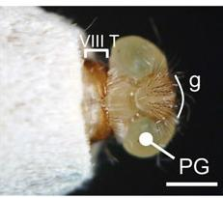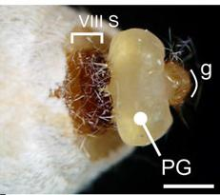

**C**

**D**

PG in *B. mori* is a pair of sacs everted from the lateral intersegmental membrane (Fonagy *et al*. 2000). Eversion of PG in *B. mori* is thought to be induced by a rise in hemolymph pressure. (a) Extended abdominal tips of *B. mori* female showing the eighth and ninth abdominal segments. g genital papilla, op oviporus, VIII T eighth abdominal tergite, VIII S eighth abdominal sternite, PG pheromone gland. b–d Lateral (b), dorsal (c), and ventral (d) views of the extended abdominal tip of females. A putative pheromone-producing intersegmental membrane is indicated by the yellow dotted line.

**Circadian rhythm**

*B. mori* female pheromone release also shows a circadian rhythm: the release of pheromone increases at the beginning of photophase to reach a peak 6·h later; this peak lasts for 2·h before decreasing until the beginning of scotophase. The circadian variation of the male’s sensitivity to pheromone allows the male to locate more efficiently the female during its pheromone release peak window. This daily correlation between male and female behavior and physiology creates a specific ecological niche of *B. mori* that has been selected through evolution. The pheromone components of the whole abdominal tip increased approximately threefold during the scotophase, which indicated that pheromone production in PG was synchronized with calling behavior (Ichikawa, 1998).

**Pheromone dispersal**

Releasing the sex attractant pheromone by the female moth is called calling. Pheromone gland exposed to outside by the following ways (i) Depressing the tip of the abdomen, (ii)Extension of the abdomen, (iii) Gland is inverted by haemolymph pressure. Exposure of the gland is accompained by wing vibration which facilitates dispersal.

**Sex pheromone receptors in *B. mori* males**

In *B. mori*, 66 OR genes were found in the almost completely sequenced genome. Of these, 5 Ors (*BmOR1, 3, 4, 5, 6*) are placed in the above mentioned cluster and specifically or predominantly expressed in male adult antennae. We previously demonstrated that *Xenopus* oocytes that co-express BmOR1 or BmOR3 and the *B*. *mori* OR co-receptor (BmOrco, originally named BmOR2), which can form heteromeric complexes with conventional ORs show specific responses to bombykol and bombykal, respectively (Nakagawa *et al*., 2005). In addition, these receptors are expressed mutually exclusively in ORNs in long s. trichodea. In contrast, neither bombykol nor bombykal activated the other 3 BmORs (BmOR4, 5, 6). These studies identified BmOR1 and BmOR3 as sex pheromone receptors in *B. mori*, and suggest that the specific detection of pheromone components by corresponding ORNs is accomplished by the strict molecular recognition of BmOR1 and BmOR3.

Among these, BmOR1 and BmOR3 are tuned to bombykol and bombykal, respectively. BmOR4, BmOR5, and BmOR6 do not respond to bombykol or bombykal, and ligands for these ORs remain to be identified. Thus, bombykyl acetate could possibly be a ligand for these male-specific orphan OR(s). However, because activation of BmOR1 or BmOR3 by bombykyl acetate has not been investigated, there remains a possibility that one or both of them are receptors for bombykyl acetate. Therefore, future studies are needed to reexamine the specificity of BmOR1 and BmOR3–6. Notably, BmOR1 and BmOR3 genes are located on the Z chromosome of *B. mori* (ZW in female and ZZ in male) where genes that confer advantages to males tend to accumulate. Similarly, among BmOR4–6, only BmOR4 is located on the Z chromosome (BmOR5 and BmOR6 are located on chromosomes 6 and 16, respectively. This may suggest the possibility that BmOR4 is the receptor for bombykyl acetate (Nakagawa *et al.,* 2005).

**Biosynthesis of Bombykol**

Fatty alcohols are important intermediates in the pheromone biosynthesis pathway in PG in *B. mori* and many other moths.These alcohols are subsequently converted to corresponding aldehydes or acetates by alcohol oxidases or acetyltransferases, depending on the moth species.

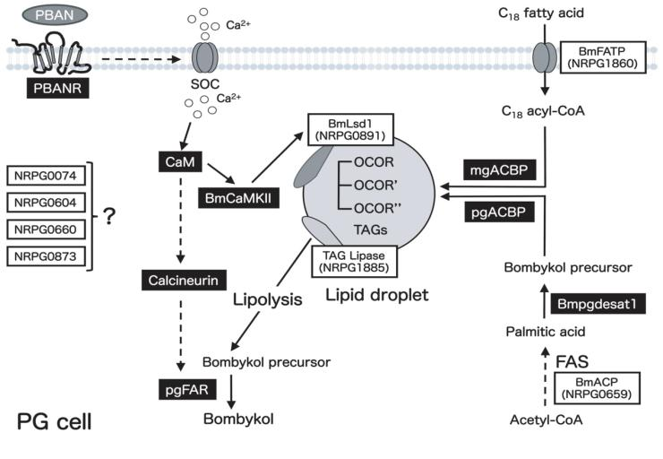

**Schematic diagram of the proposed bombykol biosynthetic pathway**

Eight EST clones involved in bombykol biosynthesis are indicated in boxes. Gene products that have been characterized are indicated in black boxes. Potential sites of regulation are indicated by dashed lines.

Species specific sex pheromones released by female moths to attract conspecific male moths are synthesized *de novo* in the pheromone gland (PG) via fatty acid synthesis (FAS). Biosynthesis of moth sex pheromones is usually regulated by a neurohormone termed pheromone biosynthesis activating neuropeptide (PBAN), a 33-aa peptide that originates in the subesophageal ganglion. In the silkmoth, *B. mori*, cytoplasmic lipid droplets (LDs), which store the sex pheromone (bombykol) precursor fatty acid, accumulate in PG cells prior to eclosion. PBAN activation of the PBAN receptor stimulates lipolysis of the stored LD triacylglycerols (TAGs) resulting in release of the bombykol precursor for final modification. While previously characterized a number of molecules involved in bombykol biosynthesis, little is known about the mechanisms of PBAN signaling that regulate the TAG lipolysis in PG cells. Genes involved in bombykol biosynthesis as well as PBAN signaling, by using a subset of 312 expressed-sequence tag (EST) clones that are in either our *B.mori* PGcDNA library or the public *B.mori* EST databases, Silk Base and CYBERGATE, and which are preferentially expressed in the PG. Using RT-PCR expression analysis and an RNAi screening approach identified another eight EST clones involved in bombykol biosynthesis. Further, more the functional role of a clone designated BmACP that encodes *B.mori* acyl carrier protein (ACP) indicate that BmACP plays an essential role in the biosynthesis of the bombykol precursor fatty acid via the canonical FAS pathway during pheromonogenesis (Ohnishi *et al.,* 2011).

**Structure of male silkmoth antennae**

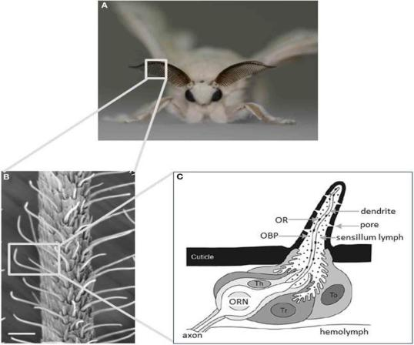

**Main olfactory sensory organs of the silkmoth *B. mori*.**

**(A)** A male silkmoth with its prominent antennae optimized for odorant detection.

**(B)** Scanning electron micrograph of an antenna displaying the external morphology of sensilla trichodea. Scale bar: 25μm.

**(C)** Schematic diagram of an olfactory sensillum showing the detailed configuration of ORNs and accessory cells with respect to cuticular specializations. Three types of accessory cell surround the cell bodies of ORNs: tormogen (To), trichogen (Tr), and thecogen cells (Th). To and Tr cells secrete odorant binding proteins into the sensillum lymph. Odorants are detected by ORs expressed on the dendritic membrane of ORNs.

**Odour receptors in silkmoths antennae**

|  |  |  |  |  |
| --- | --- | --- | --- | --- |
|  | **Sensilla trichoidae** | | **Sensilla basiconica** | **Total olfactory receptor cells** |
|  | **Long** | **Medium** |  |  |
| *Bombyx mori* | 17000  6000 | 2500  4000 | >5000  > 5000 | 50000 ♂  30000 ♀ |
| *Antheraea polyphemus* |  | 55000  0 | 10000  12000 | >140000 ♂  >24000 ♀ |
| *Lymantria dispar* | 22000  0 | 700  1000 | 3200  2000 | >50000 ♂  > 6000 ♀ |

**Pheromone processing pathway in the sensory system of *B. mori***

Sex pheromone signals are detected by pheromone receptors expressed in olfactory receptor neurons in the pheromone sensitive sensilla trichodea on male antennae. The signals are transmitted to the first olfactory processing center, the antennal lobe (AL), and then are processed further in the higher centers (mushroom body and lateral protocerebrum) to elicit orientation behavior toward females.

**Antennal lobe**

Pheromone signals that are transduced into electrical signals by ORNs are transmitted to the primary olfactory center, the AL, through the axons of ORNs. The AL is divided into two regions: the dorsally located macroglomerular complex (MGC), and the ventrally located ordinary glomeruli (OG). The MGC receives pheromone inputs from pheromone-sensitive ORNs on the antennae, and have several compartments named the toroid, cumulus, and horseshoe (Koontz and Schneider, 1987). The AL has two types of interneurons: local interneurons (LNs) that con- nect to the glomeruli, and projection neurons (PNs) that receive input from the glomeruli and send processed information to the higher-order olfactory centers.

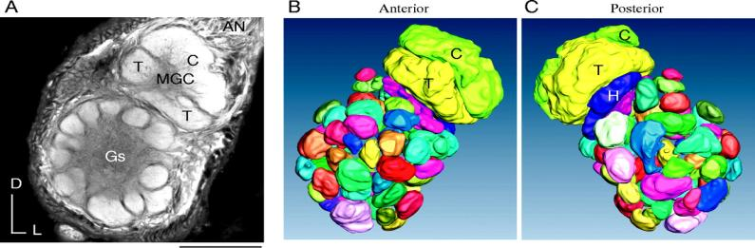

**Lateral protocerebrum**

PNs receive olfactory inputs in the AL and send processed information to the higher order centers of the lateral protocerebrum (LPC) and the calyx of the mushroom body (MB). The LPC is thought to be the center for instinctive behavior because the wiring in the LPC is independent of sensory input (Tanaka *et al.,* 2004). In *B. mori*, PNs for processing sex pheromone project distinct area than the other PNs. Stained the PNs that process bombykol information via immunocytochemistry with anti-cGMP antibodies. By simultaneously staining individual PNs and antibodies, they created an olfactory map of the *B. mori* LPC.

**Mushroom body**

The MB is thought to be the center of learning and memory (Heisenberg, 2003). However, there is no clear experimental system for investigating learning and memory in *B. mori*. Several behavioral experiments have suggested an important role of the MB in pheromone processing. The MB of *B. mori* is located in the dorsal part of the protocerebrum, and is divided into three structures: the calyx, pedunculus, and lobes. Consistent with other moth species, a second tract called the Y tract originates in the dorsoanterior region of the calyx, and projects to the branching point of the vertical and medial lobes.

The inputs from the AL form a map in the calyx (Namiki *et al.*, 2013). Different projection areas for pheromonal and non-pheromonal PNs have been reported in the calyx of moths. The inputs have a concentric spatial pattern: informa tion in the toroid, cumulus / horseshoe, and OG is ordered from the center to the edge, suggesting that pheromones and plant odors are processed differently in the calyx than in the LPC. PNs from the cumulus, horseshoe, and OG also overlap significantly. The existence of a modular structure in the calyx is supported by other types of LPC neurons that also innervate the calyx in a class specific manner.

In our study, each class of PN showed functional connectivity to KC classes with different patterns in *B*. *mori* (Namiki *et al.,* 2013). The α/β and α_ /β_ KCs exhibited large branches in the calyx. Because they showed a high level of potential connectivity with all PN classes, they could integrate information from sex pheromones and plant odors.

No KCs have a dendritic field that is restricted to the input area of toroid PNs, suggesting that pure bombykol informationis not preserved at the level of third order neurons in the MB. Therefore, the calyx may not be involved in the labeled line for pheromone coding, although it is possible that the pheromone response in KCs affects some aspects of mating behavior. The odor response of KCs is sparse in *B. mori*, consistent with other insects, but at least α_ /β_ KCs are responsive to sex pheromones and bombykol induces neural activity in cells around the calyx that are thought to be KCs (Fujita *et al.*, 2013).

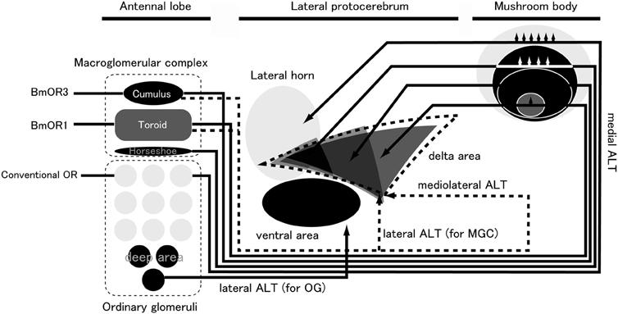

**Pheromone processing pathway in the sensory system of *B*. *mori*.** ALT, antennal lobe tract; MGC, macroglomerular complex; OG, ordinary glomeruli.

**Pheromone binding protein**

The PBP family is a subfamily of the odorant-binding protein (OBP) family in insects, which were defined originally by their ability to bind to pheromone compounds and by showing a predominant expression pattern in male antennae in the giant silk moth *Antheraea polyphemus*. PBPs are small, soluble proteins that are synthesized by two out of three accessory cells (trichogen or tormogen cells), and are secreted abundantly into the sensillum lymph at concentrations of up to 10mM. In *B. mori*, the expression of OBPs is correlated with the morphological type of sensillum: the lymph of the pheromone sensitive long sensilla trichodea (s. trichodea) contains BmPBP1, where as other sensillum types and longs. Trichodea in females that are tuned to general odorants express other OBPs.

The following model for the selective transport of bombykol to the sex pheromone receptor has been proposed: (1) BmPBP1 preferentially uptakes bombykol at areas of reduced pH near the olfactory pore; (2) during transport, bombykol is protected from degradation by odorant degrading enzyme (ODE) in sensillum lymph by binding to the cavity of BmPBP1; (3) the acidic pH around the membrane allows the release of bombykol from BmPBP1, resulting in its reception by the sex pheromone receptor protein BmOR1 (Maida *et al.,* 2005).

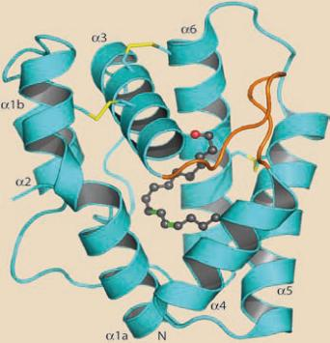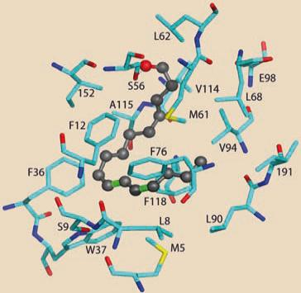

**Binding pattern of pheromone binding protein**

**Pheromone degrading enzyme**

For the efficient orientation of male moths to conspecific females, the tracking of intermittent pheromone stimuli with high temporal resolution is required. For this, after activation of the pheromone receptors, pheromone molecules must be rapidly degraded in to non-active substances to prevent from prolonged activation of the pheromone receptors. Antennae of *B. mori* possess alcohol oxidase (AOX) or alcohol dehydrogenase activity, which can oxidize bombykol into bombykal and bombykal into the inactive compound hexadecenoic acid (Pelletier *et al.,* 2007).

**Sniffing by a silkworm moth**

Many organisms increase the air or water flow adjacent to olfactory surfaces when exposed to appropriate chemical stimuli; such ‘sniffing’ samples fluid from a specific region and can increase the rate of interception of odorant molecules. Hot-wire anemometry, high-speed videography and flow visualization to study air flow near the feathery olfactory antennae of male silkworm moths (*Bombyx mori* L.). When exposed to conspecific female sex pheromone, male *B. mori* flap their wings through a stroke angle of 90–110 ° at approximately 40 Hz without flying. This behavior generates an unsteady flow of air (mean speed 0.3–0.4ms-1) towards the antennae from the front of the male. A pulse of peak air speed occurs at each wing upstroke. The Womersley number (characterizing the damping of pulsatile flow through the gaps between the sensory hairs on the antennae) is less than 1; hence, pulses of faster air (at 40 Hz) should move between sensory hairs. Calculation of flow through arrays of cylinders suggest that this wing fanning can increase the rate of interception of pheromone by the sensory hairs on the antennae by at least an order of magnitude beyond that in still air. Although wing fanning produces air flow relative to the antennae that is approximately 15 times faster than that generated by walking at top speed (0.023ms-1), air flow through the gaps between the sensory hairs is approximately 560 times faster because a dramatic increase in the leakiness of the feathery antennae to air flow occurs at the air velocities produced by fanning (Loudon and Koehil, 2000).

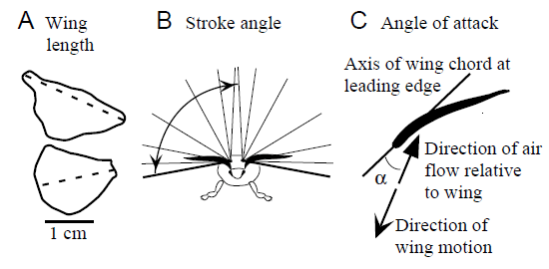

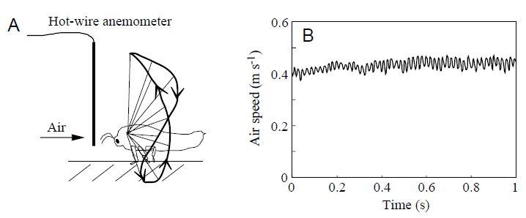

**Odor–Source Orientation in the Silkmoth**

Male silkmoths exhibit a characteristic zig-zagging pattern as they walk upwind toward the pheromones (bombykol) released by females of the same species. Upwind walking toward a pheromone source is largely controlled by an internally generated steering program, triggered by the detection of an intermittent distribution of pheromones by the antennae. Once initiated by a single puff of pheromone, the moth exhibits a programmed sequence of walking consisting of brief bouts of straight-line walking, zig-zag turns and looping (i.e., turns of more than 360◦). Upon stimulation, male moths exhibit straight-line walking in the direction of the antenna to which the stimulation was applied. Upon the loss of pheromone stimulation, males exhibit zig-zagging walking with a significant increase in time between each turn followed by looping. This programmed sequence of movements is reset and restarted from the beginning in response to pulsed pheromonal stimulation. Using such programmed behavior, and by repeating the set and reset of the program depending on the spatiotemporal distribution of the odor in the air, moths can orient toward an odor source. Therefore, as it nears an odor source, the path of a moth becomes straighter with repeated straight-line walking. In contrast, if the frequency of stimulation decreases, the path becomes a complex combination of zig-zagging and looping (Kanzaki *et al.,* 2008).

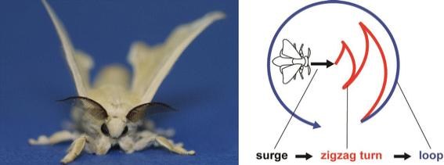

Odor–source orientation behavior of a male silkmoth. (A) A male moths behavior is triggered by pheromone released from a female’s pheromone gland. (B) The pheromone-triggered walking pattern. Bombykol, a synthetic major pheromone component, elicited the complete behavioral pattern.

**Sex pheromone preference in *B. mori***

In the sex-pheromone communication systems of moths, odorant receptor (Or) specificity as well as higher olfactory information processing in males should be finely tuned to the pheromone of conspecific females. Accordingly, male sex-pheromone preference should have diversified along with the diversification of female sex pheromones; however, the genetic mechanisms that facilitated the diversification of male preference are not well understood. Here, we explored the mechanisms involved in a drastic shift in sex-pheromone preference in the silkmoth *B. mori* using spli mutants in which the genomic structure of the gene Bmacj6, which encodes a class IV POU domain transcription factor, is disrupted or its expression is repressed. *B. mori* females secrete an11:1 mixture of bombykol and bombykal. Bombykol alone elicits full male courtship behavior, whereas bombykal alone shows no apparent activity. In the spli mutants, the behavioral responsiveness of males to bombykol was markedly reduced, whereas bombykal alone evoked full courtship behavior. The reduced response of spli males to bombykol was explained by the paucity of bombykol receptors on the male antennae. It was also found that, in the spli males, neurons projecting into the toroid, a compartment in the brain where bombykol receptor neurons normally project, responded strongly to bombykal. The present study highlights a POU domain transcription factor, Bmacj6, which may have caused a shift of sex-pheromone preference in *B. mori* through Or gene choice and/or axon targeting (Fujii *et al.,* 2011). 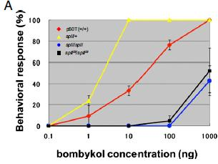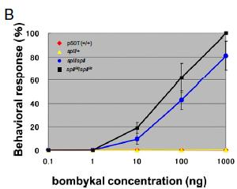

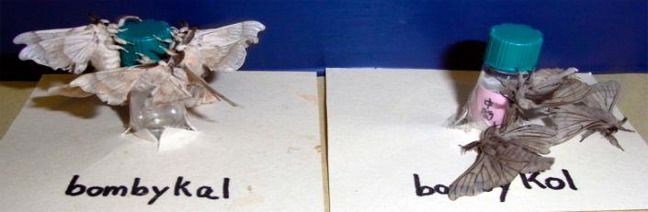

**Bombykol receptors in the silkworm moth and the fruit fly**

Male moths are endowed with odorant receptors (ORs) to detect species-specific sex pheromones with remarkable sensitivity and selectivity. We serendipitously discovered that an endogenous OR in the fruit fly, *Drosophila melanogaster*, is highly sensitive to the sex pheromone of the silkworm moth, bombykol. Intriguingly, the fruit fly detectors are more sensitive than the receptors of the silkworm moth, although its ecological significance is unknown. By expression in the “empty neuron” system, we identified the fruit fly bombykol-sensitive OR as DmelOR7a (= DmOR7a). The profiles of this receptor in response to bombykol in the native sensilla (ab4) or expressed in the empty neuron system (ab3 sensilla) are indistinguishable. Both WT and transgenic flies responded with high sensitivity, in a dose-dependent manner, and with rapid signal termination. In contrast, the same empty neuron expressing the moth bombykol receptor, BmorOR1, demonstrated low sensitivity and slow signal inactivation. When expressed in the trichoid sensilla T1 of the fruit fly, the neuron housing BmorOR1 responded with sensitivity comparable to that of the native trichoid sensilla in the silkworm moth. By challenging the native bombykol receptor in the fruit fly with high doses of another odorant to which the receptor responds with the highest sensitivity, we demonstrate that slow signal termination is induced by overdose of a stimulus. As opposed to the empty neuron system in the basiconic sensilla, the structural, biochemical, and/or biophysical features of the sensilla make the T1 trichoid system of the fly a better surrogate for the moth receptor (Syed *et al.,* 2010).

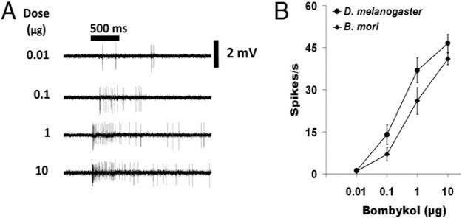

**Antennal responses of *Bombyx mandarina***

*Bombyx mandarina* is the wild ancestor of *B. mori* and often is found in mulberry fields in Japan, Korea, and China. In the laboratory, *B. mandarina* and *B. mori* readily mate. The sex pheromone communication in the wild silkmoth, *B. mandarina*, which is considered ancestral to *B. mori*. Our investigations revealed that (a) *B. mandarina* females produce (E,Z)-10,12-hexadecadienol (bombykol), but not (E,Z)-10,12-hexadecadienal (bombykal) or (E,Z)-10,12-hexadecadienyl acetate (bombykyl acetate), which are pheromone components in other bombycid moths; (b) antennae of male *B. mandarina* respond strongly to bombykol as well as to bombykal and bombykyl acetate; and (c) bombykal and bombykyl acetate strongly inhibit attraction of *B. mandarina* males to bombykol in the field (Daimon *et al.,* 2012).

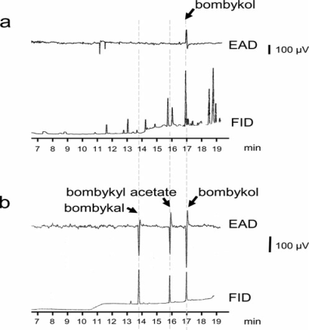

GC-FID-EAD analyses of (a) a crude PG extract of *B. mandarina* (1 female equivalent) or (b) a mixture of authentic bombykol, bombykal, and bombykyl acetate (200 ng each). The GC was equipped with a DB-Wax column. Antennae were excised from 1-dayold *B. mandarina* males.

The sex pheromone of *B. mori* and *B. mandarina* is bombykol, but *B. mori* females produce a small amount of bombykal as well, which inhibits the wing fluttering response of B. mori males to bombykol. Production of bombykal in *B. mori* might be due to the loss of absolute control of the oxidation of bombykol. Non-production of bombykal and bombykyl acetate by female *B. mandarina* and the strong aversive response of *B. mandarina* males to these compounds, may have contributed to pre-reproductive isolation from sympatric species that use bombykal or bombykyl acetate as sex pheromone components. Indeed, we frequently observed that lures containing bombykal attracted a large number of males of the sphingid moth *Neogurelca himachala* a diurnal flyer like *B. mandarina* in the field trapping experiments.

**Serotonin modifies the sensitivity of the male silkmoth to pheromone**

In the insect nervous system, the biogenic amine serotonin acts as a neurotransmitter, neuromodulator and neurohormone. Serotonin affects the central nervous system as well as the sensory periphery and the neuromuscular junction. Serotonin is responsible for the modulation of various behaviors in insects: for example, short-term memory, sensitivity to olfactory stimuli and foraging behavior in honeybees. Serotonin enhances the responses of some neurons in the first olfactory center, the antennal lobe (AL), to electrical and pheromonal stimuli. Furthermore, in cultured AL neurons, serotonin increases the spike number and induces a broadening of action potentials.

In the silkworm moth, *B. mori*, high speed optical imaging with a voltage-sensitive dye has shown that serotonin increases the maximum amplitude and duration of the optical responses in the AL (both the MGC and the ordinary glomeruli), suggesting that serotonin enhances neuronal responses in the AL (Hill *et al.,* 2003). The effects of serotonin on the response to pheromone in moths may be related to the presence of a pair of unique serotonin-immunoreactive neurons that innervate both ALs and have been identified in *B. mori* as well as in several other insects.

**Serotonin enhances the neural activity of the antennal lobe**

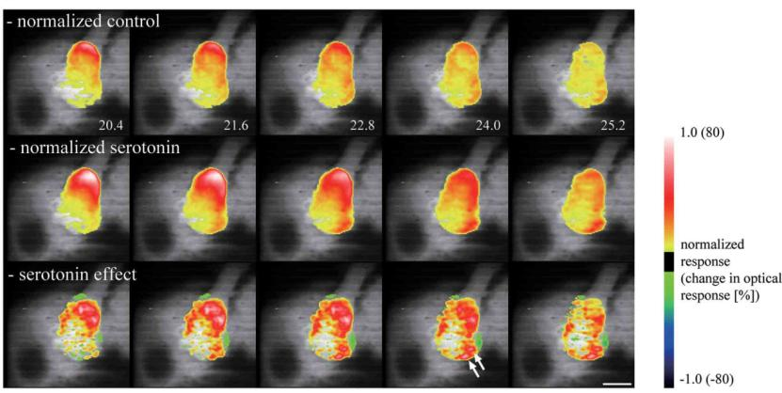

The neural activity in the antennal lobe in response to electrical stimulation of the antennal nerve was greater and longer lasting following the application of serotonin. The response was normalized by the signal from the antennal nerve. Normalized values of control (upper), serotonin application (middle) and the serotonin effect (bottom).

**Analysis of serotonin in *B. mori***

The effects of serotonin on the behavior related to the restricted pheromone olfactory pathway of the male silkmoth, *B. mori*. In order to understand the effects of serotonin at the behavioral level, we applied serotonin (10–5·mol·l–1, 10–4·mol·l–1 and 10–3·mol·l–1) to the brain and found that 10–4·mol·l–1 serotonin increases the sensitivity to female pheromone whereas   
10–3mol·l–1 serotonin had the opposite effect. Levels of serotonin in the brain were determined using HPLC with electrochemical detection. Inhibitory effects were observed after applying the serotonin antagonists mianserin (10–4·mol·l–1) and ketanserin (10–3·mol·l–1). Additionally, we quantified the circadian variation of serotonin in the brain using HPLC with electrochemical detection. Further, this variation correlated well with a circadian variation of the male sensitivity to pheromone. These results show that the serotonin-related enhancement of neuronal responses at the antennal lobe level is expressed at the behavioral level as a modulation of pheromone sensitivity and that the circadian variation of serotonin levels in the brain correlates with changes in the moth’s pheromone sensitivity (Gatellier, *et al.,* 2004).

**Conclusion**

In more than half a century since the first identification of sex pheromones from female silkmoths, the sex pheromone reception and processing systems in male moths have played central roles in insect olfactory research. Accordingly, the silk moth sex pheromone system is one of the most well under stood olfactory systems. The fundamental molecular mechanisms of pheromone detection at the periphery are clear; the pheromone signals detected by the ORNs of male moths are coded by a labeled line for the initiation of pheromone source searching behavior in the brain. The main pheromone processing pathway is also well understood from the AL to the output motor neurons. Despite this progress, there remain important unanswered questions. For example, the signal transduction mechanisms for pheromone detection and the molecular determinants of pheromone specificity remain controversial. To fully understand the mechanisms of pheromone reception, it is important to not only examine the functional details of each molecular component, but also to unravel how all components interact in the context of the *in vivo* molecular network under different physiological conditions. The silk moth has great potential to contribute to this understanding because methodologies for *in vivo* gene analysis such as the use of transgenes and gene targeting can be applied. When processing in the brain is considered, although it is clear that bombykol signals alone are sufficient to elicit pheromone source searching behavior, this behavioris modified by the presence of other odorants, as well as the internal state of moths. To better understand pheromone processing, it is important to appreciate how pheromone-processing circuits are modulated via interactions with other neural circuits.

**Reference**

1. Fonagy, A., Yokoyama, N., Okano, K., Tatsuki, S., Maeda, S., Matsumoto, S. (2000). Pheromone producing cells in the silkmoth, *Bombyx mori:* identification and their morphological changes in response to pheromonotropic stimuli. *Journal of Insect Physiology,* 46: 735 – 744.
2. Fujita, N., Nagata, Y., Nishiuchi, T., Sato, M., Iwami, M., and Kiya, T. (2013). Visualization of neural activity in insect brains using a conserved immediate early gene, *Hr38*. *Curr. Biol.* 23, 2063–2070.
3. Hill, E.S., Okada, K., and Kanzaki, R. (2003). Visualization of modulatory effects of serotonin in the silk moth antennal lobe. *Journal of Experimental Biology.* 206, 345–352.
4. Ichikawa, T. (1998). Activity patterns of neurosecretory cells releasing pheromonotropic neuropeptides in the moth *Bombyx mori*. *Proc. Natl. Acad Sci. USA,* 95: 4055 – 4060.
5. Koontz, M. A., and Schneider, D. (1987). Sexual dimorphism in neuronal projec tions from the antennae of silkmoths (*Bombyx mori*, *Antheraea polyphemus*) and the gypsy moth (*Lymantria dispar*). *Cell Tissue Res.* 249, 39–50.
6. Laureline Gatellier, Takashi Nagao and Ryohei Kanzaki. (2004). Serotonin modifies the sensitivity of the male silkmoth to pheromone. *Journal of Experimental Biology,* 207, 2487-2496.
7. Loudon, C. and M. A. R. Koehl. (2000). Sniffing by a silkworm moth: wing fanning enhances air penetration through and pheromone interception by antennae**.** *The Journal of Experimental Biology*, 203: 2977–2990.
8. Maida, R., Mameli, M., Muller, B., Krieger, J., and Steinbrecht, R. (2005). The expression pattern of four odorant binding proteins in male and female silkmoths, *Bombyx mori*. *J. Neurocytol.* 34, 149–163.
9. Nakagawa, T., Sakurai, T., Nishioka, T., and Touhara, K. (2005). Insect sex pheromone signals mediated by specific combinations of olfactory receptors. *Science* 307, 1638–1642.
10. Namiki, S., Takaguchi, M., Seki, Y., Kazawa, T., Fukushima, R., Iwatsuki, C. (2013). Concentric zones for pheromone components in the mushroom body calyx of the moth brain. *J. Comp. Neurol.* 521, 1073–1092.
11. Pelletier, J., Bozzolan, F., Solvar, M., François, M.C., Jacquin-Joly, E., and Maïbèche Coisne, M. (2007). Identification of candidate aldehydeoxidases from the silkworm *Bombyx mori* potentially involved in antennal pheromone degradation. *Gene* 404, 31–40.
12. Ryohei Kanzaki , Noriyasu Ando , Takeshi Sakurai and Tomoki Kazawa (2008). Understanding and Reconstruction of the Mobiligence of Insects Employing Multiscale Biological Approaches and Robotics. *Advanced Robotics*, 22:15, 1605-1628.
13. Simon Cotton, A. (2009). In Pursuit of Bombykol. *Education in Chemistry,*148 – 152.
14. Takaaki Daimon, Takeshi Fujii, Tsuguru Fujii, Takeshi Yokoyama, Susumu Katsuma, Tetsuro Shinoda, Toru Shimada and Yukio Ishikawa. (2012). Reinvestigation of the sex pheromone of the wild silkmoth *Bombyx mandarina:* The effects of Bombykal Bombykyl acetate. *Journal of Chemical Ecology,* 38: 1031-1035.
15. Tanaka, N. K., Awasaki, T., Shimada, T., and Ito, K. (2004). Integration of chemosensory pathways in the *Drosophila* second order olfactory centers. *Curr. Biol.* 14, 449–457.
16. Tsuguru Fujiia, Takeshi Fujiib, Shigehiro Namikic, Hiroaki Abed, Takeshi Sakuraic, Akio Ohnumae, Ryohei Kanzakic, Susumu Katsumaa, Yukio Ishikawab, and Toru Shimadaa. (2011). Sex-linked transcription factor involved in a shift of sex-pheromone preference in the silkmoth *Bombyx mori.* *PNAS,* (108) 44: 18038 – 18043.
17. Zainulabeuddin Syed, Artyom Kopp, Deborah A. Kimbrell and Walter S. Leal. (2010). Bombykol receptors in the silkworm moth and the fruit fly. *PNAS,* (107) 20: 9435 – 9439.