**Article upload option and View Page**

Manager View:  
  
UserName: **masu@tnau.ac.in**

Password: **20MAJEM23**In this page, we use to upload a new article.  
  
*Manager Only have the option to upload a new article.  
  
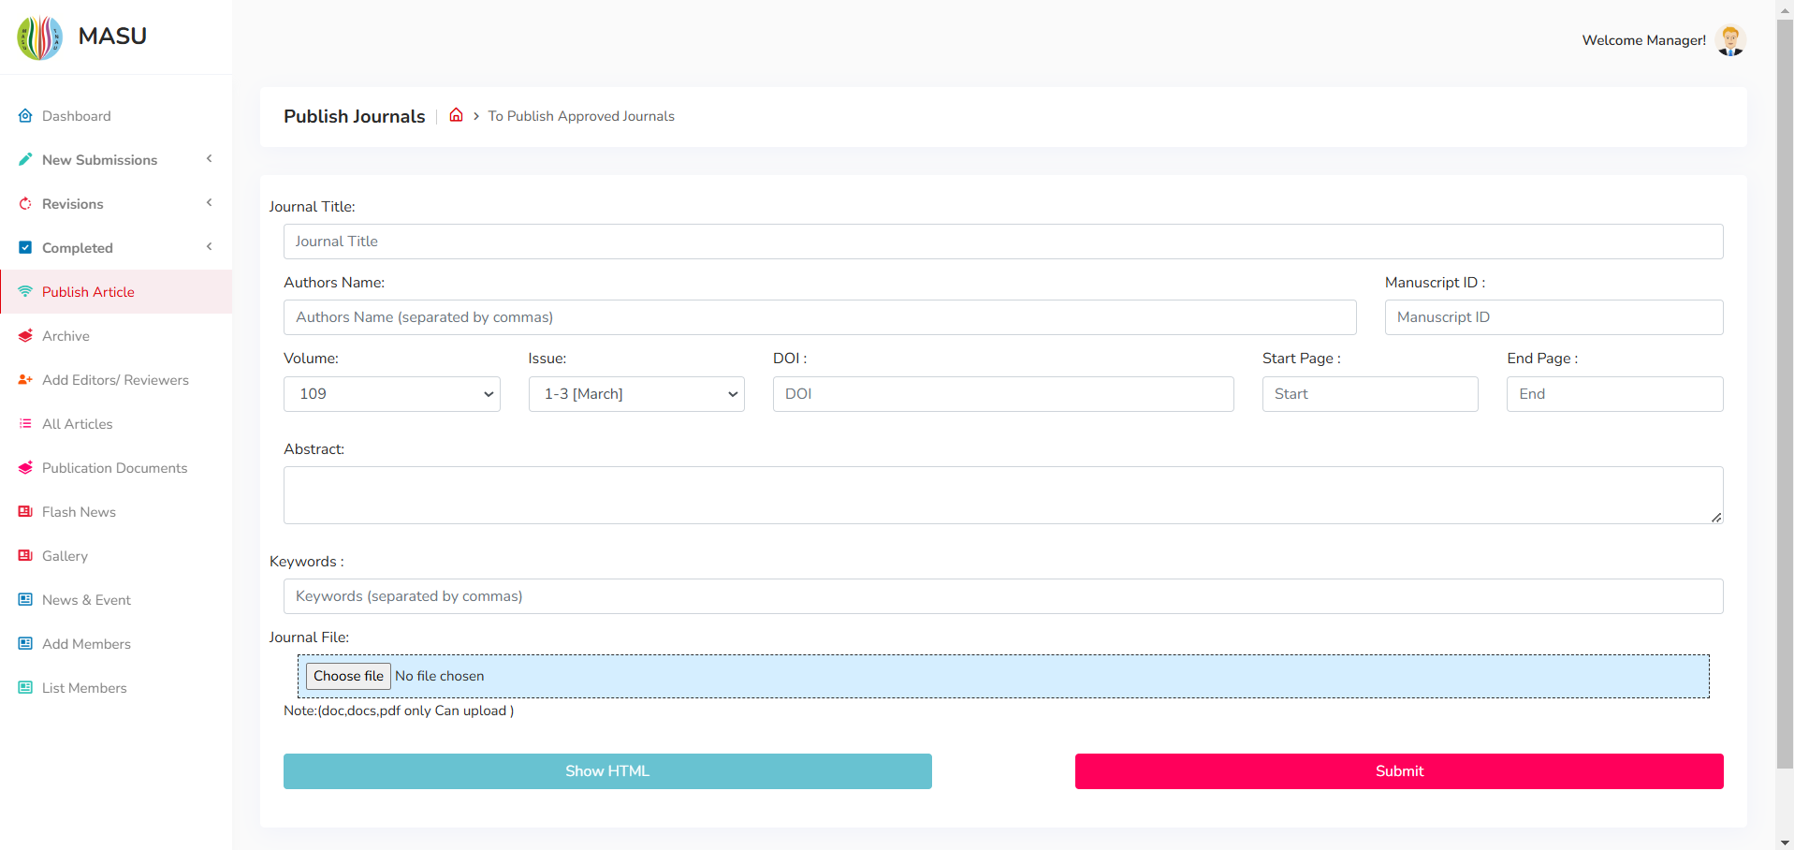  
  
View Page:   
  
This is the old view page  
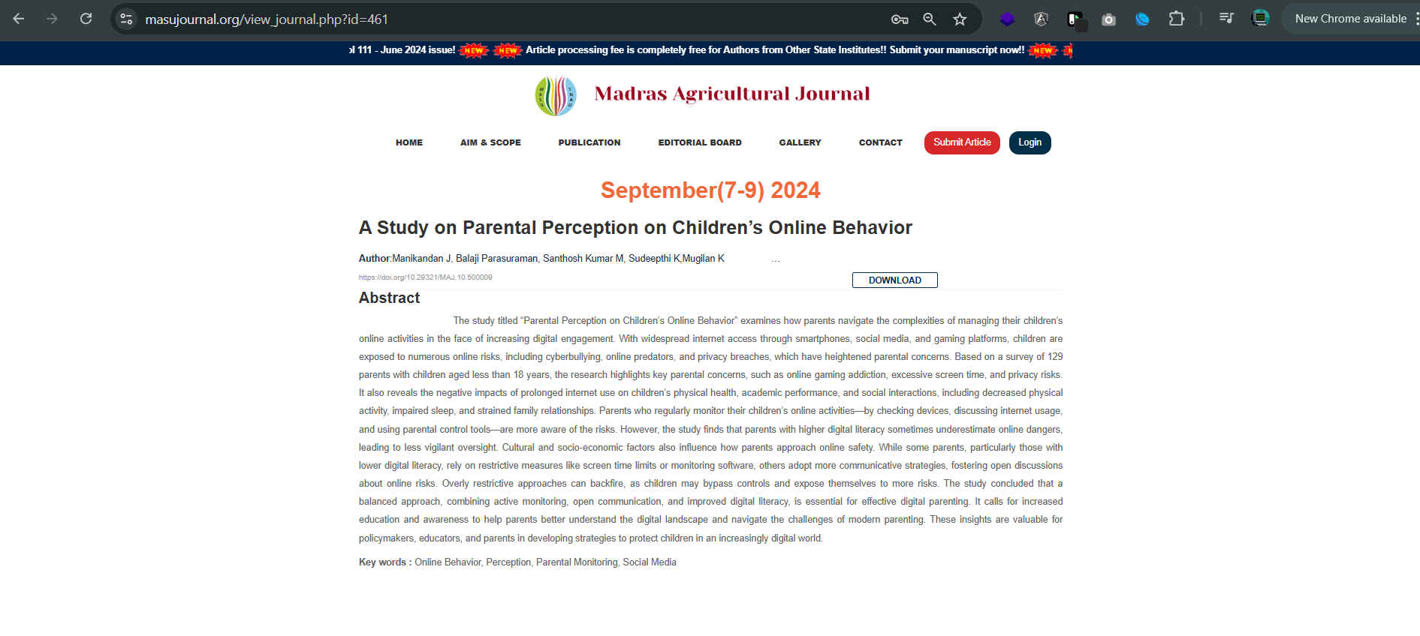  
  
We want to change this page to the given link:  
[**https://www.sciencepublishinggroup.com/article/10.11648/j.aje.20240803.11**](https://www.sciencepublishinggroup.com/article/10.11648/j.aje.20240803.11)

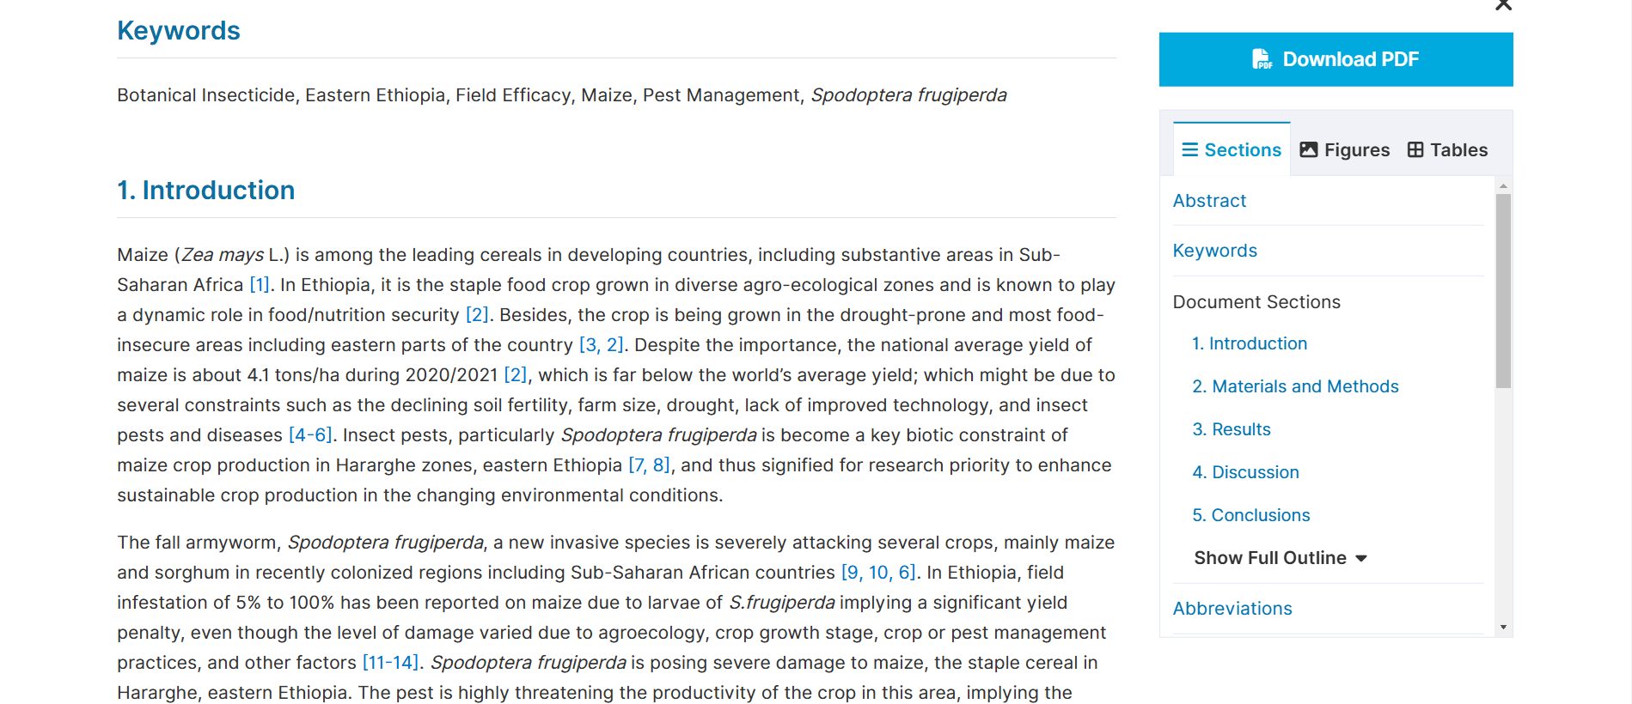

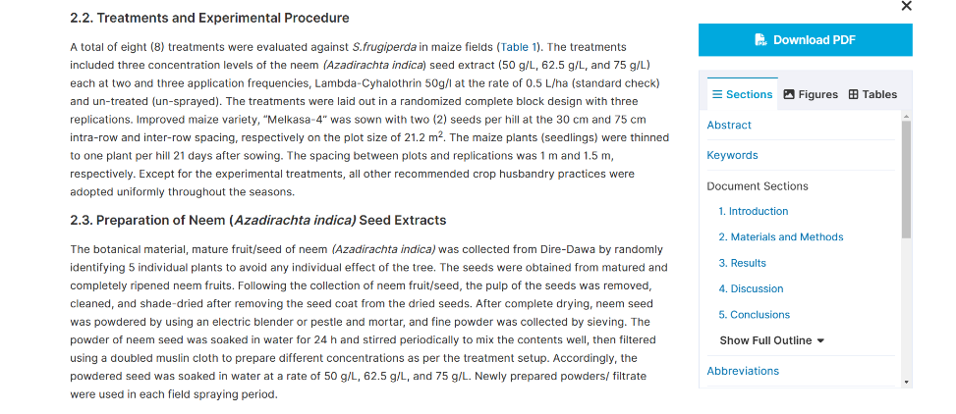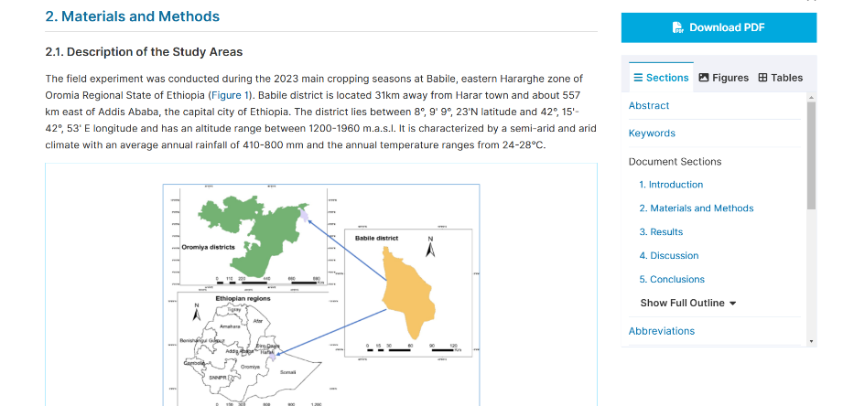

**Additional Works:** Check the php-mailer issues.  
  
 Php-mailer Use Cases:   
  
 1. When the user creates the account, we sent the confirmation.

2. When the article assigned to the reviewer, we send the notification to reviewer.

3. When the article rejected or approved, we send the notification to the author.

4. When the article submission successfully by the author portal. We send to the article submission successfully.