Physiological basis of moisture stress tolerance at heterotrophic and flowering stage in finger millet (Eleusine coracana L.)
Varsha Vidhya Mohan and Nanja Reddy Yellodu Adi Reddy*
Department of Crop Physiology, University of Agricultural Sciences, GKVK, Bangalore-65, Karnataka
*: Corresponding author, yanreddy61@gmail.com

ABSTRACT
Finger millet is a nutritionally rich millet crop, predominantly cultivated under rainfed conditions worldwide. The crop's productivity is subject to diverse environmental stresses. This study's principal objective was to evaluate the underlying physiological distinctions among tolerant genotypes (GE-845, KMR-630) and susceptible genotypes (GE-1309, GE-5123) of finger millet. The studies focus on specific morphological, physiological, and biochemical traits contributing to drought tolerance at the heterotrophic and flowering stages, utilizing polyethylene glycol (PEG) and a phenotyping platform facility, respectively. Our findings highlight KMR-630 as the most drought-tolerant genotype, while GE-5123 exhibits pronounced drought susceptibility. Notably, the drought-tolerant KMR-630 genotype exhibits robust seedling vigour during the heterotrophic stage, maintains higher relative water content, increased total chlorophyll levels, mitigated membrane damage, and demonstrates enhanced finger length and above-ground dry matter compared to sensitive genotypes at the flowering stage. These insights offer valuable guidance for the development of effective breeding strategies aimed at producing drought tolerant finger millet genotypes.
Keywords: Finger millet; Drought-tolerance; Evan’s Blue; Malondialdehyde; Flowering

INTRODUCTION
From a scientific perspective, heightened global apprehensions surrounding malnutrition, food insecurity, and the repercussions of erratic climate alterations have spurred a growing need for crops capable of enduring fluctuating environmental circumstances.While climate change projections indicate an overall increase in total rainfall (Jalihal et al., 2019), irregular precipitation patterns and a rising frequency of drought events have made water availability a limiting factor for agriculture (Dash et al., 2009). Within this framework, finger millet has emerged as a topic of considerable scientific intrigue owing to its noteworthy capacity to prosper in arid, high-temperature, and nutrient-depleted soil environments (Pradhan et al., 2019). Its adaptability to diverse ecological and cultural settings positions it is a promising food crop, particularly in rainfed agricultural systems (Davis et al., 2019). Finger millet, with its C₄ photosynthesis mechanism (Ueno et al., 2006) and exceptional nutritional value (Hiremath et al., 2018), holds great potential as an alternative crop for semi-arid regions across the globe (Dwivedi et al., 2012). Nevertheless, the deleterious consequences of drought-induced stress can lead to crop yield reductions of up to 100%, depending upon the severity and duration of the stress episode (Nanja Reddy et al., 2020; Krishna et al., 2021).
The decline in grain yield during drought stress is ascribed to compromised physiological reactions and reductions in yield-related components (Krishna et al., 2021). Drought stress currently constitutes the principal threat to global food production due to its impact on a range of physiological and biochemical processes. Plants employ three primary strategies to mitigate the effects of water deficit: (i) drought escape, (ii) drought avoidance, and (iii) drought tolerance. Drought avoidance relies on mechanisms such as enhanced water uptake and reduced water loss, whereas drought tolerance involves processes like osmotic adjustment, heightened antioxidant capacity, and the development of desiccation tolerance. In India, finger millet is predominantly grown in rainfed conditions, where exposure to 25-30 days of drought stress is common. Consequently, the identification and cultivation of finger millet genotypes with high drought tolerance are of paramount significance (Antre et al., 2021).
The ongoing research is centered on assessing the morphological characteristics of finger millet genotypes during the heterotrophic stage and studying the morpho-physiological and biochemical changes that take place under moisture stress during the flowering stage. The main objective of this investigation is to pinpoint the physiological and biochemical traits that significantly contribute to conferring drought tolerance. To achieve this goal, experiments were conducted using genotypes known for their tolerance to drought conditions (GE-845 and KMR-630), in comparison with susceptible genotypes (GE-5123 and GE-1309). The findings from this study will have the potential to aid in the identification of genotypes or donors displaying stable drought adaptive characteristics.

MATERIALS AND METHODS

Seed material

Experiments targeting the evaluation of cellular-level tolerance and water relation traits were conducted on four distinct finger millet genotypes. These genotypes, comprising two tolerant (GE-845 and KMR-630) and two susceptible (GE-1309 and GE-5123) variants concerning drought response, were chosen based on the initial screening of 101 finger millet genotypes conducted by Mayank (2020) involving field-level drought response analysis. The passport data is presented in Table 1.

Polyethylene glycol (PEG) stress treatment
Seeds from four contrasting finger millet genotypes (GE-1309, GE-5123, GE-845, and KMR-630) underwent overnight imbibition in water for 12 hours. Subsequently, 15 mL of distilled water and different concentrations of PEG 8000 (-2, -4, -6, -8 and -10 bars; Michel, 1983) solution were introduced into petri plates. The pre-soaked seeds were then positioned in the Petri plates, followed by a seven-day incubation period in darkness. On the third day following seed placement, the addition of 2 mL water or PEG solution was executed for the continuous maintenance of moisture levels in the Petri plates. On the seventh day post-incubation, assessments encompassing germination percentage, seedling growth and vigour index were recorded (Fig 1).

Observations
1. Germination percentage (%) = 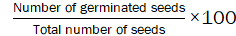
2. Seedling growth (cm): The shoot, root and total seedling length were taken using a measuring scale
3. Vigour index = Mean seedling length × Germination percentage

Temperature induction response (TIR)
The principal objective of this investigation encompassed the analysis of a chosen set of four genotypes with three replications each, to ascertain their thermo-tolerance characteristics. To gauge the genotypes’ thermo-tolerance, specific temperatures were selected: a gradual increase in temperature from 28 to 53°C for duration of 5 hours followed by a lethal temperature of 53°C sustained for 2.5 hours. Seedlings aged 72 hours were subsequently exposed to the induction temperature, followed by the lethal temperature, and allowed a 72-hour recovery period. Upon conclusion of the recovery phase, measurements were taken for both root and shoot lengths. The extent of seedling survival, expressed as a percentage, in these parameters of the induced seedlings relative to the control group served as the criterion for discerning between tolerant and susceptible genotypes.

Plant material and stress treatment under phenomics platform facility
Four finger millet genotypes with contrasting responses to moisture stress, namely GE-1309 and GE-5123 (susceptible), as well as GE-845 and KMR-630 (tolerant), were carefully chosen from a preceding study conducted by Mayank, 2020. The plants were grown in plastic containers with a capacity of 23 L, containing a mixture of red sandy loam soil and farmyard manure (FYM) in a 3:1 ratio. Upon reaching a two-week age, seedlings were treated with the recommended dosage of NPK fertilizers (50:40:25 kg ha⁻¹). The plants were subjected to moisture stress using the plant phenomics facility situated at the University of Agricultural Sciences in Bangalore. This facility simulated moisture stress through a user defined “dry-down” protocol, closely mimicking natural stress progression (Vijayaraghavareddy et al., 2020). Each genotype’s treatment was replicated thrice, following a completely randomized design. At the flowering stage of each genotype (50-65 DAS), a gradual imposition of moisture stress commenced, continuing until it reached 40% of the field capacity. This level was then maintained for 7 days. The control treatment, on the other hand, was maintained at 100% FC throughout the duration of the experiment. With a focus on the physiological, biochemical, and metabolomic responses of the finger millet genotypes under stressful conditions, data collection and sampling were conducted from 5th to 7th day of the stress period maintained at 40% field capacity.

Relative water content (%)
The determination of relative water content (RWC) in both control and stressed plants was executed in accordance with the protocol outlined by Barrs and Weatherley (1962). The procedure involved excising fully expanded leaves, followed by immediate weighing to establish the fresh weight (FW). Subsequently, the leaves were submerged in distilled water and subjected to a 6-hour incubation period to acquire the turgid weight (TW). Then, the leaves were subjected to oven drying at 80°C until a constant dry weight (DW) was attained. The RWC was computed using the following formula:
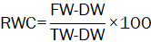

Total chlorophyll content
Freshly developed young 3rd leaf samples (0.2 g) from apex were submerged in a precise quantity (10 mL) of a mixture containing acetone and dimethyl sulfoxide (DMSO) in a 1:1 ratio. This immersion continued until the leaf tissue was fully decolorized, facilitating the extraction of chlorophyll. Subsequent absorbance measurements at wavelengths of 645 nm and 663 nm were taken using a spectrophotometer, with the acetone/DMSO solution serving as the reference, in accordance with the approach described by Arnon (1949). The quantification of total chlorophyll content (mg g⁻¹ fresh weight) was accomplished utilizing the subsequent formula:
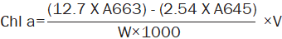

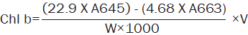

Total chlorophyll = Chl a + Chl b
Where, W is the weight of the leaf sample (0.2 g), V is the volume made (10 mL), and A663 and A645 represents the absorbance measured at 663 and 645 nm.

Proline content
The method established by Bates et al, (1973) was employed for the quantification of proline content, recognized as an indicator of osmotic stress. Leaf tissues (0.1 g) were subjected to homogenization with 5 mL of 3% sulfosalicylic acid, and ensuing supernatants were procured through centrifugation at 12,000 rpm for 15 minutes for subsequent analysis. Following this, equivalent volumes of acid ninhydrin and glacial acetic acid were introduced into the resultant 2 mL of supernatant, followed by subjecting the mixture to boiling at 100°C for 1 hour. To halt the reaction, the samples were promptly frozen in ice, and thereafter, toluene (4 mL) was integrated into the blend and subjected to vortexing for several seconds. Following a period of settling, the absorbance of the upper coloured layer was measured at 520 nm. By utilizing a standard curve prepared using different concentrations of L-proline, the proline content was quantified and expressed as µg g⁻¹ fresh weight.

Malondialdehydequantification
The quantification of malondialdehyde (MDA) in the leaf specimens for assessing lipid peroxidation was executed in accordance with the methodology outlined by Heath and Packer (1968). Leaf samples weighing 0.1g, obtained from both the control and water-stressed plants were subjected to homogenization in a solution of 0.1% TCA (trichloroacetic acid). The resulting mixture was then centrifuged at 12,000 revolutions per minute at a temperature of 4°C for duration of 15 minutes. Subsequent to centrifugation, the supernatant was collected and employed to ascertain the concentration of MDA by measuring the absorbance at wavelengths of 532 nm and 600 nm. The computation was executed utilizing the Lambert-Beer law, incorporating an extinction coefficient denoted as εM = 155 mM⁻¹ cm⁻¹, and the resultant values were expressed in units of μM MDA per gram of fresh weight (μM MDA g⁻¹ FW).

Evan’s Blue Staining
Evan’s Blue staining is a widely used technique to assess membrane damage in various biological systems, including plant cells, and tissues. It provides valuable insights into the integrity of cell membranes and can be used to study the effects various stresses on membrane structure and function. To assess the degree of membrane damage induced by moisture stress, the Evans Blue technique was implemented on leaf specimens sourced from both the control and stress-induced genotypes. The leaf samples underwent immersion in a solution comprising 0.25 g of Evans Blue, which had been prepared using a 0.1 M CaCl₂ solution adjusted to pH 5.6. Following this, the samples were subjected to an incubation period lasting 1 hour. Subsequent to the incubation, the samples were meticulously washed with water to eliminate any unbound dye present on the surface. The dye that had bound to the membranes was subsequently released from the cells through treatment with 1% sodium dodecyl sulphate (SDS). The resulting absorbance was quantified at a wavelength of 600 nm using the procedure delineated (Vijayaraghavareddy et al., 2017).

Above ground total dry matter (g plant⁻¹)
The leaves and stems of the plants were subjected to drying in a 70⁰C oven to determine their individual leaf and stem weights. The above-ground total dry matter (TDM) was computed by summing up the weights of the plant components.

Finger length (cm)
Finger length was measured from the base to the longest finger of the main tiller.

RESULTS AND DISCUSSION

(a) Effect of PEG stress on seedling parameters in contrasting genotypes

(i) Germination percentage

In the present experiment, moisture stress was induced by subjecting all four genotypes (GE-1309, GE-5123, GE-845, and KMR-630) to PEG treatment. Results revealed a significant reduction in germination percentage as the concentration of PEG increased compared to the control (0 bars) to -10 bars. Notably, the susceptible genotypes (GE-1309 and GE-5123) exhibited the least germination percentage (4% and 0%, respectively at -10 bars) and higher reduction across the PEG gradient (-2 to -10 bars), whereas the tolerant genotypes (GE-845 and KMR-630) demonstrated comparatively higher germination percentage (18% and 76%, respectively at -10 bars) with a lesser reduction across the PEG gradient (Table 2). Several studies have reported similar trends, where increasing PEG concentrations resulted in a significant decrease in germination percentage in finger millet genotypes (Govindaraj et al., 2010; Mundada et al., 2020). Interestingly, the differential response among genotypes was evident, with the susceptible genotypes (GE-1309 and GE-5123) exhibiting a greater reduction in germination percentage compared to the tolerant genotypes (GE-845 and KMR-630) which highlights the variability in the tolerance mechanisms employed by different genotypes to cope with moisture stress (Bayoumi et al., 2008; Mundada et al., 2020; Pour-Aboughadareh et al., 2020).

(ii) Reduction in seedling growth parameters
Under PEG-induced moisture stress, the genotypes exhibited a progressive reduction in shoot length with increasing PEG concentration, except for GE-845, which demonstrated an increase in shoot length at -2 bars (Fig. 1a). The substantial reduction in shoot length was observed at -10 bars across all genotypes, with the susceptible genotypes (GE-1309 and GE-5123) displaying a complete reduction of 100%, while the tolerant genotypes, GE-845 and KMR-630, exhibited reductions of 79% and 75%, respectively (Fig. 1a). Interestingly, KMR-630 maintained a higher shoot length from -2bars to -4bars of PEG concentration, which highlights the ability of the genotype to withstand moisture stress. Similar trend, where increasing PEG concentrations resulted in reduced shoot length has been reported in previous studies (Basha et al., 2015; Mundada et al., 2020; Awan et al., 2021). The specific genotypic variations observed in the reduction of shoot length under PEG-induced moisture stress can be attributed to differences in the tolerance mechanisms employed by different genotypes such as enhanced stress signalling pathways, more efficient osmotic adjustment, enabling them to mitigate the negative effects of moisture stress on shoot growth (Bayoumi et al., 2008). The initial increase in shoot length observed in one of the tolerant genotypes, GE-845 may be attributed to a compensatory growth response, where the plants attempt to overcome the stress by elongating their shoots. However, as the stress intensity intensifies, the growth inhibition becomes more pronounced, leading to a subsequent reduction in shoot length.
Root length also exhibited variation among the different genotypes in response to varying concentrations of PEG (Fig 1b). The genotypes susceptible to stress (GE-1309 and GE-5123) displayed a gradual decrease in root length as the PEG concentration increased. In contrast, the tolerant genotypes (GE-845 and KMR-630) demonstrated resilience against the stress, showing better root length retention compared to the susceptible ones. The decrease in root length from -2 bars to -10 bars, ranged from 22% to 100% in GE-1309 and 38% to 100% in GE-5123. For GE-845, the reduction ranged from 14% to 92%. Notably, KMR-630 exhibited a sudden increase in root length at stress levels of -2 bars to -4 bars (4% to 2%), indicating the genotype’s adaptive mechanism to cope with stress by emphasizing root length to enhance water absorption. This response aligns with findings from previous studies (Awan et al., 2021) highlighting the ability of tolerant genotypes to maintain root length under PEG-induced stress.
The variation in total length among the different genotypes under PEG stress followed a similar trend as observed for root length (Fig 1c). Susceptible genotypes like GE-1309 showed reductions ranging from 14% to 100%, while reductions for GE-5123 ranged from 42% to 100%. Tolerant genotypes, GE-845 and KMR-630, displayed more favourable outcomes with reductions ranging from 0% to 86% and 0% to 64%, respectively.

(iii) Seedling vigour index
The concept of vigour index in seedlings typically encompasses an assessment of the overall well-being, strength, and vitality of young plants as they emerge from seeds and initiate growth. This index takes into account factors such as germination percentage and total seedling length (Zhang et al., 2020). When subjected to PEG treatment, the vigour index demonstrated a consistent pattern of decline across all distinct genotypes as the stress level escalated from -2 bars to -10 bars (Table 2). At -10 bars, susceptible genotypes displayed negligible vigour indices, while the tolerant genotypes, namely GE-845 and KMR-630, exhibited vigour indices of 23 and 272, respectively (Table 2). This is further supported by phenotypic expression (Fig 2). This noteworthy tolerance capacity of the genotypes was highlighted by the vigour index, as previous research has indicated a comparatively smaller reduction in vigour index for tolerant genotypes under stress in comparison to their susceptible counterparts (Alom et al., 2016; Rajabi Dehnavi et al., 2020).

(b) Response of contrasting genotypes to temperature induction response (TIR)
The genotypes selected for investigating their osmotic response were subjected to an assessment of their cellular-level capacity to tolerate elevated temperatures through a technique known as temperature induction response (TIR). This method involves gradually elevating the temperature during the acclimation phase, with the aim of enhancing high-temperature tolerance. This acclimation process is expected to lead to improved survival and growth at elevated temperatures, particularly for the genotypes known for their tolerance (Ange et al., 2016). Notably, the genotypes GE-845 and KMR-630, which had already demonstrated tolerance to osmotic stress, were also found to exhibit tolerance to high-temperature acclimation (Fig 3) Intriguingly, the genotypes GE-1309 and GE-5123, susceptible to PEG-induced stress, were also observed to be susceptible to high-temperature acclimation (Fig 3).
The percentage of seedling survival was notably higher in the tolerant genotypes, namely GE-845 and KMR-630, with rates of 90% and 95%, respectively. Conversely, the susceptible genotypes GE-1309 and GE-5123 displayed lower survival rates of 25% and 15%, respectively (Fig 3a). Further assessment of root length and shoot length in the seedlings following high-temperature induction was conducted to measure the tolerance levels of the different genotypes. Among these, the genotype KMR-630, recognized for its tolerance, exhibited the least reduction in both root length and shoot length (2.30 cm and 1.45 cm, respectively), followed by GE-845 (2.02 cm and 0.94 cm, respectively). In contrast, the highest reductions in both root length and shoot length were observed in the susceptible genotype GE-5123 (0.30 cm and 0.24 cm, respectively), followed by GE-1309 (0.61 cm and 0.42 cm, respectively) (Fig 3b, 3c). These results are evidenced through the phenotype (Fig 4). The technique of TIR allowed for the identification of genetic variations in these genotypes over a limited timeframe, and the assessment of survival rates provided insights into their tolerance levels toward high temperatures, as demonstrated in this study (Ange et al., 2016; Chandola et al., 2016; Biradar et al., 2019).

(c) Response of contrasting finger millet genotypes to moisture stress at flowering stage
Under the stress conditions, there was a consistent behaviour among all genotypes during flowering stage. The susceptible genotypes, GE-5123 and GE-1309 demonstrated substantial reductions in RWC (44.03 and 63.47 %, respectively), while the tolerant genotypes (GE-845 and KMR-630) displayed comparatively lower reductions (75.17 and 82.38 %, respectively; Fig 5a). Nevertheless, at the flowering stage, the genotype KMR-630, maintained higher total chlorophyll content under moisture stress (Fig 5b). The total chlorophyll content in the susceptible genotype, GE-5123 reached 4.68 mg g⁻¹ FW at stress from 3.96 mg g⁻¹ FW in the control, whereas in the tolerant genotype, KMR-630 it reduced to 5.34 mg g⁻¹ FW at stress from 5.80 mg g⁻¹ FW in the control. The strategies employed by tolerant genotypes to uphold elevated RWC and membrane stability even under elevated stress intensities, suggest that these tolerant variants possess distinct attributes safeguarding chlorophyll content and cellular architecture during osmotic stress (Alam et al., 2021). This collective safeguarding mechanism ultimately underpins their capacity to endure stress triggered dehydration, leading to more favourable plant growth and heightened water uptake.
The heightened chlorophyll content observed in the sensitive genotype during the flowering stage under stress conditions might arise from its diminished capability to effectively manage the detriments of stress. Susceptible genotypes may potentially lack effective mechanisms for water conservation or the mitigation of stress-induced adversities, resulting in an excessive chlorophyll accumulation as a compensatory adaptation (Wang et al., 2021). This excessive chlorophyll content might not translate into optimal photosynthetic performance under stress conditions and can even exacerbate stress-induced damage, leading to reduced growth and productivity (Bita and Gerats, 2013). Plants tend to regulate chlorophyll levels downward in water-limited environments to counteract photo-oxidative damage caused by inhibited photosynthesis and the build-up of excessive light excitation energy (Chen et al., 2016). Surprisingly, the current study observed an augmentation in chlorophyll content under stress conditions.
The proline content was quantified as a marker of osmotic adjustment in all the genotypes. The proline content ranged from 4.28 to 8.67 µg g⁻¹ FW among the genotypes under stress condition (Fig 5c). Notably, the tolerant genotypes KMR-630 and GE-845 exhibited higher proline accumulation compared to the susceptible genotypes GE-5123 and GE-1309. In the drought-tolerant genotype, the build-up of organic components such as sugars and amino acids demonstrates their potential to serve as both osmo-protectants and cytoprotectants in response to moisture stress. Additionally, the maintenance of relative water content during moisture stress can be attributed to leaf folding, osmotic adjustment in younger leaves and stems, and the accumulation of NO₃⁻ and amino acids at the initial stages of stress (Kusaka et al., 2005)
In response to moisture stress conditions, the genotypes exhibited a higher level of MDA content, indicating an increase in lipid peroxidation, which, in turn, corresponds to membrane damage even during the flowering stage (Fig 5d). Susceptible genotypes, GE-5123 and GE-1309 demonstrated a significant rise in MDA content (2.67 and 1.98 µmol g⁻¹ FW, respectively) compared to tolerant genotypes, KMR-630 and GE-845 (1.38 and 1.85 µmol g⁻¹ FW, respectively). The detection of membrane damage using the Evans Blue technique corroborated the observed pattern in accordance with MDA content (Fig 5e). Among the genotypes, KMR-630 exhibited the lowest MDA content and membrane damage (0.25 ng Evan’s blue g⁻¹ FW), followed by GE-845 (0.29 ng Evan’s blue g⁻¹ FW), whereas GE-5123 (0.50 ng Evan’s blue g⁻¹ FW) showed the highest MDA content and subsequent membrane damage, followed by GE-1309 (0.39 ng Evan’s blue g⁻¹ FW).
The above-ground biomass experienced a significant decrease under the stress condition (Fig 5f). Among the different genotypes, the tolerant ones, KMR-630 and GE-845, exhibited superior above-ground biomass (96.43 and 66.86 g plant⁻¹, respectively), while the susceptible genotypes, GE-5123 (43.32 g plant⁻¹) and GE-1309 (58.60 g plant⁻¹) showed lower values. Finger length is closely linked to grain yield in finger millet, making it a practical tool for predicting potential yield losses under stress, which is crucial for crop management decisions (Sood et al., 2019). A notable decline in finger length was observed under stress condition. The highest finger length under stress condition was recorded in KMR-630 (5.50 cm), followed by GE-845 (4.43 cm). Conversely, the susceptible genotypes, GE-5123 (2.03 cm) and GE-1309 (2.8 cm), exhibited a significant reduction in finger length under stress conditions, with GE-5123 being the most severely affected (Fig 5g).

CONCLUSIONS
The present study elucidates that drought stress induces morphological, physiological, and biochemical alterations in finger millet during both the heterotrophic and flowering stages. Each genotype exhibits varying levels of tolerance, which can be attributed to distinct physiological, biochemical, and above-ground dry matter content analyses. Considering the changes in response to moisture stress during these stages, it is deduced that genotypes KMR-630 and GE-845 possess mechanisms that confer drought tolerance, while genotypes GE-1309 and GE-5123 are susceptible to drought. In the case of KMR-630, its drought tolerance mechanism is activated by its capacity to maintain seedling vigor during the heterotrophic stage. During the flowering stage, this genotype's tolerance is further expressed through the preservation of relative water content and the scavenging of reactive oxygen species, which in turn reduces membrane damage. These factors contribute to the maintenance of above-ground biomass and yield parameters, including finger length, under conditions of moisture stress. This study suggests that these physiological and biochemical approaches can serve as a foundational step in selecting drought-tolerant and sensitive genotypes for subsequent molecular analyses and omics studies.

REFERENCES
Alam, M.S., Tester, M., Fiene, G. and M.A.A. Mousa, 2021. Early growth stage characterization and the biochemical responses for salinity stress in tomato. Plants, 10 (4): 712.
Alom, R., Hasan, M.A., Islam, M.R. and Q.F. Wang, 2016. Germination characters and early seedling growth of wheat (Triticum aestivum L.) genotypes under salt stress conditions. J. Crop Sci. Biotech., 19: 383-392.
Ange, U. M., Srividhya, S., Vijayalakshmi, C. and P. Boominathan, 2016. Temperature induction response reveals intrinsic thermo-tolerant genotypes in soybean. Legume Res., 39 (6): 926-930.
Antre, S. H., Ravikumar, R. L., Subramanya, A. S. S. and K.J. Meghana, 2021. Selection of stable drought tolerant genotypes in finger millet [Eleusine coracana (L.) Gaertn] using combination of drought tolerance indices. Mysore J. Agric. Sci., 55(4): 340-348.
Arnon, D, 1949. Copper enzymes isolated chloroplasts, polyphenoloxidase in Beta vulgaris. Plant Physiol., 24: 1-15.
Awan, S.A., Khan, I., Rizwan, M., Zhang, X., Brestic, M., Khan, A., El‐Sheikh, M.A., Alyemeni, M.N., Ali, S. and L. Huang, 2021. Exogenous abscisic acid and jasmonic acid restrain polyethylene glycol‐induced drought by improving the growth and antioxidative enzyme activities in pearl millet. Physiologia Plantarum, 172 (2): 809-819.
Barrs, H. D. and P.E. Weatherley, 1962. A re-examination of the relative turgidity technique for estimating water deficit in leaves. J. Biol. Sci., 15: 413-428.
Basha, P.O., Sudarsanam, G., Reddy, M.M.S. and S. Sankar, 2015. Effect of PEG induced water stress on germination and seedling development of tomato germplasm. Int. J. Recent Sci. Res., 6 (5): 4044-4049.
Bates, L. S., Waldren, R. P. and I.D. Teare, 1973. Rapid determination of free proline for water-stress studies. Plant Soil, 39: 205-207.
Bayoumi, T.Y., Eid, M.H. and E.M. Metwali, 2008. Application of physiological and biochemical indices as a screening technique for drought tolerance in wheat genotypes. African J. Biotech., 7 (14).
Biradar, G., Laxman, R. H., Namratha, M. R., Thippeswamy, M., Bhatt, R. M. and A.T. Sadashiva, 2019. Evaluation of Solanum lycopersicum L. genotypes for high temperature stress tolerance employing temperature induction response technique. J. Exp. Biol., 57(09): 680-689.
Bita, C.E. and Gerats, T., 2013, Plant tolerance to high temperature in a changing environment: scientific fundamentals and production of heat stress-tolerant crops. Front. Plant Sci., 4: 273.
Chandola, A., Pandurangam, V. and J.P. Srivastava, 2016. Genotypic variations in tomato (Lycopersicon Esculentum M.) for acquired thermo-tolerance to temperature induction response. Int. J. Agric. Environ. Biotech., 9 (4): 649-657.
Chen, D., Wang, S., Cao, B., Cao, D., Leng, G., Li, H., Yin, L., Shan, L. and X. Deng, 2016. Genotypic variation in growth and physiological response to drought stress and re-watering reveals the critical role of recovery in drought adaptation in maize seedlings. Front. Plant Sci., 6: 1241.
Dash, S.K., Kulkarni, M.A., Mohanty, U.C. and K. Prasad, 2009. Changes in the characteristics of rain events in India. J. Geophysical Res. Atmo., 114, D10109,
Davis, K. F., Chhtre, A., Rao, N. D., Singh, D. and R. Defries, 2019. Sensitivity of grain yields to historical climate variability in India. Environ. Res. Lett., 14: 1-10.
Dwivedi, S., Upadhyaya, H., Senthilvel, S., Hash, C., Fukunaga, K., Diao, X., Santra, D., Baltensperger, D. and M. Prasad, 2012. Millets: Genetic and genomic resources. In: Plant Breeding Reviews. Hoboken, New Jersey: Wiley-Blackwell, pp. 247–375. ISBN 9781118100509
Govindaraj, M., Shanmugasundaram, P., Sumathi, P. and A.R. Muthiah, 2010. Simple, rapid and cost effective screening method for drought resistant breeding in pearl millet. Electronic J. Plant Breed., 1(4): 590-599.
Heath, R. L. and L. Packer, 1968. Photoperoxidation in isolated chloroplasts. I. Kinetics and stoichiometry of fatty acid peroxidation. Arch. Biochem. Biophys., 125: 189-198.
Hiremath, N., Geetha, K., Vikram, S. R., Nanja Reddy, Y. A., Joshi, N. and H.B. Shivaleela, 2018. Mineral’s content in finger millet [Eleusine coracana (L.) Gaertn.]: A future grain for nutritional security. Int. J. Curr. Microbiol. Appl. Sci., (Special Issue), 7: 3448-3455.
Jalihal, C., Srinivasan, J. and A. Chakraborty, 2019. Modulation of Indian monsoon by water vapour and cloud feedback over the past 22,000 years. Nature Communications, 10: 1-8.
Krishna, S.S., Nanja Reddy, Y. A. and R.L. Ravi Kumar, 2021. Assessment of traits for grain yield under drought in finger millet, Plant Physiol. Rep., 26(1): 84–94.
Kusaka, M., Ohta, M. and T. Fujimura, 2005. Contribution of inorganic components to osmotic adjustment and leaf folding for drought tolerance in pearl millet. Physiologia Plantarum, 125 (4): 474-489.
Mayank, P.S.B., 2020. Field performance of finger millet genotypes differing in drought adaptive traits: Physiological and biochemical analysis. M.Sc thesis, University of Agricultural Sciences, Bangalore.
Michel, B.E., 1983. Evaluation of the water potentials of solutions of polyethylene glycol 8000 both in the absence and presence of other solutes. Plant physiol., 72(1): 66-70.
Mundada, P.S., Nikam, T.D., Kumar, S.A., Umdale, S.D. and M.L. Ahire, 2020. Morpho-physiological and biochemical responses of finger millet (Eleusine coracana (L.) Gaertn.) genotypes to PEG-induced osmotic stress. Biocat. Agric. Biotech., 23: 101488.
Nanja Reddy, Y. A., Jayarame Gowda., Ashok, E. G. and K.T. Krishne Gowda, 2020. Effect of moderate drought stress on photosynthetic rate and grain yield in finger millet genotypes. Int. J. Curr. Microbiol. Appl. Sci., 9(5): 2951-2959.
Pour-Aboughadareh, A., Etminan, A., Abdelrahman, M., Siddique, K.H. and L.S.P. Tran, 2020. Assessment of biochemical and physiological parameters of durum wheat genotypes at the seedling stage during polyethylene glycol-induced water stress. Plant Growth Regulation, 92: 81-93.
Pradhan, A., Panda, A. K. and R.V. Bhavani, 2019. Finger millet in tribal farming systems contributes to increased availability of nutritious food at household level: Insights from India. Agric Res., 8(4): 540-547.
Rajabi Dehnavi, A., Zahedi, M., Ludwiczak, A., Cardenas Perez, S. and A. Piernik, 2020. Effect of salinity on seed germination and seedling development of sorghum (Sorghum bicolor (L.) Moench) genotypes. Agronomy, 10 (6): 859.
Sood, S., Joshi, D.C., Chandra, A.K. and A. Kumar, 2019. Phenomics and genomics of finger millet: current status and future prospects. Planta, 250: 731-751.
Ueno, O., Kawano, Y., Wakayama, M. and T. Takeda, 2006. Leaf vascular systems in C3 and C4 grasses: A two-dimensional analysis. Ann. Bot., 97(4): 611-621.
Vijayaraghavareddy, P., Vanitha, P., Vemanna, R., Sheshshayee, M. S. and U. Makarla, 2017. Quantification of membrane damage/cell death using Evan’s blue staining technique. Bio- Protoc., 7.
Vijayaraghavareddy, P., Vemanna, R.S., Yin, X., Struik, P.C., Makarla, U. and S. Sreeman, 2020. Acquired traits contribute more to drought tolerance in wheat than in rice. Plant Phenomics. https://doi.org/10.34133/2020/5905371
Wang, B., Yang, X., Chen, L., Jiang, Y., bu, H., Jiang, Y., Li, P. and C. Cao, 2021. Physiological mechanism of drought-resistant rice coping with drought stress. J. Plant Growth Regulation, 1-14.
ZHANG, T., FAN, S., XIANG, Y., ZHANG, S., WANG, J. AND Q. SUN, 2020. Non-destructive analysis of germination percentage, germination energy and simple vigour index on wheat seeds during storage by Vis/NIR and SWIR hyperspectral imaging. Spectrochimica Acta Part A: Molecular and Biomolecular Spectroscopy, 239: 118488.

Table 1. Passport data of the contrasting genotypes
Genotypes | Country of origin
GE-1309 | Africa
GE-5123 | Africa
GE-845 | India
KMR-630 | India

Table 2. Effect of PEG concentration on seed germination, seedling length and seedling vigour index of the contrasting finger millet genotypes
PEG concentration (bars) | Germination percentage  (%) |  |  |  | Total length  (cm) |  |  |  | Vigour index
PEG concentration (bars) | Genotypes |  |  |  | Genotypes |  |  |  | Genotypes
 | GE-1309 | GE-5123 | GE-845 | KMR-630 | GE-1309 | GE-5123 | GE-845 | KMR-630 | GE-1309 | GE-5123 | GE-845 | KMR-630
0 | 100 | 100 | 100 | 100 | 9.65 | 9.47 | 8.99 | 9.90 | 965 | 947 | 899 | 990
-2 | 91 | 91 | 98 | 100 | 8.34 | 5.53 | 9.02 | 9.87 | 759 | 504 | 882 | 987
-4 | 78 | 62 | 96 | 98 | 7.08 | 4.17 | 5.87 | 9.87 | 551 | 259 | 560 | 965
-6 | 76 | 36 | 84 | 96 | 4.11 | 1.97 | 4.77 | 9.63 | 311 | 70 | 403 | 920
-8 | 36 | 7 | 69 | 93 | 1.50 | 0.97 | 3.39 | 5.18 | 53 | 6 | 233 | 483
-10 | 4 | 0 | 18 | 76 | 0.00 | 0.00 | 1.30 | 3.61 | 0 | 0 | 23 | 272
C.D (5%) | 6.13 |  |  |  | 0.67 |  |  |  | 33.85
S.Em+ | 2.15 |  |  |  | 0.24 |  |  |  | 11.87

a)

b)

c)

Figure 1. Effect of PEG concentration on (a) reduction in shoot length (%), (b) reduction in root length (%), and (c) reduction in total seedling length (%) in contrasting finger millet genotypes

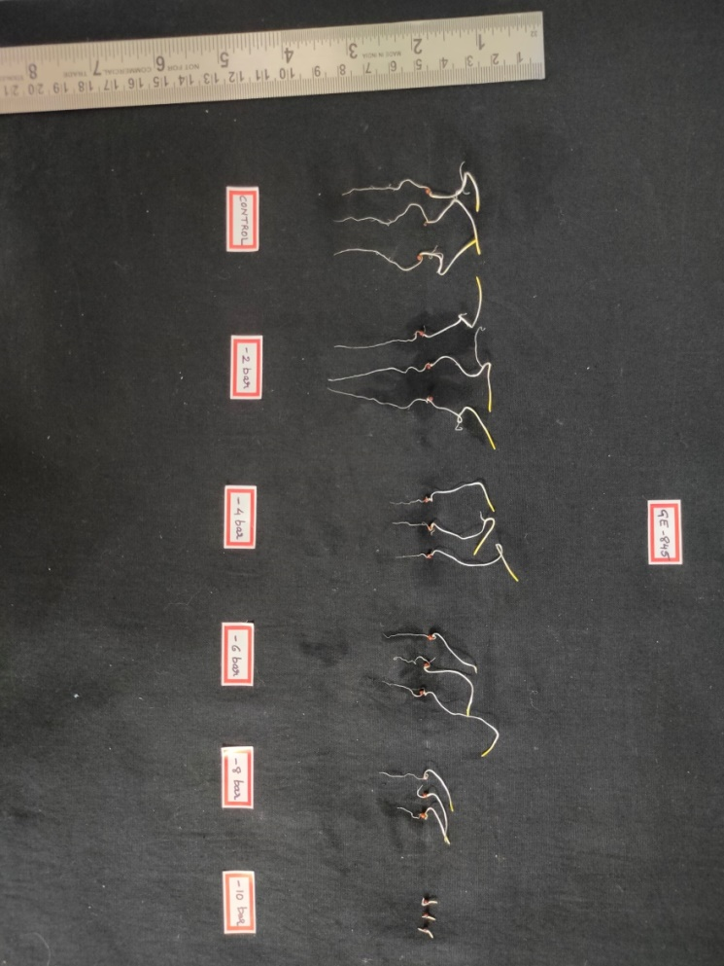
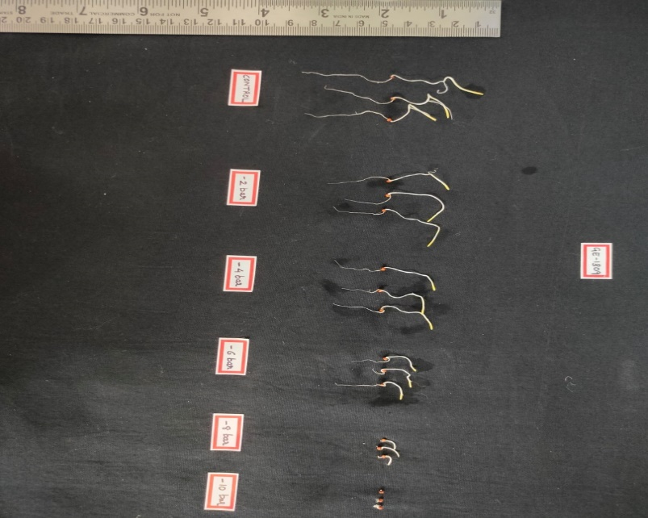
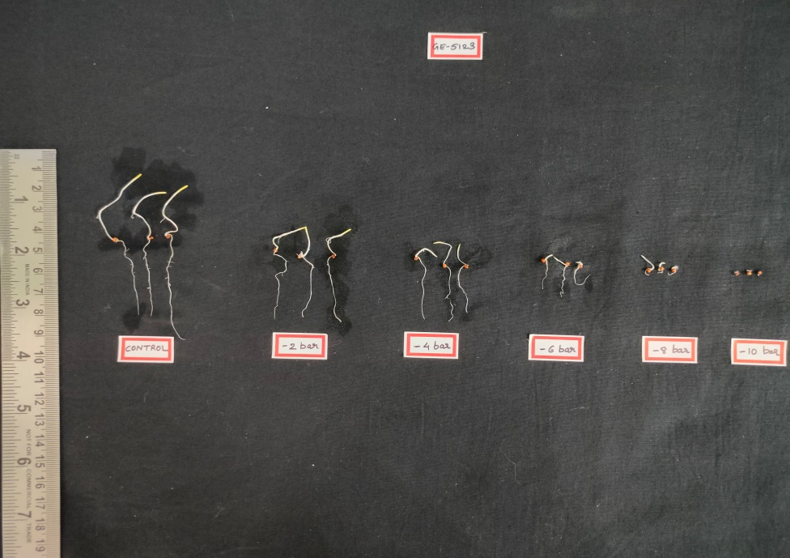
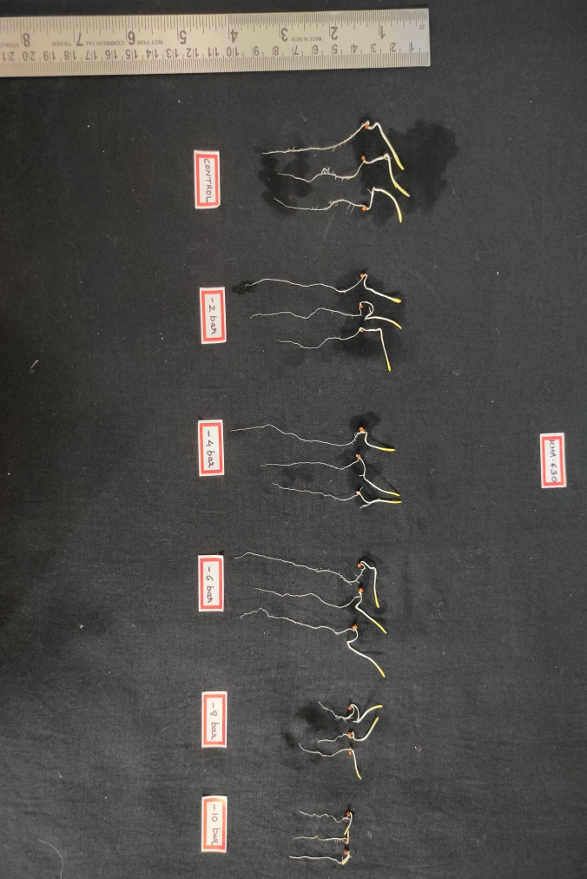
GE-1309
GE-5123
GE-845
KMR-630
Control
-2 bars
-4 bars
-6 bars
-8 bars
-10 bars
Control
-2 bars
-4 bars
-6 bars
-8 bars
-10 bars

Figure 2. Effect of PEG concentration on phenotype of contrasting finger millet genotypes

a)

b)

c)

Figure 3. Effect of induction temperature on (a) percent survival (%), (b) root length (cm), and (c) shoot length (cm) in contrasting finger millet genotypes

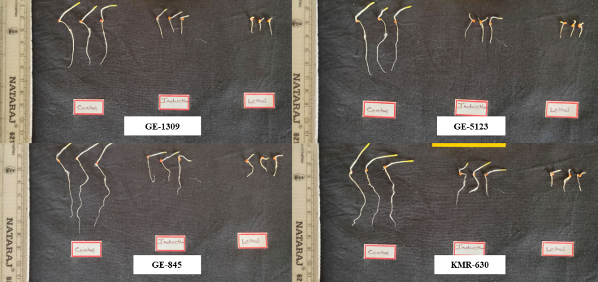

Figure 4. Phenotypic expression of seedling growth under induction temperature in contrasting finger millet genotypes

a)
b)

d)
c)

f)
e)

g)

Figure 5. Effect of moisture stress on (a) relative water content (%), (b) total chlorophyll content (mg g⁻¹ FW), (c) proline (µg g⁻¹ FW), (d) malondialdehyde content (µmol g⁻¹FW), (e) membrane damage using Evan’s blue staining (ng Evan’s blue g⁻¹FW), (f) above-ground biomass (g plant⁻¹), (g) finger length (cm) in contrasting finger millet genotypes

