RESEARCH ARTICLE

**Irrigation Scheduling and Estimating Yield Reduction in Chickpea under Rainfed Condition and Changing Climate of North Interior Karnataka**

HEMAREDDY THIMMAREDDY1*, MAHANTESH B. NAGANGOUDAR2, PUGAZENTHI. K1, SENBAGAVALLI. G1 AND PRIYANKA. P1

1Agro Climate Research Centre, Tamil Nadu Agricultural University, Coimbatore and 2Department of Agronomy, University of Agricultural Sciences, Bangalore, GKVK, India

|  |  |
| --- | --- |
|  | **ABSTRACT**  Chickpea is one of the major legumes predominately cultivated in North Interior Karnataka (NIK). This simulation study using CROPWAT model aimed at quantifying yield reduction under rainfed condition and proper irrigation scheduling in chickpea variety BGD-103. This would help farmers of NIK in tapping the potential yields of this crop through proper irrigation management. Crop management input in the model was based on the recommended practices of UAS, Dharwad across four dates of sowing from 1st October to 15th October at quarterly interval on black clay soil. The simulated outputs were analyzed at decadal interval for both past (1991-2020) and projected climate (2021-2050). Under past climate two irrigation was simulated *i.e*., one irrigation at 40-45 days after sowing (DAS) and another at pod filling stage (70 DAS). The number of irrigations decreased by one under projected climate *i.e.,* only one irrigation at 45 DAS. Yield reduction in rainfed condition on black clay soil under past climate was 31.6 %, which in contrast, decreased by 16.4 % under projected climate and is presented against spatial distribution across NIK. Sowing early *i.e.,* on 01st October under projected climate (2021-2050) simulated the lowest yield reduction (rainfed) and require fewest irrigations across 12 districts of NIK. |

**Keywords:** *CROPWAT; Yield reduction; Irrigation scheduling; NIK*

**INTRODUCTION**

Climate is one of the most important determinants of agricultural output as it is linked to physiological processes, it has a direct impact on output production. This issue has the potential to impact global food security, particularly in underdeveloped countries. Depending on location, climate zone and crop, climate change may have both positive and negative effects on agricultural production in terms of quantity and quality (Gitz *et* al., 2016). The sixth assessment report of the Intergovernmental Panel on Climate Change indicates agriculture projected yield losses of up to 32 per cent by 2100 (RCP8.5) due to the combined effects of temperature and precipitation (Caretta *et al*., 2022). Globally, 11% (±5%) of croplands are estimated to be vulnerable to projected climate-driven water scarcity by 2050 (Fitton *et al*., 2019). It clearly shows that climate is changing and in turn results in unstable agricultural production being greatly influenced by the changing climate over time.

The global consumption of water is doubling every 20 years, more than twice the rate of human population growth. FAO estimates shows that, 70 to 80 per cent increase in food demand between 2000 and 2030 will have to be met by increasing irrigation supply to field crops (FAO, 2017). Irrigated agriculture is practiced on about 300 m ha globally which accounts for only or 20 per cent of the total cultivated area, but contributing substantially with more than 40 per cent of world’s food production (Banik *et al.,* 2014). A scarce water resources and growing competitions for water will reduce its availability for irrigation. The accurate planning and delivery of the necessary amount of the water in the time and space can conserve water (Boretti and Rosa, 2019). Achieving greater efficiency of water use will be a primary challenge for the near future and will include the employment of techniques and practices that deliver a more accurate supply of water to crops.

Chickpea (*Cicer arietinum*) is called as ‘King of pulses’ as it constitutes one-third of the area and 40 per cent of total pulse production in India and protein content around 22-23 per cent. In India it occupies an area of 10.56 m ha with a production of 11.28 m t and a productivity of 1078 kg ha-1 (Anon., 2020). Karnataka, being one of the major chickpea producing states in the country constitutes an area of 12.6 lakh ha, production of 7.83 lakh t and productivity of 619 kg ha-1 (Anon., 2020). It is cultivated extensively in Northern part of Karnataka especially in Dharwad, Belagavi, Vijayapur, Bagalakote and Bidar districts on *Vertisols* during *Rabi* season under residual moisture. Since, this legume is grown on residual soil moisture (rarely under any supplemental irrigation), supplying irrigation either fully or as a lifesaving irrigation at critical stages could help in achieving the untapped productivity of the crop.

Crop simulation models use quantitative descriptions of ecophysiological processes to predict plant growth and development as influenced by environmental conditions and crop management, which are specified for the model as input data (Hodson and White, 2010). Thus, can help drive efficiency in agricultural production systems by allowing farmers to manage their inputs more efficiently by predicting crop production/food security under a range of projected climate scenarios to subsequently compute the economic consequences of the altered production i.e., to compute the water use (irrigation required) involved and to hypothesize possible adaptation/mitigation strategies. With these points in mind, the present study has been taken up to predict the optimum irrigation management strategies for increased production in NIK region under future climate scenario.

**METHODOLOGY**

North Interior Karnataka (NIK) is one of the three meteorological sub-divisions of Karnataka state of India classified by India Meteorological Department (IMD). It consists of a geographical region with mostly semi-arid plateau from 300 to 730 meters (980 to 2,400 ft) elevation constituting 12 districts namely Bagalakote, Ballari, Belagavi, Bidar, Dharwad, Gadag, Haveri, Kalaburgi, Koppal, Raichur, Vijayapura and Yadagiri (Fig. 1). This region is largely covered with rich black cotton and red sandy loamy soils, gently sloping lands and plains, summits of plateau and table lands. NIK is one of the drier regions of India receiving on an average just 731 mm rainfall per annum (Anon., 2016).

The immediate past weather data (rainfall, minimum and maximum temperature) for 12 district of NIK was collected from NASA POWER web portal (*https://power.larc.nasa.gov*) (Sparks, 2018) for the past climatic period of 30 years (1991 to 2020) and the projected climatic data for the period of upcoming 30 years (2021-2050) was collected from Copernicus Climate Change Service (IPSL-CM5A model) ([*https://climate.copernicus.eu*](https://climate.copernicus.eu)).

The field experiment was conducted at University of Agricultural Sciences (UAS), Dharwad during *Rabi* seasons of 2019-20 and 2020-21. The phenological data for initial, mid and late growth stages of chickpea variety BGD-103 collected from the field experiment were used in the model. The salient details of chickpea crop required for the study *i.e.,* crop coefficients (Kc), phenological days, critical depletion fraction (p) and yield response factor (Ky) were also taken from the available 18 published data of FAO (Allen *et al.*, 1998). The soil data on total available soil moisture content (SMC), initial soil moisture depletion, maximum rooting depth and maximum rain infiltration rate for black clay soil for all the 12 districts of NIK were collected from the world bank sponsored Sujala Project at UAS, Dharwad. The CROPWAT 8.0 model suited for windows was used for the simulation of crop and irrigation water requirements based on soil, climate and crop data for the study. It is a computer program developed by land and development division of FAO. The model has been run for all the 12 districts of NIK for chickpea using district level historical weather data of past 30 years (1991-2020) as well as projected weather data of 30 years (2021-2050) to know the critical stages of irrigation and irrigation scheduling at a proper stage of crop across different dates of sowing (DOS) *i.e.,* four dates of sowing starting from 01st October to 15th November at quarterly interval on black clay soil. The spatial interpretation of the parameters for all the 12 districts of NIK was done using ArcGIS software.

**RESULTS AND DISCUSSION**

**Irrigation Scheduling**

Vijayapur district has recorded highest average number of irrigations i.e., two irrigations in the past climate at 40-45 DAS and at 70 DAS (pod filling stage) as presented in Table 2. The lowest rainfall during the cropping period of chickpea (October to February) is the influential parameter (Table 1). Lowest average irrigations were simulated for Ballari district (1.4) because of its highest rainfall during the cropping period of chickpea among the 12 districts of NIK in the past climate (Table 2). The remaining districts have shown more than 1.5 average number of irrigations *i.e.,* one compulsory irrigation at 45 DAS. This is because of increased water requirement during development stage and less amount of rainfall in December for November sown crop. Similar results were also observed by Desta *et al.*, (2015) where two compulsory irrigations at flowering and pod filling stage were simulated. In the projected climate all the districts have shown one irrigation at 45 DAS, this is because of the increased simulated rainfall in the months of October and November months compared to past climate (Table 1). The single irrigation at 45 DAS is very critical as water requirement at this stage initiates flowering in chickpea i.e., the start of reproductive stage which is crucial in better development of the economic part of plant.

In the past climate minimum of one irrigation was simulated for crop sown on 1st October in all the districts of NIK while for all the delayed sowing dates two irrigations were simulated irrespective of the districts (Table 3). This was due to more rainfall during October month due to North-East monsoon onset which dissipates towards December. Under the projected climate for all the dates of sowing, only one irrigation was simulated at 45 DAS because of higher water requirement at this stage i.e., initiation of flowering (Table 3). Only one irrigation was simulated due to increased rainfall under projected climate than the past for all the 12 districts of NIK (Table 1). Athnere and Kolage (2019) reported that the maximum consumptive use of water has recorded under scheduling of irrigation at 40 mm CPE (305 mm), followed by the treatment irrigation at 60 mm CPE (223 mm).

**Yield Reduction under rainfed condition**

Vijayapur (34.8 %) followed by Kalaburagi (33.4 %) districts simulated highest yield reduction (YR) under rainfed condition in past climate. Lowest rainfall during the cropping period has affected the yield drastically (Table 1). The lowest YR was for Ballari (26.6 %) district followed by Haveri (28.8 %) because of their higher rainfall received during cropping period compared to other districts. Under projected climate, every district showed decreased YR compared to past climate (Table 2 and Fig. 2) because of increased rainfall under the projected climate. The highest YR in the projected climate was for Bidar district (18.1 %) and lowest was for Belagavi (12 %). This was because of associated change in their respective rainfall and temperature under the projected climate. The highest decrease in the YR in the projected climate compared to the past was for Belagavi district (20.5 %) because of its highest increased October-December rainfall in the projected climate among all the districts under study. Lowest decrease was for Ballari (12.5 %) district. Bhat *et al.* (2017) calculated yield reduction in maize for silty clay loam soil at critical depletion, irrigated at a given ETc of crop reduction per stage and irrigated at fixed interval per stage at 70 per cent field efficiency was found to be 0, 14.9 and 25.1 per cent, respectively. Also yield reduction at no water stress and at water stress was found to be 0 and 26.80 per cent, respectively.

The YR has increased with delay in sowing in both past and projected climate in all the districts of NIK (Table 3). Since the North-East rainfall dissipates towards the December month, late sowing crop receives less rainfall ultimately reflecting in increased YR. According to RCP 6.0 scenario, there would be an increase of 97.4 mm rainfall and 0.1 ̊ C temperature while number of rainy days increase by 12 during the chickpea cropping period (Oct-Feb) under the projected climate (2021-2050) compared to past climate (1991-2020) (Table 1).

**Table 1: Average weather data during chickpea cropping period (Oct- Feb) of all the 12 districts of NIK for the past climate (1991 - 2020), the projected climate (2021 – 2050) and the difference between the two periods**

|  |  |  |  |  |  |  |  |  |  |
| --- | --- | --- | --- | --- | --- | --- | --- | --- | --- |
| Districts | Past climate (1991-2020) | | | Projected climate (2021-2050) | | | Difference between Past & Projected climate | | |
| **Rain (mm)** | **Temp (˚C)** | **RD** | **Rain (mm)** | **Temp (˚C)** | **RD** | **Rain (mm)** | **Temp (˚C)** | **RD** |
| Bidar | 119.9 | 23.5 | 16 | 159.7 | 23.4 | 20 | 39.8 | -0.1 | 4 |
| Bagalakote | 123.7 | 24.2 | 18 | 234.5 | 24.0 | 31 | 110.8 | -0.3 | 13 |
| Belagavi | 135.3 | 24.1 | 19 | 281.1 | 24.9 | 39 | 145.8 | 0.8 | 20 |
| Vijayapur | 112.1 | 24.3 | 16 | 220.5 | 24.0 | 29 | 108.5 | -0.4 | 12 |
| Ballari | 149.2 | 24.4 | 25 | 275.7 | 24.3 | 34 | 126.4 | -0.1 | 9 |
| Dharwad | 153.2 | 23.9 | 21 | 281.1 | 24.9 | 39 | 127.9 | 1.0 | 18 |
| Gadag | 139.1 | 24.2 | 19 | 267.6 | 24.9 | 38 | 128.7 | 0.7 | 19 |
| Kalaburagi | 123.6 | 24.3 | 16 | 163.4 | 23.4 | 23 | 39.7 | -0.9 | 7 |
| Haveri | 175.8 | 24.0 | 24 | 267.6 | 24.9 | 37 | 91.7 | 0.9 | 14 |
| Koppal | 138.4 | 24.3 | 31 | 243.3 | 24.9 | 37 | 104.8 | 0.6 | 6 |
| Raichur | 127.3 | 24.9 | 17 | 196.2 | 24.0 | 25 | 68.9 | -0.9 | 7 |
| Yadagiri | 120.3 | 24.6 | 16 | 196.2 | 24.0 | 25 | 75.8 | -0.6 | 9 |
| NIK | **134.8** | **24.2** | **20** | **232.2** | **24.3** | **31** | **97.4** | **0.1** | **12** |

*Temp- Temperature, RD- Rainy days

**Table 2: District wise yield reduction (YR) and number of irrigations (No. of Irr.) required for past (1991-2020), projected (2021-2050) climate and difference between the two climate in Chickpea**

|  |  |  |  |  |  |  |
| --- | --- | --- | --- | --- | --- | --- |
| Districts | 1991-2020 (A) | | 2021-2050 (B) | | Difference (B-A) | |
| **YR (%)** | **No. of Irr.** | **YR (%)** | **No. of Irr.** | **YR (%)** | **No. of Irr.** |
| Bagalakote | 31.5 | 1.8 | 16.2 | 1.0 | -15.4 | -0.8 |
| Ballari | 26.6 | 1.4 | 14.0 | 1.0 | -12.5 | -0.4 |
| Belagavi | 32.5 | 1.8 | 12.0 | 1.0 | -20.5 | -0.8 |
| Bidar | 32.6 | 1.8 | 18.1 | 1.0 | -14.5 | -0.8 |
| Dharwad | 31.1 | 1.8 | 12.6 | 1.0 | -18.5 | -0.8 |
| Gadag | 31.4 | 1.8 | 14.0 | 1.0 | -17.4 | -0.8 |
| Haveri | 28.8 | 1.6 | 14.4 | 1.0 | -14.5 | -0.6 |
| Kalaburagi | 33.4 | 1.8 | 17.9 | 1.0 | -15.5 | -0.8 |
| Koppal | 30.9 | 1.8 | 13.8 | 1.0 | -17.1 | -0.8 |
| Raichur | 33.0 | 1.8 | 17.3 | 1.0 | -15.7 | -0.8 |
| Vijayapur | 34.8 | 2.0 | 16.2 | 1.0 | -18.6 | -1.0 |
| Yadagiri | 33.2 | 1.8 | 16.9 | 1.0 | -16.2 | -0.8 |
| Average | **31.6** | **1.8** | **15.3** | **1.0** | **-16.4** | **-0.8** |

**Table 3: District wise average yield reduction (YR) and number of irrigations (No. of Irr.) required for four dates of sowing in both black clay soil under both past (1991-2020) and projected (1991-2020) climate in Chickpea**

|  |  |  |  |  |  |  |  |  |  |  |  |  |  |  |  |  |  |
| --- | --- | --- | --- | --- | --- | --- | --- | --- | --- | --- | --- | --- | --- | --- | --- | --- | --- |
| Districts | Yield Reduction (%) | | | | | | | | No. of Irrigation | | | | | | | | |
| **Past climate (1991-2020)** | | | | **Projected (2021-2050)** | | | | **Past climate (1991-2020)** | | | | **Projected (2021-2050)** | | | | |
| **01-Oct** | **15-Oct** | **01-Nov** | **15-Nov** | **01-Oct** | **15-Oct** | **01-Nov** | **15-Nov** | **01-Oct** | **15-Oct** | **01-Nov** | **15-Nov** | **01-Oct** | **15-Oct** | **01-Nov** | **15-Nov** |
| Bagalakote | 24.7 | 30.1 | 36.4 | 35.0 | 9.9 | 13.3 | 17.9 | 23.6 | 1.3 | 2.0 | 2.0 | 2.0 | 1 | 1 | 1 | 1 |
| Ballari | 17.6 | 23.1 | 29.7 | 35.9 | 7.5 | 10.9 | 15.8 | 22.0 | 1.0 | 1.0 | 1.7 | 2.0 | 1 | 1 | 1 | 1 |
| Belagavi | 23.0 | 29.1 | 36.2 | 41.7 | 6.1 | 9.4 | 13.9 | 18.8 | 1.0 | 2.0 | 2.0 | 2.0 | 1 | 1 | 1 | 1 |
| Bidar | 24.8 | 30.1 | 35.8 | 39.7 | 12.1 | 15.5 | 19.7 | 25.1 | 1.3 | 2.0 | 2.0 | 2.0 | 1 | 1 | 1 | 1 |
| Dharwad | 21.1 | 27.4 | 34.8 | 41.0 | 6.3 | 9.6 | 14.1 | 20.4 | 1.0 | 2.0 | 2.0 | 2.0 | 1 | 1 | 1 | 1 |
| Gadag | 22.2 | 27.9 | 34.7 | 40.6 | 7.3 | 11.0 | 15.8 | 21.9 | 1.0 | 2.0 | 2.0 | 2.0 | 1 | 1 | 1 | 1 |
| Haveri | 18.6 | 24.9 | 32.6 | 39.3 | 7.6 | 11.3 | 16.2 | 22.3 | 1.0 | 1.3 | 2.0 | 2.0 | 1 | 1 | 1 | 1 |
| Kalaburagi | 25.4 | 30.7 | 36.6 | 40.9 | 12.0 | 15.3 | 19.5 | 24.9 | 1.3 | 2.0 | 2.0 | 2.0 | 1 | 1 | 1 | 1 |
| Koppal | 22.1 | 27.6 | 33.8 | 40.0 | 7.1 | 10.8 | 15.6 | 21.7 | 1.3 | 2.0 | 2.0 | 2.0 | 1 | 1 | 1 | 1 |
| Raichur | 24.1 | 29.9 | 36.5 | 41.6 | 10.6 | 14.3 | 19.2 | 25.0 | 1.0 | 2.0 | 2.0 | 2.0 | 1 | 1 | 1 | 1 |
| Vijayapur | 27.2 | 32.1 | 37.8 | 42.1 | 9.8 | 13.3 | 18.0 | 23.8 | 2.0 | 2.0 | 2.0 | 2.0 | 1 | 1 | 1 | 1 |
| Yadagiri | 24.4 | 30.1 | 36.6 | 41.5 | 10.2 | 14.0 | 18.9 | 24.6 | 1.3 | 2.0 | 2.0 | 2.0 | 1 | 1 | 1 | 1 |
| NIK | **22.9** | **28.6** | **35.1** | **39.9** | **8.9** | **12.4** | **17.0** | **22.9** | **1.2** | **1.9** | **2.0** | **2.0** | **1** | **1** | **1** | **1** |

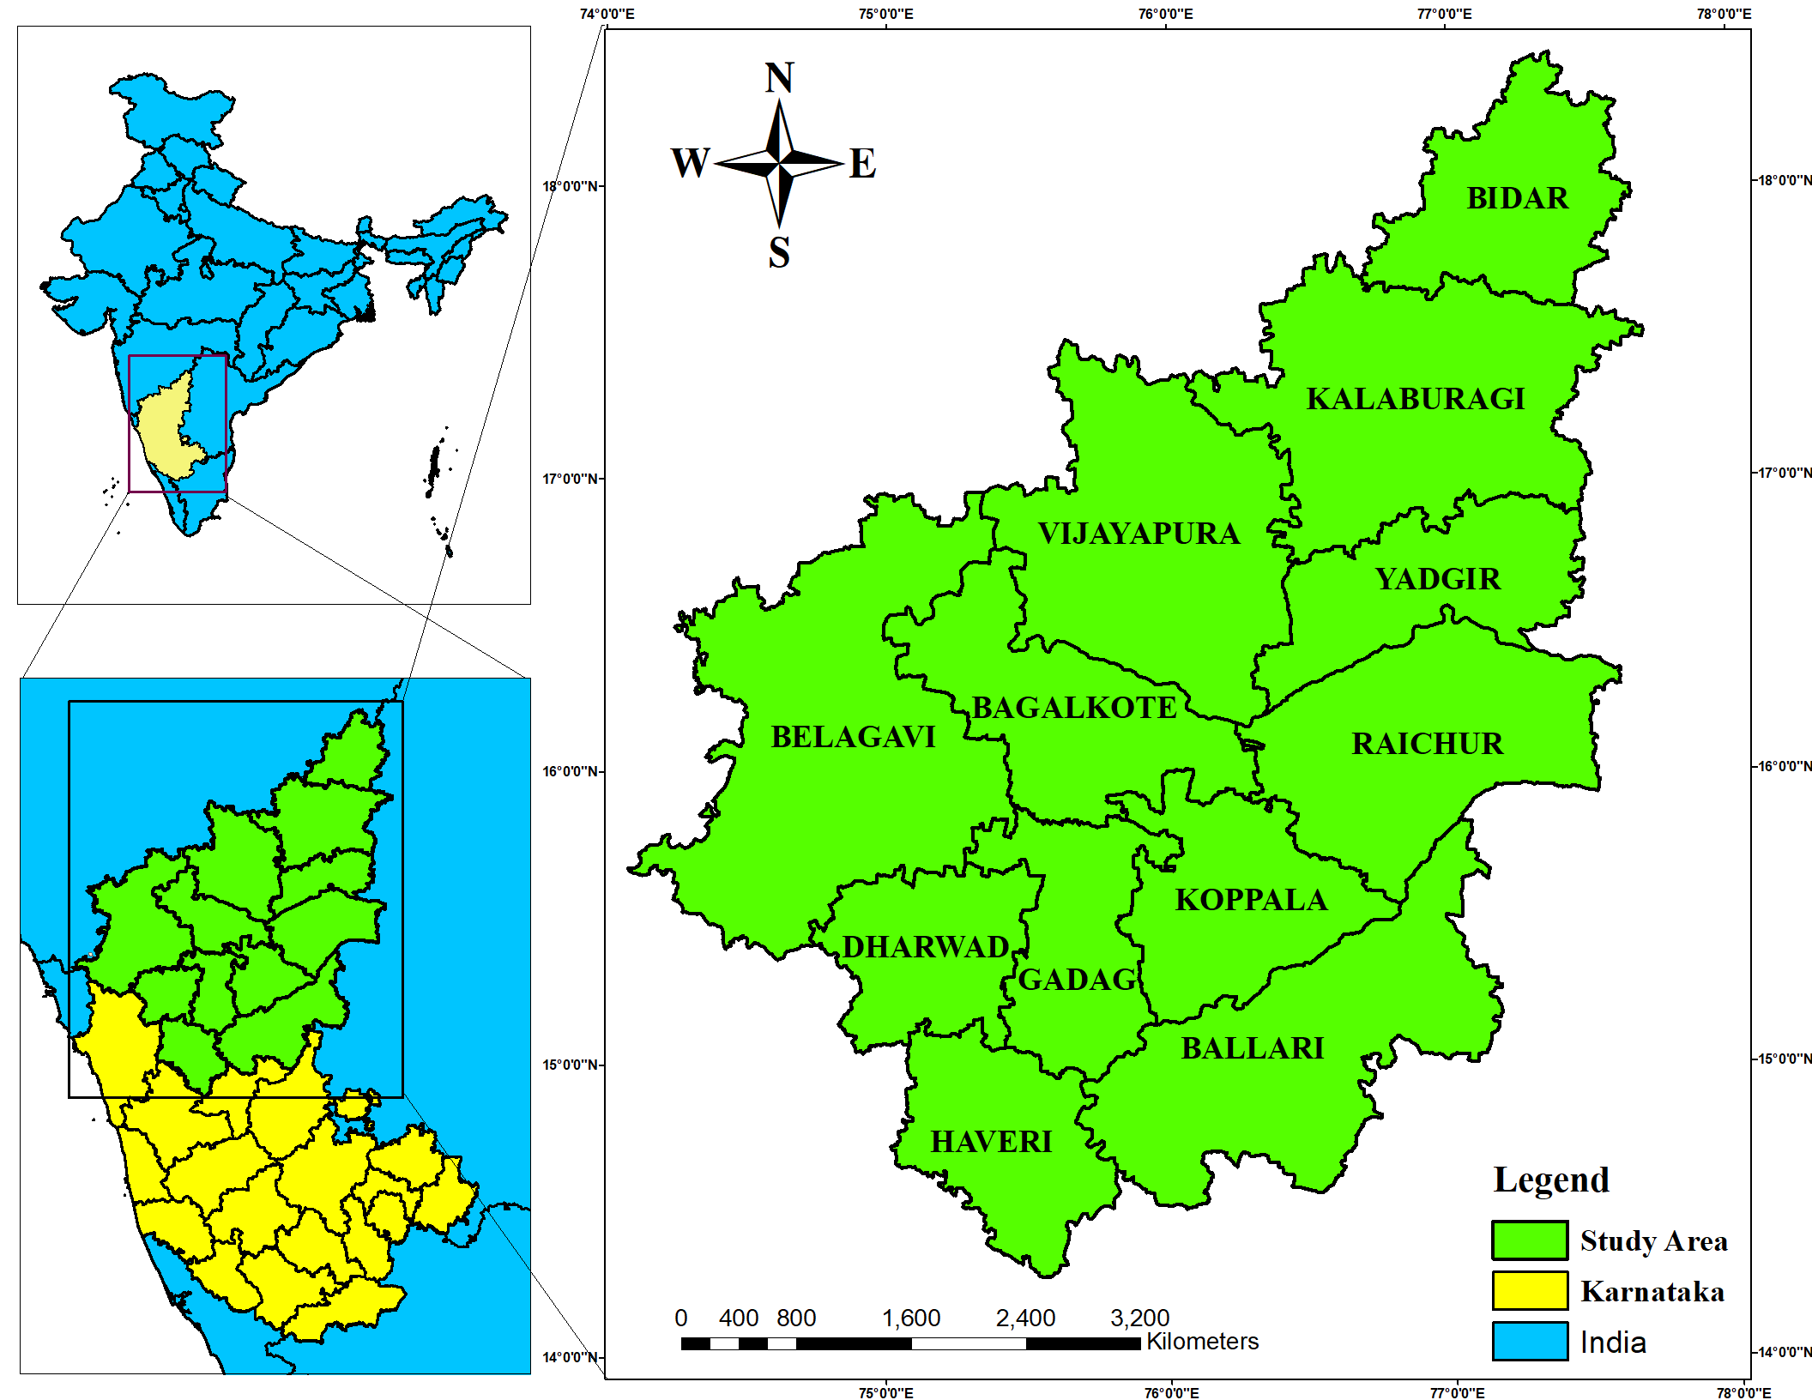

**Fig. 1: Spatial map of 12 districts of North Interior Karnataka**

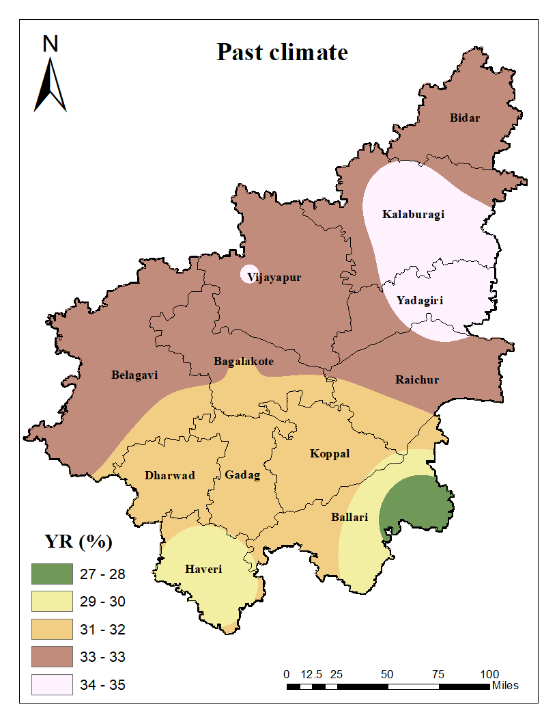 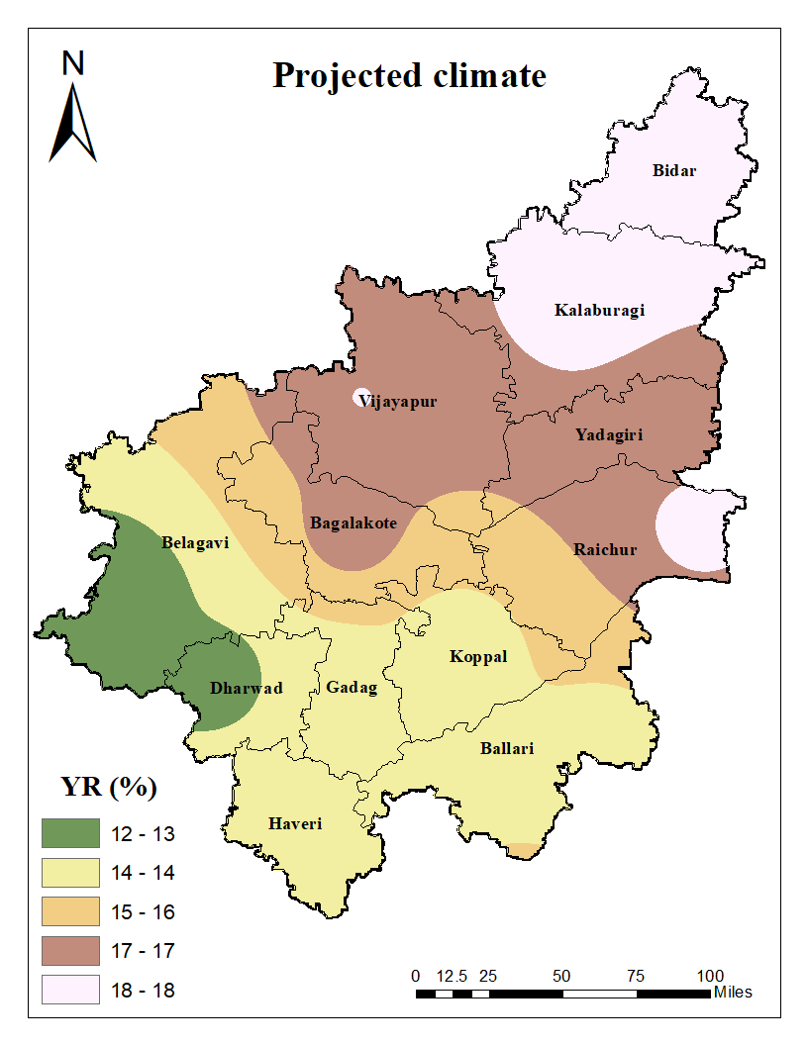

**Fig 2:** **Spatial distribution of yield reduction (YR) in chickpea simulated in black clay soil under past (1991-2020) and projected (2021-2050) climate for all districts of NIK**

**CONCLUSION**

The study for Northern Interior Karnataka revealed that the increased rainfall under projected climate during chickpea cropping period (October- February) compared to past climate. This increased rainfall resulted on the decreased number of irrigations and yield reduction. Early sowing of chickpea *i.e.,* on 1st October under projected climate (2021-2050) simulated the lowest number of irrigations i.e., one irrigation at 45 DAS (at flower initiation stage) and decreased yield reduction for all the 12 districts of NIK on *Vertisol*. In this context further research should to taken up on adaptability of pulses to the climate variability under the future climate for their sustenance and improved productivity.

**REFERENCES**

Ali, M. H., Adham, A. K. M., Rahman, M. M. and Islam, A. K. M. R. 2009. Sensitivity of Penman–Monteith estimates of reference evapotranspiration to errors in input climatic data. *J. Agrometeorol.,* **11**: 1-8.

Allen, R. G., Pereira, L. S., Raes, D. and Smith, M. 1998. Crop evapotranspiration-guidelines for computing crop water requirements- *FAO Irrigation and drainage paper 56*. FAO, Rome, **300(9)**: D05109.

Anonymous. 2016. Weather and climate of Karnataka. Karnataka.com, a tradition with technology.

Athnere, S and Kolage A. K. 2019. Effect of irrigation schedules and foliar application of potash on growth, yield and quality of summer green gram (*Vigna radiata* L.). M. Sc Thesis,MPKV Rahuri.

Banik, P., Tiwari, N. K. and Ranjan, S. 2014. Comparative crop water assessment using meteorological data and modeling techniques. *Glob. Sustainabil. Transit: Impacts and Innov.*, 168-180.

Bhat, S. A., Pandit, B. A., Khan, J. N., Kumar, R. and Jan, R. 2017. Water requirements and irrigation scheduling of maize crop using CROPWAT model. *Int. J. Curr. Microbio. Appl. Sci.*, **6(11)**: 1662-1670.

Boretti, A. and Rosa, L. 2019. Reassessing the projections of the world water development report. *NPJ Clean Water*, ***2*(1):** 15.

Caretta, M. A., Mukherji, A., Arfanuzzaman, M., Betts, R. A., Gelfan, A., Hirabayashi, Y., Lissner, T. K., J. Liu, E. Lopez Gunn, R. Morgan, S. Mwanga, and Supratid, S. 2022. Water. In: Climate Change 2022: Impacts, Adaptation and Vulnerability. Contribution of Working Group II to the Sixth Assessment Report of the Intergovernmental Panel on Climate Change [H.-O. Pörtner, D.C. Roberts, M. Tignor, E.S. Poloczanska, K. Mintenbeck, A. Alegría, M. Craig, S. Langsdorf, S. Löschke, V. Möller, A. Okem, B. Rama (eds.)]. Cambridge University Press, Cambridge, UK and New York, NY, USA, pp. 551–712, doi:10.1017/9781009325844.006.Desta, F., Bissa, M. and Korbu, L. 2015. Crop water requirement determination of chickpea in the central vertisol areas of Ethiopia using FAO CROPWAT model. Afr. J. Agric. Res., **10**: 685-689.

Fitton, N., Alexander, P., Arnell, N., Bajzelj, B., Calvin, K., Doelman, J., Gerber, J.S., Havlik, P., Hasegawa, T., Herrero, M. and Krisztin, T. 2019. The vulnerabilities of agricultural land and food production to future water scarcity. *Glob. Environ. Change,* ***58:*** 101944.

Food and Agriculture Organization of the United Nations. 2017. Water for sustainable food and agriculture: A report produced for the G20 presidency of Germany. *FAO*.

Gitz, V., Meybeck, A., Lipper, L., Young, C.D. and Braatz, S. 2016. Climate change and food security: risks and responses. *Food and Agriculture Organization of the United Nations (FAO) Report*, **110:** 2-4.

Hodson, D., and White, J. 2010. GIS and crop simulation modelling applications in climate change research. *Clim. Change Crop Prod.*, 245-262.

Sparks, A. H. 2018. nasapower: A NASA POWER Global Meteorology, Surface Solar Energy and Climatology Data Client for R. J. open source softw., **3(30):** 1035.

**Funding/Acknowledgement**

Authors duly acknowledge University of Agricultural, Dharwad, India for providing the facilities to conduct the research work.

## **Ethics statement**

## No specific permits were required for the described field studies because no human or animal subjects were involved in this research**.**

## **Consent for publication**

## All the authors agreed to publish the content.

**Conflict of interest**

The authors declare no known conflict of interests that could have appeared to influence the work reported in the present paper.

**Data availability**

The data presented in the present research paper is self-explanatory and for any further data accessibility do contact the corresponding author.

**Author’s contribution**

|  |  |  |
| --- | --- | --- |
| **Sl. No.** | **Name of the author** | **Contribution** |
| **1** | **Hemareddy Thimmareddy** | Conceptualization, Investigation, Data curation and writing first draft |
| **2** | **MAHANTESH B. NAGANGOUDAR** | Guidance, Review and editing |
| **3** | **PUGAZENTHI. K** | Guidance and overview |
| **4.** | **SENBAGAVALLI. G** | Guidance and overview |
| **5.** | **PRIYANKA. P** | Review and editing and plagiarism |