RESEARCH ARTICLE
Taxonomic Identification of Predators and Parasitoids Associated with the Invasive Whitefly Complex on the Cotton Ecosystem of Tamil Nadu

ABSTRACT
Native predators and parasitoids were identified against the invasive whiteflies in the cotton ecosystem. The natural enemies identified include Cheilomenes sexmaculata, Chrysoperla carnea, Diadiplosis sp, Orius insidiosus, two coleopteran beetles, Cybocephalus nipponicus, Delphastus catalinae and two species of Aphelinidae parasitoids, Encarsia guadeloupae and Encarsia dispersa. E.dispersa can be distinguished from E. guadeloupae by a combination of characters including body colour, colour of the meso-scutellar suture, antennal segments, tarsal formula, etc. Descriptions of other predators, viz., coccinellid, chrysopid, etc. Are also furnished.

Keywords: Cotton; Natural enemies; Predators; Parasitoids; Whitefly complex

INTRODUCTION
Cotton is the world's most important cash crop and commonly known as "white gold". Cotton is grown in more than 70 different countries throughout the world. In India, there are 443 whiteflies split into 64 genera that live on a broad variety of agricultural, horticultural, and forestry crop plants (Sundararaj and Selvaraj, 2017). Among them, some species are economically significant pests. In India, the whitefly has emerged as a major problem in terms of sucking pests because it is a carrier of the cotton leaf curl virus, which reduces seed cotton yields by up to 92.2 percent (Balakrishnan et al., 2009; Singh et al., 2013). There are four species of whiteflies associated with the cotton ecosystem, viz., B. tabaci, A. dispersus, A. rugioperculatus and P. bondari. The common whitefly, B. tabaci Gennadius is an important pest in the agricultural and horticultural ecosystems, causing direct and indirect damage (Jones, 2003). In Greece, it was first identified as a tobacco pest in 1889. Spiralling whitefly, A. dispersus Russell is indigenous to the Caribbean islands and Central America which made its way to India, most likely via Sri Lanka. In India, it was the first damage record for cassava in 1993. The rugose spiralling whitefly, A. rugioperculatus Martin, is native to Belize and was introduced to coconut palms in Pollachi (Tamil Nadu) and Palakkad (Kerala). The invasive Bondar's Nesting Whitefly (BNW), P. bondari Peracchi (Hemiptera: Aleyrodidae), was first recorded in India in 2021 on cotton in Tamil Nadu (Sadhana et al., 2021). A total of 48 natural enemies attacking 17 species of aleyrodids were discovered. Previously, all of these whitefly species were identified in southern Anatolia (Ulusoy and Ülgentürk, 2003). The whitefly is reported to have 62 natural enemies in various nations, including eight parasitoids, 53 predators and one fungal pathogen (Mani and Krishnamoorthy, 2002). Predators and parasitoids can help control whitefly infestations. Aphelinids of the genera Encarsia sp and Eretmocerus sp (Hymenoptera: Aphelinidae) are the most prevalent parasitoids of B. tabaci (Polaszek et al., 2004). Numerous species from these two genera have been proposed as biocontrol agents for B. tabaci (Gennadius) in crops (Goolsby et al., 1998). Various indigenous predators have been observed feeding on A. rugioperculatus and A. dispersus. Pseudomallada sp. (Neuroptera: Chrysopidae), Cybocephalus sp. (Coleoptera: Cybocephalidae), Diadiplosis sp. (Diptera: Cecidomyiidae), and Jauravia pallidula Motschulsky were the most abundant and active predators (Coleoptera: Coccinellidae). Numerous coccinellid predators were also spotted on whitefly-infested bananas and coconuts, including Cryptolaemus montrouzieri Mulsant, Chilocorus nigrita (F.), Sasajiscymnus dwipakalpa (Ghorpade), Scymnus saciformis Motschulsky, and Scymnus nubilus (Ramani et al., 2002). According to Elango and Jeyarajan Nelson (2020) one Aphelinid parasitoid, E. guadeloupae, as well as three predators, Mallada desjardinsi, Chrysoperla zastrowi sillemi, and C. montrouzieri, were found in large numbers, voraciously feeding on RSW and suppressing the population. The invasive whiteflies, P. bondari and A. rugioperculatus are the first identified in the cotton ecosystem associated with predators and parsitoids. This was identified based on morphological characters in this research paper.

MATERIAL AND METHODS
The natural enemy relationship with the whitefly complex was studied in the cotton ecosystem. Generally, the whitefly puparium is transparent yellow in colour. However, parasitized whitefly pupae are identified by their blackish brown colour. At that stage, parasitized whitefly pupae were protected by clip cages in the field until the emergence of parasitoids. Following the appearance of parasitoids with a circular exit hole on the last abdominal segments of the pseudo-pupa's fourth stage, the adult parasitoids were collected and stored in 70% ethyl alcohol. Then the predators were carded in insect boxes with labels for further identification.

RESULTS AND DISCUSSION
Natural enemies associated with whitefly species
Totally, eight natural enemies were identified in cotton ecosystems, viz., , C. sexmaculata (Coccinellidae: Colepoptera), C. carnea (Chrysopidae: Neuroptera), Diadiplosis sp, (Cecidomyiidae: Diptera), O. insidiosus (Anthocoridae: Hemiptera), C.nipponicus (Family? : Coleoptera) and D. catalinae (Family: Order) and E. guadeloupae and E. dispersa (Aphelinidae: Hymenoptera). Generally, the whitefly puparium is transparent yellow in colour. But parasitized whitefly pupae are identified by their blackish brown colour with a circular exit hole on the last abdominal segments of the whitefly complex, viz., B. tabaci, A. dispersus, A. rugioperculatus and P. bondari (Fig 1 a-d).
Taxonomic identification of predators and parasitoids
Key to the species of the family Aphelinidae parasitoids (Order: Hymenoptera)
- Dark brown head and gaster, pedicel, Flagellar segment (F1) and F2 usually subequal in length; gaster segments TII – TIV each at least 1+1 setae, usually more…………………………………..………………………………Encarsia guadeloupae Viggiani (Fig 2 a-d)
- Pale yellow head and gaster; F1 shorter than pedicel and F2, gaster segments TII – TIV each with 1+1 setae ……………………………………………..…………….….Encarsia dispersa Polaszek (Fig 2 a-d)
Key to the species of family Coccinellidae predator (Order: Coleoptera)
- Six-spotted zigzag marking on elytra, 3mm in body length, yellow to canary yellow body colour, convexed body, larvae have a mandibulo-suctorial mouth parts and urogomphi present in larvae’s last abdominal segment ………………………………………………….Cheilomenes sexmaculata (Fig 3 a-c)
Key to the predator species in the family Chrysopidae (Order: Neuroptera)
- Larval head capsule markings were dominated by a pair of longitudinal, dorso-lateral brown stripes with baso-lateral expansions extending toward the eyes, larvae of full body are lengthwise lines or rows of spots that are light brown, flattened with distinct legs, tubelike mouthparts that curve inwards and pair of pincer-like mandibles …………………...…………….Chrysoperla carnea (Fig 4 a-c)
Key to the predator family Cecidomyiidae (Order: Diptera)
- Body cylindrical, integument smooth, with the exception of a thin terminal segment,head with elongated antenna, short styliform mandible,spatula absent, six dorsal papillae with long setae present on all thoracic and abdominal segments…………..………………...….Diadiplosis sp (Fig 5 a-b)
Key to the predatory species of family Cybocephalidae (Order: Coleoptera)
1. Adults have a 4-4-4 tarsal formula, body is shiny brown to black with convex and rounded edges,
larvae have a head without dorsal sutures, larvae are covered with minute hairs, in the 9th
abdominal tergite and there are no urogomphi……………………...Cybocephalus nipponicus (Fig 6 a-b)
- Adults are very tiny, their bodies are brown to blackish colour and the heads female has a black in colour, while males have an orange head. Larvae are elongated, cream in colour, covered with short fine hairs and have a conspicuous leg...……………………...…Delphastus catalinae (Fig 6 c-d)
Key to the species of family Anthocoridae predator (Order: Hemiptera)
- Forewings are hemelytra, they areblack with white patches on the wings, the wing membrane is white and the base of the wings is brown and mouth parts are pierced……….………..…………………………………………………………………..............Orius insidiosus (Fig 7 a)
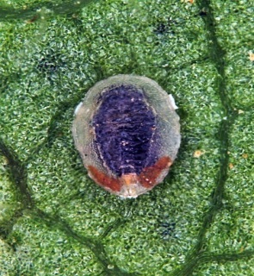 | 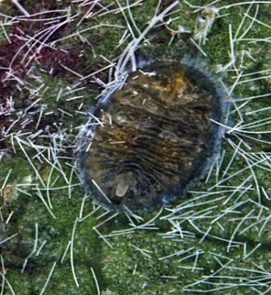 | 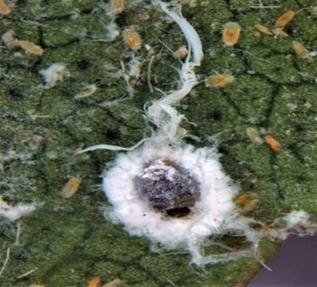 | 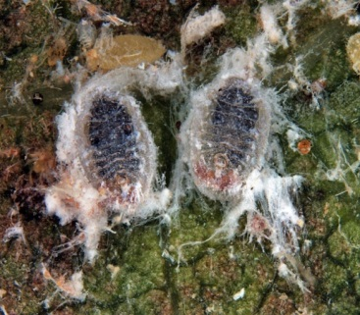
Figure 1 (a-d) Parasitized whitefly pupae on cotton leaves (a) Bemisia tabaci parasitized by Encarsia sp (b) Parasitized Paraleyrodes bondari pupa (c) Encarsia sp emerged from Aleurodicus dispersus pupa (d) Parasitized Aleurodicus rugioperculatus pupae

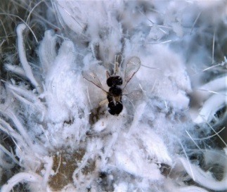 | 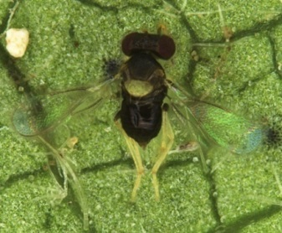 | 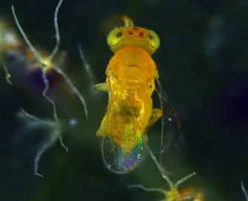 | 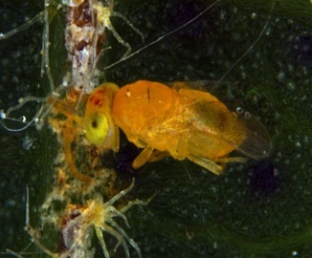
Figure 2 (a-d) Adult stages of E. guadeloupae and E. dispersa
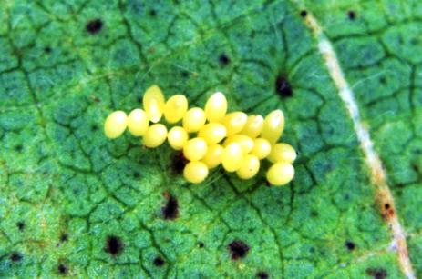 | 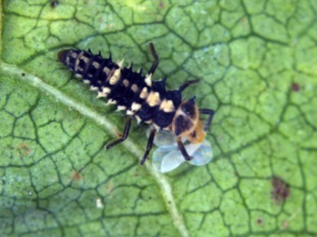 | 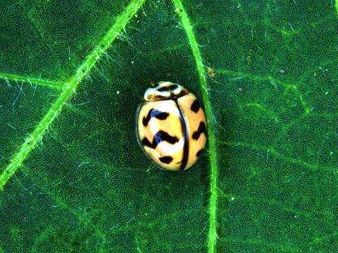
Figure 3 (a-c) Life cycle of Cheilomenes sexmaculata (a) Egg (b) Grub (c) Adult

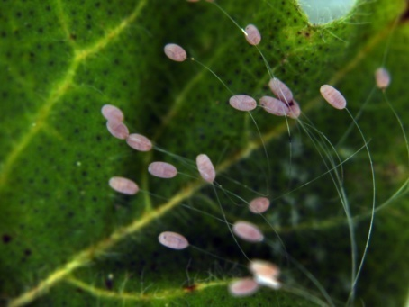 | 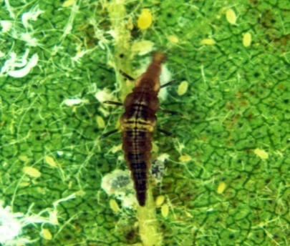 | 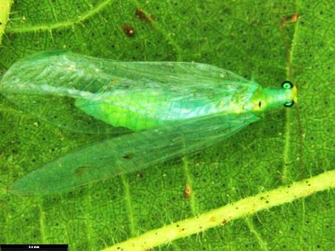
Figure 4 (a-c) Life cycle of Chrysoperla carnea (a) Egg (b) Grub (c) Adult

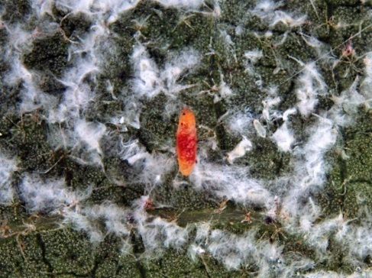 | 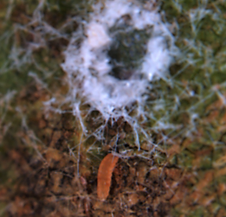 | 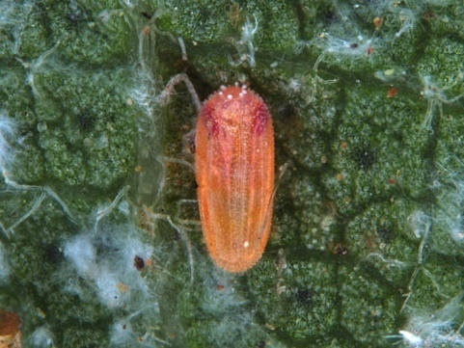
Figure 5 (a-b) Life cycle of Diadiplosis sp. (a) Larva (b) Larva feeding on eggs (c) Pupa

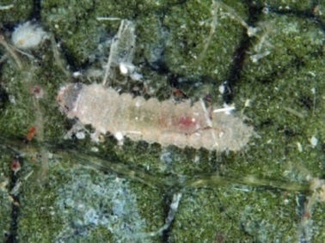 | 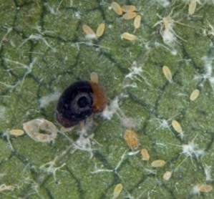 | 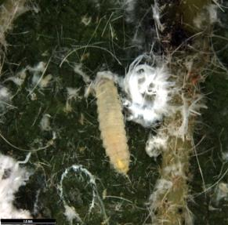 | 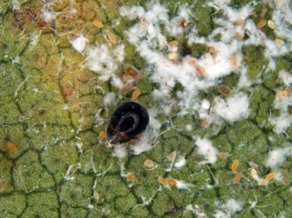
Figure 6 (a-b) Life cycle of Cybocephalus nipponicus and (c-d) Life cycle of Delphastus pusilus
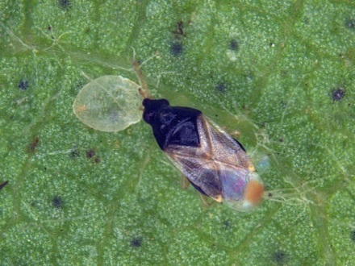
Figure 7 (a) Orius insidiosus feeding on whitefly pupa

CONCLUSION
Encarsia guadeloupae was found to be parasitoida against A. rugioperculatus. This was supported by Ramani et al. (2002) as a well-known parasitoid of A. dispersus. In addition, C. sexmaculata preferred the nymphs of B. tabaci and A. dispersus, which were regularly noticed in our study. The same research findings are confirmed by Atuncha et al. (2013). In our study, we observed that C. carnea consumed nymphal and adult stages of the whiteflies, as was confirmed by Klien et al. (1996). E. dispersa has been recorded as a parasitioid against this spiralling whitefly, A. dispersus (Poorani and Thanigairaj, 2017; Selvaraj et al., 2017). Cybocephalus sp. (Coleoptera: Cybocephalidae) and Diadiplosis sp. (Diptera: Cecidomyiidae) were found to be the most abundant and active predators on whitefly nymphs in this study. Ramani et al. (2002) also observed similar reports, which supports our findings.

Funding and Acknowledgment
I have not received any fund for research.

Ethics statement
There was no Human Participants and/or Animals included in this research.

Consent for publication

All the authors agreed to publish the content.

Competing interests
The authors, Sadhana V, Senguttuvan K and Murugan M of the research article entitled “Taxonomical Identification of Predators and Parasitoids Associated with Invasive Whitefly Complex on Cotton Ecosystem of Tamil Nadu” declared that they have no conflict of interest in the publication of this content

Author contributions
Experiments - Sadhana V, Writing- reviewing &editing - Senguttuvan K, Guidance - Murugan M

REFERENCES
Atuncha, H., Ateka, E., Amata, R., Mwirichia, R., Kasina, M., Mbevi B. and E. Wakoli. 2013. Evaluation of
predation potential of coccinellids on cassava whiteflies. J. Entomol. Nemato., 5(7): 84-87.
Balakrishnan, N., Kumar, B.V. and P. Sivasubramanian. 2009. Bioefficacy of bifenthrin 10 EC against
sucking insects, bollworms and natural enemies in cotton. Madras Agric. J., 96(1/6): 225-229.
Elango, K. and S. Jeyarajan Nelson. 2020. Population dynamics of exotic rugose spiralling whitefly,
Aleurodicus rugioperculatus Martin (Hemiptera: Aleyrodidae) on coconut as influenced by weather factors and natural enemies. J. Plant Crops., 48(2): 120-125
Goolsby, J.A., Ciomperlik, M.A., Legaspi B.C., Legaspi, J. C. and L. E. Wendel. 1998. Laboratory and Field
Evaluation of Exotic Parasitoids of Bemisia tabaci (Gennadius) (Biotype “B”) (Homoptera: A leyrodidae) in the Lower Rio Grande Valley of Texas. Biol. Control., 12 (2): 127-135.
Jones, D.R. 2003. Plant viruses transmitted by whiteflies. E. J. Plant Pathol., 109 (3): 195-219.
Klingen, I., Johansen, N.S. and T. Hofsvang. 1996. The predation of Chrysoperla carnea (Neurop.,
Chrysopidae) on eggs and larvae of Mamestra brassicae (Lep., Noctuidae). J. Appl. Entomol., 120 (1-5): 363-367.
Mani, M., and A. Krishnamoorthy. 2002. Classical Biological Control of the Spiralling whitefly, Aleurodicus
dispersus Russell—An Appraisal. Int. J. Trop. Insect Sci., 22 (4): 263-273.
Polaszek, A., Manzari, S. and D.L. Quicke. 2004. Morphological and molecular taxonomic analysis of
the Encarsia meritoria species‐complex (Hymenoptera, Aphelinidae), parasitoids of whiteflies (Hemiptera, Aleyrodidae) of economic importance. Zool. Scr., 33(5): 403-421.
Poorani, J., and R. Thanigairaj. 2017. First report of Encarsia dispersa Polaszek (Hymenoptera:
Aphelinidae) as a parasitoid of rugose spiralling whitefly, Aleurodicus rugioperculatus Martin (Hemiptera: Aleyrodidae), a recent invasive pest in India, with notes on its predators. Biol. Control., 31 (1): 1-4.
Ramani, S., Poorani, J. and B. S. Bhumannavar. 2002. Spiralling whitefly, Aleurodicus dispersus in India.
Biocontrol News Information., 23 (2): 55-62.
Sadhana, V., Senguttuvan, K., Murugan, M., Manikanda Boopathi, N. and N. Sathiah. 2021. First record of
Bondar's nesting whitefly, Paraleyrodes bondari Peracchi (Hemiptera: Aleyrodidae), occurrence
and infestation in the cotton ecosystem of Tamil Nadu, India. J. Pharm. Innov., 10(10S): 1278-
1284.
Selvaraj, K., Sundararaj, R., Venkatesan, T., Chandish, R., Ballal, S.K. and H. K. Mrudula. 2017. Potential
natural enemies of the invasive rugose spiraling whitefly, Aleurodicus rugioperculatus Martin in India. Biol. Control., 30(4): 236-239.
Singh, D., Gill, J.S., Gumber, R.K., Ramandeep S. and S. Satnam. 2013. Yield and fibre quality associated
with cotton leaf curl disease of Bt-cotton in Punjab. J. Env.Biol., 34 (1): 56-113.
Ulusoy, M. and S. Ülgentürk. 2003. The natural enemies of whiteflies (Hemiptera: Aleyrodidae) in southern
Anatolia. Zoology in the Middle East 28 (1): 119-124.
Zhou, H., Wu, W.J., Niu, L.M. and Y.G. Fu. 2013. Antennal sensilla of female Encarsia guadeloupae
Viggiani (Hymenoptera: Aphelinidae), a nymphal parasitoid of the spiraling whitefly Aleurodicus dispersus (Hemiptera: Aleyrodidae). Micron., 44: 365-372.

