RESEARCH ARTICLE
Studies on Compatibility of Metarhizium anisopliae with Insecticides

ABSTRACT
The results on compatibility of M. anisopliae (isolate TNAU-MA-GDU) with various insecticides at five different doses (0.1x, x, 2x, 5x and 10x) revealed that, highest mycelial growth was observed in flubendamide 480 SC (89.00 to 78.8 mm) and spinetoram 11.70 SC (89.00 to 76.60 mm) and was significantly superior over rest of the insecticides tested. The minimum growth of M. anisopliae was observed in insecticidal treatment with azadirachtin (Neem 1500) (65.2 to 18.2 mm) followed by novaluron 10 EC (86.6 to 42.1 mm). All the tested insecticides except azadirachtin (Neem 1500) were compatible with M. anisopliae (TNAU-MA-GDU) at lower and field doses. The results on compatibility of insecticides with M. anisopliae clearly indicates that, the pesticides having better compatibility exhibited the maximum mycelial growth, sporulation and biomass production and were in the following order in terms of their compatibility. Flubendiamide 480 SC > spinetoram 11.70 SC > emamectin benzoate 5 SG > chlorantraniliprole 18.5 SC > novaluron 10 EC > azadirachtin (Neem 1500).
Keywords: Metarhizium anisopliae, Insecticides, Compatibility, Vegetative growth, T value,

INTRODUCTION
Insecticides have different effects on the fungal growth, sporulation and germination of entomopathogenic fungi depending on the fungal species (Schumacher and Poehling, 2012). The combination of low doses of insecticides and entomopathogenic fungi is the added advantage in IPM practices as it minimises the insecticides use, reduces environmental pollution and weakens resistance in insect pests (Sain et al., 2019). An effective control of insect pests can be achieved by using a combination of entomopathogenic fungi and insecticides (Oliveira et al., 2003; Purwar and Sachan, 2006; Asi et al., 2010). Conversely, the usage of non-selective or incompatible insecticides with entomopathogenic fungus may potentially prevent the fungal growth and development, resulting in failure of IPM. The knowledge on the compatibility between entomopathogenic fungus and pesticides is essential to choose appropriate chemicals and to decide on the timing of treatments to prevent harmful effects of insecticides on entomopathogenic fungi in integrated pest management programmes (Silva et al., 2013). Hence, the present investigation was carried out to study the interaction of entomopathogenic fungi, M. anisopliae and insecticides under laboratory conditions.

MATERIAL AND METHODS
The investigation on compatibility of Metarhizium anisopliae with insecticides were carried out in Insect pathology laboratory, Department of Agricultural Entomology, Tamil Nadu Agricultural University, Coimbatore, during 2020-2021.
Source of fungal isolate
Metarhizium anisopliae (TNAU-MA-GDU) that was found to be highly virulent against Fall armyworm (FAW), Spodoptera frugiperda (J. E. Smith) was tested for its compatibility with the insecticides recommended for the management of FAW under laboratory conditions.
Details of insecticides and their doses used in compatibility studies
Common Name | Trade Name | Dose (X) (ml L⁻¹ or g L⁻¹)
Common Name | Trade Name | 0.1X | X | 2X | 5X | 10X
Chlorantraniliprole | Coragen 18.5 SC | 0.04 | 0.4 | 0.8 | 2.0 | 4
Flubendiamide | Fame 480 SC | 0.05 | 0.5 | 1.0 | 2.5 | 5
Azadirachtin | Neem 1500 | 0.5 | 5.0 | 10 | 25 | 50
Emamectin benzoate | Proclaim 5 SG | 0.04 | 0.4 | 0.8 | 2.0 | 4
Novaluron | Rimon 10 EC | 0.15 | 1.5 | 3.0 | 7.5 | 15
Spinetoram | Delegate 11.70 SC | 0.05 | 0.5 | 1.0 | 2.5 | 5

Food poison technique
The effect of insecticides on M. anisopliae (TNAU-MA-GDU) was assessed by following the poisoned food technique adopted by Neves et al. (2001). The insecticides at required concentrations (0.1X, X, 2X, 5X and 10X) were added to the sterilized Potato dextrose agar (PDA) medium before solidification and poured into the Petri plates (90 mm diameter) after proper agitation and allowed to solidify. Using sterilized cork borer, 5mm discs were cut from 7 days old selected EPF and transferred to the centre of each plate containing poisoned medium. Untreated check was maintained by placing fungal disc in medium without poison for comparison. The plates were incubated at 25 ± 1ºC for 15 days to allow maximum fungal growth. Each treatment consisted of three replications. The diameter of the fungal culture in each plate was measured on 15th day using a ruler (average of two measurements made at right angles). Fully sporulated cultures were used to determine the spore count using Neubauer haemocytometer. The observations on vegetative growth and sporulation were transformed relative to the control (100) and the product’s toxicity (T) value was calculated as per the following formula,
T = [20(VG) + 80(SP)] / 100
VG - Vegetative growth; SP - Sporulation
Where, T: 0 to 30 = very toxic; 31 to 45 = toxic; 46 to 60 = moderately toxic; > 60 = compatible.
Effect of insecticides on biomass production of M. anisopliae (TNAU-MA-GDU)
For assessment of biomass (dry weight of mycelium), potato dextrose broths (PDB) (media without agar) were prepared. Test concentrations of the insecticides (0.1X, X, 2X, 5X and 10X) were mixed with 100 ml of sterilized PDB broth separately and five mm mycelial disc of 10 days old selected fungal culture was inoculated to the broth with the help of cork-borer and the flasks were incubated at 25 ± 1ºC. The broth culture after 15 days of fungus seeding was filtered through muslin cloth and the mat collected on pre-weighed filter paper was dried at 105º C for 12 h and then reweighed. Untreated check was maintained by placing fungal disc in PDB broth without poison for comparison. Each treatment was replicated three times. The difference between the final and initial weight was considered as dry weight of mycelium (Akbar et al., 2012).
Data Analysis
All the experiments were conducted under Completely Randomized Block Design (CRBD). The data obtained in experiments were transformed to square root (X+0.5) transformation and the analysis of variance in different experiments was carried out in AGRES package and the means were separated by least significant difference (LSD).

RESULTS AND DISCUSSION
Effect of insecticides on vegetative growth and sporulation of M. anisopliae (TNAU-MA-GDU)
All the tested insecticides viz., chlorantraniliprole, flubendamide, azadirachtin, emamectin benzoate, novaluron and spinetoram tested showed significant variation in the vegetative growth and sporulation of M. anisopliae (TNAU-MA-GDU) (Table 1 and Fig. 1). Based on the product toxicity “T” value, the insecticides were classified into four different categories viz., very toxic, toxic, moderately toxic and compatible. The isolate, M. anisopliae (TNAU-MA-GDU) was found to be relatively compatible with all the tested insecticides except Azadirachtin at 0.1 x and x doses based on the T value. The highest vegetative growth (89.0, 88.4, 86.9, 82.5 and 78.8 mm respectively) and spore count (13.3, 12.8, 10.4, 8.7 and 5.8 × 10⁷ spores mL⁻¹ respectively) of TNAU-MA-GDU isolate was recorded in flubendiamide at 0.1x, x, 2x, 5x and 10x doses followed by spinetoram that recorded the maximum vegetative growth (89.90, 88.1, 86.2, 81.4 and 76.6 mm) and spore count (12.2, 11.9, 9.8, 8.2 and 5.5 × 10⁷ spores mL⁻¹).
All the other insecticides ranged between moderately toxic to toxic based on the “T” value at both two-fold higher (2x) and five-fold higher (5x) doses. At ten-fold higher dose (10x), flubendiamide and spinetoram were found to be moderately toxic with a vegetative growth of 48.0 and 46.3 mm and spore count of 5.8 and 5.5 × 10⁷ spores mL⁻¹ whereas, emamectin benzoate was found to be toxic with vegetative growth and spore count of 32.8 mm and 4.1× 10⁷ spores mL⁻¹. Azadirachtin was highly toxic to TNAU-MA-GDU isolate at all the test doses with a T value ranging from 43.4 to 4.00.
Effect of insecticides on biomass production of M. anisopliae (TNAU-MA-GDU)
Influence of different insecticides on biomass production of M. anisopliae isolate (TNAU-MA-GDU) was assessed using PD broth and the results showed that there was significant difference in biomass production among the insecticides amended broth (Table 2 and Fig. 2). The maximum dry weight of the mycelium was recorded in flubendamide treated broth at all the five doses (5.22, 4.97, 4.76, 4.48 and 3.17 g respectively) next to control. This was followed by spinetoram with a biomass production of 5.07, 4.82, 4.51, 4.25 and 3.04 g at lower dose (0.1x), recommended dose (x), two-fold (2x), five-fold (5x), ten-fold and higher dose (10x), respectively and emamectin benzoate recorded 4.77, 4.48, 4.23, 4.07 and 2.92 g in all the five test doses, respectively. Chlorantraniliprole and novaluron recorded the dry weight ranging from 4.46 to 2.18 and 4.18 to 1.91g at lower to higher dose. However, azadirachtin recorded the least dry weight (0.10 to 3.34g) than other insecticides with zero growth at 10x dose.
Current investigations on the interaction effect of M. anisopliae (TNAU-MA-GDU) with insecticides indicated that flubendiamide, spinetoram, emamectin benzoate, chlorantraniliprole and novaluron had synergistic activity at lower and field doses with less effect on vegetative growth, sporulation and biomass production, whereas, azadirachtin had antagonistic effect at all test doses. In contrast, Amutha and Banu (2012) reported that neem-based formulation, eco neem (Azadirachtin 3%) was hazardless to M. anisopliae. The contradictions could be due to the quality of neem as influenced by the extraction method and fungus strains used in the study.
Earlier, Akbar et al. (2012) also reported that spinetoram and emamectin benzoate were compatible at tested field doses with minimum inhibition on the growth and sporulation of M. anisopliae isolates (M2 and M11). In another study, the insecticides viz., emamectin benzoate, chlorantraniliprole and novaluron were found to be safer to entomopathogenic fungi with good colony growth and germination percentage (Joshi et al., 2018). Similarly, Parjane et al. (2018) investigated the potential inhibitory effects of 19 pesticides on the growth of M. anisopliae and found that the highest vegetative growth of fungus was observed in flubendamide, chlorantraniliprole and emamectin benzoate which is in agreement with the present results. Another study made by Tekam et al. (2018) also showed that new generation insecticides viz., emamectin benzoate and flubendiamide were compatible with M. anisopliae with least inhibition of 35.24, 37.11 and 39.50 percentage. Similarly, Matcha et al. (2021) also found that M. rileyi was compatible with chlorantraniliprole, flubendamide, spinetoram and emamectin benzoate with a spore yield of 2.7, 1.17, 0.9 and 0.26 × 10⁸ spores mL ⁻¹ which is in line with the present findings.

Table 1. Compatibility of M. anisopliae (TNAU-MA-GDU) with insecticides
Treatment# | 0.1 X |  |  | X |  |  | 2X |  |  | 5X |  |  | 10X
Treatment# | VG | SP | T Value* | VG | SP | T Value* | VG | SP | T Value* | VG | SP | T Value* | VG | SP | T Value*
Chlorantraniliprole | 87.3  (97.0) | 10.6  (69.7) | 75.2  (D) | 85.5  (95.0) | 10.1  (66.5) | 72.2  (D) | 81.5  (90.6) | 8.9  (58.6) | 64.9  (D) | 52.1  (57.9) | 4.3  (28.3) | 34.2  (B) | 45.2  (50.2) | 1.1  (7.2) | 15.8  (A)
Flubendiamide | 89.0  (98.8) | 13.3  (87.5) | 89.8  (D) | 88.4  (98.2) | 12.8  (84.2) | 87.0  (D) | 86.9  (96.6) | 10.4  (68.4) | 74.1  (D) | 82.5  (91.7) | 8.7  (57.2) | 64.1  (D) | 78.8  (87.6) | 5.8  (38.2) | 48.0  (C)
Azadirachtin | 65.2  (72.4) | 5.5  (36.2) | 43.4  (B) | 64.0  (71.1) | 5.2  (34.2) | 41.6  (B) | 59.0  (65.6) | 4.8  (31.6) | 38.4  (B) | 35.2  (39.1) | 0.2  (1.3) | 8.9  (A) | 18.2  (20.2) | 0.0  (0.0) | 4.0  (A)
Emamectin benzoate | 86.0  (95.5) | 11.9  (78.3) | 81.7  (D) | 85.2  (94.7) | 11.2  (73.7) | 77.9  (D) | 83.0  (92.2) | 9.1  (59.9) | 66.3  (D) | 56.9  (63.2) | 7.9  (51.9) | 54.2  (C) | 50.7  (56.3) | 4.1  (26.9) | 32.8  (B)
Novaluron | 86.6  (96.2) | 9.5  (62.5) | 69.2  (D) | 84.0  (93.3) | 9.1  (59.9) | 66.6  (D) | 80.3  (89.2) | 7.8  (51.3) | 58.9  (C) | 49.3  (54.8) | 3.9  (25.7) | 31.5  (B) | 42.1  (46.8) | 0.8  (5.3) | 13.6  (A)
Spinetoram | 89.0  (98.8) | 12.2  (80.3) | 83.9  (D) | 88.1  (97.9) | 11.9  (78.3) | 82.2  (D) | 86.2  (95.8) | 9.8  (64.5) | 70.7  (D) | 81.4  (90.4) | 8.2  (53.9) | 61.2  (D) | 76.6  (86.6) | 5.5  (36.1) | 46.3  (C)
Untreated control | 90.0  (100) | 15.2  (100) | - | 90.0  (100) | 15.2  (100) | - | 90.0  (100) | 15.2  (100) | - | 90.0  (100) | 15.2  (100) | - | 90.0  (100) | 15.2  (100) | -
X- Recommended field dose (Chlorantraniliprole- 0.4 ml L⁻¹; Flubendiamide- 0.5 ml L⁻¹; Azadirachtin- 5 ml L⁻¹; Emamectin benzoate- 0.4 g L⁻¹; Novaluron- 1.5 ml L⁻¹; Spinetoram- 0.5 ml L⁻¹). #Mean of three replications
VG- Vegetative growth (mm), SP- Sporulation (× 10⁷ spores mL⁻¹)
Values in parentheses are values relative to control (100 %)
*Classification based on formula T= (20VG+80SP)/100; A- Very Toxic, B- Toxic, C- Moderately toxic, D- Compatible
.
Table 2. Effect of insecticides on biomass production of M. anisopliae (TNAU- MA-GDU)

Treatment# | Biomass* (g)
Treatment# | 0.1 X | X | 2X | 5X | 10X
Chlorantraniliprole | 4.46  (2.11)^{d} | 4.15  (2.04)^{d} | 3.99  (2.00)^{e} | 3.27  (1.81)^{e} | 2.18  (1.48)^{d}
Flubendiamide | 5.22  (2.28)^{ab} | 4.97  (2.23)^{b} | 4.76  (2.18)^{b} | 4.48  (2.12)^{b} | 3.17  (1.78)^{b}
Azadirachtin | 3.34  (1.83)^{f} | 3.10  (1.76)^{f} | 2.92  (1.71)^{g} | 0.10  (0.32)^{g} | 0.00  (0.71s)^{f}
Emamectin benzoate | 4.77  (2.18)^{c} | 4.48  (2.12)^{c} | 4.23  (2.06)^{d} | 4.07  (2.02)^{d} | 2.92  (1.71)^{c}
Novaluron | 4.18  (2.04)^{e} | 3.94  (1.98)^{e} | 3.44  (1.85)^{f} | 2.98  (1.73)^{f} | 1.91  (1.38)^{e}
Spinetoram | 5.07  (2.25)^{b} | 4.82  (2.20)^{b} | 4.51  (2.12)^{c} | 4.25  (2.06)^{c} | 3.04  (1.74)^{bc}
Untreated control | 5.49  (2.34)ª | 5.49  (2.34)ª | 5.49  (2.34)ª | 5.49  (2.34)ª | 5.49  (2.34)ª
SEd | 0.0278 | 0.0185 | 0.0150 | 0.0188 | 0.0185
CD (0.05) | 0.0596 | 0.0397 | 0.0321 | 0.0403 | 0.0397

X- Recommended field dose (Chlorantraniliprole- 0.4 ml L⁻¹; Flubendiamide- 0.5 ml L⁻¹; Azadirachtin- 5 ml L⁻¹; Emamectin benzoate- 0.4 g L⁻¹; Novaluron- 1.5 ml L⁻¹; Spinetoram- 0.5 ml L⁻¹).
*Figures in the parentheses are square root (√(x+0.5)) transformed values.
In a column, means followed by a common letter are not significantly different at the 5% level by LSD.
#Mean of three replications
Fig 1. Effect of insecticides on vegetative growth and sporulation of M. anisopliae (TNAU-MA-GDU)
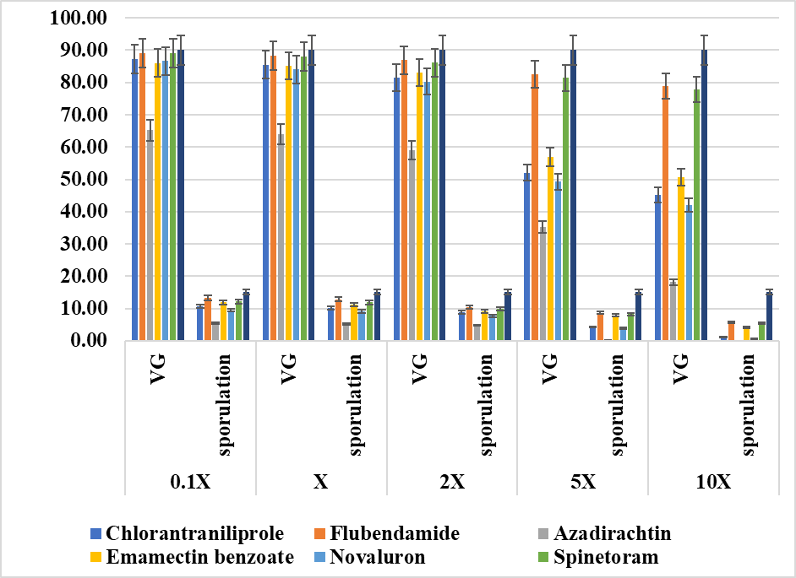
Fig 2. Effect of insecticides on biomass production of M. anisopliae (TNAU-MA-GDU)
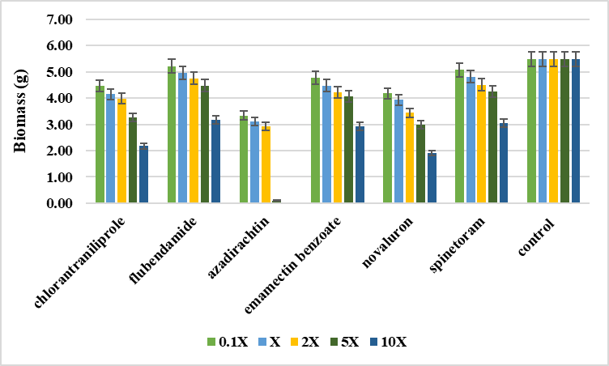
CONCLUSION
The isolate, M. anisopliae (TNAU-MA-GDU) was compatible with flubendiamide, spinetoram, emamectin benzoate, chlorantraniliprole and novaluron at field doses and hence can be combined for the management of Fall armyworm under field conditions. Green labelled insecticides, azadirachtin was toxic at all test doses and inhibited the growth and sporulation of M. anisopliae (TNAU-MA-GDU). Hence, it demonstrated that insecticides except azadirachtin had synergistic effect on M. anisopliae at field doses under laboratory conditions. It needs to be further validated through field experiments.
Funding

Not applicable

Acknowledgment
The authors gratefully acknowledge the facilities provided under the GoTN – FAW project for carrying out the above research.
Ethics statement
Not applicable
Originality and plagiarism
The authors assure that the research work submitted here is original and not subjected to any plagiarized content.
Consent for publication
All the authors agreed to publish the content.
Competing interests
There was no conflict of interest in the publication of this content
Data availability
Not applicable

Author contributions
Idea conceptualization- SJ, Guidance- SJ, NS, MM, US, DU, Experiments- GK, Writing original draft- GK, Writing- reviewing &editing- SJ.

REFERENCES
Akbar, S., Freed, S., Hameed, A., Gul, H. T., Akmal, M., Malik, M. N., Naeem, M. and M. B. Khan. 2012. Compatibility of Metarhizium anisopliae with different insecticides and fungicides. Afr. J. Microbiol. Res., 6(17): 3956-3962.
Asi, M. R., Bashir, M. H., Afzal, M., Ashfaq, M., and S. T. Sahi. 2010. Compatibility of entomopathogenic fungi, Metarhizium anisopliae and Paecilomyces fumosoroseus with selective insecticides. Pak. J. Bot., 42(6): 4207-4214.
Joshi, M., Gaur, N., and R. Pandey. 2018. Compatibility of entomopathogenic fungi Beauveria bassiana and Metarhizium anisopliae with selective pesticides. J. Entomol. Zool. Stud., 6(4): 867-872.
Matcha, N., Duraimurugan, P., and A. K. Bhowmick. 2021. Effect of insecticides and fungicides on growth and sporulation of Metarhizium rileyi (Farlow) Samson. J. Pharm. Innov., 10(7): 1444-1447.
Neves, P. M., Hirose, E., Tchujo, P. T., and J. R. Moino. 2001. Compatibility of entomopathogenic fungi with neonicotinoid insecticides. Neotrop. Entomol., 30: 263-268.
Oliveira, C. N. D., Neves, P. M., and L. S. Kawazoe. 2003. Compatibility between the entomopathogenic fungus Beauveria bassiana and insecticides used in coffee plantations. Sci. Agric., 60: 663-667.
Parjane, N. V., Kabre, G. B., Mahale, A. S., Shejale, B. T., and S. A. Nirgude. 2020. Compatibility of pesticides with Metarhizium anisopliae. J. Entomol. Zool. Stud., 8(5): 633-636.
Purwar, J. P., and G. C. Sachan. 2006. Synergistic effect of entomogenous fungi on some insecticides against Bihar hairy caterpillar Spilarctia obliqua (Lepidoptera: Arctiidae). Microbiol. Res., 161(1): 38-42.
Sain, S. K., Monga, D., Kumar, R., Nagrale, D. T., Hiremani, N. S., and S. Kranthi. 2019. Compatibility of entomopathogenic fungi with insecticides and their efficacy for IPM of Bemisia tabaci in cotton. J. Pestic. Sci., 44(2): 97-105.
Schumacher, V., and H. M. Poehling. 2012. In vitro effect of pesticides on the germination, vegetative growth, and conidial production of two strains of Metarhizium anisopliae. Fungal Biol., 116(1): 121-132.
Silva, R. A. D., Quintela, E. D., Mascarin, G. M., Barrigossi, J. A. F., and L. M. Lião. 2013. Compatibility of conventional agrochemicals used in rice crops with the entomopathogenic fungus Metarhizium anisopliae. Sci. Agric., 70: 152-160.
Tekam, K. D., Kelwatkar, N. M., and S. B. Das. 2018. Compatibility of Metarhizium anisopliae with new generation insecticide in vitro condition. J. Entomol. Zool. Stud., 6(6): 887-890.

