RESEARCH ARTICLE
Development and Evaluation of Check Valve for Electro Mechanical Inclined Plate Metering System Under Laboratory Conditions

ABSTRACT
The seeds in conventional seed metering mechanism is metered and transferred through seed tube to the furrow created by furrow opener. In this type of delivery, non-uniformity occurs due to the uncontrolled seed falling through seed tube from the metering device to the furrow. In conventional precision planters the seed rate is controlled whereas placement of seeds in furrow cannot be controlled. To achieve control over seed placement in the furrow, the check valves has been developed and fixed to the electro mechanical inclined metering system. The check valve system was tested with an opto electronic measurement system in laboratory conditions. For CO 6 variety of maize seeds, the quality feed index, missing index, multiple index and precision index found out as 86.2 – 89.6 %, 8 – 11.8 %, 1.9 – 2.9 % and 14.6 to 16.5 % respectively. Using of solenoid actuated check valve the Precision index of developed electro mechanic metering system (11.6 – 16.4 %) was increased.
Keywords: check valve, linear solenoid actuator, opto electronic measurement system, electromechanical drive, inclined plate metering

INTRODUCTION

In precision planting of maize, uniform planting pattern can be achieved by the metering mechanism which maintains the uniform plant to plant distance in each traveling pass (Özmerzi et al., 2002). The plant population over a unit area is necessary to obtain good yield. This can be achieved by changing of metering plates in chain drive metering mechanism and involves higher manufacturing and operating costs of the planter (Cay et al., 2018).

In conventional seed metering mechanism, the seeds are metered and transferred to the furrow created by furrow opener, via a seed tube. Due to the uncontrolled seed falling through seed tube from the metering device to the furrow, and bouncing of the seeds and vibrations induced by planter at higher travelling speed, the non-uniformity of seed spacing between the plants will be occurred. . In the conventional precision planters, the planter can control the seed population, but it has no control over actual timing and placement of the seed. The important disadvantage of conventional precision planters is the lack of communication of seed placement between components of the planter. which resultes in the absence of detection on time and place of seed relative to neighboring row units (Iacomi & Popescu, 2015). To minimize seed dispersion and scattering of seeds in furrow, rotary valves and reciprocating valves are used in hill dropping of seeds (Bainer et al., 1956). In the check row planters, the reciprocating valves can also be used for hill dropping. The valves are in closed default position and stores the seed. On time intervals, the valves will open and release the seed in the furrow.

Performance of metering mechanism depends on the transmission system by which metering mechanism runs (Liang et al., 2015). Another limitation involved in chain drive metering mechanism was poor performance in higher travelling speeds. In existing precision planters, mechanical transmission system is used to transmit the motion from ground wheel to seed metering mechanism

Gautam, 2017 studied the microcontroller based seed metering mechanism for pulse crops and introduced electro mechanical seed metering drive to increase the operating performance of metering mechanism In the study t was reported that quality feed index of 90 % at forward speed of 1.56 km h-1 and 5.4 mm cell diameter. Cay et al., 2018 studied the performance of electro mechanic drive system for precision planters at various levels of operating speed (5, 7.5, 10 km h⁻¹) and ten number of seed spacings (6 – 29.3 cm) at laboratory conditions. Quality of feed index (I_{qf}), multiple index (I_{multi}), miss index (I_{miss}) and precision index (I_{p}) were in the range of 2.91 - 95.36 %, 0 - 1.73 %, 4.45 - 97.09 % and 8.79 - 22.14 % respectively when using electro mechanic drive system.

Among the precision planters, inclined plate metering mechanism is commonly used and widely manufactured metering mechanism in India. Various performance studies were conducted on inclined plate metering mechanism. Singh et al., 2020 evaluated the inclined plate seed metering mechanism for maize in laboratory conditions. The quality of feed index was obtained as 83.38, 87.20 and 85.40 % respectively for PMH-1, PIONEER-3396 and PMH-10 varieties.

Keeping these points in view, it was aimed to develop the solenoid actuated check valve for Electro Mechanical Inclined Plate Metering System. The developed solenoid actuated check valve is evaluated with an objective of studying the effects of check valve operating speed on seed spacing in laboratory conditions.

MATERIAL AND METHODS

Solenoid coil operated check valve

Construction

To increase the precision of seed placement in the furrow, the solenoid actuated check valves are introduced in the seed metering system. It was placed near to the furrow and at the end of seed tube. It consists electromagnetic linear solenoid actuator, seed tube and check valve door as depicted in Fig. 1. The check valve door holds the seed from seed metering mechanism. When the signal received from control system at every plant spacing, the solenoid coil will energize and pull the check valve door attached to it for delivering the seed at correct plant spacing.. The end of seed tube was cut at an angle of 70° from horizontal to minimize the check valve door opening degree from vertical.
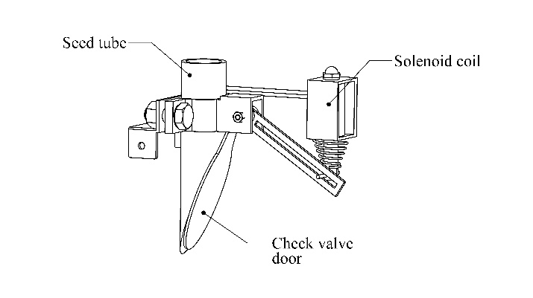

Fig. 1 Schematic diagram of solenoid actuated check valve

Study of solenoid coil

To find the pulling force required by solenoid actuator for check valve, the moments about check valve door were taken (Fig. 2). The load acting on the check valve door were assumed as 0.98 N which was 100 gm of seed weight held by it. To support this load, 1.17 N force is required on check valve door arm at the other side. Based on these, the commercially available linear solenoid actuator was selected (Fig. 3) which can exert the pulling force of 6 N and stroke length of 10 mm and works on 12 V, 1 A of DC Current.
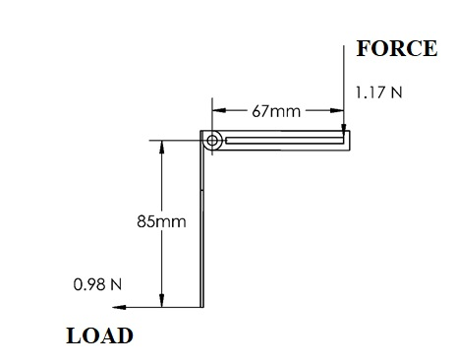

Fig. 2 Moment diagram of check valve door
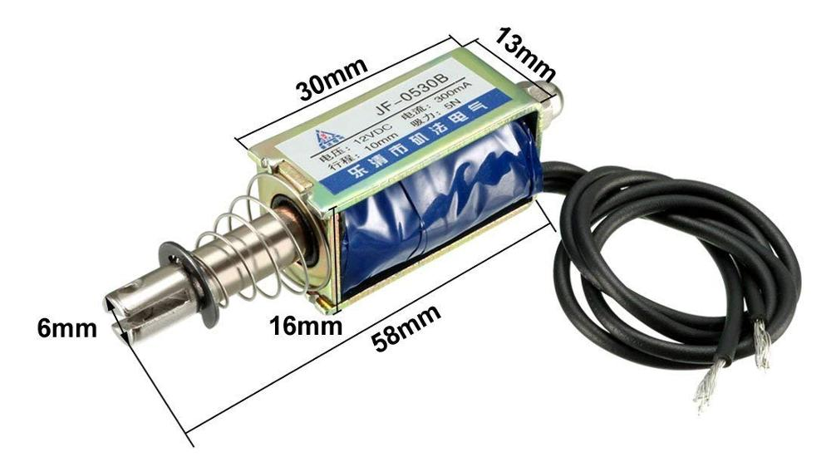

Fig. 3 Linear solenoid actuator

Testing of check valve with electro mechanic seed metering drive system

The developed electro mechanic seed metering drive system was tested with opto electronic measurement system for CO 6 variety of maize seed. Opto electronic measurement system equipped with Infrared sensor system consists 3 pairs of infra-red transmitting and receiving tubes. Functional block diagram of system is shown in Fig. 4. The effective sensing distance range was 2 to 30 cm and detection angle was 35°. The infra-red sensor was placed at minimum height from greased belt (20 to 50 mm) to reduce the errors of seed spacings by seed dropping height. Computer was equipped with open source Arduino IDE through UART serial communication protocol, it records the signals from rotary encoder and infra-red sensor system. By analyzing the recorded data, the seed spacings were measured.
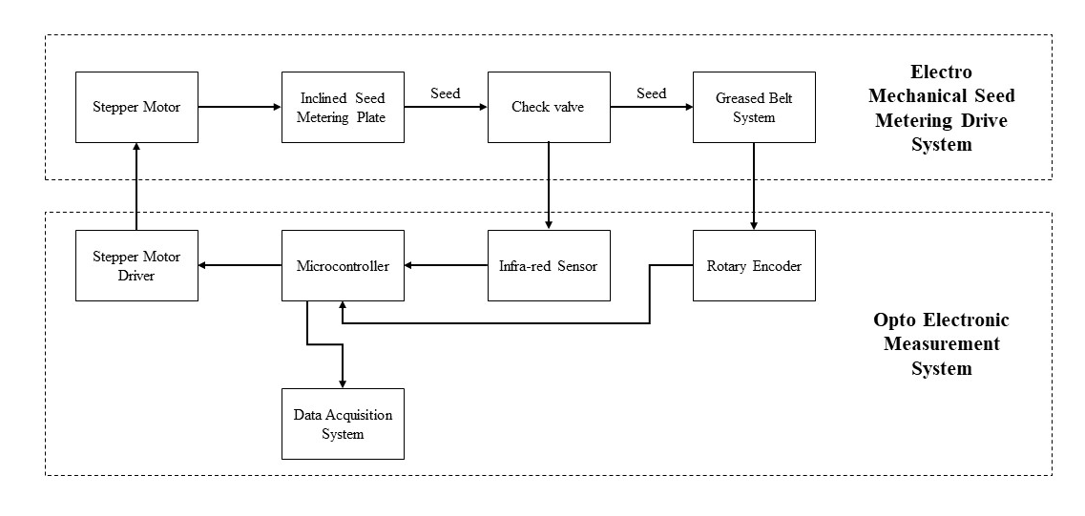

Fig. 4 Functional block diagram of test rig equipped with opto electronic measurement system

Calibration of testing platform

For successful measurements by opto electronic measurement system on developed electro mechanic seed metering system, it was compared with the measurements taken by sticky belt test rig. In this procedure, the testing platform was operated with a belt speed of 1.5 km h⁻¹, inclined metering plate speed of 0.10 to 0.20 m s⁻¹ with the seed space varying from 5 to 45 cm. The seed spacing values measured on sticky belt using measuring scale and digital caliper taken as reference values. The relationship was analyzed between greased belt and opto-electronic system readings (Karayel et al., 2006; Kocher et al., 1998; Lan et al., 1999).

Testing of developed solenoid actuated check valve with electro mechanic metering system

The proposed electro mechanic drive system for inclined plate metering system was tested in opto electronic planter testing platform equipped with greased belt system which enables the testing of metering system in various levels of travelling speed and metering plate speed. Schematic diagram of testing platform with inclined plate metering system and opto electronic measurement system is shown in Fig. 5.
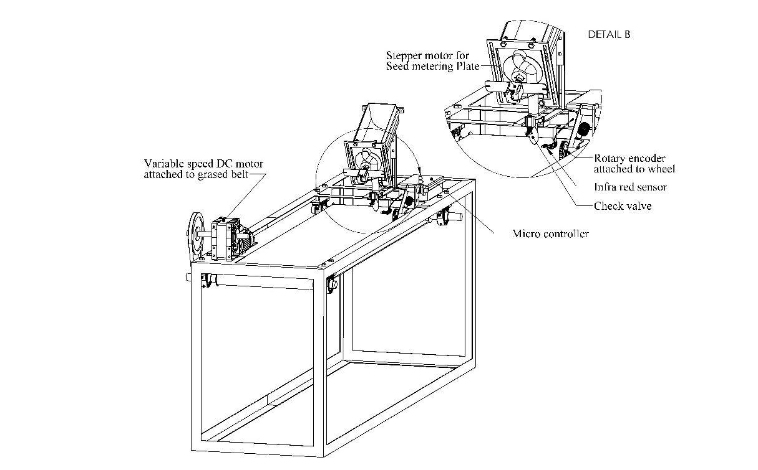

Fig. 5 Schematic diagram of testing platform with inclined plate metering system and opto electronic measurement system

The proposed electro mechanic inclined plate metering system performance was tested in four different travelling speed of operations (Ts) (1, 2, 3 and 4 km h⁻¹), check valve opening intervals (Ci) 75, 100 ms at 95 mm² cell area of inclined metering plate. The inclination of seed metering plate to horizontal was kept as 60°.

Multiple index (I_{multi}), miss index (I_{miss}), precision index (I_{p}) and quality of feed index (I_{qf}) were used to determine the performance of proposed electro mechanic drive system. Good performance of system is indicated by higher I_{qf} value and lower I_{multi}, I_{miss}, I_{p} values. These values were calculated by following equations as related standards (Cay et al., 2018)(ISO 7256-1:1984(E) Standard, 1984).
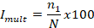
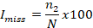
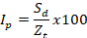

here Z_{t} is the theoretical set value of seed spacing, N is the total number of seed spacing, n₁ is the number of multiple seeds from 0 to 0.5 Z_{t}, n₂ is the number of missing seeds from 1.5 Z_{t} to ∞ and S_{d} is standard deviation of seed spacing values. Minitab 17 statistical software (StatSoft, Inc. Tulsa OK, USA) was used for data analysis.

RESULTS AND DISCUSSION
The relation between four levels of travelling speed of planter and quality of feed index (I_{qf}), missing index (I_{miss}), multiple index (I_{multi}) and precision index (I_{p}) at two levels of check valve opening intervals for CO 6 maize variety is shown in Fig. 4.

Fig. 6 Relation between four levels of travelling speed of planter and various indices at two levels of check valve opening intervals for CO 6 maize variety

It was observed as I_{qf} value higher at check valve opening interval of 50 ms as 89.6, 89.3, 88.3, 86.7 % at 1, 2, 3, 4 km h⁻¹ travelling speed respectively. Lower I_{qf} value was observed at check valve opening interval of 100 ms as 88.6 %, 88.5 %, 87.8 %, 86.2 % at 1, 2, 3, 4 km h⁻¹ travelling speed respectively. It was observed at check valve opening interval of 50 ms as 0.3 % decrease in I_{qf} when travelling speed increased from 1 to 2 km h⁻¹, 1.1 % decrease in I_{qf} when travelling speed increased from 2 to 3 km h⁻¹, 1.8 % decrease in I_{qf} when travelling speed increased from 3 to 4 km h⁻¹. From the reading it was observed that as the forward speed increases, quality feed index decreased for all the levels of check valve opening intervals (Fig. 5). It was observed that increase of travelling speed from 3 to 4 km h⁻¹ shows greater decrease in I_{qf}. Similarly for check valve opening interval of 100 ms, the decrease of I_{qf} was observed as 1.8 % when travelling speed increased from 3 to 4 km h⁻¹.
The missing index was observed lower at check valve opening interval of 50 ms as 8 %, 8.5 %, 9.8 %, 11.8 % at 1, 2, 3, 4 km h⁻¹ travelling speed respectively. Higher I_{miss} value was observed at check valve opening interval of 100 ms as 8.5 %, 8.8 %, 9.7 %, 11.8 % at 1, 2, 3, 4 km h⁻¹ travelling speed respectively. It was observed at check valve opening interval of 50 ms as 6.3 % increase in I_{miss} when travelling speed increased from 1 to 2 km h⁻¹, 15.3 % increase in I_{miss} when travelling speed increased from 2 to 3 km h⁻¹, 20.4 % increase in I_{qf} when travelling speed increased from 3 to 4 km h⁻¹ (Fig. 5). It was observed that increase of travelling speed from 3 to 4 km h⁻¹ showed greater increase in I_{miss} as similar to I_{qf}. Similarly for check valve opening interval of 100 ms, the increase of I_{miss} was observed as 21.6 % when travelling speed increase from 3 to 4 km h⁻¹.
It was observed that all levels of travelling speed and check valve opening interval does not influence the multiple index. For all levels of treatment I_{multi} was observed as 1.9 to 2.9 %. The precision index was observed at check valve opening interval of 50 ms as 14.6 %, 14.8 %, 15.9 %, 16.5 % at 1, 2, 3, 4 km h⁻¹. The I_{p} was observed at check valve opening interval of 100 ms as 14.6 %, 14.7 %, 15.5 %, 16.2 % at 1, 2, 3, 4 km h⁻¹. It was observed at check valve opening interval of 50 ms as 1.4 % increase in I_{p} when travelling speed increased from 1 to 2 km h⁻¹, 7.4 % increase in I_{p} when travelling speed increased from 2 to 3 km h⁻¹, 3.8 % increase in I_{p} when travelling speed increased from 3 to 4 km h⁻¹ (Fig. 5). It was observed that increase of travelling speed from 2 to 3 km h⁻¹ showed greater increase in I_{p} as similar as I_{qf}. Similarly at check valve opening interval of 100 ms, the increase of I_{p} was observed as 5.4 % when travelling speed increase from 2 to 3 km h⁻¹.

CONCLUSION
To increase the precision of seed placement of inclined plate seed metering mechanism, the linear solenoid actuator operated check valve was developed and evalauted . The check valve was tested with opto electronic measurement system in laboratory conditions. For CO 6 variety of maize seeds, the quality feed index, missing index, multiple index and precision index found out as 86.2 – 89.6 %, 8 – 11.8 %, 1.9 – 2.9 % and 14.6 to 16.5 % respectively. Precision index of developed electro mechanic metering system (11.6 – 16.4 %) was improved by check valves. It was higher when compared to electro mechanic drive system without check valves (8.79 - 22.14 %) (Cay et al., 2018). Due to the easier adaptation of electro mechanic drive system by metering systems, it can be easily fixed with higher precision planting systems.

REFERENCES
Bainer, R., Kepner, R. A., & Barger, E. L. (1956). Principles of farm machinery (Vol. 81, Issue 2). LWW.
Cay, A., Kocabiyik, H., & May, S. (2018). Development of an electro-mechanic control system for seed-metering unit of single seed corn planters Part I: Design and laboratory simulation. Computers and Electronics in Agriculture, 144(August 2017), 71–79. https://doi.org/10.1016/j.compag.2017.11.035
Gautam, P. V. (2017). Development of microcontroller based seed metering mechanism for planting of pulse crops. ICAR-INDIAN AGRICULTURAL RESEARCH INSTITUTE NEW DELHI.
Iacomi, C., & Popescu, O. (2015). A New Concept for Seed Precision Planting. Agriculture and Agricultural Science Procedia, 6, 38–43. https://doi.org/10.1016/j.aaspro.2015.08.035
ISO 7256-1:1984(E) Standard. (1984). Sowing equipment-test methods e Part one, single seed drills (precision drills). International Organisation for Standardization. Geneva, Switzerland.
Karayel, D., Wiesehoff, M., Özmerzi, A., & Müller, J. (2006). Laboratory measurement of seed drill seed spacing and velocity of fall of seeds using high-speed camera system. Computers and Electronics in Agriculture, 50(2), 89–96. https://doi.org/10.1016/j.compag.2005.05.005
Kocher, M. F., Lan, Y., Chen, C., & Smith, J. A. (1998). Opto-electronic sensor system for rapid evaluation of planter seed spacing uniformity. Transactions of the American Society of Agricultural Engineers, 41(1), 237–245. https://doi.org/10.13031/2013.17143
Lan, Y., Kocher, M. F., & Smith, J. A. (1999). Opto-electronic sensor system for laboratory measurement of planter seed spacing with small seeds. Journal of Agricultural and Engineering Research, 72(2), 119–127. https://doi.org/10.1006/jaer.1998.0353
Liang, Z., Zhang, D., Yang, L., Cui, T., & Hao, Y. (2015). Experimental study on motor driven pneumatic precision seed-metering device for maize. American Society of Agricultural and Biological Engineers Annual International Meeting 2015, 5, 3945–3952. https://doi.org/10.13031/aim.20152189758
Özmerzi, A., Karayel, D., & Topakci, M. (2002). Effect of sowing depth on precision seeder uniformity. Biosystems Engineering, 82(2), 227–230. https://doi.org/10.1006/bioe.2002.0057
Singh, I., Gautam, A., Dixit, A. K., Manes, G. S., & Singh, A. (2020). Development and Evaluation of Inclined Plate Metering Mechanism for the Sowing of Maize (Zea mays L) Seed. Current Journal of Applied Science and Technology, June, 118–128. https://doi.org/10.9734/cjast/2020/v39i1330689
Vasuki, G., Tajuddin, A., & Kathirvel, K. (2016). Effect of cell size and plate peripheral velocity on single seed metering in an inclined plate planter for high density cotton planting. Green Farming, 7(1), 230–232.

Funding and Acknowledgment

The data used in this work comprise a part of the research project supported by the Council of Scientific and Industrial Research, New Delhi, India. In addition, authors are thankful to Council of Scientific and Industrial Research, New Delhi, India for supporting this research project.

Ethics statement

No specific permits were required for the described field studies because no human or animal subjects were involved in this research.

Consent for publication

All the authors agreed to publish the content.

Competing interests

There were no conflict of interest in the publication of this content

