RESEARCH ARTICLE
GC-MS analysis of Hemidesmus indicus (L.) R. Br. roots and quantification of 2-hydroxy-4-methoxy benzaldehyde through RP-HPLC

ABSTRACT
Hemidesmus indicus is a commercially important medicinal crop that catches the attention of both pharmaceutical as well as the food and flavoring industry. The current investigation intends to reveal the possibilities associated with the morphologically distinct H. indicus plants. The GC-MS analysis carried out with broad-leafed H. indicus root extracts resulted in the identification of 40 various compounds. Among all the compounds 2-hydroxy-4-methoxy benzaldehyde (MBALD) was found to be the major chemical entity. Further, RP-HPLC analysis carried out to decipher the amount of MBALD present in roots of two morphologically distinct H. indicus plants were found to be 0.1827 and 0.1537 mg/gram of tissue of slender and long leafed and broad-leafed plants, respectively.

Keywords: Hemidesmus indicus, GC-MS, RP-HPLC, MBALD.

INTRODUCTION

Hemidesmus indicus (L.) R. Br. belongs to the Apocynaceae family and is a perennial twining semi-erect woody shrub, has been represented by 264 vernacular names across the world and is popularly known as Indian sarsaparilla (Kher et al., 2020). Indian sarsaparilla differs from true sarsaparilla (Smilax febrifuga) and exists as Hemidesmus indicus var. indicus and Hemidesmus indicus var. pubescens. This medicinal plant is majorly found in South Asian countries specifically India, Pakistan, Sri Lanka, Bangladesh, Maldives (George et al., 2008).

The ethnobotanical knowledge about H. indicus has been serving people from long ago and its mention in Ayurveda under the name of Anantmool can also be seen among the Rasayana plants (Ved and Goraya 2007). Due to the presence of aromatic compound, 2-hydroxy-4- methoxy benzaldehyde (MBALD), the roots of this plant have been attributed with a strong smell which makes it an ingredient in sherbet or flavored sweet drinks and bakery products (Patnaik and Debata, 1996). The roots of these plants make it more commercially valuable and medicinally useful as they possess highly desirable therapeutic properties (Kawlni et al. 2017). The root decoction of this plant have shown anti-cancerous activity against colorectal cancer (Turrini et al., 2018) and breast cancer (Suryavanshi et al., 2019).

This study briefly describes the extraction methodologies used in the preparation of solvent root extracts, reviews the utility of Gas chromatography-mass spectrometry for the analysis of compounds present in the H. indicus and the procedure for quantification of the commercially valuable compound, MBALD.

MATERIAL AND METHODS
Gas chromatography-Mass spectroscopy analysis
Collection of plant sample: Broad-leafed H. indicus plants were collected from the foot-hills of Rajapalayam (9º43’13.9’’N, 77º44'10.3''E) and were maintained at the greenhouse, TNAU, Coimbatore. The plants were kept at acclimatizing conditions for normal growth. Two-month-old transferred plants were uprooted, roots were separated and washed under running tap water, and kept for drying until further use.
Preparation of solvent root extract: For the preparation of solvent extract from the roots of H. indicus, modified method of Alade and Irobi (1993) was used. The dried roots were ground to a fine powder. Ten gram of root powder was soaked in methanol (100%) for overnight and was filtered through Whatman filter paper No. 1. The filtrate was concentrated using a Soxhlet extractor and was used for GC-MS analysis.
GC-MS condition: One ml of methanolic root extract was injected for GC-MS analysis using Perkin Elmer GC-MS Clarus® SQ 8 equipped with DB-5MS (Agilent, USA) capillary standard non-polar column (0.25mm OD x 0.25 μm ID x 30 m length). The instrument was set to an initial temperature of 40 ˚C and the injection port temperature was ensured at 220 ˚C, interface temperature set 250 °C, source kept at 220 °C, oven temperature-programmed as 75 °C for 2 min, 150 °C @ 10 °C/min, up to 250 °C at 10 °C per min. The GC conditions were: 1:12 split, helium carrier at 20 psi. The MS conditions were: positive ion mode, electron impact spectra at 70 eV. The mass spectral scan range was set at 50 to 600 Da.
Reverse-phase high-performance liquid chromatography
Explant material: In the current investigation, 2 morphologically different H. indicus plants slender and long leafed (SLL) and broad-leafed (BL) (figure 1 and 2, respectively) were taken for the quantification of 2-hydroxy-4-methoxy benzaldehyde from the roots. The dried roots of two morphologically different plants were obtained from Rajapalayam (9º43’13.9’’N, 77º44’10.3’’E). The roots were finely powdered and kept separately in airtight containers.
Reagents and Chemicals: HPLC grade Methanol and Trifluoracetic acid (TFA) were used during the study and other reagents were prepared using Milli Q water.
Sample extract preparation: For the preparation of methanolic root extract protocol by Sircar, Dey, and Mitra (2007) was followed. One gram of powder was extracted with 20 mL of aqueous methanol (50:50, v/v). The extract was incubated for 2 days with continuous shaking and was subjected to centrifugation at 10,000 rpm for 10 minutes. The supernatant taken was first filtered with Whatman filter paper No. 1 and further filtered through a 0.22 µm filter. 20µl of the sample was injected into the hplchphplc
system.
Solvent preparation: HPLC grade (98%) 2-hydroxy-4-methoxy benzaldehyde standard was used for the study. 1 mg of standard MBALD purchased from Sigma-Aldrich (Catalogue No.160695, Molecular Weight 152.15 and PubChem Substance ID 24849887) was added into 1mL of aqueous methanol (50:50, v/v) to prepare a 1000 ppm standard stock solution. The working standard solution was prepared with a concentration of 10 ppm by dilution of standard stock solution with aqueous methanol (50:50, v/v). Isocratic solvent mixture (mobile phase) was prepared by adding 1 mM aqueous TFA and methanol in a 70:30 ratio. All stock solutions were stored at 4^{O}C.
HPLC Condition: Shimadzu HPLC system equipped UV–Vis detector was used for RP-HPLC analysis. The separation of compounds was achieved by the C18 reversed-phase column (INNO column, 5µm, 120Å, 4.6×250mm). Shimadzu CLASS-VPTM software was used for data acquisition, processing, and reporting on the Windows XP platform. The wavelength was set to 280 nm for monitoring chromatograms. The mobile phase was maintained at a flow rate of 1 ml min⁻¹. The sample was identified based on the comparison of retention time with those of the standards with keeping the same conditions.
Quantification of MBALD was done by using the retention time and peak area obtained from the chromatogram. The formula for calculating the percentage of 2-hydroxy-4-methoxy benzaldehyde in the dried root extract is as follows:

RESULTS AND DISCUSSION

Phytochemical analysis through GC-MS

The gas chromatogram obtained after GC-MS analysis defined the relative concentrations of different compounds being eluted as the function of retention time. The peak heights indicated the relative concentrations of various compounds present in the methanolic extract, whereas the mass spectrometer analysed the compounds and identifies the nature and structure of the compounds based on the time of their elution (Krishnamoorthy and Subramaniam, 2014).

The methanolic root extract of broad-leafed H. indicus had shown the presence of a variety of compounds as compared to that of published in earlier literature of H. indicus. A total of 40 compounds were identified (figure 3) in the GC-MS analysis and the identification of the compounds in the extract were based on the peak area which represented the percentage of that particular compound which was deciphered from the chromatogram and molecular weight of the compound. The list of all the compounds is given in table 1. Out of all the compounds, it was found that the major volatile compound, 2-hydroxy-4-methoxy benzaldehyde (peak area 11.071%) was present in abundance forming the major entity. Due to the presence of MBALD in large proportion, it could be utilized in various sectors like pharmaceuticals, food industry, anti-microbial formulations, etc.
Anti-bacterial and anti-fungal activity of MBALD was deduced by Mehmood, Dixit, and Singh (2016) who reported the hexane extract prepared from the roots H. indicus to be effective with the maximum zone of inhibition (MIC) of 22 mm against Staphylococcus aureus and the MIC for Candida albicans to be 18 mm with zero cytotoxicity. MBALD is a non-toxic aromatic benzaldehyde which confers antimicrobial, anti-aflatoxigenic potency, antioxidant properties (Harohally et al., 2017). It has good water solubility and is a potent tyrosinase inhibitor (Ley and Bertram 2001). The Hepatoma HepG2 cells on incubation with root decoction of H. indicus in the dose range of 0-50 mg/ml caused significant inhibition on the growth of the Hep2G cell line making it amenable for its further use in cancer studies (Thabrew et al., 2005).
Quantification of MBALD through RP-HPLC
The percentage of MBALD present in morphologically distinct 2 plants of H. indicus (SLL and BL) was quantified through HPLC using methanolic root extract. In the analysis, the retention time for the standard 2-hydroxy-4-methoxy benzaldehyde at 10 ppm was recorded as 54.400 min. at 280 nm. The retention time for the compound MBALD present in the root extract of SLL in the HPLC chromatogram was observed to be 54.336 and 54.101 in the case of BL. The identity of the sample was confirmed by comparing the chromatograms of both standard and sample. The chromatograms of standard, BL, and, SLL are shown in figure (figure 4, 5, and 6, respectively). Quantification of MBALD was done by using the formula mentioned in materials and methods. It was found that the methanolic root extract of slender and long leafed (SLL) and broad-leafed (BL) Hemidesmus indicus plants contains 0.1827 and 0.1537 mg of 2-hydroxy-4-methoxy benzaldehyde per gram of tissue.
As the compound 2-hydroxy-4-methoxy benzaldehyde is an isomer of vanillin and is an aromatic compound, the demand for its supply in the food and flavoring industry is high (Rathi et al., 2017). In an earlier report, the quantity of MBALD was found to be 0.2638 mg /gram of tissue (Prathibha Devi et al., 2016), which seems more as compared to the values obtained in the current investigation. Methanolic root extracts of seven ecotypes showed variation in HPLC analysis and 2-hydroxy 4-methoxy-benzaldehyde concentration recorded was higher in ecotype 6 and lesser in ecotype 3 (Rathi et al., 2017). The variations in the accumulation of a particular compound in the specific part depend on various reasons such as genotype, plant physiology, climate, environmental conditions, and pathogens, and in some cases, the secondary metabolites are only produced during certain developmental stages (Gonçalves and Romano, 2018). Perhaps, comparatively, the SLL type H. indicus was found more promising for extracting MBALD as a source for commercial production.

CONCLUSION

From the current investigation, it could be concluded that Hemidesmus indicus contains pharmaceutically important and industrially desirable compounds which makes it stand in the frontiers of medicinally important plants. 2-hydroxy-4-Methoxybenzaldehyde is an astounding food flavoring metabolite widely used as flavors for food preparation, besides known to inhibit the activity of the enzyme acetyl choline esterase, hence can be used for curing neurodegenerative disorders like Alzheimer’s disease. The exact role of MBALD in cancer studies needs to be determined to reveal its effects on the mechanism of growth inhibition of cancer cells which might be used as natural and low-cost drugs to fight cancer with minimal or no side effects. Further, other compounds present in the roots of H. indicus serves wide spectra of utilities which need to be highlighted in the future studies. Moreover, to meet the growing demand of MBALD, more studies on the secondary metabolite production is need of an hour.

Funding and Acknowledgment

The authors acknowledge the financial support provided to SU by DBT, GoI.

Ethics statement

No specific permits were required for the described studies because no human or animal subjects were involved in this research.
Originality and plagiarism
The submitted article is original and has not been submitted to any other journal.

Consent for publication

All the authors agreed to publish the content.

Competing interests

There was no conflict of interest in the publication of this content.

Data availability

All the data of this manuscript are included in the document. No separate external data source is required. If anything is required from the document, certainly, this will be extended by communicating with the corresponding author through corresponding official mail.

Author contributions

Research grant | - | DBT
Idea conceptualization | - | RG
Experiments | - | BAA
Guidance | - | RG, SV, JS
Writing-original draft | - | BAA
Writing- reviewing &editing | - | BAA, RG

REFERENCES
Alade, I. 1993. “Antimicrobial Activities of Crude Leaf Extracts of Acalypha” 39: 171–74.
George, Satheesh, K V Tushar, K P Unnikrishnan, K M Hashim, and Indira Balachandran. 2008. “Hemidesmus Indicus (L.) R. Br. A Review.” Journal of Plant Sciences 3 (2): 146–56.
Gonçalves, Sandra, and Anabela Romano. 2018. “Production of Plant Secondary Metabolites by Using Biotechnologikhercal Tools.” Secondary Metabolites - Sources and Applications.
Harohally, Nanishankar V., Chris Cherita, Praveena Bhatt, and K. A. Anu Appaiah. 2017. “Antiaflatoxigenic and Antimicrobial Activities of Schiff Bases of 2-Hydroxy-4-Methoxybenzaldehyde, Cinnamaldehyde, and Similar Aldehydes.” Journal of Agricultural and Food Chemistry 65 (40): 8773–78.
Kawlni, Lalrinpuia, Manajit Bora, Sachchida Nand Upadhyay, Koyel Mukherjee, and Jayram Hazra. 2017. “Pharmacological and Therapeutic Profile of Anantamula (Hemidesmus Indicus (l.) R. Br.): A Comprehensive Review.” International Journal of Ayurveda and Pharma Research 5 (11): 49–57.
Kher, Mafatlal, Mahipal Shekhawat, M Natraj, and Jaime Silva. 2020. “Indian Sarsaparilla , Hemidesmus Indicus ( L .) R . Br . Ex Schult : Tissue Culture Studies,” 39: 6463–79.
Krishnamoorthy, Karthika, and Paulsamy Subramaniam. 2014. “Phytochemical Profiling of Leaf, Stem, and Tuber Parts of Solena Amplexicaulis (Lam.) Gandhi Using GC-MS.” International Scholarly Research Notices 1–13.
Ley, Jakob P., and Heinz Jürgen Bertram. 2001. “Hydroxy- or Methoxy-Substituted Benzaldoximes and Benzaldehyde-O-Alkyloximes as Tyrosinase Inhibitors.” Bioorganic and Medicinal Chemistry 9 (7): 1879–85.
Mehmood, Zafar, Arunesh K Dixit, and Ajay Singh. 2016. “Indian Herb Hemidesmus Indicus - A Potential Source of New Antimicrobial Compounds.” Medicinal Chemistry 6 (12): 734–38..
Patnaik, J, and B. Debata. 1994. “Plant Cell Reports ©.” Plant Cell Reports 14: 120–24.
Prathibha Devi, Professor, Prathibha Devi Cherku, B Rama De vi, Veena Reddy, and Sye da Fatima Manzelat. 2016. “Estimation of 2-Hydroxy-4-Methoxybenzaldehyde, Lupeol and Other Unreported Compounds in an Elite Ecotype of Hemidesmus Indicus (L.) R. BR.” An International Journal Annals of Phytomedicine 5 (1): 51–58.
Rathi, Neelima, Keerthana Harwalkar, V. Jayashree, Ashwani Sharma, and Nagashree N. Rao. 2017. “2-Hydroxy-4-Methoxybenzaldehyde, an Astounding Food Flavoring Metabolite: A Review.” Asian Journal of Pharmaceutical and Clinical Research 10 (10): 105–10.
Sircar, D., G. Dey, and A. Mitra. 2007. “A Validated HPLC Method for Simultaneous Determination of 2-Hydroxy-4-Methoxybenzaldehyde and 2-Hydroxy-4-Methoxybenzoic Acid in Root Organs of Hemidesmus Indicus.” Chromatographia 65 (5–6): 349–53.
Suryavanshi, Snehal, Amit Choudhari, Prerna Raina, and Ruchika Kaul-ghanekar. 2019. “A Polyherbal Formulation , HC9 Regulated Cell Growth and Expression of Cell Cycle and Chromatin Modulatory Proteins in Breast Cancer Cell Lines.” Journal of Ethnopharmacology 242 (June): 112022.
Thabrew, M. Ira, Ragai R. Mitry, Mohammed A. Morsy, and Robin D. Hughes. 2005. “Cytotoxic Effects of a Decoction of Nigella Sativa, Hemidesmus Indicus and Smilax Glabra on Human Hepatoma HepG2 Cells.” Life Sciences 77 (12): 1319–30.
Turrini, Eleonora, Cinzia Calcabrini, Massimo Tacchini, Thomas Efferth, Gianni Sacchetti, Alessandra Guerrini, Guglielmo Paganetto, Elena Catanzaro, Giulia Greco, and Carmela Fimognari. 2018. “In Vitro Study of the Cytotoxic, Cytostatic, and Antigenotoxic Profile of Hemidesmus Indicus (L.) r.Br. (Apocynaceae) Crude Drug Extract on t Lymphoblastic Cells.” Toxins 10 (2).
Ved, D. K., and G. S. Goraya. n.d. 2007. “Demand and Supply of Medicinal Plants in India.”

Table
Table 1. Chemical constituents present in the methanolic extract of broad-leafed Hemidesmus indicus
Peak | Retention  time | Area | Area % | Compound
1 | 3.213 | 6,992,248.5 | 0.864 | Decane, 4-methyl
2 | 3.669 | 3,183,574.0 | 0.393 | Undecane
3 | 3.809 | 3,117,720.5 | 0.385 | Melezitose
4 | 4.139 | 3,276,007.5 | 0.405 | Undecane
5 | 5.764 | 4,431,423.5 | 0.547 | Dodecane
6 | 6.435 | 3,287,432.5 | 0.406 | Benzene, 1,3-bis(1,1-dimethylethyl)-
7 | 7.555 | 89,619,072.0 | 11.071 | Benzaldehyde, 2-hydroxy-4-methoxy-
8 | 7.885 | 2,587,966.5 | 0.320 | Arsine, oxophenyl-
9 | 8.486 | 6,022,166.0 | 0.744 | Tetradecane
10 | 9.201 | 25,824,714.0 | 3.190 | Guanosine
11 | 9.456 | 9,164,683.0 | 1.132 | 4-Methyl(trimethylene)silyloxyoctane
12 | 9.566 | 6,292,480.5 | 0.777 | Tridecane, 2-methyl-
13 | 9.671 | 2,534,709.0 | 0.313 | Dodecane, 5,8-diethyl-
14 | 9.746 | 2,271,470.5 | 0.281 | Undecane, 6-ethyl-
15 | 9.821 | 5,062,362.5 | 0.625 | 2,4-Di-tert-butylphenol
16 | 10.026 | 3,298,825.8 | 0.408 | Methyl-4-O-acetyl-2,3,6-tri-O-ethyl-à-d-galactopyranoside
17 | 10.191 | 2,665,982.8 | 0.319 | Dodecane, 2,6,10-trimethyl-
18 | 10.366 | 2,400,660.5 | 0.297 | Benzaldehyde, 3,4-dimethoxy-, methylmonoacetal
19 | 10.676 | 4,810,796.5 | 0.594 | 2H-1-Benzopyran-3,4-diol, 2-(3,4-dimethoxyphenyl) 3,4-dihydro-6-methyl-, (2à,3à,4à)-
20 | 11.397 | 2,413,610.8 | 0.298 | Hexadecane
21 | 18.680 | 41,335,456.0 | 5.106 | n-Hexadecanoic acid
22 | 18.875 | 3,974,250.0 | 0.491 | Octadecanoic acid, 4-hydroxybutyl ester
23 | 21.776 | 35,683,764.0 | 4.408 | 9,12-Octadecadienoic acid (Z, Z)-
24 | 21.941 | 222,793,568.0 | 27.522 | 9-Octadecenoic acid, (E)-
25 | 22.351 | 83,508,704.0 | 10.316 | Octadecanoic acid
26 | 22.891 | 27,773,410.0 | 3.431 | trans-13-Octadecenoic acid
27 | 23.401 | 19,335,120.0 | 2.388 | 9,12-Octadecadienoic acid (Z, Z)-
28 | 23.806 | 7,194,610.5 | 0.889 | Chromone, 5-hydroxy-6,7,8-trimethoxy-2,3-dimethyl-
29 | 24.047 | 2,900,577.2 | 0.358 | 17-Pentatriacontene
30 | 24.162 | 4,038,792.5 | 0.499 | Cyclopropaneoctanoic acid, 2-[(2-pentylcyclopropyl) methyl]-, methyl-ester
31 | 24.292 | 2,521,489.8 | 0.311 | Dasycarpidan-1-methanol, acetate (ester)
32 | 24.532 | 2,842,063.0 | 0.351 | 2,3-Dihydroxypropyl elaidate
33 | 24.692 | 2,906,400.5 | 0.359 | Octadecane, 3-ethyl-5-(2-ethylbutyl)-
34 | 24.832 | 3,326,499.8 | 0.411 | 10-Acetoxy-2-hydroxy-1,2,6a,6b,9,9,12a-heptamethyl-1,3,4,5,6,6a,6b,7,8,8a,9,10,11,12,12a,12b,13,14b-octadecahydro-2H-picene-4acarboxylic acid, methyl ester
35 | 25.137 | 6,330,487.0 | 0.782 | Oxiraneoctanoic acid, 3-octyl-, cis-
36 | 25.277 | 2,491,672.5 | 0.308 | 4-Piperidineacetic acid, 1-acetyl-5-ethyl-2-[3-(2-hydroxyethyl)-1Hindol-2-yl]-à-methyl-, methyl ester
37 | 25.782 | 3,111,850.0 | 0.384 | Octadecane, 3-ethyl-5-(2-ethylbutyl)-
38 | 27.583 | 8,563,851.0 | 1.058 | Squalene
39 | 28.288 | 3,233,305.0 | 0.399 | Diisooctyl phthalate
40 | 28.373 | 2,643,616.8 | 0.327 | Oleyl oleate

FIGURES:

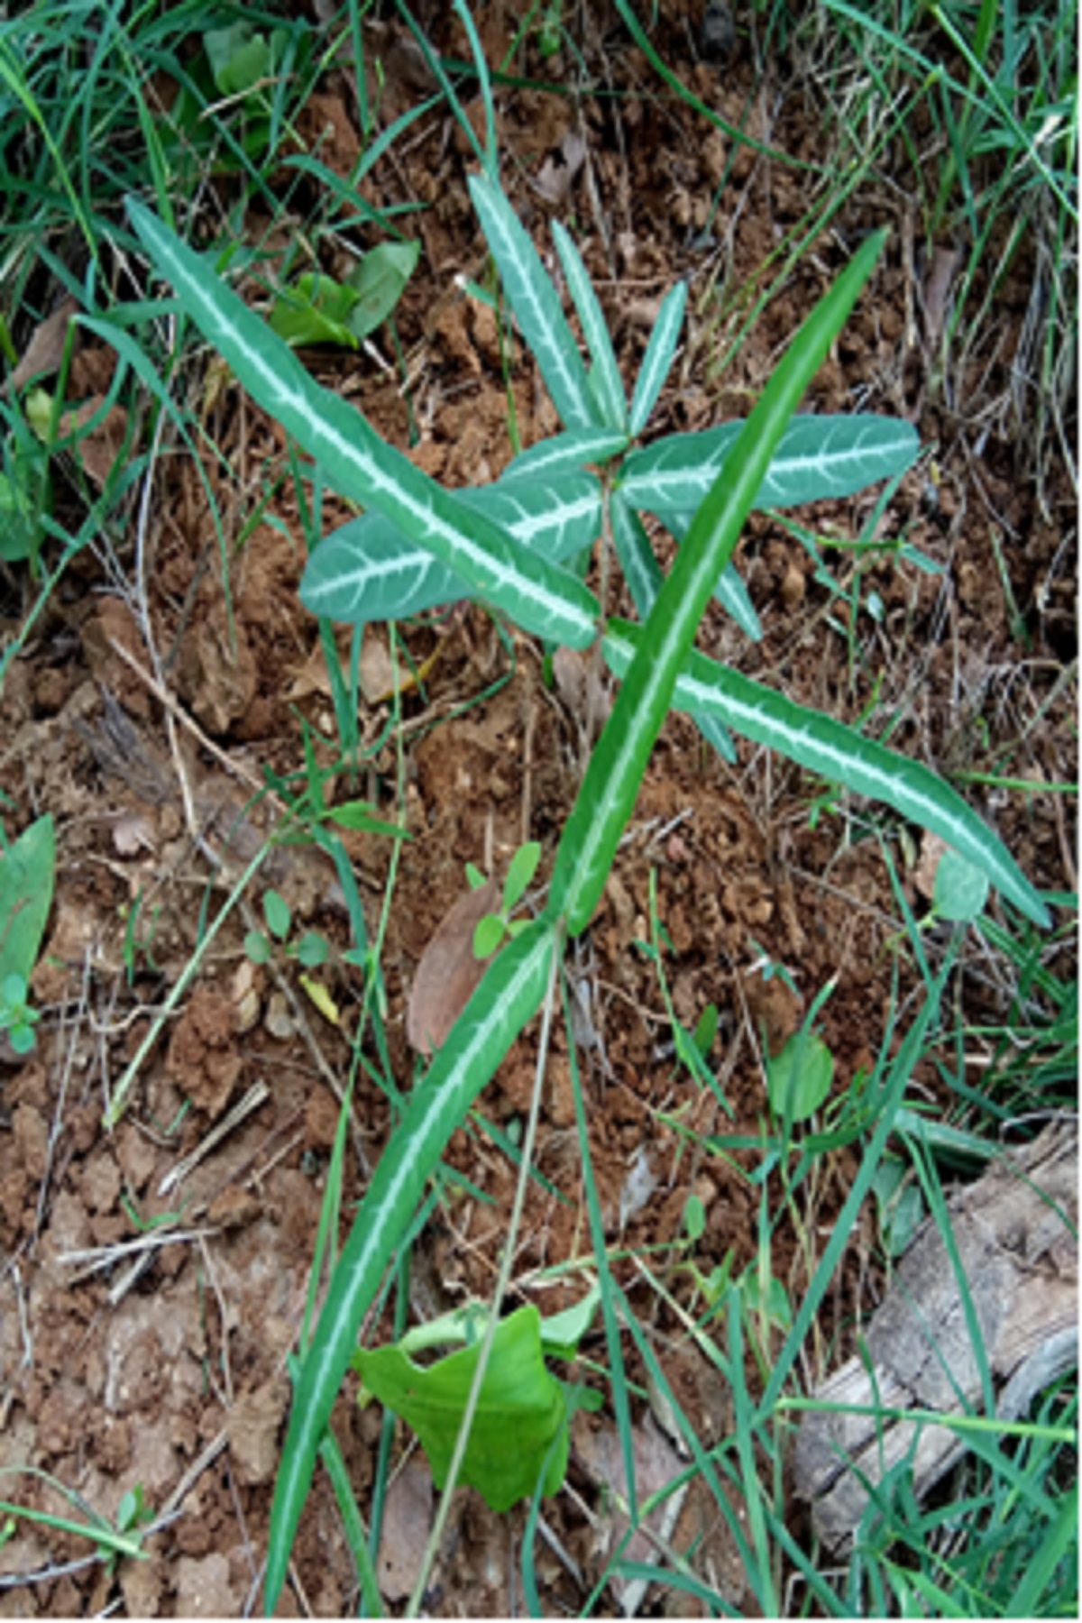
Figure 1. Slender and long leafed plant of H. indicus

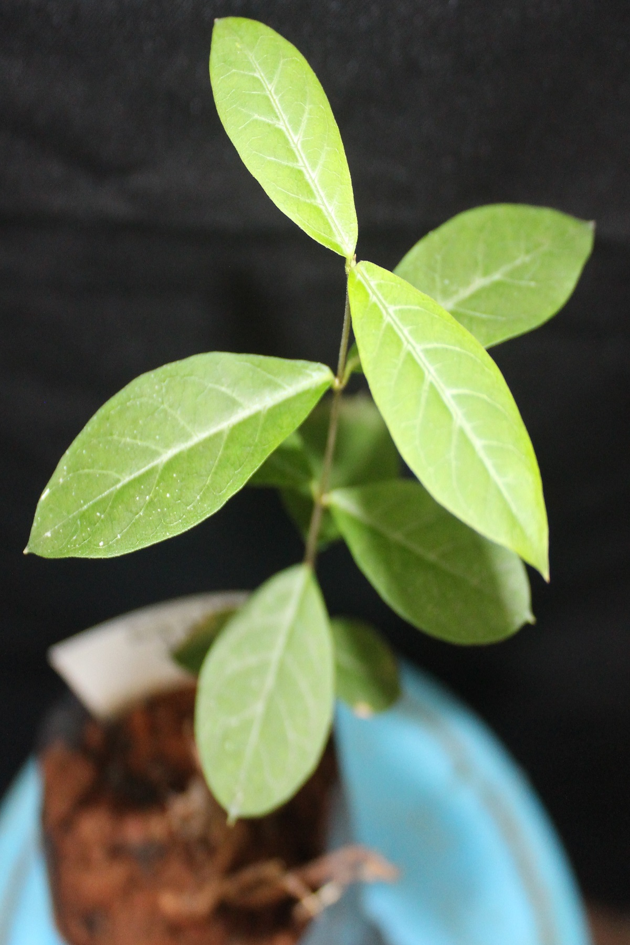
Figure 2. Broad-leafed plant of H. indicus
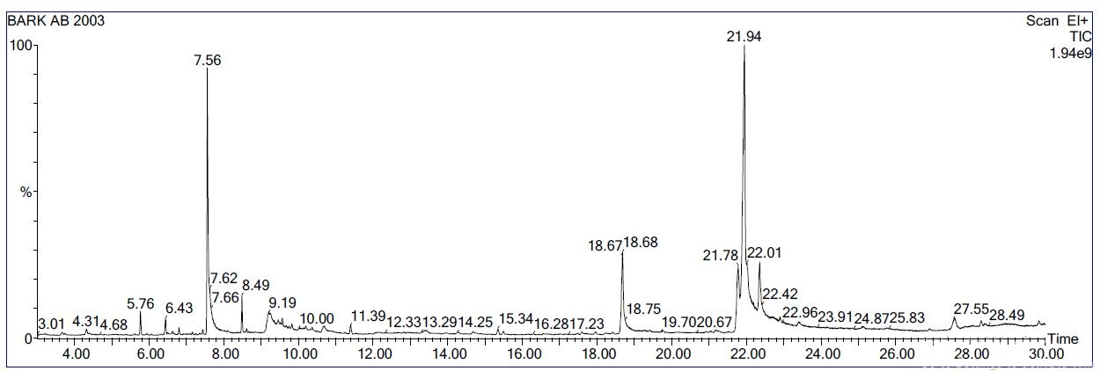
Figure 3. Chromatogram (GC/MS) of the methanolic extract of Hemidesmus indicus

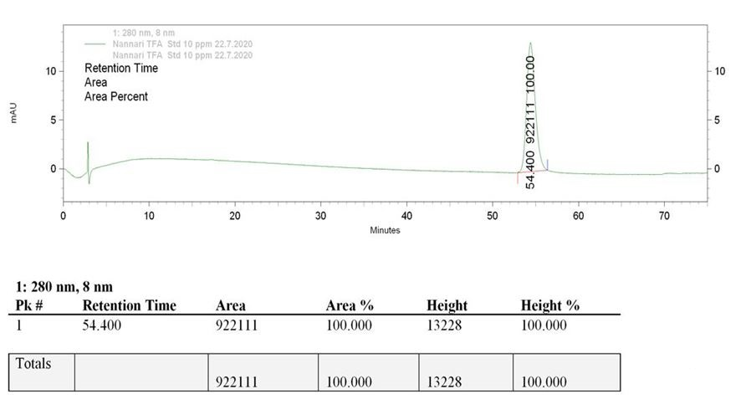
Figure 4. Chromatogram (HPLC) of standard (10ppm) 2-hydroxy-4-methoxy benzaldehyde
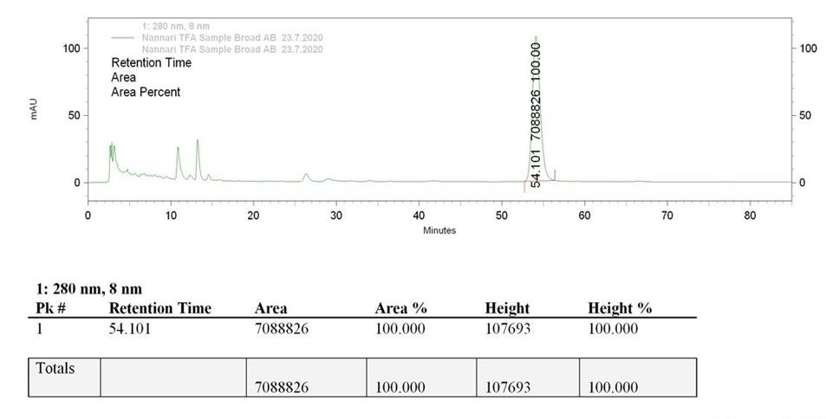
Figure 5. Chromatogram (HPLC) of broad-leafed sample of Hemidesmus indicus

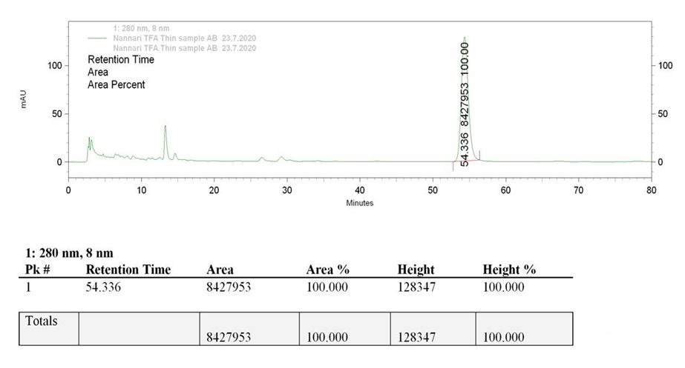
Figure 6. Chromatogram (HPLC) of slender and long leafed sample of Hemidesmus indicus

