The article may be revised and submitted
Reasons
The phenology of the varieties tried
1.The average values are worked out over three varieties and presented. Especially error was worked out average over three varieties and therefore it needs to be worked out for individual variety wise. By using available data, this may be reworked out and resubmitted.

2. The calibration was done based on single date of sowing data. By utilizing available data and again it may be reworked out using more data. Otherwise, first year data may be used for calibration and other data used for validation

RESEARCH ARTICLE
Title: Evaluation of the Cropsyst Model on Days to Crop Phenology of Rainfed Groundnut in Middle Gujarat

ABSTRACT
A field experiment was conducted on validation of CropSyst model for kharif groundnut under rainfed in middle Gujarat, Anand Agricultural University, Anand, during the year 2019 and 2020. The CropSyst model was calibrated and validated on to observed days to crop phenology by using model calibration crop parameters. The results revealed that there were 0.0 % deviation was observed in days to emergence, maturity and harvesting. During days to flowering, initiation of pod filling and peak leaf index, the deviation was 0.0 to 2.9%, 1.3 % and 0.0 to 1.2 %, respectively. The days to crop phenology of all different growth stages are overestimated by the CropSyst model except day to peak leaf area index. The model was evaluated with the test criteria viz; mean absolute error (MAE), mean bias error (MBE), root mean square error (RMSE), mean absolute percent error (MAPE) and refined index of agreement (dr). The highest refined index of agreement were observed in days to pod initiation (0.44), days to maturity (0.58) and days to harvesting (0.58). The results showed that CropSyst model was fairly accurate for the days to emergence, good for the days to pod initiation and very good accuracy for days to maturity and days to harvesting. Whereas, model were poor for days to flowering and days to peak leaf area index. Overall basis the evaluation of the model was fairly good to very good in crop phenology of groundnut.
Keywords: CropSyst Model; Calibration; validation; Evaluation, Groundnut; Gujarat.

INTRODUCTION
CropSyst is a multi-year, multi-crop and daily time step simulation model to study the influence of climate, soils, management on crop production and environment. Simulation model is useful to study the effect of climate, soils and management on crop productivity and the environment (Stockle et al., 2003). CropSyst shows an effort to simulate the growth of crops or crop rotations in response to weather, soil, management scenarios and provide an estimate of environmental impact (Stockle and Nelson, 1994, Stockle et al., 1994). In CropSyst, monolayer canopy, specific leaf area, absence of daily assimilates partitioning etc. had simplified to make easy calibration with the reduced crop parameters as compared to other models such as DSSAT (Decision Support System for Agrotechnology Transfer) which was very detailed in crop physiology and requires many of crop parameters (Singh et al., 2008). CropSyst was designed to depict the EPIC (Erosion Productivity Impact Calculator) concept for the analysis of crop growth, including a more process-oriented approach to simulate crop rotation and its interaction with the environment and management (Stockle et al., 1994; Stockle et al. 2003). This model is suitable for the study of soil, water budget, nitrogen budget, and weather paarametres, determines its reliability, application, and evaluation. Crop growth and development are simulated based on thermal time required for specific growth stages. The accuracy of the predictive models depends upon the proper identification of input parameters. They can help field experimentation because direct measurement of all elements of the crop water balance is often not possible. Calibration of CropSyst model started with base and cutoff temperature and growing degree days so that simulated crop growth stages would match with the data. Before a crop model can provide reliable results, first ensure that the model has been calibrated and that it will accurately simulate. Also, before adopting crop simulation models developed elsewhere, needs validation for a given set of environmental conditions. Validation means simply comparison between output from the model with observed (measurement) field data. Groundnut is an important oilseed crop of tropical and subtropical regions of the world. In India, groundnut occupies an area of 5.5 m ha producing 9.6 mt with a productivity of 1750 kg ha⁻¹ (Shwetha et al. 2017). Gujarat state alone occupies 1.95 million hectares (28.9%) of the total area of the country producing 3.39 million tonnes (42.4%) of the total production of the country with a productivity of 1777 kg ha⁻¹. Although the CropSyst model has been used widely to evaluate the performance of several crops under different pedoclimatic and crop-water management conditions, studies on simulation under rainfed condition are lacking. Therefore, the need to set up approach models for scenario analysis of cropping system models has been increasing. Hence, the study is planned to parameterize CropSyst model for groundnut. This study is aimed that evaluation of the Cropsyst model on crop phenology of rainfed groundnut in middle Gujarat.

MATERIAL AND METHODS

The field experiment was conducted during kharif season of the year 2019 and year 2020, Anand Agricultural University, Anand, Gujarat, India. Anand is located at the latitude of 22° 35’ N and longitude of 72° 55’ E and at an altitude of 45.1m above the mean sea level. The soil type is sandy loam soil in texture with water table is more than 10 m deep (Lakkad, 1993), with a field capacity of 15.4 to 15.8 at different depth. Bulk density was 1.52 g cm⁻³ to 1.55 g cm⁻³ in the 15 to 45 cm layer at the experimental site. The treatments consists of three dates of sowing viz; first date of sowing - onset of monsoon, second date of sowing - 10 days after onset of monsoon and third date of sowing - 20 days after onset of monsoon with three varieties GG 20, GJG 34 and TAG 37A. The experiment replicated four times in randomized block design (factorial). The crop was sown at a distance of 30 cm X 10 cm. Approximately 60 mm as heavy irrigation and 40 mm for light irrigation was given to the each plot as a life saving irrigations. The meteorological data were collected from the Agrometeorological observatory which is adjacent to the experimental site. All the package of practices was followed as per recommended.
Calibration of the model
The CropSyst model was calibrated using the measured data on crop growth parameters/stages (emergence, flowering, initiation of pod and physiological maturity) from the field experiment carried out during kharif season 2019. For calibration of CropSyst model for different varieties of groundnut (GG 20, GJG 34 and TAG 37A ) under different dates of sowing model input file such as simulation, location, soil, crop, and management were prepared. The different crop parameters of different varieties of groundnut was fine tuned up to desired level of close agreement between observed and simulated values.
Validation of the model
The calibrated model was validated for emergence, flowering, initiation of pod and physiological maturity using the observed data on crop parameters of groundnut. Soil characteristics, initial conditions of available soil water and daily weather data were model input data for CropSyst as observed in the experiment. Model validation was conventionally made by comparing simulation outputs with observed and simulated data. Validation was done using the experiment data carried out in kharif 2019 and 2020 during crop growing season. The observed and simulated values were calculated by adopting statistics according to Willmott (2012). The dr measure result of +1.0 indicates perfect model between observed and simulated values. Whereas, -1.0 indicates poor performance.
Mean absolute percent error (MAPE)

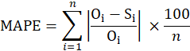
Mean bias error (MBE)
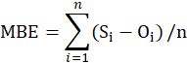
Mean absolute error (MAE)
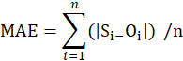
Root mean square error (RMSE)
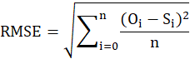
Where,
n is the number of observations
Refined index of agreement (d_{r})

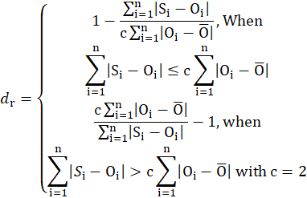 c = constant.
Where,
S_{i} = simulated values, O_{i} = observed values

RESULTS AND DISCUSSION
Calibration of the CropSyst model
The details of crop parameters used are given in Table 1. The CropSyst model calibrated days to crop phenology (DAS) with deviation under first date of sowing during 2019 at final calibration (Table 2). The results revealed that measured days to emergence, days to flowering, days to initiation of pod filling, days to peak leaf area index, days to maturity and days to harvesting was varied between 8-9 days, 34-36 days, 75-76 days, 85 days, 113 and 114. Whereas, CropSyst model simulated 8-9 days, 34-37 days, 76-77 days, 85-86 days, 113 and 114 days, respectively. There were 0.0 % deviation was observed in days to emergence, maturity and harvesting. During days to flowering, initiation of pod filling and peak leaf index, the deviation was 0.0 to 2.9%, 1.3 and 0.0 to 1.2 % respectively. Dash and Chimmad (2019) revealed that days to physiological maturity ranged from 98 to 110 days in groundnut. The calibration results show a very close match between observed values and those simulated by the CropSyst model.
Validation and evaluation for CropSyst model
The CropSyst model was validated for second as well as third dates of sowing of year 2019 and three dates of sowing of year 2020 (Fig.1 a to f). The days to crop phenology of all different growth stages are mostly overestimated by the CropSyst model except day to peak leaf area index (Table 3). The performance of the model was evaluated with the test criteria viz; mean absolute error (MAE), mean bias error (MBE), root mean square error (RMSE), mean absolute % error (MAPE) and refined index of agreement (d_{r}). Jat et. al., (2016) used similar statistics. The results revealed that the model was fairly accuracy for the days to emergence, good performance for the days to pod initiation and very good accuracy for days to maturity and days to harvesting. Whereas, model were poor for days to flowering and days to peak leaf area index (Table 3).

CONCLUSION
Based on research, conlcuded that The CropSyst model calibrated well for simulating crop phenology with deviation less than 2.9. The CropSyst model overestimated days to emergence, days to flowering, days to initiation of pod filling, days to maturity and days to harvesting and underestimated for days to peak leaf area index. CropSyst model reveled that it was fairly accuracy for the days to emergence, good performance for the days to pod initiation and very good accuracy for days to maturity and days to harvesting.

REFERENCES
Caton, B. P., Foin, T. C., and J. E. Hill. 1999. A plant growth model for integrated weed management in direct-seeded rice: II. validation testing of water-depth effects and monoculture growth. Field Crops Res., 62:145–155. .
Dash, D. and V. P. Chimmad. 2019. Effect of temperature regimes on morpho-phenological, thermal indices and yield of groundnut (Arachis hypogaea L.) genotypes. J. of Farm Science, 32 (3): 270-273.
Gauch, H. G., Hwang, J. T. G., and G. W. Fick. 2003. Model evaluation by comparison of model-based predictions and measured values. Agronomy J., 95:1442–1446.
Jat, Sita Ram., Gulati, I. J., Soni, M.L., Kumawat, A., Yadava, N.D., Nangia. V., Glazirina M., Birbal and V. S. Rathore. 2016. Water productivity and yield analysis of groundnut using CropSyst simulation model in hyper arid partially irrigated zone of Rajasthan. Legume Res., 3638:1-6.
Shwetha, Sreenivasa, A. G., Ashoka, J., Nadagoud, A. & Kuchnoor, P.H. 2017. Effect of Climate Change on Growth of Groundnut (Arachis hypogaea L.). Int.l J. of Pure Applied Biosci., 5 (6): 985-989.
Singh, A. K., Tripathy, R. and U. K. Chopra. 2008. Evaluation of CERES-Wheat and CropSyst models for water-nitrogen interactions in wheat crop. Agril. Water Management, 95:776–786.
Stockle, C.O. and R. Nelson. 1994. Cropping Systems Simulation: Model Users Manual (Version 1. 02. 00), Washington State University, p. 167.
Stockle, C. O., S. Martin and G.S. Campbell. 1994. CropSyst, a cropping systems model: water/nitrogen budgets and crop yield. Agril. Systems, 46:335-359.
Stockle, C.O., Donatelli, M. and R. Nelson. 2003. CropSyst, a cropping systems simulation model. Euro.J. of Agronomy, 18: 289–307.
Willmott, C. J., Robeson, S. M. and K. Matsuura. 2012. A refined index index of model performance. Int.l J. of Climatology, 32: 2088-2094.
Table 1: Crop parameters used in the CropSyst model for simulation of groundnut
Crop parameters | First date of sowing
Crop parameters | Variety |  |  | Source
Crop parameters | GG 20 | GJG 34 | TAG 37A
Thermal Time accumulation
Base temperature (°C) | 10 | 10 | 10 | L
Cutoff temperature (°C) | 40 | 40 | 40 | L
Phenology (°C day)
Degree days emergence | 155 | 172 | 155 | M
Degree days end of vegetative growth | 1607 | 1607 | 1607 | M
Degree days begin flowering | 677 | 712 | 693 | M
Degree days begin pod filling | 1441 | 1441 | 1423 | M
Degree days physiological maturity | 2125 | 2125 | 2125 | M
Morphology
Maximum rooting depth (m) | 0.60 | 0.60 | 0.60 | L
Initial green leaf area index (m2 m-2) | 0.011 | 0.011 | 0.011 | D
Maximum expected LAI (m2 m-2) | 4.77 | 4.39 | 4.21 | M
Specific leaf area, SLA (m2 kg-1) | 23.00 | 22.30 | 20.30 | C
Fraction of max. LAI at physiological maturity | 0.80 | 0.80 | 0.80 | D
Leaf/stem partition coefficient | 1.96 | 2.01 | 1.80 | M
Leaf area duration | 1000 | 1000 | 1000 | L
Canopy extinction coefficient for total solar radiation | 0.50 | 0.50 | 0.50 | C
Evapotranspiration crop coefficient at full canopy | 0.90 | 0.90 | 0.90 | C
Growth
Unstressed harvest index (HI) | 0.43 | 0.43 | 0.45 | C
*M= Measured, L= Literature, D= Default and C= Calibrated
Table 2: Calibration of observed (O) and simulated (S) days to crop phenology with % deviation (D) for first date sowing during 2019
Treatment | Days to emergence  (DAS) |  |  | Days to flowering  (DAS) |  |  | Days to initiation of pod filling  (DAS) |  |  | Days to peak leaf area index  (DAS) |  |  | Days to maturity  (DAS) |  |  | Days to harvesting  (DAS)
Treatment | O | S | D | O | S | D | O | S | D | O | S | D | O | S | D | O | S | D
D₁V₁ | 8 | 8 | 0.0 | 34 | 34 | 0.0 | 76 | 77 | 1.3 | 85 | 85 | 0.0 | 113 | 113 | 0.0 | 114 | 114 | 0.0
D₁V₂ | 9 | 9 | 0.0 | 36 | 37 | 2.8 | 76 | 77 | 1.3 | 85 | 85 | 0.0 | 113 | 113 | 0.0 | 114 | 114 | 0.0
D₁V₃ | 8 | 8 | 0.0 | 35 | 36 | 2.9 | 75 | 76 | 1.3 | 85 | 86 | 1.2 | 113 | 113 | 0.0 | 114 | 114 | 0.0

Table 3: Validation and evaluation statistics observed (O) and simulated (S) days to crop phenology during 2019 and 2020
Parameters | Mean |  |  | MAE | MBE | RMSE | MAPE | d_{r}
Parameters | O | S | D (%)
Days to emergence | 7.13 | 7.46 | 5.00 | 0.60 | 0.33 | 1.29 | 8.33 | -0.22
Days to flowering | 33.46 | 37.00 | 10.64 | 3.53 | 3.53 | 13.68 | 10.64 | -0.51
Days to pod initiation | 74.13 | 75.33 | 1.65 | 1.33 | 1.2 | 4.65 | 1.83 | 0.44
Days to peak LAI | 85.00 | 80.47 | -5.32 | 4.93 | -4.53 | 17.56 | 5.80 | -1.00
Days to maturity | 111.8 | 111.4 | 0.48 | 8.80 | -0.4 | 1.55 | 7.81 | 0.58
Days to harvesting | 112.8 | 112.4 | 0.48 | 8.80 | -0.4 | 1.55 | 7.74 | 0.58
*MAE: mean absolute error, MBE: mean bias error, RMSE: root mean square error, PE: % error, d_{r}: refined index of agreement

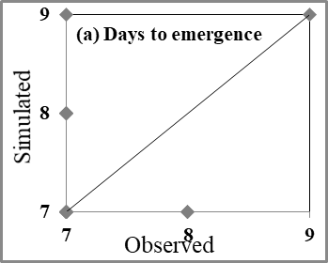 | 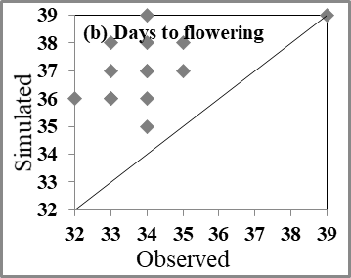
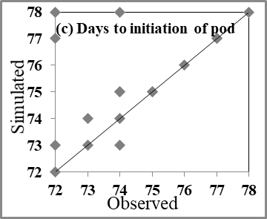 | 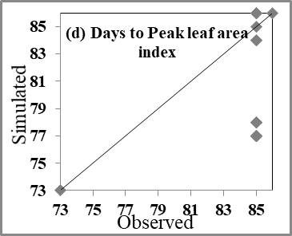
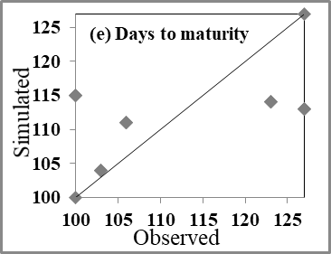 | 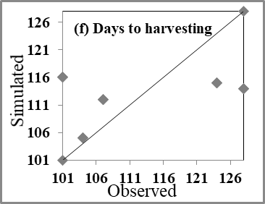
Figure 1. Mean observed and simulated (a) days to emergence, (b) days to flowering days, (c) days to pod initiation, (d) days to peak LAI, (e) days to maturity (f) days to harvesting

