RESEARCH ARTICLE

**Comparison of Remote Sensing Derived Vegetative Indices in Tirumayam Block of Pudhukkotai District**

|  |  |
| --- | --- |
|  | ABSTRACT Remote sensing data are primary sources for analyzing the environmental processes from local to global scale. Acquiring information and extracting the features in form of Spectral, Spatial and Temporal about objects, areas or phenomena, such as vegetation, land cover classification, urban area, agriculture land and water resources without coming into physical contact with these objects can be done with remote sensing. Various mathematical combinations of near-infrared bands and other spectral bands proved to be sensitive indicators of the presence and condition of green vegetation. These mathematical quantities are referred to as vegetation indices. The multispectral images are efficient in deriving the vegetation indices. In this study, Landsat 8 satellite imagery was used to interpret and explore indices like the Normalized Difference Vegetation Index (NDVI), Soil Adjusted Vegetation Index (SAVI) and Leaf Area Index (LAI) in the Tirumayam block of Pudhukkotai district. |

Keywords: Vegetation Indices, NDVI, SAVI, LAI

## INTRODUCTION

Remote sensing products are useful in viewing, classifying and analyzing areas. Based on their resolution, electromagnetic spectrum, energy source, imaging media and number of bands these data are classified. Greater satellite data resolution (spatial resolution, spectral resolution, radiometric resolution, temporal resolution) a higher degree of accuracy will achieve during classification.

Landsat 8 is the most recently launched satellite of the Landsat series. The Landsat 8 satellite images were downloaded from the USGS Earth Explorer website. Landsat 8 satellite images have two different sets of images that are from Operation Land Imager (OLI) sensor with nine bands (band 1 to 9) and Thermal Infrared sensor (TIRS) with two bands (band 10 and 11) (Roy et al., 2014).

The greenness of the leaves is illustrated by the near-infrared band (Lillesand et al., 2008). Routinely calculated simple vegetation index is normalized difference vegetation index (NDVI). The highest NDVI value is assumed to represent the maximum vegetation "greenness”. An attempt was made to improve NDVI, Huete (1988) developed a vegetation index that accounted for the differential red and near-infrared extinction through the vegetation canopy. This index called as Soil Adjusted Vegetation Index (SAVI) is a transformation technique that minimizes soil brightness influences from spectral vegetation indices involving red and near-infrared (NIR) wavelengths. The Leaf Area Index (LAI) is the ratio of the total area of all leaves on a plant to the ground area represented by the plant. It is an indicator of biomass and canopy resistance.

These vegetation attributes were used in various models to study surface albedo (Salifu and Agyare, 2012), photosynthesis, carbon budgets (Pandapotan et al., 2016), water balance, and related processes. Ramachandran et al. (2019) estimated three vegetation indexes concerning different crops grown in Lalgudi block of Trichy District, Tamil Nadu and also reported that taking satellite imagery into account for modelling greenness of different crops, would pave a roadmap for several spatial and temporal studies like biomass estimation, crop water requirement and crop management practices.

In this paper, an attempt was made to estimate the Normal Difference Vegetation Index (NDVI), Soil Adjusted Vegetation Index (SAVI), Leaf Area Index (LAI) at Tirumayam block of Pudhukkotai district. Landsat 8 satellite images with Operation Land Imager (OLI) sensor and Thermal Infrared sensor (TIRS) were used in this study.

**MATERIALS AND METHODOLOGY**

**STUDY AREA**

The study area is Tirumayam Block, which is located in the Pudhukottai district of Tamil Nad. The geographical location of the study area is 10.2471ᵒN and 78.750481ᵒ E (Fig. 1) and google earth image of the study area is shown in Figure 2. The Tirumayam Block has a total area of 564 square kilometer in which it comprises the rural area is 554.45 km2 and urban area is 9.19 km2. It’s the place where crops are grown, mainly Paddy is cultivated on large scales.

**LANDSAT 8 DATA**

Landsat 8 satellite imageries were downloaded from USGS website and the interpretation of data for two different dates has been done to compare the indices. Two Landsat images of December 2018 and December 2019 were taken for calculating the vegetation index. The particulars of the Landsat 8 images used in this study are shown in Table 1.

**Table 1. Particulars of Landsat 8 image used in this study**

|  |  |  |  |  |  |
| --- | --- | --- | --- | --- | --- |
| S. No. | Acquisition Date  (yyyy – mm – dd) | Solar Elevation Angle  (degrees) | Solar Azimuth Angle  (degrees) | Cloud Cover in image  (%) | Cloud Cover in study area  (%) |
| 1 | 2018-12-11 | 49.38 | 146.60 | 66.43 | 66.63 |
| 2 | 2019-12-03 | 50.85 | 145.43 | 99.98 | 99.98 |

***Normalized Difference Vegetation Index***

The Normalized Difference Vegetation Index (NDVI) is the most commonly used vegetation index for global observation of green conditions. Healthy vegetation is a good absorber of the visible region of the electromagnetic spectrum. Chlorophyll contains in a greeneries highly absorbs Blue (0.4 - 0.5 µm) and Red (0.6 - 0.7 µm) spectrum and reflects Green (0.5 – 0.6 µm) spectrum. Therefore, the human eye perceives healthy vegetation as green. Healthy plants having high reflectance in Near Infrared (NIR) between 0.7 to 1.3 µm (fig. 1). This is primarily due to the internal structure of plant leaves. High reflectance in NIR and high absorption in Red spectrum, these two bands are used to calculate NDVI. Using the following formula, Normalized Difference Vegetation Index (NDVI) is

 (1)

The NDVI value varies from -1 to 1. Higher the value of NDVI reflects high Near Infrared (NIR), means dense greenery. Generally, we obtain following result:

* NDVI = -1 to 0 represent Water bodies
* NDVI = -0.1 to 0.1 represent Barren rocks, sand, or snow
* NDVI = 0.2 to 0.5 represent Shrubs and grasslands or senescing crops
* NDVI = 0.6 to 1.0 represent Dense vegetation or tropical rainforest

The NDVI rate can be calculated using a raster calculator in ArcGIS.

***Soil-Adjusted Vegetation Index***

In areas where vegetative cover is low (i.e., < 40%) and the soil surface is exposed, the reflectance of light in the red and near-infrared spectra can influence vegetation index values. This is especially problematic when comparisons are made between different types of soil which can reflect different amounts of light in the red and near-infrared wavelengths (i.e., soils with different brightness values). The soil-adjusted vegetation index was developed as a revision to the Normalized Vegetation Difference Index to correct for soil brightness influence when vegetative cover is low. The SAVI is structured similar to the NDVI but with the addition of a “soil brightness correction factor”

 (2)

where NIR is the reflectance value of the near-infrared band, RED is the reflectance of the red band, and L is the soil brightness correction factor. The value of L varies by the amount or cover of green vegetation: in very high vegetation regions, L=0; and in areas with no green vegetation, L=1. Generally, an L=0.5 works well in most situations and is the default value used. When L=0, then SAVI = NDVI.

***Leaf Area Index***

LAI is a measure of the total area of leaves per unit ground area and is directly related to the amount of light that plants can intercept. It is an important variable used for predicting primary photosynthetic production, evapotranspiration, and as a reference tool for growing crops.

 (3)

Where LAI is the leaf area index and SAVI is the soil adjusted vegetation index.

## RESULTS AND DISCUSSION

***Normalized Difference Vegetation Index***

The NDVI map obtained is shown in Figure 3.Figure 3(a) which depicts the NDVI of the year 2018 gives a maximum value of 0.51 and minimum value of -0.22, while Figure 3(b) which depicts the NDVI of the year 2019 which gives a maximum value of 0.21 and the minimum value of - 0.01. From these results, it is clear that there is a decrease in vegetation in a year and we can observe that the NDVI is maximum in South East and South West parts of the study area indicating the presence of dense vegetation. The lower values of NDVI indicate the presence of water bodies which can be seen in the Northern side of the study area. similar values of NDVI were obtained for dense vegetation in the study conducted by Zaitunah et al (2018) in Indonesia.

***Soil-Adjusted Vegetation Index***

The results obtained from the processed satellite images for SAVI are shown in Figure 4. In Figure 4(a), the SAVI of the year 2018, gives a maximum value of 0.77 and minimum value of -0.33 while Figure 4(b) depicts the SAVI of the year 2019 which gives a maximum value of 0.32 and the minimum value of 0.01. From these results, it is clear that there is a slight decrease in the SAVI of the study area.

***Leaf Area Index:***

The results obtained from the processed satellite images for LAI are shown in Figure5. In Figure 5(a), the LAI of the year 2018 gives a maximum value of 13.3 and a minimum value of -0.33 while Figure 5(b) depicts the LAI of the year 2019 which gives a maximum value of 1.19 and the minimum value of 0.22. From these results, it is clear that there is a drastic and heavy decrease in the LAI of the study area. Similar to NDVI, Leaf Area Index is also maximum in South West and South East areas of the study area. However, Roberts et al. (1996) taken measurements on tropical forests, obtaining LAI values ranging from 4.63 to 6.00.

## *Conclusion*

The values of NDVI, SAVI and LAI were estimated for two Landsat 8 images taken during December 2018 and December 2019. These results indicated a decrease in vegetation, greenery, and water cover of Tirumayam block, Pudhukkotai district. The settlements, water bodies, and sand beds exhibited relatively lesser or negative values for vegetation indexes. Considering the satellite imagery for modelling the greenness of different crops, would pave a roadmap for several spatial and temporal studies like biomass estimation, crop water requirement and crop management practices.

These Vegetation Indices can be used to monitor the condition of the crops indirectly and directly guiding the farmers to overcome the struggles faced by them for farming. These results can be used to interpret the study variation of Green cover over the areal and spatial extent. It can be interpreted to study the land use land cover changes occurring in a period.

**REFERENCES**

Huete, A.R.1988. A soil-adjusted vegetation index (SAVI). *Remote Sens. Environ.* **25(3**). 295-309.

Lillesand, T. M., R. W.Kiefer, and J. W. Chipman, 2008. Remote sensing and image interpretation. Hoboken, NJ: John Wiley & Sons.

Pandapotan, J., S. Sugianto and D.Darusman, 2016. Estimation of Carbon Stock Stands using EVI and NDVI Vegetation Index in Production Forest of LembahSeulawah Sub-District, Aceh Indonesia. *Aceh Int. J. Sci.Tech*. **5**. 126-139.

Salifu, T. and W.A. Agyare, 2012. Distinguishing Land use types using Surface Albedo and Normalized Vegetative Index Derived from the SEBAL Model for the Atankwidi and Afram Sub-Catchments in Ghana. *ARPN J. Engg. App. Sci.***7(1)**:69-80.

Ramachandran, J., R. Lalitha and S. Vallal Kannan. 2019. Remote Sensing Based Greenness Modeling of Different Crops in Lalgudi Block Using Landsat 8 Image. *Journal of Soils and Crops.* **29(2)**. 232-235

Roy, D.P., M.A.Wulder, T.R. Loveland, C.E.Woodcock, R.G.Allen, M.C.Anderson, D.Helder, J.R. Irons, D.M. Johnson,R. Kennedy, T.A.Scambos, C.B.Schaaf, J.R. Schott,Y. Sheng, E.F.Vermote,A.S. Belward, R.Bindschadler, W.B.Cohen, F.Gao, J.D.Hipple, P.Hostert, J. Huntington, C.O.Justice, A.Kilic,V.Kovalskyy, Z.P. Lee, L.Lymburner, J.G.Masek, J.McCorkel, Y.Shuai, R. Trezza, J. Vogelmann, R.H. Wynne, and Z.Zhu, 2014. Landsat-8: Science and product vision for terrestrial global change research. *Remote Sens. Environ.***145:154**–172.

Zaitunah, A., Ahmad, A. G., & Safitri, R. A.2018. Normalized difference vegetation index (NDVI) analysis for land cover types using landsat 8 oli in besitang watershed, Indonesia. In *IOP Conference Series: Earth and Environmental Science* .Vol. **126: 1**, p. 012112.

Roberts, J. M., Cabral, O. M., Costa, J. D., McWilliam, A. L. C., & Sá, T. D. A.1996. An overview of the leaf area index and physiological measurements during ABRACOS. *GASH, JHC; NOBRE, CA; ROBERTS, JM; VICTORIA, RL Amazonian deforestation and climate. Chichester: John Wiley & Sons*.

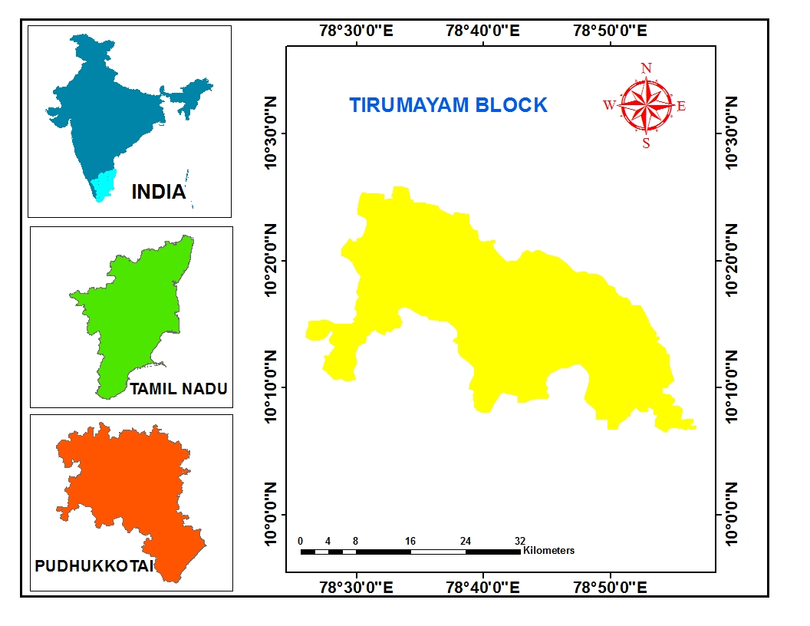

**Figure 1 study area**

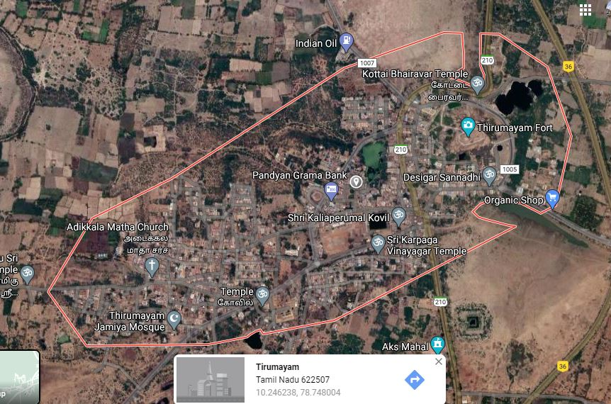

**Figure 2. Google Earth image of the study area**

|  |
| --- |
| **3(a)** |
| **3(b)** |

|  |
| --- |
| **Figure 3 comparison of Normalized Difference Vegetation Index** |

|  |
| --- |
| **4(a)** |
| **4(b)** |
| **Figure 4 Comparison of Soil Adjusted Vegetation Index** |
| **5(a)** |
| **5(b)** |
| **Figure 5 Comparison of Leaf Area Index** |