

*Madras* 4g*rtoJ .,* 2020; doi: zzzxz›az

Trali

u

**nefIcIa”des In Dharmapud Dlstdct of Tamil**

ABSTRACT

The Mahatma Gandhi National Rural Employinent Guarantee Act (MGNREGA),.guarantees 100 days of employment in a financial year to any rural household who5e adult members are willing to do ”unskilled” manual work. A study was “undertaken’ to“ assess the training needs of MGNREGS beneficiaries in Dharmapuri district, oné of the most backward districts”of Tarnfl Nadu’. Proportionate random, sampling ’method was uspd to select

120 ”respondents for .this study from the selected **panchayats.** The”datp

**was collected using a well structured and pre-tested interview schedulé**

and appropriate statistical tools were. used for **analysis.** The **findings** of the study reve9l that majority of the respondents **expr.essed** trainifjg needs on seven major su.bject areas i.e. Checking multiple entries in job cards, active participation ” in gi’a”m. sab.ha. meetings; operations.of savings accounts in banks/. post office, Active ”participation in social audit, work allocation procedure. and .airedess on grievance addressél ” mechanisms. Majority preferred to have peripatetic training in .their panchayat union Office for a day’during sum”mer **season** during forenoon"session.

**Keywords: MGNRE** , Train“ing need areas & Training methods

### INTR.ODUCTION

The ,Mahatma Gandhi National Rufél Erriployment Guaranted”A«t (hjGNREGA) is. the.largest social security scheme in the world’ implemented .in our natiqn.: This .schema provide9” a legal” guaranteb for one hundred.days of employment in every financial year to aduk members of any rural household. willing to do public related unskillbd”rrianual work at the statutory minimum wage.. The objective of the sche’me is.to enhance livelih and food”security to rural peopla by providing assured wage employment for a minimum of 100 days in a financial year for the household .whose adult member is willing to **do unskilled** manual worM. The creation of durable. assets from these ma”nuaI worM would help in soil and water conservation towards natural **resource** conservation..This loag term benefit of environmental enhancement is expected to increase farm production and productivity. Social security measures including poverty alleviation, employment generation programmes are also’ important components of this scheme. MGNREGA started in three phases, first .ph”ase. in 2006 covering 200 districts, second phase in 2O07- 2008 covering another 130 districts and in the third and final phase, the remaining districts have been notified under NREGA with effect from 1•* April 2008. Our”entire nation was brought under the purview of MGNREGA with priority gfven. to w6mén pay parity and gender equality. Being. implé'mented in the lean season of the year, study on raining needs is more important for the successful imptementation of” this “programme for ”reaching its intended objectives. So ”keeping th!s in view, a Mudy was undertaken **to assess** the training needs ”of MGNRE beneficiaries ‹n Dharmapuri dist*!Ct of Tamil Nadu.

### RESEARCH METHODOLOGY



Dharmapuri district in” Tar0il Nadu Is one of the” most **backwanls** districts as kindled by the ”State Pinning .Commission. It **hashbk›cks** viz, Dharmapuri, Karimangalam, Nallampalli, Pappireddl , Harur, Morappur, I?aIakKodu ririag8ram. Among these”bbd‹s Pennagaram **block** was. **purpécivdy”** selécted .for”this Judy his”there was more number.of. beneficiaries. bred under this social welfare scheme. Proportionate random sar«niing method”was used to” seléct 120 respondents. Thé data was céllected using a well

,strutured ihterview **schedu.ie.”.** Necessary efforts were made to cross ”check the data collected ”from

respondents In this study.”The findings of this study are given below.

*Madras 4gric.J.,* 2D2O; doi:xzxxzxxxx

**Training Needs of MGNREG**

## ABSTRACT

The Mahatma Gandhi National ”Rural Employment . Guarantee Act (MGNREGA), guarantees 100’ days of employrñent in a financial year to any rural household whose adult members are willing to do unskilled manual work. A study was undertaken to assess the training needs. of MGNREGS beneficiaries i.n Dharmapuri district, one of the most backward. dimricts of Tamil Nadu. Proportionate random ”sampling method was used to select 120 respondents for this study from the .selected panchayats. The data was collected using a I well structured and pre-tested interview schedule and appropriate statisticsl tools were used for analysis. The findings oflhe study reveal thât.majority of the respondents **expressed** training needs.on seven major subject areas.i.e. **Checking** multiple entries in’job cards, active participation in gram ”sabha meetings, operations **of savings** accounts in **banks/ post** office, Active ”pa’rticipation” in. social audit, work alloMtion **procedure** and. **awareness on** grievance addressal rñechanisms. Majority **preferred to** have. peripatetic trai”ning in their **panchayat** union. office for a day during summer season during forenoon session.

#### **Keywords:** MGNRE ; Training need areas & Training methods

**INTRODUCTION**

The. Mahatma Gandhi’ National’ Rural Employment Guarantee Act (MGNg”EGA) is. the largest social security scheme in the world implemented in our nation. This"scheme p”rovideé”a legal guarantee for. one hund”red days of employment in every financial year to adult mémbers of”any rural household willing té do public related unshllled .manual worh at the statutory minimum wage.. The objective of the scheme s”to enhance livelihood and.food security to rural people by providing assured wage employment for a minimum. of 100 days in a financial year for ’the household whose adult member is willirig to do u”nskiIIed . manual works. The creation of du,rable assets from these manual works would help in soil and wate.r conservation towards natural resource conservation. This long term benefit of environmental enhancement is expected to .increase farm production and productivity. ” Social security measures including poverty alleviation, emplbyment generation.programmes are also important components .of this scheme. MGNREGA started in three phases, first phase in 2.006 covering 200 districts, second phase in 2007- 2008 covering another

130. d’istricts and in t1e third and final phase, th’e remaining districts have b”een notified urider NREGA with effect’ from 1•’ April t2008. Our entire nation was brought under the purview of MGNREGA with priority given to women pay parity and gender equality. Being implemented in the. lean season of the year, study on raining needs is more important for the .successful implementation .of this programme for reaching its intended objectives. So keeping this in view, a study was undertaken to assess. the training needs Sof MGNRE beneficiaries in Dharmapuri district of lamiI Nadu.

## RESEARCH. METHODOLOGY



**random sampling method was used” to. select ’120 respondents. The data was collected** using.a **well** structured” interview **schedule.. Necessary** effoM were made to crash ”check the data collected” from **respondents in** this **study. The”findings of** this **study** are given below.”

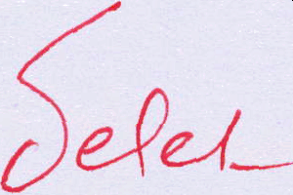

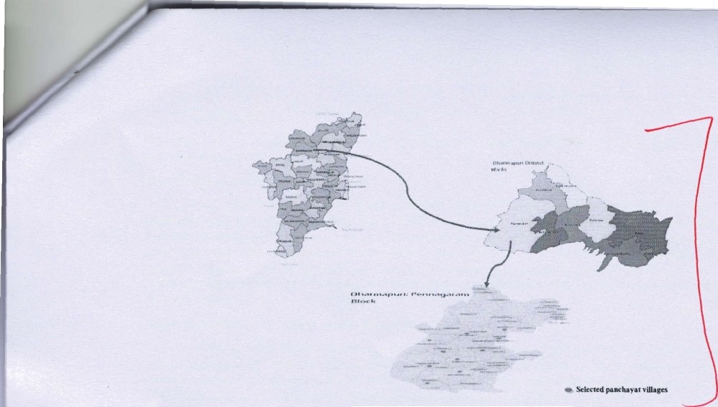Figure.1: Map showing the mudy area

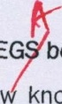FINDINGS AND DISCUSSION

Major Training need areas for MGNRE **beneficiaries**

#### Training is essential to gain ne knowledge and acquire new skill sets. The training need of the respondents in the study srea, needed training methods and strategies are discussed below.

Table- 1. Training need areas @ (¿»

Training need a

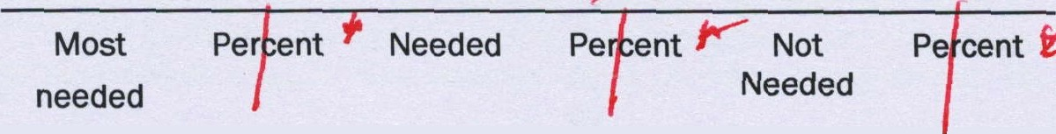

S.No

Most

**needed**

Per ent

Needed Pe nt

Not Needed

P cent U

#### Cheching multiple entries 109 90.84 11 9.16

#### in job card

#### Active participation in 109 90.84

#### Grama sabha meetings

11 9.16

1. Operation of savings 102 85.00

accounts in bank/ post

|  |  |  |  |  |  |  |
| --- | --- | --- | --- | --- | --- | --- |
| office |  | | | | | |
| 4. Active participation in  **social** audit | 102 | 85.00 | 11 | 9.16 | 7 | 5.84 |
| 5. Work allocation | 95 | 79.16 | 10 | 7.34 | 18 | 13.50 |
| 6. **nces**  ’ | ’5 | 79.16 | 22 | 18'34 | 3 | 2.50 |
| 7. Getting job card | 80 | 66.66 | 7 | 5.84 | 33 | 27.5 |
| 8. Opening up of banh account/ post office savin s | 60 | 50.00 | 49 | 40.84 | 11 | 9.16 |
| 9. Rights differently |  |  | 11 | 9.16 | 109 | 90.84 |

7 5.84 11 9.16



procedure

**meeha s**







/Pregnant ladies/

#### Transgender in

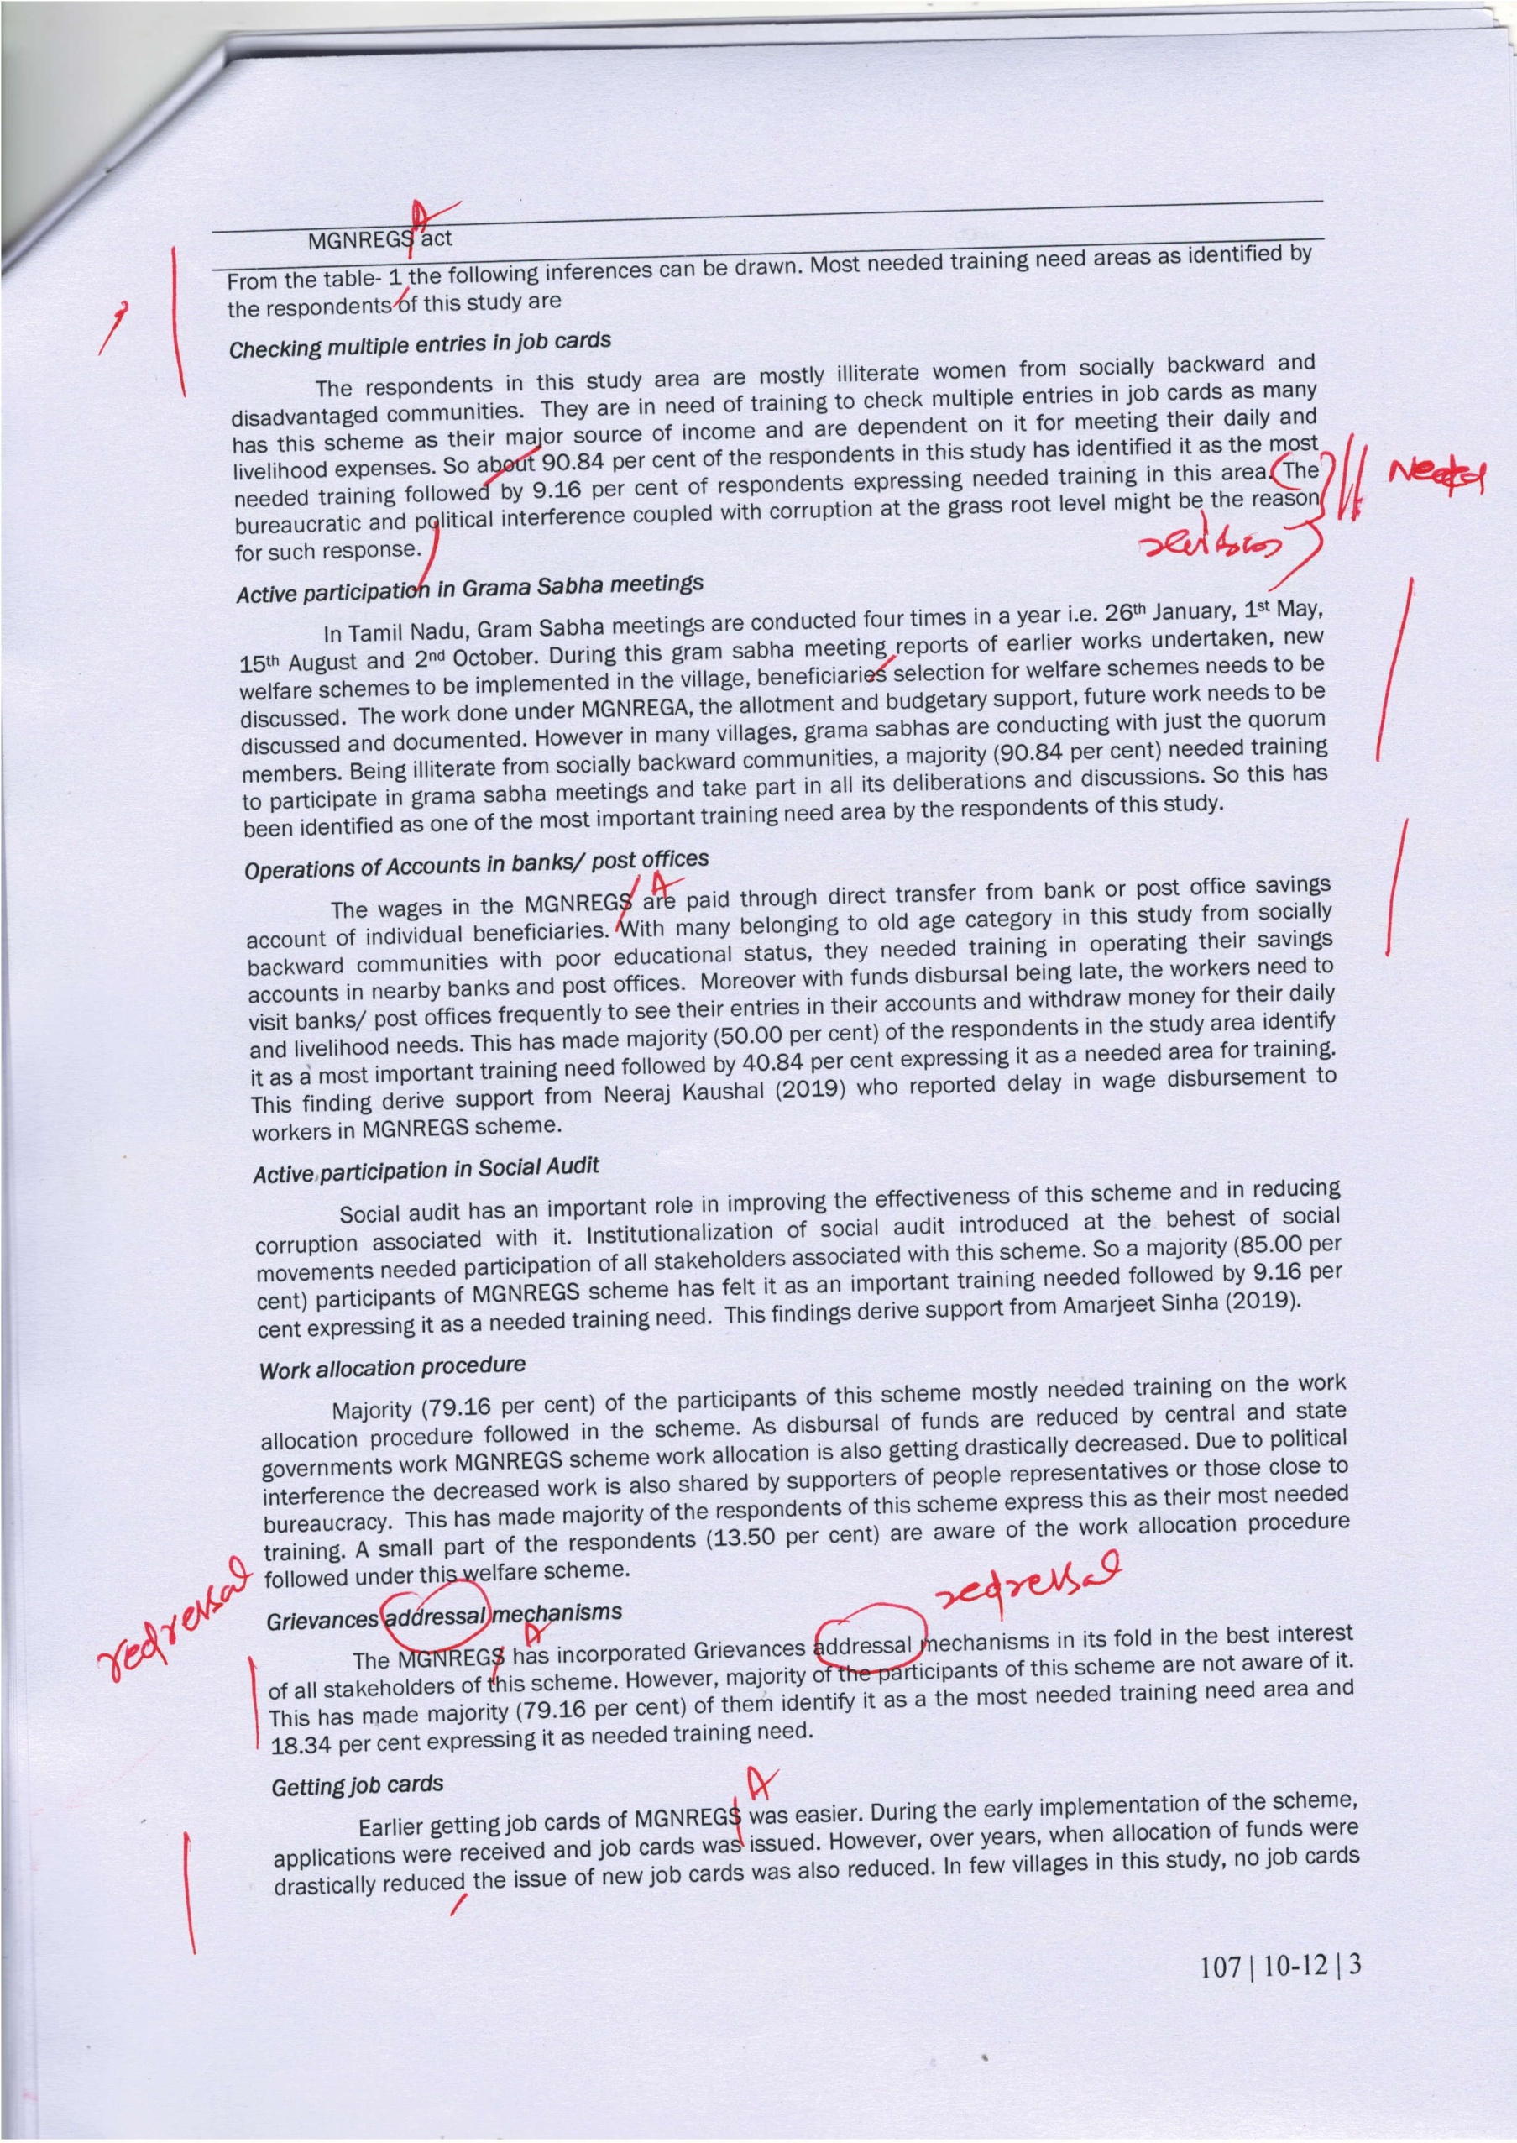

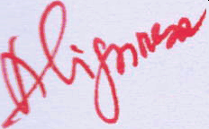



were issued for a very long period as the names has to be entered in the e-muster rolls for getting job cards and shortage of employment assistants (Gram Rozgar Sevaks) in panchayats made getting job cards becoming a difficult tasft at the grassroot level. So there was a great need for getting job cards in villages during distress times. This has been identified as a most important training need by a majority (66.66 per cent) of the respondents in this study. One third of the respondents do not need training as they have job cards and are not in need of any new job cards for their family members.

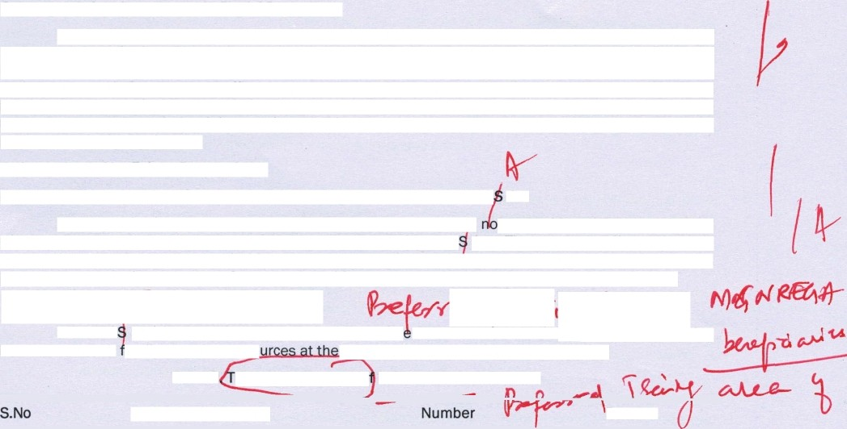

Opening tip of savlng account In Bank Post offices

Many of the respondents in the scheme received wages in their hand in the earlier stages of implementation of this **scheme.** However, to prevent corruption wages were paid through Direct Transfer Mechanisms (DTMs) in the accounts of beneficiaries in near post offices or banks. Many have started savings account in bank or post offices to receive their wage payments. However, there is a still a huge need for opening savings account in banks and post office for receiving their wages. This has made them regard it as a most needed training need by 50.00 per cent and needed training by 40.84 per cent of the respondents in the study area.

**Training** Needs Not Felt **by Respondents**

*Rights* old/fferent/yad/ed/Pregnant lad/es/ ***Transgender*** *under MGNREG Act*

Majority (90.84 per cent) of the respondents in the **scheme** do I need this training on the rights of differently abled/pregnant ladies and transgender under MGNREG Act. There was no differently abled/ transgender people associated with this scheme in the study area. Pfegnant ladies are not allowed to be a part of this scheme in rural areas. So a meager 9.16 per cent has expressed training need on this Act.

*TrainingPaces*ol' MGNRE Benef?c/arfes t

MGNREG stakeholders has **expressed** their prefer nces on various traini ‹ing into account their ’amily situation, resg iCj:disposal and time of farming activities.

Table2 raining **Preference** o MGNREGS **Beneficiaries**





Summer

Winter

92

28

**76.67**

**23.33**



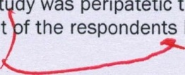From the table- 2 the following inferences are drawn. Regarding the most needed training preference as identified by majority (80.00 per cent) of the respon ents in this st dy was peripatetic training followed by 20 per cent preferring institutional training. 90.00 per cent f the respondents has preferred their

|  |  |  |
| --- | --- | --- |
|  | | |
| Training preferences |  | Percent |
| Type of Training | | |
| Peripatetic training | 96 | 80.00 |
| Institutional training | 24 | 20.00 |
| 2. Venue of Training | | |
| Panchayat office | 108 | 90.00 |
| Village School | 12 | 10.00 |
| Duration | | |
| One day | 108 | 90.00 |
| Two days | 12 | **10.00** |
| 4. Timing of Training | | |
| Forenoon | 84 | 70.00 |
| Afternoon | 36 | 30.00 |
| 5. Season of Training | | |

own pandhayat union office followed by 10.00 per cent preferring their village school.. Most of the ” re9pondents (90.00 per cerit) preferred oñe day”training programme and only 10.00 per cent needed training for two day period. Majority (70.00 per cent) of the respondents preferred. forenoon trainihg and remaining 30.00 per cent preferred afternoon trainings. More than three fourth (76.67 per cent) prefer asummer season for training and. the rest 24.33 per cent of the respondents”prefered winter season.

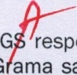CONCLUSION

It could be concluded from the above study that, majority to the MGNRE. ” respoñdents in this

.study .iden.tified bthe Checking multiple entries in job card, Active participation i”n ”G ma sabha meetings, Opening. up of banh accounts’ post office savings, Active participation in social audit, Work allocation

I ”procedure, Grievances”Addressal mechanisms, Getting job card an.d operation of accounts“ina.banks’ post ”offibe as most”needed training .need:”areas... Majority of the responderits” preferred. to have. peripatetic ”trai”ning in” their ”owri panchayat uriion office for a day during spinmer Reason on forenoon. Our. policy pIanners,”Administrators, Extension professionals need to make efforts to train MGNREGS beneCciaries .on lheir felt.needs to make it more efféctive”and reach its‘intended benefits.

REFERENCES “

Arti .Pandit Dhawan and. éjay Kumar;/ 2017. Socio economic. impam ”of .Mahatma Gandhi National Rural Employment ” Guarantee Scheme . **(MGNREGS). in Himachal Prad,esh; International** Journal of Commerce and Managemeht Research. Vol.3(11): 01-08.

Amarjeet Sinha, 2019. Making”MGNREGS more useful; Times of India dated 22a NoV”ember.

éshokkumar, H. 2016. Performance of MGNREGA:in .Mysore Distrim, Karnataka,” International .Journal. of Research in Humanities and Social Studies, Vot.3: 1-7.

Badodiya, S.K., R:S. .Kushwah, S.K.. Garg and ’S.K. Shakya. 201L Impact of Mahatma Gandhi National Rural. ’Emplo.ymerit” Guarañtee ”Act” (MGNRE .) on Poverty Alleviation, .Rajasthan Jou”rnal of Extension Education, Vol.19: 206-209.

Benni, B.S. and J.Nagargja.. 2017. Women empowerment through Mahatma Gandhi” .National Rural’ Guarantee Act (MGNREGA). in Ballari District of. Karnataka.State, IOSR Journal. of Humanities and Social Science,.Vol.22: 2&30.

Gopinathan "Rathika and Ramachandran Azhagaiah. 2017. Soci’o- Econorñic Determipants of **Unskilled** Workers of MGNREGA: A Study with Reference to Villianur Block of Puducherry Region, Pacific Bdsiness’ Review Intematlonal, Vol.9: 100-111 ”

Gowhar §ashir Ahan$ar. 2014. Women Empowerment through MGNREGA: A Study of Shahabad District ”BlocM .of Anantnag,” Jamfriu ”and Kashmir, “National Monthly Refe’rred Journal of Res¥trch in” ”Commerde and Management, Vol.3: 22•25.

Jeao Drpzé, 2020.. The need for a million worksites nd, The Hindu dated 25* May.

Kunjithapatham,' KB. arid. D. Anañd. 201,5. Role of Mahatm;a .Garidhi. Natloñal Rural. ,Employment Guarantee Scheme and its Impact. on the Upliftment of !tural .Population in Thiruvannamalai Distirct, Scholars Journal of Economics, Businéss and Management 2(12): 11?’2-1176.

Karma Loday Tamag, Bhuwan. chhetri and Sandhya Devi ”Thapa.2016. Achieverñents and Constraints of MGNREGA in Sikkim, International Reséarch Journal of Commerce”ArB and **Science, 7(9):** 58-64.



Palanidurai, G.” 2017. Unexpected consequences in Mahatma Gandhi National Rural Erñployment ” Gu”arantee Scheme, Janasakthi dated.16 April.

Thirumal .Kannan,.V. 2019. SWOT Analysis ”on ”Mahatma Gandhi Rural Employment Guarantee **Scheme.**

.(MGNREGS).e in. Dharmapuri District, Unpublished.. M.Sc ”( ) Thesis, Annamalai University, Annamalai Nagar -808. 002.