Title: Adenine Base Editor Creates Novel Substitution Mutations in eIF4G Gene of Rice

ABSTRACT
Two single nucleotide polymorphic mutations and deletion affecting Y¹⁰⁵⁹V¹⁰⁶⁰V¹⁰⁶¹ amino acid residues in a host translation initiation factor four gamma (eIF4G) gene in rice is reported to confer resistance to rice tungro spherical virus in resistant genotypes. A CRISPR based adenine base editing vector was used to target these residues in a susceptible indica cultivar, ASD16. Agrobacterium-mediated transformation of ASD16 generated 16 missense mutants and two deletion mutants. Substitution mutations occurred at A₅ > G₅ and A₄ > G₄, where 5.5 % and 3.37 % of adenosines got converted to guanosines respectively. The mutants generated had missense mutations affecting the YVV residues as well as the residues immediately adjacent to YVV. Thus, these novel mutations are promising candidates in imparting resistance against rice tungro disease.

Keywords: Rice; Adenine base editors; eIF4G

INTRODUCTION
RTD causes severe yield losses in rice growing endemic regions of South and Southeast Asia (Herdt, 1988; Azzam and Chancellor 2002; Muralidharan et al., 2003). RTSV along with its counterpart RTBV (Rice tungro bacilliform virus, a dsDNA virus), is responsible for rice tungro disease (RTD) (Bunawan et al., 2014). Management of tungro disease via development of broad-spectrum resistance through suppression of RTSV has been the preferred choice since rice plants infected with RTBV exclusively is incapable of spreading the disease. Thus, RTSV resistant cultivars rather than RTBV could successfully reduce the incidence of tungro disease in the field (Hibino, 1996; Anjaneyulu et al., 1995; Lee et al., 2010). Host-pathogen interaction studies of disease causing plant viruses reveal that majority of RNA viruses exploit the host machinery to perform their life cycle (Dreher and Miller, 2006; Pyott et al., 2016; Li, 2019). Rice tungro spherical virus (RTSV) is one such RNA virus which leverages a host translation initiation factor four gamma (eIF4G) gene of rice to replicate and establish within rice plant (Lee et al., 2010).
Lee et al. (2010) identified that naturally available cultivars resistant to RTSV had nucleotide polymorphisms and deletions affecting Y¹⁰⁵⁹V¹⁰⁶⁰V¹⁰⁶¹ amino acid residues in eIF4G gene in japonica genotypes. The mutations resulted from substitutions at nucleotide positions 4387 (A > G) and 4390 (T > C). This suggested that mimicking of such naturally occurring mutations in susceptible genotypes would be successful in imparting tungro disease resistance in target cultivars.
The latest tool of genome editing via base editors have unravelled the possibilities of creating highly specific targeted substitution mutations in the host genome (Komor et al., 2016). ABEs convert an A•T base pair to a G•C base pair, while CBEs convert a C•G base pair into a T•A base pair (Gaudelli et al., 2017; Komor et al., 2016). Unlike the Cas9 of CRISPR/Cas9 system, which has two nuclease domains, the Cas9 in base editors have only one active cleavage domain and hence, the Cas9 in base editors is referred to as nCas9/Cas9n (nickase Cas9) or dCas9 (dead Cas9). This nCas9 or dCas9 is fused to cytosine deaminase (in case of CBEs) or adenosine deaminase (in case of ABEs) that characterize a base editor pair (Gaudelli et al., 2017; Komor et al., 2016). Of the two base editors, ABE has been widely accepted for base editing in rice crop as CBEs were found to induce unintended off-target mutations and have low editing efficiency (Jin et al., 2019; Hao et al., 2019). A series of adenine base editing vectors have been developed within a short span of four years, to yield maximum A > G substitution with negligible non-canonical substitutions (Gaudelli et al., 201; Li et al., 2018; Kim et al., 2019). An adenine base editor, ABE7.10 has been reported to be effective in creating high substitution mutations, upto 59.1 % in a japonica rice variety, Zhonghua 11 (Lee et al., 2018). Considering the efficacy and specificity of ABE, the the plasmid harbouring ABE7.10, pH-PABE-7-esgRNA (Lee et al., 2018) was used in the present study to create substitution mutations in the YVV residues of eIF4G gene of indica cultivar, ASD16, to impart resistance against rice tungro disease.

MATERIAL AND METHODS
Design of sgRNA and construct development
The nucleotide sequence of eIF4G gene in indica genotype, bearing gene ID: BGIOSGA025931 was retrieved from EnsemblPlants. Single guide RNA (sgRNA) was designed using this sequence information with the web based tool, Chop Chop (Labun et al., 2016). An sgRNA sequence encoding for GKSYVVD amino acid residues was designed with top strand: 5’ AATCAACAACATAAGACTTTC 3’ and bottom strand: 5’ GAAAGTCTTATGTTGTTGATT 3’. BsaI adaptors, 5’ GGCG 3’ and 5’ AAAC 3’ were added to the oligos during synthesis to complement their ligation into BsaI restricted plant adenine base editing vector, pH-PABE7-esgRNA. The pH-PABE-7-esgRNA was a gift from Dr. Caixia Gao (Addgene plasmid # 115620; http://n2t.net/addgene:115620; RRID: Addgene_115620) (Li et al., 2018). The recombinant vector (Fig. 1) harbouring the sgRNA was mobilised into Agrobacterium strain, LBA4404 by triparental mating.
Agrobacterium-mediated rice transformation
Agrobacterium culture harbouring the recombinant plasmid was used to transform a RTD susceptible indica cultivar ASD16, a cross derivative of ADT 39 and CO 51. Immature seeds (14-16 days after flowering) of ASD16 were collected from Paddy Breeding Station, TNAU. Embryos were isolated from these seeds and used as explants for Agrobacterium-mediated transformation following the protocol of Hiei and Komari (2008). Well proliferated and friable yellow calli were subjected to two rounds of stringent selection in 50 mgl⁻¹ of hygromycin B. The calli that survived on hygromycin selection were subcultured onto pre-regeneration, regeneration and rooting media. Regenerated plants with well-developed roots were hardened and maintained in transgenic greenhouse.

On-target mutation analysis of putative T₀ mutants by Sanger sequencing
Plant genomic DNA was isolated from T₀ putative mutants and ASD16 wild type following CTAB method (Porebski et al., 1997). Molecular analyses by PCR for hpt (hygromycin phosphotransferase) and cas9 genes were performed using sequence specific primers to confirm that the putative mutants developed had T-DNA with genes required for editing (Table 1). Target region encompassing the sgRNA sequence was amplified with eIF4G primers (eIF4G F and eIF4G R; Table 1) in PCR positive mutants. PCR amplicons were purified (NucleoSpin Gel and PCR Clean-up Kit, Machery Nagel) and Sanger sequenced (Eurofins, Bengaluru).
Analysis of results obtained from Sanger sequencing was performed using web-based tools, DSDecodeM (http://skl.scau.edu.cn/dsdecode/) (Xie et al., 2017; Liu et al., 2015) and CRISPR-ID (http://crispid.gbiomed.kuleuven.be/) (Dehairs et al., 2016) to identify the position of substitution mutations in the sgRNA sequence. The percentage of substitution contributed by a base at a specific position in the sgRNA sequence was predicted using web based tool, EditR (http://baseeditr.com) (Kluesner et al., 2018). Base substituted mutants with missense mutations were identified based on these results.

RESULTS AND DISCUSSION
Agrobacterium-mediated transformation of ASD16
Agrobacterium-mediated transformation of elite rice cultivar ASD16, with the strain LBA4404, harbouring the recombinant plasmid pH-PABE7-esgRNA+sgRNA was successful in generating 139 independent events from 22 batches of co-cultivation, comprising of 2220 immature embryos. This gave an average transformation efficiency of 6.26 % (Table 2).
Identification of on-target mutations harbouring missense mutations
Molecular characterization of T₀ putative mutants by PCR for the presence of hpt and cas9 genes confirmed successful integration of T-DNA in all the 139 independent events generated (Fig. 2a and Fig. 2b). The sgRNA sequence has 4 adenine (A) residues in the editing window at positions A_{4,} A_{5,} A₇ and A₈. Substitution mutations at A₅ and A₈ will lead to missense mutations as A₅ > G₅ and A₈ > G₈ would result in V > A missense mutations at both the positions, while A₄ > G₄ and A₇ > G₇ would result in silent mutations. Sanger sequencing analysis of the T-DNA positive mutants identified 16 events harbouring missense mutations and two harbouring deletion mutations (Table 2). All the substitution mutations observed were in monoallelic form. Out of the 16 missense mutants, 14 had one missense mutation, while two mutants had two missense mutations (YK-ASD16-141 and YK-ASD16-150) (Table 3). Majority of the mutants (13 mutants) had substitution mutations at A₄ and A_{5.} No substitution mutations were detected at A₇ and A₈ positions. At A₅, 5.5 % of the adenosines were converted to guanosine while at A₄, 3.37 % of adenosines were converted to guanosine (Fig. 3). No silent mutation, arising from A₄ > G₄ alone, was observed and all the 5 mutants which had A₄ > G₄ substitution was observed along with A₅ > G₅. Four mutants (YK-ASD16-141, YK-ASD16-150, YK-ASD16-147 and YK-ASD16-151B) had substitutions immediately upstream of the YVV residues, resulting in S > F, while one mutant (YK-ASD16-234) had substitution downstream, resulting in D > H. These novel mutations are in close proximity to the YVV residues which were reported earlier by Lee et al. (2010) in naturally available resistant genotypes. Macovei et al. (2018) reported that CRISPR/Cas9-mediated genome edited rice mutants targeting a stretch of 14 amino acid residues ‘SVLFPNLAGKSYVV’, could successfully confer resistance against rice tungro disease. Thus, the 16 missense mutants with substitutions affecting YVV residues as well as residues immediately adjacent to YVV residues could serve as promising candidates for imparting resistance against rice tungro disease.
The two deletion mutants (YK-ASD16-246 and YK-ASD16-354) had similar mutations of homozygous deletion of three nucleotides ‘GTT’, encoding for valine in the target GKSYVVD residues (Table 3). Observations of such deletion mutants with adenine base editors have also been reported earlier with low frequency (Li et al., 2018; Li et al., 2021). This mutation observed in the two deletion mutants were similar to that of the naturally available resistant genotype, TKM 6, which had deletion of the V residue (Lee et al., 2010). They will serve as promising candidates in imparting resistance against tungro disease. Thus, a total of 18 mutants were identified giving a mutation efficiency of 12.95 % (Table 2).
Besides the canonical A > G substitution, we have also observed non-canonical substitution of G > A at 14th position of the sgRNA sequence. At G₁₄, 1.78 % of the guanosines got converted to adenosine (Fig. 3). Similar observations on non-canonical editing using adenine base editors and more precisely, ABE7.10 have also been reported earlier (Lee et al., 2018; Kim et al., 2019, Jeong et al., 2020). A possible explanation to this observation is the role of the adenosine deaminase enzyme. Unlike cytosine base editing, adenine base editing does not occur spontaneously in vivo as no enzymes are known to deaminate adenine in DNA (Gaudelli et al., 2017). Thus, the deaminase enzyme used in the construction of ABE 7.10 is sourced from E.coli (ecTadA, E.coli tRNA specific adenosine deaminase). The ecTadA enzyme harbours common catalytic site for deamination of both cytosine and adenine residues (Jeong et al., 2020). This explains the non-canonical substitutions of cytosine to adenine/thymine/guanine while using an ABE7.10 in human and mouse cells (Lee et al., 2018; Kim et al., 2019, Jeong et al., 2020). Such cytosine substitutions were favoured when C is present in a TC*N fashion and the editing window was limited between 5-7 bp (Lee et al., 2018; Kim et al., 2019).

CONCLUSION
The present study is a report on the application of adenine base editing vector systems in creating targeted base substitution in indica rice. The successful generation of eIF4G mutants in the local elite cultivar ASD16 harbouring mutations similar to that of naturally available tungro resistant genotypes has the potential to imparting tungro disease resistance. The inheritance of mutation need to be studied in subsequent T₁ and T₂ generations. Their performance need to be assessed in homozygous T₂ progeny by conducting bioassay against rice tungro virus. Besides, their agronomic performance also need to be compared with that of the ASD16 wild type in T₂ population. These promising mutants in ASD16 background can be used directly for cultivation or as a parent to introgress the trait to other elite genotypes, once characterised for RTD resistance.

Funding and Acknowledgment
The authors would like to thank ICAR-NASF (ICAR/CRISPR-Cas-7003/2017-18) for the funding and Department of Plant Biotechnology, Centre for Plant Molecular Biology and Biotechnology, Tamil Nadu Agricultural University, Coimbatore for the facilities. YK also thank ICAR-NASF for the fellowship.

REFERENCES
Anjaneyulu, A., Satapathy, M. and V. D. Shukla. 1995. Rice tungro. Science Publishers, Inc.
Azzam, O., and T. C. B. Chancellor. 2002. "The biology, epidemiology, and management of rice tungro disease in Asia." Plant Dis. 86(2):88-100.
Bae, S., Jeongbin P. and J-S. Kim. 2014. "Cas-OFFinder: a fast and versatile algorithm that searches for potential off-target sites of Cas9 RNA-guided endonucleases." Bioinfo., 30(10):1473-1475.
Bunawan, H., Dusik, L., Bunawan, S. N., and N. M. Amin. 2014. Rice tungro disease: From identification to disease control. World Applied Sci. J., 31(6), 1221-1226.
Dehairs, J., Talebi, A., Cherifi, Y. and J. V. Swinnen. 2016. "CRISP-ID: decoding CRISPR mediated indels by Sanger sequencing." Sci. Rep., 6(1): 1-5.
Dreher, T. W. and W. A. Miller. 2006. Translational control in positive strand RNA plant viruses. Virology, 344: 185–197.
Gaudelli, N. M., Komor, A. C., Rees, H. A., Packer, M. S., Badran, A. H., Bryson, D. I. and D. R. Liu. 2017. Programmable base editing of A• T to G• C in genomic DNA without DNA cleavage. Nature, 551(7681): 464-471.
Hao, L., Ruiying, Q., Xiaoshuang, L., Shengxiang, L., Rongfang, X., Jianbo, Y. and W. E. I. Pengcheng. 2019. CRISPR/Cas9-mediated adenine base editing in rice genome. Rice Sci., 26(2): 125-128.
Herdt, R. W. 1988. Equity considerations in setting priorities for third world rice biotechnology research. Development: Seeds of Change, 4: 19–24.
Hibino, H. (1996) Biology and epidemiology of rice viruses. Ann. Rev. of Phyto., 34(1):249-274
Jeong, Y. K., Lee, S., Hwang, G. H., Hong, S. A., Park, S. E., Kim, J. S., Woo J. S. and S. Bae. (2020). Precise adenine base editors that exhibit minimized cytosine catalysis. Nat. Biotechnol.,1: 1-8.
Jin, S., Zong, Y., Gao, Q., Zhu, Z., Wang, Y., Qin, P., Liang, C. Wang, D., Qiu, J. L. and F. Zhang. 2019. Cytosine, but not adenine, base editors induce genome-wide off-target mutations in rice. Sci., 364(37): 292-295.
Kim, H. S., Jeong, Y. K., Hur, J. K., Kim, J. S. and S. Bae. 2019. Adenine base editors catalyze cytosine conversions in human cells. Nat. Biotechnol., 37(10): 1145-1148.
Kluesner, M. G., Nedveck, D. A., Lahr, W. S., Garbe, J. R., Abrahante, J. E., Webber, B. R., and B. S. Moriarity. 2018. EditR: a method to quantify base editing from Sanger sequencing. CRISPR J., 1(3): 239-250.
Komor, A. C., Kim, Y. B., Packer, M. S., Zuris, J. A., and D. R. Liu. 2016. Programmable editing of a target base in genomic DNA without double-stranded DNA cleavage. Nature, 533(7603): 420-424.
Koressaar, T. and M. Remm. 2007. Enhancements and modifications of primer design program Primer3. Bioinfo., 23(10):1289-91
Labun, K., Montague, T. G., Gagnon, J. A., Thyme, S. B., and E. Valen. 2016. CHOPCHOP v2: a web tool for the next generation of CRISPR genome engineering. Nucleic Acids Res., 44(W1): W272-W276.
Lee, J. H., Muhsin, M., Atienza, G.A., Kwak, D. Y., Kim, S. M., de Leon, T. B.,Angeles, E. R., Coloquio, E., Kondoh, H. and K. Satoh. 2010. Single nu- cleotide polymorphisms in a gene for translation initiation factor (eIF4G) of rice (Oryza sativa) associated with resistance to Rice tun- gro spherical virus. Mol Plant-Microbe Interact., 23: 29–38.
Lee, H. K., Willi, M., Miller, S. M., Kim, S., Liu, C., Liu, D. R., and L. Hennighausen. 2018. Targeting fidelity of adenine and cytosine base editors in mouse embryos. Nat. Commun., 9(1): 1-6.
Li, J., Wenxia Y., Shisheng H., Susu W., Liping L., Jiankui Z., Yu C., Xingxu H. and Q. Yunbo. 2021. "Structure-guided engineering of adenine base editor with minimized RNA off-targeting activity." Nat. Commun., 12 (1):1-8.
Li, C., Zong, Y., Wang, Y., Jin, S., Zhang, D., Song, Q., Zhang, R. and C. Gao. 2018. Expanded base editing in rice and wheat using a Cas9-adenosine deaminase fusion. Genome Bio., 19(1): 1-9.
Macovei, A., Sevilla, N. R., Cantos, C., Jonson, G. B., Slamet-Loedin, I., Cermak, T., Voytas, D. F., Choi, I. R. and P. Chadha-Mohanty. 2018. Novel alleles of rice eIF4G generated by CRISPR/Cas9-targeted mutagenesis confer resistance to Rice tungro spherical virus. Plant Biotechnol. J., 16 (11): 1918-1927.
Muralidharan, K., D. Krishnaveni, N. V. L. Rajarajeswari, and A. S. R. Prasad. 2003. "Tungro epidemics and yield losses in paddy fields in India." Current Sci. 85 (8):1143-1147.
Porebski, S., Bailey, L. G. and B. R. Baum. 1997. Modification of a CTAB DNA extraction protocol for plants containing high polysaccharide and polyphenol components. Plant Mol. Biol. Rep., 15(1): 8-15.
Pyott, D. E., Sheehan, E. and A. Molnar. 2016. Engineering of CRISPR/Cas9-mediated potyvirus resistance in transgene-free Arabidopsis plants. Mol Plant Pathol., 17: 1276–1288.
Untergasser. A, I. Cutcutache, T. Koressaar, J. Ye, B. C. Faircloth, M. Remm and G. R. Steven. 2012. Primer3 - new capabilities and interfaces. Nucleic Acids Res., 40(15):115

Table 1. List of primer sequences along with temperature profiles used in the study
Name of gene/Region | Forward (F) and reverse (R) primers  (5’ to 3’) | Amplicon size (in bp) | PCR conditions
hpt | hpt F: GCTGTTATGCGGCCATTGGTC  hpt R: GCCTCCAGAAGAAGATGTTG | 686 | 94°C for 5 min  94°C for 1 min  35 cycles  58°C for 30 s  72°C for 30 s  72°C for 2 min
cas9 | cas9 F: ACTAACTCTGTTGGCTGGGC  cas9 R: GCGCAATGAGATTCCCGAAC | 694 | 95°C for 5 min  95°C for 45 s  30 cycles  58°C for 45 s  72°C for 45 s  72°C for 10 min
eIF4G | eIF4G F: AAGACTTTCCGGCCAAATTA  eIF4G R: TAATTTGGCCGGAAAGTCTT | 577 | 95°C for 5 min  95°C for 45 s  30 cycles  53°C for 1 min  72°C for 45 s  72°C for 2 min

Table 2. Agrobacterium-mediated transformation of ASD16 and mutants generated
No. of batches co-cultivated | No. of immature embryos co-cultivated | No. of events generated | Transformation efficiency (%)* | Events with missense mutations | Events with deletion mutations | Mutation  Frequency (%)#
20 | 2220 | 139 | 6.26 | 16 | 2 | 12.95

* Transformation efficiency = (Number of events generated)/(Total number of embryos co-cultivated) × 100
# Mutation efficiency = (Events with mutation)/(Total number of events generated) × 100

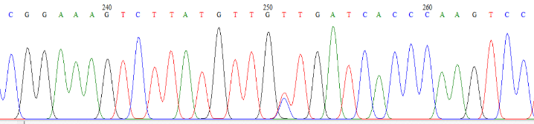  YK-ASD16-115  A1: CCGGAAAGTCTTATGTTGTTGAT (GKSYVVD)  A2: CCGGAAAGTCTTATGTTGCTGAT (GKSYVAD)  WT: CCGGAAAGTCTTATGTTGTTGAT (GKSYVVD) | 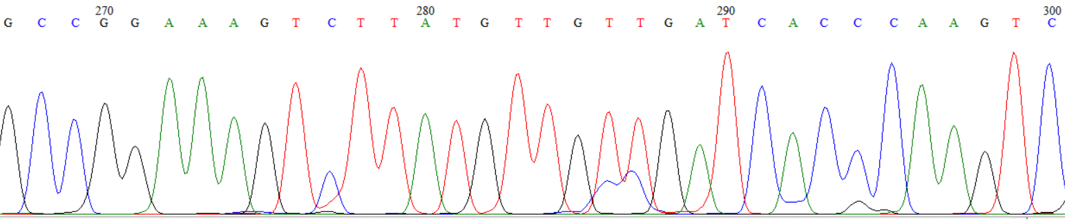  YK-ASD16-116  A1: CCGGAAAGTCTTATGTTGTTGAT (GKSYVVD)  A2: CCGGAAAGTCTTATGTTGCCGAT (GKSYVAD)  WT: CCGGAAAGTCTTATGTTGTTGAT (GKSYVVD)
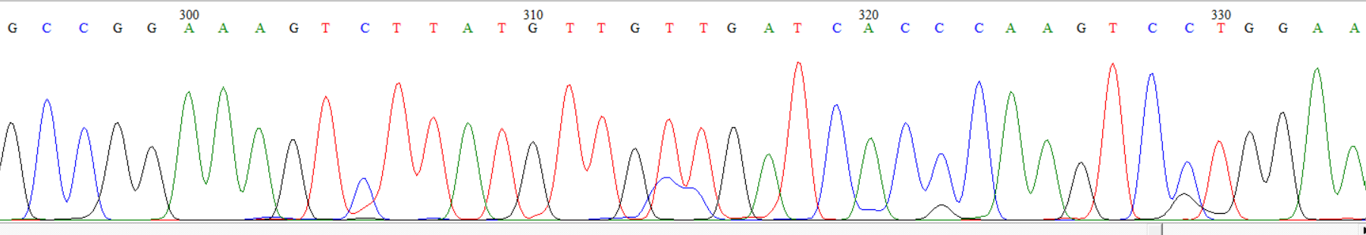  YK-ASD16-118  A1: CCGGAAAGTCTTATGTTGTTGAT (GKSYVVD)  A2: CCGGAAAGTCTTATGTTGCCGAT (GKSYVAD)  WT: CCGGAAAGTCTTATGTTGTTGAT (GKSYVVD) | 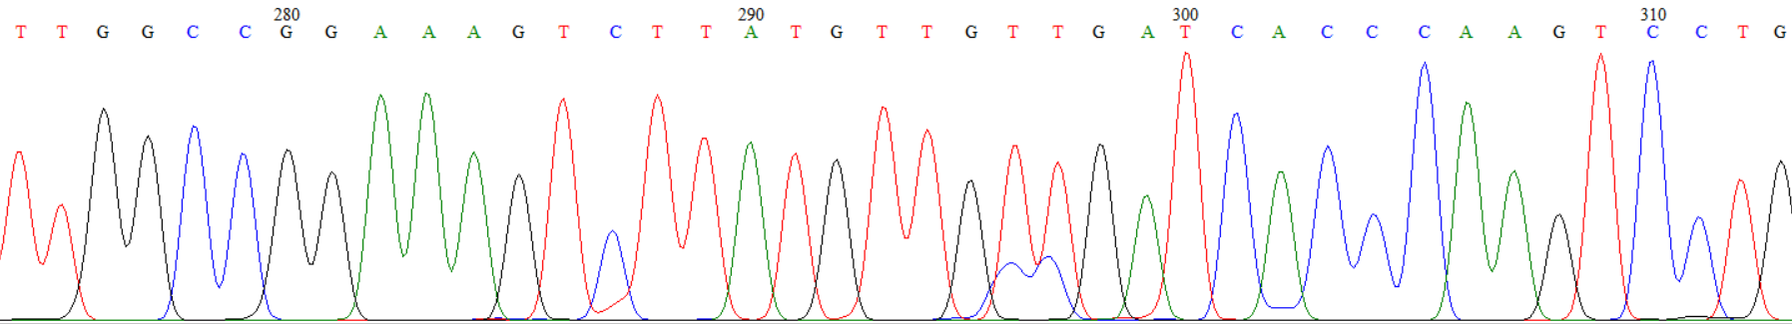  YK-ASD16-124  A1: CCGGAAAGTCTTATGTTGTTGAT (GKSYVVD)  A2: CCGGAAAGTCTTATGTTGCCGAT (GKSYVAD)  WT: CCGGAAAGTCTTATGTTGTTGAT (GKSYVVD)
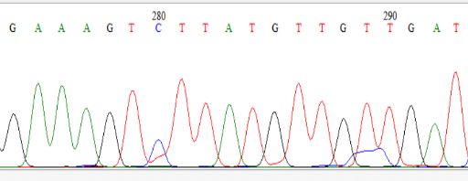  YK-ASD16-132  A1: CCGGAAAGTCTTATGTTGTTGAT (GKSYVVD)  A2: CCGGAAAGTCTTATGTTGCCGAT (GKSYVAD)  WT: CCGGAAAGTCTTATGTTGTTGAT (GKSYVVD) | 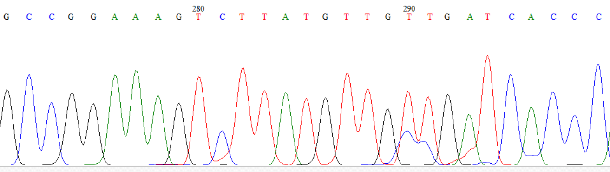  YK-ASD16-135  A1: CCGGAAAGTCTTATGTTGTTGAT (GKSYVVD)  A2: CCGGAAAGTCTTATGTTGCCGAT (GKSYVAD)  WT: CCGGAAAGTCTTATGTTGTTGAT (GKSYVVD)
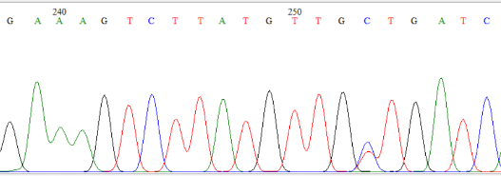  YK-ASD16-117  A1: CCGGAAAGTCTTATGTTGTTGAT (GKSYVVD)  A2: CCGGAAAGTCTTATGTTGCTGAT (GKSYVAD)  WT: CCGGAAAGTCTTATGTTGTTGAT (GKSYVVD) | 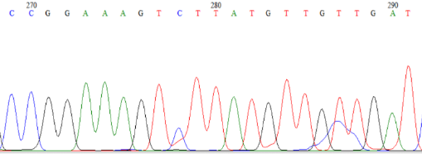  YK-ASD16-123  A1: CCGGAAAGTCTTATGTTGTTGAT (GKSYVVD)  A2: CCGGAAAGTCTTATGTTGCTGAT (GKSYVAD)  WT: CCGGAAAGTCTTATGTTGTTGAT (GKSYVVD)
Table 3. Nucleotide traces and predicted protein sequences in T₀ mutants (A1: Allele 1, A2: Allele 2, WT: Wild type, Substitutions are denoted in red.)

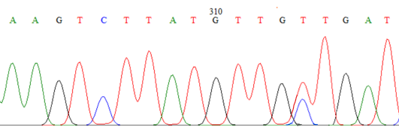  YK-ASD16-136  A1: CCGGAAAGTCTTATGTTGTTGAT (GKSYVVD)  A2: CCGGAAAGTCTTATGTTGCTGAT (GKSYVAD)  WT: CCGGAAAGTCTTATGTTGTTGAT (GKSYVVD) | YK-ASD16-151A  A1: CCGGAAAGTCTTATGTTGTTGAT (GKSYVVD)  A2: CCGGAAAGTCTTATGTTGCTGAT (GKSYVAD)  WT: CCGGAAAGTCTTATGTTGTTGAT (GKSYVVD)
YK-ASD16-232  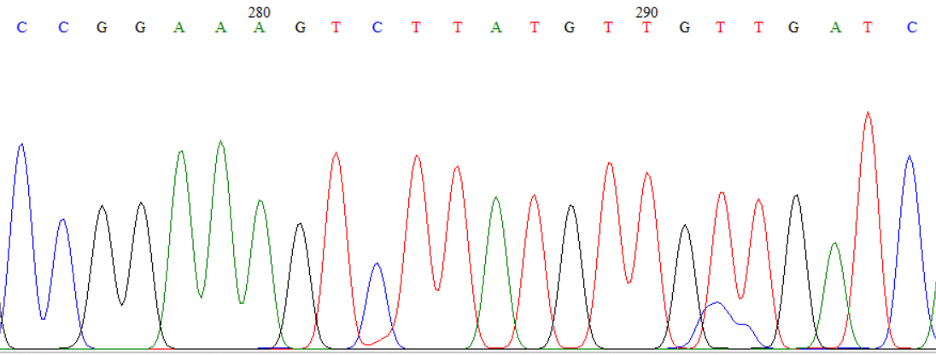  A1: CCGGAAAGTCTTATGTTGTTGAT (GKSYVVD)  A2: CCGGAAAGTCTTATGTTGCTGAT (GKSYVAD)  WT: CCGGAAAGTCTTATGTTGTTGAT (GKSYVVD) | YK-ASD16-141  A1: CCGGAAAGTCTTATGTTGTTGAT (GKSYVVD)  A2: CCGGAAAGTTTTATGTTGCTGAT (GKFYVAD)  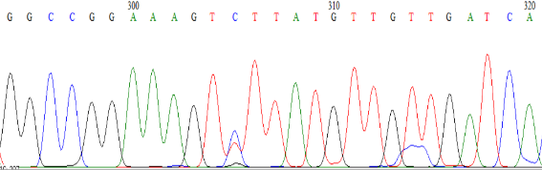  WT: CCGGAAAGTCTTATGTTGTTGAT (GKSYVVD)
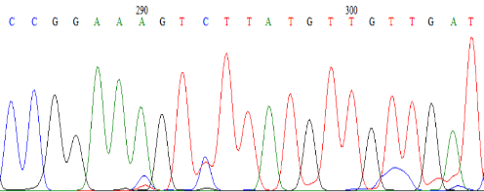  YK-ASD16-150  A1: CCGGAAAGTCTTATGTTGTTGAT (GKSYVVD)  A2: CCGGAAAGTTTTATGTTGCTGAT (GKFYVAD)  WT: CCGGAAAGTCTTATGTTGTTGAT (GKSYVVD) | 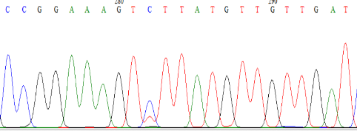  YK-ASD16-147  A1: CCGGAAAGTCTTATGTTGTTGAT (GKSYVVD)  A2: CCGGAAAGTTTTATGTTGTTGAT (GKFYVVD)  WT: CCGGAAAGTCTTATGTTGTTGAT (GKSYVVD)
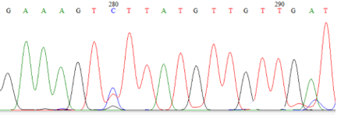  YK-ASD16-151B  A1: CCGGAAAGTCTTATGTTGTTGAT (GKSYVVD)  A2: CCGGAAAGTTTTATGTTGTTGAT (GKFYVVD)  WT: CCGGAAAGTCTTATGTTGTTGAT (GKSYVVD) | 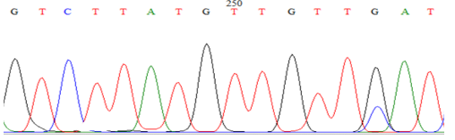  YK-ASD16-234  A1: CCGGAAAGTCTTATGTTGTTGAT (GKSYVVD)  A2: CCGGAAAGTCTTATGTTGTTCAT (GKSYVVH)  WT: CCGGAAAGTCTTATGTTGTTGAT (GKSYVVD)
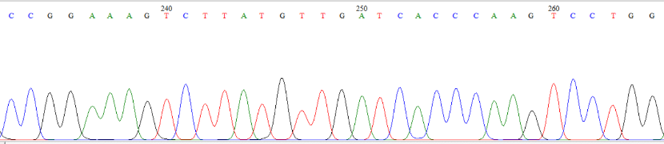  YK-ASD16-246  A1: CCGGAAAGTCTTAT---GTTGAT (GKSY-VD)  A2: CCGGAAAGTCTTAT---GTTGAT (GKSY-VD)  WT: CCGGAAAGTCTTATGTTGTTGAT (GKSYVVD) | YK-ASD16-354  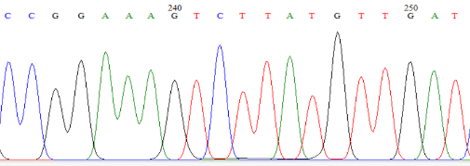  A1: CCGGAAAGTCTTAT---GTTGAT (GKSY-VD)  A2: CCGGAAAGTCTTAT---GTTGAT (GKSY-VD)  WT: CCGGAAAGTCTTATGTTGTTGAT (GKSYVVD)

Figure 1. Physical map of pH-PABE7-esgRNA harbouring sgRNA
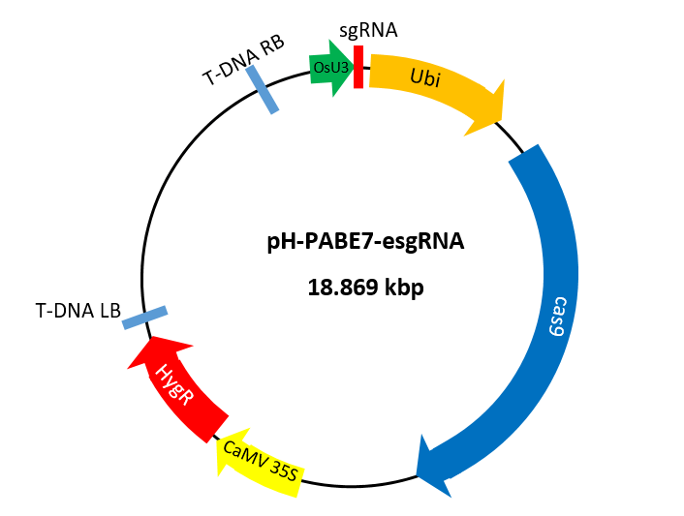

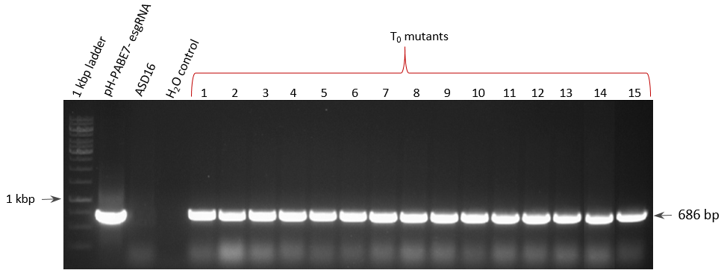
Figure 2a. PCR analysis for the presence of hpt gene in putative mutants (T₀)

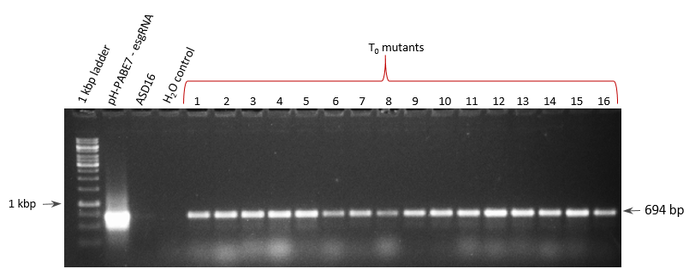
Figure 2b. PCR analysis for the presence of cas9 gene in putative mutants (T₀)

Figure 3. Nucleotide frequencies at each position in the target sequence
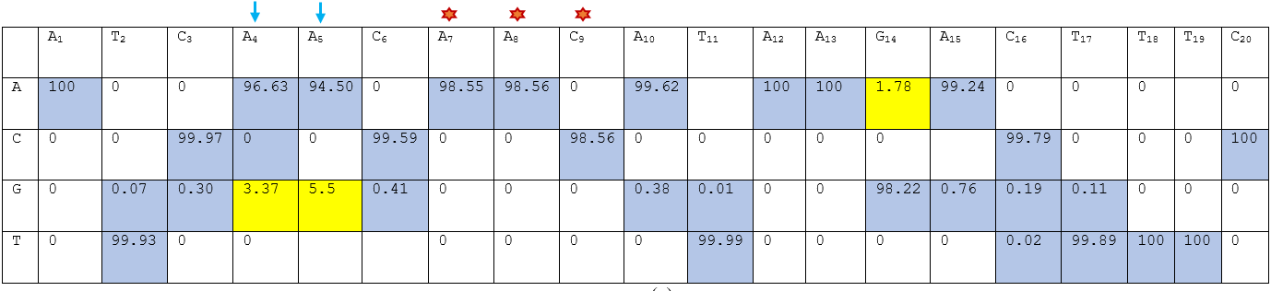Arrows indicate expected base substitution of A > G. Frequency of expected nucleotides are highlighted in blue and those of substituted nucleotides are highlighted in yellow.
As deletion mutation was observed at these nucleotide positions, total percentage value is less than 100.

