RESEARCH ARTICLE

**Preparation of 10% Dusting Powder Ready-to-Use Low Concentration Neem Botanical Formulation**

|  |  |
| --- | --- |
|  | ABSTRACT Neem (*Azadirachta indica*) is the best potential alternative, as it exhibits sufficient insecticidal property. Formulation is the process of transforming an active ingredient into a product, applied on crop pest by practical methods to permit its effective, safe and economical use. Neem green fruits were blended with an inert material (dolomite) to obtain free-flowing fine powder. Increasing the active ingredient from 2.5 to 12.5 % had smooth blends during the production of formulations.. The nature of the neem green fruits was the presence of latex, which are hydrophilic organic compounds reducing surface tension as emulsifying agent, and possess good adhesive properties. Though all the formulations tried were recorded the required formulation stability, the 10 per cent D.P. was found to be ready to use, easy for calculation and application by the farmers. All the formulations were noticed to be persistent with no changes in color, odour, pH and crude limonoids even in accelerated condition. The natural seed-based botanicals are produced in abundance and they are renewable, hence, finding green chemistry is better for environment. In this context, it has been found to be satisfactory to formulate neem-based insecticide dusting powder. The size specification met as per BIS standards for diluents, it is to be 95 percent or more through 325-mesh (44 microns) or 95 percent through 200-mesh (75 microns). |

Keywords: Neem Green Fruit, Dust Powder, Formulation, Botanicals

## INTRODUCTION

Neem (*Azadirachta indica*) is the best potential alternative, as it exhibits sufficient insecticidal property. This tree is native to India as well as other southeastern countries on the globe. Neem based products are natural and non-toxic. It is 100% biodegradable and environment friendly. India's neem trees bear about 3.5 million tonnes of kernels each year and that, in principle, about 700000 tons of oil might be recoverable (Ref ). The use of synthetic fertilizers and pesticides in agricultural practices causes serious environmental pollution. Therefore, to reduce the effect of agricultural practices on the environment, suitable natural materials are in need as insecticides and pesticides. Due to increased public concern relating to the toxicity of insecticide residues in the grain, the environment and the occurrence of insecticide resistant insect strains, there has been a need to search for new approaches for insect pest control. Triterpenoids are the key ingredients in neem-based bio-pesticide, which inhibits the growth of pests, insect antifeedant and growth regulator. Normally, oil seeds cannot be converted into fine powder because they contain oil. Thus, neem seed powder is coarser, and is widely available in cake form (neem cakes), which have comparativly smaller surface area. However, this problem can be overcome by collectiing the whole green neem fruits near stage of harvesting before it was converted into oil. Liquids are more economical and cleaner than dusts, but dust application are specific, low toxic and provide better pest management. In the current process, white clay or other carrier were used to pulverize and it is then blended with soap stone powder and after which liquid technical grade are dispersed on this blended material. Wheat flour, clay, talc, boric acid, and silicone dioxide are used as carriers in dust formulations and several inert dust formulations have been registered for the crop protection. Only few dust formulation were available for agricultural use and no botanical dust formulation developed until now (registered). In this study, a formulation is designed as ready-to-use low concentration botanical formulation for crop pest management.

## MATERIAL AND METHODS

**Formulation**

In this study, whole neem green fruits were cogrinded with an inert material (dolomite) to obtain free-flowing fine powder. Dolomite is an anhydrous carbonate mineral composed of calcium magnesium carbonate [CaMg(CO3)2]. A grinding mill is the most suitable equipment for grinding dry neem fruits. The powder obtained by grinding has large surface area and shows better biological activity owing to the presence of limonoids (e.g., salannin and nimbolide), which also helps to increase the shelf life of the products.

**Neem fruits collection and processing**

Whole green neem immature fruits (Figure 1) were subjected to a pretreatment method that included washing, cleaning, pulverizing and drying in shade followed by oven drying at ~60 °C for 8 hrs (Figure 2).

**Dusting powder formulation preparation**

The pulverized sample was subjected for blending with 1:1 parts of carrier (dolomite) for uniform distribution with overhead stirrer followed by thorough hand blend mixing. The powdered dry fruit mixed with 1:5 part along with carrier in a grinding mills of milling applications. The test dusting powder formulation contains 2.5 to 12.5 % w/w neem powder. The size specification for carrier was prepared at < 95 percent or more through 325-mesh (44 microns) or 95 percent through 200-mesh (75 microns).

**TLC analysis**

The 200 mg powdered sample was dissolved in 10 ml of acetone. The filtered 2 ml organic phase was taken and spotted on silica gel F254 plate. Then eluted with a mobile phase of methanol : ammonia (100:1.5) for alkaloid and for terpenoid using the mobile phase toluene : ethyl acetate (93:7). The chromophore was observed under UV254 nm and UV366 nm then also sprayed and derivatized with the coloring reagent Dragendorf that produced orange color for alkaloid and sulfate vanillin that produced purple color for terpenoid. Analysis of secondary metabolites were done by measurement of Rf score. The formula of R*f* score was distance of sample or reference compound divided by distance of the solvent.

**Storage condition for product stability and evaluation parameters**

Accelerated stability and real time stability were conducted as per ICH guideline (1997) storage condition mentioned below,

• Accelerated stability : Temperature: 40 °C ± 2, Relative Humidity (RH): 75 % ± 5

• Real time stability : Temperature: 25 °C ± 2, Relative Humidity (RH): 60 % ± 5

The change was observed 15 days for accelerated stability and six month for real time stability study.

**Colorimetric quantification of limonoids**

A method for estimating the total limonoid concentrations in samples in terms of limonin was adopted from Andrew *et. al. (*2007). The colorimetric quantification was based on the formation of red to orange colored derivatives resulting from the treatment of limonin or limonin glucoside and possibly some co extracts. Absorbance maxima for the limonin and limonin glucoside derivatives were found to be 470 and 503 nm, respectively. Using sulfate vanillin derivatizing agent; that produced purple color for terpenoids in the crude extract and showed strong absorption at 210- 245 nm. Hence, the Lamda max was set at 225nm for reproducibility and reducing noise level of the co extracts (Figure 3).

## RESULTS AND DISCUSSION

Crystals of dolomite are common deposits, which makes up approximately 2 percent of the Earth’s crust. By volume, however, most dolomite occurs in its massive form as dolostone or mixed dolostone/limestone sedimentary rocks. Dolomite structure comprising calcium layer, a -CO3 layer, a magnesium layer, another CO3 layer, and so forth. This layer’s lattice space offers the active ingredient and the inert nature of the material is the unique feature. The crystals properties were useful viz., colourless, white, buff-coloured, pinkish, or bluish, while handling and coating over the mineral. The free flowing of the mineral is due to individual grains ranging in size 44 micron and lower after milling. This dolomite mineral and neem green fruits were blended to obtain free-flowing fine powder and materials.

The smooth blends helped in formation of the products A to E. The nature of the neem fruits has latex before maturity, which is a water-soluble, act as emulsifier agent and possesses good adhesive properties. The latex spreads and surrounds the inert by forming thin layer coating over large surface area. This thin film coating comply nanofilms properties. Nanofilm means formation of thin layers of material spanning from a fraction of a nanometer to several micrometers in thickness. This thin film coating on carrier has improved stability of the secondary metabolites and efficiency of the formulation.

The accelerated stability study was conducted at the temperature: 40°C ± 2 at Relative Humidity (RH): 75% ± 5 for up to 15 Days. 10% degradation was set to extrapolate the accelerated stability data as the acceptable point. It is interpreted as length of time under specific conditions and storage that a product will remain within the predefined limits for all its important characteristics. The physico-chemical parameters like colour, odour, pH, curde limonoids were observed for evaluation of stability study. All formulations were noticed with no changes in color, odour, pH, crude limonoids at accelerated condition (Table 4). It ensured the efficacy and quality of active compounds in product, to establish shelf life or expiration period. The real time storage stability studies also confirmed the stability of the formulation once again.

Stability is aimed to assure that the product remains within specifications established to ensure its identity, strength, quality and purity. Results showed stability of formulation sample A to E at real time and accelerated storage condition (Table 2 & 3). All the formulations recorded required formulation stability. However, the 10 per cent D.P. (Sample D) was found to be ready to use, easy for calculation and application by the farmers.

The colorimetric quantification of color development and sensitivity were investigated and optimal assay conditions established (Table 6). With a UV-Vis spectroscopy, under the specified conditions, the limits of detection and quantification were determined to be 25 to 50 ppm for limonin. All the formulations from A to E met required specification for formulation.

TLC profiling showed different Rf values due to the presence of number of phytochemicals in it. Different Rf values of the compound reflect an idea about their polarity. The presence of any significant bioactive natural product indicates the necessity of separation of the compound from the mixture of compounds through suitable chromatographic techniques. The Rf score of the assay were 0.76 and 0.30 for alkaloid and terpinoid, respectively.

**Prilimnary Evaluation and Validation of 10% Dust formulation on insect pests**

## The 10 per cent Dust formulation was tested for its phytotoxicity on rice crop at active tillering stage. The formulation has not showed any adverse effect on rice phenology. This formulation was also applied on red soghum plant exhibiting dead heart, midrib red mining and bore holes on the stem, with caterpillar tunneling inside. Thes developed 10% D.P. ready-to-use low concentration neem fruit based formulation was found effective by suppressing further infestation and recorded no adverse effect on phenology of the sorghum (Table 5).

## CONCLUSION

From the present investigation, it is obvious that the performance of combined application of dolomite mineral and neem green fruits were blended to obtain free-flowing fine powder and materials also act as a source of calcium and magnesium, which promote plant growth too. This carrier is cheap and easily available, and also helps to neutralize the pH of acidic soil. The powder obtained by grinding has large surface area and shows better biological activity owing to the presence of limonoids, which also helps to increase the shelf life of the products. In agriculture, powdered dolomite is also an important component of many fertilizers and animal feeds. Smaller amounts of dolomite are also used for human consumption as a mineral supplement and as an antacid, although to a lesser degree than calcite. The natural seed based botanicals are abundance in production, renewable, finding the green chemistry is better for environment. These formulations are having LD50 value of >5000mg / Kg of body weight and target the pest effectively. Such formulation are broad spectrum, nontoxic to humans and other biota, biodegradable, less prone to pest resistance and resurgence, and relatively less expensive and bring hormony of ecological sound, equitable, and ethical pest management, there is a need for control agents in this era.

## Acknowledgement

The authors thank Department of Soils and Environment, AC&RI, TNAU Madurai and the DST-SERB Government of India for supporting this research.

## REFERENCES

Andrew P. Breksa and Phil Ibarra 2007. Colorimetric Method for the Estimation of Total Limonoid Aglycones and Glucoside Contents in Citrus Juices. *J. Agric. Food Chem.* **55(13)**: 5013–5017.

Balakrishnan S, Parthasarathy S, Kamalakannan A, Senthil K. (2017). A Novel Method to Develop Paste Formulation of *Trichoderma harzianum.* *Int. J. Curr. Microbiol. App. Sci.* **6 (11)** 3286-3293.

Balakrishnan S, Parthasarathy S, Kamalakannan A, Senthil K and Gopalakrishnan C. 2017. Evaluation of antagonistic activity and plant growth promotion by paste formulation of *Trichoderma harzianum*.  *Journal of Pharmacognosy and Phytochemistry. 6(6): 355-360.*

Bankoti K, Rana MS, Bharadwaj MK. 2012. Accelerated stability study of herbal capsules. *IOSR Journal of Pharmacy*. **2 (5):**1-6.

Central Insecticide Board and Registration Committee Guidelines (1997).

Chattopadhyay R.R. 1999. Possible mechanism of antihyperglycemic effect of *Azadirachta Indica* leaf extract. *Journal of Ethnopharmacology*, **67 (3):** 373-376

Devakumar C, Sukh Dev, Chemistry, in Sukh Dev. 1996. Chemistry Neem edited by Randhawa NS and Parmar BS. (2nd edition); pp–77.

IS 6940:1982 Methods of test for pesticide and their formulation, Bureau of Indian Standards, New Delhi.

Nakka AK, Gaur A, Sunku SSK, Devakumar C. 1999. Performance of neem products on the storability of soybean (Glycine max L.). *Seed Res*. **26(2):**138-146.

Renugadevi J, Natarajan N, Rajasekaran R, Srimathi P. 2000. Bioefficacy of promising botanicals against insect infesting cowpea cv. CO 4. *Indian Journal of Agricultural Research*. **4:** 262-26

Rukmani N, Prabhaharan J, Senthil K Thiyageshwari S and Banumathy S. 2018. Interaction of Zinc with cationic micronutrients under graded levels of chelated Zn in typic haplustalf. *Res. J. of Agricultural Sciences* **9 (5):**1010-1013.

Senthil K, Devakumar C, Kumar R, Tomar SMS. 2009. Synthesis and evaluation of oxanilates and oxamates as chemical hybridizing agents for wheat (*Triticum aestivum* L). *Pesticide Research Journal* **21 (2)**: 133-139.

Shah W., Rane N., Kekare M.B., Vaidya V., 2010. Estimation of two bioactive compounds from *Azadiracta indica* a.juss. leaves using HPLC. *International Journal of Pharmaceutical Bioscience*, **2**: 185-192.

Table 1. Botanical neem fruit D.P formuolation composition.

|  |  |  |  |
| --- | --- | --- | --- |
| **S. No** | **Sample Codes** | **Dolomite** | **Technical** |
|  | Sample A | 97.5%(w/w) clay | 2.5% (w/w) Technical |
|  | Sample B | 95%(w/w) clay | 5% (w/w) Technical |
|  | Sample C | 92.5% (w/w) clay | 7.5% (w/w) Technical |
|  | Sample D | 90%(w/w) clay | 10%(w/w) Technical |
|  | Sample E | 87.5%(w/w) clay | 12.5% (w/w) Technical |

Table 2. Botanical neem fruit D.P formuolation quality requirement and observed values.

|  |  |  |  |
| --- | --- | --- | --- |
| **S.No** | **Characteristics** | **Requirement As Per Is 8960:1978** | **Observed Values Sample D** |
| 1 | Material passing  through 75 micron  ASTM/BS SEIVE. | 90% | 98% |
| 2 | Bulk density after compacting | Not to exceed the value obtained before compacting by more than 60% | 54% |
| 3 | Alkalinity (as NaOH)  percent by mass, max | 0.1% | 0.01% |
| 4 | Unburnt carbon % | - | 0.05% |
| 5 | Moisture % | - | 7.5% |

Table 3. Botanical neem fruit D.P formuolation and its characteristics.

|  |  |  |  |  |  |  |
| --- | --- | --- | --- | --- | --- | --- |
| **S. No** | **Characteristics** | **Sample A** | **Sample B** | **Sample C** | **Sample D** | **Sample E** |
|  | Description | Homogenous and free flowing powder | Homogenous and free flowing powder | Homogenous and free flowing powder | Homogenous and free flowing powder | Homogenous and free flowing powder |
|  | Material passing through 75 microns ASTM/BS SEIVE. % | 93.2% | 92% | 91% | 91.5% | 92% |
|  | Bulk Density after compacting, max 60% | 53% | 55% | 54% | 54% | 53% |
|  | Alkalinity as (NaOH) percent by mass max 0.1% | 0.01% | 0.01% | 0.01% | 0.01% | 0.01% |
|  | Crude terpenoid content % by mass (average of 5 analysis) | 2.6% | 2.6% | 2.6% | 2.6% | 2.6% |

Table 4: Physico-chemical parameters

|  |  |  |  |
| --- | --- | --- | --- |
|  | Condition: 40 °C ± 2 and 75% ± 5 RH | | |
| **Parameters** | **Initial** | **7 Day** | **15 Days** |
| pH | 6.2 | 6.7 | 6.7 |
| Clod formation | NIL | NIL | NIL |
| Bulk density after compacting | 54 % | 55% | 55% |
| Alkalinity (as NaOH)  percent by mass, max | 0.01% | 0.01% | 0.01% |
| Unburnt carbon % | 0.05% | 0.05% | 0.05% |
| Moisture % | 7.5% | 6.6% | 6.1% |

Table 5. Botanical neem fruit D.P formuolation and adverse effect of crop symptoms.

|  |  |  |  |
| --- | --- | --- | --- |
| **Crop** | **Area** | **Application Dose** | **Observation** |
| Paddy | Pot Study | 10 D | No adverse change is observed in vegetative growth and yield of the crop is seen when it is applied with current formulation |
| Sorghum | Field | 10 D | Effect on larval period, further infestation stopped |

Table 6. Summary of method characteristics.

|  |  |  |
| --- | --- | --- |
| S. No | **Attribute** | **Value** |
|  | Limit of detection | 0.1 ppm |
|  | Limit of quantification | 5 ppm |
|  | Linear range | 0.1 to 5000 mg / l |
|  | Recommended range | 1 to 5000 mg / l |
|  | Typical R2 | 0.988 |

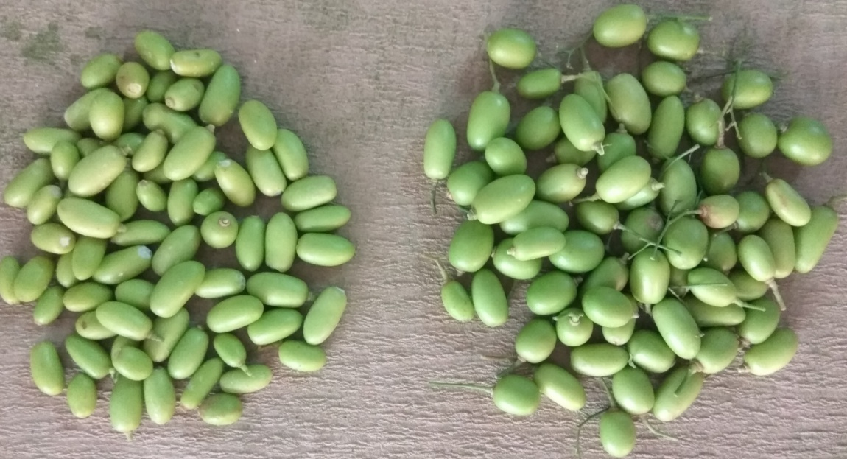

**Figure 1. The green neem fruit harvested at near maturing stage for the formulation preparation.**

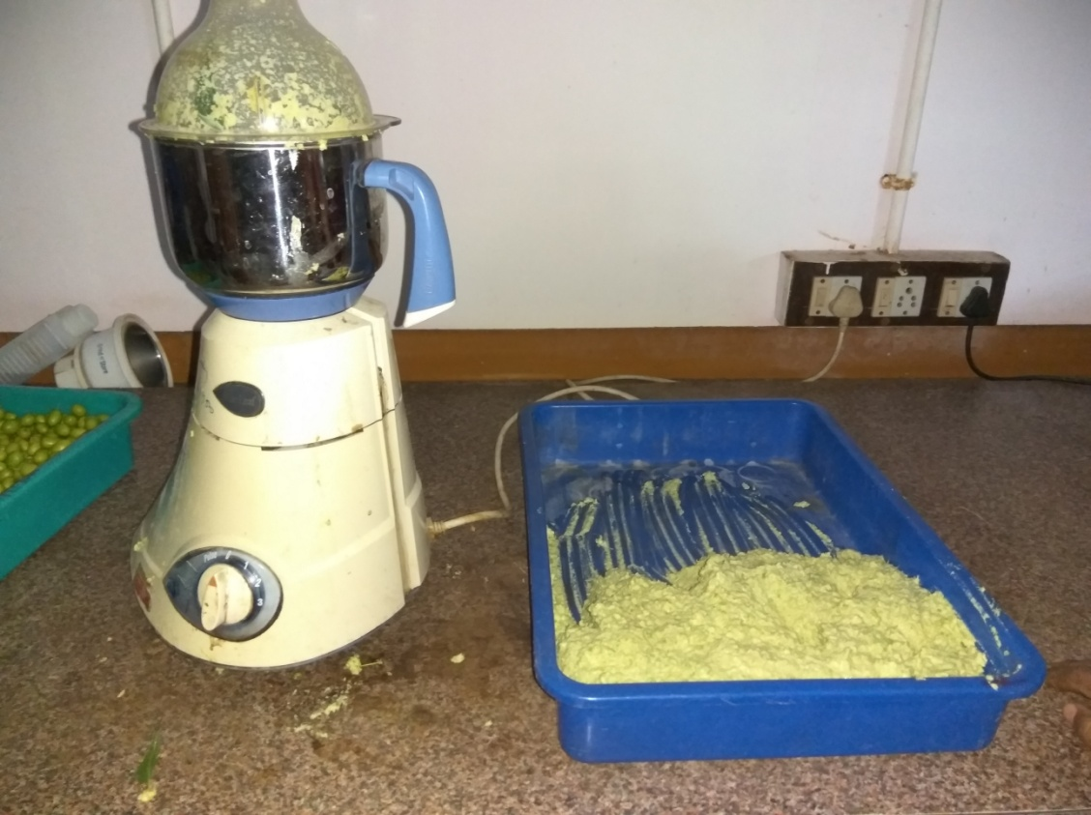

**Figure 2. The green neem fruit harvested has been grinded with cost effective mixture grinder for the formulation preparation.**

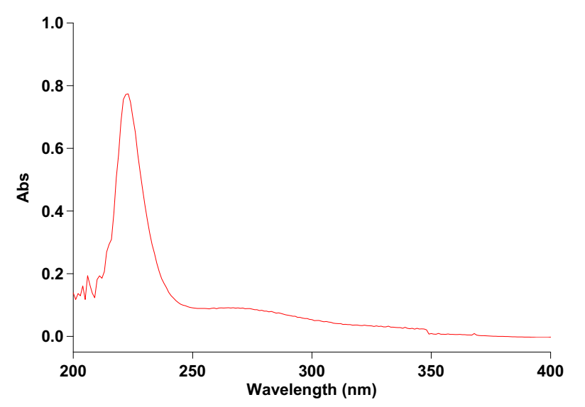

**Figure 3. The extracted crude terpene showed strong absorption at 210- 245 nm and the λmax of 225 nm.**