RESEARCH ARTICLE

Spatial variability assessment in Central Farm Soils of Horticultural College and Research Institute, Periyakulam, Tamil Nadu using GIS techniques

ABSTRACT
A total number of 201 surface soil samples were collected encompassing the fields of Central Farm of Horticultural College and Research Institute, Periyakulam, Tamil Nadu. The GPS data (Latitude ºN and Longitude ºE) were recorded for each sampling site by using GPS. Field maps were collected boundary and field number wise digitization was done. Soil samples were processed and anlaysed for soil physic-chemical and fertility parameters. Results indicated that soil samples were neutral to alkaline in reaction, non saline and slightly calcareous to non calcareous in nature. Soil fertility groupings under per cent category indicated that the soils were medium in soil organic carbon, low in available nitrogen, medium to high in available phosphorus, medium to high in available potassium and low in available sulphur. With respect to DTPA extractable micro nutrients, Fe, Zn, Mn and Cu found to dominate by low to medium, low, high, medium to high categories respectively. HWS-Boron was also recorded under high category. The nutrient index values of the samples indicated that high status for organic carbon, available P and K while medium for available N and adequate for available sulphur. With respect to micro nutrients, nutrient index values indicated that adequate for DTPA-Zn and very high for DTPA-Fe, Mn, Cu and HWS-B. Thematic maps generated on the individual parameters depicted the spatial variability of parameters in the Central Farm of Horticultural College and Research Institute, Periyakulam. In the identified areas of poor fertility status, nutrient deficiency has to be eliminated by the application of organic and /or inorganic sources to maintain sustainable soil fertility status. Soil test-based fertilizer recommendations along with micronutrients are to be followed to mitigate the nutrient deficiencies and to achieve sustained crop production and soil fertility.

Keywords: GIS, nutrient status, spatial variability, thematic maps.

INTRODUCTION
Soil is the medium for plant growth and hence, an in-depth insight on soil is a prerequisite for planning, monitoring and development of strategies viz., optimum land, water, fertilizer use and management aiming at high returns. The regional variation in yield of crops is mostly due to natural factors like soil and climate. For sustained production of crops and maintenance of soil health, maintenance of availability of nutrient and moisture have to be maintained and managed carefully. Continuous decline in soil fertility endangers the fertility and productivity soil. Cropping pattern, leaching, erosion etc., leads to loss of fertile soil and nutrient every year. Continued cropping pattern without restoring of nutrients in the soil will reduce its natural fertility and crop yields will start decline. Soil testing provides nutrient status of soils and which forms the basis for the fertilizer prescription for maximizing the crop yield.
Advanced technologies like Global Positioning System (GPS) and Geographic Information System (GIS) supports in collecting georeferenced soil samples and generating spatial variability maps of nutrients (Sharma, 2004). Soil fertility mapping is possible by the integration of GIS and GPS. These techniques help in taking decisions to improve agricultural approaches towards balanced nutrition. Geographic information system has emerged as a powerful tool for spatial analysis of natural resources and data base management. It is an efficient and versatile tool to automate the transformation of soil data in to soil information (Kasthuri Thilagam and Sivasamy, 2013). In the present study, an attempt has been made to evaluate the soil fertility status and their spatial variability in the Central farm of Horticultural College and Research Institute, Periyakulam, Tamil Nadu. An appraisal of potentialities and constraints of the farm soils is essential in the context of improving the productivity and increasing the economic returns of the farm, without deteriorating the natural resources.

MATERIAL AND METHODS

Collection of soil samples
A total of 201 surface soil samples were collected from the fields of Central Farm of Horticultural College and Research Institute, Periyakulam, Tamil Nadu. The geo-coordinates (Latitude ºN and Longitude ºE) were recorded for each sampling site using GPS (Figure 1).

Analysis of soil samples
Soil samples were air dried, sieved through 2 mm sieve, labelled and stored. For the estimation of organic carbon, processed soil samples were sieved with 0.5 mm sieve. The soil samples were analysed for pH and EC (Jackson, 1973), organic carbon (Walkley and Black, 1934), available nitrogen (Subbiah and Asija, 1956), available phosphorus (Olsen et al.,1954), available potassium (Stanford and English, 1949), available sulphur (Williams and Steinbergs, 1959), available Zn, Fe, Cu, and Mn (Lindsay and Norvell, 1978) and available Boron (Berger and Truog, 1944).
The analytical results of each soil sample were categorized as low, medium and high for organic carbon (OC) and macronutrients; as deficient, moderate and sufficient based on the critical limits for available sulphur and micronutrients as followed in Tamil Nadu (Table 1).
Table 1. Critical levels of nutrients for low, medium and high categories
Nutrient | Low | Medium | High
O.C. (g kg⁻¹) | <5.0 | 5.0 - 7.5 | >7.5
N (kg ha⁻¹) | <280 | 280 - 450 | >450
P (kg ha⁻¹) | <11 | 11 - 22 | >22
K (kg ha⁻¹) | <118 | 118 - 280 | >280
S (mg kg⁻¹) | < 10 | 10-15 | >15
Fe (mg kg⁻¹) | < 3.7 | 3.7 --8.0 | > 8.0
Mn (mg kg⁻¹) | < 2 | 2 – 4 | > 4
Zn (mg kg⁻¹) | <1.2 | 1.2 – 1.8 | > 1.8
Cu (mg kg⁻¹) | <1.2 | 1.2 - 1.8 | > 1.8
B (mg kg⁻¹) | < 0.46 | 0.46 – 1.0 | > 1.0
Making use of the number of samples in each category, the per cent sample category and Nutrient Index Values (NIV) were computed using the formulae furnished below.

Per cent sample category
No. of samples in Low or Medium or High category
Per cent sample category = ---------------------------------------------------------------------------------------- x 100
Total number of samples

Nutrient index values and fertility rating
Nutrient index value was calculated from the proportion of soils under low, medium and high available nutrient categories, as represented by
NIV= | [(P_{H} x 3)+ (P_{M x} 2)+ (P_{L} x 1)]
NIV= | 100
Where,
NIV = Nutrient Index Value
P_{L,} P_{M} and P_{H} are the percentage of soil samples falling in the category of low, medium and high nutrient status and given weightage of one, two and three respectively (Ramamoorthy and Bajaj, 1969).
The nutrient index values were rated into various categories viz., low (<1.67), medium (1.67-2.33) and high (>2.33) for OC and available N,P and K. For available S and micronutrients, the ratings are very low (< 1.33), low (1.33-1.66), marginal (1.67-2.00) adequate (2.01-2.33), high (2.34-2.66) and very high (> 2.66).

Generation of thematic soil fertility maps
Database on soil available nutrient status was generated in Microsoft Excel and the Soil fertility maps were prepared at Department of Remote sensing and GIS, TNAU, Coimbatore by using Arc-GIS software. The thematic maps on available nutrient status were generated by categorizing the fertility status such as ‘Low’, ‘Medium’ and ‘High’ by showing appropriate legend for soil fertility parameters by krigging geostatistical technique.

RESULTS AND DISCUSSION

Soil Physico- chemical Properties
The overall data (201 nos) (Table 2) revealed that pH of the soil ranged from 6.75 to 8.87 with a mean value of 7.54. The electrical conductivity of the analysed soil samples varied from 0.01 to 1.05 dSm⁻¹ with a mean value of 0.22 dSm⁻¹ and found to be non-saline. The free CaCO₃ content in the soil samples are ranged from non-calcareous to slightly calcareous in nature (3.65 to 4.23 %) with a mean value of 4.23%. The organic carbon content of the soil samples ranged from 1.15 to 9.94 g kg⁻¹ with a mean of 5.79 g kg^{-1.}

Available nutrient status
The available nutrient status is furnished in Table 2. The available N, P and K status of the soils ranged from 109 to 252; 10.5 to 38.1 and 160 to 490 kg ha⁻¹ with a mean of 177, 27.4 and 343 kg ha⁻¹ respectively. The available S content of the soil ranged from 2.97 to 23.3 mg kg⁻¹ with a mean of 11.8 mg kg⁻¹.
The DTPA extractable Fe, Zn, Mn, and Cu content ranged from 1.01 to 12.5; 0.20 to 2.95; 3.98 to 20.8; 0.78 to 8.60 mg kg⁻¹ with a mean of 5.11, 0.81, 11.3 and 3.24 mg kg⁻¹ respectively. The hot water soluble boron content varied from 1.41 to 8.76 mg kg⁻¹ with a mean of 5.09 mg kg⁻¹.

Fertility grouping of soil samples
Total number of samples belonging to each category of fertility status for every analyzed parameter were worked out and the results are given in Table 3 and Figure 2. Among the 201 soil samples, 104 are neutral and 97 are alkaline in reaction. In the case of EC, all the 201 samples were belonging to non-saline category. Organic carbon status revealed that out of total samples 76, 82 and 43 soil samples were low, medium and high category respectively. In the case of available nitrogen, all the 201 samples fell under the category of low status. With respect to available phosphorus, 3, 40 and 158 samples were coming under the category of low, medium and high status, respectively. In the case of available potassium 44 and 157 samples were belonging to the category of medium and high status. In the case of available sulphur, 77 samples came under low, 71 samples under medium and 53 samples under high category. In the case of DTPA micronutrients, 48, 136,17; 187, 10, 4; 0, 1, 200; 23, 33, 145 nos of samples are grouped under low, medium and high category for DTPA Fe, Zn, Mn and Cu respectively. In the case of HWS-B, all the 201 samples fell under the category of high status.

Per cent samples for each fertility group
Per cent category samples for soil physic-chemical properties and available nutrients was worked out and the results are given in Table 3 and Figure 3.
The pH values of soil samples were neutral (51.7 %) and alkaline (48.3 %). All the soil samples were categorized under non saline. Among the 201 soil samples, 37.8, 100, 1.5, 0 and 38.3 per cent of samples are grouped under the low status for O.C, available N, P, K and S respectively. In the case of micronutrients, 23.9, 93, 0, 11.4 and 0 per cent of samples were grouped under low status for available Fe, Zn, Mn, Cu and B respectively.
Among the 201 soil samples, 40.8, 0, 19.9, 21.9 and 35.3 per cent of samples are with medium status for O.C, available N, P, K and S respectively. Among the micronutrients, 67.7, 5, 0.5, 16.4 and 0 per cent of samples were classified under medium status for available Fe, Zn, Mn, Cu and B.
High category found to be with 21.4, 0, 78.6, 78.1 and 26.4 per cent of samples in O.C, available N, P, K and S respectively. Micronutrients viz., Fe, Zn, Mn, Cu and B recorded 8.5, 2.0, 99.5, 72.1 and 100 per cent of samples under high category.

Nutrient index values
Nutrient index values for all available nutrient status were calculated separately besides organic carbon status (Table 4). Among the major nutrients, nitrogen registered the lowest nutrient index value of 2.01 followed by phosphorus (5.57) and potassium (5.59). Among the micronutrients the order of nutrient index value was Mn>B>Cu>Fe>Zn. Nutrient index for available N was medium and for, organic carbon, available P and K the nutrient index were high. Available sulphur found to be adequate. Among the micronutrients, DTPA-Fe was classified under very high category. DTPA-Zn was adequate and while Mn, Zn and Cu were high. Similar studies were carried out by Sellamuthu et al. (2015), Theresa et al. (2019) and Muthumanickam (2020) for assessing the nutrient index values in Tiruchirapalli District, rice ecosystem of Anaimalai Block and vegetable grown soils of Horticultural College and Research Institute, Periyakulam respectively.

Thematic soil fertility maps
The thematic maps on pH, EC, organic carbon and available nutrient status were generated by showing appropriate legend for soil fertility parameters (Figures 4-6). Maps were generated and visual differences were clearly depicted the spatial variability of soil fertility parameters in the Central farm of Horticultural College and Research Institute, Periyakulam, Tamil Nadu. Similar studies were carried out by Arunkumar and Paramasivan, (2015) for Veeranam Command Area, Tamil Nadu. Similar thematic maps were created in vegetable grown soils of Horticultural College and Research Institute, Periyakulam (Muthumanickam,2020). Mapping Soil Fertility and its Spatial Variability in Tiruchirapalli District, Tamil Nadu Using GIS.

CONCLUSIONS
Soils of Central farm of Horticultural College and Research Institute, Periyakulam were neutral to alkaline in reaction, non-saline and slightly calcareous to non-calcareous in nature. Soil fertility groupings with per cent sample in each category revealed the dominance of medium in organic carbon, low in available nitrogen, medium to high in available phosphorus, high in available potassium and low to medium in available sulphur. With respect to soil available micronutrients, dominance of medium category in DTPA-Fe, low in DTPA-Zn and high in DTPA- Cu, Mn and HWS-B were observed. It was found that GIS found to be an essential tool in translating the numerical values of soil properties into visual images for better understanding of soil related constraints and to generate location specific management strategies for enhancing the soil productivity. Continuous application of organic manures or in-situ application of green or green leaf manures is necessary for improving the soil organic matter content and to enhance the nutrient use efficiency. The deficient nutrients have to be restored through chemical fertilizers and/or organic manures. Soil test based fertilizer recommendations along with micronutrients are to be followed for sustained crop production and soil fertility.
Author contributions
Research grant | - | -
Idea conceptualization | - | K.M.Sellamuthu
Experiments | - | K.M.Sellamuthu and R.Kumaraperual
Guidance | - | -
Writing-original draft | - | K.M.Sellamuthu
Writing- reviewing &editing | - | P.Malathi

REFERENCES
Arunkumar, V. and Paramasivan, M. 2015. Spatial variability and geostatistics application for mapping of soil properties and nutrients in intensively cultivated village of Veeranam Command Area, Tamil Nadu. An Asian J. of Soil Sci., 10 (2):299-305.
Berger, K. C. and Troug ,E. 1944. Boron test and determination for soils and plants. Soil Sci., 57: 25 – 26.
Jackson, M.L. 1973. Soil chemical analysis. Prentice hall of India Pvt Ltd., New Delhi.p.496
Kasthuri Thilagam, V. and Sivasamy, R. 2013. Role of remote sensing and GIS in land resource inventory-a review. Agri. Reviews, 34 (3) : 223-229.
Lindsay, N.L. and Norvell, W.A. 1978. Development of DTPA soil test for zinc, iron, manganese and copper. Soil Sci. Soc. Am. J., 42: 421-428.
Muthumanickam, D. 2020. Spatial variability mapping of available nutrient status in vegetable grown soils using GIS Techniques. Int. J. Curr. Microbiol. App. Sci. 9(5): 3227-3236.
Olsen, S. R., Cole C. V., Watanabe, P. S. and Dean. L. A. 1954. Estimation of available phosphorus in soils by extraction with sodium bicarbonate. U.S.D.A. Circ., 939.
Ramamoorthy, B. and Bajaj, J.C. 1969. Available N, P and K status of Indian soils. Fertilizer News., 14: 24-26.
Sellamuthu, K.M., Santhi, R., Sivagnanam, S., Radhika, K., Sekar, J., Pradip Dey and Subba Rao, A. 2015. Mapping soil fertility and its spatial variability in Tiruchirapalli district, Tamil Nadu using GIS. Madras Agric. J., 102 (10-12): 317-324.
Sharma P K. 2004. Emerging technologies of remote sensing and GIS for the development of spatial data structure. J. Indian Soc. Soil Sci., 52 (4): 384-406.
Stanford, S. and L. English. 1949. Use of Flame photometer in rapid soil test for K and Ca. Agron. J., 41: 446-447.
Subbiah, B. V. and G. L. Asija. 1956. A rapid procedure for estimation of available nitrogen in soils. Curr. Sci., 25: 259-260.
Theresa, K., Shanmugasundaram, R. and Kennedy, J.S..2019. Assessment of spatial variability of soil nutrient status in rice ecosystem using Nutrient Index in Anaimalai Block, Coimbatore. Int. J. Curr. Microbiol. App. Sci. 8(8): 2169-2184.
Walkley, A. and Black, I.A. 1934. An examination of soil organic carbon by chromic acid titration method. Soil Sci., 37: 29.
Williams, C.H. and Steinbergs, H. 1959. Soil sulphur fractions as chemical indices of available sulphur in some Australian soils. Australian J. Agric. Res., 10: 340-352.
Table 2.Range and mean values of various soil analytical parameters
(n = 201)

Parameter | Unit | Range | Mean | SD | CV
pH |  | 6.75 - 8.87 | 7.54 | 0.39 | 5.22
E.C | d Sm⁻¹ | 0.01 - 1.05 | 0.22 | 0.18 | 82.1
O.C | g kg⁻¹ | 1.15 - 9.94 | 5.79 | 2.01 | 34.7
Free CaCO₃ | % | 3.65 - 5.30 | 4.23 | 0.23 | 5.40
Available N | kg ha⁻¹ | 109 - 252 | 177 | 28.4 | 16.1
Available P | kg ha⁻¹ | 10.5 -38.1 | 27.4 | 6.9 | 25.0
Available K | kg ha⁻¹ | 160 - 490 | 343 | 73.1 | 21.3
Available S | mg kg⁻¹ | 2.97 - 23.3 | 11.8 | 4.4 | 37.2
DTPA-Fe | mg kg⁻¹ | 1.01 - 12.5 | 5.11 | 2.09 | 41.0
DTPA-Zn | mg kg⁻¹ | 0.20 - 2.95 | 0.81 | 0.41 | 50.3
DTPA-Mn | mg kg⁻¹ | 3.98 - 20.8 | 11.3 | 3.97 | 35.0
DTPA-Cu | mg kg⁻¹ | 0.78 - 8.60 | 3.24 | 1.58 | 48.9
HWS-B | mg kg⁻¹ | 1.41 - 8.76 | 5.09 | 1.48 | 29.1

Table 3. Number and percent samples under each category for pH and EC
Parameters | pH
Parameters | Acidic |  | Neutral |  | Alkaline
pH | No. | Per cent | No. | Per cent | No. | Per cent
pH | 0 | 0 | 104 | 51.7 | 97 | 48.3
EC | EC
EC | Saline |  |  |  | Non saline
EC | No. |  | Per cent |  | No. | Per cent
EC | 0 |  | 0 |  | 201 | 100

Table 4. Nutrient index value and fertility status
Parameters | Nutrient index value | Fertility status
O.C | 3.69 | High
Available N | 2.01 | Medium
Available P | 5.57 | High
Available K | 5.59 | High
Available S | 2.01 | Adequate
DTPA-Fe | 3.71 | Very high
DTPA-Zn | 2.19 | Adequate
DTPA-Mn | 6.02 | Very high
DTPA-Cu | 5.24 | Very high
HWS-B | 6.03 | Very high

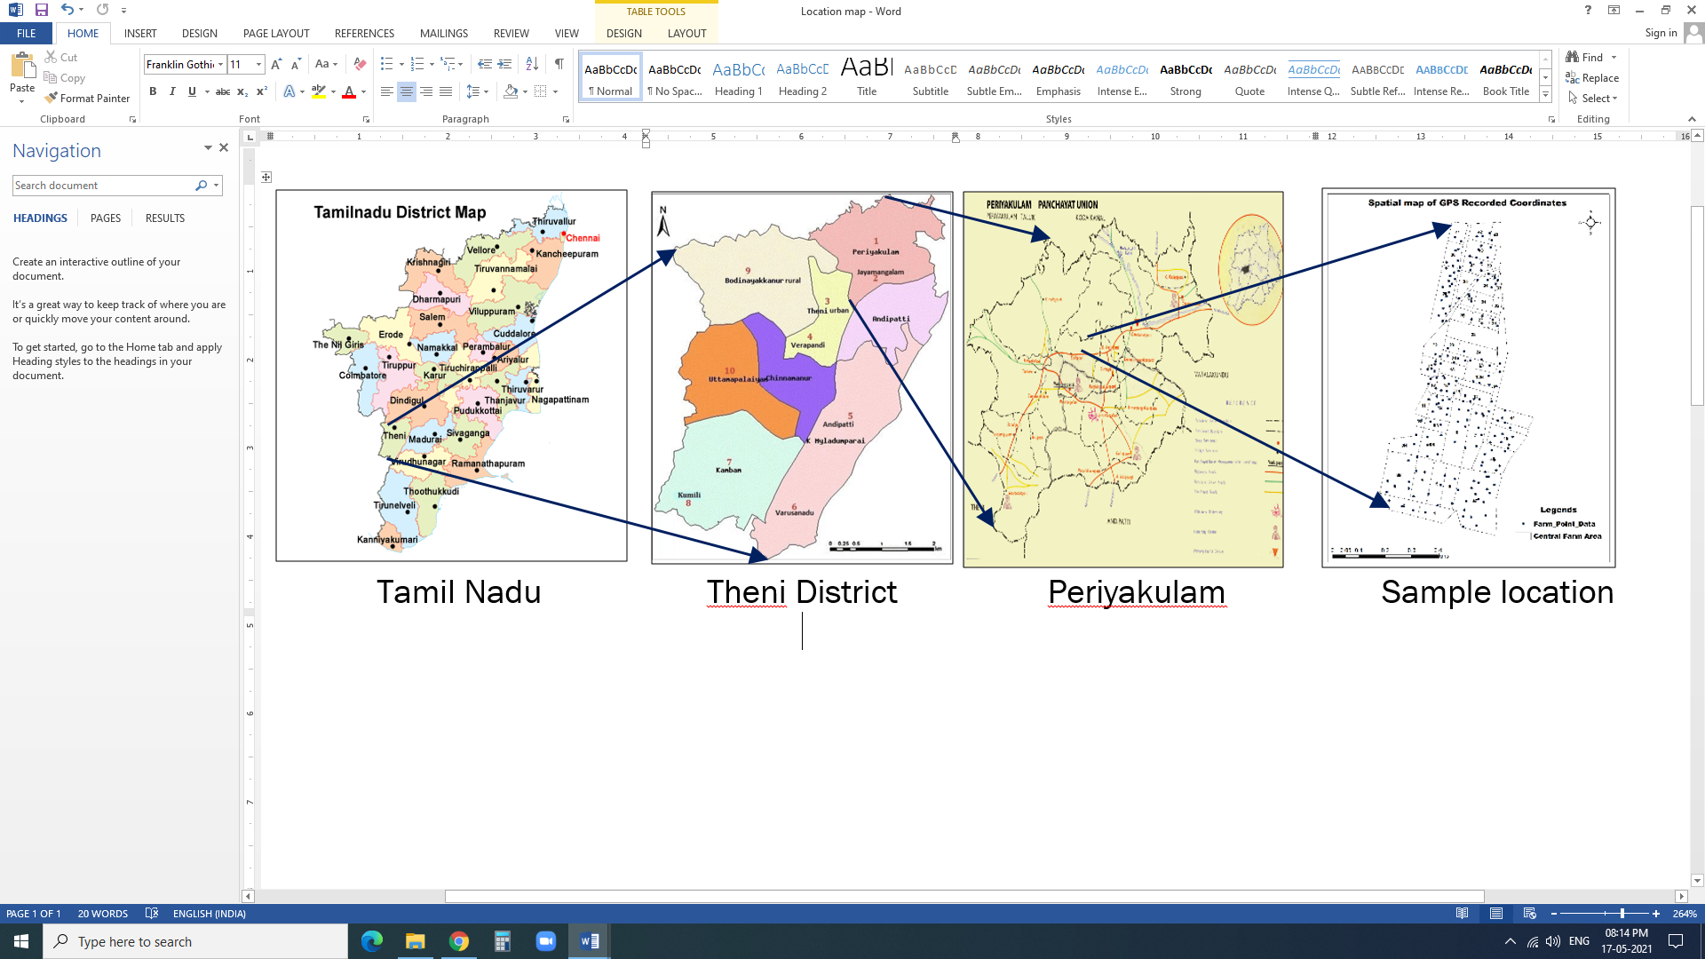
Figure 1.Geocordiantes for the locations of soil sampling

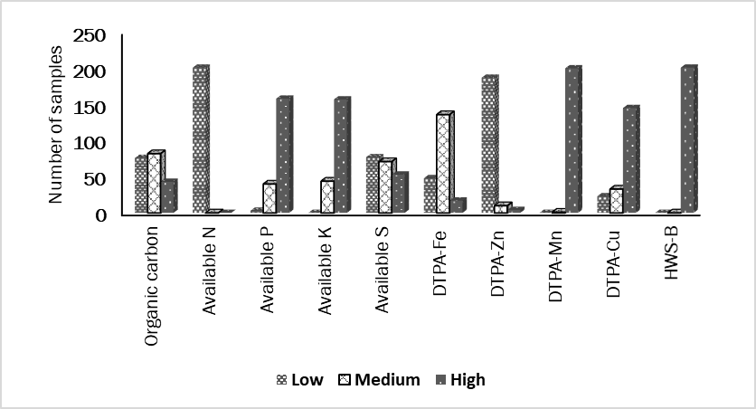
Figure 2. Number of samples under each category of fertility groups

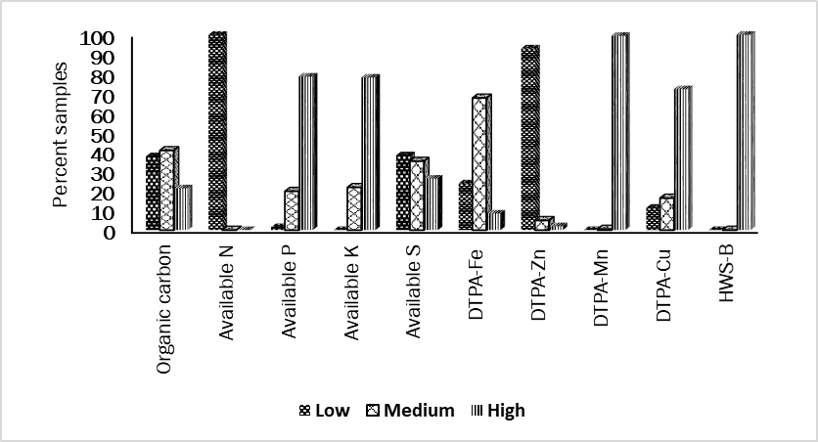
Figure 3. Percent samples under each category of fertility groups

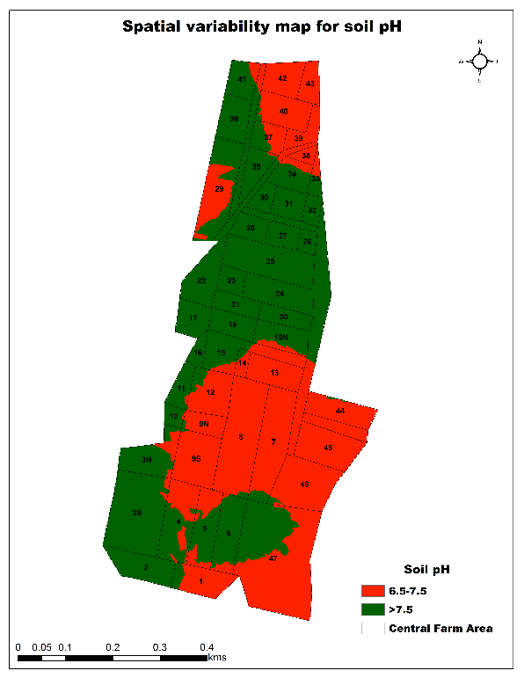 | 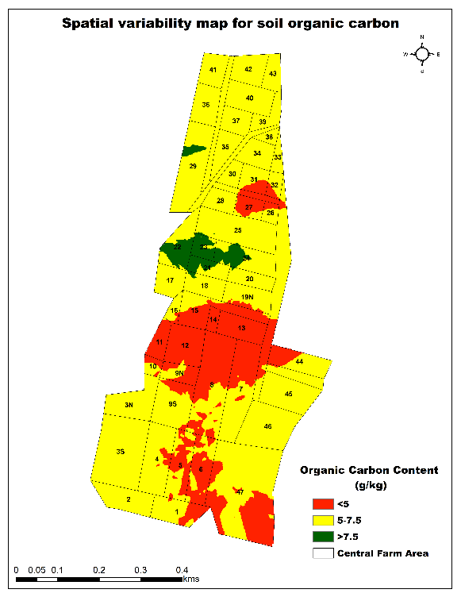
Figure 4. Spatial variability maps for the soil pH and organic carbon

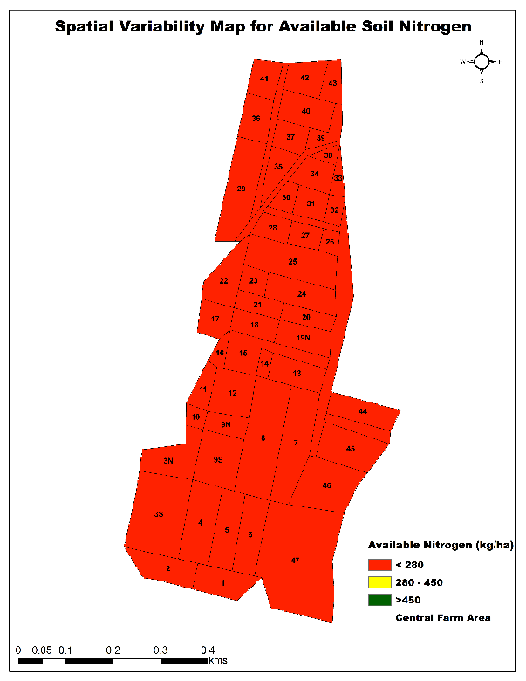 |  | 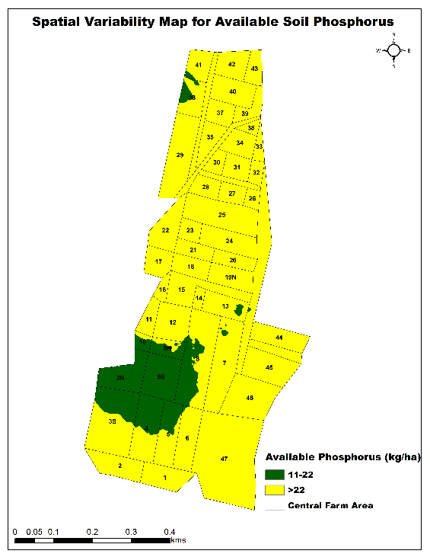
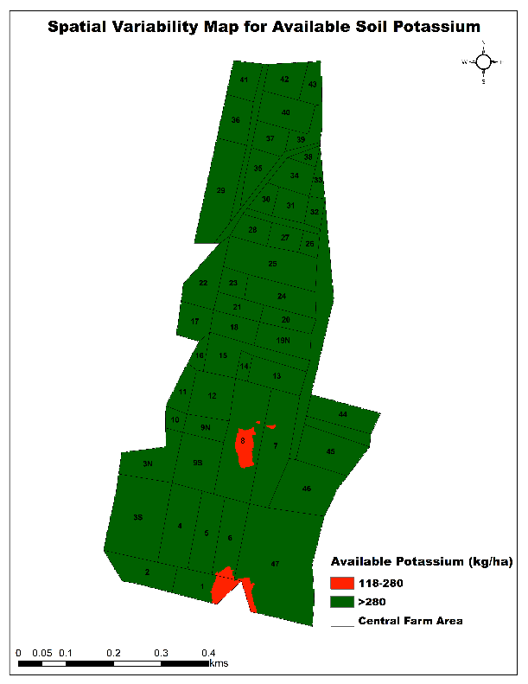 |  | 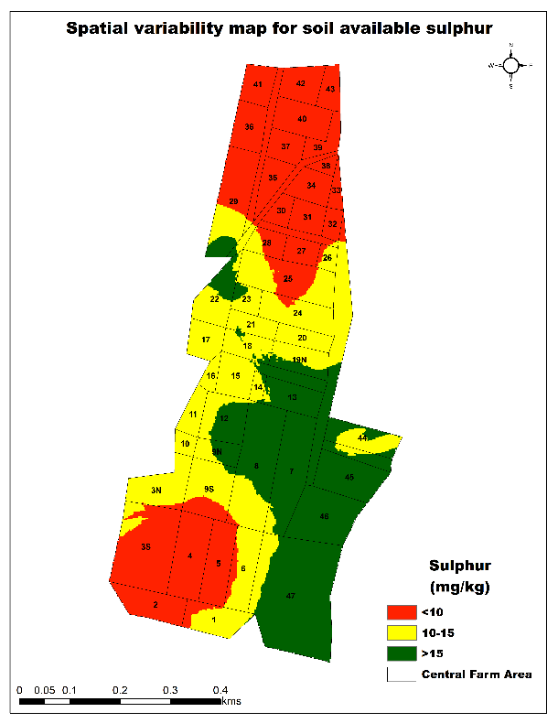
Figure 5. Spatial variability maps for the available soil nitrogen, phosphorus, potassium and sulphur

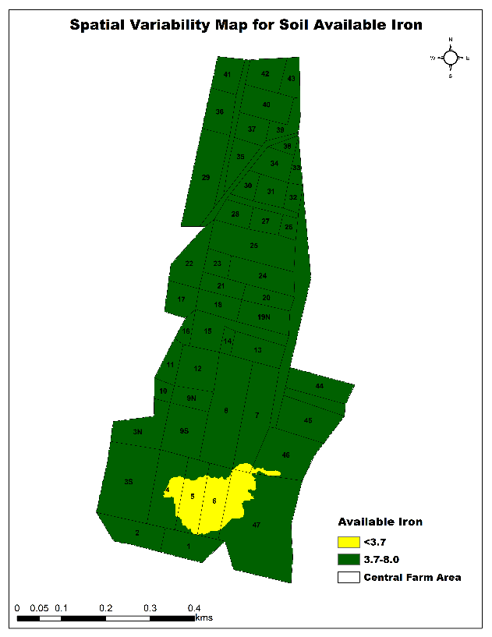 | 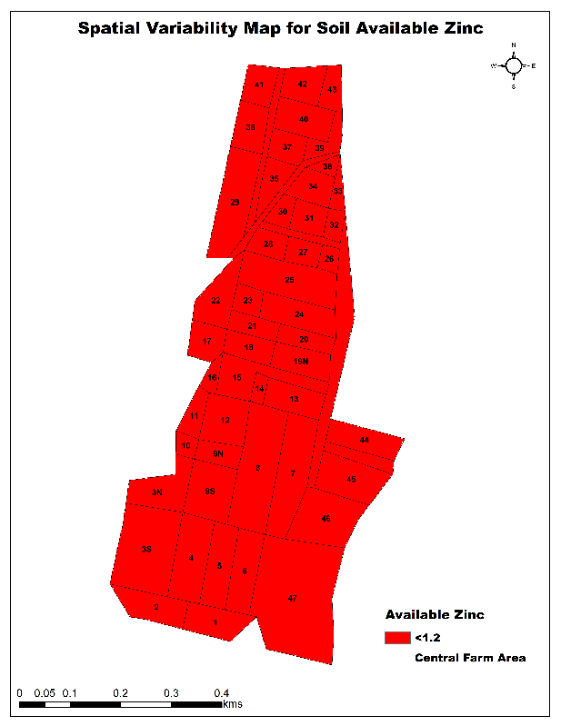
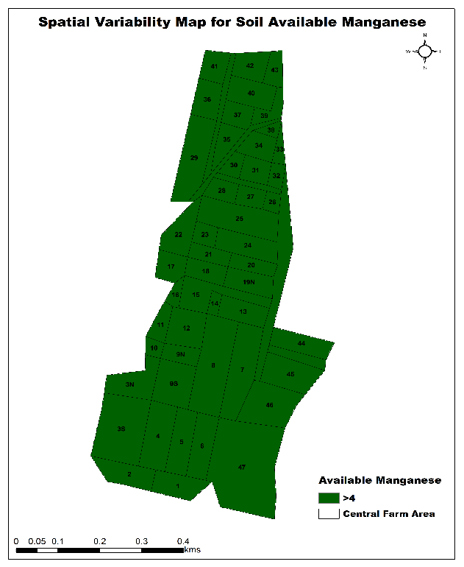 | 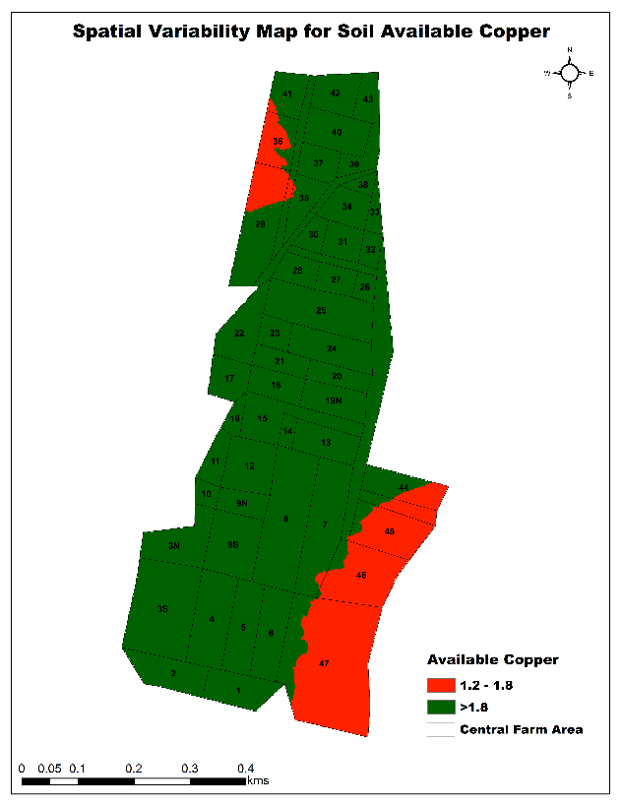
Figure 6. Spatial variability maps for the DTPA- Fe, Zn, Mn and Cu

MAJ template contains guidance text for composing and formatting the research articles. Please remove all the template text from the final formatted paper before submitting to the editor. Failure to remove template text from the final article may result in rejection of the article.

