RESEARCH ARTICLE
Effects of conservation agricultural practices on soil microbial population and yield of cotton

ABSTRACT
Field investigations were conducted to assess the effect of conservation agricultural practices on soil biological properties and yield of cotton during the kharif season of 2018 and 2019. The experiments were conducted in a split plot design with four main factors viz., conventional tillage with irrigation schedule of 0.8 IW/CPE ratio (M₁), conventional tillage with irrigation schedule of 0.6 IW/CPE ratio (M₂), minimum tillage with irrigation schedule of 0.8 IW/CPE ratio (M₃) and minimum tillage with irrigation schedule of 0.6 IW/CPE ratio (M₄). Sub plots has six treatments of weed and nutrient management viz., crop residue mulch with 100% RDF (S₁), crop residue mulch with 75% RDF (S₂), pre-emergence application of pendimethalin fb one hand weeding with 100% RDF (S₃), pre-emergence application of pendimethalin fb one hand weeding with 75% RDF (S₄), mechanical weeding twice with 100% RDF (S₅) and mechanical weeding twice with 75% RDF (S₆). Total microbial populations viz., bacteria, fungal, and actinobacteria were recorded higher in cotton rhizosphere soil with minimum tillage with irrigation at 0.8 IW/CPE ratio (M₃) in the main plot treatments. Cotton rhizosphere soil with crop residue mulch with 100% RDF (S₁) recorded higher microbial population and it was statistically similar with pre-emergence application of pendimethalin fb one hand weeding with 100% RDF (S₃) in the sub plot treatments. Among the treatment combination, minimum tillage with irrigation at 0.8 IW/CPE ratio (M₃) and crop residue mulch with 100% RDF (S₁) recorded higher microbial population. Similarly, higher seed yield of cotton were also recorded with minimum tillage and irrigating the crop at 0.8 IW/CPE ratio and pre-emergence application of pendimethalin fb one hand weeding along with application of 100% RDF (M₃S₃).
Keywords: Conventional tillage, Conservation agriculture, Minimum tillage, Mulch.

INTRODUCTION
Conservation agriculture is a concept evolved to respond to the concerns of sustainability of agriculture (FAO, 2012). This is a resource-saving agricultural production system aims to achieve high and sustaining yields and also will be able to enhance the maintain natural resource base through compliance of interrelated principles and with other good production management practices of plant nutrition (Abrol and Sangar, 2006). Traditional agriculture is based on intensive tillage and through mechanization in farming and held responsible for soil erosion problems, surface and underground water pollution and more consumption of irrigation water (Wolff and Stein, 1998). Moreover, it is implicated in land resource degradation and low energy efficiency and also contributes to global warming (Boatmann et al., 1999). Hence, conservation agriculture is a effective alternate way to cultivate annual and perennial crop-based system and with crop residue management to have a soil cover. This will precede way to increase the organic matter content in the surface soil horizons. Instantaneously, it also has the beneficial impacts on the global environment as compared to traditional agriculture (Derpsch et al., 2010).
Microorganisms are an important component of soil, directly related to plant growth and soil fertility. Soil microbes are the living portion of soil that plays an important role in the function of ecosystems through their complex interactions with the environment (Joergensen and Wichern, 2018). These include organic matter decomposition and nutrient cycling, including carbon (C) and nitrogen (N) cycling, and soil aggregate formation and maintenance (Joergensen and Wichern, 2018; Hewins et al., 2017). Furthermore, the size of microbial population in agricultural soils can be affected by management practices.
India, has a long history of agricultural activities, produces a vast amount of crop residues, which are generally discarded resulting in significant accumulation and cause pollution. Direct incorporation of crop residues into agricultural land to conserve soil nutrients, soil moisture and organic carbon content can cause considerable crop management problems. However, a long-term field experiment has confirmed that adding crop residues to agricultural land leads to a large increase in soil carbon stocks in the short term but minimal increase in the long term due to natural decay. In this regard, the study was conducted to assess the impact of conservation agricultural practice on biological properties of rhizosphere soil and yield of seed cotton during the season of kharif 2018 and 2019.

MATERIAL AND METHODS
The field experiments were conducted at Agricultural College and Research Institute, Tamil Nadu Agricultural University, Madurai. The experimental field is located in the southern agro climatic zone of Tamil Nadu at 9º54’ N latitude and 78º54’ E longitude and at an altitude of 147 m above MSL. A mean annual rainfall of 848 mm was distributed in 46 rainy days. The soil of the experimental site is clay loam with available 203.2, 16.7,419.6 kg NPK ha⁻¹, pH (8.0), Ec (0.37 dS m⁻¹) and organic carbon 0.48 per cent. Initial soil microbial population of bacteria, fungi and actinobacteria was 98.9 cfu g⁻¹, 16.7 cfu g⁻¹ and 82.6 cfu g⁻¹
The conventional tillage comprised of one disc ploughing, two cultivator ploughing and one rotavator pass. Minimum tillage plots were prepared with the help of mulcher and one pass with disc harrow followed by one cultivator ploughing. The main and sub plots were formed with irrigation and drainage channels. The experiment was laid out in split plot design with three replications. The main plot consisted of four treatments, conventional tillage with irrigation at 0.8 IW/CPE ratio (M₁), conventional tillage with irrigation at 0.6 IW/CPE ratio (M₂), minimum tillage with irrigation at 0.8 IW/CPE ratio (M₃), minimum tillage with irrigation at 0.6 IW/CPE ratio (M₄) and sub plot consisted of six treatments viz., crop residue mulch with 100% RDF (S₁), crop residue mulch with 75% RDF (S₂₎, pre emergence application of pendimethalin fb one hand weeding along with 100% RDF (S₃), pre emergence application of pendimethalin fb one hand weeding along with 75% RDF (S₄), mechanical weeding twice with 100% RDF (S₅), mechanical weeding twice with 75% RDF (S₆). Cotton variety SVPR 4 was used in the study. Bacteria, fungal and actinobacteria populations were observed at pre and post harvest sowing of seed cotton. These data were analysed statistically by following Gomez and Gomez (1984). Wherever, the treatment differences were found significant (F test), critical differences were worked out at five per cent probability level and the values were furnished. Treatment differences that were not significant were denoted as “NS”.

RESULTS AND DISCUSSION
Bacterial population
In the present study, the effect of different types of tillage, irrigation regimes, weed and nutrient management on the bacterial population of cotton rhizosphere soil was assessed and the results are given in figure 1. Among the tillage practices and irrigation regimes, total bacterial population was higher in minimum tillage practices with 0.6 IW/CPE ratio of irrigation (M₄) (101.7 × 10⁶ cfu g⁻¹ and 122.8 × 10⁶ cfu g⁻¹) at post-harvest soil of cotton during the year 2018 and 2019 respectively. These results was at par with minimum tillage practices with irrigation at 0.8 IW/CPE ratio (M₃). Among the sup plot treatments, total soil bacterial population at post-harvest soil of cotton was recorded higher in crop residue mulch with 100 per cent RDF (S₁) during 2018 and 2019 (99.9 × 10⁶ cfu g⁻¹ and 114.0× 10⁶ cfu g⁻ ¹ respectively). This treatment was followed by pre-emergence application of pendimethalin fb one hand weeding along with application of 100 per cent RDF (S₃) during 2019. Among the treatment combination soil total bacterial population at post-harvest soil of cotton recorded higher 119.7×10⁶ cfu g⁻¹ in minimum tillage practices with 0.6 IW/CPE ratio irrigation with crop residue mulch with 100 per cent RDF (M₄S₁) during 2018 and it was followed by minimum tillage practices irrigation at 0.8 IW/CPE ratio with crop residue mulch along with application of 100 per cent RDF (M₃S₁) and minimum tillage with 0.8 IW/CPE ratio irrigation with pre-emergence application of pendimethalin fb one hand weeding along with application of 100 per cent RDF (M₃S₄). However, during 2019 bacterial population (145.2×10⁶ cfu g⁻¹) was more in minimum tillage practices with irrigation at 0.8 IW/CPE ratio with pre-emergence application of pendimethalin fb one hand weeding along with application of 100 per cent RDF (M₃S₃).
Fungal population
Results of the fungal population in cotton rhizosphere soil are given in figure 2. Fungal population of soil was recorded higher in minimum tillage practices with irrigation at 0.6 IW/CPE ratio (M₄). However, at post-harvest soil of cotton recorded higher fungal population in minimum tillage practices with irrigation at 0.8 IW/CPE ratio (M₃) during 2018 as well at 2019 (52.6 × 10⁴ cfu g⁻¹ and 72.5 × 10⁴ cfu g⁻¹, respectively). Among the weed and nutrient management treatments, crop residue mulch with 100 per cent RDF (S₁) treatment showed higher soil fungal population at post-harvest soil during both the years of field experimentation (52.5 × 10⁴ cfu g⁻¹ and 63.9 × 10⁴ cfu g^{-1 in} 2018 and 2019, respectively). This result did not significantly differ from pre-emergence application of pendimethalin fb one hand weeding along with application of 100 per cent RDF (S₃) during 2019 at post-harvest soil (60.5 × 10⁴ cfu g⁻¹). Among treatment combination, minimum tillage practices with irrigation at 0.8 IW/CPE ratio with pre-emergence application of pendimethalin fb one hand weeding along with application of 100 per cent RDF (M₃S₃) recorded higher fungal population at post- harvest soil of cotton during 2019 (86.1 × 10⁴ cfu g⁻¹) followed by minimum tillage with irrigation at 0.6 IW/CPE ratio and crop residue mulch along with application of 100 per cent RDF (M₄S₁). While in 2018 more fungal population was recorded in minimum tillage practices with irrigation at 0.6 IW/CPE ratio and crop residue mulch along with 100 per cent RDF (M₄S₁) (64.7 × 10⁴ cfu g⁻¹). This treatment was followed by minimum tillage practices with irrigation at 0.8 IW/CPE and pre-emergence application of pendimethalin fb one hand weeding along with 100 per cent RDF (M₃S₃) (62.8 × 10⁴ cfu g⁻¹). Conservation tillage can also influence soil suitability for the growth of crops (Hewins et al., 2017), promoting the formation of fungal hyphal networks, and leading to higher soil fungal population sizes (Gottshall et al., 2017).
Actinobacterial population
The results of actinobacterial population aregiven in figure 3. Among the main plot treatments, at post-harvest soil (2018 and 2019) of cotton recorded more of 82.1 × 10⁵ cfu g⁻¹ and 92.0 × 10⁵ cfu g⁻¹ actinobacterial population in minimum tillage practices with irrigation at 0.6 IW/CPE ratio (M₄) and this results was at par with minimum tillage practices with irrigating crop at 0.8 IW/CPE ratio (M₃). Among the different weed and nutrient management treatments, actinobacterial population was higher in crop residue mulch with 100 per cent RDF (S₁) at post-harvest soil of cotton during 2018 and 2019 with a value of 78.9 × 10⁵ cfu g⁻¹ and 89.9 × 10⁵ cfu g⁻¹, respectively. This results did not statistically differ from the treatment of pre-emergence application of pendimethalin fb one hand weeding along with application of 100 per cent RDF (S₃) (86.6 × 10⁵ cfu g⁻¹) during 2019. Among the treatment combination with respect of post-hervest soil of cotton, minimum tillage practices with irrigation at 0.6 IW/CPE ratio and crop residue mulch along with 100 per cent RDF (M₄S₁) treatment registered higher actinobacterial population during 2018 and 2019 (95.4 × 10⁵ cfu g⁻¹ and 108.2 × 10⁵ cfu g⁻¹, respectively). This result was followed by minimum tillage practices with irrigation at 0.8 IW/CPE ratio and pre-emergence application of pendimethalin fb one hand weeding along with 100 per cent RDF (M₃S₃) during 2019. Similar to the present study Li et al., (2020) reported that the increase in soil bacteria, fungi, and actinobacteria counts in conservation tillage practices, which created favorable environmental conditions for microbial growth. Conservation tillage practices can influence the soil microclimate, the distribution and decomposition of crop residues, and the transformation of nutrients (Cheng et al., 2017); those factors, in turn, can alter soil microbial population size and diversity (Li et al., 2018). Minimum tillage causes less disturbance of the soil, creating a better environment for microbial growth, leading to increased C use efficiency and elevated activity levels of various extracellular enzymes (Sauvadet et al., 2018).
Yield
Tillage is an important management practice involving physical manipulation of soil for crop establishment. Optimization of tillage practices leads to improvement in soil health. Soil health is a dynamic and complex system, and its functions are mainly mediated by agricultural management practices (Doran and Zeiss, 2000). In the current study, Figure 1. Reveals that among the tillage practices and irrigation regimes, minimum tillage with irrigation at 0.8 IW/CPE ratio (M₃) produced the highest seed cotton yield of 1774 and 1831 kg ha⁻¹ during kharif 2018 and 2019, respectively. This treatment however did not differ from the plots with conventional tillage and irrigation at 0.8 IW/CPE ratio (M₁). While conventional tillage combined with irrigation at 0.6 IW/CPE ratio (M₂) registered the lowest seed cotton yield of 1381 and 1425 kg ha⁻¹ during kharif 2018 and 2019, respectively. Among weed and nutrient management practices, pre-emergence application of pendimethalin fb one hand weeding with 100 per cent RDF (S₃) recorded the highest seed cotton yield of 1892 and 1957 kg ha⁻¹ during kharif 2018 and 2019, respectively. Whereas, addition of crop residue mulch with 75 per cent RDF (S₂) consistently recorded the lowest seed cotton yield (1436 and 1480 kg ha⁻¹). Among the treatment combination, minimum tillage with irrigation scheduling at 0.8 IW/CPE ratio combined with pre-emergence application of pendimethalin fb one hand weeding along with application of 100 per cent RDF registered the highest yield of 2054 and 2127 kg ha⁻¹ during kharif 2018 and 2019 (M₃S₃), respectively. This treatment was at par with conventional tillage and irrigation at 0.8 IW/CPE ratio combined with pre-emergence application of pendimethalin fb one hand weeding along with 100 per cent RDF (M₁S₃). The lowest seed cotton yield was observed with conventional tillage and irrigation at 0.6 IW/CPE ratio along with crop residue mulch and application of 75 per cent RDF (M₂S₂) with a seed cotton yield 1164 and 1201 kg ha⁻¹ during kharif 2018 and 2019, respectively). Similar to the present study, Mutonga et al., (2019) also reported more grain yield in conservation tillage wheat than conventional agricultural practices by conserving more moisture.
Economics
Yield and cost of cultivation are the prime factor for determining the economic efficiency and viability of a crop. Higher crop productivity with minimum cost of cultivation resulted in higher net returns and B: C ratio.
Conservation agricultural practices showed variation with cost of cultivation, net income and benefit cost ratio (Table 1). Cost of cultivation was less under minimum tillage practices and irrigating the crop at 0.8 IW/CPE ratio and pre-emergence application of pendimethalin fb one hand weeding along with application of 100 per cent RDF (M₃S₃) due to reducing labour requirement and also reduced machinery usage. While, conventional tillage practices increased the cost of cultivation.
During the kharif season in both the years i.e., 2018 and 2019, higher gross return, net return and B:C ratio of 110916, 66541, 2.50, 114858, 70483 and 2.59, respectively, were observed with minimum tillage practices and irrigating the crop at 0.8 IW/CPE ratio and pre-emergence application of pendimethalin fb one hand weeding along with application of 100 per cent RDF (M₃S₃) . This treatment was followed by the treatment of conventional tillage and irrigation at 0.8 IW/CPE ratio and pre-emergence application of pendimethalin fb one hand weeding along with 100 per cent RDF (M₁S₃). Singh and Meena (2018) also stated that higher B:C ratio was observed with conservation agriculture as compared to conventional agriculture.

CONCLUSION

Based on the experimental results it can be concluded that minimum tillage practices with irrigation at 0.8 IW/CPE ratio and pre-emergence application of pendimethalin fb hand weeding along with 100 per cent RDF recorded the improved soil microbial population, seed coton yield, gross return, net return and benefit cost ratio. Hence the above treatment can be recommended as the best conservation management practices for the farmers in southern states of india.

REFERENCES
Abrol, I.P., and Sangar, S. (2006). Sustaining Indian agriculture-conservation agriculture the way forward. Current Science, 91(8), 1020-2015.
Boatman, N., Green, M., and Holland, J., (1999) Agri‐environment schemes – what have they achieved and where do we go from here Aspects Appl. Biol., 100, 447.
Cheng,Y., Wang, J., Wang, J., Chang, S.X., Wang, S., 2017. The quality and quantity of exogenous organic carbon input control microbial NO3 − immobilization: a meta-analysis. Soil Biol. Biochem. 115, 357–363.
Derpsch R, Friedrich T. Global overview of Conservation Agriculture adoption. Invited Paper, 4th World Congress on Conservation Agriculture: Innovations for Improving Efficiency, Equity and Environment. 4- 7 February 2010, New Delhi, ICAR
Doran, J.W., R. M. Zeiss. 2000. Soil health and sustainability: managing the biotic component of soil quality. Applied Soil Ecology. 15, 3–11.
FAO. (2012). Alive and kicking: why dormant soil microorganisms matter. Soil Biol. Biochem. 116, 419–430.
Gomez, K. A., Gomez, K. A and Gomez, A. A. (2010). Statistical procedures for agricultural research (2nd ed.) International Rice Research Institute, P.B. Box. Manila, Philippines and John Wiley and Sons, New York, USA, p. 680.
Gottshall, C.B., Cooper, M., Emery, S.M., 2017. Activity, diversity and function of arbuscular mycorrhizae vary with changes in agricultural management intensity. Agric. Ecosyst. Environ. 241, 142–149.
Hewins, D.B., Sinsabaugh, R.L., Archer, S.R., Throop, H.L., 2017. Soil-litter mixing and microbial activity mediate decomposition and soil aggregate formation in a sandy shrub-invaded Chihuahuan Desert grassland. Plant Ecol. 218, 459–474.
Li, Y., Chang, S.X., Tian, L.H., Zhang, Q.P., 2018. Conservation agriculture practices increase soil microbial biomass carbon and nitrogen in agricultural soils: a global meta-analysis. Soil Biol. Biochem. 121, 50–58.
Li, Y., Zhang, Q., Cai, Y., Yang, Q., & Chang, S. X. (2020). Minimum tillage and residue retention increase soil microbial population size and diversity: Implications for conservation tillage. Science of the Total Environment, 716, 137164.
Mutonga, M.W., Kipkorir, E.C. and Ng’etich, W.K. 2019. Assessment of Effects of Zero and Conventional Tillage Practices on Soil Moisture and Wheat Grain Yield in Arid and Semi-Arid Land of Laikipia, Kenya. Water Conservation Science and Engineering. 4 (1): 43-52.
Sauvadet, M., Lashermes, G., Alavoine, G., Recous, S., Chauvat, M., Maron, P.A. 2018. High carbon use efficiency and low priming effect promote soil C stabilization under reduced tillage. Soil Biol. Biochem. 123, 64–73.
Wolff, P., and Stein, T. M. (1998). Water efficiency and conservation in agriculture – opportunities and limitations. Agriculture and International Soil and Water Conservation Research, Vol. 2, No. 4, 2014, pp. 1-12.
Singh, K.M. and Meena, M.S. (2010). Conservation Agriculture: Economic Perspective and Future challenges. In: Resource Conservation Technologies for Food Security and Rural Livelihood, Ed: Dr.A.R.Khan et.al. R-W Consortium for Indo-Gangetic Plains, New Delhi and Agrotech Publishing Academy, Udaipur. pp. 209-224

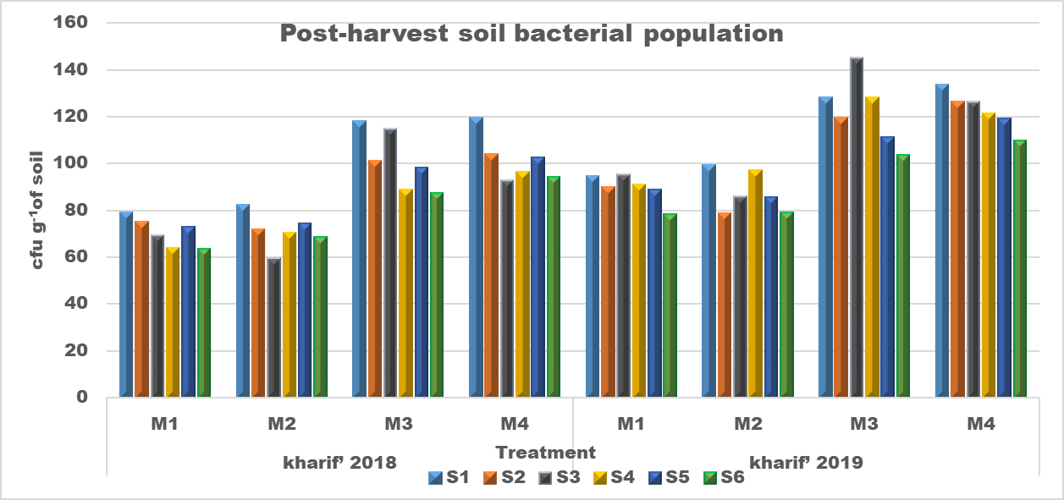

Figure 1. Effects of conservation agricultural practices on soil post-harvest bacterial population of cotton

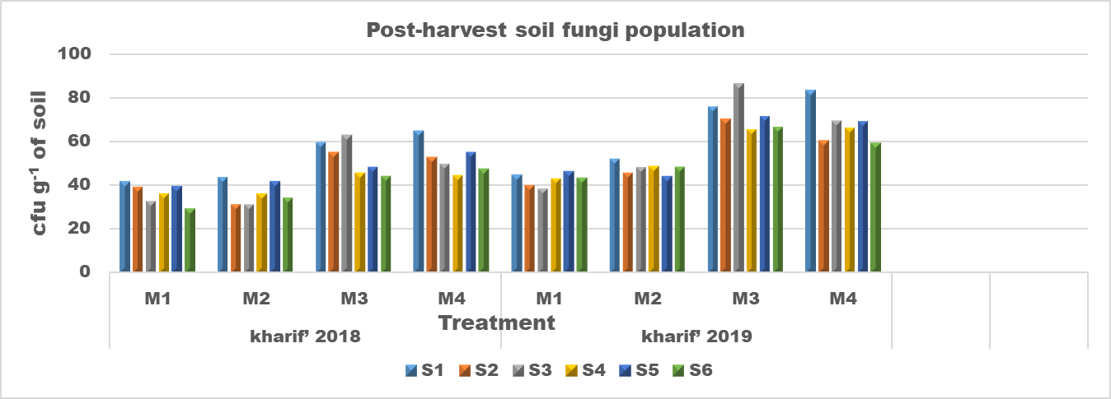
Figure 2. Effects of conservation agricultural practices on soil post-harvest fungal population of cotton

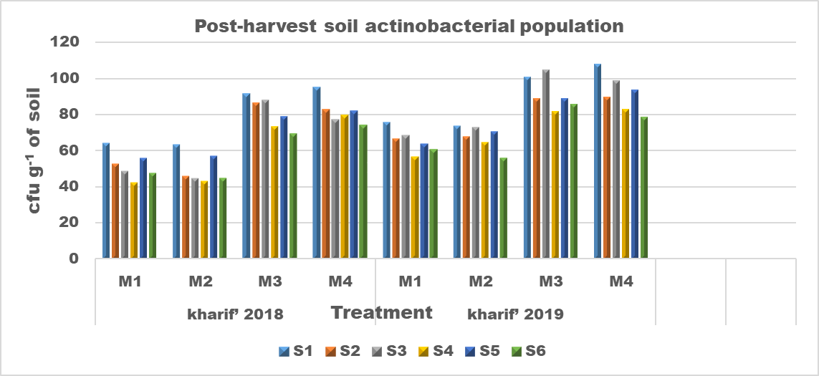
Figure 3. Effects of conservation agricultural practices on soil post-harvest actinobacterial population of cotton

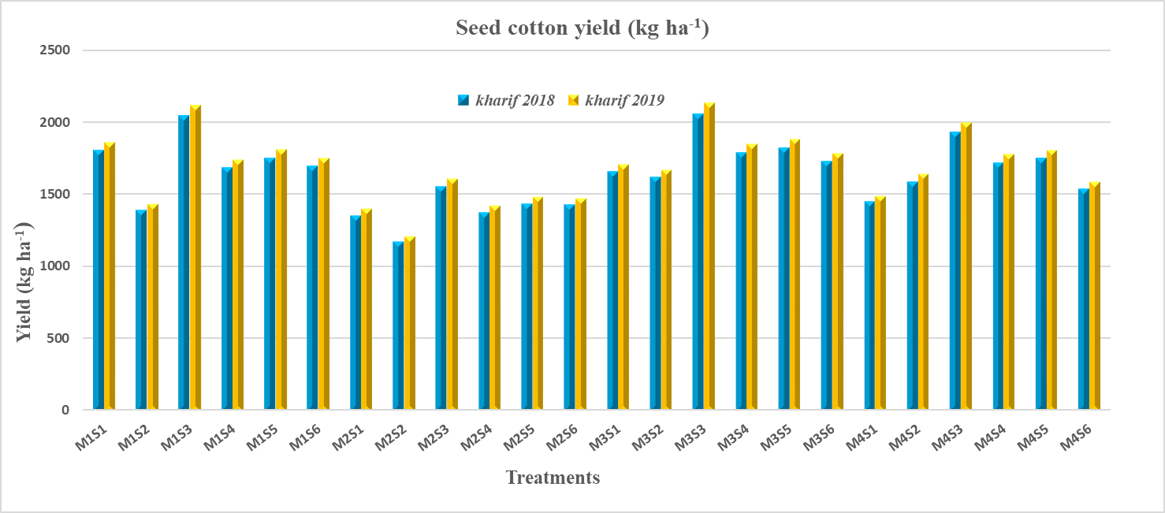
Figure 4. Effect of tillage, irrigation regimes, weed and nutrient management practices on seed cotton yield (kg ha⁻¹) (kharif’ 2018 and 2019

Table 1. Effects of conservation agricultural practices on cost of cultivation, gross return, net return, benefit cost ratio of cotton
Treatments | kharif’ 2018 |  |  |  | kharif’ 2019
Treatments | Cost of Cultivation  (Rs ha⁻¹) | Gross  Return  (Rs ha⁻¹) | Net  Return  (Rs ha⁻¹) | Benefit  Cost  Ratio | Cost of Cultivation  (Rs ha⁻¹) | Gross  Return  (Rs ha⁻¹) | Net Return  (Rs ha⁻¹) | Benefit  Cost  Ratio
M₁S₁ | 41325 | 97146 | 55821 | 2.35 | 41325 | 99954 | 58629 | 2.42
M₁S₂ | 41325 | 74628 | 33303 | 1.81 | 41325 | 77004 | 35679 | 1.86
M₁S₃ | 46175 | 110106 | 63931 | 2.38 | 46175 | 113886 | 67711 | 2.47
M₁S₄ | 46175 | 90828 | 44653 | 1.97 | 46175 | 93690 | 47515 | 2.03
M₁S₅ | 43825 | 94284 | 50459 | 2.15 | 43825 | 97416 | 53591 | 2.22
M₁S₆ | 43825 | 91368 | 47543 | 2.08 | 43825 | 94122 | 50297 | 2.15
M₂S₁ | 40825 | 72792 | 31967 | 1.78 | 40825 | 75168 | 34343 | 1.84
M₂S₂ | 40825 | 62856 | 22031 | 1.54 | 40825 | 64854 | 24029 | 1.59
M₂S₃ | 45675 | 83700 | 38025 | 1.83 | 45675 | 86454 | 40779 | 1.89
M₂S₄ | 45675 | 73980 | 28305 | 1.62 | 45675 | 76302 | 30627 | 1.67
M₂S₅ | 43325 | 77112 | 33787 | 1.78 | 43325 | 79596 | 36271 | 1.84
M₂S₆ | 43325 | 76896 | 33571 | 1.77 | 43325 | 79164 | 35839 | 1.83
M₃S₁ | 39525 | 89208 | 49683 | 2.26 | 39525 | 91854 | 52329 | 2.32
M₃S₂ | 39525 | 87318 | 47793 | 2.21 | 39525 | 89802 | 50277 | 2.27
M₃S₃ | 44375 | 110916 | 66541 | 2.50 | 44375 | 114858 | 70483 | 2.59
M₃S₄ | 44375 | 96390 | 52015 | 2.17 | 44375 | 99522 | 55147 | 2.24
M₃S₅ | 42025 | 98010 | 55985 | 2.33 | 42025 | 101304 | 59279 | 2.41
M₃S₆ | 42025 | 93096 | 51071 | 2.22 | 42025 | 95904 | 53879 | 2.28
M₄S₁ | 39025 | 77922 | 38897 | 2.00 | 39025 | 80082 | 41057 | 2.05
M₄S₂ | 39025 | 85374 | 46349 | 2.19 | 39025 | 88128 | 49103 | 2.26
M₄S₃ | 43875 | 103950 | 60075 | 2.37 | 43875 | 107406 | 63531 | 2.45
M₄S₄ | 43875 | 92610 | 48735 | 2.11 | 43875 | 95472 | 51597 | 2.18
M₄S₅ | 41525 | 94176 | 52651 | 2.27 | 41525 | 97146 | 55621 | 2.34
M₄S₆ | 41525 | 82782 | 41257 | 1.99 | 41525 | 85158 | 43633 | 2.05

