RESEARCH ARTICLE

**Awareness and Adoption of Climate Resilient Farm Technologies for Rearing Livestock and Fisheries in Namakkal District of Tamil Nadu**

|  |  |
| --- | --- |
|  | ABSTRACTIndia is still dependent on farming, lives in villages and employs more than fifty per cent of its population. The failure of crops due to climate change issues resulted in loss of livelihood and economic security to millions of our farming population. Over years the allied sectors are assisting our farming community to safeguard their livelihoods and aid in generating more revenue from agricultural farm waste. Keeping these issues in focus, a study was undertaken on awareness and adoption of climate resilient farm technologies for rearing livestock and fisheries in Namakkal district of Tamil Nadu. The study was conducted in Erumapatty block where National Initiative on Climate Resilient Agriculture (NICRA) scheme was carried out. About 120 farm respondents were selected for the study and data was collected through a pre-tested interview schedule. The findings of the study revealed that majority of the respondents (53.33 per cent) belong to old age and medium age category (36.67 per cent). They are small farmers (53.33 per cent) and marginal farmers (25.00 per cent). They possess medium (51.67 per cent) to high level of (30.00 per cent) of farming experience. Majority of them have medium level of social participation and mass media exposure. They had medium level (63.33 per cent) of risk orientation and scientific orientation. On the awareness and adoption of recommended climate resilient farm technologies, more than half of the respondents (53.33 per cent) had high level of awareness and more than half of the farmers (60.00 per cent) in the study area adopted the climate resilient farm technologies related to rearing livestock and fisheries in Namakkal district of Tamil Nadu. |

Keywords: Climate change, Climate resilient farming, Rearing livestock and fisheries, Mitigation

## INTRODUCTION

## Climate is the predominant factor for doing farming and rainfall plays a momentous role in agriculture. The present climate change related issues like prolonged droughts, frequent floods and cyclones, aberrant rainfall, changes in diurnal variations of temperature are affecting the production, productivity and livelihoods of small and marginal farmers, agricultural labourers creating negative impact on the economy of our nation. (Reference??) With climate change issues becoming the new normal, avoidance of climate variability is not possible. Hence there arise a need for awareness and adoption of climate resilient farm technologies among the farming community suited to the livelihood needs of farming community. Keeping this in view, a study was undertaken to evaluate the awareness and adoption of climate resilient farm technologies on livestock and fisheries in Namakkal district of Tamil Nadu.

## RESEARCH METHODOLOGY

Namakkal district in Tamil Nadu was purposively selected for this study as it was prone to frequent natural vagaries as a result of climate change. With the National Initiatives on Climate Resilient Agriculture (NICRA) scheme initiated through ICAR-Krishi Vigyan Kendra in Namakkal district, the introduction of smart farm practices and technological intervention is supposed to assist our farming community face climate adversities with climate resilient farm technologies in raising their farm production, productivity and safeguarding their livelihood issues of present and future. The study was undertaken in Erumaipatty block of Namakkal district where NICRA scheme was implemented. Among the 24 village panchayats, Vadavathur village panchayat was selected as it was successful in implementing many NICRA initiatives under different modules. About 120 farm respondents who were beneficiaries of NICRA were selected for this study.

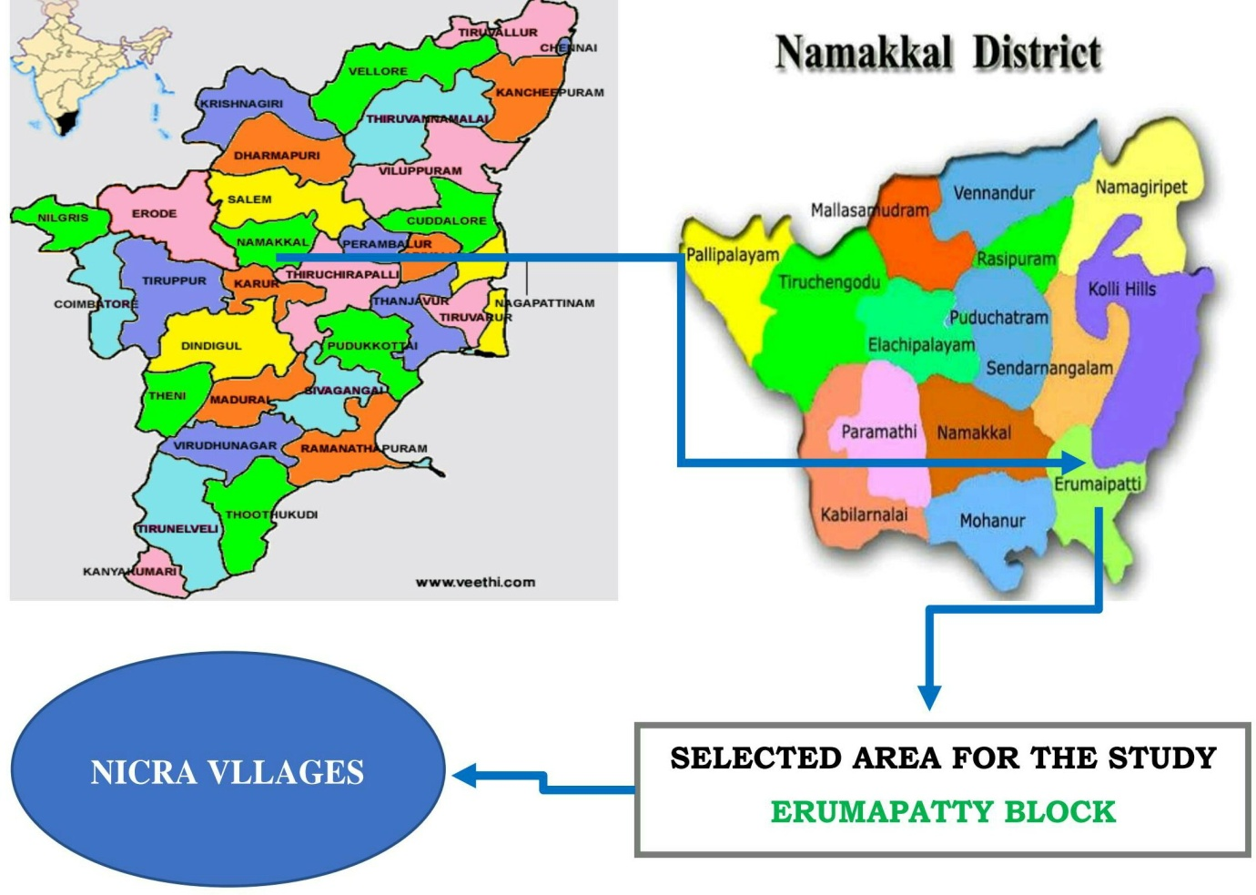

**Figure 1: Map showing the study area**

## FINDINGS AND DISCUSSION

The findings of the study on awareness and adoption of climate resilient farm technologies on livestock and fisheries is presented in Table 1

**Table 1: Distribution of respondents according to their technology wise awareness and adoption on climate resilient farm technologies on Livestock and Fisheries**

(n=120)

|  |  |  |  |  |  |
| --- | --- | --- | --- | --- | --- |
| **S. No** | **Climate resilient farm technologies** | **Awareness** | | **Adoption** | |
| **No.** | **%** | **No.** | **%** |
| 1. | Development of trees around animal shed | 100 | 83.33 | 70 | 58.33 |
| 2. | Introduction of new breeds for better production | 86 | 71.66 | 80 | 66.66 |
| 3. | Back yard poultry | 110 | 91.66 | 104 | 86.66 |
| 4. | Improved shelter for dairy animals to reduce heat stress | 88 | 73.3.3 | 26 | 21.66 |
| 5. | Slatted floor shed for goat | 90 | 75 | 26 | 21.66 |
| 6. | Improved night shelter for poultry birds | 100 | 83.33 | 82 | 68.33 |
| 7. | Improved fodder storage method (put aluminium sheet over fodder) | 116 | 96.66 | 116 | 96.66 |
| 8. | Micro nutrient feeding of (Mineral mixture and Mineral block) livestock | 100 | 83.33 | 94 | 78.33 |
| 9. | Deworming of young ones ,needy animals and birds | 110 | 91.66 | 100 | 83.33 |
| 10. | Vaccination | 120 | 100 | 112 | 93.33 |
| 11. | Fish rearing | 60 | 50 | 24 | 20 |

### Livestock and Fisheries rely on use of community lands for fodder production during drought, improved fodder/feed storage methods, preventive vaccination, improved shelters for reducing heat stress in livestock, management of fish ponds/tanks during water scarcity and excess water..

***Development of trees around animal shed***

Trees are very helpful to animals. It provides shade, acts as a barrier to wind, absorb noise pollution *etc.* It could be seen from the table-24 that about 83.33 per cent of the farmers were aware about the need of trees around cattle shed and 58.33 per cent of the farmers adopted this climate resilient farm technology. The reason might be due to tree saplings given at free of cost by development departments of the state to the farming communities in this locality.

***Introduction of new breeds for better production***

Some breeds are highly resistant to heat and also tolerant to disease but not having production potential. Therefore, our farmers must need to go for new improved breeds for better production. It will be helpful for getting higher income and providing livelihood security for small and marginal farmers. It could be seen from the table-1 that about 71.66 per cent of the farmers were aware about Introduction of new breeds for better production and 66.66 per cent of the farmers adopted this climate resilient farm technology. The reason might be due to the introduction of new breeds by KVK, Namakkal. They had introduced some new breeds in the study area villages which possessed high production potential.

**Table 2: New improved breeds introduced by KVK through NICRA scheme at Vadavathur village in Namakkal district This table must be referred in the contents/body.**

|  |  |  |
| --- | --- | --- |
| **S. No** | **Animals** | **New improved breeds** |
| 1. | Sheep | Bharath merino, Nari-swarna, Bharath merino and Nari-swarna. |
| 2. | Goat | Boar Sirohi cross, Tellicherry, Sirohi and Tellicherry. |
| 3. | Turkey | White and black beltsvile |
| 4. | Duck | Khaki campbell |
| 5. | Fish fingerlings | Koicarp, Carp |

** **

**Figure 2: Introduction of New Breed (NARI – SWARNA) by KVK through NICRA scheme at Vadavathur village, Namakkal**

**(Major/Aappropriate technology adoption plates may be included)**

***Back yard poultry***

Back yard poultry is a good source of income. It gives many benefits especially for the small and marginal farmers. It helps as a good source of manure and lay eggs. It gives additional income for the farming community. It could be seen from the table-1 that about 91.66 per cent of the farmers were aware about back yard poultry and 86.66 per cent of the farmers adopted this climate resilient farm technology. The reason may be due to this being a traditional practice adopted by most of the farmers in the study villages.

***Improved shelter for dairy animals to reduce heat stress***

Appropriate housing for animals is need for ensuring the health of animals. The open tied animals may be susceptible towards heat stress and prone to many vector borne diseases. To alleviate this issue, the farmers must proper a proper shelter for dairy animals. It could be seen from the table-1 that about 73.33 per cent of the farmers were aware about Improved shelter for dairy animals to reduce heat stress and only 21.66 per cent of the farmers adopted this climate resilient farm technology. The reason behind this less adoption is due to the poor socio economic status of small and marginal farmers in the study area.

***Slatted floor shed for goat***

It is a new flooring innovation for sheep and goat which have many advantages. It`s surface is anti-slippery when wet and there is less chance to skidding. The flooring material having longer life. It is easily cleaned with water. Hence it has been selected for this study. It could be seen from the table-1 that about 75.00 per cent of the farmers were aware about Slatted floor shed for goat and 21.66 per cent of the farmers adopted this climate resilient farm technology. The reason might be due to poor socio-economic status of the farmers. Through NICRA interventions, only rich farmers had adopted this new flooring technique.

***Improved night shelter for poultry birds***

The night shelter is need for protecting birds form adverse climatic conditions and natural enemies. It is used to facilitate proper micro climatic conditions and ensure proper supervision. Night shelter is also for protecting birds from thieves and predators. It could be seen from the table-1 that about 83.33 per cent of the farmers were aware about Improved night shelter for poultry birds and 68.33 per cent of the farmers adopted this climate resilient farm technology. By NICRA interventions, many of the farmers in this village had constructed the improved night shelter for poultry birds.

 

 

**Plate.3: Adoption of improved shelters for desi birds at Vadavathur village, Namakkal**

**Plate numbers should be referred in the body of the article??????????**

***Improved fodder storage method (Plastic sheet over fodder)***

Generally, the farmers are storing the fodder in open area, but this has negative impact as it affected by moulds and fungus during rainy season which cause food poison in livestocks. To avoid this the farmers are putting aluminium sheet over fodder to protect the fodder for longer periods and to improve the quality of fodder. It could be seen from the table-24 that about 96.66 per cent of the farmers were aware about Improved fodder storage method and 96.66 per cent of the farmers adopted this climate resilient farm technology. Through NICRA scheme demonstration, the KVK had created awareness among the famers and the most of the farmers has adopted this new technology.

**Before NICRA intervention ??? After NICRA intervention???**

** **

**Figure.4: Introduction of improved fodder storage method by KVK through NICRA scheme at Vadavathur village, Namakkal**

***Micro nutrient feeding of (Mineral mixture and Mineral block) livestock***

Minerals are very essential for proper metabolic functions in livestock. Mineral mixture contains all essential minerals in required quantities and it helps to improve the growth rate and reproductive efficiency. It increases the productivity and milk production in animals.It could be seen from the table-24 that about 83.33 per cent of the farmers were aware about Micro nutrient feeding of livestock and 78.33 per cent of the farmers adopted this climate resilient farm technology.In NICRA villages, the mineral mixtures are supplied to dairy farmers during Animal health camps conducted by KVK at periodical intervals.



**Figure.5: Mineral mixture supplementation during Animal health camp conducted by KVK, Namakkal through NICRA scheme**

***Deworming of young ones and needy animals and birds***

Deworming is a must needed one for animals which reduce the number of parasites in animals. It could be seen from the table-24 that about 91.66 per cent of the farmers were aware about deworming and 83.33 per cent of the farmers adopted this climate resilient farm technology. The reason might be due to improved production and productivity seen in animals after deworming exercises.



**Figure.6: Goat deworming during Animal Health Camp conducted by KVK through NICRA scheme in the study area**

***Vaccination***

Vaccination is very important for animal health and animal welfare. It helps to stimulate an immune system with reduce the intensity the disease itself. It could be seen from the table-24 that about cent per cent of the farmers were aware about the benefits of vaccination and 93.33 per cent of the farmers adopted this climate resilient farm technology. KVK organises vaccination camp in the study area through NICRA scheme at periodical intervals.



**Figure.7: Foot and Mouth Disease (FMD) vaccination camp conducted by KVK through NICRA scheme**

***Fish rearing***

It could be seen from the table-1 that about 50.00 per cent of the farmers were aware about fish rearing and only 20.00 per cent of the farmers adopted this climate resilient farm technology. In NICRA villages, none of the farmers adopt fish cultivation because of water scarcity. After NICRA intervention, few farmers reared fishes in temporary water storage ponds**.** KVK has introduced fish varieties like Tilapia, Genetically Improved Farm Tilapia (GIFT) and Carp for improving the income of the farming community.

 

**Figure.8: Fish catching in temporary water storage pond at Vadavathur village, Namakkal**

**SUMMARY AND CONCLUSION Needs revision as results ,need not be interpreted in conclusion.Summarise the findings with implications and conclude the study.**

To conclude, the findings on climate resilient farm technologies on livestock and fisheries reveal. Further, the need of the hour is Policy makers, administrators and extension professionals need to integrate and work together for creating awareness and adoption of this climate resilient farm technologies on Crop production and protection in Namakkal district on smart agriculture practices for managing and mitigating climate change related issues through improved rearing of livestock and fisheries among the farming communities. Very generic conclusion, be specific to your study.

**REFERENCES**

Adisa, R.S and Balogun, K.S. 2012. Analysis of Training Needs of Extension Agents on Climate Change Issues in Ekiti State Agricultural Development Project (EKSADP), Nigeria. Journal of Agricultural Extension, 16 (2).

Amritasingh. 2015. A Study on Impact of Climatic Change on Cropping Pattern Under Rainfed Area in Shahpur Block of Jabalpur District (M.P.), Unpublished M.Sc., (Ag.) Thesis, Jawaharlal Nehru Krishi Vishwa Vidyalaya, Jabalpur, Madhya Pradesh.

Kathiresan, S. 2020. Developing new extension strategies for climate change issues in Namakkal district, Unpublished M.Sc., (Ag). Thesis, Annamalai University. Annamalai Nagar.

Masanaselvam, T. 2012. A Study on Awareness, Perception and Management of the factors of Climatic Change on Agriculture by Farmers in the Rice eco-system, Unpublished M.Sc., (Ag.) Thesis, AC&RI, TNAU, Madurai.

Sangeetha, S. 2013. Assessment of Perceived Impact of Climate Change in Agriculture and Developing suitable strategies for Sustainable Development, Unpublished Ph.D. Thesis, TNAU, Coimbatore.

All these citations should find a place in the body of the article?????????

Comment : Needs complete revision. Can be accepted as a research note with one table and text matter only..