**Gene action and combining ability studies using line x tester analysis in sunflower (*Helianthus annuus* L.)**

**Abstract**

The present investigation was undertaken with the objectives to study the combining ability and gene action in parents and hybrids of sunflower for seed yield and components traits. Six female lines were crossed with four male lines by Line x Tester method, so as to obtain 24 F1s. Data were recorded on ten characters. Among the female parents CMS-108A, CMS-250A and CMS-207A were good general combiners for seed yield and other contributing traits. Among the male parents, IB-22, EC-178178, EC-601957 were identified as best general combiners for seed yield and other yield contributing traits. The crosses showing high desirable SCA effect have involved one of the parents of high GCA effect and in turn had high per se performance. The SCA effect of hybrids *viz*., CMS-207A x IB-22 and CMS-108A x GP-6-116 were highly significant for seed yield/plant (g) and other component traits in desirable direction indicating that the high performance of these crosses is due to non-allelic gene action. There is predominance of non-additive gene action for all the studied characters except days to 50% flowering, plant height (cm) and hull content (%).

**Keywords: Sunflower, Combining Ability, Gene Action, GCA, SCA, Line, Tester.**

**Introduction**

Sunflower (*Helianthus annuus* L. 2n=34), is an important oilseed crop in the world, belongs to the genus Helianthus and family ‘Asteraceae’ (compositae). It is also known as ‘Surajmukhi’ in Hindi, ‘Suryaphul’ in Marathi. It is native to Southern part of USA and Mexico. Sunflower is the second most important oilseed crop in the world after soybean on account of its wide range of adaptability and high oil (40-50%) and protein content (23%). It can be grown successfully in different parts of the world due to its wide adaptability, photo-insensitive and thermo-insensitive nature. Several biometrical techniques have been developed to generate information on gene action and mode of inheritance of various characters, among which line x tester analysis (Kempthorne, 1957) has been widely used for genetic analysis in large number of crop plants. It is a very efficient technique for evaluating large number of inbreds for their combining ability, and to study gene action controlling various characters to adopt appropriate breeding strategy.

**Materials and Methods**

The present investigation for combining ability studies in sunflower (*Helianthus annuus* L.)” by using Line x Tester mating design was conducted during *kharif*  2019-2020, at Oilseeds Research Station, Latur. The experimental material for the present study included four CMS lines as female parents and six restorers as male parents which were crossed by Line x Tester mating design to produce 24 new hybrids, in *Rabi*, 2018-19. The hybrids were evaluated for combining ability in *Kharif* 2019-20. Observations were recorded on five random but competitive plants for ten characters *viz*., days to 50 percent flowering, days to maturity, plant height (cm), head diameter (cm), seed filling (%), hull content (%), 100 seed weight (g), seed yield / plant (g), oil content (%) and volume weight (g/100ml).Mean values were subjected to line x tester analysis to estimate general combining ability (GCA) and specific combining ability (SCA) effects and their respective variances as per the method suggested by Kempthorne (1957).

**Result and Discussion**

The analysis of variance was worked out to assess the variation among the parental lines and crosses for ten characters. The significance was marked by applying F-test. The analysis of variance for ten characters consisting of replication mean square, treatment mean square, error mean square and critical differences at 5 % and 1 % is given in table 1. The mean sum of squares due to treatments was highly significant for all the characters under study. This indicates the existence of sufficient variability for yield and yield contributing characters in the material under study.

Generally the parents with high *per se* may not transmit their superiority in their progenies. Hence it is essential to assess the compatibility of parents to express their own high performance to the hybrids involving them. Crosses were found to be significant for all traits except head diameter (cm) and hull content (%). The significance of variance due to parents *Vs* crosses indicated the presence of heterosis in hybrids for all characters except days to maturity. Similar findings were also reported by Halaswamy *et al*., (2004) and Ravi Rana *et al*., (2004).

The magnitude of specific combining ability variances was larger than general combining ability variances for all the characters except days to 50% flowering, plant height, seed filling (%) and hull content (%). The ratio of (δ2GCA/δ2SCA) was less than unity for almost all characters except days to 50% flowering, hull content and plant height indicating predominance of non- additive gene action which is in agreement with the results of Radhika *et al*., (2001).

The parents were classified as good, average and poor combiners based on the estimates of general combining ability effects. Summarized account of GCA effects of parents for different characters is presented in table 2 and table 3. None of the parental lines was found to be a good combiner for all the traits studied.. General combining ability effects help to pinpoint the good parent. Perusal of GCA effects of ten parents (4 CMS lines and 6 testers) for 10 characters reveals that the CMS-249A was found to be good general combiner for head diameter (0.684) and oil content (13.55), CMS-108A for days to 50% flowering (1.438), plant height (14.916), seed yield/plant (3.593) and volume weight (3.113) exhibiting significant GCA effects in desirable direction. SimilarlyCMS-207A showed good general combining ability for seed yield/plant (3.199).

Among the male parents, IB-22R was found to be a good general combiner for seed yield/plant (2.548) and oil content (0.298). EC-198075 was good general combiner for 100 seed weight (0.326) (Table 3). EC-601957 was found to be a good general combiner for plant height (-4.083). The male parent EC-178178 registered good general combining ability for oil content (0.589) while GP-6-116 was a good general combiner for seed yield/plant (6.714), 100 seed weight (0.336) and volume weight (4.426). The present results thus suggest that the parents *viz*., GP-6-116R, IB-22 and EC-178178R possessed high concentration of favourable genes for the respective traits and may be utilized in crossing programme to develop the varieties/hybrids with desirable characteristics in sunflower. All these lines and testers can be exploited for development of better hybrids and also in conventional breeding programme. Such type of good general combiner for economic traits in sunflower was reported by Patil *et al*., (2012), and Qumar *et al*., (2015).

In sunflower negative SCA effects are considered to be desirable for days to 50% flowering, days to maturity, plant height and hull content. Among 24 crosses, one hybrid for days to maturity, two hybrids for plant height and one hybrid for hull content registered high negative significant SCA effects. Similarly positive and significant SCA effects were recorded by one hybrid for head diameter, seven hybrids for 100 seed weight, three hybridsfor oil content (%), nine hybrids for seed yield per plant and two hybrids for volume weight (g/100 ml) (Table 4).

The hybrid CMS-207A x GP-6-116R exhibited good SCA effect for 100 seed weight, volume weight and seed yield/plant. CMS 249 x EC-198075 recorded significant SCA effect for oil content and seed yield/plant. The cross CMS-249A x GP-6-263 registered good SCA effect for seed yield/plant and volume weight .The hybrid CMS-108A x IB-22 identified good SCA effects for days to 50% flowering, plant height and seed yield/plant.

Cross CMS-250A x EC-198075 showed good SCA effects for early days to maturity and seed yield/plant. The hybrid CMS-250A x EC-601957 had good SCA effect for100 seed weight and seed yield/plant . The cross CMS-250A x GP-6-263 was with good SCA effect for plant height and 100-seed weight. The crosses exhibiting higher *per se* performance and significant desirable SCA effects for various traits involved either good x good, good x average, good x poor, average x average, average x good, poor x good and poor x average combining parents.

For all the traits under study, the crosses with significant SCA effects in the desirable direction involved parents with high x high, high x low or low x low GCA effect indicating that the high performance of these crosses was due to additive, dominance and epistatic gene interaction. The ideal cross combination to be exploited is one whose high magnitude of SCA is present in addition to GCA in both or at least in one of the parents. Therefore, the hybrids CMS-207A x IB-22 and CMS-207A x GP-6-116 for seed yield/plant and CMS-108A x IB-22 and CMS-207A x EC-601957 for oil content could be exploited through heterosis breeding. These results are in agreement with the findings of Chandra *et al*., (2011), Jondhale *et al*., (2012), Qamar *et al*., (2015) and Aleem *et al*., (2015).

The value of estimates of GCA and SCA variances, their ratios and gene action is presented in table 5. It was observed that the magnitude of specific combining ability variances was larger than general combining ability variances for the all characters except days to 50 % flowering, plant height, seed filling (%) and hull content (%). The ratio of (δ2GCA/δ2SCA) was less than unity for all characters (except days to 50 % flowering, plant height and hull content (%) indicating predominance of non-additive gene action. The ratio of GCA/SCA was less than 1 for days to maturity (0.0982), head diameter (cm) (0.1631), seed filling (%) (0.4959), 100seed weight (g) (0.0928), oil content (%) (0.7401), seed yield/plant (g) (0.2715) and volume weight (g/100ml) (0.4526) which indicated the presence of non-additive gene action.

**Conclusion**

The crosses showing high desirable SCA effect have involved either one of the parents of high GCA effect and in turn had high *per se* performance. The SCA effect of hybrids *viz*., CMS-250A x EC-198075 and CMS-249A x EC-198075 were highly significant for seed yield/plant (g) and other component traits in desirable direction indicating the high performance of these crosses is due to non-allelic gene action. The ratio of (δ2GCA/δ2SCA) was less than unity for all characters except days to 50 % flowering and plant height indicating additive type of gene action and predominance of non-additive gene action for other studied traits. The hybrids *viz*., CMS-207A x IB-22 and CMS-108A x GP-6-116 recorded high significant SCA effect for yield and yield components. Most of the crosses exhibiting high SCA effect involved either good x good or average x good general combiners, for majority of the characters studied. The presence of additive or additive x additive, additive x dominance gene interaction effects would enhance the chance of crop improvement through simple selection. The prevalence of additive and non-additive genetic effects suggests the simultaneous exploitation of these gene actions by adopting selective inter-mating and recurrent selection. The parental lines 108A, 250A, IB-22 and EC-601957 have been identified as good general combiners and could be preferred in breeding programme, as these parents upon crossing are expected to give desirable segregants in the succeeding generations.

**References**

Aleem, M.U., Hafeez, A.S., Saif-ul-Malook, Muhammad, A., Saeed, A. Q., Muhammad, Z.S. and Muhammad, A.H. (2015). Estimation of gene action for achene yield in sunflower (*Helianthus annuus* L.).*American-Eurasian J. Agric. & Environ. Sci*., **15**(5): 727-732.

Chandra, B.S., Kumar, S., Ranganatha, A.R.G. and Dudhe, M.Y. (2011). Combining ability studies for development of new hybrids over environments in sunflower (*Helianthus annuus* L.). J. Agric. Sci., **3**(2): 230.

Halaswamy, K.M., Channakrishnaiah K.M. and Kulkarni, R.S., (2004). Combining ability studies in sunflower (*Helianthus annuus* L.). *Crop. Res*. **28**(1/3): 103-112.

Jondhale, A.S., Goud, I.S. and Praveenkumar, B. (2012). Combining ability and gene action studies in diverse cms sources in sunflower (*Helianthus annuus* L.). *Int. J. Sci. and Res*., **3**(3.358): 2183-2187.

Kempthorne, O., (1957). *An Introduction of Genet. Stat*., The Iowa University Press.

Patil, R., Goud S., Kulkarni V. and Bankar C., (2012). Combining ability and gene action studies for seed yield and it’s components in sunflower (*Helianthus annuus* L.). *E.J. plant breeding* **3**(3): 861-867.

Qumar, R., Hafeez, A.S., Amir, B. and Muhammad, H.N. Tahir. (2015). Estimation of combining abilities for early maturity, yield and oil related traits in sunflower (*Helianthus annuus* L.).*I.J.S.N*., **6** (1):110 -114.

Radhika, P., Jagadeshwar K. and Khan K.A., (2001). Heterosis and combining ability through line x tester analysis in sunflower (*Helianthus annuus* L.). *J. Res., ANGRAU* **29** (2-3): 35-43.

Ravi Rana, Sheoran R.K., Rakul Kumar and Gill, H.S., (2004). Combining ability analysis in sunflower (*Helianthus annuus* L.). *Nation. J. of Plant Improv.,* **6**(2): 89-93.

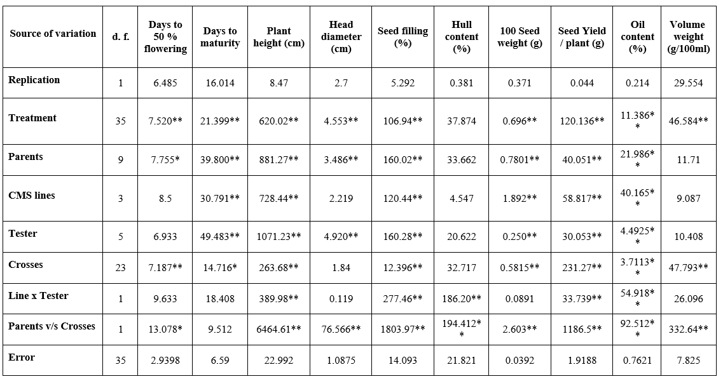**Table 1: Analysis of variance for parents and crosses for ten different characters in sunflower.**

** and * indicates significant at 1% and 5%, respectively.

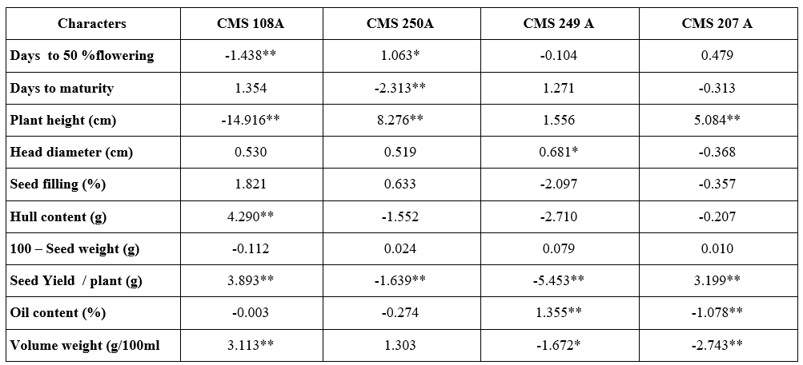**Table 2: Estimates of general combining ability (GCA) effect of male sterile lines for ten characters in sunflower.**

** and * indicates significant at 1% and 5%, respectively.

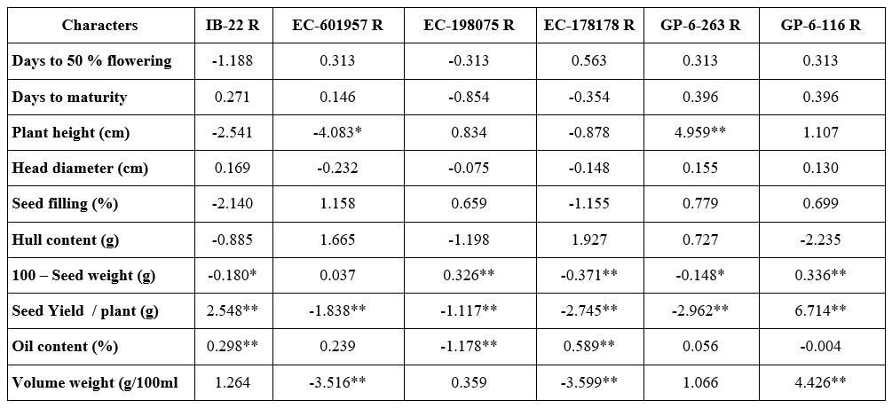**Table 3: Estimates of general combining ability (GCA) effect of testers for ten characters in sunflower.**

** and * indicates significant at 1% and 5%, respectively.(table 2 and 3 can be combined as a single table as Estimates of GCA effects of lines and testers for morphological traits in sunflower

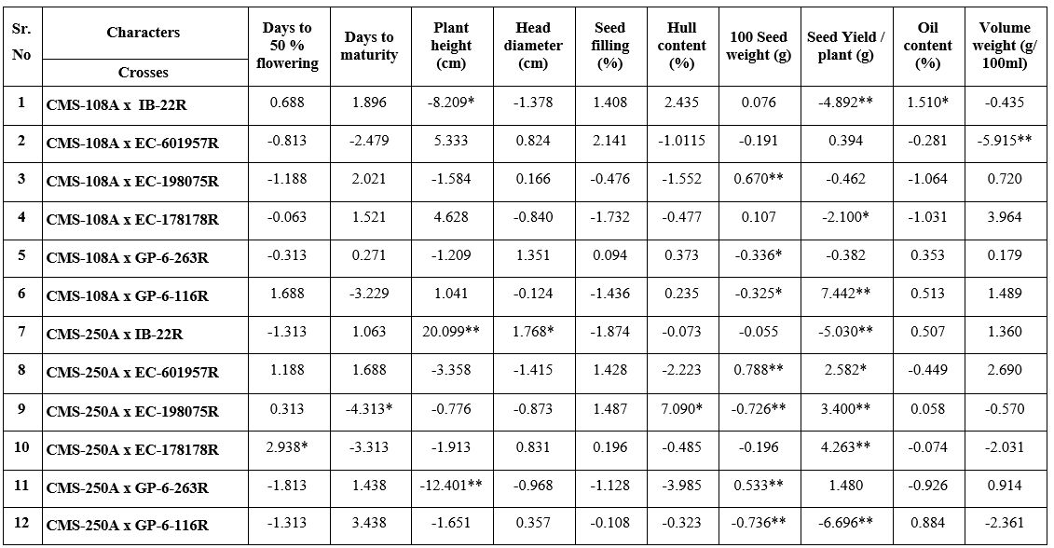**Table 4: Estimates of specific combining ability (SCA) effects of crosses for ten characters in sunflower.**

** and * indicates significant at 1% and 5%, respectively.

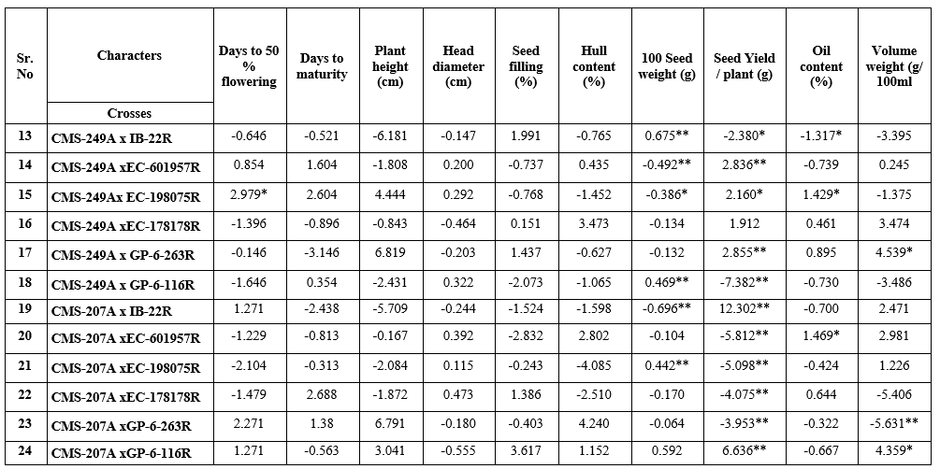**Table 4: Continued...**

** and * indicates significant at 1% and 5%, respectively.

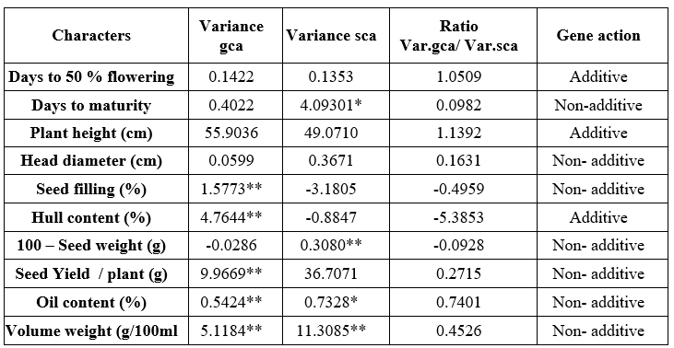**Table 5: Estimation of gene action (Var.gca and Var.sca) for ten characters in sunflower.**

** and * indicates significant at 1% and 5%, respectively.