Research Article
Antifungal volatiles from macrobasidiomycetes inhibits Fusarium oxysporum f.sp. lycopersici
Abstract
Several macrobasidiomycete fungi have potential biological properties naturally to combat fungal diseases. F.oxysporumf.sp. lycopersici is a soil borne ascomycetous fungus, which cause disease in several vegetable crops. This study aims to explore the antifungal activity of VOCs produced by several macrobasidiomycete fungi against F. oxysporum f.sp. lycopersici. The VOCs emitted by macrobasidiomycete fungi were demonstrated by inverted sealed plate method against the target pathogen. Among the mushroom isolate tested in vitro, the VOCs exhibited from Coprinus cinerea inhibited 70 % mycelial growth of F. oxysporum f.sp. lycopersici, followed by Ganoderma lucidum (60.28 %) and Lentinus edodes (35.28 %). In addition to inhibition of the pathogen, the headspace volatiles emitted by the effective isolate were trapped by tenax column and subjected to GC-MS analysis. A total of 15 and 25 VOCs were identified from C. cinerea and G. lucidum, respectively. Among them, Alfa copaene showed a peak area percentage of 7.82 (14.99 RT) in Coprinus sp. followed by 2 undecanone. Similarly, trichloromethane and 1- pentanol produced from G. lucidum, showed high relative abundance of 71.5 per cent at 9.84 RT and 70.3 per cent at 2.69 RT, respectively. The VOCs produced by macrobasidiomycete fungi could possess antimicrobial activities against the fungal pathogen. These volatile compounds may be explored as a novel biocontrol agent against soil borne pathogens of vegetable crop.
Keywords:Macrobasidiomycetes, C. cinerea, VOCs, antifungal activity.
- INTRODUCTION
Fusarium oxysporum is a common pathogen that is present in various environments both in plant tissues and rhizophere soil. It is a soil borne pathogen that is widely distributed in majority of vegetable and fruit crops. F. oxysporum express both pathogenic and non-pathogenic mode of infection. Plant pathogenic form of infection is defined by its strict host specificity (Arie et al. 2007 and Arie, 2010). Among the vegetable crops, tomato is infected by Fusarium wilt caused by F. oxysporum f.sp. lycospercisi. In India, total area under cultivation and production of tomato has gradually decreased from 2017 to 2019 (NHB, Horticultural statistics, MOA, GOI, 2018). Over the past centuries, various attempts have been made to control plant diseases by eradication or prevention through the use of synthetic fungicides. Most of the fungicides used, are found to be ineffective due to the development of fungicide resistance in the pathogen (Wuest et al. 1974; Gea et al. 2005). Currently, biological control of plant pathogens promotes disease suppression of micro-organism to improve plant health (Handelsman and Stabb, 1996). Biocontrol mechanism seems to be eco-friendly, safe and gives long-term protection to the crops (Soylu et al. 2010).
Recently, volatiles exhibited by microorganisms have been attempted to eradicate some stages of the disease during plant–pathogen interaction due to their potent antimicrobial properties (Koitabashi 2005; Fialho et al. 2011; Nishino et al. 2013). The volatile secondary metabolites from mushroom have been used to inhibit plant pathogenic microorganism, which possess several biological and pharmacological properties. Some mushroom also exhibit several aromatic odour, flavour, fragrance that helps in suppression of fungal pathogens (Nishino et al. 2013). Volatile organic compounds (VOCs) produced by Muscodoralbus, Trichoderma spp., Irpexlacteus, Oxyporuslate marginatus and several essential oils are related to the volatiles produced by mushroom (Dennis and Webster 1971; Strobel et al. 2001; Koitabashi 2005; Lee et al. 2009; Nishino et al. 2013). For instance, more than 150 VOCs were identified from wild mushroom which possess several flavour and medicinal properties (Pinho et al. 2008; Ouzouni et al. 2009). Similarly, the volatiles from fruiting bodies of Laetiporus sulphurous inhibited the growth of Aspergillus flavus in tomato paste (Petrovic et al. 2013). An antifungal volatile compound like 1-phenyl-3-pentanone produced from Mycoleptodonoides aitchisonii inhibited the growth of some phytopathogenic fungi and reported as fungistatic activity (Nishino et al. 2013; Oka et al. 2014). Berendsen et al. 2013 reported that the volatile compound Octen-3-ol produced by an edible mushroom, Agaricus bisporus inhibit spore germination of ascomycetous fungi. The volatiles produced by Hypsizygus marmoreus, an edible mushroom had antifungal activity against some phytopathogenic fungi and also suppress the mycelial growth, and spore germination of Alternaria brassicicola (Oka et al. 2015).
This study focus to identify the volatile organic compounds (VOCs) produced by several macrobasidiomycete fungi and their potential inhibitory activity towards F. oxysporum f.sp. lycospercisi .

- MATERIALS AND METHODS
2.1. Macrobasidiomycetes fungi
Pure cultures of Ganoderma lucidum, Auricularia auricular, Lentinus edodes, Coprinus cinereus, Pleurotus florida and Calocybe indica were obtained from the culture collection center at the Department of Plant Pathology, Tamil Nadu Agricultural University, Coimbatore, Tamil Nadu, India.
2.2. Isolation of pathogen
The virulent strain of Fusarium oxysporum was isolated from wilt infected necrotic tissue of stem. The infected stem was first cut into small pieces, washed with sterile water followed by disinfection with 0.1 % sodium hypochlorite, washed repeatedly with sterile water and dried on sterile filter paper. The dried fragments were cut lengthwise and placed on the petriplate containing potato dextrose agar (PDA) medium, and incubated for 4-5 days at 28 °C. The fungus was confirmed for the presence of spores, subcultured on the fresh petriplate for morphological and molecular confirmation.
2.3. Antagonistic screening of macrobasidiomycetes volatiles
The antifungal activity of volatile phase of fungus towards mycelial growth of pathogen was carried out by inverted sealed plate method. Macrobasidiomycete fungi obtained was inoculated by transferring 5 mm mycelial disc onto the petridish containing PDA medium. Likewise, a mycelia disc (5 mm) was excised from the 7 days old fungal culture and placed onto the PDA in a second petridish. The petridish with fungal culture was invertedly placed over the pathogen inoculated plate to test the antagonistic activity of volatiles from macrobasidiomycete fungal mycelia. At this point, the petridish was sealed with cling film and incubated at room temperature. The plates without macrobasidiomycete fungi served as control. The experiment was replicated four times. The colony diameter of pathogenic fungi was observed constantly until 90 mm of growth reached. The inhibition of mycelial growth of pathogenic fungi (mm) was designed by using the formula.
Growth inhibition (%) = x100
2.4. Trapping of volatiles and detection of biomolecules
The VOC emitted by effective macrobasidiomycete fungi were profiled by growing onto the PDA medium in the flask. Afterwards, the headspace volatiles collected through a specialized Tenax column, was analyzed using GC-MS fitted with an automated thermal desorber (ATD), and Turbo Matrix 150 (Perkin Elmer, USA). When the Tenax column was exposed to heat to 200 °C with a coiled heater around the tube, desorbed volatiles from heated Tenax were transferred into the injection port of the gas chromatograph through the stainless needle within 20 sec. At that point, the Tenax tube was removed from the injection port and the GC analysis was initiated. The conditions for GC-MS analysis were as follows: 10:1 split, Helium gas carrier at 20 psi, oven temperature of 50 to 250 ºC at 10 ºC per minute increment, electron impact spectra at 70 eV, and positive ion mode. The analysis was performed using 30 m × 250 µm capillary column coated with 5% phenyl methyl siloxane. The VOCs detected were compared with mass spectra available in NIST mass spectral library database. Volatile compounds that found 100% similarity were shortlisted as tentative compounds of interest.

2.5. Statistical analysis
The design of experiment and statistical analysis were performed using SPSS. The comparative analysis of volatile compounds was followed using heatmapper online (http://www.heatmapper.ca/). The metabolic pathway enrichment analysis involved in macrobasidiomycete fungi was analyzed through Metabo Analyst 4.0 (http://www.metabanalyst.ca).
- RESULT
Fusarium sp. was obtained from wilt infected necrotic tissue of stem. Based on the morphological characteristics and nucleotide sequence of 18S rRNA, Fusarium sp. was confirmed as Fusarium oxysporum f.sp. lycopercisi which showed 100 per cent identity. The sequence was submitted at the NCBI database with the accession no: MN088389.

  - Antifungal activity of macrobasidiomycetes volatiles against Fusarium
The efficacy of volatiles exhibited from mycelia of several macrobasidiomycete fungi against F. oxysporumf.sp. lycopercisi through inverted plate method are displayed in Fig. 1. We found that the volatiles produced by mycelia of Coprinus cinereus significantly inhibited 70 % mycelial growth of F. oxysporum f.sp. lycopercisi, followed by G. lucidum(60.28 %) and L. edodes (35.28 %), over control (Fig. 2). Apart from the inhibition of mycelia growth, there was also morphological differences in the mycelia of tested fungi. The mycelia are stunted, puffy appearance with no spore germination, which completely differentiated from control.
  - Isolation and trapping of headspace volatiles
The effective macrobasidiomycete fungi were cultured on PDA medium into the conical flask. A specialized tenax column was fitted into the flask with the aid of rubber cork (Fig. 3). The headspace volatiles produced by mycelia of effective macrobasidiomycete fungi were trapped from initiation of mycelia growth, over a period of 7 days. Afterwards, the volatiles trapped by tenax column are taken away from flask, fitted to the column holder for GC-MS analysis and the antifungal biomolecules were detected.
  - Identification of antifungal biomolecules
The GC-MS analysis indicated that the volatiles produced by Coprinus sp., G. lucidum and L. edodes produced diverse volatile compounds including aldehydes, ketones, alcohol, esters, fatty acids etc., The non-inoculated control were also analysed to eradicate the contaminent produced from column. No differences were observed between control and effective isolates. Based on 90 % similarity of mass spectra, a total of 15 VOCs were shortlisted from Coprinus cinereus (Fig. 4a) and 29 VOCs from G. lucidum (Fig. 4b). Among these compounds, Alfa copaene showed a peak area percentage of 7.82 (14.99 RT) in Coprinus sp. followed by 2 undecanone. Antifungal volatile compounds like trichloromethane and 1- pentanol showed high relative abundance (71.5 per cent at 9.84 RT and 70.3 per cent at 2.69 RT, respectively) in case of G. lucidum. A clear disparity observed between the VOCs of Coprinus sp., G. lucidum and L. edodes were shown with a heatmap (Fig. 5)
  - Volatile metabolite set enrichment
The over-representation analysis (ORA) was performed to identify the volatile pathway involved in Coprinus cinereus, G. lucidum and L. edodes.ORA was implemented using hypergeometric test to evaluate whether a particular volatile metabolite set was represented more than expected time by chance within the given compound list. The p-value was highest for butyrate metabolism followed by pentothenate and COA biosynthesis and least for beta alanine and fatty acid metabolism (Fig. 6).
- DISCUSSION
Several macrobasidiomycetes are known to produce wide variety of antimicrobial substances naturally, that protect from large spectrum of phytopathogenic microorganism (Spiteller 2008). In this study, the antifungal volatile activities of certain basidiomycetous fungi were screened against F. oxysporumf.sp. lycospersici. We found that antagonistic activity of volatiles produced by Coprinus sp. highly inhibited the mycelial growth of F. oxysporumf.sp. lycospersici upto 70 %, followed by G. lucidum (60.28 %). Similarly, M. aitchisonii is an edible mushroom, which highly suppressed the growth of several phytopathogenic fungi viz., Alternaria alternata, A. brassicicola, A. brassicae, Colletotrichum orbiculare and Corynespora cassiicola (Nishino et al. 2013). Previous studies have been reported that the basidiomycetes fungi have potent antimicrobial activities against wide range of pyhtopathogenic fungi (Combet et al. 2006; Noble et al. 2009 and Berendsen et al. 2013). The higher inhibitory percentages were reported for all three species of wood-rotting basidiomycetes (Coriolopsis gallica, Megacollybia platyphylla and Lentinus arcularius) against Fusarium solani and Sclerotinia sclerotiorum. These fungal pathogens are more susceptible to the antagonistic activity of the volatiles exhibited by the basidiomycetes (Petre et al. 2017). Futher more, Sangeetha (2018) also demonstrated a similar result on the effect of headspace volatiles produced by chinese caterpillar mushroom (Ophiocordyceps sinensis) that strongly inhibited the mycelia growth of F. oxysporum f. sp. lycopersici and F. oxysporum f. sp. cubense. Volatile compounds extracted from ectomycorrhizal fungus such as Russulaaff. anthracina, R. chloroides and R. senecis were shown to inhibit the of conidial germination of a phytopathogenic fungus, Alternaria brassicicola (Osaki oka, 2019). In conjunction with the available findings, Coprinus sp. and G. lucidum could play as an alternative agent for controlling the disease caused by fungus.
To demonstrate the antifungal compounds produced by Coprinus sp. and G. lucidum, headspace volatiles are trapped by special tenax GC trapping technique. The tenax trapping technique is a simple technology, highly efficient for analysis of headspace volatiles within a short time (Tsugita et al. 1979). Tenax is a porous polymer used for quantitative trapping of floral volatilomes (Dudareva and Pichersky 2006; Maiti et al. 2019). More than 50 VOCs were detected in each of the mushroom isolates. Based on the similarity percentage of mass spectra obtained, a total of 4 antifungal volatile compounds were shortlisted which could be responsible for the suppression of growth of fungal pathogens. Alfa copaene and 2 undecanone are important VOCs produced by C. cinerea and Tricholoromethane, 1 pentanol are exhibited in case of G. lucidum. The most important VOCs copaene was identified in Chinese herb (Meliaazedarach) and also from Coprinus cinereus (Melliou et al. 2007; Yang et al. 2011). Eugenio et al., 2015 reported that VOCs like pentanol, undecanone, nonanol, octanol, pentadecanoic acid produced by raspberry fruit, helps in fruit resistance to mold disease. From these findings, the methodologies strongly supported the result and could possess antifungal properties against broad spectrum of pathogen. The metabolite enrichment pathway analysis confirms that the volatile compounds produced by C. cinerea, G. lucidum and L. edodes, highly metabolize in fatty acid biosynthesis, butyrate metabolism and CoA biosynthesis pathway.
In this study, a total of 6 species of basidiomycetes were screened for volatile production with antagonistic activities against fungal pathogens. As a result, mycelia of C.cinerea and G. lucidum showed maximum inhibition, suggesting that antifungal volatile organic compounds in macrobasidiomycete fungi could be produced widely in nature. Some macrobasidiomycetes with excellent aromatic odour may have potential role as biocontrol agents.
To our knowledge, this is the first report on antifungal volatile compounds of C. cinerea which possesses antifungal activity against F. oxysporum f.sp. lycopercisi and could be effective alternatives for controlling plant diseases. Further studies are required to determine the effects of synthetic VOCs produced by C. cinerea against fungal pathogen and also to develop suitable organic based formulation against soil borne pathogens.
Acknowledgement:
The author thank for the support of UGC-SAP-DRS 1, DST-FIST, ICAR-AICRP on Mushroom laboratory facilities at the Department of Plant Pathology, TNAU, Coimbatore. Facilities extended by Department of Agricultural Entomology and Nanotechnology are also grately acknowledged.
REFERENCES
Arie, T., Takahashi, H., Kodama, M. and Teraoka.T. (2007).Tomato as a model plant for plant-pathogen interactions.Plant Biotechnol.24:135–147.
Arie, T. (2010).Phylogeny and phytopathogenicity mechanisms of soil-borne Fusariumoxysporum.J. Gen. Plant Pathol.76:403–405.
Berendsen, R.L. and Stefanie, I., Kalkhove C. and Luis, G., Lugones and Johan, J., Baars, P. and Han, A., Wosten, B. and Bakker, B. (2013). Effects of the mushroom-volatile 1-octen-3-ol on dry bubble disease.ApplMicrobiolBiotechnol. 97:5535–5543.
Combet, E., Henderson, J., Eastwood, D.C. and Burton, K.S. (2006).Eightcarbon volatiles in mushrooms and fungi: properties, analysis, and biosynthesis. Mycoscience.47:317–326.
Dennis, C. and Webster, J. (1971).Antagonistic properties of species groups of Trichoderma II.Production of volatile antibiotics.Trans Br Mycol Soc.57:41–48.
Dudareva, N. and Pichersky, E. (2006).Biology of floral scent.CRC Press, Boca Raton.
Eugenio Aprea, Biasioli, F. and Gasperi, F. (2015).Volatile Compounds of Raspberry Fruit: From Analytical Methods to Biological Role and Sensory Impact.Molecules.20:2445-2474.
Fialho, M.B., Duarte de Moraes, M.H., Tremocoldi, A.R., Pascholati, S.F. (2011).Potential of antimicrobial volatile organic compounds to control Sclerotiniasclerotiorum in bean.Pesq.agropec. Bras.46:2.
Gea, F.J., Navarro, M.J., Tello, J.C. (2005). Reduced sensitivity of the mushroom pathogen Verticilliumfungicola to prochlorazmanganesein vitro.Mycol Res.109:741–745.
Handelsman, J., Stabb, E.V., (1996). Biocontrol of soilborne plant pathogens.The Plant Cell 8.1855–1869.
Koitabashi, M. (2005).New biocontrol method for parsley powdery mildew by the antifungal volatiles-producing fungus Kyu-W63.J Gen Plant Pathol.71:280–284.
Lee, S.O., Kim, H.Y., Choi, G.J., Lee, H.B., Jang, K.S., Choi, Y.H., Kim, J.C. (2009). Mycofumigation with Oxyporuslatemarginatus EF069 for control of postharvest apple decay and Rhizoctonia root rot on moth orchid. J Appl Microbiol.106:1213–1219.
Maiti, S and Mitra, A. (2019).Elucidation of headspace volatilome in Polianthestuberosaflower for identifying non-invasive biomarkers.Horticulture, Environment, and Biotechnology.60:269–280.
Melliou, E., Stratis, E. and Chinou, I. (2007).Volatile constituents of propolis from various regions of Greecee antimicrobial activity.Food Chem. 103:375-80.
Nishino, S., Parada, R. Y., Ichiyanagi, T., Maekawa, N., Shimomura, N. and Otani, H. (2013).1-Phenyl-3-pentanone, a volatile compound from the edible mushroom Mycoleptodonoidesaitchisonii active against some phytopathogenic fungi.J Phytopathol.161: 515–521.
Noble, R., Dobrovin-Pennington, A., Hobbs, P.J., Pederby, J. and Rodger, A. (2009). Volatile C8 compounds and pseudomonads influence primordium formation of Agaricusbisporus. Mycologia.101:583– 591.
Petre, C. V., Dirțu, A. C., Niculaua, M. andTanase, C. (2017). Volatile compounds in the aroma of three species of wood-rotting basidiomycetes and their antifungal potential.J. plant develop. 24: 73-83.
Petrovi, J., Glamoclija, J., Stojkovi, D.S., Ciri, A., Nikoli, M., Bukvicki, D., Guerzoni, M.E., Sokovi, M.D. (2013).Laetiporussulphureus, edible mushroom from Serbia: investigationon volatile compounds, in vitro antimicrobial activity and in situ control of Aspergillus flavus in tomato paste. Food ChemToxicol. 59:297–302.
Pinho, P.G., Ribeiro, B., Goncalves, R.F., Baptista, P., Valentao, P., Seabra, R.M. and Andrade, P.B. (2008).Correlation between the pattern volatiles and the overall aroma of wild edible mushrooms.J Agric Food Chem. 56:1704–1712.
Oka, K. O., Suyama, S., Sakuno, E., Ushijima, S., Nagasawa, E., Maekawa, N. and Ishihara,A. (2019). Antifungal activity of the volatile compound isovelleral produced by ectomycorrhizalRussulafungi against plant-pathogenic fungi. J. General Plant Pathology. 85: 428–435.
Ouzouni, P.K., Koller, W.D., Badeka, A.V. and Riganakos, K.A.(2009) Volatile compounds from the fruiting bodies ofthreeHygrophorus mushroom species from Northern Greece. Int J Food Sci Technol. 44:854–859.
Sangeetha, C., Krishnamoorthy, A.S., Kiran Kumar, N. and ArumukaPravin, I. (2018).Effect of Headspace and Trapped Volatile Organic Compounds (VOCs) of the Chinese Caterpillar Mushroom, Ophiocordycepssinensis(Ascomycetes), against Soil-Borne Plant Pathogens.International Journal of Medicinal Mushrooms, 20(9):825–835.
Spiteller, P. (2008). Chemical defence strategies of higher fungi.ChemEur J.14:9100–9110.
Strobel, G.A., Dirkse, E., Sears, J., Markworth, C. (2001). Volatile antimicrobials from Muscodoralbus, a novel endophytic fungus.Microbiology.147:2943–2950.
Takashi, T., Toru, I., Yoshitaka, D., Tadao, K. and Hiromichi, K. (1979).GC and GC-MS Analysis of Head-space Volatiles by Tenax GC Trapping Techniques.Agricultural and Biological Chemistry.43:1351-1354.
Wuest, P.J., Cole, H., Sanders, P.L. (1974). Tolerance of Verticilliummalthouseito benomyl.Phytopathol64:331–334.
Yang, Y., Xiao, Y., Liu, B., et al. (2011).Comparison of headspace solidphasemicroextraction with conventional extraction for the analysis of the volatile components in Meliaazedarach.Talanta.86: 356-61.

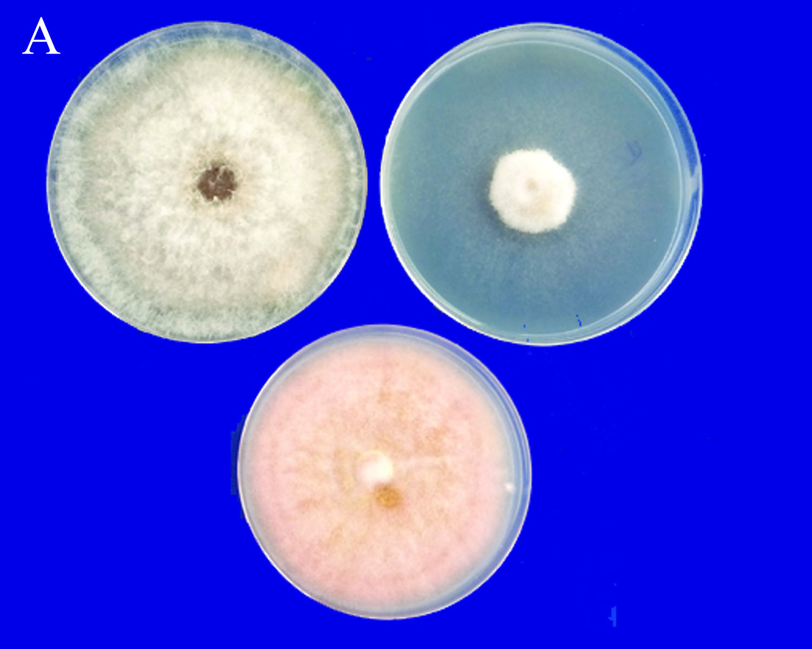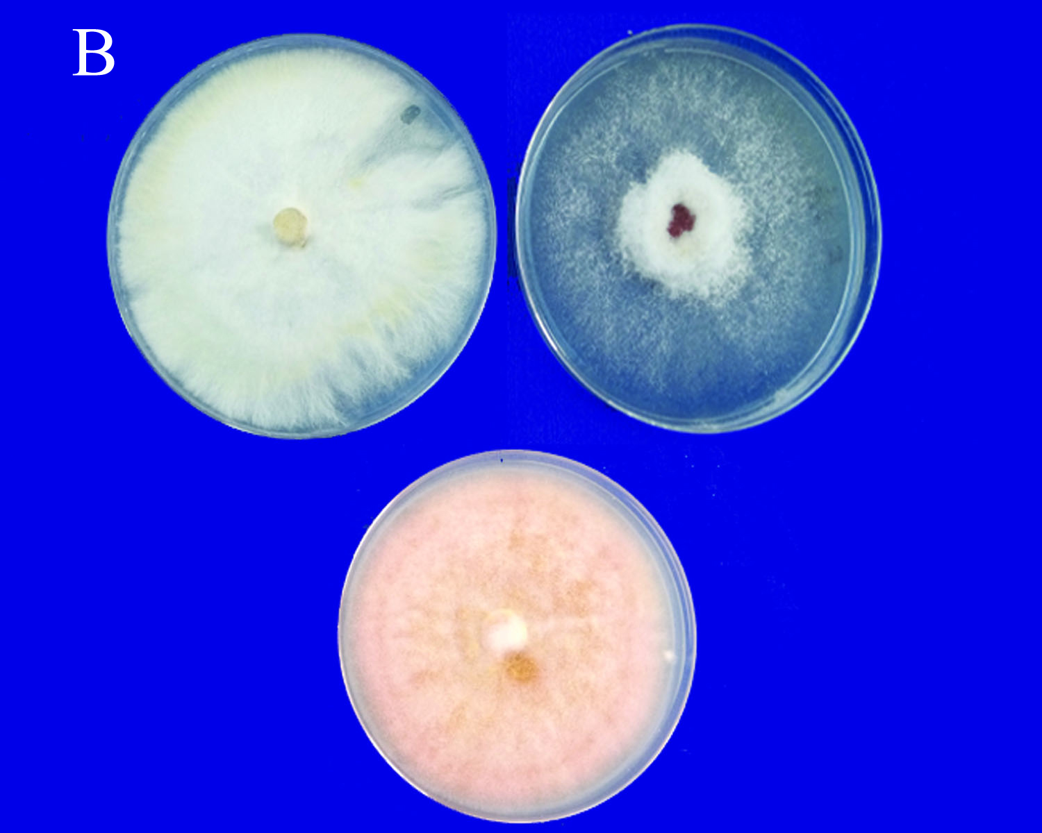
Fig 1. Effect of volatiles produced by macrobasidiomycete fungi against F. oxysporumf.sp.lycopercisi
A.C. cinereus B. G. lucidum
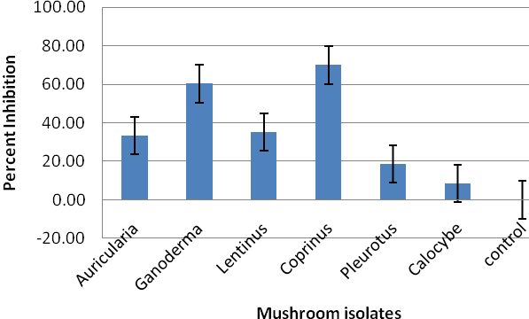
Fig 2.Inhibition potential of macrobasidiomycetes volatiles against F. oxysporum f.sp.lycopercisi
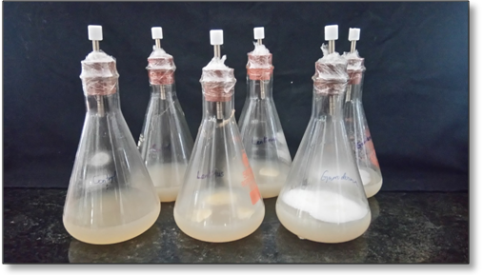
2
1
Fig 3.Trapping of headspace volatiles from effective macrobasidiomycetes,1.Inoculation of macrobasidiomycete fungi on PDA medium 2.Tenax column fitted into flask for trapping volatiles.

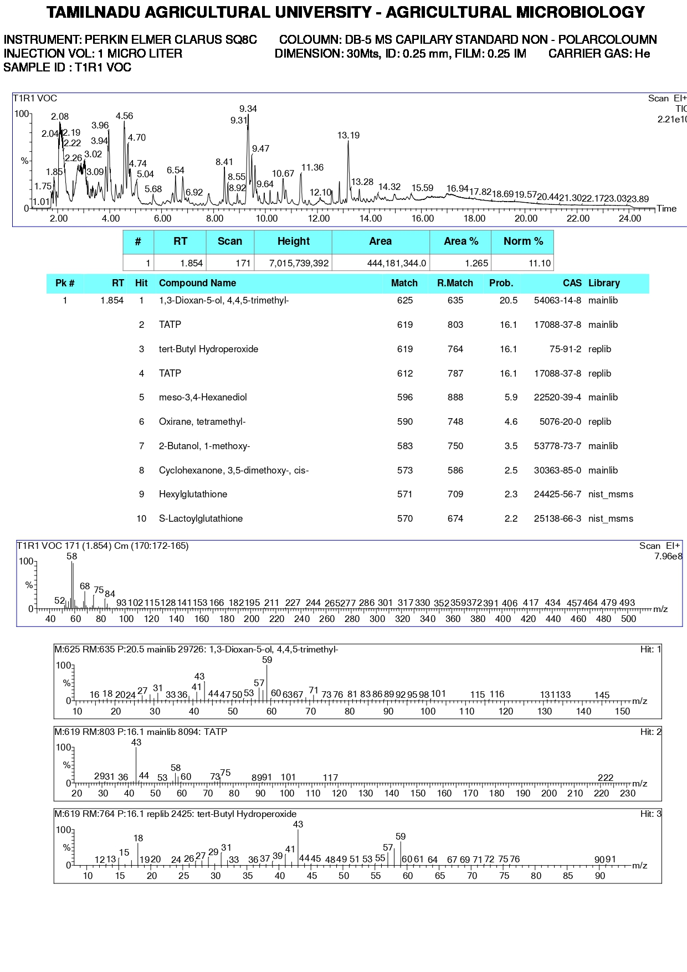
a
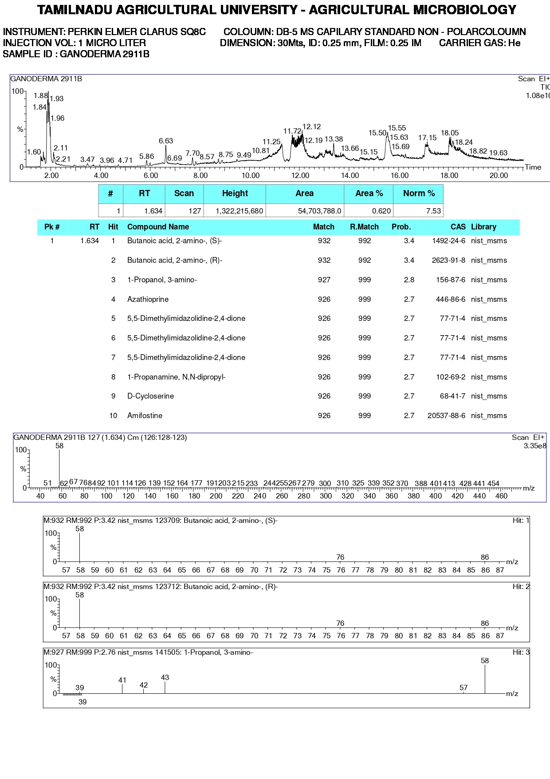
b
Fig 4. GC-MS chromatogram of VOCs from (a) Coprinus sp. and (b) G. lucidum

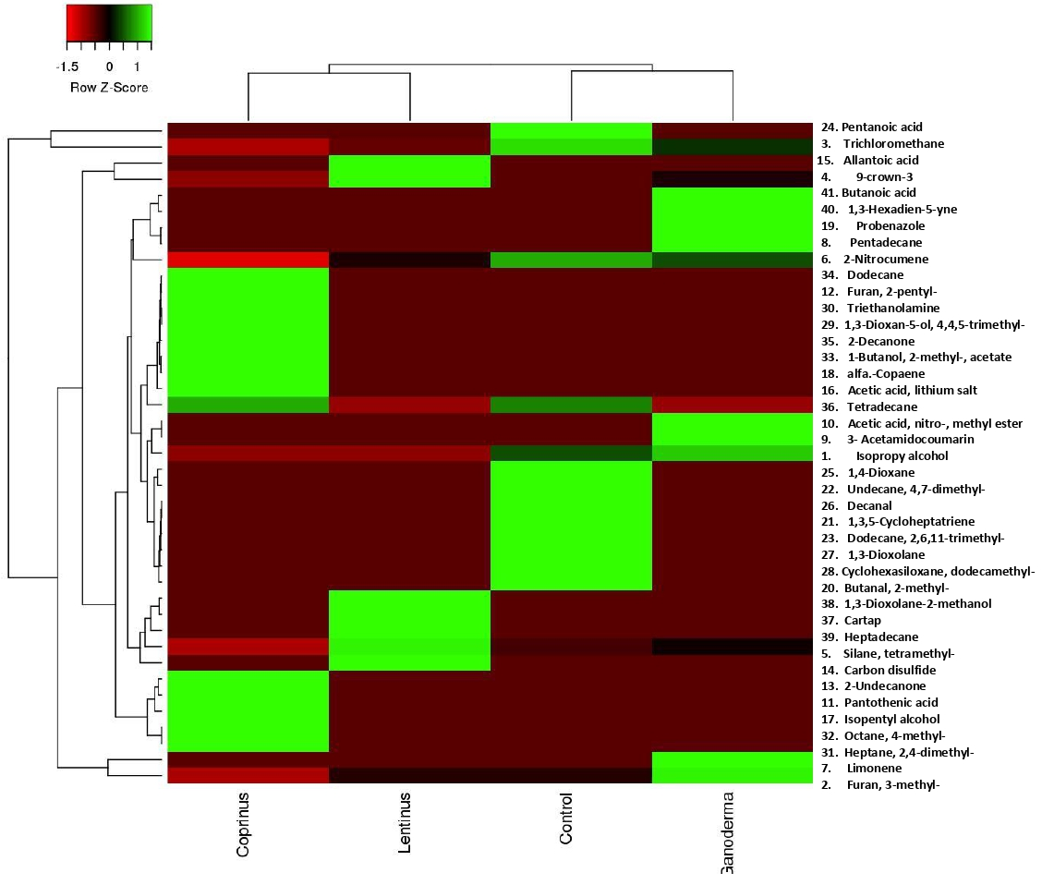

Fig 5.Heatmap of VOCs from Coprinus cinereus, G. lucidum and L. edodes indicating the highest efficiency in the compound (Alpha copaene and 2 undecanone in Coprinus sp and Trichloromethane, 1 pentanol in G. lucidum)
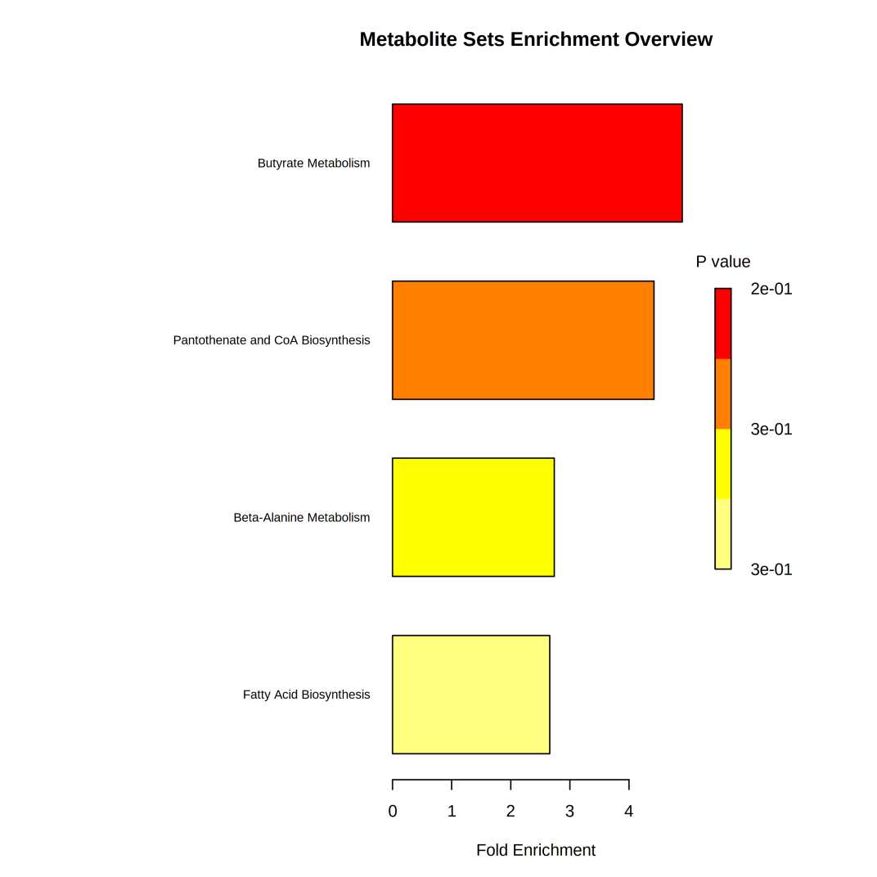
Fig 6.Over representation analysis of selected VOCs from Coprinus cinereus, G. lucidum and L. edodes

