RESEARCH ARTICLE
Title: Impact of Heat Units on the Phenology and Yield of Baby Corn (Zea mays L.) in Western Agro Climate Zone of Tamil Nadu

ABSTRACT
Field investigation was carried out during winter 2022 at Tamil Nadu Agricultural University, Coimbatore to study the phenological behaviour and yield of baby corn (Zea mays L.) as influenced by heat units. The split-plot design consisting of three dates of sowing viz., D₁ – 21st January, D₂ – 5th February and D₃ – 20th February as a main plot and three spacing viz., 60x45 cm (S₁), 60x30 cm (S₂) and 60x20 (S₃) as a sub plot was adopted and replicated thrice. Growing Degree Days, Helio Thermal Unit and Heat Use Efficiency were calculated for different phenological stages viz., plant emergence to 50% flowering (P₁), 50% flowering to cob emergence (P₂), cob emergence to harvest (P₃), plant emergence to cob emergence (P₄), 50% flowering to harvest (P₅) and plant emergence to harvest (P₆). The results revealed that sowing on 20th Feb. had completed the phenophases early, followed by 5th Feb and 21st Jan. GDD required for attaining physiological maturity was highest in 20th Feb. (1194.6 ºC days)). Except morning relative humidity, wind speed and solar radiation, all other weather parameters had negative correlation with baby corn yield (R²=0.921). The optimum temperature was obtained during D₁ (27.2 – 27.5 ºC) along with short-day length (11.7 hours) resulting in higher corn yield (9333.3 kg/ha) as well as higher HUE (5.75).

Keywords: Baby corn; sowing window; heat units; phenology; cob yield; HUE.

INTRODUCTION
Baby corn (Zea mays L.) known as mini corn or candle corn is an unfertilized young earhead, harvested when silks have turned pinkish colour just after emergence (Rani et al., 2017). The crop is newly evolved as dual purpose (vegetable and fodder) crop that grown round the year in India (Kumar et al., 2015). Baby corn is popular among domestic and foreign markets as it has both processing and export potential (Das et al., 2008). Presently in Indian, Meghalaya, Uttar Pradesh, Haryana, Karnataka, Maharashtra and Andhra Pradesh (Rahan and Sow, 2021) are growing Baby corn. Being a very short duration crop, 3 to 4 crops of baby corn can be taken up in a single year, depending upon agro-climatic conditions. Besides, it produces higher green fodder per unit area (Nataraj et al., 2011). The increase in production of baby corn is necessary to meet the demand of vegetables for the burgeoning population of both human and animals (Kumar et al., 2013).
Growth and yield potential of baby corn crop is highly season bound, vary across the growing seasons (Moreira et al., 2010). Baby corn is extremely sensitive to temperature and growth and yield is highly temperature dependent (Hatfield and Prueger, 2015). Successful growth of baby corn requires an optimum temperature of 22°C to 28°C and if daytime temperature exceeds 30°C, Baby corn may be injured and suffered with slow growth and yield reduction (Ben-Asher et al., 2008).
Optimum sowing window can not only improve maize yield but also fit corn in existing cropping pattern (Choudhury et al., 2021). Several researches had confirmed that baby corn yield significantly decreases with increase in temperature. Usually, plants require a definite Growing Degree Day (GDD) to get change in phenophases, which is calculated based on daily average temperature from date of sowing (Dahmardeh, 2012). Due to the environmental variations over time and space, sowing window has a profound influence on both growth and yield of crops (Iizumi and Ramankutty, 2015). For example, late sowing of sunflower experiences lower temperature, with decrease in GDD from 1731 to 1621 during the grain filling period resulting in low yield (Sur and Sharma, 1999). Soler et al., 2007 reported that delayed sowing reduced the hybrid maize yield about 55 per cent under rainfed condition, whereas yield reduction was only 21 per cent in irrigated condition.

Thermal environment during reproductive phase of baby corn contributed more towards yield formation process, as compared to during vegetative phases. Hence, the experiment was taken to study the phenological behaviour of baby corn (Zea mays L.) and thermal indices as influenced by sowing window and crop geometry in western region of Tamilnadu.

MATERIAL AND METHODS
Experimental location
Coimbatore district lies between 10º 13’ 00” to 11º 23’ 30” N latitude and 76º 39’00” to 77º 30’ 00” E longitude and confined on northwest side by Nilgiris, northeast by Erode districts and to the southeast by Dindigul district and on the west and south by Kerala state. Soil of the experimental plot was clay loam in texture and calcareous in nature, which contains low organic carbon and available nitrogen (213 kg ha⁻¹), high in available phosphorus (31.0 kg ha⁻¹) and potassium status (640 kg ha⁻¹).
Experimental details
The variety F1 Sundar of baby corn (Zea mays L.) was used as test crop to conduct the field experiment during winter 2022. The split-plot design consisted of three dates of sowing viz., D₁ – 21st January, D₂ – 5th February and D₃ – 20th February as a main plot and three spacing viz., 60x45 cm (S₁), 60x30 cm (S₂) and 60x20 (S₃) as a sub plot which was replicated thrice. Totally, 27 sub-plots with the plot size of 5x5 m² area used for the experiment. All other package of practices were followed as per the TNAU Crop Production Guide (CPG, 2020). Harvesting of baby corn was done when the silk turns milky white to pinkish colour.

Date of occurrences of baby corn phenophases like Plant Emergence (PE), 50 per cent flowering, cob emergence (CE) and harvesting were recorded when the 50 per cent baby corn plants reached respective stages. Accordingly, weather parameters pertaining to the different baby corn phenological stages viz., plant emergence to 50% flowering (P₁), 50% flowering to cob emergence (P₂), cob emergence to harvesting (P₃), plant emergence to cob emergence (P₄), 50% flowering to harvesting (P₅) and plant emergence to harvesting (P₆) were also studied. In addition, weather derivatives such as, Growing Degree Day (GDD) with a base temperature (Tb) of 6.6ºC, Photo Thermal Unit (PTU), Helio Thermal Unit (HTU), Relative Temperature Disparity (RTD) and Heat Use Efficiency (HUE) were also calculated as given in Table 1 to study the growth and development as well as yield. Correlation between the baby corn yield and all the heat units were worked out as suggested by Gomez and Gomez (1984).

Table 1 Formulae used for heat units calculation,
Parameter | Relationship | Reference
GDD | 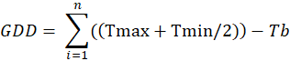 | Iwata, 1984
HTU | 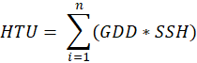 | Rajput, 1980
HUE |  | Haider et al., 2003
The daily data of weather parameters viz., maximum and minimum temperature, wind speed, rainfall, bright sunshine hours and relative humidity during the crop season (winter 2022) were obtained from the Agro Climate Research Centre, TNAU, Coimbatore. The weather prevailed during the cropping season viz., maximum temperature (31.1 ºC to 35.4 ºC), minimum temperature (19.0 ºC to 24.7 ºC), total rainfall (49.4 mm), RH (52.9 % to 71.0%), wind speed (4.0 km/hr to 6.0 km/hr) and sunshine hours (3.0 hours to 8.6 hours) are depicted in the Fig. 1.

Data on the baby corn phenological stages and yield attributes were statistically analyzed by correlation coefficient and step wise regression techniques at 5% significance level and critical differences of the treatment were examined through using R software. The detailed results were discussed in this paper.

RESULTS AND DISCUSSION
The results of the present field experiment during the winter 2022 to study the impact of different sowing window and crop geometry on the phenology and yield of baby corn were statistically analyzed and presented in this paper.
Phenophases duration of baby corn
Duration of different phenophases across the different dates of sowing were summarized and presented in Table 1. The mean duration for emergence to 50% flowering (P₁), 50% flowering to emergence of cobs (P₂) and emergence of cobs to harvest (P₃) were 47.8, 3.0 and 3.2 days, respectively.
Among the different sowing window, the quick attainment of phenophases had noticed in D₃ (20th February), which was followed by D₂ (5th February) and D₁ (21st January). In crop geometry, wider spacing (60x45 cm – S₁) attained the phenological maturity earlier than other two crop geometries (60x30 cm – S₂ and 60x20 cm – S₃). Among the treatment combinations, D₁S₃ had taken longer duration between the first and final harvest (16.3 days), whereas lesser duration recorded in D₃S₁ treatment (7.3 days). The same trend of phenophases duration was obtained in the total duration of the crop, where the D₁S₃ had completed the life cycle in 81.7 days and the shortest duration was noticed in D₃S₁ treatment (62.0 days) (Table 2).
Results on the days to phenophases of the crop indicated that the crop duration had reduced with delayed planting due to start facing of summer at its early stage itself. The amount of solar radiation and daily mean temperature received were higher in late sown crop than early and mid sown, which accelerated the physio-chemical process and thereby enhanced the growth and development of baby corn.
Similar results were obtained by Thavaprakash et al., 2007 that the crop was attained phenophases very quickly during summer season and it was delayed during late rabi and early winter seasons. Borowiecki (1992) reported that May month sown crop had shortened period from emergence to spikelet differentiation of the tassel and effective heat sums was 1299-1450 ºC days. Bairagi et al., 2020 observed that early to mid-winter sown plants’ cobs took longer days to attain the maturity whereas late winter to early summer sown plants’ cobs took lesser duration to mature.
The late winter sown (D₃- 20th February) cobs matured early due to higher ambient temperature which favoured the cob yield. Days taken to attain the flowering stage was lesser in late sown (D₃- 45.8 days) than early sown (D₁- 49.9 days). High temperature significantly reduced the days to 50% flowering and maturity in maize (Vanaja et al., 2017). The main plot and subplot interactions showed that the treatments of February planting of baby corn took significantly lower number of days to 50% flowering than November planting (Bairagi et al., 2015). Shrestha et al., 2016 mentioned that days to attain different phenological stages were decreased with delayed sowing due to the mean ambient temperature during their research period was increasing with delayed sowing.
Coefficients of variabilities of various weather parameters
Growing Degree Days (GDD)
Growing Degree Days (GDD) required for attaining physiological maturity was highest in D₃ (1195 ºC days) followed by D₂ (1174 ºC days) and D₁ (1162 ºC days). Delayed sowing during winter season increased the GDD by up to 32.6 ºC days. Results revealed that CV (%) was lowest during P₁ stage (0.2%) than all other stages which clearly explained that early sowing (21st January) received increasingly stable weather condition during sowing to 50% flowering stage of Baby corn as compared to other phenophases. In contrast, highest CV (%) was observed during the physiological harvest stage (26.8%) followed by P₂ stage (23.4%). It showed that physiological harvest stage and 50% flowering to cob emergence stage of Baby corn had experienced to maximum variability of weather and these variations at different phenophases were affected the yield components of baby corn at harvest. The same trend was obtained by Bairagi et al., 2020. Shrestha et al., 2016 mentioned that the statistically similar GDD was recorded for different sowing dates and higher values were noticed with delay in planting.
Helio Thermal Unit (HTU)
The HTU observed among different phenophases was highest at P₆ stage (8759.0 ºC day hour) than all other stages. Among the different sowing windows, D₁ achieved highest HTU (11236.7 ºC day hour), followed by D₂ and D₃ (10496 and 10486.5 ºC day hour) respectively (Table 3). More days to pass each phenological stages required by Baby corn in turn increased the day hours and in turn HTU (Need to rewrite clearly). the days taken to complete each stage was minimum in summer and lower values of degree days which in turn reduced the HTU.
Heat units on baby corn yield

The yield was highest in S₃ crop geometry during all the sowing windows. Among the different sowing windows, D₁ achieved highest yield than other sowing dates (Fig 2). The optimum temperature during D₁ (27.4°C), D₂ (28.2°C) and D₃ (28.5 °C) and mean day length of D₁ (11.7 hours), D₂ (11.9 hours) and D₃ (12 hours), combined helped to obtain the maximum yield under D₁ sowing window than others. The planting densities of baby corn were 37,037, 55,555 and 83,333 plants ha⁻¹ at S₁ (60x45), S₂ (60x30) and S₃ (60x20) crop geometries, respectively. The result showed that the increase in planting density combined with proper agronomic management and micro-meteorological influences significantly improved the physiological traits, which consequently increased the crop yield. Result obtained by Thiem et al., 2020 supported this research that highest planting density combined was effective in controlling weeds and increased the cob yield. Panda and Dutta (2019) also found similar results that closer spacing (45x20) of Baby corn achieved highest yield due to increasing in the plant population.
Statistical relationship
Detailed statistical relationship between baby corn yield and weather variables pertaining to a particular phenophases showed maximum degree of association and the results were presented in Fig. 3a-3d.
The results revealed that all meteorological weather parameters had negative significant correlation with the Baby corn yield, except RH1, WS and SR which had positive correlation with respect to crop yield (Table 4). Similarly, the correlation analysis between various thermal indices and yield revealed that there was significant relationship among GDD, HTU and Baby corn yield (Fig 3c-3d).
Using correlation analysis, the relationship between yield and average weather parameters was analysed and developed a regression model as given below,
Y= -20517.326+18.231 (GDD), R²=0.921
The correlation relationship between cob yield and weather parameters indicates that comparatively lesser mean temperature during early winter sowing (27.4°C) was more conducive for higher cob yield than average temperature observed during late winter period (28.5°C). This relationship also corroborated by Hemalatha et al., (2013) that higher accumulation of heat units with respect to long phenophasic duration of early sowing increased maize yield, while lower accumulation of heat units in late sowing resulted with low yield. Naveen et al., 2020 found the same relationship in green gram study.
Heat Use Efficiency (HUE)
HUE values of baby corn during different sowing windows were calculated and presented in Fig 4. Among the different sowing windows, higher HUE was observed during D₁ (5.7) sowing window, which could be attributed to the higher baby corn yield. Due to high maximum temperature during D₃ sowing window, baby corn yield was reduced, as the crop is highly sensitive to increasing temperature. The optimum temperature for Baby corn is 22°C to 28°C which was obtained during the D₁ sowing, optimum mean temperature and short-day length during the D₁ sowing of winter 2022 season resulted in higher baby corn yield. Similar relationships were obtained by Rajput et al., 1987, Paul and Sarkar (2000) and Haider et al., (2003) in different sowing windows. Sahoo and Panda (1999) got the highest yield of Baby corn in both wet and winter season.

CONCLUSION
It is concluded that, among the different weather parameters, temperature played a vital role in plant growth and development, which had decided the change of different phenophases of the crop. Though the maximum temperature was beneficial for the quick attainment of phenophases in D₃ sowing window, the yield was reduced drastically. The optimum temperature obtained during D₁ (27.2 – 27.5 ºC) along with short-day length (11.7 hours) supported the equitable day-night temperature condition and thereby resulted in higher corn yield. The increase in planting density combined with proper agronomic management resulted in micrometeorological influence which significantly improved the physiological traits, which consequently increased the higher Baby corn yield in S₃ (60x20) crop geometry during all the sowing windows than other crop geometries. Optimum date of sowing is an important factor which influence the performances of the crop through better utilization of available resources supplied to the crop.
Authors’ contribution: The authors are contributed equally for the analysis and preparation of manuscript.
Declaration: The authors should declare that they do not have any conflict of interest.

Funding and Acknowledgment

Authors are acknowledged to Agro Climate Research Centre for the successful conduct of this study.

Ethics statement

No specific permits were required for the described field studies because no human or animal subjects were involved in this research.

Consent for publication

All the authors agreed to publish the content.

Competing interests

There were no conflict of interest in the publication of this content

Data availability

All the data of this manuscript are included in the MS. No separate external data source is required. If anything is required from the MS, certainly, this will be extended by communicating with the corresponding author through corresponding official mail; sankaracrc@gmail.com

Author contributions
Author contributions: Research idea conceptualization - ST, SPR, SK, Experiments Conducted - ST, Guidance – SPR, SK, KC, MKK, Writing original draft – ST, Writing, reviewing and editing of manuscript - ST, SPR.

REFERENCES
Bairagi, S., Pandit, M. K., Sidhya, P., Adhikary, S., and Koundinya, A. V. V. (2015). Impacts of date of planting and crop geometry on growth and yield of baby corn (Zea mays var. rugosa). J. Crop and Weed, 11(2), 127-131.
Bairagi, S., Saha, A., Pandit, M. K., and Das, A. (2020). Phenology and Yield of Baby Corn (Zea mays var. rugosa) as Influenced by Thermal Regime. Int. J. Curr. Microbiol. App. Sci, 9(10), 1361-1369.
Ben-Asher, J., Garcia y Garcia, A., and Hoogenboom, G. (2008). Effect of high temperature on photosynthesis and transpiration of sweet corn (Zea mays L. var. rugosa). Photosynthetica, 46(4), 595-603.
Borowiecki. J. 1992. Effect of the sowing date of maize cultivars with various lengths of growth period on the rates of development and ripening. Pamietnik Puawski., 101: 123-13.
Choudhury, A. K., Molla, M. S. H., Zahan, T., Sen, R., Biswas, J. C., Akhter, S., and Hossain, A. (2021). Optimum Sowing Window and Yield Forecasting for Maize in Northern and Western Bangladesh Using CERES Maize Model. Agronomy, 11(4), 635.
Dahmardeh, M. (2012). Effects of sowing date on the growth and yield of maize cultivars (Zea mays L.) and the growth temperature requirements. African J. Biotechnology, 11(61), 12450-12453.
Das, S., Ghosh, G., Kaleem, M. D., and Bahadur, V. (2008, February). Effect of different levels of nitrogen and crop geometry on the growth, yield and quality of baby corn (Zea mays L.). In Symposium on the Socio-Economic Impact of Modern Vegetable Production Technology in Tropical Asia 809 (pp. 161-166).
Dibyajiban Panda and Rinjumoni Dutta. 2019. Production of Baby Corn Influenced by Different Dates of Sowing and Planting Geometry. Int. J. Curr. Microbiol. App. Sci. 8(11): 1302- 1309. doi: https://doi.org/10.20546/ijcmas.2019.811.15.
Gomez, K. A., and Gomez, A. A. (1984). Statistical procedures for agricultural research. John wiley and sons.
Haider, S. A., Alam, M. Z., Alam, M. F., and Paul, N. K. (2003). Influence of different sowing dates on the phenology and accumulated heat units in wheat. J. Biol. Sci, 3(10), 932-939.
Hatfield, J. L., and Prueger, J. H. (2015). Temperature extremes: Effect on plant growth and development. Weather and climate extremes, 10, 4-10.
Iizumi, T., and Ramankutty, N. (2015). How do weather and climate influence cropping area and intensity? Global food security, 4, 46-50.
Iwata, F. (1984). Heat unit concept of crop maturity. Physiological aspects of dryland farming. (Gupta, US ed).
Kumar, A., Jat, S. L., Kumar, R., and Yadav, O. P. (2013). Maize production systems for improving resource-use efficiency and livelihood security.
Kumar, R., Bohra, J. S., KUMAWA, N., and Singh, A. K. (2015). Fodder yield, nutrient uptake and quality of baby corn (Zea mays L.) as influenced by NPKS and Zn fertilization. Research on Crops, 16 (2).
Major, D. J., Johnson, D. R., Tanner, J. W., and Anderson, I. C. (1975). Effects of daylength and temperature on soybean development. Crop Science, 15(2), 174-179.
Moreira, J.N., Silva, P.S.L., Silva, K.M.B., Dombroski, J.L.D. and Castro, R.S. 2010. Effect of detasseling on baby corn, green ear and grain yield of two maize hybrids. Horticultura Brasileira, 28: 406-411.
Nataraj, D., Murthy, K. N., and Viswanath, A. P. (2011). Economics of baby corn cultivation under sole and intercropped situation with leguminous vegetables. Agri. Sci. Digest-A Research Journal, 31(3), 211-213.
Naveen S. A., S. Kokilavani, S. P. Ramanathan, G. A. Dheebakaran and S. Anitta Fanish. 2020. Influence of Weather Parameters and Thermal Time Approach on Green Gram at Coimbatore, Tamil Nadu. IJECC, 10(12): 1-5. Article no. IJECC.62545.
Paul, N. K., & Sarker, D. K. (2000). Accumulated heat units and phenology relationships in wheat as influenced by sowing dates. Bangladesh J. Botany, 29(1), 49-54.
Rajput, R. P. (1980). Response of soybean crop to climate and soil environments. Unpublished Ph. D Thesis, IARI, New Delhi, India.
Rajput, R. P., Deshmukh, M. R., and Paradkar, V. K. (1987). Accumulated heat units and phenology relationships in wheat as influenced by planting dates under late sown conditions. Journal of Agronomy and Crop Science, 159(5), 345-348.
Rani, R., Sheoran, R. K., Soni, P. G., Kaith, S., and Sharma, A. (2017). Baby corn: a wonderful vegetable. International J. Sci., Envt. and Tech., 6(2), 1407-1412.
Ranjan, Shivani and Sow, Sumit. (2021). Baby Corn: A Crop with Immense Importance. Volume 3: issue2.
Sahoo, S. C., and Panda, M. M. (1999). Effect of level of nitrogen and plant population on yield of baby corn (Zea mays). Indian J. Agrl. sci. 69(2), 157-158.
Shrestha, U., Amgain, L. P., Karki, T. B., Dahal, K. R., and Shrestha, J. (2016). Effect of sowing dates and maize cultivars in growth and yield of maize along with their agro-climatic indices in Nawalparasi, Nepal. J. AgriSearch, 3(1), 57-62.
Soler, C. M. T., Hoogenboom, G., Sentelhas, P. C., and Duarte, A. P. (2007). Impact of water stress on maize grown off‐season in a subtropical environment. J. Agr. and Crop Science, 193(4), 247-261.
Sowmiya, R., Krishnan, R., Jeyarani, S., and Chandrasekhar, C. N. (2022). Influence of Agro Meteorological Indices on Different Sowing Time of Irrigated Maize in Western Agro-Climatic Zone of Tamil Nadu. Madras Agricultural Journal, 109:1.
Sur, H. S., and Sharma, A. R. (1999). Response to sowing dates and performance of different sunflower (Helianthus annuus) hybrids during rainy season in high intensity cropping systems. Indian J. Agrl. Sci., 69(10), 683-689.
Thavaprakaash, N., Jagannathan, R., and Velayudham, K. (2007). Seasonal influence on phenology and accumulated heat units in relation to yield of baby corn.
Thiem, T. T., Thu, T. T. P., and Loan, N. T. (2020). Effect of plant density and hand weeding on weed control and yield of the vegetable corn. Vietnam J. Agrl. Sci., 3(4), 784-797.
Girijesh, G. K., Kumara, A. S., Sridhara, S., Dinesh Kumar, M., Vageesh, T. S., & Nataraju, S. P. (2011). Heat use efficiency and helio-thermal units for maize genotypes as influenced by dates of sowing under southern transitional zone of Karnataka state. International journal of science and nature, 2(3), 529-533.

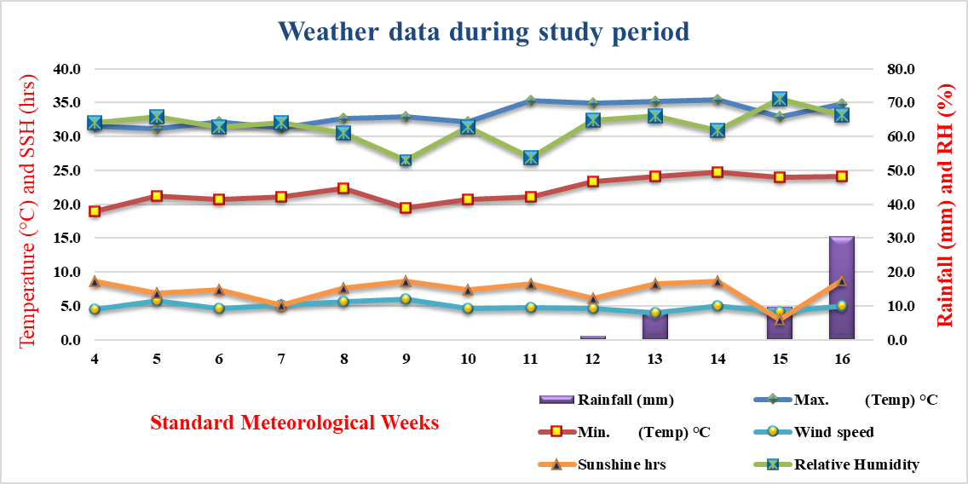
Fig 1. Standard meteorological data during the study period (winter 2022)

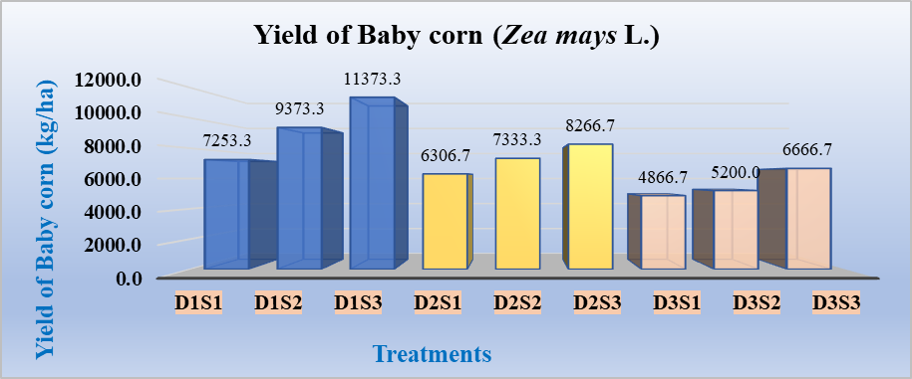
Fig 2. Yield of Baby corn (Zea mays L.) during different sowing window

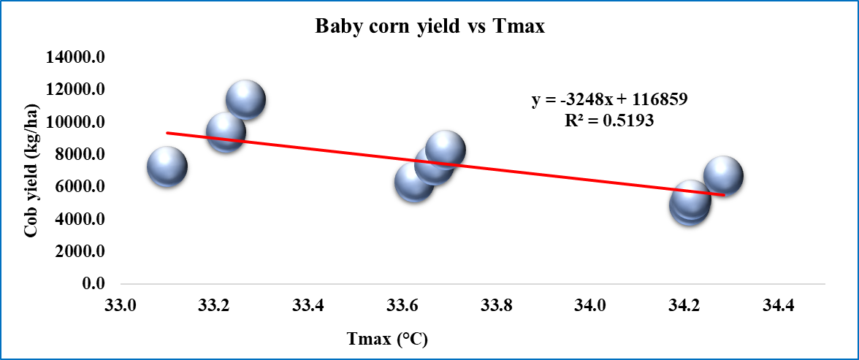 | 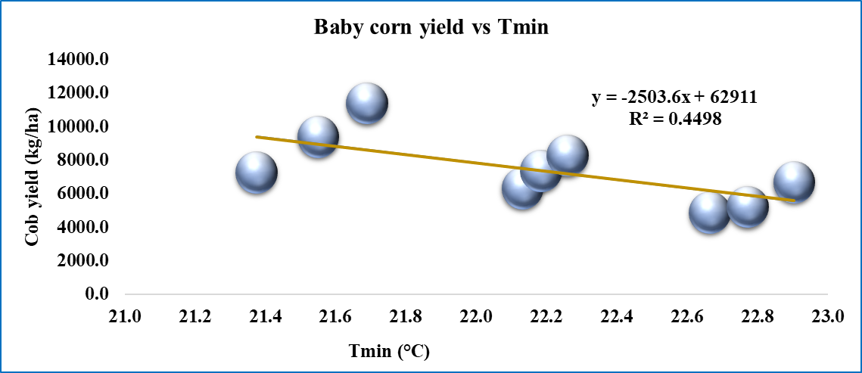
Fig 3a. Impact of Tmax (°C) on Baby corn yield | Fig 3b. Impact of Tmin (°C) on Baby corn yield
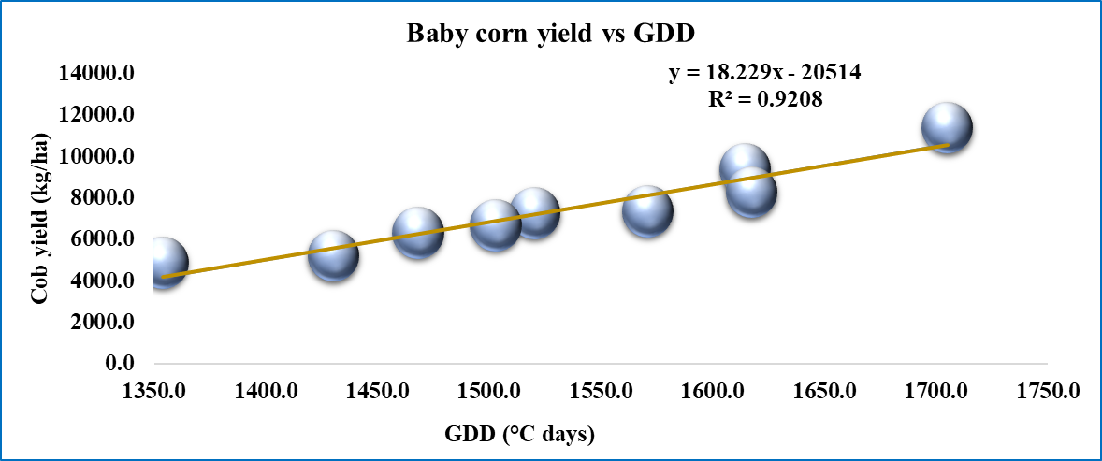 | 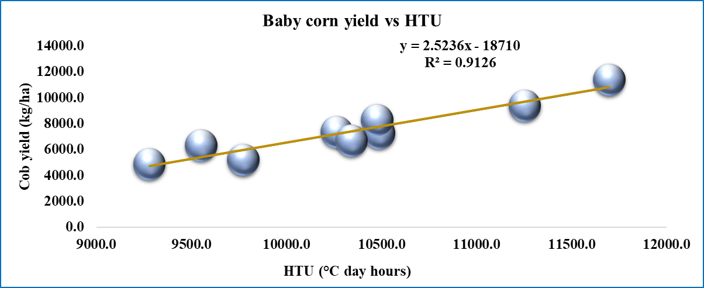
Fig 3c. Impact of GDD (°C days) on Baby corn yield | Fig 3d. Impact of HTU (°C day-hours) on Baby corn yield

Fig 4. Heat Use Efficiency during different sowing window of winter season

Table 1. Duration of different phenophases of Baby corn as influenced by dates of sowing
Phenophases | D₁ |  |  | D₂ |  |  | D₃ |  |  | Mean | SD | CV (%)
Phenophases | S₁ | S₂ | S₃ | S₁ | S₂ | S₃ | S₁ | S₂ | S₃ | Mean | SD | CV (%)
P₁ | 48.7 | 50.3 | 50.7 | 47.3 | 48.0 | 48.3 | 45.3 | 45.7 | 46.3 | 47.8 | 1.9 | 4.0
P₂ | 3.0 | 3.7 | 4.3 | 2.3 | 3.0 | 3.3 | 2.0 | 2.0 | 3.3 | 3.0 | 0.8 | 26.0
P₃ | 3.3 | 3.3 | 4.3 | 2.7 | 3.3 | 3.7 | 2.0 | 3.0 | 3.0 | 3.2 | 0.6 | 20.1
P₄ | 51.7 | 54.0 | 55.0 | 49.7 | 51.0 | 51.7 | 47.3 | 47.7 | 49.7 | 50.9 | 2.6 | 5.1
P₅ | 6.3 | 7.0 | 8.7 | 5.0 | 6.3 | 7.0 | 4.0 | 5.0 | 6.3 | 6.2 | 1.4 | 22.4
P₆ | 54.7 | 57.3 | 59.3 | 52.3 | 54.3 | 55.3 | 49.3 | 50.7 | 52.7 | 54.0 | 3.1 | 5.8
1st to final Harvest | 14.0 | 15.0 | 16.3 | 10.7 | 13.3 | 13.7 | 7.3 | 9.0 | 9.7 | 12.1 | 3.0 | 25.1
Total duration | 74.0 | 78.0 | 81.7 | 69.0 | 73.7 | 75.7 | 62.0 | 65.3 | 68.3 | 72.0 | 6.3 | 8.8

Table 2. Weather parameters pertaining to indices (GDD and HTU)
Phenophases | GDD |  |  |  |  |  | HTU
Phenophases | D₁ | D₂ | D₃ | Mean | SD | CV (%) | D₁ | D₂ | D₃ | Mean | SD | CV (%)
P₁ | 1001.4 | 1003.4 | 1005.1 | 1003.3 | 1.9 | 0.2 | 7536.6 | 7436.3 | 7745.3 | 7572.7 | 157.6 | 2.1
P₂ | 80.2 | 67.2 | 49.6 | 65.7 | 15.4 | 23.4 | 550.1 | 584.0 | 147.7 | 427.3 | 242.7 | 56.8
P₃ | 80.3 | 75.6 | 56.9 | 70.9 | 12.4 | 17.5 | 481.3 | 636.2 | 343.7 | 487.1 | 146.3 | 30.0
P₄ | 1081.6 | 1070.6 | 1053.3 | 1068.5 | 14.3 | 1.3 | 8086.7 | 8020.3 | 7905.6 | 8004.2 | 91.6 | 1.1
P₅ | 158.0 | 142.8 | 110.2 | 137.0 | 24.4 | 17.8 | 1013.6 | 1220.2 | 492.3 | 908.7 | 375.1 | 41.3
P₆ | 1162.0 | 1174.0 | 1194.6 | 1176.9 | 16.5 | 1.4 | 8568.0 | 8892.7 | 8816.3 | 8759.0 | 169.8 | 1.9
1st to final Harvest | 348.6 | 283.1 | 200.3 | 277.3 | 74.3 | 26.8 | 2668.7 | 1603.3 | 1670.2 | 1980.7 | 596.7 | 30.1
Table 3. Correlation coefficient of weather parameters and pertaining indices with respect to Baby corn yield during Winter 2022
Correlations | yield | Tmax | Tmin | BSS | Daylength | RH-I | RH-II | RF | WS | Evp | SR | GDD | HTU | PTU | RTD | HUE
yield | 1
Tmax | -.700* | 1
Tmin | -.669* | .994** | 1
BSS | -.352 | .351 | .292 | 1
Daylength | -.665 | .965** | .971** | .120 | 1
RH-I | .713* | -.576 | -.547 | .000 | -.614 | 1
RH-II | -.468 | .905** | .927** | .072 | .934** | -.331 | 1
RF | -.576 | .869** | .886** | .099 | .860** | -.440 | .917** | 1
WS | .546 | -.745* | -.694* | -.811** | -.582 | .273 | -.567 | -.600 | 1
Evp | -.821** | .765* | .769* | .000 | .841** | -.822** | .628 | .616 | -.325 | 1
SR | .726* | -.995** | -.994** | -.291 | -.980** | .599 | -.913** | -.878** | .701* | -.815** | 1
GDD | .960** | -.652 | -.602 | -.445 | -.603 | .779* | -.346 | -.431 | .582 | -.788* | .666 | 1
HTU | .955** | -.650 | -.629 | -.096 | -.684* | .818** | -.454 | -.540 | .353 | -.902** | .692* | .922** | 1
PTU | .822** | -.361 | -.300 | -.440 | -.303 | .744* | .009 | -.108 | .410 | -.623 | .374 | .929** | .799** | 1
RTD | .944** | -.874** | -.846** | -.394 | -.840** | .763* | -.649 | -.682* | .669* | -.880** | .886** | .934** | .908** | .747* | 1
HUE | .998** | -.722* | -.695* | -.329 | -.695* | .707* | -.511 | -.617 | .552 | -.835** | .751* | .945** | .955** | .791* | .946** | 1

