RESEARCH ARTICLE

**Interaction of Copper with Macro and Micro Nutrient Concentration of Rice (*Oryza sativa.L*) in *Typic Haplustalf***

|  |  |
| --- | --- |
|  | ABSTRACT The effect of soil application of different levels of copper (0, 0.5, 1.0, 1.5, 2.0, 2.5, 3.0 kg Cu ha-1) and foliar application (0.25% CuSO4 at tillering stage, 0.25% CuSO4 at tillering and flowering stage, 0.5% CuSO4 at tillering stage and 0.5% CuSO4 at tillering and flowering stage) on total nutrient content of rice and wetland soil was examined by leading field trail in *Typic Haplustalfs* where the soil Copper content was least (0.88 mg kg-1). The treatment plots were repeated three times in randomized block design. The outcomes uncovered that the low Copper application (0.5 to 1.5 kg Cu ha-1) significantly increased the nutrient content in plant, however higher concentrations drastically reduced the nutrient content of rice. |

Keywords: *Rice; Copper; Total nutrients; Leaves; Grains; Straw*

## INTRODUCTION

Among the micronutrients, Copper (Cu) is required only in small quantities for normal plant growth, but its role in maximizing yield is very impressive (Emami 2005). When Cu is supplied with below the requirement of crop, there may be a drop in the crop yield. Besides, Copper is additionally one of the basic micronutrients for plant development. It is engaged with various physiological functions as a segment of a several enzymes, fundamentally those which take an interest in electron flow, catalyze redox reaction in mitochondria and chloroplasts (Harrison *et al.,* 1999). Be that as it may, in unreasonable amounts copper ends up dangerous as it interferes with photosynthetic and respiratory processes, protein synthesis and improvement of plant organelles (Upadhyay and Panda 2009). Explicitly abundance copper can cause chlorosis, restraint of root development and harm to plasma layer penetrability, prompting ion leakage (Bouazizi *et al.,* 2010). Reports are additionally accessible on induced deficiency of different mineral substance under copper toxicity. Henceforth endeavours have been made to build up the toxicity level of copper on rice plants in the present investigation (Mocquot *et al.,* 1996).

## MATERIAL AND METHODS

A field experiment was conducted in *Typic haplustalfs* to study the effect of copper on other nutrients in rice and soil. The experiment was laid out in Randomized Block Design (RBD) with eleven treatments replicated thrice. Plot size of 4m×4m (16 m2) was adopted with buffer channel of (size ?) around each plot in the experimental field. The field experiment was conducted with paddy, variety TKM 13 (medium duration) as a test crop.

Treatment details T1 - RDF alone T2 - RDF + 0.5 kg Cu ha-1 ; T3 - RDF + 1.0 kg Cu ha-1 ; T4 - RDF + 1.5 kg Cu ha-1 T5 - RDF + 2.0 kg Cu ha-1 T6 - RDF + 2.5 kg Cu ha-1 T7 - RDF + 3.0 kg Cu ha-1 T8 - RDF + Foliar spray of 0.25 per cent CuSO4 at tillering stage T9 - RDF + Foliar spray of 0.25 per cent CuSO4 at tillering stage and flowering stage T10 - RDF +Foliar spray of 0.5 per cent CuSO4 at tillering stage T11 - RDF +Foliar spray of 0.5 per cent CuSO4 at tillering stage and flowering stage.

As per the treatment schedule, nitrogen (N), phosphorous (P) and potassium (K) were applied at the rate of 150:50:50 kg N, P2O5 and K2O ha-1 respectively. Entire dose of P was applied basally and N and K were applied in three equal splits as basal, active tillering stage and panicle initiation stage. The graded levels of copper (0.5, 1.0, 1.5, 2.0, 2.5, 3.0 kg ha-1) were mixed with 25 kg of sand for uniform distribution and the mixture was broadcast basally at the time of transplanting as per the treatment schedule (T2 to T7). The Cu fertilizer in the form of CuSO4.5H2O was applied in the form of foliar spray @ 0.25 and 0.5 per cent at the time of and flowering as per the treatment schedule (T8 to T11).

**Methods for plant samples analysis**

Leaf samples were collected at flowering and post harvest stages (grain and straw) and shade dried followed by oven drying at 650C, ground in Willey mill and analyzed for total N, P, K, Cu and other micro nutrients. Grain samples were collected at harvest from each treatment, shade dried followed by oven drying at 650, powdered and analysed for total N, P, K, Cu and other micro nutrients by adopting the standard procedures furnished in Table 1. Statistical analysis was performed using analysis of variance (ANOVA) for Randomized Block Design (Gomez *et al.,* 1984) The treatment means were compared at the p<0.05 level using LSD for all the parameters.

## RESULTS AND DISCUSSION

**Total Nitrogen (Figure 1)**

Nitrogen content of rice showed progressive decline with increase in copper level. The nitrogen content in leaves at flowering stage and in grain and straw at harvest stage significantly reduced by the higher levels of copper application. The maximum N content in leaves at flowering stage and grain and straw at harvest stage was observed in plots received 1.5 kg Cu ha-1 as foliar spray with 100 per cent RDF and minimum N content in leaves at flowering stage and grain and straw at harvest stage was observed in plants with 0.5 per cent CuSO4 spray at tillering and flowering stages. This shown that the uptake of nitrogen was significantly increased at lower level of copper, while higher concentration shdecreased the nitrogen uptake due to .

Ureta *et al.,* (2005) noticed a decrease in nitrogen content of green gram leaf due to higher dose of copper and it has beenattributed to the poor nodule development, diminished nitrogen fixation and reduced N uptake from soil.

**Total Phosphorus (Figure 2)**

A depressive effect was observed on P content in leaves, grain and straw with graded levels of Cu application at all the growth stages of rice. Application of more than 1.5 kg Cu ha-1 brings down the P content in leaves, grain and straw and demonstrated negative relation between phosphorus and copper. High convergence of Cu stifles P metabolism by decreasing the substance of inorganic phosphorus in plants. This confirmed the negative correlation between Cu and P in rice and this was also revealed by Wallace and Cha (1989) and Mateos-Naranjo *et al.,* (2008).

**Total Potassium (Figure 3)**

On inspection of the data, a disconsolate effect on total K content at flowering (leaves) and harvest (grain and straw) was seen with elevated level of copper spray. The decrease in K content of rice due to elevated levels of copper was in conformity with the reports of Lidon and Henriques (1993) and Ouzounidou (1994). The decrease in K content of rice due to the toxic effect of copper on plant growth or competition by other ions which in turn exercised a regulatory control on K uptake was reported by Manivasagaperumal *et al.,* (2011).

**Total Copper (Figure 4)**

The Cu concentrations in leaves at flowering stage and grain and straw at harvesting stage increased significantly with an increase in level of applied Cu and maximum copper accumulation in the rice leaves, grain and straw was recorded in 0.5 per cent CuSO4 spray at tillering and flowering stage (T11). Kumar *et al.,* (2009) made similar observations that the Cu content of leaves increased with the increased use of copper in wheat. This view was also supported by Mocquot *et al.,* (1996) and Loneragan *et al.,* (1980).

**Total Manganese (Figure 5)**

The Cu application at adequate or lower levels did not affect the Mn content in leaves at flowering stage and grain and straw at harvesting stage of rice, however at higher doses of Cu (> 1.5 kg Cu ha-1), the Mn concentration in plant tissues decreased significantly. Decrease in Mn content under high Cu level may attribute to the competition of Cu with Mn for transport sites in plasma lemma. This is proven fact that Cu and Mn behave antagonistically in soil and plant as reported by Lidon and Henriques (1992)

**Total Iron (Figure 6)**

The Cu fertilization with different levels significantly reduced the Fe content in leaves at flowering stage compared to the control. Similar result was reported by Brar and Sekhon (1978) who stated that the translocation of Fe from stem to leaves was affected by excess Cu. Excess Cu in soil may path to Fe chlorosis in crop plants and thereby affecting the productivity of rice crop (Alva and Chen 1995). Previous results have also revealed that the excess Cu has very routinely accredited to an obtrusion with Fe metabolism. Ouzounidou (1994) and Kim *et al.,* (1978) reported that excess of heavy metals may interrupt with normal Fe metabolism and thus obvious to induce physiological Fe deficiency. However Fe content in grain and straw at harvest stage with respect to different Cu levels increased up to 1.5 kg Cu ha-1 and decreased significantly with higher Cu level (2.5 and 3.0 kg ha-1).

**Total Zinc (Figure 7)**

The concentration of Zn in leaves at flowering stage, grain and straw at harvest stage exhibited significant variation with the addition of Cu at different growth stages. The Zn concentration in leaf tissues was higher at lower levels of copper (0 to 1.5kg ha-1) and significantly decreased with higher levels of Cu (2.0 and 3.0 kg ha-1). In the present study, the total Zn content in different plant parts of rice reached maximum at the Cu level of 1.5 kg ha-1 and thereafter significant reduction in Zn content was noticed with further increment level of Cu indicating the antagonistic relationship between Cu and Zn. The antagonistic effect of Cu and Zn on plant has been well documented by Arora and Sekhon (1982) and Dangarwala (2001).

## CONCLUSION

Effect of graded levels of copper on total nutrients in different plant parts of rice showed that total N, P and K contents were significantly increased at low level of copper, while higher concentration showed a declining trend of these nutrients in plants. Similarly, Mn, Fe and Zn concentration in different plant parts of rice was higher at lower levels of copper (0 to 1.5 kg ha-1) whereas, its contents decreased significantly with higher levels of Cu (2.5 and 3.0 kg ha-1). Application of Cu in excess amounts (2.0 to 3.0 kg ha-1) exhibited antagonist interaction on all nutrients and adversely affected the growth, dry matter and nutrient content.

The present findings thus suggest that high Cu concentration and it’s interactions with other macro (N, P and K) and micronutrients (Fe, Mn and Zn) affect the growth and yield of rice plants. Application of Cu in excess amount may induce the deficiency of other macro micronutrients and adversely affect the yield. Hence, judicious and adequate amendment of Cu can contribute to a great deal in enhancing the yield of rice crop especially in Cu responsive soils.

## Funding and Acknowledgment

I would like to thank Professor P.P. Mahendran for his expert advice and encouragement throughout this thesis work.

**Ethics statement**

No specific permits were required for the described field studies because no human or animal subjects were involved in this research.

**Originality and plagiarism**

I ensure that I have written and submit only entirely original works, and if I have used the work and/or words of others, that this has been appropriately cited. Plagiarism in all its forms constitutes unethical publishing behavior and is unacceptable.

## Consent for publication

## All the authors agreed to publish the content.

## Competing interests

## There were no conflict of interest in the publication of this content

## Data availability

## All the data of this manuscript are included in the MS. No separate external data source is required. If anything is required from the MS, certainly, this will be extended by communicating with the corresponding author through corresponding official mail; [akilag1995@gmail.com](mailto:akilag1995@gmail.com)

## REFERENCES

Alva, AK, and EQ Chen. 1995. Hydrogen ion inhibition of copper uptake by citrus seedlings. In *Plant-Soil Interactions at Low pH: Principles and Management.*,**25 (2)**: 631-634.

Arora, CL, and GS Sekhon. 1982. The effect of soil characteristics on the zinc-copper interaction in the nutrition of wheat. *The Journal of Agricultural Science*.,**99** **(1)**:185-189.

Bouazizi, Houda, Hager Jouili, Anja Geitmann, and Ezzeddine El Ferjani. 2010. Copper toxicity in expanding leaves of Phaseolus vulgaris L.: antioxidant enzyme response and nutrient element uptake. *Ecotoxicology and Environmental Safety*.,**73** **(6)**:1304-1308.

Brar, Ml S, and GS Sekhon. 1978. Effect of Zinc and Copper application on the yield and micronutrient content of Wheat (Triticum aestivum L.). *Journal of the Indian Society of Soil Science.,* **26** **(1)**:84-86.

Dangarwala, RT. 2001. Need for sustaining balanced supply of micronutrients in soil rather than their correction. *Journal of the Indian Society of Soil Science.,* **49** **(4)**:647-652.

Emami, A. 2005. The effect of foliar absorption of macro and microelements on growth and yield of potato."M. Sc. thesis. Agriculture Faculty. Khorasgan branch of Islamic Azad ….

Gomez, Kwanchai A, Kwanchai A Gomez, and Arturo A Gomez. 1984. *Statistical procedures for agricultural research*: John Wiley & Sons.

Harrison, Mark D, Christopher E Jones, and Charles T Dameron. 1999. Copper chaperones: function, structure and copper-binding properties. *JBIC Journal of Biological Inorganic Chemistry.,* **4** **(2)**:145-153.

Jackson, ML. 1973. Methods of chemical analysis. *Prentic Hall., EngleWood Cliffs, NTJ*.

Kim, BY, KS Kim, BJ Kim, and KM Han. 1978. Uptake and yield of heavy metal Cu, Ni, Cr, Co and Mn. *Rep. Off. Rural Development*:1-10.

Kumar, Ratan, NK Mehrotra, BD Nautiyal, Praveen Kumar, and PK Singh. 2009. Effect of copper on growth, yield and concentration of Fe, Mn, Zn and Cu in wheat plants (Triticum aestivum L.). *Journal of Environmental Biology.,* **30** **(4)**:485-488.

Lidon, FC, and FS Henriques. 1992. Copper toxicity in rice; a diagnostic criteria and its effect on Mn and Fe contents. *Soil Sci.,* **154** **(2)**:130-135.

Lidon, Fernando C, and Fernando S Henriques. 1993. Effects of copper toxicity on growth and the uptake and translocation of metals in rice plants. *Journal of Plant Nutrition.,* **16 (8)**:1449-1464.

Lindsay, Willard L, and Wt A Norvell. 1978. Development of a DTPA soil test for zinc, iron, manganese, and copper 1. *Soil Science Society of America Journal*.,**42** **(3)**:421-428.

Loneragan, JF, K Snowball, and AD Robson. 1980. Copper supply in relation to content and redistribution of copper among organs of the wheat plant. *Annals of Botany.,* **45** **(6)**:621-632.

Manivasagaperumal, R, P Vijayarengan, S Balamurugan, and G Thiyagarajan. 2011. Effect of copper on growth, dry matter yield and nutrient content of Vigna radiata (L.) Wilczek. *Journal of Phytology*.

Mateos-Naranjo, Enrique, Susana Redondo-Gómez, Jesús Cambrollé, and M Enrique Figueroa. 2008. Growth and photosynthetic responses to copper stress of an invasive cordgrass, Spartina densiflora. *Marine Environmental Research.,* **66** **(4)**:459-465.

Mocquot, Bernard, Jaco Vangronsveld, Herman Clijsters, and Michel Mench. 1996. Copper toxicity in young maize (Zea mays L.) plants: effects on growth, mineral and chlorophyll contents, and enzyme activities. *Plant and Soil*.,**182 (2)**:287-300.

Ouzounidou, Georgia. 1994. Copper-induced changes on growth, metal content and photosynthetic function of Alyssum montanum L. plants. *Environmental and experimental botany.,* **34 (2)**:165-172.

Piper, Clarence Sherwood. 1966. *Soil and plant analysis: a laboratory manual of methods for the examination of soils and the determination of the inorganic constituents of plants*: Hans Publications, Bombay.

Upadhyay, Rishi Kesh, and Sanjib Kumar Panda. 2009. Copper-induced growth inhibition, oxidative stress and ultrastructural alterations in freshly grown water lettuce (Pistia stratiotes L.). *Comptes rendus biologies*.,**332** **(7)**:623-632.

Ureta, Ana-Claudia, Juan Imperial, Tomás Ruiz-Argüeso, and Jose M Palacios. 2005. Rhizobium leguminosarum biovar viciae symbiotic hydrogenase activity and processing are limited by the level of nickel in agricultural soils. *Appl. Environ. Microbiol.,* **71 (11)**:7603-7606.

Wallace, Arthur, and Jong Whan Cha. 1989. Interactions involving copper toxicity and phosphorus deficiency in bush bean plants grown in solutions of low and high pH. *Soil Science*.,**147** **(6)**:430-431.

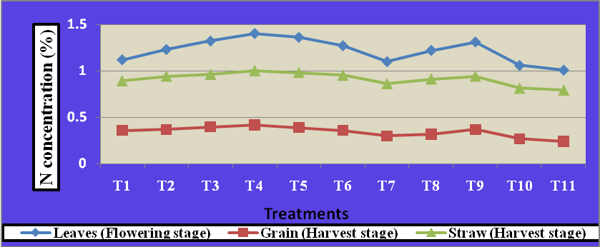

**Figure 1. Effect of copper application on Nitrogen concentration (%) in different plant parts of rice**

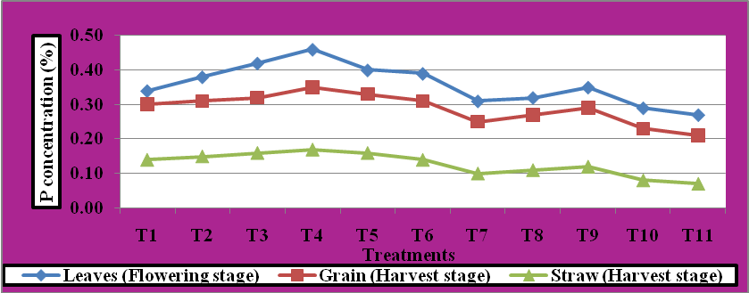

**Figure. 2 Effect of copper application on phosphorus concentration (%) in different plant parts of rice**

**in different plant parts of rice**

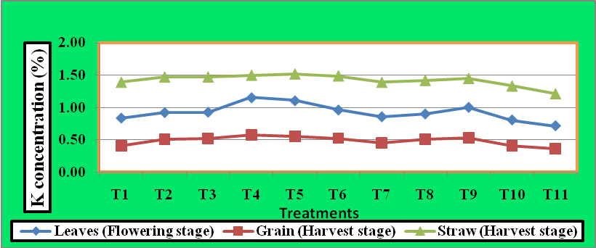

**Figure. 3 Effect of copper application on Potassium concentration (%) in different plant parts of rice**

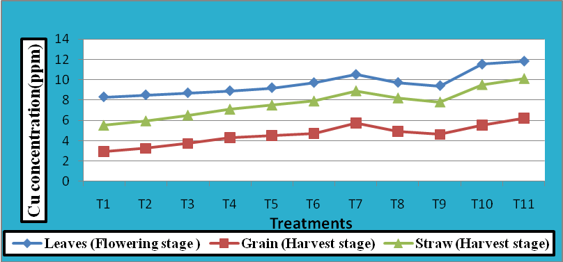

**Figure 4. Effect of copper application on Copper concentration (ppm) in different plant parts of rice**

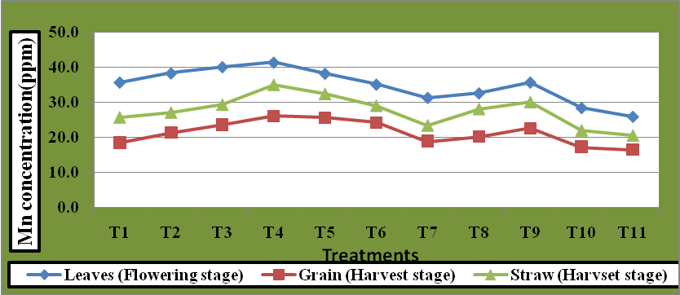

**Figure 5. Effect of copper application on Manganese concentration (ppm) in different plant parts of rice**

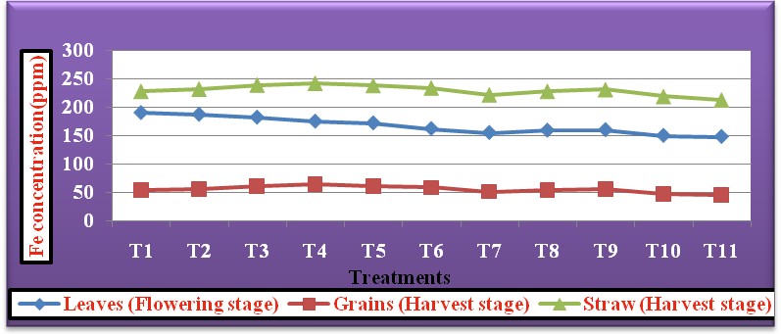

**Figure 6. Effect of copper application on Iron concentration (ppm) in different plant parts of rice**

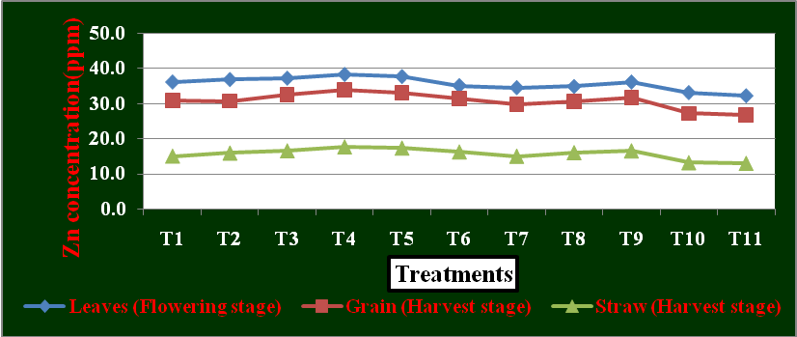

**Figure 7. Effect of copper application on Zinc concentration (ppm) in different plant parts of rice**

**Table 1. Methods for plant samples analysis**

|  |  |  |  |
| --- | --- | --- | --- |
| **S. No.** | **Properties** | **Analytical method** | **References** |
| i. | Total Nitrogen | Di-acid extract- Micro kjeldahl method of distillation | Piper (1966) |
| ii. | Total phosphorous | Triple acid extract-Vanadomolybdate yellow colour (Colorimetry) –method | Jackson (1973) |
| iii. | Total Potassium | Triple acid extract and Flame photometer | Piper (1966) |
| iv. | Total Copper | Triple acid extract- ICP OES | Lindsay and Norvell (1978) |
| v. | Total Iron | Triple acid extract- ICP OES |
| vi. | Total Zinc | Triple acid extract- ICP OES |
| vii. | Total Manganese | Triple acid extract- ICP OES |