RESEARCH ARTICLE
Rainfall-Runoff analysis by using Runoff-Coefficient and SCS-CN Methods in different approaches with the help of Remote Sensing & GIS techniques

ABSTRACT
Estimation of runoff in a watershed is very important to manage the water resources efficiently. In this regard, surface runoff quantification is an essential study. The main objective of this study is to quantify the surface runoff of the catchment area of a well located in AEC & RI, TNAU, Kumulur, Trichy District in Tamil Nadu. An attempt also made to analyze the précised surface runoff by SCS-CN event and annual basis as well as by runoff-coefficient method modified from rational method. The parameters like land use/ land cover, soil texture, runoff coefficient, Curve Number, intensity of rainfall and catchment area were considered for runoff quantification. This study identified the variation of runoff volume within different approaches of SCS-CN method and runoff coefficient method. By using GPS and with the help of GIS, remote sensing techniques along with field observations an exact catchment area of a well and slope direction was delineated. The land use/ land cover and soil map were delineated for the study area, and seven land use patterns were identified in the catchment area, and most of the area is covered with cultivable land. Sandy loam and sandy clay loam type of soils are predominating and HSG ‘C’ was identified for the study area. The highest CN value is 92 and the maximum runoff coefficient value is 0.95 for the Built-up land, the lowest CN value is 71 and the lowest runoff coefficient is 0.11 for the area covered with trees. Three AMC conditions were considered while estimating runoff volume by SCS-CN event approach. Among 15 years of rainfall data from 2004 to 2018, the highest runoff 38452.36 m³ generated in the year 2005 and the lowest runoff 8718.29 m³ generated in 2018 by SCS-CN event basis method. From this study between two concepts of SCS-CN and runoff coefficient models, the SCS-CN model with an event basis approach is yielding productive results. For quantifying surface runoff and for planning water conservation structures event basis calculations are more effective.
Keywords: Curve number, Groundwater, land use, Rainfall, Remote Sensing, Runoff-coefficient.

INTRODUCTION
A watershed is that contributes runoff water to a common point. There are many methods offered for rainfall-runoff modeling. The Soil Conservation Service and Curve Number (SCS–CN) technique is one of the primogenital and simplest method for rainfall-runoff modeling. The curve number method (SCS–CN, 1972) is adaptable and widely used for runoff estimation. Several models based on SCS–CN are being referred by different researchers worldwide used such as the original SCS–CN, Mishra-Singh (MS) model (2002), Michel model (2005), and Sahu model (2007), on the SCS–CN concepts, with some modifications are used. Earlier studies carried out by several researchers such as Sateeshkumar et al. (2017), Kadam et al. (2012), USDA (1986), Mishra et al. (2004), Saravanan and Manjula (2015), Vinithra and Yeshodha (2016) and Bhura et al. (2015). The rational method is also widely used to calculate the peak stormwater runoff rate for a variety of storm water management applications (Chandramohan and Vijaya 2017). The runoff coefficient will vary due to different types of physiographic features like vegetation interception, soil infiltration, slope, geo-morphological structure, etc. To estimate surface runoff volume instead of peak discharge the runoff coefficient method is used by using average rainfall intensity. The SCS-CN with event and annual as well as runoff coefficient models were adopted in this study for estimating surface runoff from the study area.

Study Area
The study area, a micro watershed of AEC & RI, TNAU, Kumulur located in Lalgudi Taluk of Thiruchirapally District in Tamil Nadu lies in between 10°55'56"–10°55'47" North latitudes and between 78°49’43”–78°49'38” East longitudes. The area of the catchment is about 44,832.3 m². The catchment area is covered with built-up land, agriculture land, plantation crops, fallow land, wasteland, forestry (cultivable trees) and one open well. The study area is having third-order stream passing from near the open well. With these backgrounds, the objectives of the study are to estimate the runoff catchment area of a well, to find out the runoff coefficients and CN values for runoff coefficient and SCS-CN methods, to estimate and analyze the precise runoff contribution from the catchment area of a well.

MATERIAL AND METHODS
Tools like GPS, total station were used for identifying the catchment area of a well in AEC & RI, Kumulur. International Pipette (Robinson Pipette) laboratory method was used for soil texture analysis at Soil Chemistry Laboratory, AEC&RI, TNAU, Kumulur. Double Ring Infiltrometer was used to identify soil infiltration characteristics of the study area to identify the Hydrologic Soil Groups. Remote Sensing, GIS techniques and Google Earth map were used to delineate catchment area, slope map, land use/land cover and soil map. 15 years of rainfall data from 2004 to 2018 collected from Meteorology Station of AEC&RI, TNAU, Kumulur. Daily average rainfall intensity was estimated by IDF empirical approach (Hydrologic Science and Engineering, Civil and Environmental Engineering Department, Colorado State University model). SCS-CN method and runoff coefficient method were used for the calculation of surface runoff from the catchment area of a well.
Identification of well catchment area: GPS was used to identify the landmarks of latitude and longitude along with elevations. Total station survey was conducted and the readings were superimposed in GIS software to delineate the exact catchment area of a well.
Land use/ land cover: Using the Google earth map interface along with field verifications, the land use/ land cover map of the study area was generated.
Soil map: Soil samples were collected and texture analysis was carried out by International Pipette Method (Robinson Pipette method).
SCS–CN Model
The SCS–CN (1985) method was established in 1954 by the USDA SCS (Rallison1980), defined in the Soil Conservation Service (SCS) by National Engineering Handbook (NEH-4) Section of Hydrology (Ponce and Hawkins 1996). The Soil conversation Service-Curve
Number approach is based on the water balance calculation and two fundamental hypotheses had been proposed (Jun et al. 2015).
The first suggestion states that, the ratio of the real quantity of direct runoff to the maximum possible runoff is equal to the ratio of the amount of real infiltration to the quantity of the potential maximum retention. The second hypothesis states that the amount of early abstraction is some fraction of the probable maximum retention. The Soil Conservation Service Curve Number approach is frequently used to estimate the direct runoff from a watershed (USDA 1972).
Q = 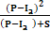 (1)
Where ‘Q’ is the runoff depth in mm, ‘P’ is the rainfall depth in mm, I_{a} is the initial abstraction in mm, ‘S’ is Potential maximum retention in the watershed in mm.
Surface storage, interception and infiltration prior to the runoff is defined as initial abstraction I_{a} and it is given by,
I_{a} = 0.3×S (2) (for Indian Conditions)
For Indian condition the form ‘S’ the potential maximum retention is given by,
(3)
Where CN is known as the curve number. Now the equation can be rewritten as
(4)
(5)
Where ‘Q_{v}’ is the runoff volume in m³, ‘A’ is the area of the watershed in m² and ‘Q’ is the runoff depth in mm.
The SCS Curve Number describes the ability of soils to allow infiltration of water concerning to their land use/ land cover (LU/LC) and antecedent soil moisture conditions (AMC) (Amutha and Porchelvan 2009).
Based on the U.S soil conservation service (SCS), soils are classified into four hydrologic soil groups such as A, B, C & D concerning the rate of runoff and final infiltration as presented in Table 1. By analyzing the land use/ land cover and HSG, curve number values can be obtained from Arc GIS software with digitized boundaries.
Antecedent moisture condition (AMC): Antecedent Moisture Condition (AMC) is considered as the moisture available before the modeled rainfall event. For modeling purposes, AMC II in the watershed is essentially an average moisture condition, for dry condition AMC I and wet condition for AMC III. Antecedent Moisture Condition classes were categorized as I, II, III reported in Table 2.
The standard and already reported method must be clearly given or cited. Any modification of the original method must be duly highlighted. This section may be subtitled for clarity. Use standard abbreviations of the various units. ISI units should be used for measurements.
The following equations are used in the cases of AMC-I and AMC-III (Chow et al. 2002):
CN (I) = (5)
CN (III) = (6)
CN_{w} (7)
Where CN_{w} is the weighted curve number for the whole catchment area, CN_{i} is the curve number from 1 to any number N, A_{i} is the area with curve number CN_{i} and A is the total area of the watershed.
Runoff Coefficient Method
Instead of the rational method to calculate peak flow discharge, the runoff coefficient method is used to calculate the runoff volume with average rainfall intensity of a storm (IDF relation, Colorado State University, Dept. of Civil. Eng.). The Rational formula is modified as follows (runoff coefficient method):
(8)
Where: ‘Q’ is maximum runoff (m³/day), ‘C’ is runoff coefficient representing a ratio of runoff to rainfall (unitless) (or) depends on land use, soil properties and topography (unitless), ‘I’ is the average rainfall intensity (mm/day) (IDF relation, Colorado State University, Dept. of Civil. Eng.), and ‘A’ is the catchment area (m²).

RESULTS AND DISCUSSION
Delineation of catchment area of a well: The contour map for the catchment of a well was delineated and the slope direction identified towards the South-East direction as shown in Fig. 1. With the help of ground truth verifications and total-station survey final well catchment was delineated as shown in Fig. 2. One open well is exiting in the low-lying part of the study area towards South-East direction.
Land Use/ Land Cover Classification: The land use and land cover map of the study area obtained as shown in Fig. 3. Fig. 3. shows the land use/ land cover details of the study area constituting of cultivated area (42.27%) followed by plantation crop (21.52%), pasture land (12.45%), tree cultivated area (12.09 %), fallow land (7.4%), built-up land (4.01%) and water body i.e. open well (0.14%). The major area of the watershed was under crop land (cultivable land) plays an important role in producing direct surface runoff. Land use/ land cover details are shown in Table 3.
Soil Classification: Soil texture analysis carried out by Robinson;s Pippette method and the study area soils are categorized into two soil groups i.e. sandy clay loam and sandy loam. Majority of the area covered with sandy loam soil followed by clay loam soil as shown in Fig. 4.

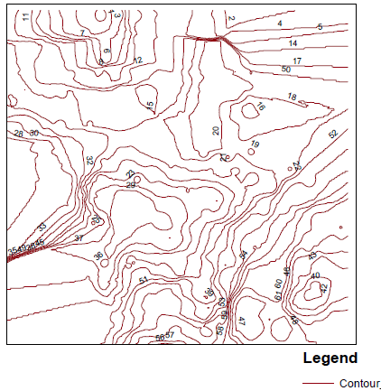 |  | 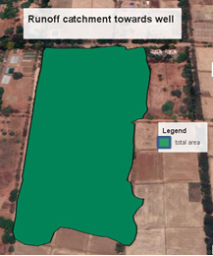  N
Figure 1. Contour map of the study area |  | Figure 2. Well catchment area
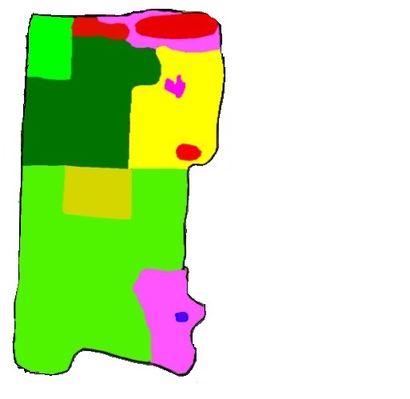  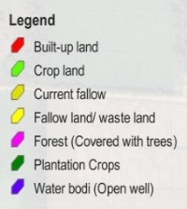  N | 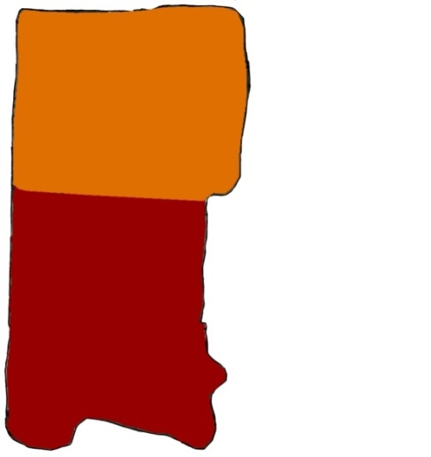  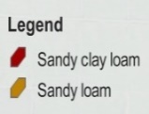  N
Figure 3. Land use/land cover map of the study area | Figure 4. Soil map of the study area
3.4 Curve Numbers and Maximum Retention Capacity (SCS-CN Method)
CN values were estimated based on hydrologic soil group and land-use patterns of the study area were presented in Table 3. The weighted values of curve number for the three AMC conditions as well as maximum soil-water retention capacity for three antecedent moisture conditions were calculated as per the USDA SCS-CN method and presented in Table 4. (USSCS, 1964).
3.5 Estimation of Runoff Volume by SCS-CN Method
3.5.1 Estimation of Runoff Volume (annual basis): From the rainfall data for 15 years (2004 to 2018), the annual runoff volume was estimated from annual rainfall depth by the SCS-CN annual basis method. The highest runoff volume generated in 2005 is 63046.09 m³ and the lowest runoff volume amount observed in the year 2018 is 18924.7 m³ as shown in Table 5 [Sateeshkumar et al. (2017), Kadam et al. (2012), USDA (1986), Mishra et al. (2004), Saravanan and Manjula (2015)]. Fig. 5. shows the relation between rainfall (mm) and runoff (mm) from 2004 to 2018 years. The maximum runoff depth i.e. 1338.86 mm was obtained in the year 2005 with the highest rainfall of 1476.4 mm. The lowest runoff depth was observed 401.89 in the year 2018 with the lowest rainfall of 524.2 mm.

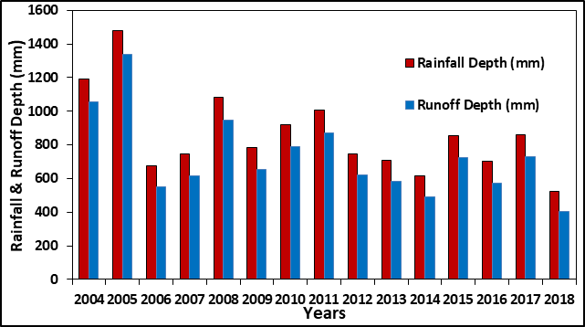
Figure 5. Rainfall-runoff (mm) relationship for 2004-2018 years using SCS-CN annual basis
3.5.2 Estimation of Runoff volume (Event Basis): In this concept, the runoff volume was calculated for each rainfall event. The annual runoff volume was computed by summing up each runoff volume of the rainy day throughout the year by considering their AMC conditions and CN values. The runoff volume from 2005 to 2014 years is shown in Fig. 6. This approach consumes more time for calculating longer periods of rainfall data, but it is a precise method for gauged watershed and more useful for planning of water conservation structures such as farm ponds, gully plugs, percolation ponds, check dams, and other artificial water recharge structures. [Nhamo Luxon and Chilonda Pius (2013), Latha et.al (2012), TejramNayak et.al (2012)]. Fig.6. reveals that the maximum runoff volume determined in the year 2005 is 38,452.36 m³ and the lowest runoff volume determined in the year 2018 is 8718.3 m³.
Figure 6. Runoff volume for 2004-2018 years from SCS-CN method (Event basis)

3.6 Estimation runoff volume by runoff coefficient method
Runoff coefficient method was adopted to estimate runoff volume by using the runoff coefficient of the catchment, average rainfall intensity, (IDF relationship, Colorado State University paper) and the watershed area. Runoff coefficient values were determined based on their land use, slope, and Hydrologic Soil Groups of the study area (Hydraulics in Civil Engineering, Harlan Bergson, NRCS.USDA.gov). Table 6. Shows the highest runoff coefficient values determined for water body i.e. 1 and the next highest value for built-up land is 0.95, and the lowest value identified for the forest/ the land covered with trees is 0.12 and then after plantation crops (citrus & drum stick) is 0.2. The highest runoff coefficient value tends to produce more surface runoff and the lowest values retain more moisture as abstraction losses hence the runoff volume will be less as compare to the highest runoff coefficient values.
From this runoff coefficient method among 15 years of rainfall data (2004 to 2018), the highest runoff was determined in the year 2005 as 38,499.81 m³ and the lowest runoff was determined in the year 2018 as 10,011.89 3 m³ as shown in Fig. 7.
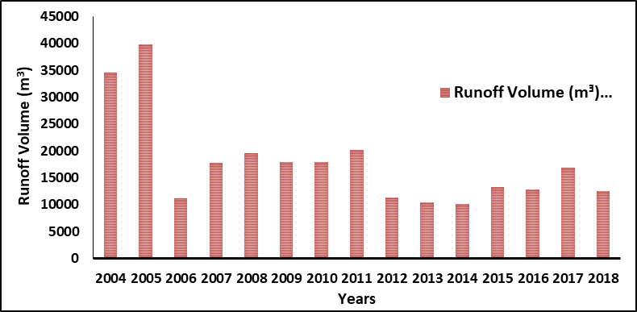
Figure 7. Runoff volume for 2004-2018 years from runoff coefficient method
3.7 Comparison of runoff volume by SCS-CN method and runoff coefficient method
In most cases, the SCS-CN method was used for gauged and un-gauged watersheds to estimate runoff volume for a shorter and longer period. The large catchment area’s annual runoff volume estimating by considering the average AMC condition and avg. CN value with SCS-CN annual basis approach as annual basis approach. But in the event basis approach, three AMC conditions were followed. From Table 5 and Figures 7 and 8 among 15 years of rainfall data from 2004 to 2018, the highest runoff volume found in the year 2005 is 63,046 m³ by SCS-CN annual basis method, 38452.36 m³ by SCS-CN event basis method, and 38,499.81 m³ by runoff coefficient method. The lowest runoff volume found in 2005 is 18924.87 m³ by SCS-CN annual basis, and 8718.29 m³ by event basis, and 10,011.89 m³ by the runoff coefficient method as shown in Table 7.
Table 7 shows that, a significant difference in runoff volume within the SCS-CN model of the event and annual basis. The maximum runoff volume determined in the year 2005 is 63046.09 m³ for an annual basis and 38452.36 m³ for event basis. The lowest runoff volume is about 18924.87 m³ in the case of the annual method, and 8718.30 m³ in the case of event basis. Within two values from the event and annual basis, the lowest values were considered as correct runoff amount i.e. event basis calculations. Because in annual basis method 30% abstraction losses are neglecting from the total rainfall depth as a whole, only once in a year so that it may not give the accurate abstraction losses. In the case of event basis, the same 30% abstraction losses are neglecting for each rainfall event i.e. all abstraction losses due to each dry-spell are considering, as well as three AMC conditions are considering for runoff estimation. There is no much significant difference between the runoff values of SCS-CN event basis and runoff coefficient values. The runoff values of the runoff coefficient method and SCS-CN event basis are almost nearer to each other as shown in Fig. 8. Therefore, the event basis calculations are considered accurate and precise techniques as compare to the annual basis concept of the SCS-CN method. Hence, the SCS-CN event basis approach is more productive as compared to SCS-CN annual basis calculations and runoff coefficient method.
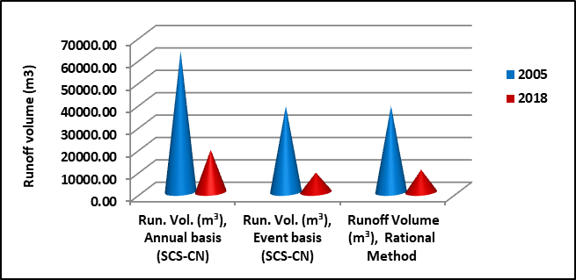
Figure 8. Comparisons of three different approaches of runoff calculations for 2005 and 2018 years
(SCS-CN and runoff coefficient methods)

CONCLUSION

From this study, a catchment area of a well 4.48 ha was delineated in the AEC & RI, Kumulur, TNAU. The majority of the catchment area constitutes cultivable cropland (42.27%) followed by plantation crop (21.52%), wasteland (12.45%), tress cultivation (12.09 %), fallow land (7.4%), built-up land (4.01%) and water body i.e. open well (0.14%). Based on the results of soil classification and land use data, the study area identified in hydrologic soil group ‘C’. The highest CN value and runoff coefficient values were determined for built-up land i.e. 92 and 0.91. The lowest CN value and runoff coefficient value estimated for forest land (tree cultivation). The composite curve number for the normal condition is 77.78, whereas for the dry and wet conditions are 62.95 and 89.12 respectively. Surface runoff computed by using three concepts i.e. SCS-CN with annual, event basis, and runoff-coefficient method. A significant difference was found within the SCS-CN model of event and annual basis calculations as well as the runoff coefficient model. The results revealed that SCS-CN event basis and runoff coefficient method values are almost nearer to each other, and significant difference found in SCS-CN annual basis method with event basis and runoff coefficient methods. In the SCS-CN event basis method and runoff coefficient methods, considering all the surface abstraction losses for each rainfall event, as well as considering three AMC conditions whereas that is not possible in the case of the SCS-CN annual method. Therefore, among these three methods, the lowest values found in the SCS-CN event basis method hence, the SCS-CN event basis method is more fruitful as compared to SCS-CN annual basis method and runoff coefficient method.

This study analysis revealed an appropriate model for precise runoff estimation for any watershed and is more useful for the students and research scholars as well as for watershed development programs. From this study, the highest runoff volume of the catchment among the past 15 years (2004-2018) is found 38452.36 m3 in 2005 and the lowest is 8718.3 m3 in 2018 according to the SCS-CN event basis method. A Significant amount of surface runoff generating from the study area, hence a suitable water harvesting structure should be provided at the low-lying part of the catchment area of a well to arrest the surface runoff as well as to improve groundwater resources.

REFERENCES
Fageria, N. K., Dos Santos, A. B. and T. Cobucci. 2011. Zinc nutrition of lowland rice. Commun. Soil Sci.
Plant Analysis.,42: 1719-1727.
Amutha, R., and P. Porchelvan. "Estimation of surface runoff in Malattar sub-watershed using SCS-
CN method." Journal of the Indian Society of Remote Sensing 37, no. 2 (2009): 291-304, [54].
Bhura, Chirag S., N. P. Singh, P. R. Mori, Indra Prakash, and Khalid Mehmood. "Estimation of
surface runoff for Ahmedabad urban area using SCS-CN method and GIS." International Journal of
Science Technology & Engineering 1, no. 11 (2015): 411-416,[4].
Chandramohan, K. and Vijaya, R., 2017. Hydrologic Computations of SCS-CN, Rational, Area
velocity and Tc Methods for Quantifying the Forest Surface Water Runoff—A case study in
Sirumalai hill environs of Sathiyar Reservoir, Madurai, Tamil Nadu, India. Int. Res. J. Eng. Technol.
IRJET, 4, pp.662-670,[3].
Chow, Ming Fai, Zulkifli Yusop, and M. Mohamed. "Quality and first flush analysis of stormwater
runoff from a tropical commercial catchment." Water Science and Technology 63, no. 6 (2011):
1211-1216, [32].
Jun, Li, Changming Liu, Zhonggen Wang, and Kang Liang. "Two universal runoff yield models: SCS
vs. LCM." Journal of Geographical Sciences 25, no. 3 (2015): 311-318, [37].
Kadam, Ajaykumar K., Sanjay S. Kale, Nagesh N. Pande, N. J. Pawar, and R. N. Sankhua.
"Identifying potential rainwater harvesting sites of a semi-arid, basaltic region of Western India,
using SCS-CN method." Water resources management 26, no. 9 (2012): 2537-2554, [131].
Latha, M., M. Rajendran, and A. Murugappan. "Comparison of GIS based SCS-CN and strange
table method of rainfall-runoff models for Veeranam Tank, Tamil Nadu, India." Int. J. Sci. Eng.
Res 3, no. 10 (2012): 1407-1416, [14].
Mishra, S. K., J. J. Sansalone, and Vijay P. Singh. "Partitioning analog for metal elements in urban
rainfall-runoff overland flow using the soil conservation service curve number concept." Journal of
Environmental Engineering 130, no. 2 (2004): 145-154, [29].
Nhamo, Luxon, and Pius Chilonda. "Validation of the rainfall-runoff SCS-CN model in a catchment with
limited measured data in Zimbabwe." International Journal of Water Resources and
Environmental Engineering (2013), [13].
Rallison, Robert E. "Origin and evolution of the SCS runoff equation." In Symposium on watershed
management 1980, pp. 912-924. ASCE, 1980, [212].
Saravanan, S., and R. Manjula. "Geomorphology based semi-distributed approach for modeling rainfall-
runoff modeling using GIS." Aquatic Procedia 4 (2015): 908-916, [12].
Satheeshkumar, S., S. Venkateswaran, and R. Kannan. "Rainfall–runoff estimation using SCS–CN and GIS
approach in the Pappiredipatti watershed of the Vaniyar sub basin, South India." Modeling Earth
Systems and Environment 3, no. 1 (2017): 24, [78].

List of Tables

Table 1. Soil Conservation Service Classification (USDA 1974)
Hydrological Soil Group(HSG) | Soil Textures | Runoff potential | Water transmission | Final infiltration (mm)
Group A | Deep, well-drained sands and gravels | Low | High rate | >7.5
Group B | Moderately deep, well- drained with moderate | Moderate | Moderate rate | 3.8-7.5
Group C | Clay loams, shallow sandy loam, soils with moderate to fine textures | Moderate | Moderate rate | 1.3-3.8
Group D | Clay soils that swell significantly when wet | High | Low rate | <1.3

Table 2. Group of Antecedent soil moisture classes (USDA 1985)
AMC group | Total 5-day antecedent rainfall (mm):
 | Dormant season | Growing season
I | Less than 13 | Less than 36
II | 13 to 28 | 36 to 53
III | More than 28 | More than 53

Table 3. Spatial distribution of land use and land cover and CN values for HSGs
S. No | Land use/ land cover | Area  (m²) | Percentage  (%) | Hydrologic Soil Group  (C)
1 | Built-Up land | 1802 | 4.01 | 92
2 | Plantation crop | 9651 | 21.52 | 71
3 | Fallow land/ Pasture | 5583 | 12.45 | 79
4 | Long fallow | 3356 | 7.4 | 82
5 | Cropland | 18954 | 42.27 | 81
6 | Waterbody | 64.3 | 0.14 | 100
7 | Trees/ forest | 5422 | 12.09 | 70

Table 4. Curve Number and ‘S’ values for Three Antecedent Moisture Conditions

S. No | Antecedent Moisture Condition | Weighted CN value for the catchment area | Max. retention capacity ‘S’ (mm)
1 | AMC-I | 62.958 | 149.443
2 | AMC-II | 77.78 | 72.56
3 | AMC-III | 89.127 | 30.98

Table 5. Annual Rainfall and Runoff Values (2004-2018)
Year | Rainfall | Runoff Depth (mm) | Runoff Volume (m³)
2004 | 1192.9 | 1057.56 | 49799.76
2005 | 1476.4 | 1338.86 | 63046.09
2006 | 675.1 | 547.90 | 25800.18
2007 | 745.7 | 616.81 | 29044.94
2008 | 1083.5 | 949.29 | 44701.33
2009 | 783.9 | 654.20 | 30805.89
2010 | 921.2 | 789.11 | 37158.45
2011 | 1006.4 | 873.12 | 41114.48
2012 | 747.9 | 618.96 | 29146.27
2013 | 709.4 | 581.34 | 27374.87
2014 | 613.6 | 488.15 | 22986.42
2015 | 855.6 | 724.57 | 34119.26
2016 | 700.6 | 572.75 | 26970.54
2017 | 861.9 | 730.76 | 34410.84
2018 | 524.2 | 401.89 | 18924.87

Table 6. Topography and existing Runoff coefficient (c) values of the study area

S. No | Land Use/Cover | Area (m²) | Topography | Runoff Coefficient  ©
1 | Built-Up land | 1802 | Nearly level | 0.95
2 | Plantation crop | 9651 | Moderate | 0.2
3 | Current fallow/ Pasture | 5583 | Moderate | 0.3
4 | Current fallow | 3356 | Gentle | 0.68
5 | Cropland | 18954 | Gentle | 0.4
6 | Waterbody | 64.3 | - | 1
7 | Tress/ forest | 5422 | Gentle | 0.12

Table 7. Comparisons of lowest and highest runoff volumes by the three approaches
Year | Annual runoff volume (mᴲ)
Year | SCS-CN Method |  | Runoff Coefficient Method
Year | Annual Basis | Event Basis | Runoff Coefficient Method
2005 | 63046.09 | 38452.36 | 38,499.81
2018 | 18924.87 | 8718.29 | 10,011.89

