**Effect of Copper on Growth and Yield and Macro and Micro Nutrient Concentration of Rice (Oryza sativa.L) in *Typic Haplustalf***

|  |  |
| --- | --- |
|  | ABSTRACT A field experiment was conducted at of soil application of different levels of copper (0, 0.5, 1.0, 1.5, 2.0, 2.5, 3.0 kg Cu ha-1) and foliar application (0.25% CuSO4 at tillering stage, 0.25% CuSO4 at tillering and flowering stage, 0.5% CuSO4 at tillering stage and 0.5% CuSO4 at tillering and flowering stage) to test the response of rice plants grown in a copper-responsive in *Typic Haplustalfs* of Tamil Nadu. The treatment plots were replicated three times in randomized block design. The growth attributes like plant height, tillering and dry matter yield enhanced with increasing Cu levels and was maximum at 1.5 mg kg-1 Cu. The grain yield at 1.5 mg kg-1 Cu was enhanced by 62.9% from the control. The outcomes uncovered that the Cu concentrations in leaves, grain and straw enhanced with increasing levels of Cu application. Application of low Copper application (0.5 to 1.5 kg Cu ha-1) significantly increased the macro (total N, P, K) and micro nutrient (Fe, Mn, Zn) content in leaves, grain and straw of rice, however higher concentrations (2.0 to 3.0 kg Cu ha-1) drastically reduced the nutrient content of rice. |

Keywords: *Rice; Copper; Total nutrients; Leaves; Grains; Straw; Growth; Grain and Straw yield*

## INTRODUCTION

Micronutrient deficiency has become a major constraint for crop productivity in many Indian soils. The deficiency of micronutrients may either be primary, due to their low total contents or secondary, caused by soil factors that reduce their availability to plants (Sharma and Chaudhary, 2007). Copper is well documented as an essential micronutrient for normal plant growth and metabolism (Sharma and Agarwal, 2005; Singh *et al*., 2007). Deficiency of Cu in soils has been observed only in certain pockets of Tamil Nadu (Reshma *et al.,* 2016) and therefore responses of crops to Cu were assessed only at a few locations (Jegan and Subramanian, 2006). Although the reported available soil Cu content in soils of Tamil Nadu is not indicative of Cu deficiency but plant response to Cu application is known for such soils (Jegan and Subramanian, 2006; Vishwas, 2010).

When Cu is supplied with below the requirement of crop there may be a drop in the crop yield. It is engaged with various physiological functions as a segment of a several enzymes, fundamentally those which take an interest in electron flow, catalyze redox reaction in mitochondria and chloroplasts (Upadhyay and Panda 2009). Be that as it may, in unreasonable amounts copper ends up dangerous as it interferes with photosynthetic and respiratory processes, protein synthesis and improvement of plant organelles (Upadhyay and Panda 2009). A nutrient imbalance may also arise by the presence of an excessive amount of a nutrient element that hinders another nutrient in performing its normal metabolic functions (Malewar, 2005; Zengin and Kirbag, 2007). Furthermore, the knowledge of the plant parts, which accumulate the highest concentration of any nutrient, should prove to be useful criterion in delineating the deficiency levels of nutrients from sufficiency and toxicity levels. The concentration of micronutrient cations (Cu, Fe, Mn and Zn ) often does not vary greatly within plant parts, however, application of nutrient(s) in question may alter the concentration of other micronutrients to some extent which may influence their critical level in plant parts (Sharma and Bapat, 2000). Rice is an important cereal crop of India, which is highly susceptible to low level of Cu (Patel and Singh, 1995). Despite the application of recommended quantities of the major plant nutrients, the increase in productivity of Rice crop is not encouraging. This indicates that in addition to major plant nutrients, there is a need to apply those micronutrients, which are deficient or low in the soil in a balanced manner. Many interactions among these micronutrients may also occur. Studies have shown that Cu and Zn interact with each other due to antagonistic relationship as many workers (Dangarwala, 2001) have suggested Cu-Zn antagonism. Hence, the present study was undertaken to evaluate the effect of application of Cu on the growth, yield and the interactive effect of graded levels of Cu with concentrations of N, P, K, Fe, Mn, Zn, and Cu in various parts of the rice plant in a field experiment with a Cu-responsive Typic Haplustalf of Tamil Nadu.

## MATERIAL AND METHODS

A field experiment was conducted with rice (*Oryza sativa.L*. cv.TKM 13) in*Typic Haplustalf* (090 58’ 02.2’’ latitude, 78⁰12’ 25.8’’ East longitude). Some physico-chemical characteristics of the soil were: texture- sandy clay loam, pH(1:2.5 soil water extract)- 8.1, EC(1:2.5 soil water extract) - 0.21 dSm-1 , organic matter- 4.1 g kg-1, calcium carbonate (CaCO3)- 6.25 %, available N-201.6 kg ha–1, available P- 20.0 kg ha–1, available K-320 kg ha–1, available S- 8.5 kg ha–1,diethylene triamine penta acetic acid (DTPA) extractable Cu, Fe, Mn and Zn were 0.88, 18.2, 5.25 and 3.02 mg kg-1 soil, respectively. Soil available phosphorus was measured using the method suggested by Olson and Dean, (1965). Soil available N was measured by alkaline permanganate method, available K was done by Neutral normal ammonium acetate method. Soil analysis for CaCO3 was done by rapid titration method (Jackson, 1958); organic matter by Walkley and Black’s titrimetric method and available Cu, Fe, Mn and Zn in DTPA extract (Lindsay and Norvell, 1978).

The experiment was laid out in Randomized Block Design (RBD) with eleven different treatments (T1 - RDF alone (150:50:50 kg of N, P2O5, K2O ha-1); T2 - RDF + 0.5 kg Cu ha-1; T3 - RDF + 1.0 kg Cu ha-1 ; T4 - RDF + 1.5 kg Cu ha-1;T5 - RDF + 2.0 kg Cu ha-1;T6 - RDF + 2.5 kg Cu ha-1; T7 - RDF + 3.0 kg Cu ha-1; T8 - RDF + Foliar spray of 0.25 per cent CuSO4 at tillering stage; T9 - RDF + Foliar spray of 0.25 per cent CuSO4 at tillering stage and flowering stage; T10 - RDF +Foliar spray of 0.5 per cent CuSO4 at tillering stage; T11 - RDF +Foliar spray of 0.5 per cent CuSO4 at tillering stage and flowering stage, and the treatments were replicated thrice. Plot size of 4m×4m (16 m2) was adopted with buffer channel (0.3m) around each plot in the experimental field.

Fertilizers were applied in accordance with the treatment schedule, with all plots receiving 150 kg N ha-1 as urea, 50 kg P ha-1 as (SSP), and 50 kg K ha-1 as Murate of Potash (MOP) except control plot (T1). Entire dose of P was applied basally and N and K were applied in three equal splits as basal, active tillering stage and panicle initiation stage. Copper levels (0.5, 1.0, 1.5, 2.0, 2.5, 3.0 kg ha-1) as CuSO4 were graded and mixed with 25 kg of sand for uniform distribution before being broadcast basally at the time of transplanting according to the treatment schedule (T2 to T7). The Cu fertilizer in the form of copper sulphate (CuSO4.5H2O) was applied in the form of foliar spray @ 0.25 and 0.5 per cent at the time of tillering and flowering per the treatment schedule (T8 to T11).

**Data acquisition**

Data pertaining to growth parameters were recorded as plant height, tillering, and dry matter yield. Various grain yields attributes were also recorded at harvest. Samples of leaves at flowering stage, grain and straw at maturity were taken for chemical analysis. The plant samples were oven dried at 70⁰C for 48 hours and powdered. For analysis of nutrients like P, K, Fe, Mn, Zn and Cu, 1 g powdered plant sample was wet digested in nitric-perchloric acid (10:1 v/v) mixture (Piper, 1942). One g powdered plant sample was wet digested in a sulphuric-perchloric acid (5:2 v/v) mixture for N analysis (Jackson, 1973). The concentrations of Fe, Mn, Zn and Cu were determined by using an atomic absorption spectrophotometer (Techtron AA120).

**Statistical analysis**

Statistical analysis was performed using analysis of variance (ANOVA) for Randomized Block Design (Gomez *et al.,* 1984). The treatment means were compared at the p<0.05 level using LSD for all the parameters.

## RESULTS AND DISCUSSION

**Plant growth, fresh and dry matter yield:**

The increase in plant height was maximum (44.1%) at 1.5 mg kg-1 Cu application in comparison to control plants. The number of tillers was maximum in 1.5 mg kg-1 Cu level (37.7 tillers plant-1 ) which decreased to a minimum in control plants (15.3 tillers plant-1) (Table 1). However, not all the tillers of control plants were of effective type. Thus, the plants at low copper had decreased height and profuse tillering, which could be attributed to the loss of apical dominance of the main stem. Similar effects of low Cu have also been described in different plants (Ratan Kumar *et al*., 2009; Marschner, 1995).

Dry matter yield was minimum in the control plants and increased with an increase in Cu application rate to a maximum (61.9% over control) at 1.5 mg kg-1 Cu at harvest stage of the crop (Table 1). At levels higher than 1.5 mg kg-1 Cu, the dry matter yield decreased slightly in agreement with the reports of Kumar *et al*., (1990) and Ratan Kumar *et al*., (2009) in rice plants.

**Grain yield attributes and straw yield:**

The number of the panicle (17.3 panicle hill-1) andnumber of grains per panicle(171.8) was significantly increased in plants applied with 1.5 mg kg-1 Cu. The grain yield was maximum in the plants at 1.5 mg kg-1 Cu level and it was 41.3% higher than the control plants. However, the grain yield was reduced by further addition of Cu at 2.0 mg kg-1 and 3.0 mg kg-1. The panicle weight (5.6g) was also increased significantly in plants at 1.5 mg kg-1 Cu (Table 1). There was no significant effect of applied graded levels of copper on test grain weight (Table 1), since test grain weight was generally managed by hereditary attributes of the variety. Similarly, Moghadam *et al.,* (2012) also reported that applied copper had no effect on 1000 grain weight and corn sheath diameter in maize. The grain yield enhancement at 1.5 mg kg-1 Cu was mainly due to increase in the number of the panicle, grain number per panicle, test grain weight and panicle weight. The results are in accord with the earlier reports that plants grown in alluvial soils of Uttar Pradesh respond to Cu application even if the soil is not deficient in available Cu (Mehrotra, 1993; Ratan Kumar *et al*., 2009; Scheiber *et al*., 2013). Reduced grain yield in low Cu plants is in accordance with the reports of Mateos-Naranjo *et al.,* (2008) and Azeez *et al*., (2015). This is due to the reduction in the number of effective tillers, disturbed setting of grains and the production of rudimentary and blind panicle in such plants. The reduction in grain yield at 2.0 and 3.0 mg kg-1 Cu levels may be due to excess of Cu and its interaction with other micronutrients like Fe ad Zn (Dangarwala, 2001).

**Tissue concentrations of N, P and K:**

Nitrogen content of rice showed progressive decline with increase in copper level (Fig.1). The higher levels of copper application significantly reduced the nitrogen content in leaves during the flowering stage, as well as grain and straw during the harvest stage. The highest N content was observed in leaves at the flowering stage and grain and straw at the harvest stage in plots that received 1.5 kg Cu ha-1 as soil application with 100% RDF (T4), while the lowest N content was observed in plants that received 2 to 3 kg Cu ha-1 as soil application (T5- T7) and 0.5 percent CuSO4 spray at the tillering and flowering stages (T11). This demonstrated that N uptake was significantly increased at lower levels of copper, whereas higher concentrations decreased N uptake. This may due to N and Cu were found to have a mutually antagonistic effect on each other's concentration in the plants. The antagonism was greater with NH4+ sources than with NO3- compounds (Zheng *et al*., 2004). According to Vinod kumar *et al*., (1990) increasing Cu levels (0, 5, 10, and 20 ppm Cu) significantly decreased the available soil-nitrogen after harvest as well as the concentration of N in the plants; however, applying 5 ppm Cu with adequate supplies of N was sufficient for a wheat crop in Cu deficient soil.

A depressive effect was observed on P content in leaves, grain and straw with graded levels of Cu application at all the growth stages of rice (Fig.2). Application of more than 1.5 kg Cu ha-1 (T5- T7) brings down the P content in leaves, grain and straw and demonstrated negative relation between phosphorus and copper. High convergence of Cu stifles P metabolism by decreasing the substance of inorganic phosphorus in plants. This confirmed the negative correlation between Cu and P in rice and this was also revealed by Wallace and Cha (1989) and Mateos-Naranjo *et al.,* (2008).

On inspection of the data, a disconsolate effect on total K content at flowering (leaves) and harvest (grain and straw) was seen with elevated level of copper spray (Fig.3).The decrease in K content of rice due to elevated levels of copper was in conformity with the reports of Lidon and Henriques (1993) and Ouzounidou (1994). The decrease in K content of rice due to the toxic effect of copper on plant growth or competition by other ions which in turn exercised a regulatory control on K uptake was reported by Manivasagaperumal *et al.,* (2011).

**Tissue concentrations of Cu, Mn, Fe and Zn:**

The Cu concentrations in leaves at flowering stage and grain and straw at harvesting stage increased significantly with an increase in level of applied Cu and maximum copper accumulation in the rice leaves, grain and straw was recorded in 0.5 per cent CuSO4 spray at tillering and flowering stage (T11) (Fig.4). Kumar *et al.,* (2009) made similar observations that the Cu content of leaves increased with the increased use of copper in wheat. This view was also supported by Mocquot *et al.,* (1996) and Scheiber *et al*.,(2013).

The Cu application at adequate or lower levels did not affect the Mn content in leaves at flowering stage and grain and straw at harvesting stage of rice, however at higher doses of Cu (> 1.5 kg Cu ha-1 and 0.5 per cent CuSO4 spray at tillering and flowering stage), the Mn concentration in plant tissues decreased significantly (Fig.5). Decrease in Mn content under high Cu level may attribute to the competition of Cu with Mn for transport sites in plasma lemma. This is proven fact that Cu and Mn behave antagonistically in soil and plant as reported by Ratan Kumar *et al*., (2009); Savithri *et al*.,(2003)

The Cu fertilization with different levels significantly reduced the Fe content in leaves at flowering stage compared to the control (Fig.6). Similar result was reported by Brar and Sekhon (1978) who stated that the translocation of Fe from stem to leaves was affected by excess Cu. Excess Cu in soil may path to Fe chlorosis in crop plants and thereby affecting the productivity of wheat crop by Ratan Kumar *et al*., (2009). Previous results have also revealed that the excess Cu has very routinely accredited to an obtrusion with Fe metabolism. Ouzounidou (1994) and Azeez *et al*., (2015) reported that excess of heavy metals may interrupt with normal Fe metabolism and thus obvious to induce physiological Fe deficiency. However Fe content in grain and straw at harvest stage with respect to different Cu levels increased up to 1.5 kg Cu ha-1 and decreased significantly with higher Cu level (2.5 and 3.0 kg ha-1).

The concentration of Zn in leaves at flowering stage, grain and straw at harvest stage exhibited significant variation with the addition of Cu at different growth stages. The Zn concentration in leaf tissues was higher at lower levels of copper (0 to 1.5 kg ha-1) and significantly decreased with higher levels of Cu (2.0 and 3.0 kg ha-1) (Fig.7). In the present study, the total Zn content in different plant parts of rice reached maximum at the Cu level of 1.5 kg ha-1 (T4)and thereafter significant reduction in Zn content was noticed with further increment level of Cu indicating the antagonistic relationship between Cu and Zn. The antagonistic effect of Cu and Zn on plant has been well documented by Ratan Kumar *et al*., (2009) and Dangarwala (2001).

## CONCLUSION

Effect of graded levels of copper on total nutrients in different plant parts of rice showed that total N, P and K contents were significantly increased at low level of copper, while higher concentration showed a declining trend of these nutrients content in plants. Similarly, Mn, Fe and Zn concentration in different plant parts of rice was higher at lower levels of copper (0 to 1.5 kg ha-1) whereas, its contents decreased significantly with higher levels of Cu (2.5 and 3.0 kg ha-1). Application of Cu in excess amounts (2.0 to 3.0 kg ha-1) exhibited antagonist interaction on all nutrients and adversely affected the growth, dry matter and nutrient content. Application of Cu in excess amount (> 1.5 kg Cu ha-1 ad 0.5 per cent CuSO4 spray at tillering and flowering stage) may induce the deficiency of other macro and micronutrients and adversely affect the yield. Hence, judicious and adequate Cu amendment (1.5 kg Cu ha-1) combined with 100 percent RDF can significantly improve rice crop yield, especially in Cu responsive *Typic Haplustalf* of Tamil Nadu.

## Funding and Acknowledgment

I would like to thank Professor P.P. Mahendran for his expert advice and encouragement throughout this thesis work.

**Ethics statement**

No specific permits were required for the described field studies because no human or animal subjects were involved in this research.

**Originality and plagiarism**

I ensure that I have written and submit only entirely original works, and if I have used the work and/or words of others, that this has been appropriately cited. Plagiarism in all its forms constitutes unethical publishing behavior and is unacceptable.

## Consent for publication

## All the authors agreed to publish the content.

## Competing interests

## There were no conflict of interest in the publication of this content

## Data availability

## All the data of this manuscript are included in the MS. No separate external data source is required. If anything is required from the MS, certainly, this will be extended by communicating with the corresponding author through corresponding official mail; [akilag1995@gmail.com](mailto:akilag1995@gmail.com)

## REFERENCES

Alva, A.K, and Chen, E.Q. 1995. Hydrogen ion inhibition of copper uptake by citrus seedlings. In *Plant-Soil Interactions at Low pH: Principles and Management.*,**25 (2)**: 631-634.

Arora, C.L, and Sekhon, G.S. 1982. The effect of soil characteristics on the zinc-copper interaction in the nutrition of wheat. *The Journal of Agricultural Science*.,**99** **(1)**:185-189.

Azeez, M.O, Adesanwo, O.O. and Adepetu, J.A. (2015). Effect of Copper (Cu) application on soil available nutrients and uptake. *African Journal of Agricultural Research*, ***10*(5)**, 359-364.

Bouazizi, Houda, Hager Jouili, Anja Geitmann, and Ezzeddine El Ferjani. 2010. Copper toxicity in expanding leaves of Phaseolus vulgaris L.: antioxidant enzyme response and nutrient element uptake. *Ecotoxicology and Environmental Safety*.,**73** **(6)**:1304-1308.

Brar, M.l.S, and Sekhon, G.S. 1978. Effect of Zinc and Copper application on the yield and micronutrient content of Wheat (Triticum aestivum L.). *Journal of the Indian Society of Soil Science.,* **26** **(1)**:84-86.

Dangarwala, R.T. 2001. Need for sustaining balanced supply of micronutrients in soil rather than their correction. *Journal of the Indian Society of Soil Science.,* **49** **(4)**:647-652.

Emami, A. 2005. The effect of foliar absorption of macro and microelements on growth and yield of potato."M. Sc. thesis. Agriculture Faculty. Khorasgan branch of Islamic Azad ….

Gomez, Kwanchai A, Kwanchai A Gomez, and Arturo A Gomez. 1984. *Statistical procedures for agricultural research*: John Wiley & Sons.

Harrison, Mark D, Christopher E Jones, and Charles T Dameron. 1999. Copper chaperones: function, structure and copper-binding properties. *JBIC Journal of Biological Inorganic Chemistry.,* **4** **(2)**:145-153.

Jackson, M.L. 1973. Methods of chemical analysis. *Prentic Hall., EngleWood Cliffs, NTJ*.

Kim, B.Y, K.S Kim, B.J Kim, and Han K.M. 1978. Uptake and yield of heavy metal Cu, Ni, Cr, Co and Mn. *Rep. Off. Rural Development*:1-10.

Kumar, V., Yadav, D. V. & Yadav, D. S. (1990). Effects of nitrogen sources and copper levels on yield, nitrogen and copper contents of wheat (Triticum aestivum L.). *Plant and Soil*, ***126*(1)**: 79-83.

Ratan Kumar, NK Mehrotra, BD Nautiyal, Praveen Kumar, and PK Singh. 2009. Effect of copper on growth, yield and concentration of Fe, Mn, Zn and Cu in wheat plants (Triticum aestivum L.). *Journal of Environmental Biology.,* **30** **(4)**:485-488.

Lidon, F.C, and FS Henriques. 1992. Copper toxicity in rice; a diagnostic criteria and its effect on Mn and Fe contents. *Soil Sci.,* **154** **(2)**:130-135.

Lidon, Fernando C, and Fernando S Henriques. 1993. Effects of copper toxicity on growth and the uptake and translocation of metals in rice plants. *Journal of Plant Nutrition.,* **16 (8)**:1449-1464.

Lindsay, Willard L, and Wt A Norvell. 1978. Development of a DTPA soil test for zinc, iron, manganese, and copper 1. *Soil Science Society of America Journal*.,**42** **(3)**:421-428.

Loneragan, JF, K Snowball, and AD Robson. 1980. Copper supply in relation to content and redistribution of copper among organs of the wheat plant. *Annals of Botany.,* **45** **(6)**:621-632.

Manivasagaperumal, R, P Vijayarengan, S Balamurugan, and G Thiyagarajan. 2011. Effect of copper on growth, dry matter yield and nutrient content of Vigna radiata (L.) Wilczek. *Journal of Phytology*.

Mateos-Naranjo, Enrique, Susana Redondo-Gómez, Jesús Cambrollé, and M Enrique Figueroa. 2008. Growth and photosynthetic responses to copper stress of an invasive cordgrass, Spartina densiflora. *Marine Environmental Research.,* **66** **(4)**:459-465.

Moghadam, MJ, HH Sharifabad, G Noormohamadi, SYS Motahar, and SA Siadat. 2012. "The effect of zinc, boron and copper foliar application, on yield and yield components in wheat (Triticum aestivum)." *Annals of Biological Research* 3 (8):3875-3884.

Mocquot, Bernard, Jaco Vangronsveld, Herman Clijsters, and Michel Mench. 1996. Copper toxicity in young maize (Zea mays L.) plants: effects on growth, mineral and chlorophyll contents, and enzyme activities. *Plant and Soil*.,**182 (2)**:287-300.

Olsen, Sterling R. 1954. *Estimation of available phosphorus in soils by extraction with sodium bicarbonate*: United States Department Of Agriculture; Washington.

Ouzounidou, Georgia. 1994. Copper-induced changes on growth, metal content and photosynthetic function of Alyssum montanum L. plants. *Environmental and experimental botany.,* **34 (2)**:165-172.

Piper, Clarence Sherwood. 1966. *Soil and plant analysis: a laboratory manual of methods for the examination of soils and the determination of the inorganic constituents of plants*: Hans Publications, Bombay.

Savithri, P, Biju, J, & Poongothai, S. (2003). Effect of copper fungicide sprays on the status of micronutrient in soils of hot semi-arid region of India. *Tamil Nadu Agricultural University, Coimbatore*, *641*(003).

Scheiber, I, Dringen, R, & Mercer, J. F. (2013). Copper: effects of deficiency and overload. *Interrelations between essential metal ions and human diseases*, 359-387.

Upadhyay, Rishi Kesh, and Sanjib Kumar Panda. 2009. Copper-induced growth inhibition, oxidative stress and ultrastructural alterations in freshly grown water lettuce (Pistia stratiotes L.). *Comptes rendus biologies*.,**332** **(7)**:623-632.

Ureta, Ana-Claudia, Juan Imperial, Tomás Ruiz-Argüeso, and Jose M Palacios. 2005. Rhizobium leguminosarum biovar viciae symbiotic hydrogenase activity and processing are limited by the level of nickel in agricultural soils. *Appl. Environ. Microbiol.,* **71 (11)**:7603-7606.

Wallace, Arthur, and Jong Whan Cha. 1989. Interactions involving copper toxicity and phosphorus deficiency in bush bean plants grown in solutions of low and high pH. *Soil Science*.,**147** **(6)**:430-431.

Walkley, Aldous, and I Armstrong Black. 1934. "An examination of the Degtjareff method for determining soil organic matter, and a proposed modification of the chromic acid titration method." *Soil Science* 37 (1):29-38.

Zheng, Y, Wang, L, & Dixon, M. A. (2004). Response to copper toxicity for three ornamental crops in solution culture. *HortScience*, ***39*(5)**:1116-1120.

**Table 1. Effect of graded levels of copper application on the growth and yield attributes of rice at harvest stage.**

|  |  |  |  |  |  |  |  |  |
| --- | --- | --- | --- | --- | --- | --- | --- | --- |
| Treatments | Plant height (cm) | Number of tillers hill-1 | Dry matter production  (kg ha-1) | Number of the panicle (panicle hill-1) | Number of grains per panicle | Panicle weight  (g) | Test grain weight (g) | Grain yield  (kg ha-1) |
| T1- RDF alone (Control) | 80.1 | 15.3 | 8203 | 10.2 | 113.1 | 2.1 | 12.1 | 4041 |
| T2- RDF+ 0.5 kg Cu ha-1 | 85.2 | 28.4 | 10642 | 12.5 | 137.6 | 3.6 | 12.8 | 4804 |
| T3 -RDF+ 1.0 kg Cu ha-1 | 88.5 | 29.6 | 10875 | 12.8 | 140.2 | 3.8 | 12.9 | 4881 |
| T4 -RDF+ 1.5 kg Cu ha-1 | 115.4* | 37.7* | 13278* | 17.3* | 171.8* | 5.6* | 13.4 | 5709* |
| T5 -RDF+ 2.0 kg Cu ha-1 | 110.3* | 35.0* | 12585* | 15.7* | 161.5* | 5.0* | 13.2 | 5373* |
| T6 -RDF+ 2.5 kg Cu ha-1 | 96.7 | 32.4 | 11583 | 14 | 149.8 | 4.3 | 13 | 4982 |
| T7 -RDF+ 2.3 kg Cu ha-1 | 75.5 | 24.2 | 9683 | 11.5 | 124.6 | 3.1 | 12.4 | 4661 |
| T8 -RDF+ 0.25% foliar spray@ tillering | 83.7 | 26.6 | 10415 | 12.1 | 135.7 | 3.5 | 12.5 | 4779 |
| T9 - RDF+ 0.25% foliar spray@tillering&flowering | 99.9* | 33.8* | 11840* | 14.4* | 152.9* | 4.5* | 13.1 | 5077* |
| T10 - 0.5% foliar spray@ tillering | 68.4 | 20.3 | 9328 | 11.2 | 119.5 | 2.8 | 12.2 | 4605 |
| T11- RDF+ 0.5% foliar spray@tillering&flowering | 63.5 | 17.2 | 8953 | 11 | 121.4 | 2.5 | 12.2 | 4568 |
| SEd (±) | 3.02 | 1.15 | 304 | 0.53 | 6.1 | 0.15 | 0.58 | 143 |
| CD (*P=0.05*) | 6.13 | 2.52 | 682 | 1.09 | 12.8 | 0.33 | NS | 308 |

*Significant at p = 0.05, NS: non-significant

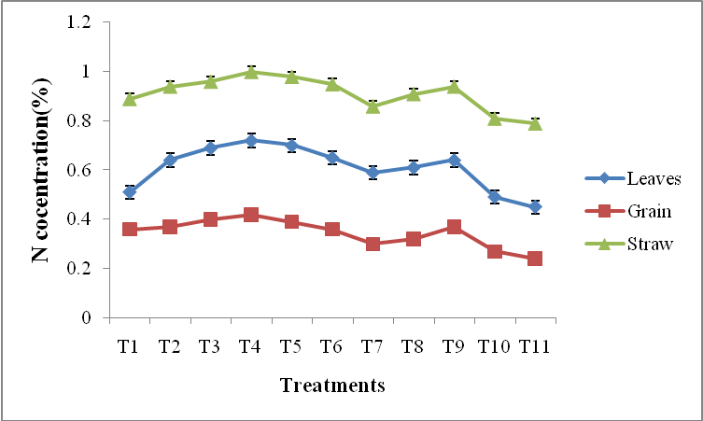

**Figure 1. Effect of copper application on Nitrogen concentration (percentage) in different plant parts of rice** (Bars represent Mean values ± Standard error of means of nitrogenconcentration)

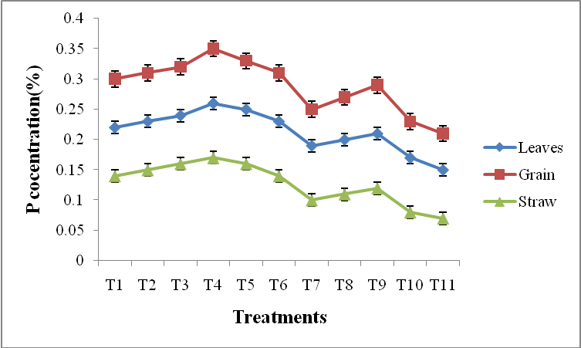

**Figure 2. Effect of copper application on phosphorus concentration (percentage) in different plant parts of rice** (Bars represent Mean values ± Standard error of means of phosphorus concentration)

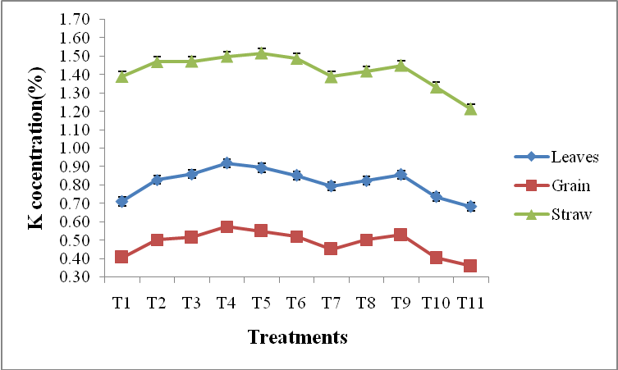

**Figure 3. Effect of copper application on potassium concentration (percentage) in different plant parts of rice** (Bars represent Mean values ± Standard error of means of potassium concentration)

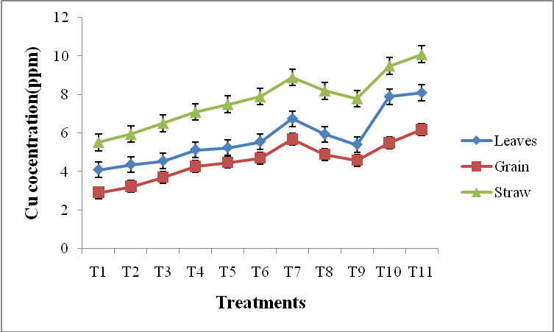

**Figure 4. Effect of copper application on copper concentration (ppm) in different plant parts of rice** (Bars represent Mean values ± Standard error of means of copper concentration)

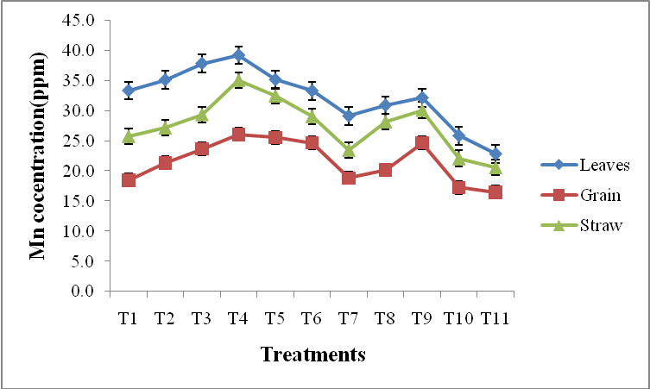

**Figure 5. Effect of copper application on manganese concentration (ppm) in different plant parts of rice** (Bars represent Mean values ± Standard error of means of manganeseconcentration)

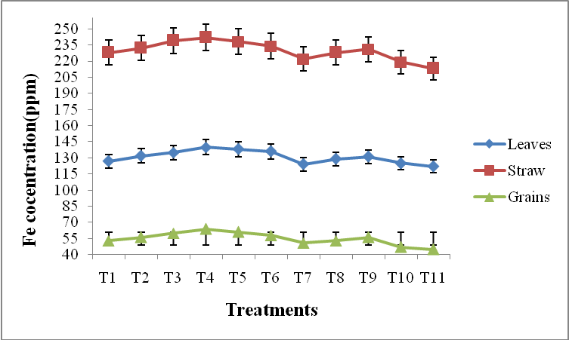

**Figure 6. Effect of copper application on iron concentration (ppm) in different plant parts of rice** (Bars represent Mean values ± Standard error of means of iron concentration)

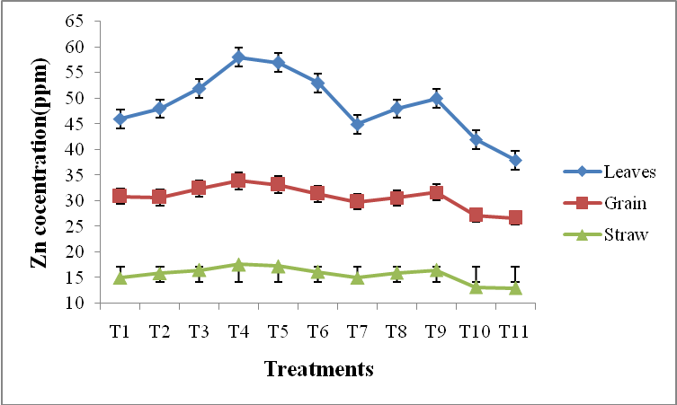

**Figure 7. Effect of copper application on zinc concentration (ppm) in different plant parts of rice** (Bars represent Mean values ± Standard error of means of zinc concentration)