Madras *Agric.J.,* 2021; doi: 0.29321/MAJ.10 OOOXXX

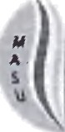

1. **RESEARCH ARTICLE**
2. Antifeedant and Insecticidal Effect of Hexane Botanical



1. **Diamondbach moth (DBM), P/vte/la zy/oste//a L.**

4

5



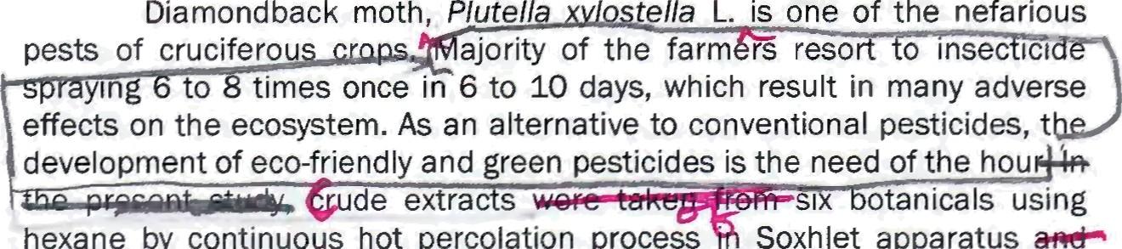

Diamond back moth, *Plutell*

*ella* L. is one of the nefarious

pests of cruciferou ajority of the farm rs reso o inse ici in to times once in 6 to 10 days, which result in many adverse

effects on the ecosystem. As an alternative to conventional pesticides, t development of eco-friendly and green pesticides is the need of the hou

de extra s

hexane by continuous hot percolation process

si otanicals using

Soxhlet apparatus

evaluated for their effect on larval mortality, antifeedant and growth and

development of second instar larvae DBM,}/' The results revealed that the antifeedant index of Sesbania *grandiflora* 5% exhibited 20.82% followed by Swietenia *macrophylla* 5%, which had 15.61%. The larval mortality and adult emergence S. grand/f/ora exhibited (66.67% and 33.33%) after 72 h of feeding on treated leaf. It was statistically on par with S. *macrophylla,* which had 63.33% larval mort§tity and 36.67% adult emergence. With regard to developmental period of life stages, no significant difference was observed among the treatments. However, all the treatments were significantly superior over untreated chech in prolonging the developmental period of DBM. It is concluded that the S. *grandiflora* and S. *macrophylla* hexane leaf extract 5% are promising botanicals against *P. xylostella,* as they possess insecticidal, antifeedant and growth inhibitory activity. These results open up the scope for further isolation of bioactive compounds and validation under field conditions, which would lead to formulation development, ultimately it can be incorporated as ecofriendly component in the integrated pest management strategies.

1. **KEYWORDS:** Diamondback moth, Hexane, botanicals, Soxhlet extraction, antifeedant, toxicity, growth
2. inhibitory

# INTRODUCTION

1. India ranks send largest producer of cruciferous vegetables in the world. They are prone for infestation
2. by a nuder of insect pests, among them, Diamond back moth (DBM) is the most destructive pest

.(Fletcher, zei4 . Heavy population of this insect can n inflict more than 90% crop loss. Management of

\2 DBM costs US60.77 billion annually (Li et Majority of the cabbage farmers are using

\3 insecticides like quinalphos, chlorpyriphos, profenophos, cypermethrin, lambda-cyhalothrin,

1. chlorantraniliprole and flubendiamide eith calendar-based spraying or routine spraying at an interval
2. of 6 to 10 days for 6 to 8 times (Deore *e*t^*al.,* 2017). It is well known that DBM has developed resistance to
3. a lot ethylaof synthetic insecticides, has led to insecticide resistance, pest outbreaks, undesirable
4. environmental effects (Negahban et *al.,* 2006). Botanical-based products are environmentally safe
5. alternative in t place of harmful chemicals. They are inexhaustible source of structurally diverse
6. biologically Ave substances and approximately 1800 plants with insecticidal properties were reported by
7. Grainge et”aI. (1984). Bioactive compounds in plants have complex combination of behavioural and
8. physiological effects and make the insects difficult to evolve resistance to them. *Sesbania grandiflo* 0%
9. aqueous leaf extract was reported to possess insecticidal activity against *P.* xy/oste//a (Sang5vi and
10. Edward, 2017). With this bachground, the laboratory screening of hexane extracts of six different
11. botanicals was done against *P. xylostella* larva, to evaluate their effect on larval mortality, antifeedant
12. index and growth and development.

Tssue xxxxx | 1



## MATERIAL AND METHODS

1. The laboratory experiment was conducted to evaluate the effect of six botanicals against *P.*
2. xy//oste/la at Natural Pesticides Laboratory, Department Of Agiultua **Enomoogy, Agiukua** Colege
3. and Research Institute (AC&RI), Tamil Nadu Agricultural Universit Madura d (
4. botanicals selected for the evaluation were unripen fruits Of neem, *Azadirachta indica* (Meliaceae);
5. oleander leaves, *Nerium oleander* (Apocynaceae); plumeria leaves, *Plumeria rubra,* (Apocynaceae);
6. humming bird tree leaves, *Sesbania $randiflora* (Fabaceae); mahogany leaves, Sw/etenia *macrophylla*
7. (Meliaceae); marigold leaves, *Tagetus erecta* (Asteraceae).
8. *Preparation of botanical* **extracts**
9. The botanicals were collected from the fields of AC & RI, Madurai, Tamil Nadu. The collected plant



1. samples were shade dried for 15 days and then powdered using mechanical blender; Sieve no. 40. was
2. used to achieve uniform size fine powder and then the powder was stored in amber colored bottles to
3. prevent the sunlight exposure. The hexane extract was taken by continuous hot percolation process in
4. Soxhlet apparatus. Powdered botanical samples (10g) were packed in cellulose thimble and subjected for
5. extraction with hexane, a non-polar solvent, at 45°C for 8 hours, i.e., until the solvent extracts all the
6. bioactive compounds completely and visibly clear. The temperature was adjusted below the boiling point of
7. hexane. The solvent extract was filtered through Buchner funnel using Whatman No.1 filter paper and
8. condensed in Rotary Flash Evaporator at 45°C under reduced pressure to obtain the crude extract, which
9. was weighed, to estimate the recovery percentage of each botanical.
10. *Evaluation of* insect/cfda/, antifeedant *and growth Inhibitory* effect *of botanica/s*
11. A laboratory bioassay was carried out under no choice condition by standard leaf disc dip method.
12. Fresh leaves were collected from cauliflower plants grown without any insecticides spray, under controlled
13. conditions. The leaves were washed with distilled water and leaf discs were cut (5 cm dia) followed bj• air
14. drying for 30min. The leaf discs were dipped in 5o/• test solution for about 30 seconds, to facilitate uniform
15. 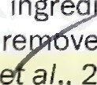treatment of active ingred ent. The leaf discs were slantly placed for about 2 minutes in a tray containing

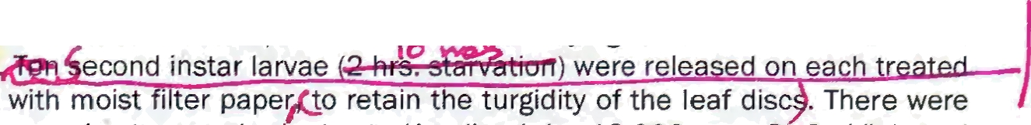

1. blotting paper to re ve excess solution and then allowed f r ir drying about 30 min. at room



1. temperature (Ingle a/., 2017) econd instar larvae were relea ed on each tr
2. disc in a plastic container lined with moist fi ter pape o retain the turgidity of the leaf disc . There were
3. nine treatments including sol t heck standard check (Azadirachtin 10,000ppm @ 2ml/It.) and
4. untreated check and replicated e arvae were allowed to feed on the treated leaf disc daily and
5. observations were recorded until adult emergencer Uh

57 

1. Antifeedant index (AI) was estimated using the formula, AFI = [(C-T)/(C+T)J* 100 Where, C= Leaf area
2. consumed in control; T= Leaf area consumed in treatment (Sadek, 2003) by the observations taken on leaf
3. area fed after 24, 48 and 72 hours of treatment. Every 24hrs interval larvae were observed for any
4. mortality, malformations till adult emergence. Larval and pupal developmental period, adult life span and
5. the number of pupa and adults emerged were monitored and recorded. Using the collected data, the per
6. cent larval mortality and adult emergence were estimated.
7. Data analysis
8. Antifeedant data were arc sine transformed and statistically analyzed using AGRES software with means
9. separated by LSD (p=0.05). Developmental period (square root) and larval mortality, adult emergence data
10. were arc sine transfprmed and statistically analyzed using SPSS 22 version (IBM Crop. Released 2013)
11. software to car ut ANOVA and grouping were done by using Duncan’s Multiple Range Test (DMRT)

€9 (Gomez and omez, 1984).

1. RESULTS AND DISCUSSION
2. The recovery yields (%) of the test botanicals were ranged from 6.20 to 8.92 per cent. The
3. recovery per cent is presented in descending order *viz., P. rubra* (8.92o/ ), *A. indica* (8.4 , S. *macrophylla*
4. (7.90o/ ), *N. oleander* (7.85oé), T. erecta (7.34%) and S. *grandiflora* (6.20%). Rohmah e'f a/., (2020) reported
5. that the n-hexane extracts of S. grandif/ora leaves yield 3.43% of dry weight.
6. Antifeedant effect of hexane extracts of botanicals
7. The result of leaf disc dip bioassay on antifeedant activity is presented in Fig. 1. When the larvae
8. were exposed to S. *grandiflora* 50/ treated leaf, the area of leaf fed by the larva was minimum, with
9. 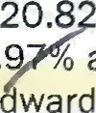antifeedant index of 20.8 % after 72hrs. At the same time, Azadirachtin 10000 ppm (treated check) at
10. 2ml/It. registered 34. é antifeedant index. The antifeedant activity was declined over time from 24 h to
11. 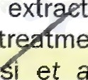72 h. Sangavi and E ward (2017) also reported that s. *grandiflora* 10% aqueous leaf extr s showed
12. 52.31% antifeedant activity on *P. xylostella* after two days of treatment. The next best tr ment was S.
13. *macrophylla* which exhibited moderate antifeedant activity (15.61%). Moghadamtou i et *al.* (2013)

reported that S. *macrophylla* ethyl acetate extracts of seeds showed good antifeedant activity against

1. fourth instar larvae of *Spodoptera fru$lperda.*
2. The class of compounds which impede insect feeding are antifeedants. They are not intended for
3. direct killing of the insects, but when the insect do not feed, ultimately it results in death of insects. The
4. secondary metabolites exhibiting antifeedant activity are grouped into major four **classes** *viz.,*
5. 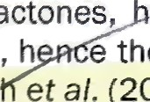sesquiterpene lactones, eterogeneous flavonoids, quassins, and limonoids. They are aded dl
6. 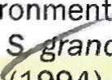after application, h e they do not / cause little impact on the environme (Li ef al., '2005). Bahera *qfi fil.*
7. (2012) and Wag et *al.* (2009) reported the phytochemical profile of *ndiflora* as alkaloids, flavonoids,
8. saponins, glycosides, cardiac glycosides, tannins and phenols. Reed (1994) reported that the high content
9. of condensed tannins affects the palatability, hence the presence of condensed tannins in S. *grandiflora*
10. might have been responsible for their antifeedant activity. According to Akhtar et *at.* (2008), the
11. insecticidal activity of plant derived extracts showed the antifeedant activity against most of the
12. lepidopteran insects.

60.00 a

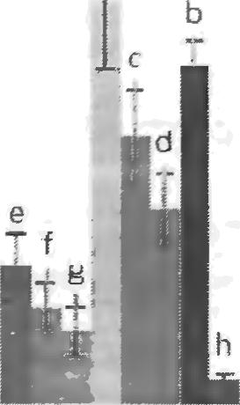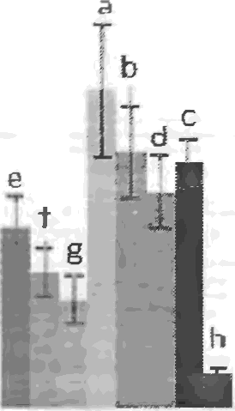**SO.OO**

Antifeedant Index (%)



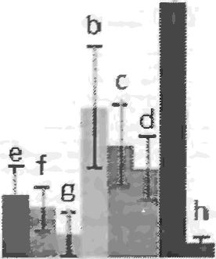30.00

# to no

* *A. iridi’co*

*'fi. gzandiflora a 5. mac:rophj/f/a* w Peserta

W **Trcatc** d chc ck

O.OO

96

24hn 48hrs

## Hours After Treatment



72hrs

1. Fig1. Antifeedant effem of hexane extracts of botanicals against *P.* xyfoste/la
2. Insecticidal and groMh inhibitory effect of hexane extracts of botanicals

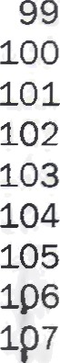Developmental period of life stages, larval mortality and adult emergence percentage of *P.* xy/ostef/a was recorded and presented in table 1. The treated check with azadirachtin 10O00ppm at 2mI/It. left no larvae alive. Highest larval mortality percentage was observed in S. *$ iflora* (66.67%) and

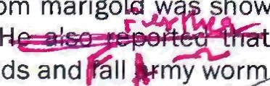*S. macrophylla* (63.33%). These findings are supported by the report of Elango *eral.,* (2011). Wagh et a/. (2009) reported that S. *grandiflora* contains plenty of seco ry metabolites viz., sterols, saponins and tannins, responsible for its insecticidal property. Ravikum&F(2010) also reported that the phytotoxin, alpha terthienyl from marigold w hown to be extremely insecticidal against mosquitoes but not on non-target organisms. , the hexane extracts of *T. erecta* showed better insecticidal property

a g n st n

1. ah a+ dnd Ku aesan 20 I doted the GOMS anaysis resuG as the methanoic leaf '
2. 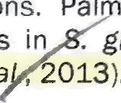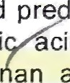extract of S. *$randiflora* were mainly composed of oxygenated hydrocarbons and pre ominantly phenolic HO hydrocarbons. Pal itic acid (11.8%), 9-hexadecenoI (9.0%) and Octadecanoi acid we



1. compounds in . *$randiflora* that possessed pesticidal activities (Gopalakrish an and a el, 2011;
2. Geetha et *a ,* 2013).

 Table 1. Impact of plant extracts using hexane on developmental period, larval mortality and

1. adult emergence percentage in *P.* by/oste/la.

Treatments Mean developmental period (days)*

Larva Pupa Adult life span

Cumulative Adult larval mortality emergence

## ( •)’ (')’

|  |  |  |  |  |
| --- | --- | --- | --- | --- |
| T -A. ***Indica*** 12.33+0.11 | 4.67+0.11 | 6.0010.19 | 43.3310.11 | 56.6710.11 |
| (3.51)a | (2.16)a° | (2.45)b | (41.17)a | (48.83)d |
| Tz-/V. o/eander 12.67+0.11 | 4.67+0.11 | **5.6710.22** | **53.33+0.11** | 46.6710.11 |
| (3.56)a | (2.16)a* | (2.38)b | (46.91)« | (43.09)« |
| Ta-P. *rubra* **12.33+0.11** | 4.00+0.00 | 6.3310.11 | 46.6640.11 | 53.331-0.11 |
| (3.51)b | (2.00)°^ | (2.52)°‘ | (43.O9)d | (46.91)d |
| T‹-S. *gran0iflora* 13.33+0.11 | 5.331-0.11 | 5.3310.11 | 66.671:0.11 | 33.3310.11 |
| (3.65)a | (2.31)b | (2.31)b | (54.74)a | (35.26)a |
| Ts-S. *macrophylla* 13.33+0.11 | 5.00+0.00 | 5.67+0.11 | 63.33:k0.11 | 36.67+0.11 |
| (3.65)b | (2.24)a | (2.38)b | (52.73)a | (37.27)b |
| Te-7. erecta 12.3310.11 | 5.33+0.11 | **6.33+0.11** | 56.6740.11 | 43.33+0.11 |

### T7-Treated check*

|  |  |  |  |  |
| --- | --- | --- | --- | --- |
| (3.51)a | (2.31)b | (2.52) | (48.83)« | (41.17)• |
| 0.00+0.00 | 0.OO+0.00 | 0.O0*0.OO | 1O0iO.00 | 0.OO*0.OO |
| (0.71• | (0.71 a | (0.71) | (90.00) | (4.05)° |
| 10.67+0.11 | 3.67+0.11 | 7.67+0.11 | 0.0040.00 | 10040.00 |
| (3.27)« | (1.91)d | (2.77) | (4.05)e | (90.00)° |
| 10.67+0.11 | 3.67+0.11 | 8.00+0.00 | 0.00+0.00 | 100+0.00 |

(Azadirachtin 1 o4)

### Ts-Solvent check Te-Untreated check

|  |  |  |  |  |  |
| --- | --- | --- | --- | --- | --- |
|  | (3.27)* | (1.91)d | (2.83)d | (4.O5)e | (90.00)° |
| SEd | 0.062 | 0.087 | 0.110 | 0.351 | 0.386 |

1. # 100% mortality of larvae observed after 7 days after treatment, hence developmental period was not
2. presented
3. Mean values of three replications are represented as mean I: standard deviation; *Figures in the
4. parentheses are square root transformed values ( -I- 0.5): SFigures in the parentheses are arc sine
5. transformed values (x+0.5); in a column, the mean followed by the same letter are not significantly
6. different from each other, DMRT (p fi 0.05); SEd: Standard Error of the difference.
7. Adult emergence was observed in all the treatments with no pupal mortality and malformations.
8. There was no significant difference among the treatments regarding the developmental period (days) of
9. different life stages but all the treatments were significantly superior over untreated check. There are
10. evidences for the reduction in growth and fecundity, when the insect feed on the dietary tannins. Normally
11. tannins bind with the proteins, hence, they affect insect growth and development, thereby reducing the
12. nutrient absorption efficiency resulted in growth retardation. As S. *@randiflora* and S. *macrophylla*
13. evidenced to possess tannins, this might be the reason for growth inhibitory effect, which would have
14. resulted in prolongation of developmental period and mortality.
15. **CONCLUSION**
16. Knowledge pertaining to this study provides the information about plants having anti insect activity. It is
17. concluded that S. *grandiflora* and S. *macrophylla* plant hexane extracts have potential for the development
18. of new and safe control products for *P. xylostella. Ns* naturally occurring insecticides, it could be useful as
19. an alternative for synthetic pesticides. It may be used as eco-friendly and sustainable insecticide.

# Funding and Acknowledgment p

1. The authors are thankful to the Department of Entomology, Ange is i u e,
2. Madurai, TQ for providing facilities to conduct this research.

# REF ENCES

1. htar, Y., Yeoung, Y.R. and M.B. Isman. 2008. Comparative bioactivity of selemed extrams from Meliaceae
2. and some commercial botanical insecticides against two noctuid caterpillars, *Trichoplusia ni*
3. and *Pseudaletia unipuncta. Phytochem.* 'ev., 7(1): 77-88.

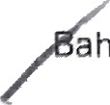

1. ahera, M., Karki, R. and C. Shekar. 2012. Preliminary phytochemical analysis of leaf and bark
2. methanolic extract of Sesdania *$randiflora. Int.1. Phytopharm.,* 1(2): 10-20.
3. eore, B.D., Saindane, Y. and S. Patil. 2017. Insemicide usage pattern in cabbage against diamondback
4. moth, P. *xylostella. Biosci Trends.,* 10(14): 2487-2490.
5. tango, G., Rahuman, A.A., Kamaraj, C., Bagavan, A. and A. Zahir. 2001. Screening for feeding deterrent
6. activity of herbal extracts against the larvae of malaria vector *Anopheles subpictus. Parasitol*

147 ftes.. 109:715.

1. etcher, T.B. 1914. Some South Indian Insects. Superintendent Government Press, Madras, p. 565.

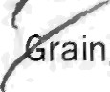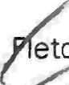

1. rainge, M., Ahmed, S., Mitchell, W.C. and J.W. Hylin. 1984. Plant species reportedly possessing pest-
2. control properties-A database. Resour. Sys. Inst., East-West Cent., Honolulu, Hawaii, USA, p. 240.
3. etha, D.H., Rajeswari, M. and J. Indhiramuthu. 2013. Chemical profiling of *Elaeocarpus* serratus L. by
4. GC-MS. *Asian Pac. J. Trop. Biomed.,* 3(12): 985-987.
5. „••Gomez, K.A., and A.A. Gomez. 1984. Statistical procedures for agricultural research: John Wiley & Sons. p.

154 680.

1. /GopaIakrishnan, S. and E. Vadivel. 2011. GC-MS Analysis of some bioactive constituents *of Mussaenda*
2. /’rondosa Linn. *Int.1. Pharm. Bio.* Sci., 2(1): 313-20.
3. sain,

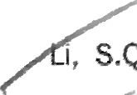

u e

*lid/anda* .*

aat2 I :, 9MS3

udies and phytochemical screening of Sesbania

1. ngle, K.P., Deshmukh, A.G., Padole, D.A., and M.S. Dudhare. 2017. Screening of insecticidal activity of
2. *Jatropha* curcas (L.) against diamond back moth and *Helicoverpa armi era.* Seed 5(80): 20.
3. i, S.g., Fang, Y.L. and Z.N. Zhang. 2005. Studies and applications of botanical insect antifeedants. 162 Entomo/. *Knowledg.,* 42(5): 491-496.
4. ,ii, Z., Feng, X., et al. Liu, S.S., You, M. and M.J. Furlong. 2016. Biology, Ecology, and Management of the
5. Diamondback Moth in China. *Ann. Rev. Entomol.* 61(1): 277-296.
6. hadamtousi, S.Z., Goh, B.H., Chan, C.K., Shabab, T. and H.A. Kadir. 2013. Biological activities and
7. " phytochemicals of **Swietenia** *macrophylla.* Mo/ecu/es, 18(9): 10465-10483.
8. egahban, M., Moharramipour, S. and F. Sefidhon. 2006. Insecticidal activity and chemical comp tion
9. of Artemisia sieben besser essential oil from Karaj, Iran. 1. Asia *Pac.* Entomol., 9(1): 61-66.

1.69 Ravikumar, P. 2010. Chemical examination and insecticidal properties of *Tayetes* erecta and *Ta$etes*

1. *patula. Asian 1. Biol.* Sci., 5(1): 29-31.



1. eed, J.D. 1994. Nutritional toxicology of tannins and related polyphenols in forage legumes. 1. *Anim.* Sc/., 172 34: 82-93.
2. Rohmah, J., Saidi, I.A., Rini, C.S., Purwanto, Z.A.P., Kiana, T.J., and T.C.R. Putri. 2020. Antioxidant activity
3. 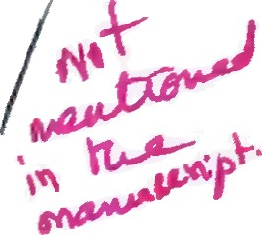assay of white Turi (Sesbania grand/f/ora (L.) extracts using DPPH radical scavenging method. 175 *Pharmacian.,* 10(3): 257-268.
4. Sadek, M.M. 2003. Antifeedant and toxic activity of *Adhatoda* vasica leaf extract against Spodoptera
5. *littoralls.1. Appl. Entomol.,* 127(7): 396-404.
6. angavi, R. and Y.J.T. Edward. 2017. Anti-Insect Activities of Plant Extracts on the Diamondback Moth,
7. *Plutella xylostella* (L.). *Int. . curr. Microbiol. App.* Sci., 6(12): 28-39.



agh,

1. V.D., Wagh, K.V., Tandale, Y.N. and S.A. Salve. 2009. Phytochemical, pharmacological and
2. phytopharmaceutics aspects of Sesban/a grand/fiora (Hadga). 1. *Pharm.* Res., 2(5): 889- 182 892.