RESEARCH ARTICLE
Use of Organic acid coated phosphatic fertilizer to improve growth and phosphorus use efficiency of brinjal

ABSTRACT
Phosphorus nutrition plays a significant role in the growth and yield of crops, but it is the most deficient nutrient in the soil. Coating of the phosphorus (P) fertilizers can control the release of nutrients and improve the efficiency. In this study organic acids such as humic acid and fulvic acid are used as the coating material for gradual release of P from the Di ammonium phosphate (DAP) fertilizer. In the present investigation, brinjal (var.CO 2) was used as the test crop.he study emphasizes enhanced phosphorus use efficiency (PUE) along with improved growth of brinjal at different rates of organic acids (Humic acid and Fulvic acid) coated DAP in comparison with uncoated DAP. In the incubation experiment the release pattern of P in soil from different coating concentrations (0, 5, 10, 15, 20%) was tested under controlled condition and the growth and PUE were tested under field conditions. Results showed that at 60 days of incubation T9 (20% HA coated DAP) showed maximum P release and the application of NK+P as HA coated DAP (20%) increased plant height, number of leaves, leaf area, dry matter production and PUE in brinjal. These results proved that organic coated DAP could be used as an effective fertilizer to improve growth and PUE in brinjal over uncoated DAP

Keywords: Humic acid, Fulvic acid, Incubation study, Growth, PUE

INTRODUCTION
Vegetables constitute a significant part of human diet supplying the essential nutreints, vitamins and other vital substances required for a healthy life. Brinjal (Solanum melongena L.) is one of the most important vegetable crops having nutritional value with respect to vitamins A, C and minerals.
Fertilizers are the nutrient source which will provide sufficient nutrients for the plant growth. . Fertilizers are essential for for commercial farming and tremendous yields. Phosphorus is the main element required for the plant’s growth. P is essential for root growth; act as an energy source also. Phosphorus however commonly limits plant growth in deficient condition. The major problem in P uptake from soil by root is the very low solubility of most of the phosphorus compounds resulting in a low concentration of phosphate ions in the soil solution
PUE is very low in alkaline soil due to fixation with calcium or magnesium ions which reduces the P availability to the plants. Coating of phosphorus fertilizers with organic acids can improve the PUE without harming the environment.
Humic acids (HA) and Fulvic acids (FA) are natural biostimulants which will improve the growth of plants. The coating of fertilizers using organic acids will help in improving the fertilizer efficiency and also it will reduce the fertilizer losses. Paramasivam et al., (2015) studied the influence of humic acid on growth and yield of brinjal. Application of 75%RDF+10kg HA +0.2%HA recorded significantly higher plant height, number of branches/plant, fruit yield and total dry matter production compared to control. El-Nemr et.al (2015) showed that all morphological parameters of egg plants were improved by application of biostimulators. Humic acids acts as a soil conditioner and enhance the ability of soil to hold more nutrients which are available to plant (Iqbal and Mastorakis, 2014). Adani et.al (1998) reported that humic acid believed to increase nitrogen use efficiency and stimulated shoot and root length. Suh et al., (2014) studied the effects of foliar application of Fulvic acid on plant growth, fruit quality and yield of tomato. Different levels of Fulvic acid sprayed on plants and these treatments led to a significant increase in plant height, fresh and dry weight.
DAP is the most widespread phosphate fertilizer because of its high analysis and good physical properties. Phosphorus however commonly limits plant growth in deficient condition. The main reason for this deficiency is rapid dissolution and fixation of nutrients in the soil. For reducing P losses and to improve PUE, gradual release of P is essential. Gradual release can be promoted by coating P fertilizer . Pauly et al., (2002), assessed coated fertilizers by using various coatings to regulate release of P and to compare the growth and P uptake of barley in greenhouse. Net fertilizer P efficiency, dry matter production, P uptake, and net fertilizer release efficiency were better in coated fertilizers.
Keeping the above points the present study was undertaken to standardize organic acid coating (humic acid, fulvic acid) for phosphatic fertilizer to improve growth as well as PUE in Brinjal.

MATERIAL AND METHODS
Experimental material for laboratory studies
An incubation study was conducted to observe the P release from the HAand FA coated DAP. The experiment was conducted at Department of Soil Science and Agricultural Chemistry, Tamil Nadu Agricultural University, Coimbatore.
The coatings of phosphate fertilizers DAP (granular), using humic acid and fulvic acid with the coating percentage of 0, 5, 10, 15, and 20% were carried out. The coating was done using oil (vegetable oil) initially then with humic acid and Fulvic acid separately by physical mixing. Then the fertilizer was dried in hot water bath until the moisture was removed completely. The dried material was used for the experiment.
The soil was collected from the location of field experiment. The texture of the soil was sandy loam. The soil was low in available N, high in available P, and high in available K with EC 0.29 dS m⁻¹and pH 8.45. Disposable cups of 250 cm³ were used and each cup was filled with 100g soil. Saturation percentage of soil used was determined to maintain moisture content in cups. Coated and uncoated DAP were applied in cups with respective concentration according to the treatment schedule, and mixed with soil thoroughly. The incubation study lasted for 60 days and the samples were taken for analysis at 0.7, 15, 30, 45, &60 days.
The available soil P was estimated using 0.5M NaHCO₃ at pH 8.5 as per the standard procedure ( Olsen et.al ,1954).

Field experiment: Field experiment was conducted during winter season (October – November) at a Farmer’s field at Thondamuthur block of Coimbatore district.The experimental site is geographically located at 10°59’ N latitude and 76°49’ E longitude at an altitude of 315 m above MSL. Coimbatore recorded excess rainfall in 2019. In the four rainfall seasons, Coimbatore received 859.50mm rainfall which is 27.5% more than 50 year’s average rainfall. An amount of 450 mm of rain was received during North east monsoon season. The mean maximum and minimum temperatures were 32.5⁰C and 21⁰C, respectively. The field experiment was laid out in Randomized Block Design (RBD) and consisted of ten treatments and replicated thrice. The treatments comprised of T1: NK + P as uncoated DAP, T2:NK + P as FA coated DAP(5%), T3: NK + P as FA coated DAP (10%), T4: NK + P as FA coated DAP (15%), T5: NK + P as FA coated DAP (20%), T6 NK + P as HA coated DAP (5%), T7 : NK+ P as HA coated DAP (10%), T8 : NK + P as HA coated DAP (15%), T9 : NK + P as HA coated DAP (20%), T10 : control . Urea and MOP were used as N and K sources respectively. The coating of fertilizers was done as done for incubation study.
The main field was ploughed and ridges and furrows were formed at a spacing of 60 cm. The Brinjal (CO2) seedlings were raised in the nursery for transplanting..Transplanting of 25-30 Days old seedlings was carried out at 60 cm apart on the ridges . Recommended cultural practices such as weeding, irrigation and plant protection were preformed . Nitrogen and Potassium was applied in the form of Urea and MOP as per the fertilization schedule for Brinjal. Phosphorous was applied in the form of HA&FA coated DAP. Recommended dose of brinjal (As per STCR recommendation) is 127:37:100 kg N:P₂O₅: K₂O ha-1. The fertilizer was applied as per the fertilization schedule of Brinjal variety at different growth stages. Tewnty five days older brinjal seedlings were transplanted in the field and the observations were taken at 30 days interval. The growth and yield parameters were recorded. The cultural operations were carried out based on CPG (2012).
Five plants in each plot other than guard row were randomly selected and tagged for recording observations on growth and yield parameters. The plant height was recorded in centimeters . . Leaf area is measured by . using length and breadth values.
Five plants were taken from sampling rows for recording the dry matter production at active 30 and 60 days after transplanting and also during the harvest stage. The plant samples were collected with utmost care not to damage the roots. The samples were cleaned, separated, shade dried and then oven dried at 70 5⁰C until a constant weight is obtained and dry weight was recorded in kg.
Soil available P at each stage was analyzed for available P by using Olsen’s extractant. Total phosphorus was determined by taking a known quantity of tri acid extract of the plant and P was determined using wavelength at 470 nm of UV Spectrophotometer (Jackson,1973). PUE is related to the P sources, environmental factors and soil and crop management. It is defined as the yield increase per kilogram due to fertilizer P added.

Agronomic PUE (kg kg⁻¹) = (Fruit yield in treated plot (kg/ha) - Fruit yield in control (kg/ha))

Quantity of Nutrient applied (kg)

Statistical analysis
The data on the various characters recorded were statistically analysed under randomized block design as suggested by Gomez and Gomez (1984). In laboratory analysis data recorded were statistically analysed under Completely randomized design. Wherever the treatment differences were found to be significant (F test), critical differences were worked out at five per cent probability level (P= 0.05) and the treatment differences that were found not to be significant was denoted NS (Non- significant) in the respective tables.

RESULTS AND DISCUSSION
Results pertaining to the incubation experiment, f growth and phosphorus use efficiency of brinjal in a field experiment is given below.
Incubation study
Significant difference in Olsen’s P concentration in soil treated with coated and uncoated DAP fertilizer sources at different time intervals are shown in table 1.Soils treated with the uncoated DAP showed the highest concentration of Olsen’s P in the soil after 15 days of incubation period as compared to DAP coated with different concentrations of humic acid and fulvic acid. At 30 days of incubation period a maximum P release was recorded in 5% HA coated DAP. Decreasing trend in P release was observed in treatment with uncoated DAP. DAP coated with 5% HA&FA showed maximum P release in 30 days of incubation then showed the decreasing trend. The organic acid coated DAP shows an increasing trend in P release up to 60 days of incubation period. At 60 days of incubation T9 (20% HA coated DAP) recorded maximum P release. Among the treatments, at 60 days, uncoated DAP showed the minimum P release. Similar results were reported by Noor et.al. (2017).

Field experiment
The growth parameters obtained from the field experiment are given in table 2

Plant height
Organic acid coated DAP showed significant effect on plant height. At harvest stage maximum plant height showed by T9 (20%HA coated DAP) which recorded 91.2 cm, followed by T5 (20%FA coated DAP) with a plant height of 86.80 cm. The shortest plant were recorded in absolute control. The results revealed that organic acid coated DAP application had brought variation in plant height (Fig1) Similar results were found by El-Nemr et.al (2015), Paramasivan (2015), Azarpour et.al (2012) and Fathima et.al (2013)

Number of leaves per plant
According to data observed maximum number of leaves were observed in T9 (20%HA coated DAP) followed by T8 (15%HA coated DAP) and the least leaf count was in control. The results showed that organic acid coated phosphatic fertilizer application could improve the number of leaves in plant( Fig1) Similar results are reported by Padem et.al (1999) who observed that the addition of humic acid fertilizer improved the number of leaves in egg plant.

Leaf area
Leaf area was also significantly influenced by the application organic acid coated phosphate fertilizer. The maximum leaf area (113.05 cm²⁾ was obtained from the treatment T9 (20%HA coated DAP) followed by T8( 15% HA coated DAP) which received 102.31 cm². The lowest value (55.47 cm²) was observed from the control ( Fig1). Similar results were observed by Ruban et.al (2019).

Dry matter production (kgha⁻¹)
Considering all treatments highest dry matter production (3019.2 kgha⁻¹) was observed in T9 (20%HA coated DAP) and the least observed in control. All treatments applied with organic acid coated DAP showed high dry matter production compared to control (Fig 2). Similar results were found by Chtouki et.al (2020), Abdel-Razzak et.al (2012) and Paramasivan (2015) in brinjal.

Phosphorus use efficiency (PUE)
Effects of organic acid coated DAP on phosphorus use efficiencies are reflected from the table 3. Results showed that Agronomic efficiency (AE) is increasing with increase in the coating percentage of organic acid. Highest PUE is observed in 20% HA coated DAP (T9) which is 43.8 % higher than uncoated DAP application (Fig. 3). Similar results were observed by Chtouki et.al (2020) in calcareous soil and Noor et.al (2017).

Table 1: Effect of HA&FA coated phosphatic fertilizer on available P status (kg ha⁻¹)- Incubation study.
Tr.No | Treatments | Days after incubation
 |  | 0th day | 7th day | 15th day | 30th day | 45th day | 60th day
T₁ | NK+ P as Uncoated DAP | 36.12 | 39.48 | 47.80 | 41.78 | 37.89 | 32.90
T₂ | NK+ P as FA coated DAP (5%) | 32.69 | 35.85 | 44.12 | 49.21 | 46.12 | 42.98
T3 | NK+ P as FA coated DAP (10%) | 30.12 | 34.21 | 43.12 | 47.21 | 49.26 | 50.75
T4 | NK+ P as FA coated DAP (15%) | 28.28 | 33.26 | 44.12 | 49.02 | 51.07 | 53.49
T5 | NK+ P as FA coated DAP (20%) | 27.11 | 31.28 | 37.25 | 40.20 | 46.85 | 54.16
T6 | NK+ P as HA coated DAP (5%) | 32.16 | 36.85 | 44.22 | 49.22 | 47.22 | 44.86
T7 | NK+ P as HA coated DAP (10%) | 31.22 | 35.90 | 40.26 | 47.22 | 50.78 | 52.21
T8 | NK+ P as HA coated DAP (15%) | 29.62 | 34.74 | 41.02 | 45.22 | 51.19 | 55.85
T9 | NK+ P as HA coated DAP (20%) | 27.98 | 33.21 | 42.66 | 47.56 | 52.12 | 57.96
T10 | Control | 29.10 | 30.60 | 31.40 | 27.10 | 26.50 | 25.80
 | Mean | 30.44 | 34.54 | 41.59 | 44.37 | 45.90 | 47.09
 | SEd | 0.44 | 0.42 | 0.77 | 1.41 | 0.80 | 0.72
 | CD(P=0.05) | 0.88 | 0.86 | 1.57 | 2.85 | 1.62 | 1.46

Tr.No. | Treatments | Plant height (cm) | Number of leaves/plant | Leaf area (cm²) | Drymatter production(kg/ha)
T₁ | NK+ P as Uncoated DAP | 69.20 | 74.50 | 75.20 | 1699.1
T₂ | NK+ P as FA coated DAP (5%) | 72.35 | 78.35 | 81.52 | 1786.3
T3 | NK+ P as FA coated DAP (10%) | 78.26 | 81.23 | 87.44 | 2265.8
T4 | NK+ P as FA coated DAP (15%) | 84.32 | 84.34 | 95.52 | 2375.4
T5 | NK+ P as FA coated DAP (20%) | 86.80 | 86.85 | 96.75 | 2707.8
T6 | NK+ P as HA coated DAP (5%) | 72.35 | 73.26 | 86.9 | 2325.4
T7 | NK+ P as HA coated DAP (10%) | 79.20 | 81.50 | 98.59 | 2413.1
T8 | NK+ P as HA coated DAP (15%) | 85.45 | 88.63 | 102.31 | 2692.9
T9 | NK+ P as HA coated DAP (20%) | 91.20 | 92.87 | 113.05 | 3019.2
T10 | Control | 65.64 | 53.65 | 55.47 | 1204.3
 | Mean | 78.48 | 79.52 | 89.27 | 2248.95
 | SEd | 1.46 | 1.38 | 1.55 | 47.98
 | CD(P=0.05) | 3.08 | 2.91 | 3.25 | 100.80

Table 2: Response of organic acid-coated DAP fertilizer on growth parameters of brinjal
All treatments received 127:37:100 kg N:P₂O₅:K₂O ha⁻¹ as per soil test based recommendation . N as Urea, P as Coated DAP and K as MOP.

Table 3: Response of Organic acid coated DAP fertilizer on PUE and of brinjal (Solanum melongena L.)
Tr. No. | Treatments | Agronomic PUE(q/kg)
T₁ | NK+ P as Uncoated DAP | 24.92
T₂ | NK+ P as FA coated DAP (5%) | 28.19
T3 | NK+ P as FA coated DAP (10%) | 27.57
T4 | NK+ P as FA coated DAP (15%) | 29.23
T5 | NK+ P as FA coated DAP (20%) | 31.73
T6 | NK+ P as HA coated DAP (5%) | 23.69
T7 | NK+ P as HA coated DAP (10%) | 31.27
T8 | NK+ P as HA coated DAP (15%) | 33.82
T9 | NK+ P as HA coated DAP (20%) | 35.84
T10 | Control | -

All treatments received 127:37:100 kg N:P₂O₅:K₂O ha⁻¹ as per soil test based recommendation . N as Urea, P as Coated DAP and K as MOP.

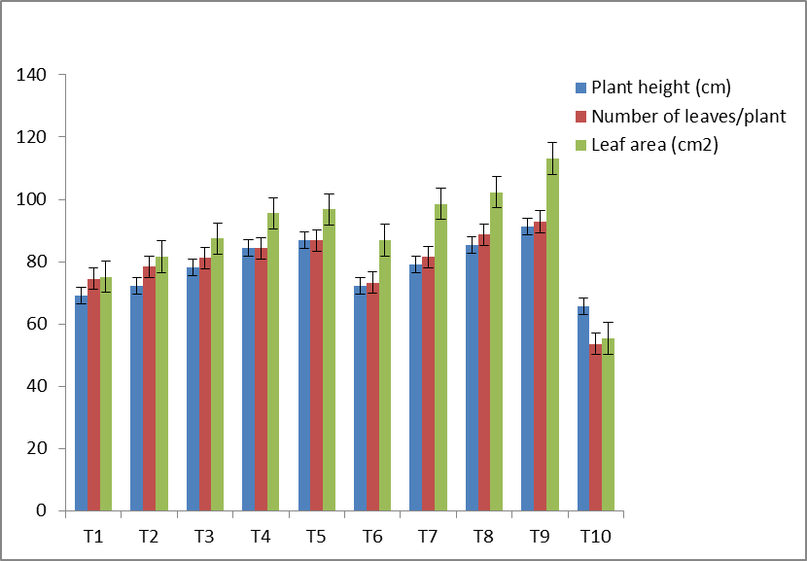
Figure 1. Response of organic acid-coated DAP fertilizer on plant height, number of leaves/plant and leaf area of brinjal

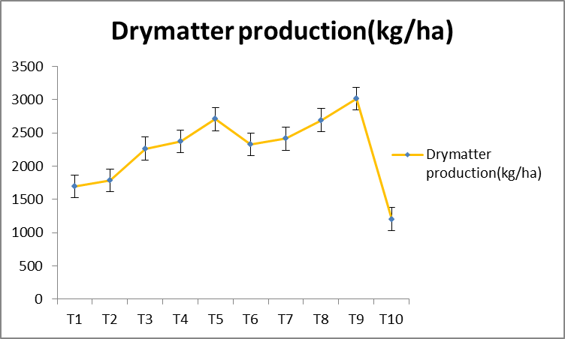
Figure 2. Response of organic acid-coated DAP fertilizer on dry matter production of brinjal

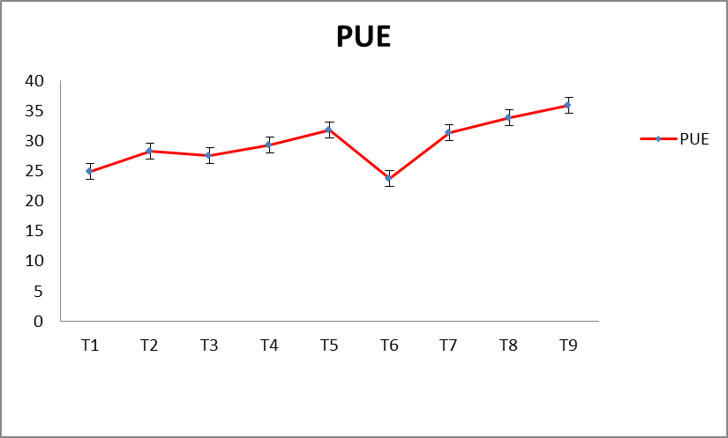
Figure 3. Response of organic acid-coated DAP fertilizer on PUE of brinjal.

CONCLUSION
The organic acid-coated phosphate fertilizers are superior over uncoated DAP in achieving phosphorus release, growth and agronomic phosphorus use efficiency in brinjal. Among the organic acid-coated treatments, 20% HA coated DAP showed the best results in vegetative production and phosphorus use efficiency. In incubation study also organic acid coated phosphatic fertilizer showed higher P release than uncoated DAP. Hence, the present study revealed that organic acid-coated phosphate fertilizer can be safely used within the applied concentrations with a positive effect on growth, P release and PUE. .

REFERENCES
Abdel-Razzak, H.S. and G.A. El-Sharkawy. 2012. Effect of Biofertilizer and Humic Acid Applications on Growth, Yield, Quality and Storability of Two Garlic(Allium sativum L.) Cultivars. Asian Journal of Crop Science, 5(1):48-64.
Adani, F., Genevini, P., Zaccheo, P. and G.Zocchi. 1998. The effect of commercial humic acid on tomato plant growth and mineral nutrition. Journal of plant nutrition, 21(3):561-575.
Azarpour, E., Motamed, M.K., Moraditochaee, M. and H.R. Bozorgi. 2012. Effects of bio, mineral nitrogen fertilizer management, under humic acid foliar spraying on fruit yield and several traits of eggplant (Solanum melongena L.). African Journal of Agricultural Research, 7(7):1104-1109.
Chtouki, M., Lyamlouli, K., Oukarroum, A. and Y. Zeroual. 2020. Humic acid coated P fertilizers to improve phosphorus use efficiency in calcareous soils.
El-Nemr, M.A., El-Bassiony, A.M., Tantawy, A.S. and Z.F.Fawzy. 2015. Responses of eggplant (Solanum melongena var. esculenta L) plants to different foliar concentrations of some Bio-Stimulators. Middle East J. Agric. Res, 4(4):860-866.
Fathima, P.S. and G.R.Denesh. 2013. Influence of humic acid spray on growth and yield of chilli (Capsicum annum L.). International Journal of Agricultural Sciences, 9(2):542-546
Gomez, K.A. and A.A.Gomez. 1984. Statistical procedures for agricultural research. John Wiley & Sons.
IQBAL, S. and N. MASTORAKIS. 2014. Effect of Various Growth Mediums on the Germination and Growth of Jatropha curcas. In Proceedings of the 2nd International Conference of Geodesy & Geomatics Engineering.(GENG'14), Brasov, Romania (Vol. 26, No. 28:147-156).
Jackson, M. L. 1973. Soil chemical analysis Prentice Hall of India Pvt Ltd., New Delhi
Noor, S., Yaseen, M., Naveed, M. and R.Ahmad. 2017. Use of controlled release phosphatic fertilizer to improve growth, yield and phosphorus use efficiency of wheat crop. Pak. J. Agri. Sci, 54(4):541-547
Olsen, S.R. 1954. Estimation of available phosphorus in soils by extraction with sodium bicarbonate (No. 939). US Department of Agriculture.
Pauly, D.G., Malhi, S.S. and M.Nyborg. 2002. Controlled-release P fertilizer concept evaluation using growth and P uptake of barley from three soils in greenhouse. Canadian journal of soil science, 82(2):201-210.
Padem, H., Ocal, A. and R. Alan. 1999. Effect Of Humıc Acıd Added To Folıar Fertılızer On Qualıty And Nutrıent Content Of Eggplant And Pepper Seedlıngs. Acta Hort.(ISHS), 491:241-246.
Paramasivan, M. 2015. Studies on influence of humic acid on growth and yield of brinjal var. KKM1 in Alfisols of Tamil Nadu. Indian Journal of Horticulture, 72(3): 438-440.
Ruban, S., Priya, M.R., Barathan, G. and S.S.Kumar.2019. EFFECT OF FOLIAR APPLICATION OF BIOSTIMULANTS ON GROWTH AND YIELD OF BRINJAL (Solanum melongena L.). Plant Archives, 19(2:.2126-2128.
Suh, H.Y., Yoo, K.S. and S.G. Suh 2014. Effect of foliar application of fulvic acid on plant growth and fruit quality of tomato (Lycopersicon esculentum L.). Horticulture, Environment, and Biotechnology, 55(6):455-46

