Studies on Field Diagnostic Characters of Mealybug Species in Cassava

## Abstract

Cassava (*Manihot esculenta Crantz*) is an important tuber crop grown for food, feed and beverages. Because of its ability to grow in the soil of low organic content and produce high yield, it is considered a food security crop in African countries. Now it became the industrial crop since it' is a raw material for the production of starch, energy and live stock feed. In Tamil Nadu, it is grown in Salem, Namakkal, Erode, Cuddalore, Dharmapuri and Kanyakumari districts, both in irrigated and rainfed condition. Recently, the major constraint in cassava production are mealybug damage. The invasive mealybug species, *Phenococcus manihoti Matile-Ferrero (Pseudococcidae)* was first reported from Salem district and its occurrence was found associated with other species of mealybug. The nymphs and adult of mealybugs were collected from farmers' field in Namakkal, Salem and Tiruppur district and morphological characters were observed to identify the key characteristics of mealybug species. Among the specimens collected, the species identified with colour, wax coating and body filaments were *Ferrisia virgata, Pseudococcus jackbeardsleyi and P. manihoti. P. manihoti* differentiated from the other species with its distinct symptom of distortion of leaves at the tip (Bunchy top) and extensive honey dew secretion.

Key words: *Cassava; Mealybug species; Morphological identification*

## Introduction

Cassava is a staple food for many countries worldwide and can withstand drought and poor soil. It is not only used for starch extraction, but also used in many ways *viz.,* savouries, soup making, and deserts *etc*. In India the major cassava growing areas are in Kerala, Tamil Nadu and Andhra Pradesh .Tamil Nadu contributes 83.75 % of total production in India (APEDA,[2022](https://agriexchange.apeda.gov.in/,2022)). Sixty percent of the crop in Tamil Nadu are in irrigated condition, and rainfed crop is forty percent. One of the major constraints in cassava production was insect pests infesting cassava crop. The important pests of cassava in Asia are whiteflies (*Bemisia tabaci Gennadius*), mealybugs (*Phenococcus manihoti Matile-Ferrero*) and red spider mites (*Tetranychus urticae* Koch) (Supartha *et al.,* 2022). Mealybugs are polyphagous and cause economic damage to several crops. It is reported in many hosts crops *viz.,* Poacea, Asteraceae, Fabaceae, Rosaceae, Rubiaceae, Euphorbiaceae, Myrtaceae, Labiatae, Moraceae and Cyperaceae and Cassava received 24 species of mealybugs (Garcia Morales *et al.,* 2016). Most of the species co existed in the cassava crop, and seasonal incidence differed with species *viz.,* regular, occasional and invasive. Among the mealybug species *P. Manihoti* native to South America attained pest status after entering Africa and it was introduced to Thrissur, Kerala, India during 2020 . It was also reported from the Salem district of Tamil Nadu (Sampath *et al.,* 2021). *P. Manihoti* occurred in cassava with other mealybug species and hence field level identity is important not only for the management of pests but also for the identification of species specific natural enemies, to study the seasonal incidence of the particular species and intensity of infestation. Apart from that, maintaining year round availability of insect culture (live repository) plays a key role in students' research and production of biological control agents. Hence, the present study was conducted to identify the different species of mealybug in cassava for maintaining type species of mealybug in the laboratory.

## Materials and Methods

Mealybugs were collected from Rasipuram and Kalkurichi of Namakkal district, Vennandur of Salem District and Madathukulam of Thiruppur district. Under stereo zoom binocular microscope (LEICA M205C) observation was made on colour, presence or absence of posterior and lateral filaments and presence or absence of wax coating on the cuticle, which are the key characters for the field level identification of mealybug species (Sunil Joshi *et al.,*2021). At the field level, the typical symptom of bunchy top was documented.

## Result and Discussion

The mealybug species were identified by morphological characters *viz.,* colour, presence or absence of mealy coating, anal filament, and lateral body filaments. It was found that *Ferrisia virgata* (Cockerell), *Pseudococcus jackbeardsleyi* Gimpel and Miller and *P. manihoti* are co existed in cassava plant.

*F. virgata*: Adult female is dull yellowish orange,which later turns brownish, absence of mealy coating on thorax and abdomen (definite paired patches on thorax and abdomen) and pair of stout posterior filaments. The length of the body is 2.03 mm and the posterior filament length is 0.84 mm (Fig. 1). This was confirmed with Ariane and Amanda (2017) who described that *F. Virgata and it* is named as striped mealybug because of the presence of two dark dorsal longitudinal stripes on the body which is visible as bare patches on the cuticle and has two posterior wax filaments with a length of half of the body length. Kaydan and Gullan (2012) detailed that the genus *Ferrisia* can easily be distinguished from other taxa of mealybugs with the presence of dark dorsal areas because of absence of wax. *F. virgata* in cassava was reported by Sunil Joshi *et al*. (2021).

*P. jackbeardsleyi*: Colour of the adult female is light yellow to reddish-orange. Presence of two broad dorso medial lines and two thin submarginal lines. Filaments are of two pair of posterior filaments and long lateral filaments. The first caudal pair is longer than the body, and the next pair is the half length of the first pair. Lateral filaments length equals body width (Fig. 2). Mani *et al*. (2013) described that *P. jackbeardsleyi* is characterized with thin filaments around the body and caudal pair of one-half length of body. Sunil Joshi *et al*. (2021) narrated the filaments of *P. Jackbeardsleyi* which is in accordance with the present study.

*P.manihoti*: The adult female is rosy pink to yellow with clearly visible segmentation. The wax filaments are not well developed in lateral and posterior regions which gives marginal wavy appearance to the body (Fig. 3). Sunil Joshi *et al*. (2021) detailed that *P. manihoti* is characterized with poorly developed caudal and lateral filaments.

At severe infestation level of *P. manihoti*, the mealybugs were found in all parts of the plant *viz.,* twigs, stem, and base of the leaves. Most of the time, the occurrence was in terminal portion of the plant and caused stunted growth, distortion of leaves and bunchy top appearance which was evidenced by Supartha *et al.*(2022). It was also observed that *P. manihoti* secretions were much extensive and caused more sooty mould development and defoliation of the leaf extensively (Fig. 4).

The collection and identification of mealybug species in cassava registered the presence

*F. virgata*, *P.jackbeardsleyi* and *P. manihoti* in cassava.

## Conclusion

The identified mealybug species in cassava in three different locations of Tamil Nadu were *F. virgata*, *P.jackbeardsleyi* and *P. manihoti*. This field-level identification was used to maintain the year-round culture availability in the laboratory and is being used by the students' research *viz.,* predator's potential on mealybug, the toxicity of insecticides against mealybug which is in need of species confirmation. Further, to maintain the type specific culture molecular characterization and deposit of culture may be followed.

## Acknowledgement

The authors greatly acknowledged the help rendered by Insect Museum, TNAU, Coimbatore for the identification of the specimen.

## Ethics statement

No specific permits were required for the described field studies because no human or animal subjects were involved in this research.

## Originality and Plagiarism

I ensure that this is the original work carried out as a part of University Sub Project and the manuscript is written by own.

## Consent for publication

All authors agreed to publish the content

## Competing interests

There were no conflicts of interest in the publication of this content.

## Authors contribution

Collection, identification and maintaining mealybug culture – KP, Collection of mealybug culture – SK, Identification of mealybug culture – PSS, NC, KB, Initial field survey and collection of mealybug culture – SVK, Writing original draft – KP, Writing – reviewing & editing - KP

## References

Ariane, M. C. and Amanda, H. 2017. Striped Mealybug *Ferrisia virgata* Cockerell (Insecta: Hemiptera: Pseudococcidae). *EENY674, Series of the Department of Entomology and Nematology*, UF/IFAS Extension. [*http://edis.ifas.ufl.edu*](http://edis.ifas.ufl.edu).

Garcia Morales, M., Denno, B. D., Miller, D. R., Miller, G. L., Ben-Dov and N.B. Hardy. 2016. Scale Net: A literature – based model of scale insect biology and systematics. *http://scalenet.info.*

Kaydan, M. B. and P. J. Gullan. 2012. A taxonomic revision of the mealybug genus *Ferrisia* Fullaway (Hemiptera: Pseudococcidae), with descriptions of eight new species and a new genus. *Zootaxa*, **3543**: 1–65

Mani , M., Sunil Joshi. , Kalyanasundaram , M., Shivaraju , C., Krishnamoorthy , A., Asokan, R. and K. B. Rebijith. 2013. A New Invasive Jack Beardsley Mealybug, *Pseudococcus jackbeardsleyi* (Hemiptera: Pseudococcidae) on Papaya in India. *Fla. Entomo.*, **96(1)**:242-245.

Sampathkumar ,M., Mohan, M., Shylesha, A. N., Sunil Joshi., Venkatesan, T., Ankita Gupta , Vennila, S., Venkatachalam, S. R., Vijayakumar, M., Madhu Subramanian., Yoganayagi, M., Ashika, T. R. and N. Bakthavatsalam. 2021. *Curr. sci.*, **120** **(2)**: 432-435.

Sunil joshi., Madhu Subramanian., Smitha revi., Sampath kumar, M. and M. Mohan. Identification keys to live and mounted mealybug (Hemiptera: pseudococcidae) species associated with cassava in India and their present distribution. *Pest manage. hortic. ecsyst.,* **27(2)**: 114-127.

Supartha, I. W., Widaningsih, D., Susila, I. W., Wisma Yudha, I. K., Eka Karya., I. W. and U. P. A. Wiradana, 2022. Range of host plants, spatial distribution and insect predator of *Phenacoccus manihoti* (Hemiptera: Pseudococcidae) as an emerging pests of cassava plants in Bali, Indonesia, *Biodiverse.*, **23(6)**: 3022-3030.

<https://agriexchange.apeda.gov.in/>

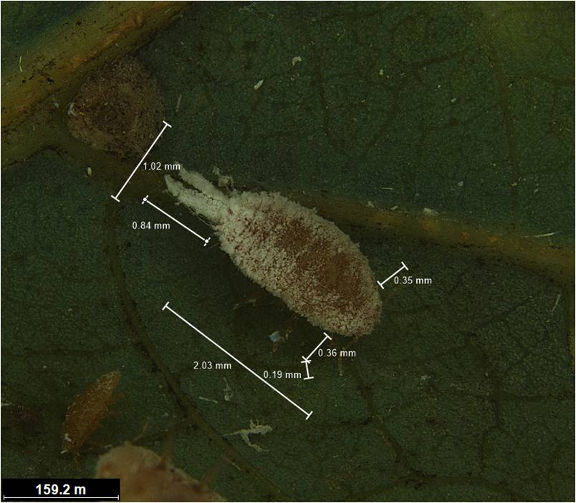

Fig. 1 *Ferrisia virgata*(Cockerell)

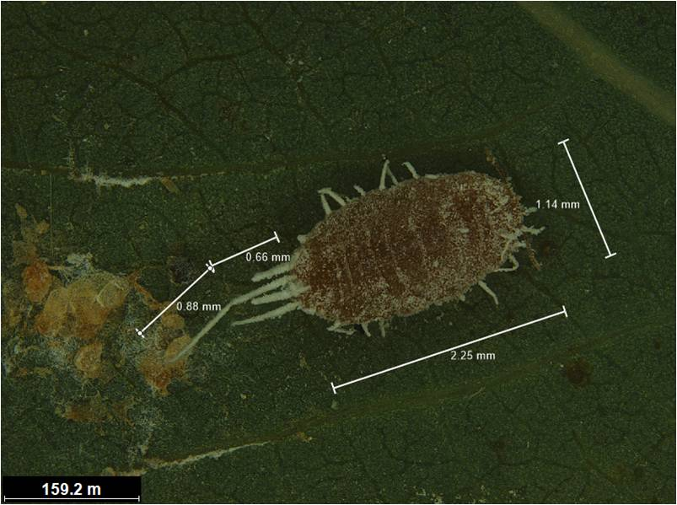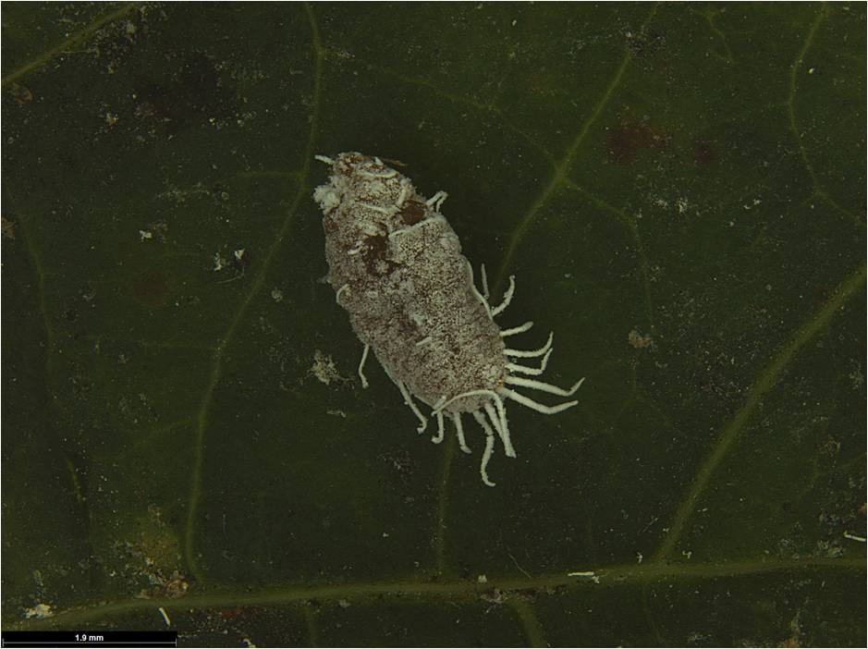

Fig. 2. *Pseudococcus jackbeardsleyi* Gimpel

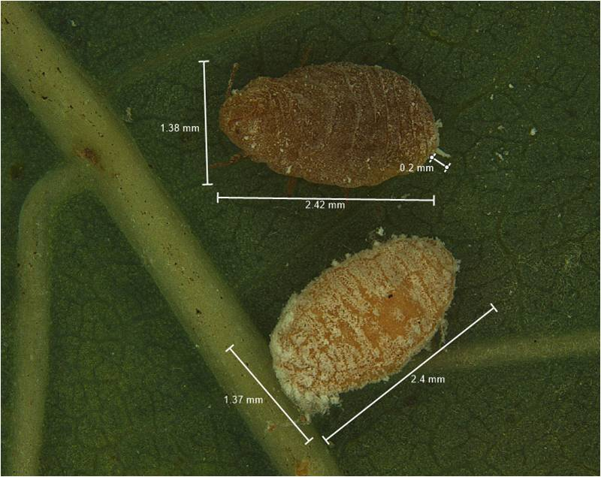

Fig. 3. *Phenococcus manihoti Matile-Ferrero*

Fig. 4. Symptom of damage by *P. manihoti*

