**RESEARCH ARTICLE**

**Influence of rainfall deviation on Onion (*Allium cepa* var. *aggregatum*) productivity over Tamil Nadu**

|  |  |
| --- | --- |
|  | ABSTRACT Agriculture proves to be the life supporting business of mankind, where not only for food but the raw material for any industry is being generated. Owing to several crops in the sector, vegetable crops are vital in everyday need, especially the role of onion in Indian cuisine is inevitable. The crop possesses such an importance every year with the up surging prices to have a potential influence on policy makers of the Government. Research on the productivity of onion in Tamil Nadu during recent decades might help to understand it performance under rainfall variability. The trend of small onion productivity over Tamil Nadu was found to be in increasing phase. Tamil Nadu has been a Moderate Productive Region for small onion, where Western Zone is the only High Productive Region among all other Agro Climatic Zones. From the analysis of rainfall deviation on small onion productivity, could be understood that there is a negative correlation between them with a correlation coefficient of – 0.14. The negative relationship between rainfall deviation and small onion productivity reveals that whenever there is more rainfall than normal, the productivity will surely be affected. It was also observed that rainfall deviation was able to influence the small onion productivity by 27.2 per cent. Moreover the influential role of all other weather parameters would strengthen the knowledge about performance of small onion crop in future. |

**Keywords:** small onion, Productivity Index, Rainfall deviation, Agro Climatic Zones

## INTRODUCTION

Agriculture is the primary business in India providing food for the human life and other raw materials that is necessary for our livelihood. This backbone of our country has been forced to face the difficulties like vagaries of monsoonal rainfall, water availability, urbanization and fluctuations in market price on crop produce. Tamil Nadu holds about 70 per cent of the human resource in agricultural sector with 48.92 lakh hectares is presently under net cultivable land area (Krishnan, 2017). Annual normal rainfall of Tamil Nadu (945 mm) is supported with both South West and North East Monsoons, where the later one is the predominant rain bearer.

Onion is an important crop of Indian agriculture that proves vital for GDP. India stands second in Onion production with 15.18 lakh MT and 10.64 lakh hectare area, while the productivity is 14.2 MT/ha. Malaysia, Indonesia, Srilanka, Singapore, Philippines and Gulf countries are the major importers of Indian Onion with different packing grades. Tamil Nadu cultivates small onion during the early *kharif*, *kharif* and *rabi* seasons, which could be available during the months of August, October – November and March – April. Special markets for onion in Tamil Nadu are located at Coimbatore, Perambalur, Namakkal, Dindigul, Tiruchirappalli and Erode districts (APEDA????? year). Onion price hike crossing Rs 100/kg is being witnessed every year especially during the rainy season and 2019 did see the critical case owing to onion imports from Egypt (Economic times ????? year). This proves the mismatch between demand and supply of onion in the entire country along with the need towards better storage facilities and market regulation. Thus understanding the productivity of small onion and the influential role of rainfall deviation has been focused in this research paper for Tamil Nadu state.

## MATERIAL AND METHODS

*Productivity Index*

Productivity Index was calculated using the following formula through Enyedi’s method (Enyedi, 1966) for its accuracy

image2.png (Picture is broken, crate on your own)

Where Y – Production of the selected crops in an unit area i.e., district,

Yn – Total Production of the selected crops at the entire zone,

T – Area under selected crops in unit area,

Tn – Total cropped area in the entire zone.

***Table 1. Productivity Index Classification***

|  |  |
| --- | --- |
| **Index range** | **Classification** |
| Below 70 | Low productivity region |
| 70.1 - 104 | Moderate productivity region |
| Above 104.1 | High productivity region |

Average productivity index for entire Tamil Nadu was calculated by obtaining the average from all the districts. This productivity index was calculated using the secondary data from Department of Economics and Statistics, Chennai and Statistical Hand book of Tamil Nadu for the time period 2000-2014.

*Rainfall Deviation*

Rainfall deviation was calculated as the deviation percentage from the mean rainfall and the years were further identified as

|  |  |
| --- | --- |
| **Classification** | **Rainfall Deviation** |
| Deficit | below -19% |
| Normal | +19% to -19% |
| Excess above | 19% |

Statistical analysis between rainfall deviation (%) and average productivity index of Tamil Nadu was done using SPSS software.

## RESULTS AND DISCUSSION

Productivity Index was calculated to identify agricultural productivity of small onion crop in Tamil Nadu under the 15 years study (2000-2014), where Enyedi’s method was used to classify the regions as LPR (Low productivity regions), MPR (Moderate productivity regions) and HPR (High productivity regions). The results on the productivity index analysis are depicted in Table 2.

Based on the analysis Tamil Nadu has been under the Moderate Productive Region for the entire study period of 15 years and the productivity trend was in the increasing phase as depicted in Figure 1.

Rainfall deviation study for 2000-2014 time period in Tamil Nadu defined 3 years of deficit rainfall, 3 years of excess rain and 9 years of Normal rainfall years. The correlation value between rainfall deviation and small onion productivity Index was calculated to be -0.14 which clearly shows a negative relationship between both the parameters. Thus, excess rainfall would possibly affect the production of small onion crop influencing the market supply. The level of influence of rainfall deviation could be explained with the R2 value of 0.2717, therefore owing 27.17 per cent variations over productivity of small onion, where the equation from graph (Fig.1) is given as:

**y = 0.7389x + 75.937**

This analysis had a contradictory result with Kowshika *et al.* (2019), where deficit rainfall had affected the chilli productivity in their research, while excess rainfall is harmful in case of Onion productivity. Ghodke *et al.* (2018) had a supportive statement for this study claiming that 20-30 DAT (Days After Transplanting)*ie.*, Bulb initiation stage is sensitive towards water log conditions. This could justify the adverse effect of rainfall over bulb formation during the critical stages of crop growth.

1. *Agro Climatic Zones*

During the entire study period of 15 years Tamil Nadu has maintained a consistency to be a Moderate Productive Region of small onion. But productive regions vary with different Agro Climatic Zones as mentioned in Table 3, where Western Zone is excelled to become High Productive Region; North Eastern Zone, North Western Zone, Cauvery Delta Zone and Southern Zone are Moderately Productive, while High Rainfall Zone and Hilly area with High Altitude Zones are Low Productive. Since small onion is rarely cultivated in the high rainfall and hilly areas, this could have resulted in low productive, hence the spatial distribution of small onion productivity is being represented with other five agro climatic zones of Tamil Nadu in Figure 2.

## CONCLUSION

Study with productivity index of small onion crop over Tamil Nadu revealed that the state had been a Moderate Productive Region for the study period of 2000-2014. Among the seven Agro Climate Zones, the western zone was identified as highly productive, whereas the hilly and high rainfall zone were low productive region for small onion. The other four zone *viz*., North Eastern Zone, North Western Zone, Cauvery Delta Zone and Southern Zone were moderately productive region for small onion. The excess rainfall had negative influence on the small onion production, which insisted that the drainage facility must be ensured during rainy season for higher production of small onion.

## REFERENCES

Enyedi, G. 1966. Geographical types of agriculture in Hungary. Hungarian Academy of Sciences, Institute of Geography.

FAO, I., 2014. WFP. 2013. The State of Food Insecurity in the World 2013. The multiple dimensions of food security. FAO, Rome.

Krishnan, S. 2017. Micro analysis on changes in land use and cropping pattern in Tamil Nadu *American Journal of Information Management* 2, no. 2 (2017): 30-36.

https://economictimes.indiatimes.com/news/economy/agriculture/mmtc-contracts-to-import-6090-tonnes-onion-to-boost-supply-cut-prices/articleshow/72224685.cms?from=mdr

Godke, P.H., Shirsat, D.V., Thangasamy, A., Mahajan, V., Salunkhe, V.N., Khade, Y. and Singh, M. 2018. Effect of water logging stress at Specific Growth Stages in Onion Crop. *Int.J.Curr.Microbiol.App.Sci*., 7(1): 3438-3448

Kowshika, N., Panneerselvam, S., Geethalakshmi, V., Arumugam, T., Jagadeeswaran, R., and Krishnakumare, B. 2019. Impact of Rainfall deviation on Agricultural Productivity of Chilli Crop over Tamil Nadu. *Multilogic in Science*. 9(29):149-151.

**Figure 1. Correlation between Average Productivity Index of small onion and Rainfall Deviation (%) over Tamil Nadu (2000-2014)**

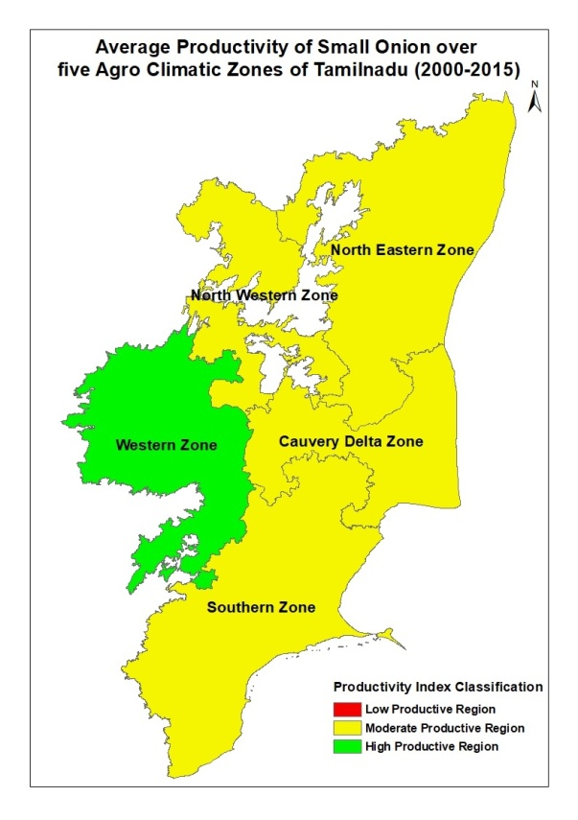

**Figure 2. Classification of small onion productivity over different Agro Climatic Zones of Tamil Nadu (2000-14)**

**Table 2. Comparing the Average Productivity Index and Annual Rainfall of Tamil Nadu**

|  |  |  |  |  |  |
| --- | --- | --- | --- | --- | --- |
| **Year** | **Rainfall (mm)** | **Rainfall deviation (%)** | **Rainfall classification** | **Average Productivity Index** | **Productivity Index Classification** |
| 2000 | 979.4 | 6.2 | Normal | 77.3 | MPR |
| 2001 | 734.7 | -20.4 | Deficit | 79.7 | MPR |
| 2002 | 694.7 | -24.7 | Deficit | 80.8 | MPR |
| 2003 | 708.9 | -23.2 | Deficit | 81.7 | MPR |
| 2004 | 994.1 | 7.8 | Normal | 88.4 | MPR |
| 2005 | 1273.1 | 38.0 | Excess | 74.8 | MPR |
| 2006 | 951.4 | 3.1 | Normal | 70.9 | MPR |
| 2007 | 949.1 | 2.9 | Normal | 73.6 | MPR |
| 2008 | 1279.2 | 38.7 | Excess | 84.3 | MPR |
| 2009 | 963.7 | 4.5 | Normal | 81.5 | MPR |
| 2010 | 1201.2 | 30.2 | Excess | 80.0 | MPR |
| 2011 | 1067.5 | 15.7 | Normal | 90.0 | MPR |
| 2012 | 780.1 | -15.4 | Normal | 82.0 | MPR |
| 2013 | 789.9 | -14.4 | Normal | 92.2 | MPR |
| 2014 | 867.7 | -5.9 | Normal | 90.4 | MPR |

LPR- Low Productivity Region; MPR- Moderate Productivity Region; HPR- High Productivity Region

**Table 3. Productivity Index of small onion over different Agro Climatic Zones of Tamil Nadu (2000-15)**

|  |  |  |
| --- | --- | --- |
| **Agro Climatic Zones** | **Average Productivity Index (2000-2015)** | **Productivity Index Classification** |
| North Eastern Zone | 77.8 | MPR |
| North Western Zone | 101.7 | MPR |
| Western Zone | 104.2 | HPR |
| Cauvery Delta Zone | 72.8 | MPR |
| Southern Zone | 88.9 | MPR |
| High Rainfall Zone | 6.7 | LPR |
| Hilly area and High Altitude Zone | 34.4 | LPR |

LPR- Low Productivity Region; MPR- Moderate Productivity Region; HPR- High Productivity Region