RESEARCH ARTICLE
Effect of different processing methods on the nutritional composition and antinutritional factors of peanut milk

ABSTRACT
Comparative effects of different five processing methods like fresh, blanching, soaking, roasting and germination methods on nutritional composition and antinutritional factors in local and CO 6 variety peanut milk were investigated. Local and CO 6 peanut variety were selected for preparation peanut milk from five different processing methods. Peanut milk was extracted from fresh( control), blanching (2 mins), soaking (3 hrs), roasting (roasting 5 mins and soaking 3 hrs) and germination (8 hrs) peanuts. Peanuts were washed, grinded, slurry separated, filtered, homogeneized ,double pasteurized and stored.. Different processing methods influence the nutritional composition of local and CO 6 variety peanut milk. Nutritional composition like total solids, protein, fat, calcium and iron content. Total solid content does not change in soaking, germination method, less reduction in roasting method, greater reduction in blanching method. Protein content was increased in germination, soaking and roasting method and reduction in blanching method.fat content was significantly reduction in all methods expect roasting method. Calcium and iron content was greater reduction in blanching and lesser reduction in roasting method. Antinutritional factors like phytic acid ,tannin, trypsin inhibitor, oxalate and phenol was greater reduction in roasting method. From the findings of the study roasting method had conservative of nutritional properties and greater reduction of antinutritional factors
.

Keywords: Peanut milk, Local Variety, CO 6 Variety , Nutritional Composition, Antinutritional Factors.

INTRODUCTION

Peanut (Arachis hypogaea) is an important oil seed crop belongs to family fabaceae and it was originated in South America. Peanut is also considered as poor man’s meat, poor man’s cashew, monkey nut, ground nut and wonder nut (Madhusudhana., 2013) .USDA 2015 reported that china was the largest peanut producer in the world it occupies (45%) , India has (15%),America has (5%) of total world peanut production [USDA 2015].

Plant based milk is an most suitable alternative for cow’s milk and other diary based milk sources. Plant based milk sources does not contain any lactose content , so it may more suitable for people who had lactose intolerance syndrome and also suitable for cow ‘s milk allergy, hypercholesterolemia people. It had high nutritional value making it more suitable for vegan diet people, infants, children , under nourished and malnourished people. Satisfying customers’ demands for special needs at the lowest possible cost has always been the major challenge faced by the foodservice industry.

Now a days the non dairy based functional beverage sectors development was increased dramatically. plant based milk source was least expensive and so easily affordable by poverty level people also. Peanut is a good source of protein (25%),fatty acid (50%) especially linoleic acid and oleic acid, fiber, vitamin B2,vitamin B6, vitamin B12,minerals like zinc, selenium, phosphorous and potassium. .( International Nut and Dried Fruit Council, 2019).

Substance presence in the food can cause reduce the nutrient bioavailability or poison for human consumption called as antinutritional factors, these substance must be eliminated or inactivated , it can maintains the value of the food.( Inuwa et al.,2011).Antinutritional factors like phytates, condensed tannin, trypsin and α amalyse inhibitors were present in peanuts it reduces the usages and nutritive value. (Embaby et al., 2010) . Antinutritional factors in the seeds can cause adverse health effects for human. (Martín-Cabrejas et al.,2009 ).

Different processing conditions like soaking, cooking, blanching and germination can influences the physical, chemical, nutritional, antinutritional factors and sensory properties of the peanut milk.( Lee et al., 1992). In this study peanut milk was prepared from fresh, blanching, roasting, soaking and germination method from local and CO 6 peanut variety. Effects of processing methods on nutritional characteristics and antinutritional factors were studied and determining the best method for nutrition retention and reduction of antinutritional factors in local and CO 6 variety peanut milk.

MATERIAL AND METHODS

2.1.Procurement of materials

Local peanut variety was purchased from a local market (simmakal) and TNAU CO 6 peanut variety was purchased from Department of Plant Breeding and Genetics, Tamilnadu Agricultural university, Coimbatore. The selected peanut seeds were raw, free from mould, dust and infectant 2.2.Processing Techniques

Peanut milk sample was prepared by five different processing methods were following:

a)Fresh peanut milk production (control)

In this method both the local and CO 6 peanut varieties were deshelled, washed and weighed (100 g).Then it was grinded (1:3 ratio kernel to water ),filtered by muslin cloth. Peanut milk was extracted and the slurry was separated. Then the peanut milk was homogeneized for 5 mins and double pasteurized (85ºC for 15 mins).

b) Soaking method

In this method local and CO 6 peanut varieties were weighed (100g) and soaked for 3 hrs,washed, grinded (1:3 ratio kernels to water ),filitered by muslin cloth, peanut milk was extracted and the slurry was separated. Then the peanut milk was homogeneized for 5 mins and double pasteurized (85ºC for 15 mins). Jain (2013) soaking method peanut milk extraction with slighter modification.

c) Roasting method

In this method open pan roasting method were followed in both the local and CO 6 peanut variety.Local and CO 6 peanut variety were weighed (100 g), Roasted for 5 mins and soaked for 3 hrs ,grinded (1:3 ratio kernels to water ), filtered by muslin cloth, peanut milk was extracted and the slurry was separated. Then the peanut milk was homogeneized for 5 mins and double pasteurized (85ºC for 15 mins). Salunkhe and kadam (1998) roasting method for peanut milk extraction was followed with slighter modification.

d)Blanching method :

Local and CO 6 peanut variety were blanched by pressure blanching method. In this method both the selected peanut varieties were weighed (100g) and blanched at (121^{₀}C 15 psi for 2 mins), washed, grinded (1:3 ratio kernels to water ), filitered by muslin cloth, peanut milk was extracted and the slurry was separated.Then the peanut milk was homogeneized for 5 mins and double pasteurized (85ºC for 15 mins).Parul jain (2011) describe blanching method was followed with silght modification.

e) Germination method

In this method local and CO 6 peanut variety were deshelled, weighed (100 g), soaked for 12 hrs and geriminated for 8 hrs. Then it was washed and grinded (1:3 ratio kernels to water ),filitered by muslin cloth, peanut milk was extracted and the slurry was separated.Then the peanut milk was homogeneized for 5 mins and double pasteurized (85ºC for 15 mins).lkemefuna (1991) germination method for peanut milk extraction was followed with slighter modification.

2.3.Analytical methods

a) Nutritional analysis

Protein content of the peanut milk was estimated by kjeldhal method AOAC (1995), fat and Total solids of the peanut milk was analyzed by AOAC (2000) method. Calcium content of the sample was determined by AOAC (1990) and Iron content of the peanut milk was estimated by (Sadasivam 1996).

b) Antinutritional factors analysis

Phytic acid determination

Phytic acid content of the peanut milk sample was carried out as described by Aina et al., (2012). Sample (2 ml) was taken in a conical flask and it was soaked in (100 ml) 2% conc.HCl for 3 hours and it was filtered by Whatman No. 1filter paper.From that 50 ml filtrate was taken and 10 ml water ,10 ml ammounium thiocyanate solution (0.3%) was added.It was titrated against std iron II chloride containing 0.00195 g iron per ml,titration was continues until the persistence of yellow colour.phytic acid was determined by following formula

% Phytic acid =y*1.19*100

y-titre value *0.00195

Tannin content determination

Tannin content of the peanut milk sample was done by vanillin –HCl method dcarried out as decriped Mazahib et al.,(2013) with sight modification. Sample 0.3 ml was extracted with 10 ml 1%v/v conc.HCl in methanol for 20 mins in capped rotating test tubes.vanillin reagent (0.5 %) 1 ml was added to the extract and after 20 mins ,500nm the absorbance was observed and noted.

Trypsin inhibitor determination

Trypsin inhibitor content of the peanut milk sample was estimated by Liu and Markakis(1989) with slight modification. In this method trypsin inhibitor in sample reacts with trypsin for 3-4 mins, addition of 30% acetic acid terminate the reaction and it was absorbed spectrophotometrically at 410 nm and measured the inhibited trypsin content.

Phenol content determination

Phenol content of the sample was determined by sadasivam and manickam (2016) with sighter modification 1 ml sample was taken and mixed with 80 % ethanol,centrifuged for 20 mins at 10000 rpm,from that supernatant was collected and the residue was dissolved by 5 ml water.From the aliquots 0.2-2 ml was pipette out in a test tube, this each test tube was made into a 3 ml by using water,0.5 ml of Folin –ciocateau reagent ,2 ml 20 % Na₂ CO₃ was added and placed in a water bath for 1 min.Then the phenol content was absorbed at 650 nm in UV spectrophotometer. The std curve was using catechol at different concentaration.From the std curve,conc. Of phenol was found out in the test sample and expressed as mg phenols 100 g material.

Oxalate content determination

Oxalate content of the peanut milk sample was determined by Munro and Bassiro (2000). 2 ml of the peanut milk sample was taken in a 250 ml volumetric flask containg 250 ml water.6MHCl 10 ml solution was added to the sample and allowed digestion for 100^{₀} c for 1 hr, it was cooled and made up into 250 ml, it was filtered and 4 drops of methyl red indicator was added and then conc.NH₄OH was added until the pink colour changed into yellow colour.It was filtrated and again heated to 90 ^{₀}c 5 % 10 ml CaCl₂ solution was added. It was Cooled stand for overnight. Then the solution was centrifuged at 2500 rpm for 5 mins. Supernatant were discarded and it contained precipitation were dissolved by using 10 ml 20 %H₂SO₄.from that 2ml was taken and made into 200 ml.from that aliquot 125 ml was taken and it was heated and titrated against the 0.05 M std KMnO₄ .The titration continues until the pink colour persist for 30 sec.

2.4 Statistical analysis

Data were analyzed by ANOVA (Analysis of variance ) and the treatments were conducted in triplicate and means were compared using the fischer’s least significant difference test (P<0.05).

RESULTS AND DISCUSSION
Nutritional and antinutritional factors of the local and CO 6 variety prepared peanut milk from fresh, roasting, blanching, soaking and germination methods were carried out in the laboratory of Community science college and research institute, Madurai.
Nutritional analysis
Table 1 shows the result of nutitional composition of peanut milk from fresh, blanching, soaking, roasting and germination method in both the selected local and CO 6 peanut variety. . Total solid content of peanut milk there was no siginificant changes with germination method (13.99g/100g).soaking (12.78g/100g) in local variety and also with germination method (15.26 g/100g).soaking (15.20 g/100g) compared to fresh peanut milk in both the selected peanut varieties.In blanching method local variety was (12.36 g/100g) and CO 6 variety was (13.97 g/100g)siginificantly decreased the total solid content in peanut milk.There is a slight changes occurs in both local variety ( 13.96g/100g) and CO 6 variety (15.20 g/100g) in roasting method compared to fresh peanut milk. (Table 1).
Protein content of the local variety peanut milk was siginificantly higher in processed peanut milk in local and CO 6 peanut variety compared to fresh peanut milk.due to soaking and germination methods. Mubarak also reported the protein content 9.1 % was increased in processing of mungbean seeds. (Mubarak 2005).Alonso et al.,(2000) reported that during germination (3%) and dehulling (6%) siginificantly increased the protein content in kidney beans compared to the raw kidney beans.During germination and soaking method the protein content in local and CO 6 peanut variety were siginificantly higher, blanching method the protein content in both the selected varieties were reduced but roasting method siginificantly does not affect the protein content in local and CO 6 peanut variety milk (Table 1).
Table 1 shows that roasting method of peanut milk no siginificantly affect the fat content in local and CO 6 peanut variety compared to fresh peanut milk.(Table 1).During Soaking and germination method observed reduced fat content in local variety 3.80 g/100g, 3.60 g/100g, and CO 6 peanut variety 3.55 g/100g, 3.50 g/100g respectively.Blanching method reduces the fat content in local variety 3.63 g/100g and CO 6 variety 3.32 g/100g respectively when compared to fresh peanut milk.Sekhon et al., reported that during roasting of peanut there is no changes occurs in peanut fat content. Sekhon et al .,(1970).Those findings are in agreement with those of Ejigui et al.,(2005).
As shown in Table 1 Calcium content of peanut milk in local and CO 6 peanut variety siginificantly (p<0.05) reduced in the blanching, soaking , roasting and germination methods with a a value of 11.5 mg/100g,11.6mg/100g,11.8 mg/100g,11.7 mg/100 g in local variety and 11.9 mg/100g,11.8 mg/100g,12 mg/100mg, 11.7 mg/100mg in CO 6 peanut variety respectively when compared to fresh peanut milk in both the peanut varieties.
Table 1 shows that iron content of peanut milk in local and CO 6 peanut variety siginificantly (p<0.05) reduced in the blanching, soaking , roasting and germination methods with a a value of 2.24 mg/100g,2.27 mg/100g,2.57 mg/100g, 2.49mg/100g in local variety and 3.04 mg/100g,3.04 mg/100g,3.07 mg/100mg,3.05 mg/100mg in CO 6 peanut variety respectively when compared to fresh peanut milk in both the peanut varieties.
Parul jain et al., (2013) reported that total solid content in the peanut milk prepared by soaking method , pressure blanching method was decreased due to leaching of solid contents. Normal soaking, 1 % NaHCO₃ and pressure blanching method the total solid content in the peanut milk were12.30 %, 11.58 % and 11.49 % respectively were reported.
Peanut milk was prepared by different blanching time intervals at (121˚C 15 psi 0 mins,2 mins,3 mins,5 mins) among that 0 min pressure blanching method contain 3.76 % protein high protein when compared to 2 min,3 min and 5 min contain less protein 3.27%,3.23 %,2.6 % respectively.Observed that there was increase in blanching time decreases the protein in the peanut milk .Parul jain et al.,(2013)
Adesola et al.,(2013) descriped that groundnut milk was prepared from fresh, roasted (170 °C, 25 min) and steeped (water, 20 min) groundnuts .Nutritional properties like fat,protein and carbohydrate were observed and its value was ranged from2.40 to 3.48%,2.05 to 2.33%,5.50 to 5.60% respectively. Azhari Siddeeg et al.,(2020) reported that carbohydrate, protein, fat, calcium content of the peanut processed milk were analyzed and its values 7.5 g/100g,6.3 g/100g,6.3 g/100g and 10-12 mg/100g were reported. Agurbiade et al.,(2011) reported that Calcium content of almond milk contain 33.0 mg/100g. Kundu et al.,(2018) stated the total solids,fat,calcium,iron content of soymilk and almond milk 8.11g/100g,2.350mg/100g,5.970mg/100, 1.587 mg/100g and 27.960 g/100g, 8.250 g/100g, 16.019 mg/100g ,3.980 ,mg/100grespectively. During germination in legumes (peanut )carbohydrates, protein, fat content were siginificantly decreased was reported by Megat rusydi et al., (2011).
Antinutritional factors analysis
Results of different processing methods like fresh, soaking, blanching, roasting and germination methods affect of antinutritional factor in both local and CO 6 peanut variety milk as shown in Table 2.
As shown in Table 2, processing methods like blanching, soaking, roasting and germination methods siginificantly (p<0.05) reduced the phytic acid content when compared to the fresh peanut milk in both the local and CO 6 peanut variety milk.
Phytic acid content of the fresh peanut milk (without treatment) from local variety 1.20 (g/100g) and CO 6 peanut variety was 1.12 (g/100g)|.In blanching method ,phytic acid content of the local variety was 1.15 (g/100g) and CO 6 variety was 1.10(g/100g),soaking method the phytic acid content of the local variety was 1.17 (g/100g) and CO 6 variety was 1.11(g/100g),Roasting method the phytic acid content of the local variety was 1.14 (g/100g) and CO 6 variety was 1.09(g/100g). Germination method the phytic acid content of the local variety was 1.00 (g/100g) and CO 6 variety was 0.92(g/100g).among these different processing method germination method reduced the phytate content compare with other methods.
Ejigui et al .,(2005)found that germination, roasting and gerimination-roasting method reduced the phytate content in red peanuts. During Roasting the phytic acid content in the peanut milk were reduced due to partial damage of the pytic acid content during roasting by Ejigui et al., (2005).During roasting,soaking and Germination process the phytase enzyme activity were increased in peanut and reduced the phytate content in peanut milk. Alonso et al., (2000).During blanching methods leaching out effect may reduced the phytate content in peanut. Azeke et al., (2011) reported that phytic acid content was decreased during germination process because higher phytase activity. During blanching and soaking method, the phytic acid content was reduced due to decrease in the acid content by leaching and the process enhanced by high temperature by Mosha et al.,(1995).
Table 2 shows that there is siginificantly (p<0.05) reduced the tannin content in blanching,soaking,roasting and germination methods compared to fresh peanut milk in both the selected local and CO 6 peanut variety . Tannin content of fresh peanut milk (0.05 mg/100g) in local variety and (0.04 mg/100g) in CO 6 peanut variety milk.
As shown in Table 2 ,Trypsin inhibitor activity of the local variety peanut milk from blanching, soaking, roasting and germination methods were siginificantly (p<0.05) decreased with the value of 0.90 (U/mg),0.88 (U/mg),0.78 (U/mg),0.85 (U/mg) compared to fresh peanut milk. Trypsin inhibitor activity of the CO 6 variety peanut milk from blanching, soaking, roasting and germination methods were siginificantly (p<0.05) decreased with the value of 0.88 (U/mg),0.86 (U/mg),0.67 (U/mg),0.80 (U/mg) compared to fresh peanut milk. Among these five processing roasting method greatly reduced the trypsin inhibitor activity in both the local and CO 6 variety peanut milk. Comparison between these two varieties CO 6 variety had low trpysin inhibitor activity.(Table 2).
Table 2 shows the result of phenol content in fresh, blanching, soaking, roasting and germination method of both local and CO 6 peanut variety milk. This results showed that there is siginificantly (p<0.05) reduced phenol content in blanching, soaking, roasting, and germination methods compared to fresh peanut milk. Among these five different processing method roasting had reduced phenol content in peanut milk effective and followed by germination, soaking and blanching method in both the local and CO 6 variety peanut milk.
As shown in Table 2, oxalate content in local and CO 6 peanut variety milk is siginificantly (p<0.05) reduced in blanching, soaking, roasting and germination methods when compared to fresh peanut milk. In local variety the oxalate content in fresh, blanching, soaking, roasting, germination methods and its value was 25mg/100mg,18.56 mg/100g,18.24 mg/100 g,15.21 mg/100g,16.3 mg/100 g. In CO 6 variety the oxalate content in fresh, blanching, soaking, roasting, germination methods and its value was 20mg/100mg,17.82 mg/100g,17.91 mg/100 g,13.26 mg/100g,15.1 mg/100 g. Roasting method in local and CO 6 peanut milk had greatly reduced oxalate content in peanut milk.
Megat rusydu et al.,(2011) reported that total phenol,tannin and phytic acid content was decreased due enzymatic changes in germination process. Pugalenthi and vadivel.,(2007) stated that phytate, trypsin inhibitor activity and tannin contents were siginificantly reduced by soaking methods.Vijayakumari et al.,(2007) reported that soaking method reduced the phytic acid content in Bauhinia purpurea seeds. Cooking,soaking and dehulling combined effect of pigeon pea seeds was siginificantly higher than cooking method alone for reducing the phytic acid content. Duhan et al .,(2002).Yu wei luo et al.,(2013) reported that trypsin inhibitor activity was siginificantly reduced in40% green and white faba bean seeds by combination of different cooking methods. Cooking methods can reduce the antinutritional factor contents in legumes. Alonso et al.,(2000) .Tannin content in the soaked seeds were siginificantly reduced. Mubarak et al.,(2005). Soaking, boiling, fermented and sprouted methods reduces the oxalate content in pigean pea flour. Nwanekezi et al.,(2017)..

CONCLUSION
Peanut milk was prepared from different processing methods like blanching, soaking, roasting , fresh and germination methods had varying impact on the nutritional properties and antinutritional factors in local and CO 6 peanut variety. Peanut milk from roasting method there was less reduction in nutritional composition like total solid, fat, protein, calcium, iron and siginificantly reduced the antinutritional factors like phytate, tannin, trypsin inhibitor, oxalate and phenol content in both the local and CO 6 variety peanut milk. From the findings of the research work, peanut milk from roasting treatment appears beneficial as it was relatively conservative of physico chemical and nutritional characteristics and greater decrease in antinutritional factors when compared to soaking, blanching, fresh and germination methods in both local and CO 6 variety peanut milk.

Consent for publication

All the authors agreed to publish the content.

Competing interests

There were no conflict of interest in the publication of this content

REFERENCES
Adesola, A. O., Olasunkanmi, G. S., & Kehinde, T. A. (2013). Effects of some processing factors on the characteristics of stored groundnut milk extract. African Journal of Food Science, 7(6), 134-142.
Agurbiade SO, SharwieMH, OlanlokunJO. Evaluation of some nutritional characteristicsof Indian almond (Prunus amygdalus)Nut. J. of Nutrition.2011;4:316-318.
Aina, V. O., Sambo, B., Zakari, A., Haruna, M. H., Umar, H., Akinboboye, R. M., & Mohammed, A. (2012). Determination of nutritional and anti-nutrient content of Vitis vinifera (Grapes) grown in Bomo (Area C) Zaria, Nigeria. Advance Journal of Food Science and Technology, 4(6), 445-448.
Alonso,R.,A.Aguirre and F.Marzo, 2000.Effects of extrusion and traditional processing methods on antinutrients and in vitro digestibility of protein and starch in faba and kidney beans.Food Chem.,68:159-165.
Azeke, M. A., Egielewa, S. J., Eigbogbo, M. U., & Ihimire, I. G. (2011). Effect of germination on the phytase activity, phytate and total phosphorus contents of rice (Oryza sativa), maize (Zea mays), millet (Panicum miliaceum), sorghum (Sorghum bicolor) and wheat (Triticum aestivum). Journal of food science and technology, 48(6), 724-729.
Duhan, A., Khetarpaul, N., & Bishnoi, S. (2002). Content of phytic acid and HCl-extractability of calcium, phosphorus and iron as affected by various domestic processing and cooking methods. Food Chemistry, 78(1), 9-14.
Ejigui, J., Savoie, L., Marin, J., & Desrosiers, T. (2005). Influence of traditional processing methods on the nutritional composition and antinutritional factors of red peanuts (Arachis hypogea) and small red kidney beans (Phaseolus vulgaris). Journal of Biological Sciences, 5(5), 597-605.
Embaby HES.2010 b.Effect of soaking,dehulling and cooking methods on certain antinutrients and in vitro digestibility of bitter and sweet lupin seeds.Food Sci Biotechnol 19 (4): 1055-62.
International Nut and Dried Fruit Council, 2019.Nutritional value of peanuts.
Inuwa, H. M., Aina, V. O., Gabi, B., Aimola, I., & Toyin, A. (2011). Comparative determination of antinutritional factors in groundnut oil and palm oil. Advance Journal of Food Science and Technology, 3(4), 275-279.
Jain P, Deep Narayan Yadav, Hradesh Rajput, Devendra Kumar Bhatt. Effect of pressure blanching on sensory and proximate composition of peanut milk. Journal of Food Science and Technology. 2013; 50(3):605-608.
Jain, Parul, et al. "Effect of pressure blanching on sensory and proximate composition of peanut milk." Journal of food science and technology 50.3 (2013): 605-608.
Kundu, P., DhANKhAr, J., & ShArMA, A. (2018). Development of non dairy milk alternative using soymilk and almond milk. Current Research in Nutrition and Food Science Journal, 6(1), 203-210.
Lee, C., & Beuchat, L. R. (1992). Chemical, physical and sensory characteristics of peanut milk as affected by processing conditions. Journal of Food Science, 57(2), 401-405.
Liu, K., & Markakis, P. (1989). Trypsin inhibition assay as related to limited hydrolysis of inhibitors. Analytical Biochemistry, 178(1), 159-165.
Luo, Y. W., & Xie, W. H. (2013). Effect of different processing methods on certain antinutritional factors and protein digestibility in green and white faba bean (Vicia faba L.). CyTA-Journal of Food, 11(1), 43-49.
Madhusudhana, B. "A survey on area, production and productivity of groundnut crop in India." IOSR journal of Economics and Finance 1.3 (2013): 1-7.
Martín-Cabrejas, M. A., Aguilera, Y., Pedrosa, M. M., Cuadrado, C., Hernández, T., Díaz, S., & Esteban, R. M. (2009). The impact of dehydration process on antinutrients and protein digestibility of some legume flours. Food Chemistry, 114(3), 1063-1068.
Mazahib, A. M., Nuha, M. O., Salawa, I. S., & Babiker, E. E. (2013). Some nutritional attributes of bambara groundnut as influenced by domestic processing. International Food Research Journal, 20(3), 1165.
Megat Rusydi, M. R., Noraliza, C. W., Azrina, A., & Zulkhairi, A. (2011). Nutritional changes in germinated legumes and rice varieties. International Food Research Journal, 18(2).
Mosha, T. C., Gaga, H. E., Pace, R. D., Laswai, H. S., & Mtebe, K. (1995). Effect of blanching on the content of antinutritional factors in selected vegetables. Plant Foods for Human Nutrition, 47(4), 361-367
Mubarak,A.E., 2005.Nutritional composition and antinutritional factors of mung bean seeds (phaseolus aureus ) as affected by some home traditional processes.Food Chem., 89:489-495.
Munro,A.B., 2000.Oxalate in Nigerian vegetables.W.A.J.Biol.Appl.Chem.,12(1):14-18.
Nwanekezi, E. C., Ehirim, F. N., & Arukwe, D. C. (2017). Combined effects of different processing methods on vitamins and antinutrients contents of pigeon pea (Cajanus Cajan) flour. Journal of Environmental Science, Toxicology and Food Technology, 11(4), 73-81.
Obizoba, Ikemefuna C., and Helen I. Egbuna. "Effect of germination and fermentation on the nutritional quality of bambara nut (Voandzeia subterranea L. Thouars) and its product (milk)." Plant Foods for Human Nutrition 42.1 (1992): 13-23.
Sadasivam and manickam (2016)Biochemical methods, New age international journal.
Salunkhe DK, Kadam SS. Handbook of world food legumes: nutritional chemistry, processing technology, and utilization. CRC Press. Inc., Boca Raton, 1989,. Aina, V.,Bina,S.,
Sekhon ,K.S.,K.L. Ahuja and R.S. Sandhu, 1970 .chemical composition of Raw and Roasted peanuts.Ind.J.Nutr.Diet., 7:243-246.
Siddeeg, A., Salih, Z. A., Ammar, A. F., Saeed, N. S. M., Howladar, S. M., & Alzahrani, F. O. (2020). Production of Peanut Milk and Its Functional, Physiochemical, Nutritional and Sensory Characteristics. Annual Research & Review in Biology, 79-88.
USDA 2015,world peanut production report.
Vijayakumari, K., Pugalenthi, M., & Vadivel, V. (2007). Effect of soaking and hydrothermal processing methods on the levels of antinutrients and in vitro protein digestibility of Bauhinia purpurea L. seeds. Food Chemistry, 103(3), 968-975.

Table 1 : Nutritional composition of peanut milk from different processing methods in local and CO 6 peanut variety
Nutritional parameters | Fresh |  | Blanching |  | Soaking |  | Roasting |  | Germination
Nutritional parameters | L | C | L | C | L | C | L | C | L | C
Total solid (g) | 14.0ª±0.9 | 15.27ª ±0.7 | 12.36 e±0.2 | 13.97^{d} ±0.6 | 13.98^{d}±0.7 | 15.0^{b} ±0.1 | 13.96^{d}±05 | 15.20 ª ±0.3 | 13.99^{d} ±0.2 | 15.26ª ±0.4
Protein(g) | 5.9^{b} ±0.7 | 6.2ª ±0.1 | 4.1^{c}±0.2 | 5.0^{b} ±0.3 | 6.0ª ±0.4 | 6.3 ª ±0.6 | 5.6 ^{b} ±0.7 | 5.8 ^{b} ±0.8 | 6.1ª ±0.9 | 6.4ª ±0.2
Fat(g) | 3.82ª ±0.56 | 3.54 ^{c} ±0.57 | 3.63e ±0.93 | 3.32 ^{b} ±0.52 | 3.80ª ±0.99 | 3.55^{c}±0.4 | 3.81ª ±0.2 | 3.53 ^{c}±0.74 | 3.60 e ±0.82 | 3.50^{c} ±0.65
Calcium(mg) | 12.34^{b}±0.04 | 13.0 ª ±0.46 | 11.5^{c} ±0.74 | 11.9 ^{c} ±0.02 | 11.6^{c}±0.78 | 11.8^{b}±0.3 | 11.8^{b}±0.9 | 12 ª ±0.98 | 11.7 ^{c} ±0.82 | 11.7^{c} ±0.02
Iron (mg) | 2.87ª ±0.53 | 3.15 ª ±0.6 | 2.24^{d} ±0.78 | 3.04 ª ±0.34 | 2.27^{c} ±0.44 | 3.01^{b}±0.4 | 2.57^{c}±0.7 | 3.07 ª ±0.78 | 2.49 ^{d}±0.67 | 3.05ª±0.73

Table 2. Effect of different processing method in antinutritional factors of local and CO 6 peanut variety milk
Nutritional parameters | Fresh |  | Blanching |  | Soaking |  | Roasting |  | Germination
Nutritional parameters | L | C | L | C | L | C | L | C | L | C
Phytic acid(g) | 1.20ª±0.75 | 1.12ª±0.83 | 1.15^{d}±0.99 | 1.10^{d}±`073 | 1.17 ^{c} ±0.87 | 1.11^{c}±0.4 | 1.14 ^{d} ±0.02 | 1.09 ^{d} ±0.65 | 1.00 ^{b} ±0.77 | 0.92 ^{b} ±0.99
Tannin (mg) | 0.05 ª ±0.82 | 0.04ª±0.54 | 0 ^{b} ±0.72 | 0 ^{b} ±0.57 | 0 ^{b} ±0.97 | 0 ^{b} ±0.87 | 0 ^{b} ±0.54 | 0 ^{b} ±0.33 | 0 ^{b} ±0.64 | 0 ^{b} ±0.82
Trypsin inhibitor(U/mg) | 1.21 ª ±0.87 | 1.18^{c}±0.34 | 0.90 ±0.77 | 0.88 ^{b} ±0.98 | 0.88 ^{b} ±0.03 | 0.86 ^{c} ±0.99 | 0.78 ^{d} ±0.72 | 0.67 ^{b}±0.87 | 0.85 ^{b} ±0.34 | 0.80 ^{b} ±0.23
Phenol (GAE/mg) | 2.90 ª ±0.88 | 2.86^{b}±0.32 | 2.74^{d}±0.36 | 2.67 ^{d} ±0.67 | 2.10 ^{b} ±0.88 | 2.00 ^{b} ±0.99 | 1.90 ^{c} ±0.76 | 1.98 ^{c}±0.72 | 1.91 ^{b} ±0.87 | 1.97 ^{b} ±0.99
Oxalate (mg/100g) | 25 ª ±0.04 | 20 ª ±0.74 | 18.56^{b}±0.7 | 17.8^{b} ±0.48 | 18.24 ^{d}±0.87 | 17.91 ^{d} ±0.99 | 15.21^{b}±0.6 | 13.26^{b} ± 0.02 | 16.3 ^{c} ±0.56 | 15.1 ^{c}±0.78

Figure 1: Effect of different processing methods on nutritional composition of peanut milk from local variety
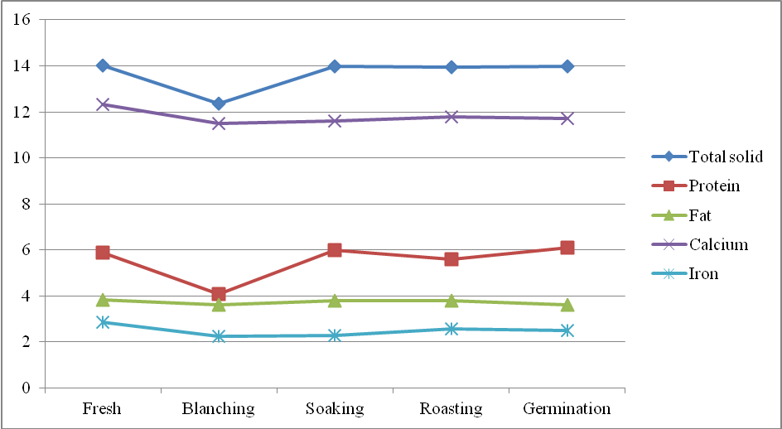
Figure 2: Effect of different processing methods on nutritional composition of peanut milk from CO 6 variety
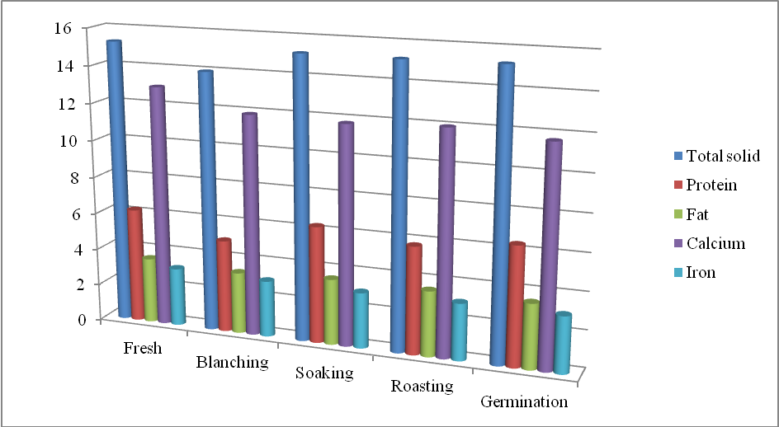
Fig 3 : Effect of different processing methods on antinutritional factors of peanut milk from local variety
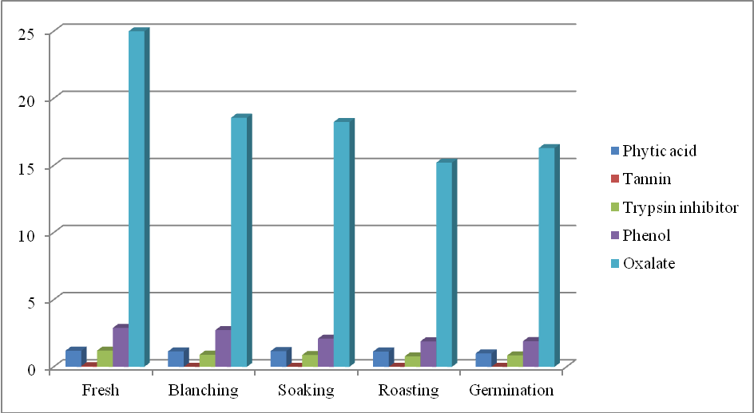
Fig 4: Effect of different processing methods on antinutritional factors of peanut milk from CO 6 variety
