**RESEARCH ARTICLE**

**Effect of Stem Diameter, Moisture Content and Cutting Speed on Cutting Force for Groundnut Harvesting.**

|  |  |
| --- | --- |
|  | ABSTRACT To design, and development of any harvesting machines, the most important optimized parameter is the cutting force. The study was conducted to investigate the effect of stem diameter, moisture content and cutting speed on cutting force required for cutting of groundnut stalks. The cutting force was measured using the reciprocating cutter bar test rig. Experiments were carried out at three levels of moisture content (40 - 47, 47 – 53, and 53 – 60 %) (wet basis), three levels of crop stem diameter (15- 17, 17 – 19, and 19- 21 mm) and three levels of cutter bar speed (0.80 – 0.90 ,0.90 – 1.00 and 1.00 – 1.10 ms-1 ). The cutting force required for cutting of groundnut crop was calculated for all the treatments. It was observed that with increase in moisture content, stem diameter and cutter bar speed, the cutting force increased by 37.57 %, 19.83 % and 34.11 %, respectively. The required cutting force (100 - 120 N) and energy (1.5 - 2.0 J) was minimum at the cutter bar speed of 0.80 – 0.90 ms-1 for 40 – 47 % moisture content, 15- 17 mm stem diameter and they were maximum at cutter bar speed of 1.00 - 1.10 ms-1 (140- 160 N and 2.5 – 3.0 J) for 53 – 60 % moisture content, 19 – 21 mm stem diameter. The results showed that the cutting force requirement was increased with increase in stem diameter, moisture content and cutting speed. |

Keywords: Groundnut: cutting energy; crop parameters; stem diameter; moisture content.

## INTRODUCTION

The peanut, which is also called as the groundnut (Arachis hypogaea) is a legume crop. It is said to be an oil seed crop, due to its high oil content. It gives the vegetable protein and edible oil in the tropical and semi-arid tropical areas. It plays an important role both as oil or food crop and also grown as an important forage crop. Among the oilseed crops, it is the sixth most important oilseed crop in the world. In India, it is cultivated under the rain-fed conditions and irrigated. It has two crop cycle harvested in March & October, so it is available throughout the year in India. Gujarat is the largest producer in India, followed by Tamil Nadu, Andhra Pradesh, Karnataka and Maharashtra. In 2015-16 around Tamilnadu, the groundnut area and production was 3.2 lakh hectares and 4 lakh tonnes, respectively. The major groundnut producing districts in Tamil Nadu are Thiruvannamalai, Villupuram, Vellore, Namakkal, Salem, Erode and Cuddalore. (Thulasiram*et al.* 2018) .It is grown, mainly for its edible quality. The physical properties of plant stem and the cutting resistance play a vital role to understand the force required in harvesting operations.

In safflower stalk, the bottom region of stalk with the moisture content of 37.16%, registered the maximum shear energy of 938.33 mJ and shear stress of 11.04 MPa. An increase in the shear stress and shear energy is due to an increase in the moisture content of the safflower stalk. (Shahbzi and Galedar 2012). The effect of stem diameter, moisture content on cutting energy for cassava stem was studied. At 33.29 mm stem diameter the cutting energy was maximum (34.84 J) and at 25.22 mm stem diameter, the cutting energy was minimum (28.81 J). As the stem diameter increased from 25.22 to 33.29 mm, the cutting energy increased by 17.31 %.( Prasanthkumar and Saravanakumar 2020). The effect of bengal gram crop and machine parameters on cutting energy was investigated. A double cutter bar test rig for measuring the cutting force to cut bengal gram crop and the minimum cutting energy required to cut the bengal gram crop was 0.67 Nm. (Ramachandran and Asokan 2020). The effect of cutting velocity, blade type and stalk cross sectional area of stalk for chickpea on cutting force, cutting energy and specific energy. The cutting energy, specific energy and cutting force needed were decreased as the cutting velocity increased for both type of blades Sushilendra*et al*. 2016). The investigation on the effect of moisture content, bevel angle and cutting speed on shearing energy for three wheat varieties. They reported that decrease in shearing energy would increase the shearing speed and with decreasing moisture content and bevel angle Hoseinzadeh *et al.* (2009).

MATERIAL AND METHODS

The parameters pertinent to influence the harvesting of groundnut crop were identified as stem diameter, moisture content and linear speed of the cutter bar.

**I *Crop parameter***

1. ***Stem Diameter***

Randomly ten samples of groundnut plants were taken at harvesting stage and diameter was measured from the ground level at 5 to 7 cm height. Each groundnut plant consisted of number of branches varying from 5 to 6 branches. The whole plants (bunch of stems) were taken for the experiment. The diameter of the stem was measured using the vernier caliper and the readings were noted in mm.

1. ***Moisture content***

Immediately after cutting the stem, 15 to 20 numbers of small pieces was taken as sample for measuring the moisture content. The moisture content was measured by weighing its initial weight in an electronic weighing balance (ws) with accuracy of 1 g. A sample was placed on a crucible and kept inside the oven for 24 hours at 105 0C to eliminate the moisture (Gravimetric method) Talpur (2011).The dried weight of the sample was measured and noted as wd. The moisture content of the sample was worked out on wet basis using the formula,

Moisture content (w.b) = $\frac{Ws- Wd }{Ws}$ × 100 per cent (1)

Where,

ws = weight of groundnut stem before drying, g

wd= weight of the dried groundnut stem, g

**II *Machine Parameter***

1. ***Linear Speed of Cutter Bar***

The linear speed of cutter bar was given by the following equation (Celik, 2006).

Knife speed, Vk = (2)

Where,

Vk = knife speed, ms-1

s = length of stroke, m

n = crank speed, rpm

**III Evaluation *Parameter***

1. ***Cutting force***

The force required for cutting the groundnut crop was measured by using the load cell expressed in kilogram. The measured cutting force values were recorded.

1. ***Cutting energy***

The cutting energy could be determined using the formula.

Cutting energy, Ec = Fc × D (3)

Where,

Ec = cutting energy, J

Fc = cutting force, N

D = diameter, mm

***Materials Used***

The cutting force was measured using the test rig, fabricated for measuring the cutting energy. The cutter bar test rig consisted of mainframe, cutter bar assembly, load cell, load indicator, load measuring set up, analog to digital converter, variable speed drive, power transmission assembly, signal conditioning and amplifying unit, digital load measuring set up and power supply. (Figure.1) Nisha and Saravanakumar (2019)

***Mainframe***

The size of the main frame was 1790 × 500 mm. The main frame consists of cutter bar assembly, connecting rod, electric motor (1 hp), power transmission system and digital load measuring set up.

***Cutter bar Assembly***

The cutter bar assembly comprises of cutter bar, knife guard and knife clip. Fourteen number of cutting knifes were riveted on a mild steel flat to form a cutter bar and the cutter bar of length 1015 mm was mounted on the main frame. Eleven number of knife guards were mounted on mild steel. Two knife clips were mounted on main frame.

***Load Cell***

A load cell measures the load or force encountered during cutting of the groundnut stem and converts pressure into electrical signals and vice versa. The cutting force was measured by using an S-type load cell.

***Load Indicator***

A load indicator was used for the purpose of indicating the cutting force. It displays the measured value in four digits. It consists of three parts namely analog to digital converter, signal conditioning with amplifying unit and power supply.

***Analog to Digital Converter***

The output from the amplifier was noted in terms of analog DC voltage. This analog output was converted into digital output by using Analog to Digital converter.

***Variable Speed Drive***

The variable speed drive is an electronic device used to vary the speed, torque and direction of induction motor. It is connected to the three phase induction motor through electric wires.

**Power Transmission Assembly**

The cutter bar assembly was operated by taking the mechanical power from the electric motor. To operate the test rig an one hp three phase induction electric motor was selected as the prime mover.

***Signal Conditioning and Amplifying Unit***

The signal conditioner also protects the input signal given to the differential amplifier.

***Digital Load Measuring Set Up***

Digital load measuring set up consists of a load cell and a load indicator.

***Power Supply***

A power supply of ±12 V 500 mA was used to operate the digital integrated circuitry (signal conditioning and amplifying unit) and the Analog to Digital converter(load indicator without error), respectively.

The sample was placed between reciprocating cutting knife for cutting groundnut stems of diameter varying from 15 to 21 mm (Figure.2).The force required was measured by the load cell and noted from the load indicator in kilogram (Figure.3). The force required at different stem diameter and moisture content was worked out for its average and it is discussed below.

***Operational Parameters***

Experiments were carried out at three levels of groundnut stem diameter (15- 17, 17 – 19, and 19- 21 mm), three levels of moisture content (40 - 47, 47 – 53, and 53 – 60 %) (wet basis), and three levels of cutter bar speed (0.80 – 0.90, 0.90 – 1.00 and 1.00 – 1.10 ms-1 ).

RESULTS AND DISCUSSION

This study was done to measure the cutting force required to cut groundnut stems at three different levels of moisture content and three levels of stem diameters with reciprocating cutter bar test rig.

***Effect of groundnut stem diameter on cutting force and cutting energy***

The relation between the stem diameter and required cutting force and cutting energy is shown in (Figure.4). At stem diameter of 19 - 21 mm, the maximum required cutting force of 140-160 N and cutting energy of 2.5 – 3.0 J was measured. At 15 - 17 mm lower stem diameter, the minimum required cutting force of 100 - 120 N and cutting energy of 1.5 – 2.0 J was measured. Therefore, when the stem diameter increased from 15 to 21 mm, the required cutting force and cutting energy also increased. Nisha and Saravanakumar (2019) studied the effect of finger millet crop parameters effect on cutting force. The experiment was conducted at three levels of moisture content and three levels of stem diameter of 62 to 63, 70 to 71, and 77 to 80 % and 6, 9 and 12 mm, respectively. The results shows that increase in diameter increased the cutting force and energy.

***Effect of moisture content on cutting force and cutting energy***

Azadbakht*et al.* (2014) investigated cutting energy for corn stalks and reported that the maximum cutting energy i.e. 3.22 kJ at 63% moisture content and 5 cm cutting height.

The minimum cutting energy i.e. 1.63 kJ at 83.25 % moisture content and 15 cm cutting height. The study revealed that the cutting energy was directly proportional to the moisture content.

The relation between the moisture content (w.b) and cutting force and cutting energy is shown in (Figure. 5). At a moisture content of 53 - 60 %, the maximum required cutting force of 140 - 160 N and cutting energy of 2.5 - 3.0 J was recorded. At moisture content of 40 - 47 %, the minimum required cutting force of 100 - 120 N and cutting energy of 1.5 – 2.0 J was recorded. Therefore, when the moisture content increased, the required cutting force and cutting energy also increased.

***Effect of cutting speed on cutting force and cutting energy***

The relation between the cutting speed cutting force and cutting energy is shown in (Figure. 6). The maximum required cutting force and cutting energy of 140 - 160 N and 2.5 – 3.0 J, respectively was observed at 1.00 - 1.10 ms-1. The minimum required cutting force and cutting energy of 101.98 N and 1.5 -2.0 J, respectively was observed at 0.80 – 0.90 ms-1. Therefore, when the cutting speed increased, the required cutting force and cutting energy also increased. Allameh*et al.* (2016) reported the effect of specific cutting energy on different rice stem cultivars and blade parameters. The experiments were carried out at four levels of blade bevel angle 25, 30, 35 and 40 degrees, at three levels of cutting angle and blade speed of 25, 30, and 35 degrees and 1.5, 2.0, and 2.5 ms-1, respectively. They concluded that the blade velocity increases from 1.5 to 2.5 ms-1, with increase in the specific cutting energy by 77 %.

The analysis of variance for the effect of crop diameter, moisture content and cutter bar speed on cutting force is shown in Table 1. The effect of crop diameter and cutting speed on cutting force had 1% significance and the moisture content on cutting force had 5% significance. The result revealed that the increase in stem diameter and moisture content increased the cutting force and cutting energy for all the treatments.

CONCLUSION

From the measured values of cutting force the power requirements for designing of harvester was calculated. The effect of groundnut stem parameters on required cutting force was recorded. The experiment concluded that the maximum cutting force required for cutting a groundnut crop of 19 - 21 mm diameter at 53 - 60 % moisture content and 1.00 - 1.10 ms‑1cutter bar speed was (140- 160 N). The result was enough and this cutting force of (140 - 160 N) was effective for harvesting the groundnut crop.

REFERENCES

Azadbakht, M., Asl, A.R. and K.T. Zahedi. 2014. Energy Requirement for Cutting Corn Stalks (Single Cross 704 Var.). World Academy of Science, Engineering and Technology, *Int. J. Bio. Biomolecular, Agric. Food and Biotech. Engi*., **8 (5):**479-482.

Allameh, A. and M.R. Alizade. 2016. Specific cutting energy variations under different rice stem cultivars and blade parameters. *IDESIA (Chile).,* **34 (5):** 11-17.

Hoseinzadeh, B., Esehaghbeygi, A. and N. Raghami. 2009. Effect of Moisture Content, Bevel Angle and Cutting Speed on Shearing Energy of Three Wheat Varieties. *Wrld Appl. Sci. J.,***7 (9):** 1120-1123.

Nisha, N. and M. Saravanakumar. 2019a. An Investigation on the effect of moisture content, crop diameter and cutting speed on cutting force of finger millet stem. *Int. J.Agric. Sci. Res*., **9** :187- 192.

Nisha, N. and M. Saravanakumar. 2019b. Development of Reciprocating Cutter Bar Test Rig for Measurement of Cutting Force of Finger Millets. *Int. J. Curr. Microbiol. App. Sci.,* **8(04):** 2441- 2447.

Prasanthkumar, K. and M. Saravanakumar. 2020.Cassava Stem Crop Parameters Effect on Cutting Energy *Adv. Res*., **21(2):** 25-30.

Ramachandran, S. and D. Asokan. 2020. Effect of Crop and Machine Parameters on Cutting Energy for Harvesting of Bengal gram crop*. Int. J. Agric. Sci. Res.,* **10**: 1–8.

Shahbazi, F. and M.N. Galedar. 2012. Bending and Shearing Properties of Safflower Stalk. *J. Agric. Sci. Tech.,* **14:** 743-754.

Sushilendra., Veerangouda, M., Anantachar, M. Prakash, K.V. Desai, B.K. and S.N. Vasudevan. 2016. Effect of Blade Type, Cutting Velocity and Stalk Cross Sectional Area of Chickpea Stalks on Cutting Energy, Cutting Force and Specific Energy. *Int. J. Agric. Sci.,* **8:***2658- 2662.*

Thulasiram, R., Alagumani,T., Raman, M.S. and G. Parthasarathi. 2018. Resource-Use Efficiency of Groundnut Cultivation in Tamil Nadu. *Int. J. Curr. Microbiol. App. Sci.* **6:** 351-357

Talpur, M.A., Changying, J.,Chandio, F. A. Junejo, S. A. and I. A. Mari. 2011. Application of oven drying method on moisture content of ungrounded and grounded (long and short) rice for storage. *J. Stored Prdts and Postharvest Res*. **2(12)**., 245 – 247.

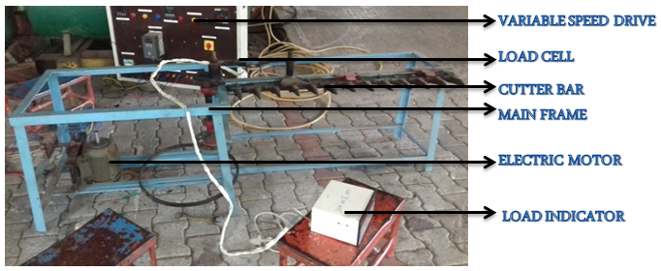

**Figure1.Reciprocating Cutter Bar Test Rig**

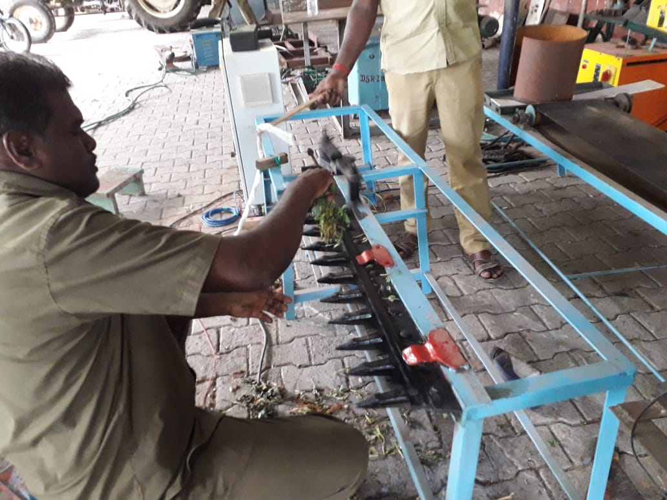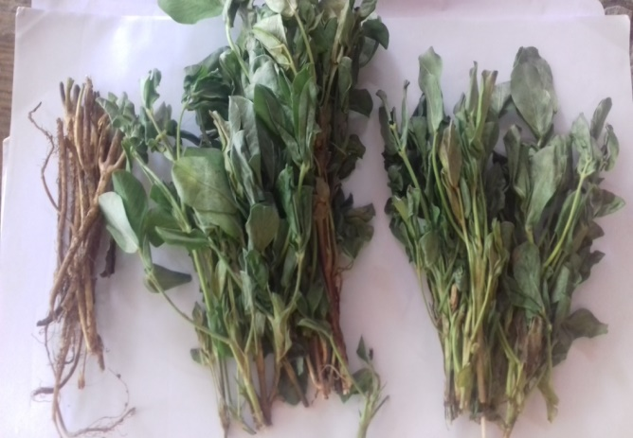

**Figure 2. Cutting of Groundnut Stems**

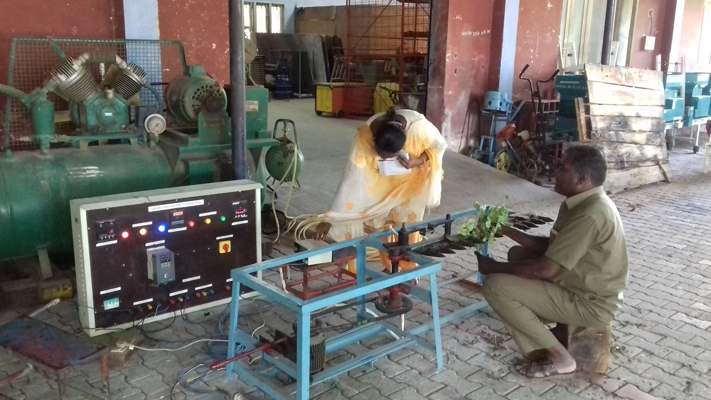

**Figure 3. Readings were taken during Experiment.**

**Figure 4. Effect of groundnut stem diameter on cutting force and cutting energy**

**Figure 5. Effect of moisture content on cutting force and cutting energy**

**Figure 6. Effect of cutting speed on cutting force and cutting energy**

**Table.1. Analysis of variance for the effect of crop diameter, moisture content and cutter bar speed on cutting force.**

|  |  |  |  |  |  |
| --- | --- | --- | --- | --- | --- |
| **ANOVA RESULTS** | **df** | **Sum** | **Sq Mean** | **Sq F Value** | **Pr (>F)** |
| Diameter  Residuals  Moisture Content  Residuals  Cutter bar Speed  Residuals | 1  1  1  1  1  1 | 1070.3  2.1  1056.5  15.9  1067.8  4.5 | 1070.3  2.1  1056.5  15.9  1067.8  4.5 | 509.7  66.61  235.2 | 0.01**  0.0776*  0.0415** |