1. REVIEW ARTICLE

# PHENOTYPING METHODS AND PLATFORMS TO STUDY THE RESPONSE OF

1. PLANTS TO ABIOTIC STRESS TOLERANCE

## 7

8 ABSTRACT

9

1. Tittle page: Phenotyping methods are available to identify the stress
2. and its response in the plants. The available phenotyping platforms
3. could be useful for screening of the plant stress, to mitigate the abiotic
4. stress in the plants these pheonotyping methods does favours. The
5. abiotic stresses mainly drought and salt tolerance is economically
6. realistic measure to tackle the global challenges stemming from the
7. unfavorable environmental constrain in the agricultural productivity. In
8. fact, first step towards development of a practical stress-tolerant crop
9. plant is to understand the fundamental mechanism working for the
10. tolerance, which are based on the physiological and biochemical traits.
11. Conventional plant breeding and modern biotechnologies have been
12. applied to explore the tolerances of drought and salinity so far.
13. However, a great challenge in the exploration of the stress-tolerant
14. genotypes was to link between target genes, functioning for the
15. tolerance, and relevant phenotypes, especially, at whole plant level.
16. Keywords: Phenotyping methods, Plants, Abiotic stress and Tolerance

## INTRODUCTION

1. Recently, a large number of reviews have been published on the advantages and possibilities higher through
2. plant phenotyping approaches like climate change and abiotic stress etc.Climate change is altering the
3. availability of resources and the conditions that are crucial to plant performance. In one way the plants will
4. respond to these changes through environmentally induced shifts in phenotype. Understanding phenotypic
5. responses is crucial for predicting and managing the effects of climate change on native species as well as
6. crop plants. Climate change is altering the environments in which all organisms develop (Nicotra *et al*.,

33 2010).

## ABIOTIC STRESS

1. Plants are often subjected to unfavorable environmental conditions – abiotic factors, causing abiotic
2. stresses - that play a major role in determining productivity of crop yields but also the differential distribution
3. of the plants species across different types of environment. Some examples of abiotic stresses that a plant
4. may face include decreased water availability, extreme temperatures (heating or freezing), decreased
5. availability of soil nutrients and/or excess of toxic ions, excess of light and increased hardness of drying soil
6. that hamper roots growth. The ability of plants to adapt and/or acclimate to different environments is directly
7. or indirectly related with the plasticity and resilience of photosynthesis, in combination with other processes,
8. determining plant growth and development, namely reproduction (Duque *et al*., 2012).

## DROUGHT

1. Drought refers to a condition in which the amount of water available through rainfall and/or irrigation
2. is insufficient to meet the transpiration needs of the crop. The different mechanisms that allow plants to
3. withstand and eventually mitigate the negative effects of water deficit. In general, a clear distinction should
4. be made between traits that help plants to survive a severe drought stress and traits that mitigate yield
5. losses in crops exposed to a mild or intermediate level of water stress.
6. FUNCTIONAL BASIS OF DROUGHT RESISTANCE
7. Drought resistance offers a rational approach to classify the strategies that allow plants to mitigate
8. the negative effects of water deficit. [(Levitt, 1980)](https://www.frontiersin.org/articles/10.3389/fphys.2012.00347/full#B208) classified the different mechanisms or strategies of
9. drought resistance into two broad categories: dehydration avoidance and dehydration tolerance. In this
10. respect, morpho-physiological features (e.g., deep roots, early flowering, deposition of epicuticular waxes,
11. osmotic adjustment (OA), etc.) that enable the plant, or parts thereof, to maintain hydration are classified
12. under dehydration avoidance. Conversely, features (e.g., remobilization of stem water-soluble carbohydrates
13. (WSC), accumulation of molecular protectants, etc.) that allow the plant to maintain, at least partially, proper
14. functionality in a severely dehydrated state are classified under dehydration (desiccation) tolerance
15. (Tuberosa, 2012).

## 59

1. SALT STRESS
2. Salt tolerance in plants operates specific mechanisms such as ionic homeostasis, nutritional
3. balance, ion-specific signaling and gene expression. Hence, it is important to understand the physiological
4. mechanisms of tolerance regarding stress at whole plant level (Munns,1993). In saline environment, salt-
5. induced reduction of plant growth is predominantly caused by osmotic stress at first short-term stress
6. conditions (Munns *et al.,* 2002), which is a similar response caused by drought. After the first phase, the
7. second phase reduction of plant growth is predominantly occured by ion toxicity, which appears due to
8. excessive toxic ion accumulation especially in the mature leaves, causing premature senescence and less
9. photosynthetic ability. Plant tolerance against the stresses at whole plant level can be defined as
10. maintaining ability of growth and metabolic process under the adverse stress conditions (Munns and
11. Tester 2008)

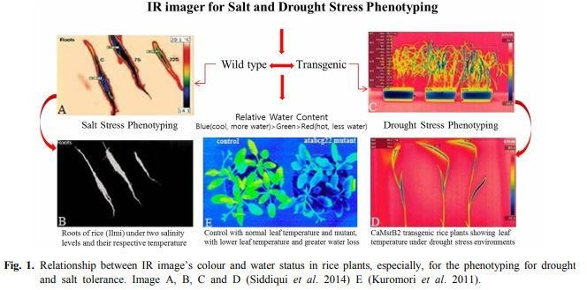

## 71

1. TEMPERATURE STRESS
2. IR thermal sensing can provide rapid, vast and effective phenotyping but it has to be adopted certain
3. principles. For instance, infra-red thermography is a part of the electromagnetic spectrum which emits a
4. certain amount of radiation as a function of their temperatures. Generally, plants would display higher
5. temperature when they have less water; the more infra-red radiation is emitted. A special camera like IR can
6. detect this radiation in a way similar to the way an ordinary camera detects visible light. It works well in total
7. darkness because ambient light level does not matter. Infra-red thermal images tend to have a single color
8. channel because the camera commonly uses an image sensor that does not differentiate wavelengths of
9. infra-red radiation (Kwon *et al*.,2015)

## 81

82

1. PHENOTYPING METHODS FOR DROUGHT:
2. Early Vigor
3. Early vigor under conditions of low evapotranspiration may allow annual crops to optimize WUE and
4. limit the loss of water due to direct evaporation from the soil surface.
5. Root Architecture
6. Roots exhibit an astounding level of morphological plasticity in response to soil physical conditions
7. a peculiarity that allows plants to adapt better to the chemical and physical properties of the soil, particularly
8. under drought conditions
9. Stomatal Conductance
10. Stomatal conductance plays a pivotal role in regulating the water balance of the plant and
11. determining WUE indicating the possibility of raising the yield potential, hence the amount of water used by
12. the crop, through an indirect selection for stomatal conductance and/or leaf temperature.
13. Canopy Temperature Depression
14. CTD as measured by thermal imaging is the difference in temperature between the canopy surface
15. and the surrounding air. CTD is a highly integrating trait resulting from the effects of several biochemical and
16. morphophysiological features acting at the root, stomata, leaf, and canopy levels. In the field, genotypes with
17. a cooler canopy temperature under drought stress, or a higher CTD, use more of the available water in the
18. soil to avoid excessive dehydration
19. Abscisic Acid Concentration
20. One of the main factors influencing leaf temperature via an effect on transpiration through stomatal
21. conductance is the concentration of ABA in the leaf tissue and, ultimately, in guard cells Therefore, ABA is a
22. fundamental component of the mechanisms allowing the plant to match the water demand with the water
23. supply and to optimize growth and survival in response to both daily and more long-term environmental
24. fluctuations
25. Osmotic Adjustment
26. OA is a metabolic process entailing a net increase in intercellular solutes in response to water stress.
27. As soil moisture declines, OA favors turgor maintenance, and hence the integrity of metabolic functions.
28. Importantly, OA can bias estimates of the value of relative water content.

## PLATFORMS AVAILABLE FOR PHENOTPING STRESS

1. High-throughput plant phenotyping platforms:
2. (A) small scale phenotyping platform consisting of XYZ PlantScreenTM growth-chamber with automatic
3. top view RGB imaging (Photon System Instruments, Czechia) for screening biostimulant substances
4. based on the changes on *Arabidopsis* rosette growth in multi-well plates at Palacký University in
5. Olomouc, Czechia
6. (B) medium-scale phenotyping platform PlantScreenTM Modular System (Photon System Instruments,
7. Czechia) with integrated high-resolution RGB, chlorophyll fluorescence, thermal and both VNIR and
8. SWIR hyperspectral imagers for high-precision digital plant phenotyping and plant cultivation of mid-
9. scale size up to large plants in greenhouse or semi-controlled environment
10. (C) Phenomobile for fruit trees and berry bushes developed at the James Hutton Institute (Scotland,
11. United Kingdom), with VNIR and SWIR hyperspectral imagers [(Martin *et al*., 2017](https://www.frontiersin.org/articles/10.3389/fpls.2018.01197/full#B36)).
12. (D) Large scale automated field phenotyping system. PlantScreenTM Field System is autonomous
13. mobile platform with multi-functional sensor platform mounted on an XZ-robotic arm with high-
14. resolution visible, chlorophyll fluorescence, thermal infrared, hyperspectral imagers, and 3D laser
15. sensor (Photon System Instruments, Czechia).

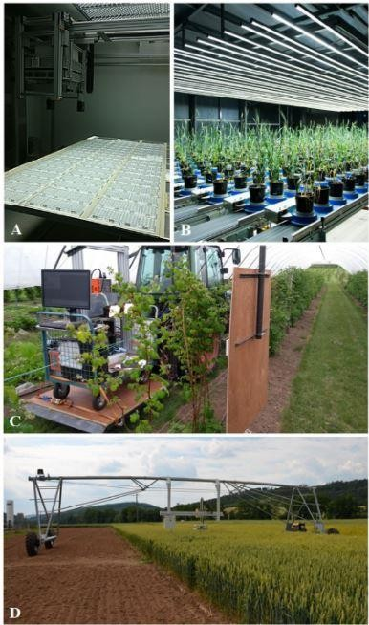

Figure 2: High-throughput plant phenotyping platforms:

## PHENOMICS FACILITY PICTURES IN IARI :

1. 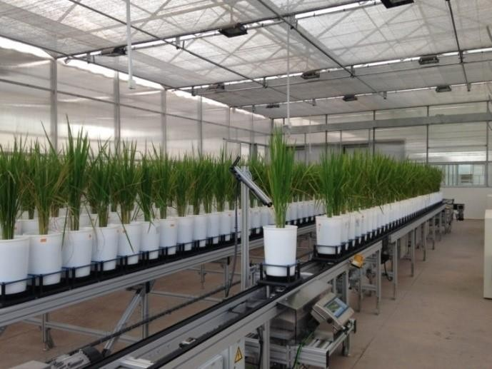
2. Figure 3: Nanaji deshmukh plant phenomic centre in IARI
3. 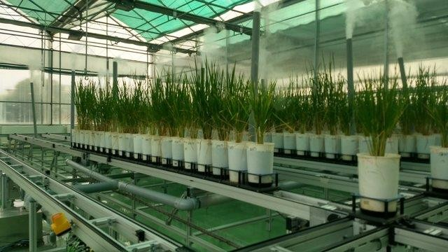
4. Figure 4 : experimental set up at nanaji deshmukh plant phenomics in IARI

## INSILICO METHODS TO IDENTIFY PLANT STRESS

1. The identification of genes controlling both the stress would mean a lot in understanding molecular
2. mechanism of tolerance, which in turn assist in development of stress resilient genotypes. The methods for
3. identifying the plant stress, an in silico approach was used to identify genes commonly expressed under
4. combined drought and salt stress using microarray.

## CONCLUSION

1. Drought and salinity are greater challenges that cut off agricultural production substantially all over
2. the world. Crop breeding for drought and salt tolerance is economically realistic measure to tackle the global
3. challenges stemming from the unfavorable environmental constrain in the agricultural productivity. In fact,
4. first step towards development of a practical stress-tolerant crop plant is to understand the fundamental
5. mechanism working for the tolerance, which are based on the physiological and biochemical traits.
6. Conventional plant breeding and modern biotechnologies have been applied to explore the tolerances of
7. drought and salinity so far. However, a great challenge in the exploration of the stress-tolerant genotypes
8. was to link between target genes, functioning for the tolerance, and relevant phenotypes, especially, at whole
9. plant level.

## FUTURE THRUST

1. Assessment of stress tolerant plants shall be done in a larger field area.

## REFERENCES

1. Kuromori, T., Sugimoto, E. and Shinozaki, K., 2011. Arabidopsis mutants of AtABCG22, an ABC transporter
2. gene, increase water transpiration and drought susceptibility. *The Plant Journal.*, 67(5), pp.885-894.
3. Kwon, T., Chung, M.I., Gupta, R., Baker, J.C., Wallingford, J.B. and Marcotte, E.M., 2014. Identifying direct
4. targets of transcription factor Rfx2 that coordinate ciliogenesis and cell movement. *Genomics*

167 *data.*, 2, pp.192-194.

1. Levitt, J., 1980. Responses of plants to environmental stresses. *Water, radiation, salt, and other stresses.*, 2.
2. Martin, R. R., Ellis, M.A., Williamson, B. and Williams, R.N. eds., 2017. *Compendium of raspberry and*
3. *blackberry diseases and pests.,* (pp. 1-175). St Paul, MN: APS Press.
4. Munns, R. and Tester, M., 2008. Mechanisms of salinity tolerance. *Annu. Rev. Plant Biol.*, 59, pp.651-681.
5. Munns, R., 1993. Physiological processes limiting plant growth in saline soils: some dogmas and
6. hypotheses. *Plant, Cell & Environment.*, 16(1), pp.15-24.
7. Munns, R., 2002. Comparative physiology of salt and water stress. *Plant, cell & environment,*, 25(2), pp.239-

175 250.

1. Nicotra, A. B., Atkin, O.K., Bonser, S.P., Davidson, A.M., Finnegan, E.J., Mathesius, U., Poot, P., Purugganan,
2. M.D., Richards, C.L., Valladares, F. and van Kleunen, M., 2010. Plant phenotypic plasticity in a
3. changing climate. *Trends in plant science*, 15(12), pp.684-692.
4. Siddiqui, M. H., Al-Whaibi, M.H., Firoz, M. and Al-Khaishany, M.Y., 2014. Role of nanoparticles in plants.
5. In *Nanotechnology and Plant Sciences.,* (pp. 19-35).
6. Tuberosa, R., 2012. Phenotyping for drought tolerance of crops in the genomics era. *Frontiers in*
7. *physiology.*, 3, p.347.