RESEARCH ARTICLE

Effect of climatic interference on the phenological stages of the Cherry tree Prunus cerasus in Tlemcen region: Case of the Black Bigarreau and the Sunburst

Soulef HAMED¹, Baha-Eddine GHEZLAOUI-BENDI-DJELLOUL^{1,2*}

^{*1}Laboratory of Ecology and Management of Natural Ecosystems, Faculty of Nature and Life Sciences, and Earth and Universe Science, University of Tlemcen, B.P13000. Algeria. ²Department of agronomy. Faculty of Natural and Life Sciences, and Earth and Universe Science, University of Tlemcen, B.P13000 Algeria.
Corresponding author:
Baha-Eddine GHEZLAOUI-BENDI-DJELLOUL.
Address:
Département d’agronomie. Faculté des sciences de la nature et de la vie, et science de la terre et de l’univers, Université de Tlemcen, B.P13000 Algérie.
Email:ghezlaoubahae@gmail.com
Phone :00213 7 74 01 5 17

Abstract
The monitoring of the phenology of the two varieties of the cherry tree, the Black Bigarreau and the Sunburst, revealed to us that the climate of the region plays a very important role in the progress of the harvests, where the Black Bigarreau showed an earliness of 9 days between the year of 2018 and 2019. The Sunburst variety showed an earliness of only 6 days compared to the same years. This is explained by a time lag of flowering due to the fact that the climate-related interference linked to the thermal amplitudes of 2018 is greater than the one of 2019.
Keywords:
Black Bigarreau - Sunburst - phenology - climate.

1. Introduction
The cherry tree has a very important varietal range; some are early, mid-season or late with very different fruit characteristics. The climate plays a very important role in the determination of these types enjoyed by our region, so we must understand the needs for temperature, rainfall, atmospheric humidity as well as a suitable wind speed in order to have effective pollination, good fruiting and subsequently a good yield (Ctifl, 1997).
Long records of flowering dates have proven to be extremely useful for reconstructing past phenology and for predicting phenology in future climate scenarios. In Japan for example, the flowering dates of cherry trees (Prunus jamasakura) have been recorded for centuries and analyzes of these records have revealed that flowering of cherry trees currently occurs earlier than at any time during the seven to twelve years. previous centuries, due to the impact of global warming. and urbanization on phenology (Primack, R. B., et al. 2009) (Aono, Y. & Omoto, Y. 1993) (Aono, Y. & Kazui, K. 2008). Our work then aims to study the effect of climatic factors on the phenology of the case cherry of the Black Bigarreau and the Sunburst.
2. Material and methods
The study of the phenological stages of the cherry tree was carried out at the level of Mr. Chikhi's orchard in Ain Fezza at Tlemcen region, at 34.87 ° latitude and - 1.23 ° longitude with 800 m altitude (Figure. 1). This station is characterized by a sandy loam, non-calcareous soil and a neutral pH (Zellam. And Hamed. 2013). The orchard has an apiary (4 hives), which is not much for 7 hectares of cherry trees as well as many other crops at the farm. The water resources are constituted by a borehole 100 m deep with a flow rate of 8-10 liters per second. The observations are carried out during the period of 2 years (2018 - 2019) of 2 varieties of the cherry tree (the Black Bigarreau and the Sunburst). The visits of the experimental site were done every week to be able to folow all the phelogical stages. The varieties were cultivated in 2007 and 2009. The climatic data were taken from the website of the Tlemcen Zenata weather station (35.01 latitude and -1.46 longitude).
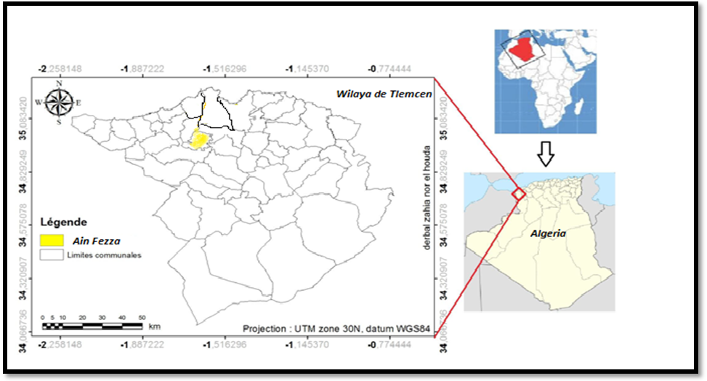
Figure 1. Geographical location of the experimental site

3. Results
Monitoring of phenological stages
The monitoring of the phenological stages represented in Table 1, shows a difference of 57 to 55 days for the fruiting of the Black Bigarreau and of 58 to 55 days for the Sunburst in the two climatic years studied (2018 and 2019). Both varieties inter the stage of bud dormancy in February and last 15 to 23 days for the Black Bigarreau and 17 to 25 days for the Sunburst. The very first flowers bloomed for both varieties in 03/04/2018, 03/14/2019, 03/08/2018 and 03/17/2019. Flowering lasts 4 weeks for the Black Bigarreau and 28 days for the Sunburst. Fruiting, which begins with fruit set and ends with fruit ripening, is marked by an earliness of 9 days for the Black Bigarreau and 6 days for the Sunburst.

Table 1. The dates of the phenological stages of the Black Bigarreau and the Sunburst
(2018/2019)
 | Bigarreau noir |  | Sunburst
Phenological stage | 2018 | 2019 | 2018 | 2019
Bud dormancy | 18 february | 19 february | 19 february | 21 february
Bud break | 04 march | 13 march | 07 march | 17 march
blooming | 04 march-03 april | 14 march-14 april | 08 march-05 april | 17 march-14 april
Fruit set | 03 april | 14 april | 05 april | 14 april
fruiting | 30 may | 08 june | 02 june | 08 june

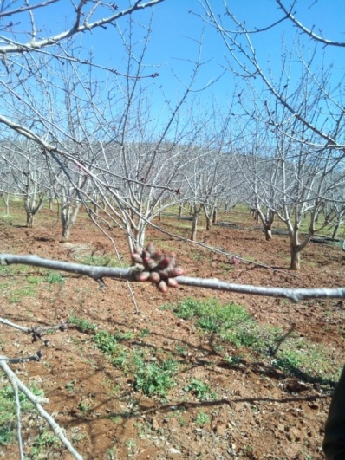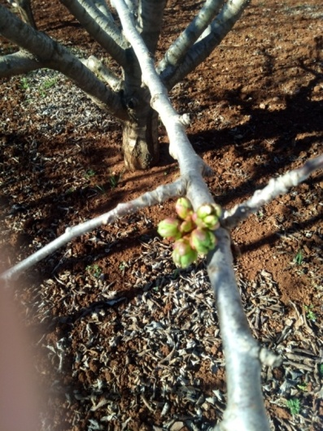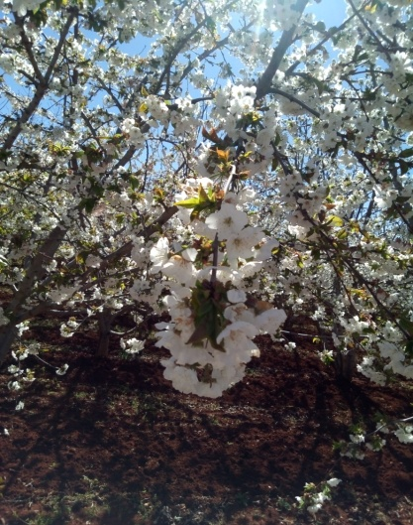
Bud dormancy Bud break Blooming
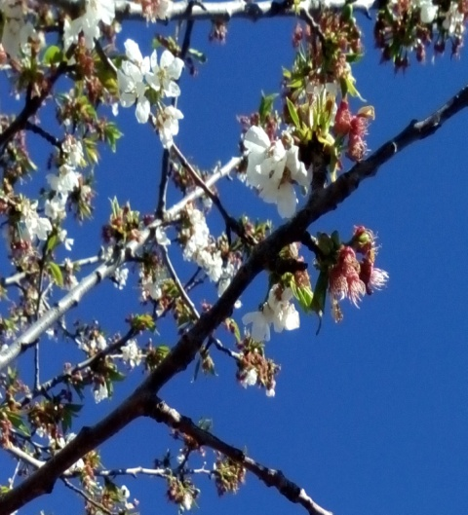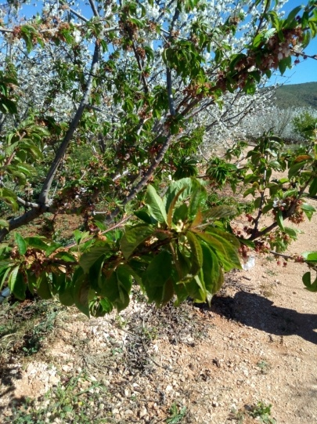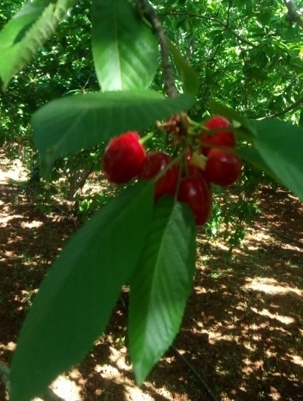
Fruit set Leafing Fruiting
Figure 2. The phenological stages of the cherry tree (Hamed. 2019)

Climate data
The region of Tlemcen is classified in the semi-arid bioclimatic stage with a dry period that lasts 4 to 5 months. The average temperature of the year 2018 and 2019 is very close (17.6 and 17.9 c °). The highest temperature of the day of the year 2018 and 2019 is recorded in August (34.4 c ° and 33.3 c °), on the other hand the coldest averages were recorded in February (5 c ° and 4 c °). For precipitation, it remains low (384.28 and 299.95 mm / year) compared to the needs of the crop (3000 to 5000 m³). The humidity in turn presents a high rate of 66.9% in 2018 and 61.8% in 2019. The wind, which plays a very important role in pollination, is 8.8 and 9.1 km / h, which are within the standards.

Table 2. Climate data of Tlemcen region for 2018 and 2019 (Fr.tutiempo.net)
2018
Month | J | F | M | A | Mai | June | July | At | S | O | N | D
T | 11 | 10.5 | 14 | 14.9 | 17.4 | 21.9 | 25.6 | 27.1 | 24.1 | 18.7 | 14.1 | 11.6
TM | 17.2 | 16.4 | 19.4 | 20.8 | 23.6 | 28.1 | 32.5 | 34.4 | 30.6 | 26.1 | 20.5 | 19.7
Tm | 6 | 5 | 9.1 | 10.1 | 11.3 | 15 | 18.8 | 20.1 | 18.7 | 12.9 | 8.8 | 5.6
P | 38.61 | 31.24 | 80.75 | 76.97 | 15.25 | 8.63 | 0 | 0.51 | 15.24 | 79.24 | 35.81 | 2.03
H | 70.6 | 73.8 | 69.5 | 77.2 | 68.8 | 60.5 | 47.3 | 54.3 | 68.2 | 65.3 | 75 | 75.3
V | 9.3 | 9.6 | 15.9 | 9.2 | 7.7 | 8.3 | 10.2 | 8.3 | 6.4 | 8.6 | 8.4 | 5.2
2019
Month | J | F | M | A | Mai | June | July | At | S | O | N | D
T | 9.9 | 10.6 | 13.4 | 15.5 | 20.1 | 22 | 25.9 | 26.7 | 23.6 | 19.4 | 14.5 | 12.8
TM | 17.1 | 18.5 | 21.1 | 22.4 | 27.1 | 27.9 | 32.6 | 33.3 | 30.2 | 26.9 | 19.6 | 18.7
Tm | 3.9 | 4 | 6.3 | 8.7 | 12.3 | 15.8 | 20 | 20.7 | 18.1 | 12.8 | 10.3 | 8.1
P | 63.23 | 10.92 | 6.35 | 34.55 | 26.93 | 0.25 | 8.12 | 1.02 | 8.39 | 55.87 | 59.69 | 24.63
H | 63.2 | 67.8 | 63.2 | 60.4 | 53.6 | 57.5 | 58 | 55.5 | 64.6 | 57.8 | 68.1 | 72
V | 9.9 | 6.9 | 6.7 | 10.3 | 8 | 9.2 | 9.8 | 8 | 7.3 | 7.6 | 15.1 | 10.1
T : Temperature in c°, TM : Maximum Temperature in c°, Tm : minimum Temperature in c°, P : Precipitation in mm/year, H : Humidity in %, V : wind speed in Km/h. J : January, F : February, M : March, A : April, At :August, S :September, O :October, N :November, D :December.
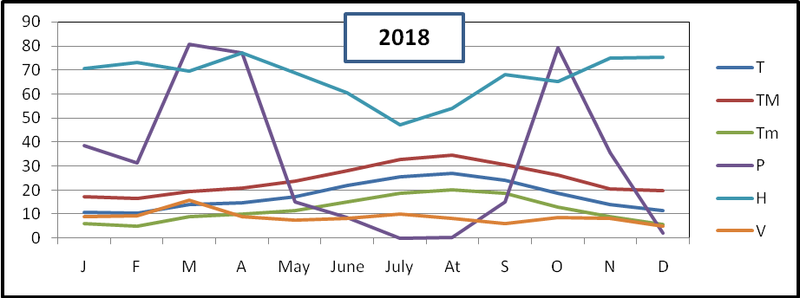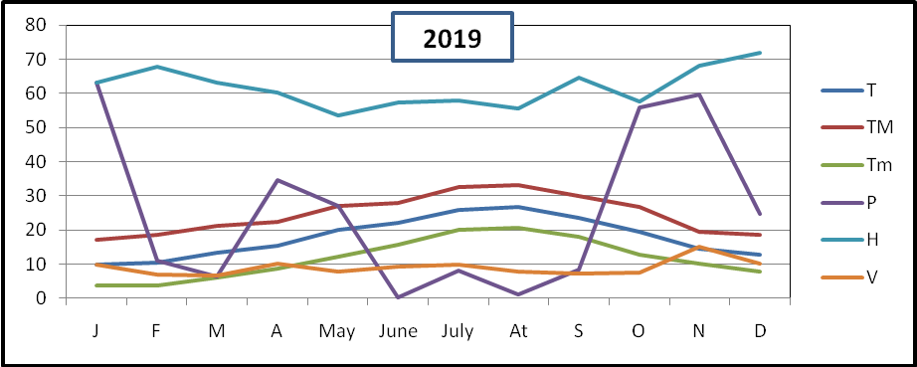
Figure 3. Climate data of Tlemcen region for 2018 and 2019

4. Discussion
The results of climatic data provided by the Zenata meteorological station, showed that there is a very small difference between the average temperatures between 2018 and 2019, despite this we observed dates of dormancy, flowering, fruit setting and staggered fruiting. According to Chmielewski and Rötzer (2001), an increase in temperature of 1 ° C during the onset of the spring season leads to an advancement of the growth phases of about 7 days. The length of the growing season is an important measure in horticulture. Variations in the development cycle of fruit trees are caused by temperature fluctuations, starting with disruptions in the dates of the breaking of dormancy, which modify the budding and flowering phenology, and consequently affect vegetative development, maturity and fruit production (Legave, 2007). Breaking dormancy also experienced a longer period in 2019 compared to 2018 for both varieties, as well as an advancement of bud break of 9 days for Bigarreau noir and 10 days for Sunburst. The difficult elimination of dormancy appears to be linked to the lack of cold, especially since the first cold of autumn play a role in intensifying dormancy. Physiologically, when dormancy is incomplete and disturbed, bud break is therefore deficient and widespread and a strong apical dominance characterizes the vegetative growth of trees (Oukabli, 2004). The maximum temperature in April (fruit set) is 20.8 to 22.4, which is within the norm for our climate. Temperatures above 25 ° C are considered as threshold temperatures for the occurrence of fruit set problems in Prunus. Erez et al. (1998; 2000). The maximum temperature in May rises after flowering to 23.6 ° C in 2018 and 27.1 ° C in 2019, which translates into a fruiting period of 57 to 55 days for the Bigarreau noir and 58 to 55 days. for the Sunburst. Several authors, notably Day et al. (2008), confirmed that high temperatures after flowering shortened fruit development time and accelerated fruit growth, thereby advancing the harvest date. Excessive heat (over 30 ° C) impairs firmness (Claverie, 2005). For other climatic factors such as precipitation, humidity and wind we have not found an influence on the shift in phenology, although they may have an effect on flower fall, pollination as well as on the quality of fruit. Also there may be other factors limiting depending on the climatic conditions of the phenological site and the climatic station, for example the exposure and the inclination (Schnelle 1955; Chen 1994), the underlying surface (Snyder et al. 2001 ) or the surrounding area (Rotzer 1996), may differ so that the temperature data does not exactly describe the phenological site. In addition, the age and height of a tree influence the phenology of its leaves (Seiwa 1999), and the genotype of the plant species can also affect the timing of phenological stages. For example, Rötzer and Chmielewski (2001) found mean differences of 6 days at the start of leaf unfolding of two varieties of Fagus sylvatica as well as in the May shoot of two varieties of Picea abies. Other climatic parameters, such as air humidity, precipitation (Wielgolaski 2001), radiation (Cenci and Ceschia 2000) or even the thickness of the snowpack (Inouye et al. 2002), can have an influence. on a phenological phase, and non-climatic parameters such as the soil moisture and the level of nutrients (Wielgolaski 2001) or CO2 (Jach and Ceulemans 1999; Sigurdsson 2001) can also modify the timing of the phenological phases.
5. Conclusion
Our study on the phenological stages of the two varieties of cherry allowed us to determine the durations of full blooms, important for pollination. Also the climatic factor represented by the temperature influences the breaking of dormancy. It also has an effect on the setting of fruit as well as the precocity of ripening. Positive coefficients in the cooling phase indicate that higher temperatures during the given period delay flowering. It is also important to note that lower than average temperatures accelerate flowering, while negative coefficients reveal that warmer temperatures lead to earlier flowering dates. (Bénédicte et Mahendra. 2017)
6.References
- Aono, Y. et Kazui K., (2008). Phenological data series of cherry tree flowering in Kyoto, Japan, and its application to reconstruction of springtime temperatures since the 9th century. Int. J. Biometeorol. 28, 905–914.
- Aono, Y. et Omoto Y., (1993). Variation in the March mean temperature deduced from cherry blossom in Kyoto since the 14th century. J. Agr. Met. 48, 635–638.
- Bénédicte W., et Mahendra M., (2017). Sweet cherry phenology in the context of climate change: A systems biology approach .Acta Horticulturae. DOI: 10.17660/ActaHortic.2017.1162.6
-Cenci, C.A., Ceschia M., (2000). Forecasting of the flowering time for wild species observed at Guidonia, central Italy. Int J Biome-teorol 44:88–96.
- Chen X., (1994). Untersuchung zur zeitlich-räumlichen ähnlichkeiten phonologischen und klimatologischen Parametern inWestdeutschland und zum Einfluss geoakologischer Faktoren auf die phanologische Entwicklung im Gebiet des Taunus.Reports of the German Weather Service 189, Offenbach amMain.

- Chmielewski, F.M., Rötzer, T., (2001). Response of tree phenology to climate change across Europe. Agric. For. Meteorol. 108, 101–112.
- Claverie, (2005). De la taille à la conduite des arbres fruitiers. Edition Rouergue. P, 60- 70.
- Ctifl., (1997). Cerise, les variétés et leur conduite. Guide pratique. Centre technique interprofessionnel des fruits et légumes. ISBN 2-87911-048-X.
- Day, K., Lopez, G., DeJong, T.M., (2008). Using growing degree hours accumulated thirty days after bloom to predict peach and nectarine harvest date. Acta Hort. 803, 163-167.
- Erez, A., Yablowitz, Z., Korcinski, R., (1998). Greenhouse peach growing. Acta Hort. 465, 593-600.
- Erez, A., Yablowitz, Z., Korcinski, R., Zilberstaine M., (2000). Greenhouse-growing of stone fruits: Effect of temperature on competing sinks. Acta Hort. 513, 417-426.
-Inouye, D.W., Morales, M.A., Dodge G.J., (2002). Variation in timing and abundance of flowering by Delphinium barbeyi Huth (Ranunculaceae): the roles of snowpack, frost and La Ninˇa, in the context of climate change. Oecologica 130:543–550.
-Jach, M.E., Ceulemans R., (1999). Effects of elevated atmospheric CO2 on phenology, growth and crown structure of Scots pine (Pinus sylvestris) seedlings after two years of exposure in the field. Tree Physiol 19:289–300.
- Legave, J.M., (2007). Les impacts du réchauffement global sur la phénologie des arbres fruitiers et de la vigne : quelles conséquences agronomiques ? Journées Techniques Fruits & Légumes Biologiques, Caen, pp. 1–8.
- Oukabli A., (2004). le cerisier une zone de culture d’altitude, transfère de la technologie ; ministère de l’agriculture et du développement rurale, P,1-4.
- Primack, R. B., Higuchi, H. & Miller-Rushing A. J., (2009). The impact of climate change on cherry trees and other species in Japan. Biol. Conserv. 142, 1943–1949.
- Rötzer T., (1996). Neuartige Karten der Phänologie und des Wasserhaushalts von Bayern unter Berücksichtigung möglicher künftiger Klimaverhältnisse (a new kind of phenology- and water balance-maps of Bavaria in regard to possible future climate change). PhD thesis, Technical University München, Freising, Germany.
-Schnelle F., (1955). Pflanzen-Phaenologie (plant phenology).Akad.Verlasgsgesellschaft. Leipzig
- Sigurdsson B.D., (2001). Elevated CO₂ and nutrient status modified leaf phenology and growth rhythm of young Populus tri-chocarpa trees in a 3 year field study. Trees 15:403–413.
- Snyder, R.L., Spano, D., Duce P, Cesaraccio C., (2001). Temperature data for phenological models. Int. J .Biometeorol 45:178–183.
-Seiwa K., (1999). Changes in leaf phenology are dependent on tree height in Acer mono, a deciduous broad-leaved tree. Ann Bot 83:355–361.
-Wielgolaski F.E., (2001). Phenological modifications in plants by various edaphic factors. Int J Biometeorol 45:196–202.
- Zellam W., et Hamed S., (2013). Bilan de deux Ceriserais au niveau de la wilaya de Tlemcen. Mém. Ing. Agrono. Univ. Tlemcen.p.57, 59.57, 59.
-https://fr.tutiempo.net/climat/ws-605310.html

