RESEARCH ARTICLE
Preliminary study on the in situ prevention of food spoilage fungi using antifungal Lactic acid bacteria

ABSTRACT Many fungal species cause losses of food, raw materials like grains, fruits and vegetables throughout the world. In the world, 5 to 10% of the food and in the tropics 50 % of the fruits and vegetables are lost annually due to fungal spoilage. Chemical preservatives and fungicides have negative impacts on health and environment. In contrast, bio preservatives such as lactic acid bacteria (LAB) are effective, safe, biodegradable and have additional health benefits. Totally 45 isolates were obtained from various crops, fermented and non-fermented foods in which 21 and 13 isolates showed activity against A. flavus and F. oxysporum respectively. Based on their antifungal activity, six LAB isolates were selected in which LABT3 showed high antifungal activity was further characterized for their growth in different environmental conditions. The focus of this research is to survey the occurrence of native LAB species with antifungal activity in different sources as well as to obtain a potential LAB isolate for strategic application to control fungal pathogen in field and food.
Keywords: Lactic acid bacteria, A. flavus, F. oxysporum, dual plate technique, fungal spoilage

INTRODUCTION
Postharvest loss refers to major food loss in the postharvest system (Lucia, 1994). Life style change had made the food industry flourish and processed foods are ruling the food market. Raw agricultural products and processed foods products like fruit juices carry many spoilage bacteria and fungi. In India, the production of raw food materials is about 450 million tonnes of which 10 % postharvest losses is in cereals and pulses, 20 % in semi perishable and 25 % in products like milk, meat, fish and egg (Rajasri et al., 2014).
Fungi are known as one of the important spoilage organisms in food (Pitt and Hocking, 2009). The Food and Agricultural Organization reported that significant losses are due to contamination of 25% of worldwide crops by Mycotoxins producing filamentous fungi like Fusarium, Aspergillus, Penicillium (Joint et al., 2002). To eliminate the mycotoxins, postharvest detoxification strategies like physical, chemical and biological strategies have been reported (Jard et al., 2011).
The excessive use of fungal detoxicants leads to development of resistant pathogen population and consequent increase in toxic residue in food products. For example, acquired resistance by Penicillium italicum and P. digitatum to many synthetic fungicides used on citrus fruits have been demonstrated (Fogliata et al., 2000). The chemical treatment also has some disadvantages like high cost, biosafety risk or limited binding capacity. Also, consumer preference for natural antimicrobial compounds of plant and animal origin has led to the reach for bio preservatives to prevent or control fungal spoilage in raw and processed foods (de Souza Sant’Ana et al., 2008; Walter et al., 2015). The decontamination by biological method might be an alternative to chemical methods because of their efficacy and nature friendly properties.
Lactic acid bacteria (LAB) have attained Generally Recognized As Safe (GRAS) status (Stiles, 1996) for food application. Antifungal metabolites produced by members of lactic acid bacteria like lactic acid, acetic acid, formic acid, propionic acid, fatty acid, hydrogen peroxide, diacetyl, cyclic dipeptides, reuterin and phenolic compounds (Crowley et al., 2013). The cell free supernatant of Lactobacillus sp. from buttermilk of raw buffalo milk has strong and broad antimicrobial activity against both harmful bacteria and toxigenic fungi and also inhibit aflatoxin and ochratoxin to extend the shelf life of wheat grains (Shehata et al., 2019). The LAB isolated from fermented beverages were identified as L. plantarum, L. paracasei and L. pentosus showed strong antifungal activity against Colletotrichum gloeosporioides (Barrios-Roblero et al., 2019). Bio preservation of tomatoes with the cell free supernatant of L. plantarum reduced the fungal spoilage (Luz et al., 2020). In the present study, LAB isolates with potential antifungal property to be suitable for in situ application in food were screened.

MATERIAL AND METHODS
Collection of sample
The sample of curd and idly batter which was fermented for 10 h was obtained from household, fresh vegetables such as tomatoes and cabbage were obtained from Uzhavar sandhai, Mettur and paddy grains obtained from Central Farm, Tamil Nadu Agricultural University, Coimbatore.
Fungal cultures
The fungal cultures of Aspergillus flavus and Fusarium oxysporum were obtained from the Department of Plant Pathology, Tamil Nadu Agricultural University, Coimbatore. The fungal cultures were sub cultured in Malt Extract Agar media by disc method and incubated at 25 ºC for 4-5 days.
Preparation of samples
Approximately 5 g of paddy grains was soaked in 25 ml sterile water and incubated for 12 h at 28 ºC. Cabbages were cut into pieces and 180 g was taken in sterile airtight container and added with 2% (w/v) salt, mixed and pressed tightly without the air space and incubated at 28 ºC for 12 days (Lee et al., 2006). Tomatoes were cut into pieces and 1 g was weighed approximately and taken in stomacher bag and homogenized in the stomacher (Bag Mixer ®, Interscience, France) for 2 min (Elmabrok et al., 2013).
Isolation of LAB from the prepared samples
For the isolation of LAB, 1 ml of curd, 1 g of idly batter, 1 ml of homogenized tomato sample, 1 ml of soaked water of paddy grains and 1 ml from fermented cabbage were taken. Appropriate dilutions were plated in MRS (de Man Rogosa Sharpe) agar plate (De Man et al., 1960) by pour plate technique and the plates were incubated at 37 ºC for 48 h. After incubation, the different morphological colonies were selected and purified. The Gram’s reaction of purified colonies was determined by Gram’s staining technique.
Antifungal activity of LAB isolates
LAB isolates were screened for antifungal activity by overlay method as described in (Magnusson and Schnürer, 2001; Barrios-Roblero et al., 2019). LAB isolates were seeded until covering one-third of the surface of MRS agar plates and incubated at 37 ºC for 48 h. A Malt extract agar plug with A. flavus and F. oxysporum was placed on the center of the free surface of these MRS agar plates and incubated aerobically at 25 ºC for 5 days. The mold growth was observed daily and inhibition radius was recorded
Studies on probiotic characteristic of the antifungal LAB isolate
Viable cell population and pH
The LAB isolate was inoculated in sterile MRS broth and incubated at 37 ºC for 24 h. From the above culture, 1 % inoculum was inoculated in MRS broth to evaluate the viable cell population and pH determination for different time intervals (0, 2, 4, 6, 8, 10, 12, 24, 36, 48, 60 and 72 h). The viable cell count was determined by plating in MRS medium. The growth of the cells was expressed in log cfu ml⁻¹. The inoculated broth was centrifuged at 8,000 rpm for 15 min and supernatant was collected to determine pH using pH meter (μ pH System 361, Systronics ®, India).
Growth under different pH
The 1 % v/v of 24 h old LABT3 was inoculated in sterile MRS broth prepared at different pH (3, 4, 6, 6.4, 7, 9 and 11) and incubated at 37 ºC for 24 h. After incubation viable bacterial colonies were plated on MRS agar plate. The cfu calculated and compared with cfu calculated from MRS broth with pH of 6.4 and expressed as log cfu ml⁻¹ (Jacobsen et al., 1999; Vermeulen et al., 2007).
Growth under different incubation temperatures
The 24 h old LABT3 isolate (1 % v/v) was inoculated in the MRS broth and incubated at different temperatures (0, 15, 25, 30, 37, 45 and 60 ºC) for 24 h (Gardini et al., 2001). After incubation viable bacterial colonies were plated on MRS agar plate and expressed as log cfu ml⁻¹.
Growth under different bile salt concentrations
Growth of LABT3 isolate under different concentration of bile salts (0.4, 0.8, 1.2, 1.6 and 2 % w/v) was determined. Without bile salt in MRS broth was considered as control. LABT3 isolate was inoculated in sterile MRS broth and incubated for 24h (Sabir et al., 2010). Approximately 1 % v/v of 24h culture was inoculated in test tubes containing different concentration of bile salts. The viable cell count was determined at different intervals 0, 2, 4, 6, 8, 10, 13, 24, 36, 48 h by plating on MRS agar medium (expressed as cfu ml⁻¹).
Exopolysaccharide production
Exopolysaccharides was estimated in the LABT3 culture following the procedure given by Cerning et al. (1994). The LAB isolate was grown in MRS broth containing different concentration of sucrose (2, 3, 4 and 5 % w/v). Then the cultures were heated at 100 ºC for 15 min to inactivate the polymer degrading enzymes. Then the cells were removed by centrifugation at 12000 rpm for 30 min at 4 ºC. The EPS were precipitated with 2 volumes of ice cold 95% ethanol and incubated at 4 ºC for overnight. The resultant precipitate was collected by centrifugation at 12000 rpm for 20 min at 4 ºC. Dissolve the EPS in deionized water and stored at 4 ºC. Total EPS production by LAB isolate was estimated by phenol-sulphuric acid method using glucose as the standard (Dubois et al., 1956).

RESULTS AND DISCUSSION
Occurrence of LAB in food samples
The lactic acid bacteria population was enumerated on MRS agar media. Fermented food samples used in the study namely idly batter, fermented cabbage and curd contained more population than raw paddy grains and fresh tomato fruits. Based on colony morphological variation totally 60 isolates were selected (Table 1). Idly batter and curd harbored more isolates with different colony morphology. Thakkar et al. (2015) obtained 29 isolates from dairy and non-dairy products and found two microscopic morphological forms namely cocci and bacilli with gram positive reaction. Majority of the isolated LAB from traditional butter were bacilli (52.34 %) compared to cocci (47.66 %) (Bettache et al., 2012). In our study, majority of the LAB were cocci (58.34 %) than to bacilli (41.66 %) in different food samples.
Antifungal activity and growth of LAB isolates
The use of LAB as antifungal agent is effective since it has greater potential for fungal growth inhibition and detoxification of mycotoxins (Gourama and Bullerman, 1995). The 60 LAB isolates obtained were tested for antifungal activity by dual plate technique (Fig. 1). Among 60 isolates tested for antifungal activity, 21 isolates exhibited inhibition pf growth of A. flavus and 13 isolates inhibited F. oxysporum. Both the fungi were inhibited by 10 of the total isolates (Table 2; Figure 2). It was also found that percentage occurrence of LAB isolates with antifungal activity was higher in fermented foods (curd and idly batter) than non-fermented foods (Paddy grains and tomato). Lactobacillus rhamnosus and L. fermentum showed inhibitory activity by both overlay and dual plate technique against A. flavus (Gerbaldo et al., 2012). From the fungal growth inhibitory LAB isolates, six isolates (LABT3, LABC2, LABP1, LABP2, LABP3 and LABC7) were selected as effective based on inhibition zone and subjected for further growth characteristics. The isolate LABT3 measured the highest area of inhibition zone against A. flavus and F. oxysporum and was selected as an efficient potential LAB isolate to control mycotoxigenic fungi and used for further studies.
Probiotic characteristics of isolate LABT3
Viable cell population and pH
The growth of LABT3 isolate was determined by growing in MRS broth and maximum population of about 11.72±0.98 attained at 48 h and after 48 h the population starts to decline. Due to the production of organic acids by lactic acid bacteria, the pH was reduced to 4.59 at 72 h (Table 4). The growth of L. plantarum isolated from sourdough showed lag phase of 3-4 h and exponential phase for 18 h (Üçok and Sert, 2020).
Growth under various pH
Probiotic bacteria must transit passage through the stomach where the pH can be as low as 1.5 to 2 (Dunne et al., 2001). The isolate survived in pH of 4, 5, 6, 6.4, 7 and 9 and showed maximum growth in pH of 6.4. The isolate can tolerate low pH of 4 and high pH of 9 (Fig.3). Some of the lactic acid bacterial isolates were able to survive in low pH of 1 to 3 (Thakkar et al., 2015).
Growth under various temperature
LABT3 isolate showed effective growth in 30 ºC, 37 ºC and 45 ºC and does not grow in low temperatures below 30 ºC (Fig.4) in accordance with the findings of Thakkar et al. (2015). But, Lactobacillus plantarum grow in the temperature range of 12 to 37 ºC and no growth at low temperature of 4 ºC (Silva et al., 2018).
Growth under various bile salt concentration
The growth of LABT3 in the presence of various bile salt concentration ranged from 0.4 to 2.0 % in MRS-Glucose broth at 37 ºC is presented in Fig.5. The presence of bile salt significantly reduced the viable cell population. The LABT3 showed tolerance capability to high concentration of about 1.2 % bile salt. Adaptive responses to bile salt were observed in Lactococcus lactis subsp. lactis (Kim et al., 1999). Highest viable population was obtained when the isolate grown in the absence of bile salt. Lactobacillus plantarum was able to grow in concentration of 1 % bile salt and showed greater bile salt resistant activity than L. bulgaricus (Qian et al., 2018).
Effect of sucrose concentration on Exopolysaccharide production
Exopolysaccharides form a layer surrounding cells which protect the cells against adverse environmental conditions (De Vuyst and Degeest, 1999). The LABT3 isolate was cultivated in MRS broth containing sucrose concentrations ranging from 2 % to 5 % and the quantity of exopolysaccharide was highest when sucrose was not added (2 % Glucose), of about 315.76±2.90 (Table 5). High sucrose concentration reduced the exopolysaccharide released into the medium by LABT3. L. plantarum produced high amount of exopolysaccharides of about 515.48 mg L⁻¹ at 30 ºC and the highest amount was obtained after 120 h of incubation (Mıdık et al., 2020).

Abbreviations
cfu – Colony forming units
LAB – Lactic acid bacteria

CONCLUSION
The present study was conducted to select naturally occurring lactic acid bacteria with antifungal activity from different food system. The LAB isolates with antifungal activity was high in fermented foods than in non-fermented foods. Under in vitro condition the isolate LABT3 was identified as a potential isolate to inhibit the growth of A. flavus and F. oxysporum. Since these two fungi produce mycotoxins, the antifungal LAB isolate LABT3 obtained in the present study would be a potent LAB candidate for in situ application in food system to inhibit fungal growth. In future, their application in food should include where their antifungal activity should be evaluated.

Ethics statement

No specific permits were required for the described field studies because no human or animal subjects were involved in this research.
Originality and plagiarism
Authors should ensure that they have written and submit only entirely original works, and if they have used the work and/or words of others, that this has been appropriately cited. Plagiarism in all its forms constitutes unethical publishing behavior and is unacceptable.

Consent for publication

All the authors agreed to publish the content.

Competing interests

There was no conflict of interest in the publication of this content

Data availability

All the data of this manuscript are included in the MS. No separate external data source is required. If anything is required from the MS, certainly, this will be extended by communicating with the corresponding author through corresponding official mail; vijiladauphin@yahoo.co.in

Author contributions
Research grant | - | KV
Idea conceptualization | - | KV
Experiments | - | CS
Guidance | - | KV
Writing-original draft | - | KV, CS
Writing- reviewing &editing | - | KV,CS
REFERENCES
Barrios-Roblero, C., R. Rosas-Quijano, M. Salvador-Figueroa, D. Gálvez-López, and A. Vázquez-Ovando. 2019. "Antifungal lactic acid bacteria isolated from fermented beverages with activity against Colletotrichum gloeosporioides." Food Bioscience 29:47-54.
Bettache, G., A. Fatma, H. Miloud, and K. Mebrouk. 2012. "Isolation and identification of lactic acid bacteria from Dhan, a traditional butter and their major technological traits." World Applied Sciences Journal 17 (4):480-488.
Cerning, J., C. Renard, J.F. Thibault, C. Bouillanne, M. Landon, M. Desmazeaud, and L. Topisirovic. 1994. "Carbon source requirements for exopolysaccharide production by Lactobacillus casei CG11 and partial structure analysis of the polymer." Applied and environmental microbiology 60 (11):3914-3919.
Crowley, S., J. Mahony, and D. van Sinderen. 2013. "Current perspectives on antifungal lactic acid bacteria as natural bio-preservatives." Trends in food science & technology 33 (2):93-109.
De Man, J.C., d. Rogosa, and M.E. Sharpe. 1960. "A medium for the cultivation of lactobacilli." Journal of applied Bacteriology 23 (1):130-135.
de Souza Sant’Ana, A., A. Rosenthal, and P.R. de Massaguer. 2008. "The fate of patulin in apple juice processing: A review." Food Research International 41 (5):441-453.
De Vuyst, L., and B. Degeest. 1999. "Heteropolysaccharides from lactic acid bacteria." FEMS Microbiology Reviews 23 (2):153-177.
Dubois, M., K.A. Gilles, J.K. Hamilton, P.A.t. Rebers, and F. Smith. 1956. "Colorimetric method for determination of sugars and related substances." Analytical chemistry 28 (3):350-356.
Dunne, C., L. O'Mahony, L. Murphy, G. Thornton, D. Morrissey, S. O'Halloran, M. Feeney, S. Flynn, G. Fitzgerald, and C. Daly. 2001. "In vitro selection criteria for probiotic bacteria of human origin: correlation with in vivo findings." The American journal of clinical nutrition 73 (2):386s-392s.
Elmabrok, A., Z. Hassan, K. Hussin, and A. Mokhtar. 2013. "Antifungal activity of Lactobacillus plantarum LAB-C5 and LAB-G7 isolated from Malaysian fruits." Acta Biologica Malaysiana (2013) 2 (1):22-30.
Fogliata, G.M., G.J. Torres Leal, and L.D. Ploper. 2000. "Detection of imazalil-resistant strains of Penicillium digitatum Sacc. in citrus packinghouses of Tucumán Province (Argentina) and their behavior against currently employed and alternative fungicides." Revista industrial y agrícola de Tucumán 77 (2):71-75.
Gardini, F., M. Martuscelli, M.C. Caruso, F. Galgano, M.A. Crudele, F. Favati, M.E. Guerzoni, and G. Suzzi. 2001. "Effects of pH, temperature and NaCl concentration on the growth kinetics, proteolytic activity and biogenic amine production of Enterococcus faecalis." International journal of food microbiology 64 (1-2):105-117.
Gerbaldo, G.A., C. Barberis, L. Pascual, A. Dalcero, and L. Barberis. 2012. "Antifungal activity of two Lactobacillus strains with potential probiotic properties." FEMS Microbiology Letters 332 (1):27-33.
Gourama, H., and L.B. Bullerman. 1995. "Inhibition of growth and aflatoxin production of Aspergillus flavus by Lactobacillus species." Journal of Food Protection 58 (11):1249-1256.
Jacobsen, C.N., V.R. Nielsen, A.E. Hayford, P.L. Møller, K.F. Michaelsen, A. Paerregaard, B. Sandström, M. Tvede, and M. Jakobsen. 1999. "Screening of probiotic activities of forty-seven strains of Lactobacillus spp. by in vitro techniques and evaluation of the colonization ability of five selected strains in humans." Applied and environmental microbiology 65 (11):4949-4956.
Jard, G., T. Liboz, F. Mathieu, A. Guyonvarc’h, and A. Lebrihi. 2011. "Review of mycotoxin reduction in food and feed: from prevention in the field to detoxification by adsorption or transformation." Food Additives & Contaminants: Part A 28 (11):1590-1609.
Joint, F.A.O., W.H.O.E.C.o.F. Additives, and O. World Health. 2002. Evaluation of certain mycotoxins in food: fifty-sixth report of the Joint FAO/WHO Expert Committee on Food Additives: World Health Organization.
Kim, W.S., J. Ren, and N.W. Dunn. 1999. "Differentiation of Lactococcus lactis subspecies lactis and subspecies cremoris strains by their adaptive response to stresses." FEMS Microbiology Letters 171 (1):57-65.
Lee, J.-Y., C.-J. Kim, and B. Kunz. 2006. "Identification of lactic acid bacteria isolated from kimchi and studies on their suitability for application as starter culture in the production of fermented sausages." Meat science 72 (3):437-445.
Lucia, M.d. 1994. Agricultural engineering in development: post-harvest operations and management of foodgrains. FAO.
Luz, C., V. D'Opazo, J.M. Quiles, R. Romano, J. Mañes, and G. Meca. 2020. "Biopreservation of tomatoes using fermented media by lactic acid bacteria." LWT 130:109618.
Magnusson, J., and J. Schnürer. 2001. "Lactobacillus coryniformis subsp. coryniformis strain Si3 produces a broad-spectrum proteinaceous antifungal compound." Applied and environmental microbiology 67 (1):1-5.
Mıdık, F., M. Tokatlı, S.B. Elmacı, and F. Özçelik. 2020. "Influence of different culture conditions on exopolysaccharide production by indigenous lactic acid bacteria isolated from pickles." Archives of microbiology 202 (4):875-885.
Pitt, J.I., and A.D. Hocking. 2009. Fungi and food spoilage. Springer New York.
Qian, Y., X. Long, Y. Pan, G. Li, and X. Zhao. 2018. "Isolation and identification of lactic acid bacteria (Lactobacillus plantarum YS2) from yak yogurt and its probiotic properties."
Rajasri, M., P.S. Rao, and K. Kumari. 2014. "Inert dusts better alternatives to manage Angoumois grain moth Sitotroga cerealella in stored rice." Int. J. Sci. Res 3 (10):278-283.
Sabir, F., Y. Beyatli, C. Cokmus, and D. Onal‐Darilmaz. 2010. "Assessment of potential probiotic properties of Lactobacillus spp., Lactococcus spp., and Pediococcus spp. strains isolated from kefir." Journal of Food Science 75 (9):M568-M573.
Shehata, M.G., A.N. Badr, S.A. El Sohaimy, D. Asker, and T.S. Awad. 2019. "Characterization of antifungal metabolites produced by novel lactic acid bacterium and their potential application as food biopreservatives." Annals of Agricultural Sciences 64 (1):71-78.
Silva, A.P.R.d., D.A. Longhi, F. Dalcanton, and G.M.F.d. Aragão. 2018. "Modelling the growth of lactic acid bacteria at different temperatures." Brazilian archives of biology and technology 61.
Stiles, M.E. 1996. "Biopreservation by lactic acid bacteria." Antonie van leeuwenhoek 70 (2):331-345.
Thakkar, P., H.A. Modi, and J.B. Prajapati. 2015. "Isolation, characterization and safety assessment of lactic acid bacterial isolates from fermented food products." Int. J. Curr. Microbiol. App. Sci 4 (4):713-725.
Üçok, G., and D. Sert. 2020. "Growth kinetics and biomass characteristics of Lactobacillus plantarum L14 isolated from sourdough: Effect of fermentation time on dough machinability." LWT 129:109516.
Vermeulen, A., F. Devlieghere, K. Bernaerts, J. Van Impe, and J. Debevere. 2007. "Growth/no growth models describing the influence of pH, lactic and acetic acid on lactic acid bacteria developed to determine the stability of acidified sauces." International journal of food microbiology 119 (3):258-269.
Walter, P.P., P. Tünde, and P. István. 2015. "Mycotoxins-Prevention and Decontamination by Yeasts." Journal of basic microbiology 55 (7):805-818.

Tables
Table 1 Population of LAB in different samples
S.No. | Place of collection | Name of the sample | Description of the sample | Population of LAB (cfu ml⁻¹ or cfu g⁻¹) | No. of Selected isolates
1. | Central farm, Tamil Nadu Agricultural University, Coimbatore | Paddy grains | Stored grains (2 months) soaked for 12 h | 28.3*10⁴ | 5
2. | Mettur | Idly batter | Rice and black gram ratio is 4:1 and fermented for 18 h | 75.2*10⁵ | 15
3. | Uzhavar sandhai, Mettur | Tomato | Fresh vegetable | 38.6*10⁴ | 10
4. | Uzhavar sandhai, Mettur | Cabbage | Fermented for 12 days | 62.5*10⁵ | 10
5. | Mettur | Curd | Fermented for 12 h | 83.5*10⁵ | 20

Table 2 Antifungal activity of LAB isolates against fungal contaminants by dual plate technique
S.No. | Isolate No. | Aspergillus flavus | Fusarium oxysporum
1. | LABT1 | - | ++
2. | LABT3 | ++ | +++
3. | LABT4 | + | +
4. | LABT5 | - | ++
5. | LABT8 | - | +
6.. | LABP1 | ++ | ++
7. | LABP2 | ++ | ++
8. | LABP3 | + | ++
9. | LABP4 | + | +
10. | LABB2 | - | +
11. | LABB3 | ++ | -
12. | LABB5 | - | ++
13. | LABB8 | + | -
14. | LABB9 | - | +
15. | LABC1 | - | +
16. | LABC2 | + | +
17. | LABC3 | - | ++
18. | LABC4 | + | +
19. | LABC6 | + | +
20. | LABC7 | ++ | +
21. | LABC8 | - | +
22. | LABC10 | - | +
23. | LABC11 | - | ++
24. | LABC15 | ++ | -
Note
+++ | : | >2.5cm inhibition radius
++ | : | 1 to 2.5 cm inhibition radius
+ | : | ≤1 cm inhibition radius
- | : | No inhibition

Table 3: Effect of sucrose concentration on Exopolysaccharide production of LABT3
Sucrose concentration(%) | Exopolysaccharide production (mg L⁻¹ broth)
0 | 315.76±2.90
2 | 289.09±0.66
3 | 276.34±0.85
4 | 246.70±1.09
5 | 214.26±2.41

Data are Mean ± Standard error; Mean values differ significantly at p <0.05

Figures and Structures
Figure 1: Fungal growth inhibition of LAB isolate (LABP2). Figure a and b are compatibility against A. flavus and F. oxysporum c and d control for A. flavus and F. oxysporum respectively
a. | 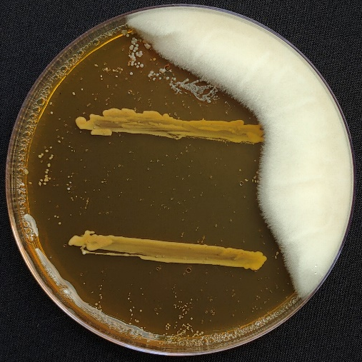 | b. | 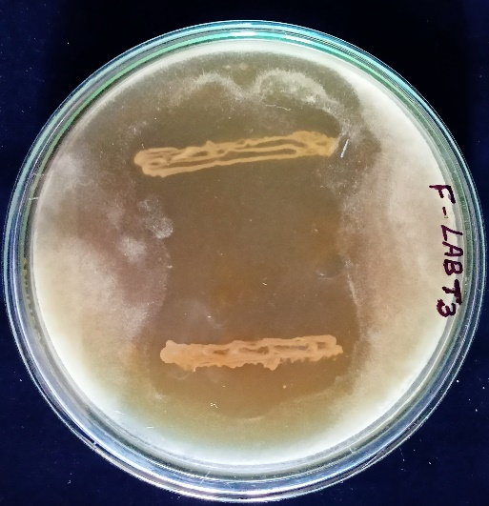
c. | 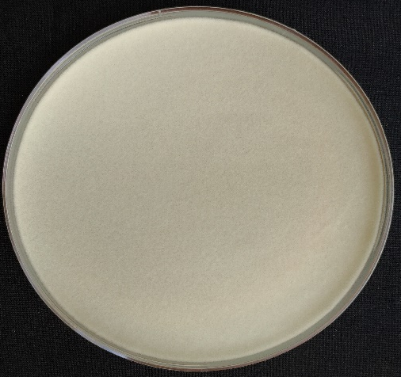 | d. | 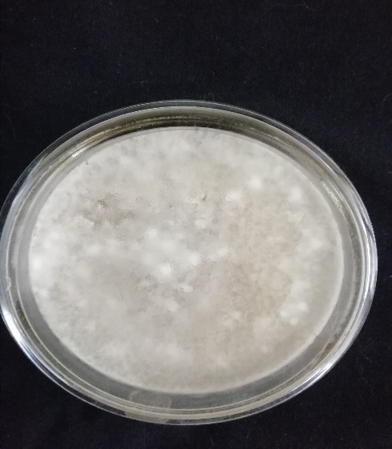

Figure 2: Percentage of fungal inhibition by LAB isolates from different samples
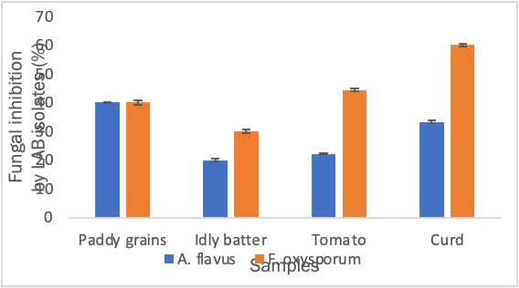
Error bars represent the standard error
Figure 3: Viable cell population of LABT3 isolate at different time intervals
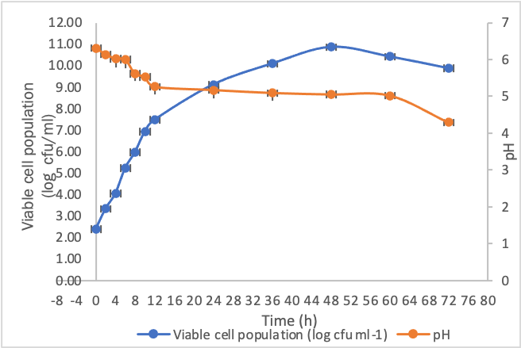
Error bars represent the standard error

Figure 4. pH (a) and temperature (b) tolerance of the isolate LABT3
a.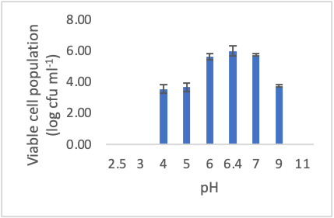 | b.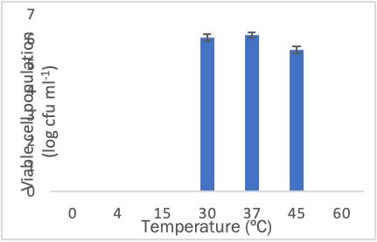
Error bars represent the standard error;

Figure 5. Growth under different bile salt concentration
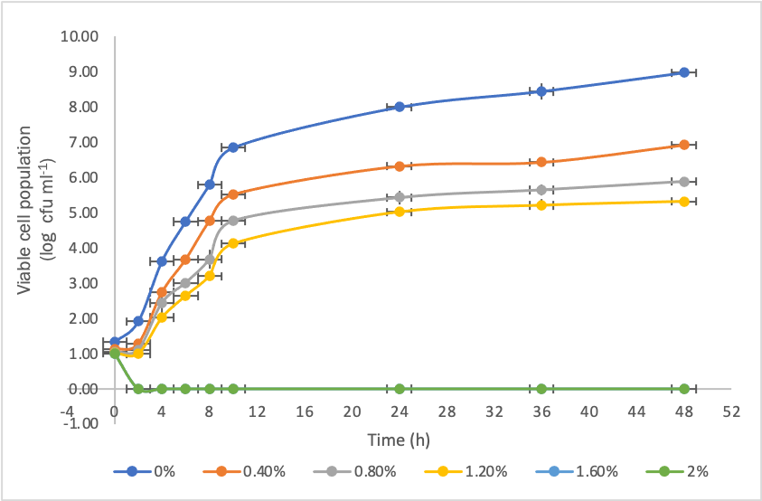
Error bars represent the standard error

