RESEARCH ARTICLE
Exogenous Plant Growth Regulators on Gas Exchange Parameters and Physiological Traits in Kharif Horsegram (Macrotyloma uniflorum)

ABSTRACT
Horsegram is an important pulse crop grown as Rabi crop in Tamil Nadu and not grown during Kharif season due to absence of flowering. An attempt was made to induce flowering in horsegram during Kharif season using plant growth regulators (PGRs). Field experiment was conducted to study the impact of PGRs viz., salicylic acid (100 ppm), chlormequat chloride (CCC - 250 ppm), mepiquat chloride (250 ppm), tri iodo benzoic acid (TIBA - 200 ppm) and nitrobenzene (0.2%) on gas exchange parameters and physiological traits associated with flowering in horsegram during Kharif season by foliar spray at 25 days after sowing. Among the PGRs, CCC showed its supremacy on gas exchange parameters and physiological traits related with flowering. However, foliar spray of TIBA registered the lowest number of tendrils (2.3) followed by CCC (3.0) compared to other treatments. Higher root length of 16.8 cm and RWC of 82.3% was found in CCC treatment. Among the treatments, CCC registered the highest photosynthetic rate (27.15 µmol m⁻² s⁻¹), transpiration rate (18.06 mmol m⁻² s⁻¹) and the lowest leaf temperature (26ºC). Also, the highest soluble protein content of 13.1 mg g⁻¹ was found in CCC treatment followed by salicylic acid (12.51 mg g⁻¹). Sucrose phosphate synthase (SPS) activity did not show any significant difference between the treatments and also flowering did not take place in any of the treatments. Among the plant growth regulators used, CCC registered its positive action on flowering by enhancing RWC, soluble protein and photosynthetic rate, however not enough to induce flowering.

Keywords: CCC, Horsegram, RWC, Soluble protein, Photosynthetic rate, Leaf temperature

INTRODUCTION
Horsegram, called as poor men’s crop, is widely grown in India. It is a drought tolerant crop, typically adapted to a wide range of soils. Among the pulses grown in India, it ranks third in area covering 17.02 lakh hectares with an annual production of 7.19 lakh tonnes. The national average productivity of horsegram is 494 kg ha⁻¹ (Suthar et al., 2017).
However, its photo and thermo-sensitive nature does not permit its horizontal expansion in non-traditional regions considered as a major constraint in horsegram production. Rabi is the only season for growing horsegram and second week of October is the optimum time of sowing in Tamil Nadu. Kharif sown crop does not flower and formation of more number of tendrils may be one of the main reasons for non flowering during kharif season. Hence, it is not grown in Tamil Nadu during kharif season.
Induction of flowering in horsegram during kharif season is an immense task and if achieved it is highly valuable for increment of national production. Use of plant growth regulators is one of the possible ways for the induction of flowering. Foliar application of TIBA produced more number of flowers per plant (Abdelkadir et al. 2010) in Jatropha curcas. Sivakumar et al. (2020) reported that the application of nutrient consortium along with CCC induced early flowering compared to control in horsegram. Foliar application of cycocel induced early emergence of inflorescences approximately 10 days earlier in chrysanthemum was reported by Qureshi et al. (2018). Nitrobenzene is a new generation plant energizer and induces profuse flowering (Mithila et al., 2012) in tomato. Pacheco et al. (2013) found that the foliar application salicylic acid registered higher number of inflorescences in marigold. Exogenous application of CCC and mepiquat chloride increased the number of flowers by 111% and 141% respectively in groundnut was stated by Vinothini et al. (2018).
Production of more number of tendrils is a major constraint and it acts as a sink and affects source-sink relationship ultimately flowering. Secondo and Reddy (2018) found that the greater proportion of photo-assimilates diverted for vegetative growth rather than reproductive parts leads to more plant height. Above statement clearly indicated that diversion of photosynthates to tendril, which is vegetative part, of horsegram can arrest the flowering. Based on this background, a study was undertaken for the induction of flowering in horsegram under kharif season using plant growth regulators. This was the first attempt made to induce flowering in horsegram during kharif season.

MATERIAL AND METHODS
A field experiment was conducted at Regional Research Station, Tamil Nadu Agricultural University, Paiyur during 2018 to 2020. Horsegram variety Paiyur 2 seeds were sown with the spacing of 30 x 10 cm during first week of July. Plant growth regulators include salicylic acid (SA - 100 ppm), chlomequat chloride (CCC - 250 ppm), mepiquat chloride (MC - 250 ppm), tri iodo benzoic acid (TIBA - 200 ppm) and nitro benzene (NB - 0.2%) were applied as foliar spray at 25 days after sowing along with control maintained with water spray and absolute control without any spray. The experiment was carried out in randomized block design with three replications.
To measure the root length, the plant was uprooted and the root was taken with minimum damage and the length from the cotyledonary node to the root tip was measured and expressed as cm. Number of tendrils per plant was counted manually in each replications and average was taken. The relative water content (RWC) was estimated according to Barrs and Weatherley (1962) and calculated by using following formula and expressed as per cent.
RWC = [(Fresh weight – Dry weight) / (Turgid weight – Dry weight)] x 100
Measurement of gas exchange parameters was performed by using Portable Photosynthesis System (PPS) (Model LCpro-SD., ADC BioScientific Ltd., Hoddesdon, UK) equipped with a halogen lamp (6400-02B LED) positioned on the cuvette. Third leaf from the top was used for the measurement and replicated thrice. Leaf was inserted in 3 cm² leaf chamber and PPFD at 1500 μmol photons m⁻² s⁻¹, and relative humidity (50-55%) were set. The photosynthetic rate (μmol CO₂ m⁻² s⁻¹), transpiration rate (mmol CO₂ m⁻² s⁻¹) and leaf temperature (ºC) were measured between 9 am to 11.30 am and the value was expressed with respective units. Soluble protein content of leaf was estimated as per the method of Lowry et al. (1951) and expressed as mg g⁻¹ fresh weight. Sucrose phosphate synthase activity was determined as described by Pavlinova et al. (2002). Sucrose content was estimated using anthrone reagent as the method modified by Ashwell (1957). Absorbance was measured at 630 nm and the activity was expressed in mg sucrose mg protein⁻¹ h⁻¹. The data on various parameters were analyzed statistically as per the procedure suggested by Gomez and Gomez (1984).

RESULTS AND DISCUSSION
The growth of the plant is determined by the root length and hence it is considered as an important parameter for the development process of plants. In the present study, the highest root length of 16.8 cm was recorded by foliar spray of CCC followed by TIBA (15.9 cm) while the lowest length of 13.7 cm registered in absolute control (Figure 1). Longer root length improves water and nutrient absorption from soil and helps growth and development of plant.
In the present study, root length increased up to 22.6% by the application of CCC. Increment of root length by the application of CCC might be due to the diversion of photo-assimilates to root growth instead tendril growth by its growth retardant nature. Anosheh et al. (2016) observed that the cycocel increased the IAA content which improved the root growth. Present study corroborated with the earlier investigation.
Fig 1. Effect of plant growth regulators on root length (cm) in Kharif Horsegram
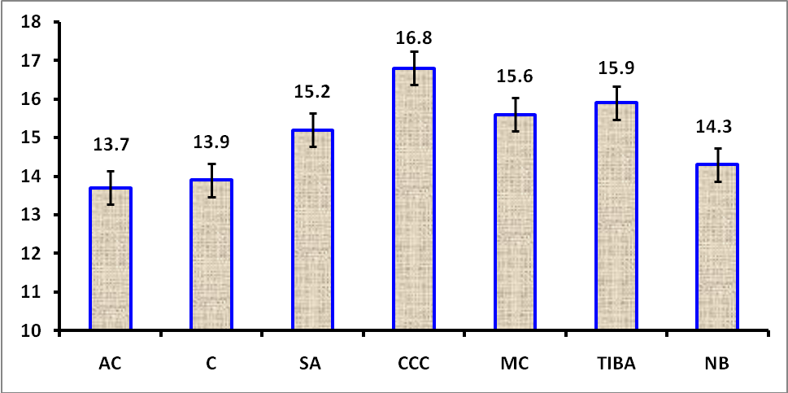
Tendrils are filamentous organs that permit climbing plants together to their neighbours. Horsegram has compound leaves and the leaf is further specialized organ formed at the terminal position of the leaf is a tendril, rather than a leaflet. Formation of tendrils indicates that the vegetative growth of the plant is continues. Even though tendril is a vegetative part, it is not useful for photosynthesis and flowering, however it utilizes photosynthates for its growth ultimately inhibit flowering. Hence, decrease the number of tendrils is a pre requisite for the induction of flowering.
In the present study, the highest number of tendrils (6.7) per plant was recorded in control while the lowest number of tendrils (2.3) in foliar spray of TIBA followed by CCC which recorded 3 numbers per plant (Figure 2). It clearly indicated that TIBA reduced the number of tendrils might be due to arresting the apical dominance by its anti-auxin role and CCC through its anti-gibberellin activity. Mansuroglu et al. (2009) reported that most plant growth retardants inhibit the growth by arresting the active gibberellins synthesis and reduce unwanted shoot elongation. Foliar application of CCC reduced the number of tendrils in horsegram was reported by Sivakumar et al. (2020). Present study corroborated with earlier findings.
Fig 2. Effect of plant growth regulators on tendril number in Kharif Horsegram
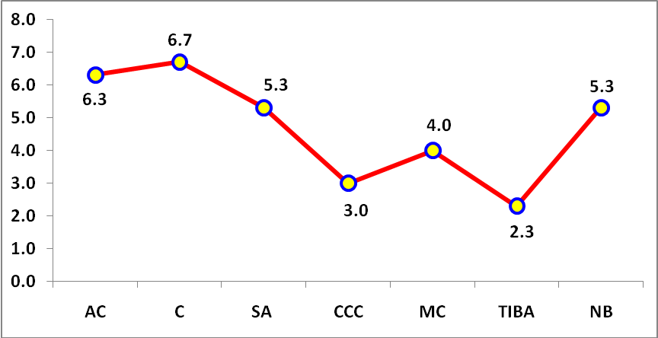
Exogenous application of CCC increased the photosynthetic rate and transpiration rate in horsegram under kharif season. Among the treatments, CCC recorded higher photosynthetic rate of 27.05 µmol m⁻² s⁻¹ followed by salicylic acid (25.52 µmol m⁻² s⁻¹) and lower photosynthetic rate of 24.46 µmol m⁻² s⁻¹ was recorded by absolute control (Table 1). The photosynthetic rate of a plant is a function of diffusion of CO₂ through stomata from atmosphere into chloroplast and the subsequent enzyme reactions. In the present investigation, application of CCC increased the photosynthetic rate up to 10.59% compared to control. The possible reason for the enhancement of photosynthetic rate by the application CCC might be due to the increased transpiration through stomatal opening. Wang et al. (2010) found that the application of CCC prevents chlorophyll destruction in potato and facilitate maintenance of photosynthetic rate. The highest photosynthetic rate was registered by foliar spray of 1% TNAU Horsegram Wonder which might be due to CCC as its constituent which enhanced the photosynthetic rate (Sivakumar et al., 2020). This result corroborated with the present study.
The lowest transpiration rate was recorded in water sprayed control (12.68 mmol m⁻² s⁻¹), while foliar spray of CCC registered the highest transpiration rate of 18.06 mmol m⁻² s⁻¹. Maintenance of transpiration rate is an essential to maintain the photosynthetic rate and leaf temperature. Among the treatments, CCC increased the transpiration rate up to 42.4% compared to control. This condition is attributed to reduce leaf temperature which helps the plants to tolerate high temperature. However, application CCC reduced the transpiration rate was reported by Wang et al. (2010) in potato.
Table 1. Impact of PGRS on gas exchange parameters, RWC and SPS activity in Kharif horsegram
Treatments | Photosynthetic rate  (µmol m⁻² s⁻¹) | Transpiration rate  (mmol m⁻² s⁻¹) | Leaf temperature  (ºC) | RWC (%) | SPS activity  (mg sucrose mg protein⁻¹ h⁻¹)
Absolute control | 24.46 | 12.78 | 27.4 | 73.8 | 1.21
Control | 24.64 | 12.68 | 27.6 | 74.1 | 1.21
Salicylic acid | 25.52 | 15.30 | 26.7 | 77.5 | 1.25
CCC | 27.05 | 18.06 | 26.0 | 82.3 | 1.31
Mepiquat chloride | 24.95 | 14.91 | 26.8 | 78.6 | 1.29
TIBA | 24.77 | 14.92 | 26.9 | 76.9 | 1.34
Nitro benzene | 24.84 | 13.15 | 27.2 | 74.7 | 1.31
SEd | 0.682 | 0.375 | 0.302 | 1.98 | 0.088
CD (P=0.05) | 1.377 | 0.809 | 0.611 | 4.14 | NS
Leaf temperature is an important physiological trait for plant growth and flower induction. Foliar spray of CCC reduced the leaf temperature compared to unsprayed one. Water sprayed control registered higher leaf temperature of 27ºC. However, the lowest leaf temperature of 26ºC was found in CCC spray which is on par with salicylic acid (26.6ºC). The increased transpiration rate directly lowers the leaf temperature contributed positively to the plant health. In the present study, leaf temperature was reduced up to 1.6ºC by the application of CCC compared to control. The reduced leaf temperature by the application of CCC might be due to increased transpiration rate which cools the plant. Anosheh et al. (2012) reported that the canopy temperature reduced by the application of CCC in wheat may be due to improving stomatal regulation.
Relative water content (RWC) is an appropriate physiological trait which measures plant water status and also photosynthesis. CCC showed positive impact on RWC compared to control (Table 1). Among the treatments, CCC sprayed plants registered highest RWC of 82.3% followed by mepiquat chloride (78.6%).
Unsprayed absolute control recorded lowest RWC of 73.8% followed by water spray control (74.1%). RWC is considered as a reliable indicator that reflects the water content of plant and level of hydration (Rosales-Serna et al., 2004).
In the present study, application of CCC increased the RWC up to 11.5% compared to absolute control. Jiriaie and Sajedii (2012) reported that the CCC application increased RWC in wheat. The present study agreed with the earlier investigation. Even though CCC application increased the transpiration rate, the RWC of the plant could be maintained by the increment of root length to absorb more water from the soil.
Fig. 3. Effect of plant growth regulators on soluble protein content in Kharif Horsegram
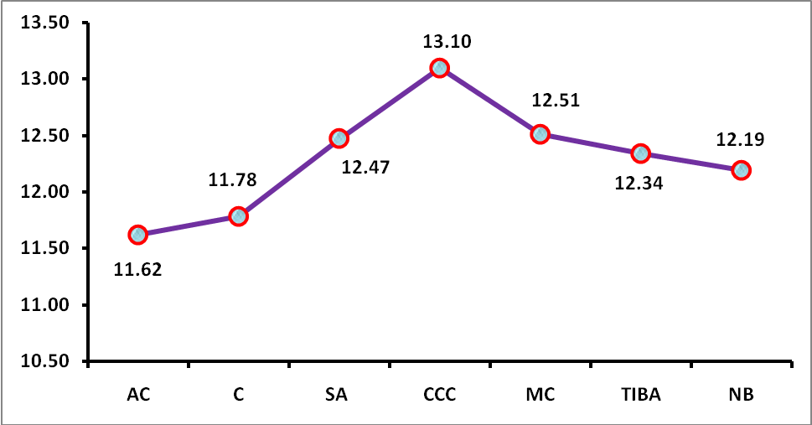
Rubisco enzyme occupied more than 50 per cent of the soluble proteins in crop plants was reported by Myat et al. (2014). Hence, the soluble protein content is an indirect index for assessing photosynthetic efficiency of crop plants. Among the treatments, foliar spray of CCC registered higher soluble protein content of 13.10 mg g⁻¹ while lower was recorded in absolute control (11.62 mg g⁻¹). An increment of 12.7% soluble protein was observed in the present study by the application of CCC (Figure 3). Bhagure and Tamble (2013) reported that the CCC has the ability to promoting the synthesis of soluble protein and enzyme. An increment of 15.4% soluble protein content was observed in horsegram by the application of TNAU Horsegram Wonder which contains CCC as main component (Sivakumar et al., 2020). The present study corroborated with the earlier findings.
Sucrose phosphate synthase (SPS) is the plant enzyme which plays a major role in sucrose biosynthesis and sustains the assimilatory carbon flux from source to developing sink (Isopp et al., 2000). In the present study, exogenous application of plant growth regulators did not show any significant difference in the SPS activity. Chen et al. (2005) found that SPS enzyme involved in the partitioning of photo-assimilates and regulating the partitioning of carbon between starch production and carbohydrate accumulation in many physiological and developmental processes. Baxter et al. (2003) reported that the increased rates of SPS activity have accelerated flower development and profound impact on flowering. However, no one plant growth regulators used in this study showed positive effect on SPS activity. This may be one of the reasons for absence of flowering in horsegram under kharif season.

CONCLUSION
Exogenous application of CCC (250 ppm) showed some positive initiation to induce flowering by reduced the number of tendrils, enhancement of RWC, soluble protein and photosynthetic rate. However, it does not show any positive impact on SPS activity. Hence, it is not enough to produce flowers even in the favorable physiological traits achieved except SPS activity. Further study is required on gene profiling under kharif season to achieve the target.

REFERENCES
Abdelkadir, H.A., A.K. Jager, S.D. Johnson and J.V. Staden. 2010. Influence of plant growth regulators on flowering, fruiting, seed oil content, and oil quality of Jatropha curcas. South Afr. J. Bot., 76(3): 440-446
Anosheh, H.P., Y. Emam, M. Ashraf and M.R. Foolad. 2012. Exogenous application of salicylic acid and chlormequat chloride alleviates negative effects of drought stress in wheat. Adv. Stud. Biol., 4 (11): 501-520
Anosheh, P., Y. Emam and A. Khaliq. 2016. Response of cereals to cycocel application. Ir. Agri. Res., 35(1): 1-12.
Ashwell, G. 1957. Colorimetric analysis of sugars. In: S. P. Colowick and N. O. Kaplan (eds.), Methods in Enzymology, III, pp. 73-105, Academic Press, New York.
Barrs, H.D. and P.E. Weatherley. 1962. A re-examination of relative turgidity for estimating water deficits in leaves. Aus. J. Biol. Sci., 15: 413-428.
Baxter, C.J., C.H. Foyer, J. Turner, S.A. Rolfe and W.P. Quick. 2003. Elevated sucrose-phosphate synthase activity in transgenic tobacco sustains photosynthesis in older leaves and alters development. J. Exp. Bot., 54: 1813-1820
Bhagure, Y.L. and T.B. Tamble. 2013. Effect of seed soaking and foliar sprays of plant growth regulators on germination, growth and yield of okra (Abelmoschus esculentus (L.) Moench) var. Parbhani Kranti. The Asian J. Hort., 8(2): 399-402.
Chen, S., M. Hajirezaei and F. Bornke. 2005. Differential expression of sucrose-phosphate synthase isoenzymes in tobacco reflects their functional specialization during dark-governed starch mobilization in source leaves. Pl. Physiol., 139(3): 1163-1174.
Gomez, K.A. and Gomez, A.A. 1984. Statistical procedures for agricultural research. (2nd Ed.) John Wiley and sons, NewYork, USA.
Isopp, H., M. Frehner, S.P. Long and J. Nosberger. 2000. Sucrose phosphate synthase responds differently to source-sink relations and photosynthetic rates: Lollium perenne L. growing at elevated CO₂ in the field. Pl. Cell Environ., 23: 597-607.
Jiriaie, M. and N.A. Sajedii. 2012. Effect of plant growth regulators on agro physiological traits of wheat [Triticum aestivum (L.) var. Shahriar] under water deficit stress. Res.Crops, 13(1): 37-45.
Lowry, O.H., N.T.R. Brought, L.A. Farr and R.J. Randall. 1951. Protein measurement with folin phenol reagent. J. Biol. Chem., 193: 265-275.
Mansuroglu, S., O. Karaguzel, V. Ortacesme and M.S. Sayan. 2009. Effect of paclobutrazol on flowering, leaf and flower colour of Consolida orientalis. Pak. J. Bot., 41: 2323-2332.
Mithila, D., R. Sajal and S.M. Imamul Huq. 2012. Effects of nitrobenzene on growth of tomato plants and accumulation of Arsenic. Bang. J. Sci. Res., 25: 43-52.
Myat, T., A. Lin, P. Occhialini, A.J. John Andralojc, M. Martin, M. Parry and R. Hanso. 2014. A faster Rubisco with potential to increase photosynthesis in crops. Nature, 513: 547-550.
Pacheco, A.C., C.S. Cabral, E.S.S. Fermino and C.C. Aleman. 2013. Salicylic acid-induced changes to growth, flowering and flavonoids production in marigold plants. J. Med. Plant Res., 7(42): 3158-3163.
Pavlinova, O.A., E.N. Balakhontsev, M.F. Prasolova and M.V. Turkina. 2002. Sucrose phosphate synthase, sucrose synthase and invertase in sugar beet leaves. Russ. J. Plant Physiol., 49: 68-73.
Qureshi, I.A., S. Gulzar, A. Rashid, R. Rehman and T. Inayatullah. 2018. Effect of growth retardants on the growth and flowering of Chrysanthemum morifolium cv. Flirt. Ind. J. Agric. Res., 52(3): 319-322.
Rosales-Serna, R.J., J.A. Kohashi-Shibata, C. Acosta-Gallegos, J. Trejo-Lopez, Ortiz-Cereceres and K.D. Kelly. 2004. Biomass distribution, maturity acceleration and yield in drought-stressed common bean cultivars. Field Crops Res., 85: 203-211.
Secondo, A.S.P. and Y.A.N. Reddy. 2018. Plant growth retardants improve sink strength and yield of sunflower. Inter. J. Curr. Microbiol. App. Sci., 7(10): 111-119.
Sivakumar, R., M. Vijayakumar and N. Tamilselvan. 2020. Impact of foliar spray of PGR nutrient consortium on growth, photosynthesis and yield of horsegram (Macrotyloma uniflorum Lam) under rainfed condition. Leg. Res. Inter. J., DOI: 10.18805/LR-4413
Suthar, R., P.H. Patel, A. Kumar and Urmila. 2017. Effect of horsegram (Macrotyloma uniflorum Lam. Verdec) varieties and different row spacing on yield attributes and yield. Life Sci. Inter. Res. J., 4: 1-6.
Vinothini, N., R. Vijayan and R. Umarani. 2018. Impact of foliar application of plant growth regulators on seed filling and seed multiplication rate in groundnut (Arachis hypogaea L.). Inter. J. Chem. Stud., 6(5): 2186-2189.
Wang, H., L. Xiao, J. Tong and F. Liu. 2010. Foliar application of chloro choline chloride improves leaf mineral nutrition, antioxidant enzyme activity, and tuber yield of potato (Solanum tuberosum L.). Sci. Hort., 125: 521-523.

