Rice Yield under High-Temperature Stress is Influenced by Morpho –Physiological Traits

ABSTRACT
High-temperature stress adversely affects crop production, particularly reducing the rice yield. It is essential to study the effect of heat stress on morphological, physiological, and yield responses to develop mitigation strategies. Hence the present work was carried out by raising Nagina (N22) and Coimbatore 51 (CO51) rice varieties in controlled conditions. Increased plant height and tiller number were observed in case of high-temperature conditions, coupled with reduced leaf area and chlorophyll index observed. Exposure of plants to high temperatures also resulted in a reduction of panicle length, panicle weight, and thousand-grain weight, which ultimately resulted in lower grain yield. Percent reduction in physiological traits such as leaf area and chlorophyll index was less in N22 compared to CO51. N22 had the highest panicle length, panicle weight, and thousand-grain weight under heat stress, thus maintaining the yield under stress.

Keywords: Rice, morpho-physiological traits, yield components, high-temperature stress.

INTRODUCTION
Rice is a staple food crop cultivated in Asian continents. An increase in frequency and intensity of high temperature emerges as a potential threat to the sustainability of rice production. Rice is extremely sensitive to heat stress during the reproductive stage, whereas it is tolerant at the vegetative stage (Jagadish et al, 2010). According to NOAA (2019), land and ocean temperature has increased by an average of 0.07 °C per decade. High temperature restricted the growth of the plant and reduced the yield up to 41% (Krishnan, 2011).
Heat stress changes morphological, physiological, and biochemical characters which serve as a base for yield reduction (Wang et al, 2003). With the rising temperature, plant height, and the number of tillers increases in rice (Oh-e et al, 2007). High temperature reduces leaf area due to early senescence (Sebastian and Selvaraju, 2017) and lowers SPAD values that contribute to reduced dry matter accumulation and yield (Kurniawan et al, 2019).
During ripening, the panicle is a highly sensitive organ to high-temperature stress (Morita et al, 2004). Panicle length and panicle weight in rice may get affected as temperature attains beyond 35 °C (Gaballah and Abu, 2019). Paddy yield had a strong genetic correlation with the number of grains per panicle and 1000 grain weight (Karwa et al, 2020). So far, physiology and yield under heat stress are studied separately, and to date, there is no clear understanding of the morpho-physiological traits that impact the yield of rice under high-temperature stress. Hence, the present study was designed with the following objectives (i) To identify morpho-physiological traits that influenced yield under high-temperature stress. (ii) To correlate the yield with morphological and physiological traits such as plant height, tiller number, leaf area, chlorophyll index, panicle length, panicle weight, and 1000 grain weight.

MATERIAL AND METHODS
Rice genotypes
Coimbatore 51 (CO51) a popular rice variety in Tamil Nadu, high yielding but susceptible to high-temperature stress (HTS). Nagina 22 (N22) a landrace of rice used as an ideal donor for high-temperature stress tolerance.
Growth chamber and heat treatments
The research was conducted in Open Top Chamber (OTC), Department of Crop Physiology, TNAU Coimbatore, during Feb-June 2019. OTC is made of a polycarbonate sheet of 4m×4m×4m. The whole experiment needed two chambers, one for control (Ambient temperature) and others for exposing high temperature (+5 °C from ambient). By using infrared source and humidifiers and wireless signal transmission with SCADA integration facility, temperature and relative humidity (RH) were maintained inside the chambers. Sixteen pots were placed inside the chambers. From the anthesis to the early grain grail filling stage, high-temperature treatments were imposed. The maximum temperature for control and high-temperature chambers ranged from 33.19°C – 42.88°C, with high RH in control (80.29%) and HTS (74.89%) (Figure 1).
Morpho- physiological traits
All the morpho-physiological traits were measured after completion of stress treatments at the mid grain filling stage (10 DAF). Plant height was measured from the soil surface to top of the longest leaves/panicle and expressed in cm/plant. The number of tillers was measured after the flowering stage by manual counting. The chlorophyll index was measured on the flag leaf using Soil-plant analysis development (Minolta SPAD 502). From each replication and treatment, three values were recorded. As described by Minolta (1989) and Jumiatun et al (2016), the average values were computed. Leaf area (m²/plant) was measured after the flowering stage using leaf area meter (LICOR, Model LI 3000).
Yield and yield components
Panicle length (m) was measured from the base of the top of the panicle. After harvesting, panicle weight (g) was observed. Three values of both panicle length and panicle weight were recorded for each variety and treatment. The grain yield of both the cultivars was recorded and expressed in gram. Weight of 1000 grain (g) was estimated from filled grains.
Statistical analysis
Treatments were arranged in a completely randomized design (CRD) with eight replications. Using SPSS (Statistical Package Social Sciences) software Pearson correlation analysis, including all morphological, physiological, and yield traits were correlated.

RESULTS AND DISCUSSION
Morphological responses
Results showed that high temperatures increased plant height in heat tolerant and susceptible rice varieties. When exposed to high temperature, N22 showed higher plant height (158.9 cm) than CO51 (104.1 cm) (Table. 1). This is similar to the findings of Sandeep et al. (2020), who reported that high temperature causes an increment in plant height, and it acts as an important factor for genetic differentiation in rice genotypes. Interaction between high-temperature treatment and varieties affects the tiller number, and it gets increased with rising temperatures. Compared to control, tiller numbers of both N22 (10) and CO51 (14) were higher at elevated temperatures. Plant height was positively correlated with grain yield but negatively correlated with the number of tillers (Table. 2). These results reflected that the lesser tiller number and higher plant height in N22 is one of the reasons to mitigate heat stress and maintain yield when exposed to HTS.
Physiological responses
High temperature decreased the leaf area and chlorophyll index (SPAD) in rice varieties. Leaf area of N22 under control and high temperatures were 0.98 m² and 0.89 m² respectively, while those of CO51 were 0.17 m² and 0.13 m², respectively (Figure 2). A less reduction in leaf area of N22 (9.18%) was observed under elevated temperature compared to that of CO51 (23.53%). Similarly, from the above findings, Gupta and Guhey (2011) reported a significant reduction in leaf area in susceptible genotypes than tolerant genotypes under HTS. Thus, an optimum leaf area is required to maintain photosynthesis and grain yield under heat stress.
In the present study, N22 recorded a higher chlorophyll index in control (42.4) and elevated chambers (40.4). N22 recorded lesser percentage reduction (4.71%) compared to CO51 (7.86%) over control (Figure 2). It collaborates with the results of Tafesse et al. (2020), who reported a 14.67 % reduction at high temperatures over control. Lower reduction in chlorophyll content under heat is a good indicator of tolerance, which has been proved in rice varieties. According to Nirmal Kumar et al (2018) decreased chlorophyll content was observed in rice at elevated temperature. These data supported a positive correlation between leaf area, chlorophyll index, and grain yield (Table. 2).
Yield responses
Yield and yield components were assessed using panicle length, the weight of primary panicle per plant, and 1000 grain weight. Panicle length and panicle weight was significantly affected by an increase in temperature. In the present study, N22 recorded a higher panicle length (30.7 cm) with a lower reduction over control (2.84%). The heat susceptible CO51 had lower panicle length (22.83%) with a higher reduction (8.93%) compared to control (Table. 1). N22 recorded the highest panicle weight of 2.72 g and 2.49 g at ambient and elevated temperatures. CO51 invariably showed a higher panicle weight of 3.21 g under control, but the great decline was recorded (26.16%) compared to N22 (10.10%) at HTS (Table. 1). These results were similar to the findings of Gaballah and Abu (2019) where panicle length and panicle weight of rice genotypes was reduced due to heat stress.
At elevated temperature, N22 showed higher grain yield (62.48 g) than the CO51 (55.37 g) when subjected to high temperature (Figure 3). A less percent reduction of grain yield was observed in N22 (6.09%). Similarly to the results of Vivitha et al (2017), who reported a less percent reduction of yield in N22 up to 6.94% under heat stress condition. The yields of two varieties had a direct correlation with 1000 grain weight. N22 recorded a higher 1000 grain weight of 19.59 g, and CO51 had a lower weight of 14.90 g at HTS (Figure 3). Correlation studies also agreed with the conclusion that yield was positively correlated with panicle length, panicle weight, and 1000 grain weight (Table. 2). The study proved N22 as a heat-tolerant cultivar (Ye et al 2012).

CONCLUSION
Heat stress in rice varieties affected leaf area, chlorophyll index values, panicle length, panicle weight, and 1000 grain weight significantly. The yield was found to be negatively correlated to plant height and number of tillers. The heat-tolerant N22 had better yield because of higher panicle length, panicle weight, and 1000 grain weight, coupled with a lesser reduction in leaf area and chlorophyll index values.

REFERENCES
Anil Sebastian and P. Selvaraju. 2017. Crop phenology and seed yield as influenced by high-temperature stress in rice. International J. of Agricultural Science and Research., 7(6): 419-426.

Gaballah, M. M., and A. F. Abu. 2019. Genetic behavior of some rice genotypes under normal and high-temperature stress. Alexandria Science Exchange J., 40(2): 370-384.

Gupta, R., and A. Guy. 2011. Responses of rice genotypes to water stress imposed at the early seedling stage. Oryza., 48(4): 366-369.

Jagadish, S. V. K., Cairns, J., Lafitte, R., Wheeler, T. R., Price, A. H., and P. Q. Craufurd. 2010. Genetic analysis of heat tolerance at anthesis in rice. Crop Sci., 50(5): 1633–1641.

Jumiatun, A. Junaedi, Lubis, M.A. Chozin and A. Miyazaki. 2016. Morphological, Physiological and Yield Responses of Some Rice Varieties (Oryza sativa L.) as Exposed Under High Temperature in Indonesia. American Journal of Plant Physiology., 11(1-3): 33-41.

Karwa, S., Bahuguna, R. N., Chaturvedi, A. K., Maurya, S., Arya, S. S., Chinnusamy, V. and M. Pal. 2020. Phenotyping and characterization of heat stress tolerance at reproductive stage in rice (Oryza sativa L.). Acta Physiologiae Plantarum., 42(2): 1-29.

Krishnan, R., Ramakrishnan, B., Reddy, K. R. and V. R. Reddy. 2011. High- temperature effects on rice growth, yield and grain quality. Adv. Agron., 111: 87-206.

Kurniawan, D. Y., Junaedi, A., Lubis, I. and T. C. Sunarti. 2019. Evaluation of growth and physiological responses of three rice (Oryza sativa L.) varieties to elevated temperatures. Indian J. of Tropical Sci., 6(1): 17-23.

Minolta, C. 1989. Manual for Chlorophyll meter SPAD-502. Minolta Cameraco., Osaka, Japan.

Morita, S., Yonemaru, J.I. and J.I. Takanashi. 2005. Grain growth and endosperm cell size under high night temperatures in rice (Oryza sativa L.). Ann Bot., 95: 695–701.

Nirmal-Kumar, A. R., Vijayalakshmi, C. and D. Vijayalakshmi. 2018. Combined effects of drought and moderately high temperature on the photosynthesis, PS II photochemistry and yield traits in rice (Oryza sativa L.). Indain Journal of Plant Physiology., 23(3): 408–415.
NOAA, 2020. National Centers for Environmental Information: Global Climate Report- an analysis of global temperatures and precipitation, placing the data into a historical perspective. http://www.ncdc.noaa.gov/sotc/global/202005.
Oh-e, I., Saitoh, K. and T. Kuroda. 2007. Effects of high temperature on growth, yield and dry-matter production of rice grown in the paddy field. Plant Production Sci., 10 (4): 412-422.
Sandeep, S., Sujatha, M., Subbarao, L. V. and C. N. Neeraja. 2020. Assessment of morphometric diversity for yield and yield attributing traits in rice (Oryza sativa L.) for tolerance to heat stress. Current Journal of Applied Science and Technology., 39(10): 29-49.

Tafesse, E.G., Gali, K. K., Lachagari, V. B. R., Bueckert, R. and T. D. Warkentin. 2020. Genome- wide association mapping for heat stress responsive traits in field pea. Int. J. Mol. Sci., 21(2043): 1-26.

Vivitha, P., Raveendran, M. and D. Vijayalakshmi. 2017. Introgression of QTLs controlling spikelet fertility maintains membrane integrity and grain yield in improved white Ponni derived progenies exposed to heat stress. Rice Science., 24(1): 32-40.

Wang, W., Vinocur, B. and A. Altman. 2003. Plant responses to drought, salinity and extreme temperatures: Towards genetic engineering for stress tolerance. Planta., 218: 1-14.

Ye, C. R., Argayoso, M. A., Redona, E. D., Sierra, S. N., Laza, M. A., Dilla, C. J., Mo, Y. J., Thomson, M. J., Chin, J., Delavina, C. B., Diaz, G. Q. and , J. E. Hernandez. 2012. Mapping QTL for heat tolerance at flowering stage in rice using SNP markers. Plant Breeding, 131(1): 33–41.

Table 1. Morpho-physiological traits of rice under high-temperature stress
Rice Varieties | Plant height (cm) | Number of tillers | Panicle length (cm) | Panicle weight (g)
N22 Control  N22 Stress  Percent decrease | 153.96  158.9  -3.21 | 8  10  -25.0 | 31.6  30.7  2.84 | 2.77  2.49  10.10
CO51 Control  CO51 Stress  Percent decrease | 101.03  104.1  -3.03 | 13  14  -7.69 | 25.07  22.83  8.93 | 3.21  2.37  26.16

Table 2. Correlation between yield with SPAD and morphological parameters

 | Yield | Plant height | Tiller | Panicle length | Panicle weight | Leaf area | SPAD | 1000 grain weight
Yield | 1
Plant height | 0.128 | 1
Tiller | -0.438 | -0.916 | 1
Panicle length | 0.412* | 0.956* | -0.975* | 1
Panicle weight | 0.766** | -0.540 | 0.225 | -0.270 | 1
Leaf area | 0.261* | 0.986* | -0.970* | 0.985* | -0.419 | 1
SPAD | 0.883* | 0.579 | -0.792 | 0.792 | 0.374 | 0.681 | 1
1000 grain weight | 0.353* | 0.973* | -0.971* | 0.998** | -0.331 | 0.993** | 0.751 | 1

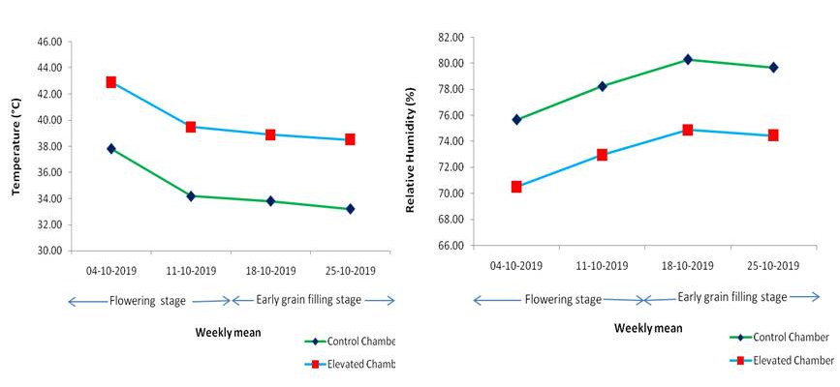
Figure 1. Temperature and Relative humidity in ambient and elevated chambers

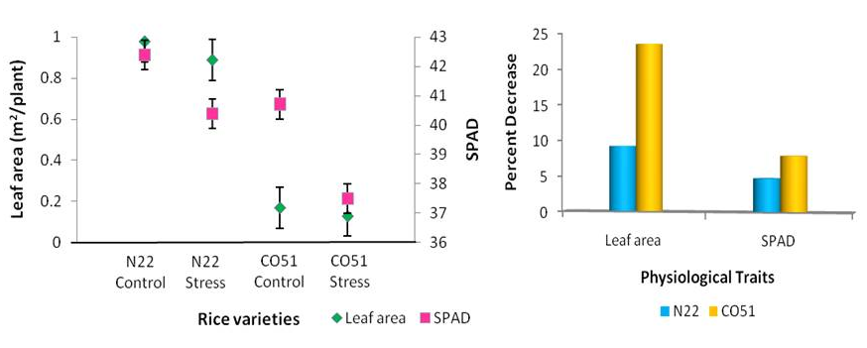
Figure 2. Variation in leaf area and SPAD in rice genotypes exposed to HTS

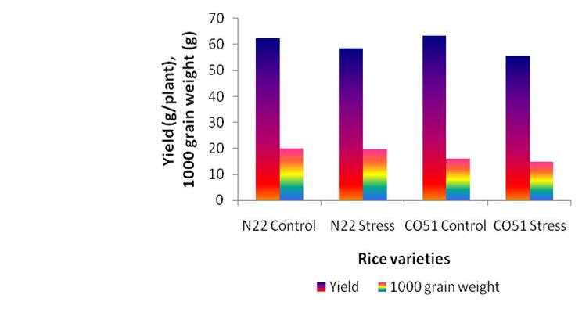
Figure 3. Effect of heat stress on grain yield and 1000-grain weight

