RESEARCH ARTICLE

**Screening of Rice Landraces for Insect Pests and its Comparison with Other Popular Rice Varieties**

|  |  |
| --- | --- |
|  | ABSTRACT Rice landraces are traditional gene resources considered as a valuable asset for the breeders.Value of these traditional land races are neglected due to intensive cultivation of high yielding varieties. In order to realize the significance of traditional land races and to identify better genetic resources, screening of landraces for their resistance against major pests and comparing with the cultivated varieties is important. Hence, the present study was carried out to assess the insect pest population in selected rice landraces and varieties under field condition. The observations were recorded at four important stages of rice *viz.,* early tillering, active tillering, booting and panicle development. Most of the rice landraces were observed to perform similar to other varieties with no significant difference. However, landraces like mattai triveni and aathira were found to be highly susceptible to yellow stem borer and rice leaf folder respectively at reproductive stage. Except for plant hoppers thuyamalli was tolerant to other pests. Sivappu chithiraikar was highly tolerant to hopper pests like Ptb33.  Abstract should be re-written with more results |

Keywords: Rice landraces, varieties, screening, insect pests, stages of rice.

## INTRODUCTION

## Rice is the important food crop consumed by more than half of the global population. More than 90% of its production is from the tropical and semi-tropical Asia. Recently, the cultivation of traditional rice landraces and its conservation is the felt need and is gaining significance (Rana et al., 2009). The diverse gene pool of the rice landaces will be the future key to food security in countries like India (Maikhuri et al. 1996). The landraces are also reported to be highly nutritious and medicinal. On comparison with the other popular high yielding varieties, rice landraces are reported to possess higher dietary fibre content and lower phytate content (Longvah and Prasad, 2020). Moreover, the coloured rice landraces are preferred by the people for its medicinal properties. They are found beneficial to treat diabetes, heart diseases, anemia, improve eye sight, kidney function, etc (Sompong et al., 2011 and Gayacharan et al., 2019).

## Around 1,40,000 rice landraces are reported globally of which India alone is believed to treasure 50,000 landraces (IGMORIS, 2017). However, due to the introduction of many high yielding rice varieties and hybrids, the cultivation of traditional rice landraces had declined drastically. This poses a serious threat in the extinction of traditional rice landraces in Asia. The underexploited traditional rice landraces can be of high economic significance if explored well for its tolerance level to various biotic stresses. Due to their high genetic diversity, the rice landraces are said to have the ability to tolerate the changing environmental conditions as well as resist new biotic stresses. However, minimum reports have been made in the population studies of insect pest and natural enemies in rice landraces. Hence, the present study aims at field screening of some of the rice landraces of Tamil Nadu for insect pests and is compared with other popular rice varieties. This will help in understanding the biotic stress tolerance level in the rice landraces compared with other cultivated varieties.

## MATERIAL AND METHODS

## *Rice landraces/ varieties*

## The seeds of the following rice landraces: Kallurundaikar, Poonkar, Thavala kanan, Kala Namak, Kuzhiadichan, Norungan, Thuyamalli, Aathira, Varapu Kudaichan, Sivappu Chithiraikar, Karuthakar and Mattai Triveni were obtained from the department of plant genetic resources, Tamil Nadu Agricultural University Coimbatore. Other rice varieties like IR 20, PTB 33, TN 1 and CO 52 were obtained from the department of Rice, Tamil Nadu Agricultural University, Coimbatore.

## *Field*

## A paddy field of 400 square meters was taken for the study. The field was located at the wetland, Tamil Nadu Agricultural University, Coimbatore. GPS coordinates of the location is 11.0031° N, 76.9249° E. Regular agronomic practices were followed to raise the crops under unprotected conditions. A total of sixteen rice landraces/varieties were raised in a plot size of 25 square meter each.

## *Insect sampling*

## Insect sampling was done for each landrace/variety at four important stages of rice like early tillering, active tillering, booting and panicle development. Three replications were done at each stage of sampling.

Methodology followed was not correct. It has to be re-written. Generalized statement of hoppers is not correct. There are several hoppers such as plant hoppers and leaf hoppers (GLH, BLH, BPH and WBPH, which needs to be specified

## *Insitu counting of insect pests*

## Visual insitu observation was made for the rice hopper pest complex and larval stage of minor pests like rice horned caterpillar, skipper and hairy caterpillar. Randomly three places were selected in each plot for sampling. Each place contributed to three replications. In each replication five hills were observed for the presence of insect pests and recorded.

## *Sweep net collection of insect pests*

## Other insect pests were assessed by sweep net method. One to and fro motion of the sweeps were considered as one sweep. Randomly three sweeps were made in each plot using the ordinary insect sweep net (673mm mouth diameter and 1076 mm long aluminium handle). The mean of the sweeps was calculated and represented as number of insects per sweep.

## *Insect damage assessment*

## Rice yellow stem borer and leaf folder damage were observed and recorded. In each plot randomly three places were chosen for observation. Yellow stem borer damage was assessed by recording the dead hearts and white ears at vegetative and reproductive stage respectively. Dead heart percent and white ear percent of damage was calculated using the following formula

## 

## Number of affected tillers per hill

## Per cent dead heart = X 100

## Total number of tillers per hill

## Number of affected tillers per hill

## Per cent white ear = X 100

## Total number of tillers per hill

## Rice leaf folder damage was assessed by recording the number of leaf folder damaged leaves. Per cent leaf folder damage is calculated as follows

## Number of damaged leaves per hill

## Per cent leaf damage = X 100

## Total number of leaves per hill

## RESULTS AND DISCUSSION

### Significant differences in yellow stem borer damage among the landraces and varieties were observed in the reproductive stage of the crop (Table 1). Highest record of white ear infestation was recorded in the rice landrace mattai triveni with 12.75% and the lowest was in thuyamalli (1.01%) and karuthakar (1.19%). Significant differences in leaf folder damage were observed in booting stage (Table 2). Overall, the landrace Aathira recorded highest leaf folder infestation (9.50%) and thuyamalli the lowest (1.80%). As far as stem borer and leaf folder infestation is concerned, the performance of the landrace thuyamalli is better with less infestation under field condition. On comparison of rice landraces with varieties, there is no much significant differences except during the reproductive stage of the plant.

### The insitu observation of hopper pests showed significant differences in the occurrence of white backed plant hopper (WBPH) at all stages of the plant (Fig.1). Their incidence was comparatively lower in all stages of the landrace sivappu chithitraikar. Thuyamalli had higher infestation of WBPH mainly at the booting stage of the crop which was similar to the laboratory screening results of Venkatesh et al. (2019). Brown plant hopper (BPH) incidence was also not observed in the landrace sivappu chithiraikar like ptb33. Sivappu chithiraikar has shown moderate resistance in artificial screening by Venkatesh et al. (2019). There was no significant difference in the occurrence of green leaf hopper and white hopper in the landraces and varieties. With respect to the incidence of minor pests, minimum incidence of pests like green horned caterpillar, skipper and hairy caterpillar were observed (Fig.3). Their occurrence was not constant and at each stage of rice plant each exhibited significant differences. Green horned caterpillar was maximum in thavala kanan at early tillering stage, skipper at varapu kudaichan in active tillering stage and hairy caterpillar in CO 52 of booting stage.

In Results and Discussion part, most of the statements are generalized statements. Results are not written properly and needs to be revised completely. For each pest the results are to be written elaborately. Conclusion is also general. Needs complete revision

### The sweep net sampling of insects showed that the landraces thuyamalli and varapu kudaichan did not record thrips; mattai triveni recorded comparatively higher yellow stem borer adults; poonkar and aathira had comparatively more leaf folder adult catches in reproductive stage of the crop (Fig. 2). Other minor pests were not found to show any preference in occurrence according to the landraces or variety.

## CONCLUSION

Overall, from the results it is understood that the incidence of majority of insect pests in the rice landraces is more or less similar to rice varieties. However, in certain cases, some landraces like mattai triveni, aathira were found to be highly susceptible for yellow stem borer and leaf folder respectively. Some landraces like thuyamalli were tolerant to these pests with minimum or no damage. The landrace thuyamalli is also reported to be drought tolerant (Anupriya et al., 2020). The performance of these landraces under laboratory screening should be done further for confirmation and selection of tolerant ones. The promising landraces can be used for resistance breeding programmes.

## REFERENCES

Anupriya, R., Pillai, M. A., Senthil, A., Rajakumar, D. and A. K. Binodh. 2020. Investigation on frequency distribution of traditional rice landraces for drought tolerance at seedling stage. *Electronic Journal of Plant Breeding*., **11(3)**: 867-874.

Bisht, I. S., Bhardwaj, R., Rana, J. C., Singh, A. K. and M. C. Yadav. 2019. Nutritional Diversity of Elite Rice Landrace from Subsistence-oriented Farming Systems. *Indian Journal of Plant Genetic Resources*., **32(1)**: 18-27.

IGMORIS (Indian Genetically Modified Organism Research Information System). 2017. Oryza sativa L. (Rice). Ministry of Environment, Forest and Climate Change, Government of India.

Longvah, T. and V. S. S. Prasad. 2020. Nutritional variability and milling losses of rice landraces from Arunachal Pradesh, Northeast India. *Food chemistry*., **318**: 126385.

Maikhuri, R. K., Rao, K. S. and K. G. Saxena. 1996. Traditional crop diversity for sustainable development of Central Himalayan agroecosystems. *The International Journal of Sustainable Development & World Ecology*., **3(3)**: 8-31.

Sompong, R., Siebenhandl-Ehn, S., Linsberger-Martin, G. and E. Berghofer. 2011. Physicochemical and antioxidative properties of red and black rice varieties from Thailand, China and Sri Lanka. *Food chemistry*., **124(1)**: 132-140.

Venkatesh, K., Soundararajan, R. P., Muthukrishnan, N. and P. Jeyaprakash. 2019. Evaluation of rice landraces for resistance to planthoppers and leafhoppers. *Electronic Journal of Plant Breeding*., **10(2)**: 413-418.

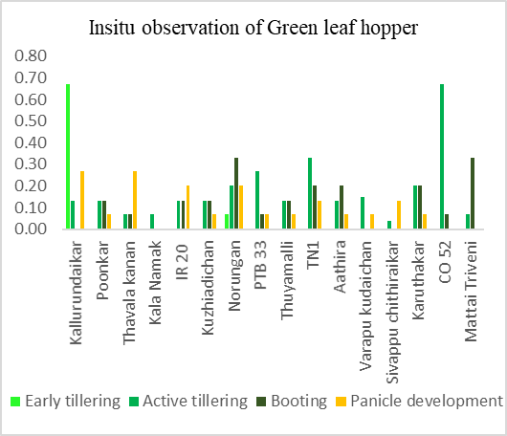 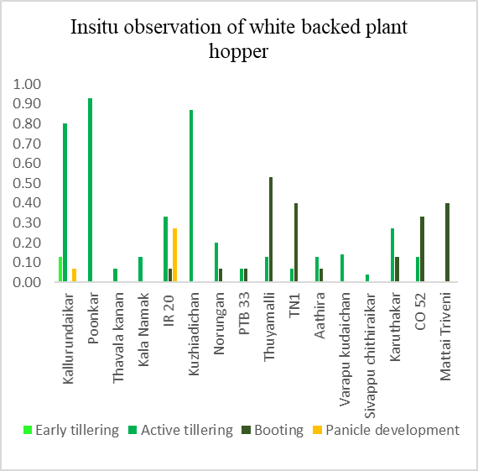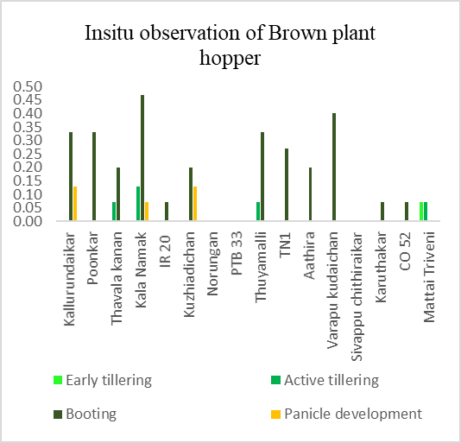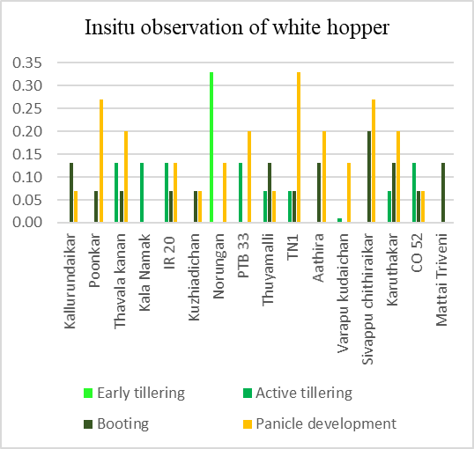

**Figure 1. Insitu observation of rice plant and leaf hoppers**

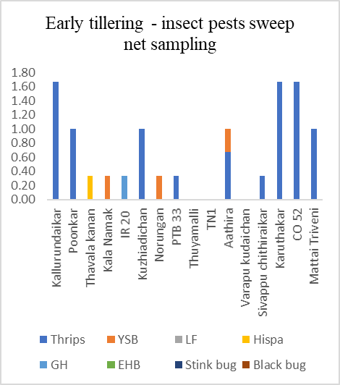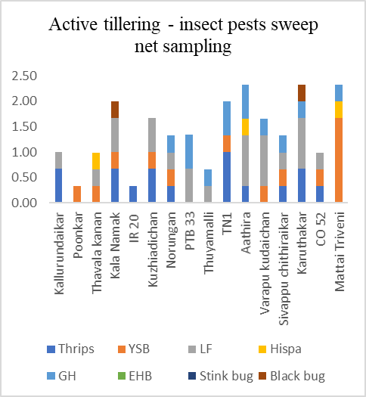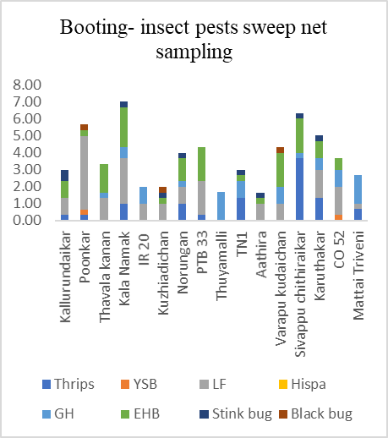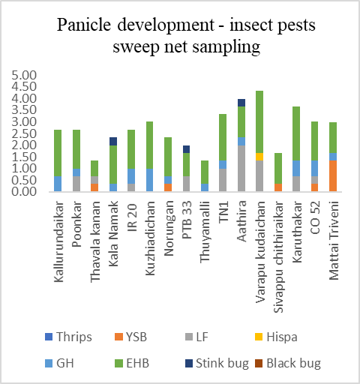

**Figure 2. Sweep net sampling of rice insect pests**

**Figure 3. Insitu observation of minor insect pest larvae**

Table 1. Yellow stem borer infestation in rice landraces

|  |  |  |  |  |  |  |  |  |  |  |  |  |  |  |  |
| --- | --- | --- | --- | --- | --- | --- | --- | --- | --- | --- | --- | --- | --- | --- | --- |
| S.NO. | Landraces | Early tillering | | | Active tillering | | | Booting | | | Panicle development | | | Mean % infestation | |
| Tillers | DH | % | Tillers | DH | % | Tillers | WE | % | Tillers | WE | % | Dead heart | White ear |
| 1 | Kallurundaikar | 2.87 | 0.07 | 3.33 | 7.20 | 0.53 | 9.93 | 11.73 | 0.87 | 8.43cd | 11.73 | 0.60 | 6.15 ab | 6.63 | 7.29 cd |
| 2 | Poonkar | 2.73 | 0 | 0 | 7.67 | 0.40 | 7.19 | 16.93 | 0.87 | 4.99bc | 16.93 | 0.40 | 2.46 ab | 3.60 | 3.72 ab |
| 3 | Thavala kanan | 3.53 | 0 | 0 | 6.67 | 0.33 | 6.07 | 14.07 | 1.20 | 8.75d | 13.80 | 1.00 | 7.71 ab | 3.04 | 8.23 d |
| 4 | Kala Namak | 3.00 | 0 | 0 | 8.67 | 0 | 0 | 12.00 | 0.40 | 3.35ab | 11.67 | 0.47 | 4.13 ab | 0 | 3.74 ab |
| 5 | IR 20 | 5.00 | 0 | 0 | 8.40 | 0.87 | 9.51 | 14.87 | 0.67 | 4.80bc | 14.73 | 0.73 | 5.01 ab | 4.76 | 4.90 bc |
| 6 | Kuzhiadichan | 3.07 | 0 | 0 | 10.47 | 0.80 | 8.19 | 14.33 | 0.27 | 1.80ab | 14.00 | 0.40 | 3.16 ab | 4.09 | 2.48ab |
| 7 | Norungan | 2.93 | 0 | 0 | 9.87 | 1.00 | 9.57 | 12.60 | 0.40 | 3.22ab | 12.53 | 0.53 | 5.19 ab | 4.78 | 4.20 abc |
| 8 | PTB 33 | 3.27 | 0.07 | 1.33 | 9.07 | 0.27 | 4.94 | 14.27 | 0.07 | 0.44a | 12.47 | 0.53 | 5.19 ab | 3.14 | 2.81 ab |
| 9 | Thuyamalli | 4.20 | 0 | 0 | 9.07 | 0.07 | 0.67 | 16.73 | 0.07 | 0.39a | 16.40 | 0.27 | 1.63a | 0.33 | 1.01a |
| 10 | TN1 | 3.33 | 0 | 0 | 8.87 | 0.27 | 2.61 | 12.60 | 0.27 | 2.11ab | 12.40 | 0.40 | 2.87 ab | 1.31 | 2.49 ab |
| 11 | Aathira | 3.53 | 0.13 | 3.33 | 8.07 | 0.13 | 2.41 | 9.07 | 0.20 | 2.31ab | 9.33 | 0.20 | 2.33 ab | 2.87 | 2.32ab |
| 12 | Varapu kudaichan | 5.07 | 0 | 0 | 9.07 | 0.20 | 2.32 | 13.53 | 0.40 | 3.03ab | 13.47 | 0.60 | 4.28 ab | 1.16 | 3.65 ab |
| 13 | Sivappu chithiraikar | 3.93 | 0 | 0 | 8.33 | 0.07 | 0.74 | 7.73 | 0.33 | 4.80bc | 12.40 | 0.47 | 4.07ab | 0.37 | 4.44 abc |
| 14 | Karuthakar | 3.93 | 0 | 0 | 8.73 | 0 | 0 | 19.67 | 0.20 | 1.02ab | 19.47 | 0.27 | 1.36a | 0 | 1.19a |
| 15 | CO 52 | 4.80 | 0.07 | 1.33 | 14.60 | 0.40 | 2.68 | 9.73 | 0.20 | 2.65ab | 10.47 | 0.53 | 5.29ab | 2.01 | 3.97 abc |
| 16 | Mattai Triveni | 7.80 | 0 | 0 | 11.93 | 0.87 | 7.16 | 11.73 | 1.20 | 10.12d | 12.53 | 1.93 | 15.39c | 3.58 | 12.75 e |
|  | F value |  |  | 0.841 |  |  | 1.754 |  |  | 5.924 |  |  | 4.166 | 1.431 | 7.563 |
|  | Sig (0.05) |  |  | NS |  |  | NS |  |  | 0.000 |  |  | 0.000 | NS | 0.000 |

Table 2. Rice leaf folder infestation in rice landraces

|  |  |  |  |  |  |  |  |  |  |  |  |  |  |  |
| --- | --- | --- | --- | --- | --- | --- | --- | --- | --- | --- | --- | --- | --- | --- |
| S.NO. | Landraces | Early tillering | | | Active tillering | | | Booting | | | Panicle development | | | Mean % infestation |
| Total no. of leaves | No. of Leaves infested | % infestation | Total no. of leaves | No. of Leaves infested | % infestation | Total no. of leaves | No. of Leaves infested | % infestation | Total no. of leaves | No. of Leaves infested | % infestation |
| 1 | Kallurundaikar | 8.53 | 0.73 | 12.62 | 26.40 | 2.33 | 8.97 | 45.33 | 0.87 | 2.36 ab | 44.07 | 0.33 | 0.98 | 6.24 |
| 2 | Poonkar | 9.73 | 0.60 | 5.22 | 27.13 | 0.53 | 1.78 | 66.47 | 0.33 | 0.58a | 64.27 | 0.27 | 0.47 | 2.01 |
| 3 | Thavala kanan | 10.93 | 0.87 | 11.35 | 30.00 | 1.87 | 7.44 | 56.00 | 0.13 | 0.21 ab | 53.93 | 0.27 | 0.51 | 4.88 |
| 4 | Kala Namak | 10.07 | 1.40 | 13.90 | 33.67 | 1.20 | 4.29 | 42.87 | 0.20 | 0.56ab | 41.40 | 0.40 | 1.03 | 4.94 |
| 5 | IR 20 | 20.07 | 1.53 | 7.88 | 33.47 | 2.60 | 7.88 | 58.93 | 0.40 | 0.73 ab | 56.13 | 0.47 | 0.91 | 4.35 |
| 6 | Kuzhiadichan | 11.00 | 1.60 | 12.62 | 53.67 | 0.60 | 1.05 | 53.60 | 0.27 | 0.60 ab | 52.60 | 0.27 | 0.74 | 3.75 |
| 7 | Norungan | 10.13 | 1.53 | 15.53 | 41.60 | 1.80 | 5.41 | 34.27 | 0.20 | 0.66 bc | 32.53 | 0.53 | 1.83 | 5.86 |
| 8 | PTB 33 | 12.27 | 0.73 | 7.97 | 38.80 | 0.60 | 2.37 | 46.47 | 0.53 | 1.06 ab | 32.53 | 0.53 | 1.83 | 3.31 |
| 9 | Thuyamalli | 16.80 | 0.87 | 4.30 | 31.07 | 0.40 | 1.51 | 67.80 | 0.33 | 0.54 ab | 65.80 | 0.53 | 0.84 | 1.80 |
| 10 | TN1 | 10.80 | 1.47 | 11.88 | 30.27 | 0.27 | 1.23 | 40.60 | 0.20 | 0.63 ab | 39.67 | 0.20 | 0.53 | 3.57 |
| 11 | Aathira | 12.13 | 3.60 | 26.11 | 26.80 | 0.87 | 3.18 | 23.87 | 0.73 | 3.32 c | 23.87 | 1.27 | 5.38 | 9.50 |
| 12 | Varapu kudaichan | 17.73 | 1.80 | 8.29 | 26.73 | 0.47 | 2.14 | 39.07 | 0.53 | 1.47 ab | 39.20 | 0.53 | 1.48 | 3.34 |
| 13 | Sivappu chithiraikar | 13.87 | 0.80 | 5.23 | 30.80 | 1.27 | 4.02 | 18.53 | 0.20 | 1.14 ab | 38.13 | 0.20 | 0.65 | 2.76 |
| 14 | Karuthakar | 12.67 | 1.00 | 7.74 | 35.13 | 2.47 | 7.89 | 59.07 | 0.20 | 0.33 ab | 58.47 | 0.27 | 0.44 | 4.47 |
| 15 | CO 52 | 14.80 | 0.93 | 5.98 | 47.00 | 0.47 | 1.14 | 23.33 | 0.33 | 1.50 ab | 24.80 | 0.80 | 3.26 | 2.74 |
| 16 | Mattai Triveni | 25.33 | 1.20 | 4.90 | 27.13 | 0.73 | 2.65 | 28.27 | 0.13 | 0.65 ab | 29.07 | 0.33 | 1.54 | 2.43 |
|  | F value |  |  | 1.246 |  |  | 1.360 |  |  | 2.183 |  |  | 1.993 | 1.094 |
|  | Sig (0.05) |  |  | NS |  |  | NS |  |  | 08 |  |  | NS | NS |