RESEARCH ARTICLE
Evaluation of Parallel Pipe Subsurface Drainage System in a Waterlogged Paddy Field

ABSTRACT
Inadequate natural drainage facilities and flat lands causes, some of the Cauvery river basin command are suffering waterlogging and alkalinity problems during the canal water supply and period of excess rainfall. Subsurface drainage system is the method to lower the depth to groundwater level below the root zone and creates a favorable environment for crop growth. A study has been conducted to evaluate the performance of the parallel drain subsurface system installed in farmers’ field at Sembari village, Lalgudi Taluk, Trichy District, Tamil Nadu in waterlogged paddy field during October 2020 to February 2021. Field experiment was conducted with the combination of three lateral drain spacing (7.5, 10.0 and 12.5 m) and two drain depth (60 and 80 cm). 63 mm PVC perforated pipes wrapped with coir envelope was laid as lateral drains at a grade 0.3 per cent. Inspection chambers connected with collector drains laid at a grade of 0.6 per cent were used to measure the drain water discharge, observation wells installed midway between lateral pipes drains were used for measuring the depth to ground water level. Hydraulic properties of soil, depth to water level, discharge collected in drain pipe were used as evaluation parameters. This study revealed that soil hydraulic conductivity has been increased to 30 per cent, pH, EC and ESP has been reduced to 12, 54 and 20 per cent respectively. The system has performed well to alleviate the waterlogged condition in 7.5 m lateral drain spacing and 80 cm drain depth treatment by observing the higher rate of decrease in depth to water of 0.3 to 0.4 m and a drainage coefficient of 0.069 to 0.29 cm/day and is recommended for adoption.

Keywords: Drainage coefficient, hydraulic conductivity, subsurface drainage, waterlogging, water table depth

INTRODUCTION
One of the major problems of land degradation in India is water logging (Component of Reclamation of Waterlogging | Department of Water Resources, RD & GR | Government of India, 2021). The term “water-logged” is referred as soil that is saturated completely with water and thus cannot retain oxygen between its pores. Usually waterlogging arises whenever water enters the soil at a higher rate than it can drain away, when the surplus water stagnates due to poor drainage or when the shallow water table rises to an extent that soil pores in the root zone of a crop become saturated. It can be caused by heavy or prolonged rainfall, over-irrigation, flooding or the presence of a permanent or temporary (perched) high water table. The duration and severity of the waterlogging event is influenced by the amount of water entering the system, the topography of the site, soil structure and the water absorbing capacity of the soil (Knowledge Network centre on Floods & Water logging, 2021). The actual depth of water table, when it starts affecting the yield of the crops adversely, may vary over a wide range from zero for rice to about 1.5 meters for other crops.
A Working Group constituted by the Ministry of Water Resources identified the problem areas affected by water logging/ salinity/ alkalinity in existing irrigation projects in the country and suggested suitable remedial measures for reclamation adopted in 1991. The norms for identification of waterlogged areas are: water logged areas due to rise in water table are referred when water is table within 2 meters of the land surface, potential areas for water-logging are water table between 2 to 3 meters below land surface and safe areas when water table below 3 meters of land surface (Knowledge Network centre on Floods & Water logging, 2021). Some of the water-logging problems are permanent and some others are as seasonal. Thus water-logging is time and place specific as well Sahu (2014).
An area of 6.73 M ha has been characterized as salt-affected areas in India, out of which 3.77 M ha is alkali and the remaining 2.96 M ha is saline and spread across 11 states in India. Uttar Pradesh having the largest alkali area of 1.35 M ha accounts for 35.75 per cent of total alkali affected area followed by Gujarat (14.36 per cent), Maharashtra (11.21 per cent), Tamil Nadu (9.41 per cent), Harayana (4.86 per cent) and Punjab (4.02 per cent). These six states are having about 80 per cent of the total alkali lands in India (ICAR-CSSRI/Technology Folder/2016/01). In Tamil Nadu state, parts of Trichy, Tanjore, Nagapattinam, Tiruvarur, Erode districts are frequently under the problem of waterlogging during North-East monsoon heavy rainfall periods (October to December). At the same time, the above areas are under the realms of water scarcity for a few months (February - May) during canal non supply periods Selvaperumal et al., (2017). Alkali soils degrade soil structure, hardens soil surface, reduces infiltration and creates water logging after rainfall or irrigation. Because of this water availability to plant reduces, poor seed germination and root development, as a result it lowers crop yield.
Waterlogging problems are best managed by removal of extra water through surface and subsurface drainage methods, thus creates favorable conditions for crop production country (Patil and Balakrishnan (2016)). Surface drainage methods are open drains or through natural drainage to dispose the extra water and salts away from an affected area. Absence of natural drainage and limited scope of open ditches, different kinds of subsurface drainage system have been practiced for reclamation of waterlogged areas. In India, installation of subsurface drainage system has recorded increase in the yield of rice and cotton of about 69 per cent and 64 per cent Ritzema et al., (2008). The subsurface drainage system mainly involves of a network of perforated PVC pipes and pipes are enclosed with gravel/synthetic filter to prevent clogging and are placed manually in the trenches at a preferred design spacing and depth (ICAR-CSSRI/Technology Folder/2016/02). The drain spacing generally influences the quickness of lowering water table based on the interruption of rainfall. Therefore, drain spacing and the depth and drain discharge play a decisive function in deciding the fluctuations of the water table (Rahul and Balakrishnan (2017)). To test and demonstrate parallel pipe subsurface drainage system to remove the excess water in the subsurface soil, a pilot study had been conducted in a farmer’s field with the objective to evaluate performance of the subsurface drainage system based on soil properties, depth to water table and drainage coefficient.

MATERIAL AND METHODS

Study Area
This study was conducted in a waterlogged paddy field in Sembari Village. Some parts of the village suffers waterlogging problems. This village is located in Lalgudi Taluk, Trichy Dt, Tamil Nadu and receives water from river courses of Cauvery and adjacent to Coleroon river. The average annual rainfall of the study area is 881 mm out of which 75 percent occurs in the north east monsoon season from October to January. Nature of the soil in this village is sandy loam. The main crop grown in the village is paddy and farmers are having a land holding of less than one ha. Normally, paddy is grown during kharif (June - Sep) and Rabi (Oct - Jan) season. Canal water is released from Mettur Dam every year during June for Kharif and October for Rabi. Crops are also irrigated by groundwater pumping from bore wells. Water table is very shallow in canal irrigated regions whereas it is somewhat deeper in other regions. The maximum depth of bore well is upto 60 m and submersible pump is used for irrigation. Ten samples were collected from the village randomly for analyzing the physical and chemical characteristic of the soil before installation of drainage system. Physical and chemical properties of soil before installation of drainage system are presented in Table 1.
From the Table, soils are said to be alkaline because pH is greater than 8.5, EC is less than 4.0 and Exchangeable Sodium Percentage (ESP) is greater than 15. Water quality test was also conducted in the Village. Although the quality of irrigation water is good (EC=1.51 dS m⁻¹) as per the Central Ground Water Board standards, because of alkalinity of soil, waterlogging problems develops in the farmers’ field. The other causes of waterlogging are mainly by poorly drainable sandy loam soils, seepage from the canal network adjacent to the field, lack of land development, inefficient irrigation practices and inadequate drainage. Inadequate drainage facility causes submergence of paddy crop and hence affecting the crop yield severely. It was also perceived that salt accumulation problem is exist during summer season. Waterlogging issues were noticed around 60 ha of land in Sembarai village. Depth to water table was measured in the study area during pre-monsoon and it was 0.3 m below ground level.
Farmers are usually suffering from a considerable yield loss due to water logging problem. They apply green manure before cultivation for improving crop yield. Some places farmers tried to remove excess water through open drains. However, removal of drain water through open ditch method occupied more land areas and lowering of water table practically was not so easy. Installing the parallel pipe subsurface drainage system is one of the best way for removal of subsurface water. Because it lowers ground water table and creates favorable environment for crop growth. To address the water logging combined with alkalinity problem, a pilot study was conducted during the October 2020 to February 2021 to study the performance evaluation of parallel drain subsurface drainage system at farmer’s field in Sembarai village. The field is located in 10°53ʹ50ʹʹ latitude and 78°53ʹ54ʹʹ longitude with mean altitude of 56 m above mean sea level.
Table 1. Physical and chemical characteristics of the study area soil during before installation of drainage system
Physical properties | Value | Chemical Properties | Value
Bulk Density (g/cc)  Particle Density (g/cc)  Porosity (per cent)  Mechanical Composition  Sand (per cent)  Silt (per cent)  Clay (per cent)  Texture | 1.56  2.60  49  67.50  22.30  13.20  Sandy Loam | Soil Reaction (pH)  Electrical Conductivity (dS/m)  Exchangeable Calcium [cmol (p⁺) kg⁻¹]  Exchangeable Magnesium [cmol (p⁺) kg⁻¹]  Exchangeable Sodium [cmol (p⁺) kg⁻¹]  Exchangeable Potassium [cmol (p⁺) kg⁻¹]  Exchangeable Sodium percentage (per cent) | 9.5  0.97  6.22  4.88  5.18  0.08  31.66

Parallel pipe subsurface drainage system
Subsurface drainage system refers to placement of perforated PVC pipe wrapped by coir fiber envelope material in the trenches below the ground surface for lowering groundwater level. Spacing and depth of the drain pipe as well as hydraulic conductivity of the soil determine the rate of water removal from the field. There is a close relationship exists between soil hydraulic conductivity and the spacing and depth of drains. The drain spacing and depth should be considered based on soil type, hydraulic conductivity, the crops to be grown, the desired drainage coefficient and type of drainage system. Water discharges into the perforated pipes placed at a depth below the ground surface for lowering the initial water table to the desired depth of the water table under steady state condition as shown in Fig. 1. Placement of drain pipes above the heavy layered soil if there is an abrupt transition from lighter to heavier soil.
A subsurface drainage system consists of lateral drain pipe, inspection chamber, collector drains, main drain and outlet. Different methods of subsurface drainage system can be practiced based on topography of lands. Because of flat lands in the study area, one method of subsurface drainage system called parallel pipes subsurface drainage system including inspection chamber with collector drain was tried in this study. Determination of lateral drain pipe spacing, pipe placement depth and pipe diameter was calculated based on observations of the soil physical parameters before installation and experiment was set.
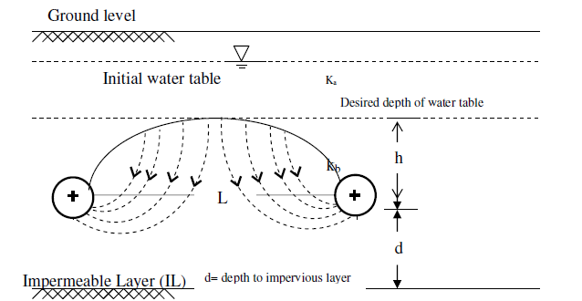
Fig. 1. Flow pattern into sub surface drain pipes (Ritzema, 1994)

Determination of lateral drain pipe spacing
Drain spacing can be computed by several formulae developed from the theories of groundwater flow substituting the drainage coefficient, hydraulic conductivity, height of water level above water table and other parameters. The drainage spacing formulae are based on a) steady state flow and homogeneous b) non-steady state flow conditions. For the present study as the profile in the study area is homogeneous and isotropic, steady state flow condition was considered and Hooghoudt’s equation as given below was used for computing the lateral drain spacing Hooghoudt (1952).
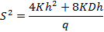
Where,
S = Lateral Drain spacing, m
K = Hydraulic conductivity of the soil, m/day
h = Height of water level above the water table in the drain, m
D = Depth to impervious layer, m
q = Drainage coefficient or drain discharge rate per unit surface area, m/day
Hooghoudt’s equation is mainly based on the assumption that flow is radial near the drains pipe because of the curvature nature of drain water flow and the Dupuit Forcheimer assumptions showed that flow in the region is always away from the drains Ritzema (1994).

Measurement of hydraulic conductivity
Hydraulic conductivity was measured using inverse auger hole method, before the installation of drainage system. A hole was made in the soil surface to required depth and the hole was filled with water, water was left to drain away freely. The hole was refilled with water repeatedly till the soil around the hole was saturated over a considerable distance and the infiltration has attained to reach steady value. The detailed procedure of measurement of hydraulic conductivity by the inversed auger hole method as explained by Ritzema (1994) was followed. From the test conducted, the hydraulic conductivity was found to be 0.518 m/day.

Computation drainage coefficient before installation
The drainage coefficient is generally expressed as a total depth of water removed from an area in 24 hours. Initially before installation of drainage system, a drainage coefficient was calculated using water balance equation for finding out the drain spacing. Drainage coefficient can be computed by
Average rainfall as 20 per cent of effective rainfall and deep percolation losses as 25 percent of crop water requirement was considered in this study. Crop period for Paddy was taken as 134 days. The computed drainage coefficient based on water balance equation was 3.55 mm/day.

Design drain pipe spacing
The designed drain spacing was calculated by taking the height of the water level above water table observed in the study area as 20 cm, depth to impervious layer taken as 4 m and drainage coefficient as 3.55 mm/day and hydraulic conductivity as 0.518 m/day. The designed drain spacing was found to be 31m.
To test the performance of design drain pipe spacing, a trial study was conducted to assess the radial flow towards the drain pipe by installing the 63 mm drain pipe at 30 m spacing and 60 cm depth for a water level of 20 cm above water table. It was observed that the drainage discharge was 0.002 cm/day and flow towards the pipe was found to be very low. Hence, narrow drain spacing of 7.5 m, 10.0 m and 12.5 m was selected by considering the radial flow and nature of field as farmers are having small land holdings.

Design drain pipe depth
The depth of drain pipe placement was selected on the basis of crop root zone depth, soil texture and cost of the system. The system has to work at favored depth for culminate the extra water. The depth of drain pipe needs to be more than the depth of root zone of the selected paddy crop so that the surplus water from the root zone of the crop will be eliminated and appreciable the air circulation will be achieved. In this study, placement of drain pipe depth of 60 cm and 80 cm has been favorably chosen for paddy crop.

Design drain pipe diameter
Wessling’s equation Ritzema, (1994) for uniform flow in smooth and corrugated pipes derived from Manning’s equation was applied to calculate the size of the lateral drain pipes. The size of the lateral pipe required to carry the design flow rate is given as below
Where
Q = Discharge in the pipe, m³/day
= Length (m) X Width of the field (m) X Initial drainage coefficient (m/day)
d_{L} = Diameter of lateral pipe, m
i = Slope of lateral pipe fraction 0.3 per cent as 0.003
Length of the field as 7.5 m, width of the field as 10 m and initial drainage coefficient as 0.003 m/day) was applied in Wessling’s equation and diameter of the pipe was found to be 33 mm. To drain more water in wider spacing, greater pipe diameter which is more than design diameter was selected. The commercially available pipe diameter of 63 mm was selected in this study.

Experimental Details
Based of designed lateral drain pipe spacing, placement depth and pipe diameter, a field experiment was setup to study the performance of the parallel drain pipe sub surface system. This experimental design consists of factorial randomized block design with three replications. The factors used in this study were three lateral drain spacing (7.5, 10.0 and 12.5 m) and two drain depth (60 and 80 cm). Details of treatments for the experiment are furnished below.
7.5 m drain spacing with 60 cm depth of drain (S₁D₁)
10 m drain spacing with 60 cm depth of drain (S₂D₁)
12.5 m drain spacing with 60 cm depth of drain (S₃D₁)
7.5 m drain spacing with 80 cm depth of drain (S₁D₂)
10 m drain spacing with 80 cm depth of drain (S₂D₂)
12.5 m drain spacing with 80 cm depth of drain (S₃D₂)

Layout of the System and crop details
The parallel pipe subsurface drainage system was installed in an area of 0.144 ha as per the different treatment combinations. Length and width of the field was 120 m and 12 m. A plot size of the treatment was decided based on lateral drain spacing and length of the plot was taken as 6 m. Each plot was separated by providing buffer pipe of 63 mm diameter at 60 cm and 80 cm depth. The main purpose for proving buffer pipe is that reading of drain discharge and depth to water table recorded at one plot does not to affect the adjacent plot.
The PVC pipes 63 mm are used as lateral drain pipes and collector drain pipes. These pipes were perforated using 6 mm drill bit with the spacing of 2.5 cm between the perforations. PVC pipes were wrapped by two layers of coir fiber envelope material and it was tied with nylon rope. 1 m length and 63 mm diameter PVC perforated pipes were used as the observation wells. They were installed at the midway between drains to measure the depth to water table. There are totally 24 observation wells installed. Each plot contains three lateral drain pipes, one inspection chamber and one collector pipe.
Entire study area was divided into six plots and each plot is again sub divided into three sub plots to accommodate different lateral drain spacing. Inspection chambers carrying the 250 liter of water were provided at the end all the lateral drain pipes. All the inspection chambers are connected by the collector drain of 63 mm pipe and collector drains are connected to the main drain of 63 mm. Collected water are finally disposed in to a outlet near the odai. Performance of the system is evaluated by measuring the drain discharge from the lateral drainpipe. The slope of the lateral drainpipe was 0.6 per cent and for collector drain pipe was 0.3 per cent. Layout of the subsurface drainage system in the study area is shown in Fig. 2.
Paddy crop was transplanted over the parallel pipe sub surface system during October 2020 and harvested during February 2021. The crop variety was BPT 5204 and paddy was transplanted at 15 X 15 cm spacing. Crop was grown as per the packages of practices given in Crop Production Guide, 2019.
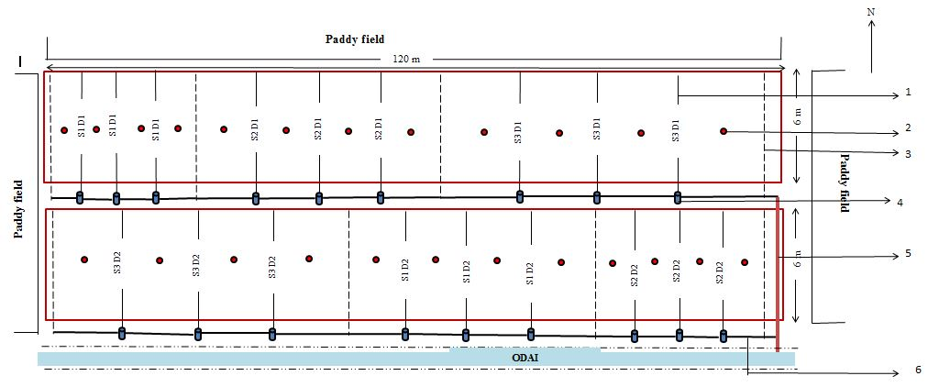
1. Lateral drain pipe, 2. Observation well, 3. Buffer pipe, 4. Inspection chamber, 5. Main drain 6. Collector drain
Fig. 2. Layout of subsurface drainage system in an experimental area

Observations recorded
Observations recorded in this study for evaluating the performance of parallel drain sub surface systems are (i) soil properties (pH, EC and ESP), (ii) depth to water table from the observation wells and (iii) discharge collected at the inspection chamber. During the crop period, observations were recorded next day after it was rained. After experiment was over, hydraulic conductivity was measured by following similar auger hole depths as that of before installation. Depth to water table was measured using 1 m steel scale in 24 observation wells regularly. The drain discharge from the lateral drain pipes was measured using a bucket, stop watch and a graduated cylinder on volume basis. Drainage coefficient was calculated by dividing the drain discharge with the area of influence of each lateral drainpipe and expressed in the form of cm/day. Area of influence of each lateral drainpipe was calculated by multiplying the length of each lateral drain pipe and spacing between drain pipes.
RESULTS AND DISCUSSION
The results of observations and measurements recorded with respect to soil properties, hydraulic conductivity, depth to water table in the observation wells and drainage coefficient from the study and relevant discussions have been summarized here.

Soil properties
Soil properties such as pH and EC measured after installation of subsurface drainage system is presented in Table 2. From the table it has been noticed that after installation of drain system soil properties have changed remarkably when compared to the values before installation. The reason may be stated that due to removal of sodium and bicarbonate ions along with drain water, soil properties have changed. Bharambe et al., (2001), Rakesh et al., (2005) and Pradeep et al., (2005) have reported the similar findings.
The hydraulic conductivity (k) determined by inverse auger hole method before and after the installation of drainage system is presented in Table 2. The results revealed that the hydraulic conductivity measured before installation of drainage system has been increased by 30 per cent when compared to hydraulic conductivity measured after installation. Because of reduction in values of EC and ESP after installation of drainage system, pores in the soils easily transmit the water which improves hydraulic conductivity of soil. Similar result was observed by Jafari-Talukolaee et al., (2016) in their study that the hydraulic conductivity of the soil has been increased and water movement in the soil and drain discharge rate has also improved.
Table 2. Soil properties before and after installation
S. No. | Parameters | Before Installation | After Installation
1. | Hydraulic Conductivity | 0.5184 m/day | 0.6780 m/day
2. | pH | 9.5 | 8.43
3. | EC | 0.97 dS/m | 0.45 dS/m
4. | Exchangeable Sodium Percentage | 31.66 per cent | 25.42 per cent

Depth to water table
The pattern of depth to water table from the ground surface at three lateral drain pipes measured next day after rainfall in the observation wells for drain depth of 60 cm and 80 cm is depicted in Fig. 3 & 4. Before installation of drainage system, the water table was very nearer to the ground surface during Rabi season (October to January). After installation of the lateral drain pipes, water started to flow towards the drain pipe radially and flow is mainly influenced by hydraulic conductivity of soil, soil properties, spacing between the drains, depth of drains, deep percolation and location of impervious stratum.
Initially the depth to water table was 0.3 m from the surface. From the figure, it can be observed that depth to water table has been fluctuated from 0.29 m to 0.47 m during the crop period for 7.5 m lateral drain spacing and 80 cm drain depth treatment (S₁D₂). Whenever rainfall occurs, water table reaches to ground surface. Due to lesser lateral drain pipe spacing and higher hydraulic conductivity, depth to water table has been lowered notably. Other lateral drain spacings and drain depth recorded lesser variations in depth to water table. Reasons for decreased level of depth to water table were due to continuous rainfall, drainage problem develops, and water stands at least 20 cm height above surface. The rate of lowering the depth to water table was found to be slow from the next day after rainfall till next rainfall. When there is no rainfall, crops are irrigated by ground water pumping from bore wells, possibilities of lowering of water was minimum as height of water standing over the surface was also very minimum. Srinivasulu et al., (2006) have reported that due to the installation of drainage system water table that was very close to the ground surface during the paddy-growing season could be lowered up to 0.25 to 0.4 m below the ground surface at the drain spacing of 30 m and there by problem of water logging was controlled. Manjunatha et al., (2004) have reported that the average water table in the experimental area during kharif season was shallower than during rabi due to monsoon rains. The average water table depth of 50 and 67 cm during kharif and rabi in the first year lowered down to, respectively, 62 and 85 cm in the second year but no further change was observed in the third year. Selvaperumal et al., (2017) have condculded that the treatments of 7.5 m drain spacing at 75 cm depth with 75 mm diameter recorded 0.28 to 0.33m in variation of depth to water table. Srinivasulu et al., (2014) have observed by that deeper groundwater was found to contribute more significantly to the total drain flow compared with shallow groundwater. Maximum and minimum depth of water table was observed as 67 and 63 cm where drains installed at spacing of 30 m and 60 m. Malota & Senzanje, (2015) have concluded that reduction in water table depth below the soil surface increases with decrease in drain spacing and constant drain depth.
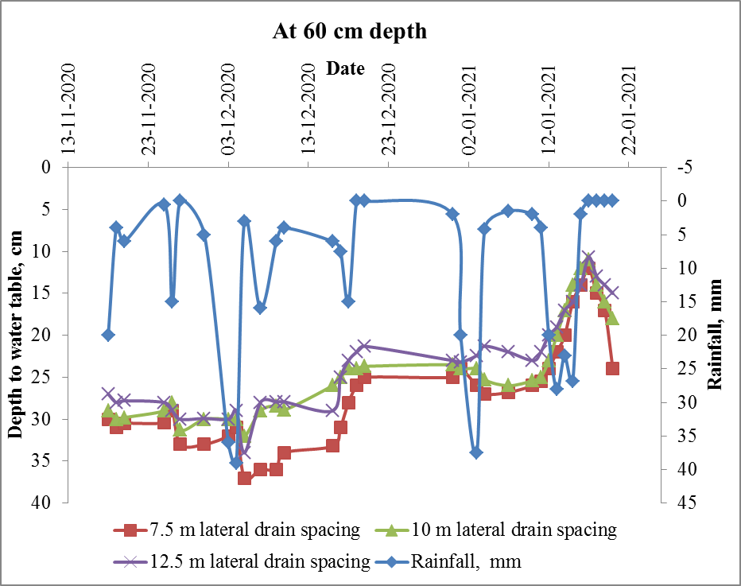
Fig. 3. Depth to water table at 7.5, 10, 12.5 m drain pipe spacing in 60 cm drain depth
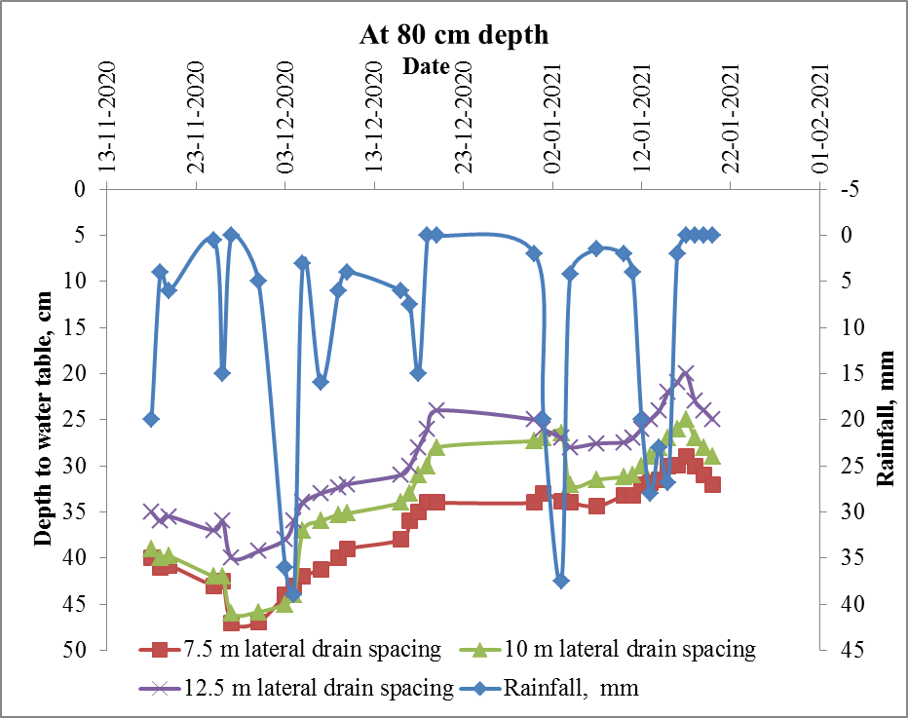
Fig.4. Depth to water table at 7.5, 10, 12.5 m drain pipe spacing in 80 cm drain depth

Drainage coefficient
Depth of water to be removed in a day was computed based on drain discharge collected in the inspection chamber and area of influence. The pattern of drainage coefficient at three lateral drain pipes measured next day after rainfall in the inspection chamber for drain depth of 60 cm and 80 cm is presented in Fig.5 and 6. From the figures, it can be noted that 7.5 m lateral drain spacing and 80 cm drain depth treatment (S₁D₂) has shown the higher variation of drainage coefficient from 0.069 to 0.29 cm/day. As the drain spacing decreased, contributing area per unit perforated area on the drain pipes decreased and hence drain flow in lesser drain spacing increased. The higher drainage coefficient for lesser (7.5m) lateral drain spacing when compared to higher lateral drain spacing was due to reduced flow path of water in soil. The minimum value of drainage coefficient 0.030 cm/day is observed for 12.5 m lateral drain spacing at drain depth of 60 cm.
Similar finding was reported by Chen & Liu, (2002) that heavy texture soil in the hardpan and its low hydraulic conductivity for low drainage volume in the treatments with higher spacing. Christen & Skehan, (2001) concluded that the low porosity of the subsoil was responsible for the long draining period and influenced inducing flow in the drain. Srinivasulu et al., (2014) concluded in his study that as the lateral drain spacing decreased, the drain discharge increased. Helmers et al., (2012) reported that deeper drains increase drainage amounts. Schott et al., (2017) recorded 40 per cent of reduction of annual drainage volume at a drain depth of 0.76 m as compared to 1.20 m.
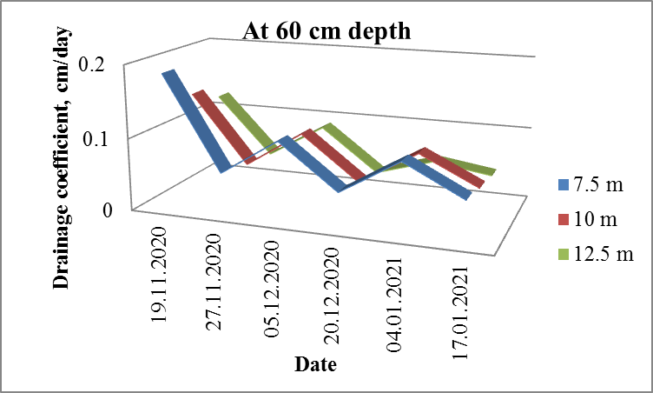
Fig.5. Drainage coefficient at 7.5, 10 and 12.5 m drain pipe spacing in 60 cm drain depth
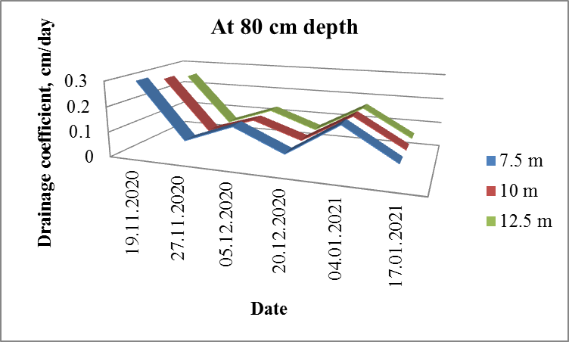
Fig.6 Drainage coefficient at 7.5, 10 and 12.5 m drain pipe spacing in 80 cm drain depth
CONCLUSION
This study has been conducted to evaluate the performance of parallel drain subsurface system in waterlogged paddy field by varying lateral drain spacing and drain depth as these factors influences the depth to water table and drain discharge. Soil properties before and post installation, depth to water table and drainage coefficient are the parameter used for assessing the performance of the subsurface system. After installation of the subsurface drain system soil hydraulic conductivity has been increased to 30 per cent, pH, EC and ESP has been reduced to 12, 54 and 20 per cent respectively. A notable decline of depth to water table of 0.29 m to 0.47 m from ground surface during the crop period and higher drainage coefficient of 0.069 to 0.29 cm/day was observed for 7.5 m lateral drain spacing and 80 cm drain depth treatment. Lesser lateral drain pipe spacing has increased higher hydraulic conductivity and lowered depth to water table. As the drain spacing decreased, contributing area per unit perforated area on the drain pipes decreased and hence drain flow in lesser drain spacing increased. Even though narrow spacing and higher depth of placement of drain pipe wrapped with coir envelope materials plays a vital role in deciding economics of the system, from the productivity point of view it is worth investment.

REFERENCES
Ale, S., Satyanarayana, M. R. B. T. V., & Kumar, H. V. H. (2006). Performance evaluation of drainage systems in water logged coastal sandy clay loam soil at a pilot area in Krishna western delta. Journal of Agricultural Engineering, 43(1), 8–12.
Central Ground Water Board North Western Region Bhujal Bhawan 27A CHANDIGARH. (2017, November 20). Retrieved from http://cgwbchd.nic.in/qulstd.htm
Chen, S., & Liu, C. (2002). Analysis of water movement in paddy rice fields (I) experimental studies. Journal Of Hydrology, 260(1-4), 206-215. doi: 10.1016/s0022-1694(01)00615-1
Christen, E., & Skehan, D. (2001). Design and Management of Subsurface Horizontal Drainage to Reduce Salt Loads. Journal Of Irrigation And Drainage Engineering, 127(3), 148-155. doi: 10.1061/(asce)0733-9437(2001)127:3(148)
Helmers, M., Christianson, R., Brenneman, G., Lockett, D., & Pederson, C. (2012). Water table, drainage, and yield response to drainage water management in southeast Iowa. J. Soil Water Conserv., 67(6), 495–501. doi: 10.2489/jswc.67.6.495
Hooghoudt, S. (1952). Tile Drainage And Subirrigation. Soil Science, 74(1), 35-48. doi: 10.1097/00010694-195207000-00005
Iitk.ac.in. 2021. Knowledge Network centre on Floods & Water logging. [online] Available at: <http://www.iitk.ac.in/waterwoes/north-bihar-coastal-odisha.html> [Accessed 31 March 2021].
L. Schott, A. Lagzdins, A.L.M. Daigh, K. Craft, C. Pederson, G. Brenneman and M.J. Helmers (2017), Drainage water management effects over five years on water tables, drainage, and yields in southeast Iowa), Journal of Soil and Water Conservation, 72 (3) 251-259; DOI: https://doi.org/10.2489/jswc.72.3.251
Malota, M., & Senzanje, A. (2015). Modelling mid-span water table depth and drainage discharge dynamics using DRAINMOD 6.1 in a sugarcane field in Pongola, South Africa. Water SA, 41(3), 325. doi: 10.4314/wsa.v41i3.04
Management of Salt-affected Vertisols with Sub-surface Drainage and Crop Residue Incorporation under Soybean-Wheat Cropping System. (2001). Indian Society of Soil Science.., 49(1):24-29
Manjunatha, M., Oosterbaan, R., Gupta, S., Rajkumar, H., & Jansen, H. (2004). Performance of subsurface drains for reclaiming waterlogged saline lands under rolling topography in Tungabhadra irrigation project in India. Agricultural Water Management, 69(1), 69-82. doi: 10.1016/j.agwat.2004.01.001
Mowr.gov.in. 2021. Component of Reclamation of Waterlogging | Department of Water Resources, RD & GR | Government of India. [online] Available at: <http://mowr.gov.in/programmes/component-reclamation-waterlogging> [Accessed 31 March 2021].
Patil, R., & Balakrishnan, P. (2016). IMPACT OF SUBSURFACE DRAINAGE SYSTEM ON SOIL CHEMICAL PROPERTIES AND CROP YIELD IN UPPER KRISHNA COMMAND. International Journal of Agriculture Sciences, 9(1), 2202–2205.
Patil, R., & Balakrishnan, P. (2017). Performance evaluation of subsurface drainage system in upper Krishna command. International journal of agricultural engineering, 10(1), 202–207. doi: 10.15740/HAS/IJAE/10.1/202-207
Pradeep, H.M., N.S. Hebsur, S.K. Gali and Koti,R.V. 2005. Effects of subsurface drainage and amendments on soil physical and chemical properties of black soil of Ghataprabha command area. Karnataka J. Agri. Sci., 18(3):953-958
Rakesh, K., R.D. Singh and Sharma, K.D.2005. Water resources in India. Curr.Sci., 89:794-811
Ritzema, H. P., Satyanarayana, T. V., Raman, S., & Boonstra, J. (2008). Subsurface drainage to combat waterlogging and salinity in irrigated lands in India: Lessons learned in farmers’ fields. Agric. Water Manage., 95(3), 179–189. doi: 10.1016/j.agwat.2007.09.012
Ritzema, H., Jafari-Talukolaee, M., Darzi-Naftchali, A., & Shahnazari, A. (2016). Subsurface Drainage to Enable the Cultivation of Winter Crops in Consolidated Paddy Fields in Northern Iran. Sustainability, 8(249). doi: 10.3390/su8030249
Ritzema, H.P. (1994). Drainage Principles and application. 2th Ed. ILRI publication 16, International Institute for Land Reclamation and Improvement, Wageningen, The Netherlands, pp: 181 p, 487 p, 544 p.
Sahu, A. S. (2014). A Study on Moyna Basin Water-Logged Areas (India) Using Remote Sensing and GIS Methods and Their Contemporary Economic Significance. Geography Journal, 2014. doi: 10.1155/2014/401324
Selvaperumal, A., Muthuchamy, I., Vallalkannan, S., & Hemakumar, H. V. (2017). Drainage Investigations for the Design of Water Table Management Systems in AEC&RI, Kumulur, Trichy District, Tamil Nadu. 1., 1–9. doi: 10.9734/CJAST/2017/36888
Sharma PC, Kaledhonkar MJ, Thimmappa K and Chaudhari SK. 2016. Reclamation of waterlogged saline soils through subsurface drainage technology. ICAR-CSSRI/Karnal/Technology Folder/02.
Sharma PC, Kaledhonkar MJ, Thimmappa K and Chaudhari SK. 2016. Reclamation of Alkali soils through gypsum technology. ICAR-CSSRI/Karnal/Technology Folder/01.
Srinuivasulu, M., Rao, A. R., Babu, M. R., Babu, G. R., & Kumar, H. H. (2014). Performance of sub-surface drainage system installed at Appikatla region of Andhra Pradesh. International Journal of Agricultural Engineering, 7(1), 180-185.

