REVIEW ARTICLE
Application of Fuzzy Cognitive Mapping in Agriculture – A Review

ABSTRACT
A Fuzzy Cognitive Map (FCM) is an extension of cognitive maps which inherited the main aspects of fuzzy logic and Artificial Neural Networks for graphically representing the reasoning behind a given domain of interest (Kosko, 1986). This FCM is useful in various fields including Agriculture for developing models which will depict the knowledge structure of many stakeholders. This study deals with the concepts of FCM, application of FCM in various fields, software used for FCM and application of FCM in Agriculture. The results from the study revealed that FCM has been helpful for suggesting the important elements in transitioning the Impact of COVID -19 and Amphan cyclone into the future. FCM was also helpful in identifying the problems faced by Tribals using Experts knowledge. The Major factors responsible for cotton yield has also been depicted using FCM and FCM has also played a major role used for developing Ecological model using Multi step cognitive approach.

Keywords: Fuzzy Cognitive Mapping, Concept, Applications, Software, Multi step approach.

INTRODUCTION
Lack of information and large uncertainties can constrain the effectiveness and acceptability of environmental models. Fuzzy-logic Cognitive Mapping (FCM) is an approach that deals with these limitations by incorporating existing knowledge and experience. FCM is a simple, transparent and flexible participatory method where numerous actors such as experts, scientists, decision makers and other stakeholders are involved. One of the most significant characteristics of the method is the possibility to study causal relationships and feedback loops. Jetter and Kok (2014) stated that it enables the inclusion of multiple and diverse sources to overcome the limitations of expert opinions. In this way, FCM supports decision-making by simulation and scenario studies. Fuzzy cognitive mapping includes mental models and cognitive maps. In this article, what is mental model and cognitive map are discussed along with their different uses in agriculture.

MATERIALS AND METHODS
The paper is based mainly on literature review and statistical data. Exploratory analysis of seventeen articles and two websites on Fuzzy Cognitive Mapping (FCM), its applications in agriculture, softwares used in fuzzy cognitive mapping was conducted by the author. An attempt was made to collect various concepts on cognitive map, mental modeler, fuzzy cognitive mapping and were discussed in detail. The details of software used in FCM like FC - Mappers, mental modeler, FCM expert, FCM analyst, FCM wizard were described. Four articles very much pertinent to fuzzy cognitive mapping in agriculture had been analyzed and reviewed. The first article had dealt with usage of Fuzzy-Logic Cognitive Mapping tool to explore the multiple pathways of present and future impact created by the Covid – 19 pandemic and “Amphan” cyclonic storm on smallholder agricultural systems by Rupak Goswami and Kalyan Roy in the year 2021. In the second article, usage of Fuzzy theory in general and fuzzy cognitive maps in particular to analyze the problems faced by tribals in Siruvani hills of Coimbatore district in Tamilnadu were dealt (Narayanamoorthy and Thangapandi (2016)). The third article had explained the study on Fuzzy cognitive map based approach for predicting yield in Cotton crop production as a basis for Decision support system in precision Agriculture application conducted by Papageorgioua et al. (2011). The fourth article was on Ecological models based on people’s knowledge: a multi-step fuzzy cognitive mapping approach studied by Uygar and Stacy (2004).

RESULTS AND DISCUSSION

Mental Model (MM)
Mental models are individuals' internal representation of perceived reality, which help individuals to make sense of and give meaning to the world around them (Shen, Z., Tan, S., & Siau, K., 2019) (Figure 1).
A mental model is an explanation of someone's thought process about how something works in the real world. MM exits within the mind and not available for direct inspection or measurement (Forrester, 1971).

Cognitive map
Cognitive maps are the externalized portrayals of mental models in some kind of visuospatial layout (Shen, Z., Tan, S., & Siau, K., 2019) (Figure 2).
A cognitive map is any visual representation of a person's (or a group's) mental model for a given process or concept. Example – Guiding directions to reach a particular place. It's a form of structured knowledge representation commonly referred in the social science as Cognitive mapping (Eden.C,1988).

Fuzzy Cognitive Map
A Fuzzy Cognitive Map is an extension of cognitive maps which inherited the main aspects of fuzzy logic and Artificial Neural Networks for graphically representing the reasoning behind a given domain of interest (Kosko, 1986) (Figure 3).
Fuzzy Cognitive Maps (FCMs) consist of concept nodes and weighted arcs, which are graphically illustrated as a signed weighted graph with feedback.
Fuzzy Cognitive Map = Fuzzy Logic + Artificial neural network

Glykas, M. (Ed.).2010 explained that the signed weighted arcs, connecting the concept nodes represent the causal relationship that exists among concepts. Nodes of the FCM are fuzzy sets and they are called as fuzzy nodes. FCMs with edge weights or causalities from the set {−1, 0, 1} are called simple FCMs.
Fuzzy Logic (FL) is a method of reasoning that resembles human reasoning. The approach of FL imitates the way of decision making in humans that involves all intermediate possibilities between digital values YES and NO.
An Artificial neural network (ANN) is the piece of a computing system designed to simulate the way the human brain analyzes and processes information. It is the foundation of artificial intelligence (AI) and solves problems that would prove impossible or difficult by human or statistical standards.
From the theoretical underpinnings of these recurrent neural networks, Felix et al. (2019) stated that selecting the proper transfer function and updating rule is a key aspect when designing the system. These factors will impact the network’s capability of producing meaningful and accurate results.
Eden (2004) stated that cognitive maps have not been taken as models of cognition but rather tools for reflective thinking and problem solving.

History
Fuzzy cognitive maps were introduced by Bart Kosko, in 1986. A first simple application of FCMs is described in a book of William R. Taylor, where the war in Afghanistan and Iraq is analyzed. Johnson (2004) described that the theory of mental models owes its origins to Peirce's logic in the nineteenth century and to Craik's psychological research during the Second World War.

Concept
Fuzzy cognitive maps (FCMs) are fuzzy-graph structures for representing causal reasoning similar to the human reasoning and human decision-making process.
Fuzzy cognitive map (FCM) is a cognitive map within which the relation between the elements (e.g. concepts, events, project resources) of a "mental landscape" can be used to compute the "strength of impact" of these elements. The concepts in FCM depicts the process that happens from input of a problem to output that gives the impact or casual relationship (Figure 4).
- Fuzzification: Transforming crisp values into linguistic terms of fuzzy sets.
- Inference mechanism: Interprets the values in the input vector and based on user-defined rules and assigns values to the output vector. Usually based on if-then rules.
- De-Fuzzification: conversion of fuzzy output to crisp Fuzzy cognitive mapping.

Applications of FCM
Fuzzy cognitive maps (FCMs) have gained considerable research interest due to their ability in representing structured knowledge and model complex systems in various fields. While applications in social sciences introduced FCMs to the public, they are used in a much wider range of applications.
In Business, it deals with product planning and decision support, in Economics, Game theory in more complex settings, in Education, Critical Success Factors of Learning Management Systems whereas in Medical applications, it provides diagnosis, develop decision support systems and medical assessment. In Robotics, machines were used to develop fuzzy models of their environment and to use these models to make crisp decisions, computer assisted learning, computer to check whether students understand their lessons. In expert systems, a few or many FCMs can be aggregated into one FCM in order to process estimates of knowledgeable persons. IT project management, a FCM based methodology helps to success modeling, risk analysis and assessment.

Application in Extension
Scientific data in a defined system is lacking and need to develop a model based on stakeholders' knowledge. We need to understand a complex problem and solve them using diverse stakeholder groups. we need to understand how people value (individually and collectively) a construct and what are their linkages to decision making.

Software’s used for Fuzzy Cognitive Maps in earlier days
Some software tools were developed that simulate Fuzzy Cognitive Maps as described as follows:
The first attempt was a program for a very simple implementation of FCM based on C++. The second known software for FCM was an applet to draw Fuzzy Cognitive Maps based on Java through Internet. Another similar tool is a virtual reality system based on VR techniques to simulate Fuzzy Cognitive Maps. All these software tools are using quite simple mathematical forms of FCM. They do not permit the user to change and adapt the mathematical equations and most importantly, they do not support advanced techniques for constructing Fuzzy Cognitive Maps (Meletis Margaritis et.al.,(2020)).This is a constraint in these softwares.
To overcome these constraints , few new softwares were developed. They are
FCMappers, Mental Modeler, FCM Expert, FCM Analyst, FCM Wizard, FCM Designer tool and discussed as follows:

1. FCMappers
FCMappers is an international online community for the analysis and the visualization of fuzzy cognitive maps. FCMappers offer support for starting with FCM and also provide a Microsoft Excel-based tool that is able to check and analyse FCMs. They also offer to adapt the software to specific research needs.
Additional FCM software tool viz. Mental Modeler was recently developed as a decision-support tool for use in social science research, collaborative decision-making, and natural resource planning.

2. Mental Modeler
Mental Modeler was developed by Dr. Steven Gray with funding from the USDA and NSF in the year 2013. Mental Modeler is modeling software that helps individuals and communities capture their knowledge in a standardized format that can be used for scenario analysis. Certain drawbacks include less experimentation facilities, no learning algorithms, could not combine different cognitive maps and there is only adequate Graphical Representation.

3. FCM Expert
Nápoles et al. (2018) stated that it is a software tool for fuzzy cognitive modeling, where it was focussed on scenario analysis and pattern classification. The main features of FCM Expert rely on Machine Learning algorithms to compute the parameters that might define a model and improve the system convergence without losing information. Also, FCM Expert allows performing WHAT- IF simulations and studying the system.

4. FCM analyst
A software tool that has been created to help the designer of a complex system to model it by implementing FCM technology and simulates the operation of the system. FCM-Analyst has been written on JAVA because there are many important advantages for this platform.

5. FCM Wizard
A JAVA software for Fuzzy cognitive mapping. FCM WIZARD is a powerful software tool for simulating new scenarios over FCM-based models. This feature is specially useful in decision-making tasks where experts often examine the effect of one concept over the whole cognitive system.

6. FCM Designer tool
The FCM Designer tool allows creating multilayer FCM. It is possible to have several FCMs for the same problem, where each one expresses a different level of knowledge of the system under study, but interlinked. In multilayer approach, the relationship between the cognitive maps in different layers can be carried out in various ways: with fuzzy rules, connections with weights and with mathematical equations.
(Table 1) A comparative analysis was made among the four softwares.

Use of Fuzzy Cognitive mapping in Agriculture

I. Multi-faceted impact and outcome of COVID-19 on smallholder agricultural systems:
A research study was conducted on Multi-faceted impact and outcome of COVID-19 on smallholder agricultural systems: Integrating qualitative research and fuzzy cognitive mapping to explore resilient strategies at West Bengal by Rupak Goswami and Kalyan Roy who are working at Integrated Rural Development and Management Faculty Centre, Ramakrishna Mission Vivekananda Educational and Research Institute, West Bengal, India in the year 2021. The issue focused is to explore the multiple pathways of present and future impact created by the pandemic and “Amphan” cyclonic storm on smallholder agricultural systems. A Fuzzy-Logic Cognitive Mapping tool, to develop multi-stakeholder mental models for the smallholder agricultural systems of the region was used as model. Ten farmers were selected as respondents and Data was collected through Interviews using mobile phones (during lockdown). For FCM exercise, two farmers, two experts (research fellow and subject matter specialist) and one NGO staff were considered. Thus, five selected stakeholders developed the cognitive maps. The diagram (Figure 5) given is the representation of both qualitative and fuzzy cognitive mapping used for the study along with their validation. The Individual cognitive map representation of different stakeholders and the holistic cognitive map of all stakeholders are given below (Figure 6 & Figure 7).
The study reveals that the shared mental model suggested the importance of current household income, expenditure in farming and future crop production in transitioning the impact of COVID-19 and Amphan cyclone into the future. The differences and similarities in mental models among stakeholders provided a means to examine the potential consensus and discrepancies in developing shared mental models based on which locally-relevant management strategies could be crafted in the post-COVID-19 situation.

II. A Mathematical Approach to analyze the problems faced by Tribals in Siruvani Hills, Coimbatore District In Tamilnadu :
A Mathematical Approach to analyze the problems faced by Tribals in Siruvani Hills, Coimbatore District In Tamilnadu is an yet another research study on FCM, conducted by S. Narayanamoorthy and K.Thangapandi, Department of Mathematics, Bharathiar University, Coimbatore, India during the year 2016. The authors investigated the problems faced by Tribals in Siruvani Hills, Coimbatore District. Fuzzy theory in general and fuzzy cognitive maps in particular is the model used for this study. Exactly 76 Tribal households was taken and data was collected through Interviews using linguistic Questionnaire. Fuzzy cognitive maps expressed by two experts consider for this study are given in the figures below. Five arbitrary attributes (P1, P2, . . . , P5) are taken as the main nodes for study as follows:
P1- No Education
P2- No Transport Facilities
P3- Living Condition is Poor
P4- Wandering of Wild Animals (Unable to cultivate their lands)
P5- Government Policies on Forest
Cognitive map was drawn based on two experts opinion. The Diagram (Figure 8) gives the cognitive map drawn by first expert and (Figure 9) gives the cognitive map drawn by second expert.The study reveals that from the algorithm of the given problem the fixed point is (1 1 1 1 1) and wandering of wild animals and no education is the major problems of the Tribals in Siruvani hills. To reduce the problem, following suggestions were offered to the government

- Protection from wild animals to be given,
- Education for the children of these tribals should be made compulsory,
- Laying of better roads in forest area will be helpful.
- It is high time government takes steps to revive the life of tribals

III. Fuzzy cognitive map based approach for predicting yield in Cotton crop
production as a basis for Decision support system in precision Agriculture
application:
A research study on Fuzzy cognitive map based approach for predicting yield in Cotton crop production as a basis for Decision support system in precision Agriculture application was conducted by E.I. Papageorgioua, A.T. Markinos and T.A. Gemtos working at Technological Educational Institute (TEI) of Lamia, Greece and Crop Production and Rural Environment, University of Thessaly, Greece in the year 2011. This work investigates the process of yield prediction in cotton crop production using the FCM. Exactly 360 cases measured during the time of six subsequent years (2001–2006) in a 5 ha experimental cotton field (Secondary data).
The Eleven main factors or variables used to determine cotton yield are given in the (Table 1). For the development of this FCM model in precision farming, three experts were used (one experienced cotton farmer and two experienced soil scientists). The FCM model for describing the final cotton yield is depicted in the (Figure 10).
The study revealed that Phosphorus and Electrical conductivity are the major factors for cotton yield. A new modeling and simulation approach based on the soft computing technique of fuzzy cognitive maps was investigated. This was useful to connect yield defining parameters with yield in cotton crop production in Central Greece, as a basis for a decision support system for precision agriculture application.

IV. Ecological models based on people’s knowledge: a multi-step fuzzy cognitive mapping approach :
A worth mentioning research study was conducted on Ecological models based on people’s knowledge: a multi-step fuzzy cognitive mapping approach by Uygar Ozesmi and Stacy L. Ozesmi working at Environmental Science Chair, Department of Environmental Engineering, Erciyes University, Turkey in the year 2004.
This research includes examining and obtaining the perceptions of different stakeholders to facilitate the development of participatory environmental management plans, and determining the wants and desires for resettlement of people displaced by a large scale dam project. This multi-step FCM analysis approach includes the following steps:
(1) Drawing of cognitive maps.
(2) Determining if the sample size is adequate.
(3) Coding the cognitive maps into adjacency matrices.
(4) Augmenting individual cognitive maps and then adding them together to form stakeholder social cognitive maps.
(5) Analyzing the structure of individual and social cognitive maps using graph theoretical indices.
(6) Analyzing the differences and similarities in variables among stakeholder groups.
(7) Condensing complex cognitive maps into simpler maps for comparison purposes.
(8) Analyzing the outcomes of cognitive maps using neural network computation.
(9) Simulating different policy options through neural network computation.
The findings of this study was useful for obtaining the perceptions of different people in different stakeholder groups concerning an ecosystem. This allows for more appropriate conservation strategies and management plans to be made. This result suggests that FCMs could be used in a meta analysis, to compare for example people’s perceptions of ecological systems in different areas.

Tables
Table 1 : A comparative analysis was made among the four softwares
Software name | Year | Experimentation Facilities | Learning Algorithms | Graphical Support
FCM Modeler | 1997 | Not at all | Only one | Poor
FCM Designer | 2005 | Some, but not enough | Not at all | Adequate
Mental Modeler | 2013 | Some, but not enough | Not at all | Adequate
Java FCM | 2013 | Only for developers | Not at all | Not at all

Table 2 : The Elements used to determine cotton yield.

Numbers | Concepts/ Elements | Number of scaled values
C1 | Shallow EC | Five Fuzzy
C2 | Mg | Five Fuzzy
C3 | Ca | Five Fuzzy
C4 | Na | Five Fuzzy
C5 | K | Five Fuzzy
C6 | P | Five Fuzzy
C7 | N | Five Fuzzy
C8 | OM | Three Fuzzy
C9 | pH | Seven Fuzzy
C10 | Sand | Four Fuzzy
C11 | Clay | Three Fuzzy
C12 | Yield | Two Fuzzy

Figures and Structures
Figure 1 : Mental Model

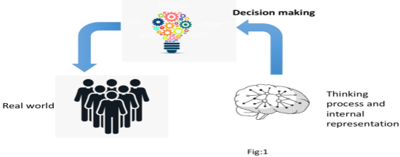

Figure 2 : Cognitive map

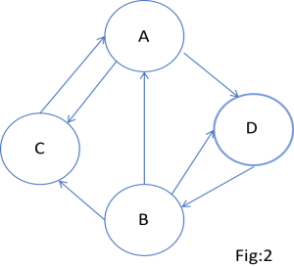

Figure 3 : Fuzzy cognitive mapping

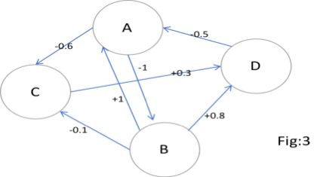

Figure 4 : Concept of FCM

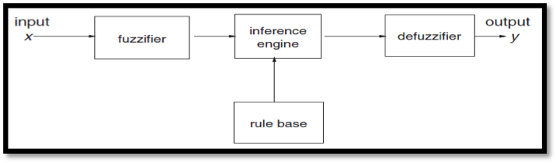

Figure 5 : The qualitative and Fuzzy cognitive mapping approach along with their validation.

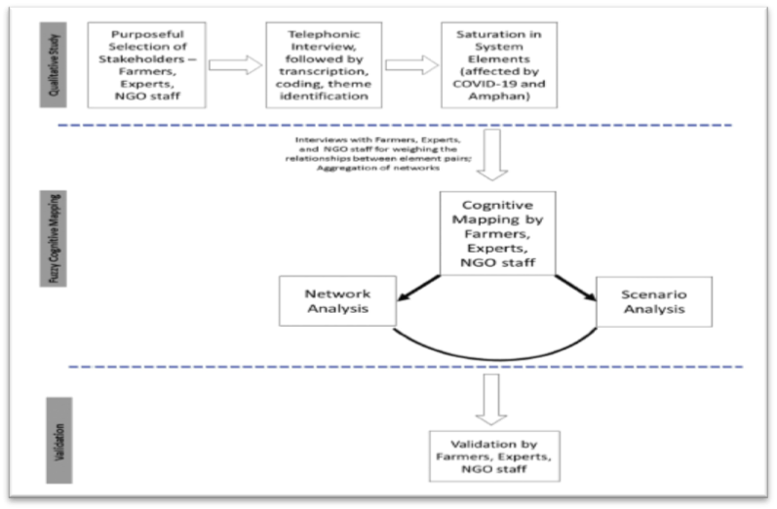
Figure 6 : Cognitive map of Farmers(a) and Experts (b)
Figure 7 : Cognitive map of NGO staff(c) and Holistic model(d)
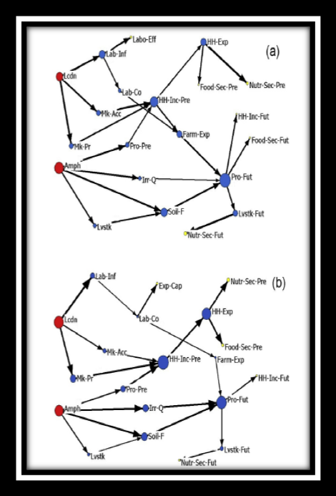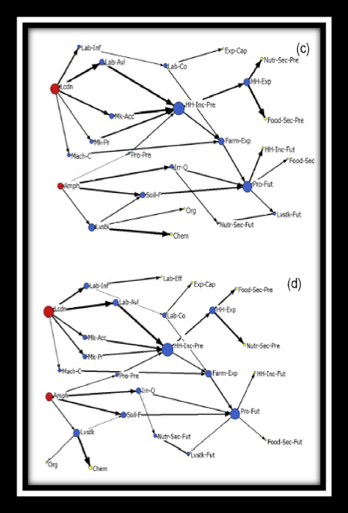

Figure 8 : Cognitive map by First Expert Figure 9 : Cognitive map by Second Expert
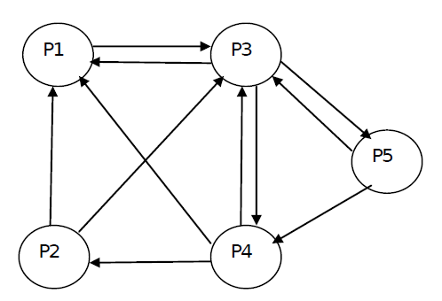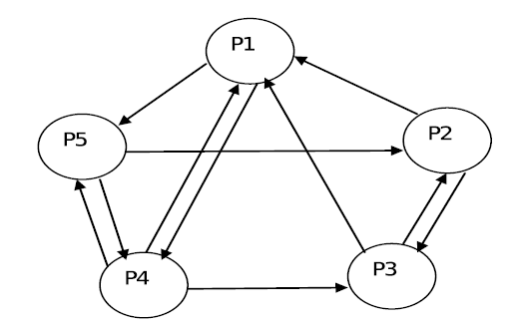

Figure 10 : FCM model describing the cotton yield.
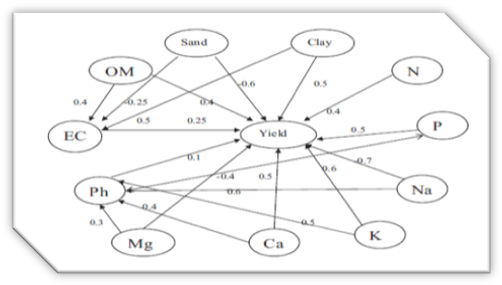

CONCLUSION
The main advantage of this FCM approach is its simple structure and flexibility, representing knowledge visually and more descriptively. It is helpful in combining knowledge and information from different stakeholders. The main advantage of this method is simple. It functions on experts’ opinion for giving appropriate conclusion.
FCM can help identifying the (lack of) alignment of perceptions and serve as a basis for recommendations for improving policy design and communication. Fuzzy cognitive mapping offers many advantages for ecological modeling including the ability to include
1) Abstract and aggregate variables in models,
2) The ability to model complex relationships which are full of feedback loops, and
3) The ease and speed of obtaining and combining different knowledge sources.

REFERENCES
Eden, C. 1988. Cognitive mapping. Eur. J. Oper. Res., 36(1): 1-13.
Eden, C. 2004. Analyzing cognitive maps to help structure issues or problems. Eur. J. Oper. Res., 159(3): 673-686.
Felix, G., Nápoles, G., Falcon, R., Froelich, W., Vanhoof, K. and R. Bello. 2019. A review on methods and software for fuzzy cognitive maps. Artif. Intell. Rev, 52(3): 1707-1737.
Forrester, J. W.1971. Counterintuitive behavior of social systems. Theory Decis, 2(2): 109-140.
Glykas, M. (Ed.). 2010. Fuzzy cognitive maps: Advances in theory, methodologies, tools and applications. Springer Sci. Rev, 247.
Goswami, R., Roy, K., Dutta, S., Ray, K., Sarkar, S., Brahmachari, K. and K. Majumdar. 2021. Multi-faceted impact and outcome of COVID-19 on smallholder agricultural systems: Integrating qualitative research and fuzzy cognitive mapping to explore resilient strategies. Agric. Syst., 189, 103051.
Jetter, A. J. and K. Kok. 2014. Fuzzy Cognitive Maps for futures studies—A methodological assessment of concepts and methods. Futures, 61: 45-57.
Johnson-Laird, P. N.2004. The history of mental models. Psychology of reasoning: Theoretical and historical perspectives, (8): 179-212. DOI: 10.4324/97802035
Napoles, G., Espinosa, M. L., Grau, I. and K. Vanhoof. 2018. FCM expert: Software tool for scenario analysis and pattern classification based on fuzzy cognitive maps. Int. J. Artif. Intell. Tools, 27(07): 1860010.
Narayanamoorthy, S. and K. Thangapandi. 2016. A mathematical approach to analyze the problems faced by tribals in Siruvani hills Coimbatore district in Tamilnadu. Int J Pure Appl Math, 109: 109-115.
Özesmi, U. and S.L. Özesmi. 2004 . Ecological models based on people’s knowledge: a multi-step fuzzy cognitive mapping approach. Ecol Modell, 176(1-2): 43-64.
Papageorgiou, E. I., Markinos, A. T., and T.A. Gemtos. 2011. Fuzzy cognitive map based approach for predicting yield in cotton crop production as a basis for decision support system in precision agriculture application. Appl. Soft Comput., 11(4): 3643-3657.
Shen, Z., Tan, S. and K. Siau. 2019. Use of mental models and cognitive maps to understand students’ learning challenges. J. Educ. Bus., 94(5): 281-289.
https://en.wikipedia.org/wiki/Fuzzy_cognitive_map
https://www.sciencedirect.com/topics/computer-science/fuzzification

