

*Madras Agric. J.,* 2020; doi:xxxxxxxxx

## RESEARCH ARTICLE

Temporal Variability in the Precipitation Concentration at Salem District of Tamil Nadu

### ABSTRACT

The temporal behavior of precipitation is more important in crop planning and prediction of extreme events. Salem District is one of the land- protected districts in Tamil Nadu. The main objectives of this study is to describe the temporal patterns of rainfall amount and concentration of Salem District. The rainfall data for various locations and at different course of time were collected from Indian Meteorological Department (IMD) and analyzed to study the variability of rainfall in Salem district. It receives rainfall under influence of both southwest and northeast monsoons. The south west monsoon chiefly contributes to the rainfall in the district. The important food crops are paddy, cholam, cumbu, ragi, red gram, green gram, black gram, horse gram, turmeric, sugarcane, mango, banana, tapioca, groundnut and gingelly. The other important crops are cotton, castor seed and coffee. It was observed that the maximum rainfall in the district was recorded in 2005 (1375.90 mm) and the minimum rainfall was recorded in 1980 (51.30 mm). It was also observed from the annual rainfall plot that the rainfall in the district is uneven. The overall average annual rainfall of the district over the years is around 812.26 mm. The maximum number of rainy days was recorded in 2010 (91 days). The station wise average rainfall analysis showed that that the Yercadu station has recorded the highest average annual rainfall of1223.16mm compared to the other stations. The major contribution of rainfall to the district is from the South-west monsoon, which is about 42%, followed by the north-east which is 38%. On an average, the north- east monsoon contributed a maximum of 306.43 mm to the total rainfall in the district and the minimum rainfall is recorded during the winter season. Between 1977 and 2012, the maximum rainfall was observed in 2005 (1375.90 mm) which has its highest contribution from the northeast monsoon. Also, the highest record of north east monsoon have been recorded in 2005 (712 mm). Around 20 years, the rainfall is lesser compared to the average annual rainfall (812.26 mm).Hence, the district has not experienced any major distress with respect to rainfall as majority of years fall under normal category. This temporal variability analysis of rainfall in the district helps in crop planning and proposing water conservation activities.

**Keywords:** Crop planning, Precipitation, Rainfall distribution, Temporal variability.

### INTRODUCTION

Rainfall is a prime source of water for human activities. The changing precipitation pattern, and its impact on surface water resources, is an important climatic problem facing society today. Understanding rainfall characteristics plays a vital role in sustainable watershed development and management. Rainfall characteristics also help in setting up irrigation networks, water storage reservoirs and identifying cropping pattern. Knowledge on rainfall temporal structure is an important factor in all planning and monitoring studies. Research into historical changes in the climatic system using instrumental records was recognized as one of the necessities of climate change research (Houghton et al., 1990). Several studies have been done regarding spatial and temporal variation of rainfall throughout India and around the globe. Türkeş (1996) presented spatial and temporal characteristics of Turkey's annual rainfall data in the context of climatic variability and reported annual rainfall variations over the rainfall regions except the Black Sea region were related closely to those of the rest of Turkey. Subbaramayya and Naidu (1992) and Ghosh et al. (2009) analyzed the spatio-temporal variations of

Indian monsoon rainfall. Different regional level analysis of climatic parameters in India were done by Srivastava et al. (1992), Kumar and Jain (2010), Mandal et al. (2013). In the last decades considerable advances in quantitative estimation of distributed rainfall have been made, in particular weather radars (Leijnse et al., 2007; van de Beek et al., 2010; Otto and Russchenberg, 2011). With this background, the main objectives of this paper is to describe the temporal variation of rainfall characteristics including annual and monthly rainfall concentration of Salem District located in Tamil Nadu.

### MATERIAL AND METHODS

#### About the Study Area

Salem district receives the rainfall under the influence of both southwest and northeast monsoons. The south west monsoon chiefly contributes to the rainfall in the district. A perusal of the data showed that the normal annual rainfall over the district varies from about 500 mm to 1200 mm. The district enjoys a tropical climate (Figure 1). The weather is pleasant during the period from November to January. Mornings in general are more humid than the afternoons with the humidity exceeding 75% on an average. In the period June to November the afternoon humidity exceeds 60% on an average. In rest of the year, the afternoon are drier and the summer afternoons being the driest. The important food crops are paddy, cholam, cumbu, ragi, red gram, green gram, black gram, horse gram, turmeric, sugarcane, mango, banana, tapioca, groundnut and gingelly. The other important crops are cotton, castor seed and coffee.

#### Data Collected

The rainfall data for various locations of Salem district and at different course of time were collected from Indian Meteorological Department (IMD) and analyzed to study the variability in rainfall. Rainfall data from fifteen stations over the last thirty four year period were utilized. The major stations taken into consideration are Anaimudi, Athur, Gangavalli, Kolathur, Kullampatti, Mettur, Nangavalli, Omalur, Pillukurichi, Salem, Sankagiri, Thammampatti, Valapadi, Veeraganur and Yercadu.

#### Rainfall mean characteristics

Annual rainfall (R) for each station was calculated. The temporal annual average rainfall and station wise annual average rainfall are calculated for Salem district. The rainy days are those, which have an observed record of rainfall more than 2.5 mm. The number of rainy days was calculated by accounting days having rainfall greater than 2.5 mm. It helps in depicting the facts about rainfall localization. The station wise temporal variation of rainfall was also analyzed. The decadal changes of rainfall was estimated spatially for Salem district. Normal rainfall analysis was also done using the rainfall data.

### RESULTS AND DISCUSSION

#### Rainfall and Rainy days

The average annual rainfall of the district from 1977 to 2012was done and the overall average annual rainfall of the district over the years is around 812.26 mm. From Figure 2, it was observed that the maximum rainfall in the district was recorded in 2005 (1375.90 mm) and the minimum rainfall was recorded in 1980 (51.30 mm). It is also observed from the plot that the rainfall in the district is uneven. The rainy days are those, which have an observed record of rainfall more than 1-2 mm. The number of rainy days and its corresponding studies could often depict the facts about rainfall localization. The maximum number of rainy days was recorded in 2010 (91 days) (Figure 3).

From Figure 4, it was found that the Yercadu station has recorded the highest average annual rainfall of1223.16 mm compared to the other stations. It is minimum in Gangavalli (533.13 mm) in the central eastern part of the district. It gradually increases towards south, west, and north and attains a maximum in Yercadu (1223.16 mm) in the northern part

#### Seasonal distribution of rainfall

The seasonal rainfall distribution is an important parameter to be assessed for the agricultural community to decide the cropping pattern and their irrigation sources. The major seasons as mentioned earlier are the winter, summer, southwest monsoon and the Northeast monsoon. The contribution of rainfall in each season is represented in the chart (Figure 5). The major contribution of rainfall to the district is from the South west monsoon which is about 42% followed by the north east which is 38% (Figure 5).

On an average the north east monsoon contributed a maximum of 306.43 mm to the total rainfall in the district and the minimum rainfall is recorded during the winter season. Between 1977 and 2012, the

maximum rainfall was observed in 2005 (1375.90 mm) which has its highest contribution from the northeast monsoon. Also, the highest record of north east monsoon have been recorded in 2005 (712 mm) (Figure 6).The rainfall distribution during the north east monsoon as depicted in Figure 6 which shows the highest record of rainfall along is obtained in the year 2005. It was also interpreted that the highest contribution of SW monsoon has occurred in Yercadu and its surroundings. Hence, this results helps in location specific crop planning and will be a useful factor of consideration in crop water requirement studies.

#### Annual normal rainfall

The percent of annual normal rainfall indicates the percentage deviation of any year’s rainfall from the average rainfall. The deviations are both positive and negative indicating the irregularities in the rainfall over the years. The mean annual rainfall of the district was shown in Figure 7 along with the moving average curve. The percent annual rainfall is shown in the Figure 8. Around 20 years, the rainfall is lesser compared to the average annual rainfall (812.26 mm).It was found that the district has not experienced any major stress with respect to rainfall as majority of years fall under normal category.

**CONCLUSION**

The economy of a region is highly dependent on the climatic conditions because agricultural production, fishing, lumbering, industry etc. depend on the nature of weather variables of that region. The overall average annual rainfall of the district over the years was around 812.26 mm. The maximum number of rainy days was recorded in 2010 (91 days). The station wise average rainfall analysis showed that that the Yercadu station has recorded the highest average annual rainfall of 1223.16mm compared to other stations. The major contribution of rainfall to the district was from the South west monsoon which is about 42% followed by the north east which is 38%. On an average the north east monsoon contributed a maximum of 306.43 mm to the total rainfall in the district and the minimum rainfall is recorded during the winter season. Around 20 years, the rainfall is lesser compared to the average annual rainfall (812.26 mm). The district has not experienced any major distress with respect to rainfall as majority of years fall under normal category. This temporal variability analysis of rainfall in the district helps in crop planning and proposing water conservation activities. Further, spatial distribution rainfall mapping will serve as a tool in identifying the low and high rainfall regions within the district which will enhance the crop planning.

### REFERENCES

Ghosh, S., Luniya, V. and A. Gupta. 2009. Trend analysis of Indian summer monsoon rainfall at different spatial scales. *Atmos. Sci. Lett*. 10: 285–290.

Houghton, J.T., Jenkins, G.J., and Ephraums JJ (eds). 1990. Climate Change: The IPCC Scientific Assessment. Cambridge University Press: Cambridge.

Leijnse H., Uijlenhoet R., Stricker J. 2007. Rainfall measurement using radio links from cellular communication networks. *Water Resour. Res*., 43.

Otto T., Russchenberg H. W. 2011. Estimation of Specific Differential Phase Backscatter Phase From Polarimetric Weather Radar Measurement of Rain. *IEEE Geosci. Remote S*. 5: 988–922.

Subbaramayya I., Naidu C. V. 1992. Spatial variations and trends in the Indian monsoon rainfall. *Int. J. Climatol.* 12: 597–609.

Türkeş M. 1996. Spatial and Temporal Analysis of Annual Rainfall Variations in Turkey. *Int. J. Climatol*.

16: 1057-1076.

Van de Beek C. Z., Leijnse H., Stricker J. N. M., Uijlenhoet R., Russchenberg H. W. J. 2010. Performance of high-resolution Xband radar for rainfall measurement in The Netherlands. *Hydrol.Earth Syst. Sci*. 14: 205–221.

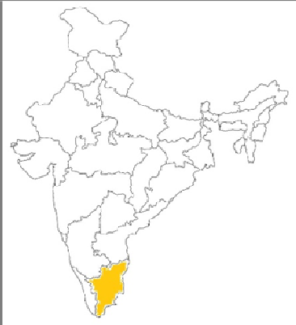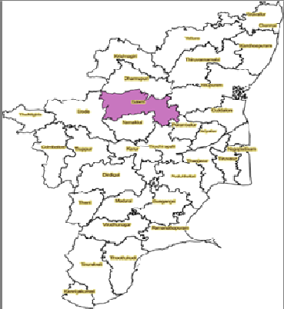

# Figure 1: Location map of Salem district

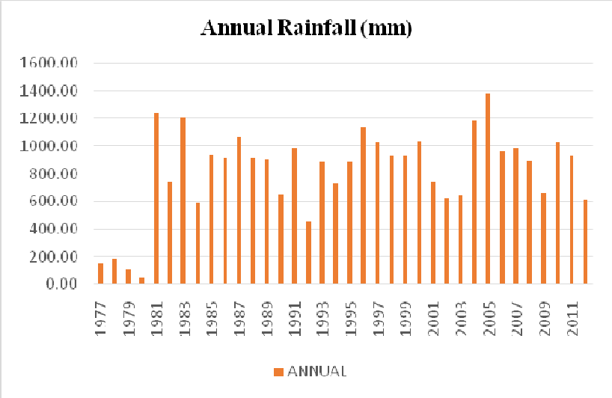

**Figure 2: Annual Rainfall in Salem District**

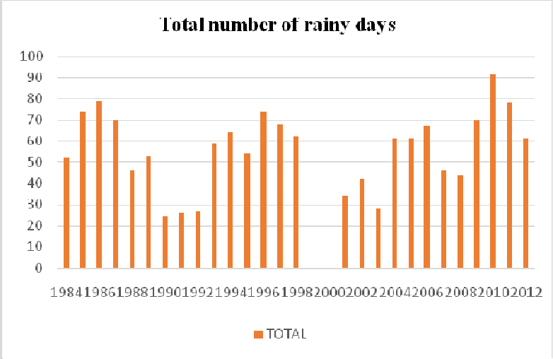

**Figure 3: Rainy Days in Salem District**

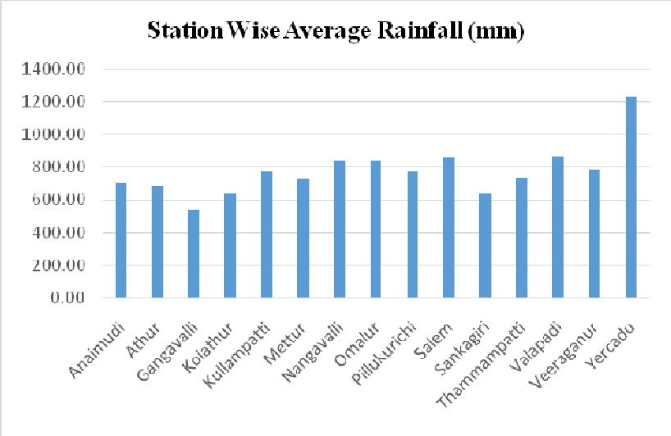

**Figure 4: Station Wise Average Rainfall**

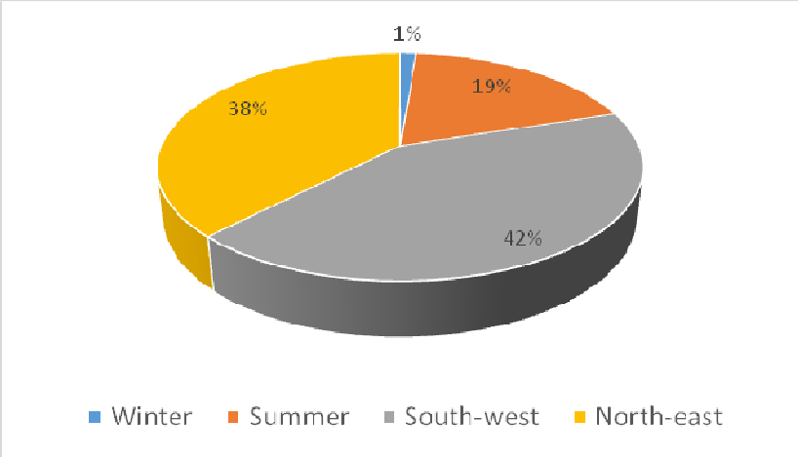

**Figure 5: Seasonal Distribution of Rainfall**

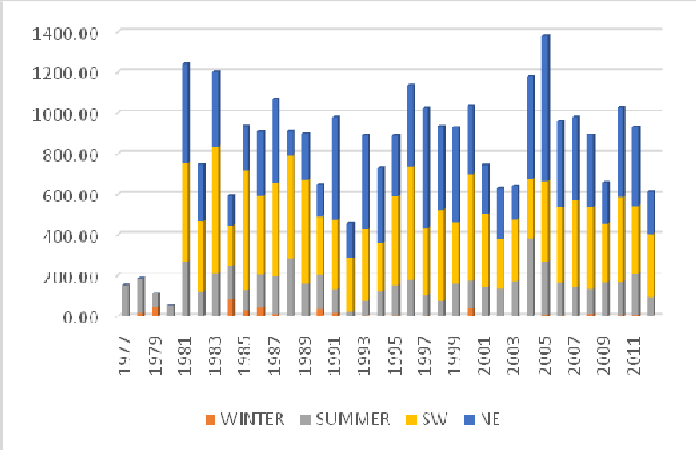

**Figure 6: Temporal variation of seasonal average rainfall from 1971-2012**

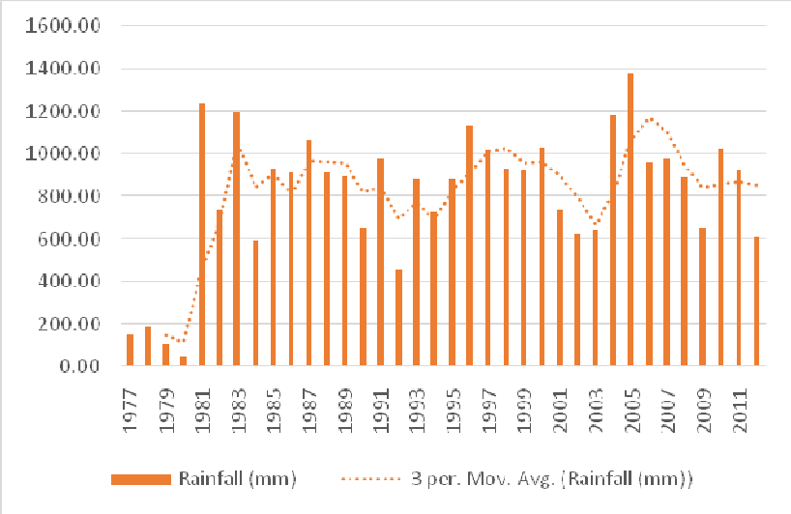

**Figure 7: Mean annual rainfall of the district**

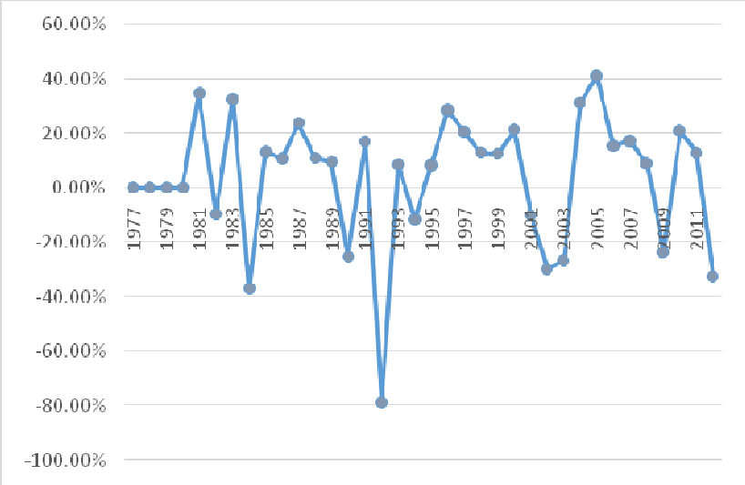

**Figure 8: Percent annual normal rainfall of the district**