RESEARCH ARTICLE
Effect of Foliar application of FeSO₄ on Growth, Yield and Yield attributes of Rice (Oryza sativa L.)
Kamali.B¹, Chandra Sekaran.N^{1*}, Kalaiselvi.T² and Chitdeshwari.T¹
¹Department of Soil Science and Agricultural Chemistry, Tamil Nadu Agricultural University, Coimbatore-3
²Department of Agricultural Microbiology, Tamil Nadu Agricultural University, Coimbatore-3

ABSTRACT
An experiment conducted during 2019 in kharif season (July to October) at the Department of Soil Science and Agricultural Chemistry, Tamil Nadu Agricultural University, Coimbatore, to evaluate the foliar application of FeSO₄ on growth, yield, and yield attributes of CO 51 rice cultivar. The experiment laid out in a factorial completely randomized design (FCRD) with two factors viz., five levels of FeSO₄ (water spray - control, 0.5% FeSO₄, 0.75% FeSO₄, 1.0% FeSO₄, and 1.5% FeSO₄ along with 0.1% citric acid) and 14 different foliar application stages of rice crop (T₁-Panicle initiation, T₂-Flowering, T₃-Milking, T₄-Dough, T₅-Panicle initiation + Flowering, T₆-Panicle initiation + Milking, T₇-Panicle initiation + Dough, T₈-Flowering + Milking, T₉- Flowering + Dough, T₁₀-Milking + Dough, T₁₁-Panicle initiation + Flowering + Milking, T₁₂-Panicle initiation + Flowering+ Milking, T₁₃-Panicle initiation + Milking + Dough, T₁₄-Panicle initiation+ Flowering + Milking+ Dough). The growth, yield, and yield attributes were analyzed. The experimental results reveals that foliar application of 1.5% FeSO₄ + 0.1 % CA at Panicle initiation + Flowering + Milking + Dough stages (T₁₄) recorded significantly higher thousand-grain weight (15.54g), plant height (80.21cm), panicle length (27.00cm), number of productive tillers per hill (24), number of grains per panicle (201), leaf area index (2.58), total chlorophyll content (44.5), straw yield (40.37 g pot⁻¹) and grain yield (30.11 g pot⁻¹).
Keywords: Rice, Fe, FeSO₄, iron, and foliar spray of FeSO_{4.}

INTRODUCTION
Rice is a life-saving cereal and widely cultivated crop around the world. It is grown under diverse climatic conditions. It is a potent energy source for the global population and feeds 50% of the people. Rice crop is grown in an area of about 163.62 million hectares, with the production of 499.89 million tones globally. India covers the area of about 43.99 million hectares, with a production of 109.7 million tons (WAP, 2018). It gives about 21% of the dietary calories for more than half of the global world populations (Fitzgerald et al., 2009). Among the factors limiting rice productivity, micronutrient deficiency is most critical, specifically Fe deficiency. The deficiency of iron in human beings causes the death of about 0.8 million people around the globe. These deficiencies can be corrected by enriching the cereal with micronutrients (Sudha and Stalin, 2015). Foliar spray of FeSO₄ is the most widely used method in crops for alleviating Fe deficiency. A plethora of evidence are there in the literature on foliar application of FeSO₄ in rice crop produced more number of panicles m⁻², panicle length, number of filled grains panicle⁻¹ and yield than with soil application of ferrous sulfate (Velu and Savithiri, 1985). Zayed et al., (2011) reported that foliar spray of Fe increased the growth and yield attributes like panicle length, plant height, no of grains per panicle. Foliar sprays of FeSO₄ at different growth stages of rice crop (maximum tillering, pre-anthesis and post-anthesis) increased the growth and yield attributes. The present study undertaken to evaluate the growth, yield, and yield attributes on various levels of FeSO₄ at different growth stages of CO 51 rice a new variety.

MATERIAL AND METHODS
A pot experiment conducted during 2019 in kharif season (July to October) with rice ruling variety CO 51 at the Department of soil science and Agricultural Chemistry, Tamil Nadu Agricultural University, Coimbatore. The experimental soil was non-saline (EC -0.18 dS m⁻¹), slightly alkaline (pH – 7.9) sandy loam in texture with low available nitrogen (190.4 kg ha⁻¹), phosphorous (10.5 kg ha⁻¹) and organic carbon (0.33 %) and high in available potassium (346 kg ha⁻¹) status. The STCR recommended dose of NPK was applied as 191, 110, and 26 kg ha⁻¹ of N (urea), P (single super phosphate), and K (muriate of potash). The nitrogen and potassium were applied in three splits viz., basal, active tillering and flowering stages, and full dose phosphorous was applied as basal. The nursery was raised, and 21 days old seedling was transplanted three hills per pot. Foliar dose of FeSO₄ (water spray - control, 0.5% FeSO₄, 0.75% FeSO₄, 1.0% FeSO₄ and 1.5% FeSO₄ along with 0.1% citric acid) was applied at various stages of crop plants i.e., T₁-Panicle initiation, T₂- Flowering, T₃- Milking, T₄- Dough, T₅-Panicle initiation + Flowering, T₆- Panicle initiation + Milking, T₇- Panicle initiation + Dough, T₈- Flowering + Milking, T₉- Flowering + Dough, T₁₀- Milking + Dough, T₁₁- Panicle initiation + Flowering + Milking, T₁₂- Panicle initiation + Flowering+ Milking,T₁₃-Panicle initiation + Milking + Dough, T₁₄-Panicle initiation+ Flowering + Milking+ Dough.
The growth parameters like plant height, leaf area index, and chlorophyll meter (SPAD-502) readings measured at panicle initiation, 50% of flowering, milking, and dough stages of rice crop and the yield attributes like the number of productive tillers, panicle length, and the number of filled grain per panicle were recorded at maturity stage. The thousand-grain weight is taken at 14 per cent moisture content. The statistical analysis was carried out with the help of statistical tool version 16.0 (SPSS). Critical difference (CD) was used to compare the treatment effects at P<0.05.

RESULTS AND DISCUSSION

Rice Growth
A perusal of Table.1 data pertaining to plant height and leaf area index reveals that the effect of different treatments tried in the experiment were not influenced the plant height significantly. However, among the various levels of FeSO₄, the maximum plant height (78.77 cm) was recorded in 1.5 % FeSO₄ +0.1% CA followed by 1.0% spray (78.52 cm) and minimum at water spray treatment (77.68 cm). With respect to spray stages, the maximum height of the plant (79.41 cm) was observed with four times applications viz., (T₁₄) Panicle initiation + Flowering + Milking + Dough stages followed by three times applications during (T₁₁) Panicle initiation + Flowering + Milking stages (79.24 cm) and minimum in one-time application especially during (T₄) Dough stage (77.30cm). Interaction between levels of foliar FeSO₄ and spray stages of the rice crop was also not influenced by the plant height significantly. However, a slight increase in plant height in various levels of FeSO₄ might be due to the influence of various metabolic activities of plants and the production of a high amount of auxin, which is a crucial growth promoter, regulating cell enlargement and cell elongation. The results were in accordance with Ali (2012) and Sudha and Stalin, (2015).
Among the growth factors of rice, leaf area index (LAI) is the most commonly used indicator in rice production. Comparing various levels of FeSO_{4,} the foliar spray of 1.5% FeSO₄ +0.1% CA was registered highest LAI (2.32), and it was on par with 1.0 % (2.25) but superior to 0.75%, 0.5%, and water sprays. The minimum value of LAI (1.23) was recorded with water spray (Table 1). The percentage increase over control ranges from 68.55 to 88.84. Among the different times of spray, the maximum LAI (2.20) was recorded with four times application (T₁₄- Panicle initiation + Flowering + Milking + Dough), and it was comparable (2.15) with three times application (T₁₁- Panicle initiation + Flowering + Milking) but superior to rest of the treatments. The minimum mean value of LAI (1.85) was observed in the Dough stage (T₄). The interaction between the various concentration of FeSO₄ and different growth stages of spray had a significant influence on LAI. This might be due to the increased leaf area due to the increased concentration of Fe, which has a specific role in chlorophyll synthesis results in increased leaf area index and chlorophyll content. In line with our results were supported by Zayed et al. (2011) and Rawashdeh and sala, (2014).
The leaf chlorophyll content is the important index of growth parameter and it was significantly influenced by foliar spray of FeSO₄ (Table 2). The maximum chlorophyll content (42.6) was recorded in 1.5% FeSO₄ + 0.1% citric acid treatment, and it was comparable with 1.0 % spray (41.1) but superior to remaining all other treatments. The minimum chlorophyll content (30.5) was observed in water spray (control). The per cent increase over control was varied from 25.2 to 40.0. Total chlorophyll content increased due to the timely spray of FeSO₄ at different growth stages. The significantly maximum chlorophyll content (39.9) was observed at Panicle initiation + Flowering + Milking + Dough stages of spray (T₁₄), and it was comparable (39.6) with Panicle initiation + Flowering + Milking stages of application (T₁₁) but superior to rest of the treatments. The minimum total chlorophyll content (37.0) was recorded in water spray at Dough stage (T₄). Interaction between the concentration of FeSO₄ and different crop stages of spray showed a significant effect on total chlorophyll content. This could be because of the biochemical and physiological activities of plants increased the crop growth with the help of Fe nutrient, thereby increased the chlorophyll content in plants. The finding of Mazaherinia et al. (2010) supported these results.
Further, the role of citric acid on crop growth increased the cell division and protect the cells from free radicals, which was the reason for plant senescence, results in increasing the growth parameters (El-Yazal, 2019).

Yield attributes
A significant influence on panicle length due to the foliar spray of FeSO₄ plus citric acid was observed, and it varied from 18.54 cm to 25.65 cm (Table 3). Among the various levels of FeSO₄, the maximum length of the panicle (25.65 cm) was noticed in 1.5% FeSO₄ +0.1% CA concentration, and it was on par with 1.0% FeSO₄ spray (25.43 cm) but superior to remaining all other treatments and minimum at water spray treatment (18.54 cm). The per cent increase over control ranges from 28.97 to 34.08. The foliar spray of FeSO₄ at different growth stages influenced the panicle length, and the values recorded were in the ranges from 22.29 to 24.55 cm. Significantly highest mean value of panicle length (24.55cm) was recorded in four times spray (T₁₄- Panicle initiation + Flowering + Milking + Dough), and it was comparable (24.35 cm) with three times spray (T₁₁- Panicle initiation + Flowering + Milking). The lowest mean value of panicle length (22.29 cm) was observed in water spray (control) treatment. This might be due to the process of photosynthesis, and higher chlorophyll formation results in an increased supply of photosynthates to sink, because of foliar spray of micronutrients at various growth stages results in increased the panicle length. In the present study, the interaction between various levels of FeSO₄ and spray stages on panicle length was found to be significant. These results corroborated the findings of Ali, (2012) and Duraisamy and Mani, (2001).
An examination of data depicted in Table.3 revealed that the number of grains per panicle was found to be significant due to foliar application of FeSO₄ plus 0.1% citric acid. The maximum no. of grains per panicle (174) was obtained in 1.5 % FeSO₄ +0.1%CA, and it was on par with 1.0% spray (170) but significantly superior to other levels. The minimum number of grains per panicle (117) was observed in the water spray. The percentage increase over control was ranged from 26.91 to 48.99. With respect to various spray stages of rice crop, the maximum no. of grains per panicle (171) was recorded with T₁₄ (Panicle initiation + Flowering + Milking + Dough stages of spray) treatment. However, it was comparable (167) with T₁₁ (Panicle initiation + Flowering + Milking stages of spray) treatment. The lowest no. of grains per panicle (138) was observed in T₄ (Dough stage of spray) treatment. Levels of foliar FeSO₄ and spray stages of the rice crop was a significant interaction with the number of grains per panicle. This was due to increased uptake of nutrients results in increased photosynthesis and translocate to the panicle for increasing the number of grains per panicle. A similar finding was supported by Ali, (2012).
The effectiveness of all the treatments on the number of productive tillers per hill was clearly evident from data presented in Table. 4. The maximum number of productive tillers per hill (21) was recorded in 1.5 % FeSO₄ +0.1 % CA spray, and it was on par with 1.0% but superior to 0.75%, 0.5% and water sprays. The minimum number of productive tillers per hill (12) was noticed in water spray treatment. The increase per cent over control was 62.1. With respect to FeSO₄ applied at different growth stages of the crop, the maximum number of productive tillers per hill (20) was recorded at four time’s application (T₁₄- Panicle initiation + Flowering + Milking + Dough). The lowest number of productive tillers per hill (15) was observed in one-time application during Flowering (T₂), Milking (T₃) and Dough (T₄) stages. The interaction effect of various levels of FeSO₄ at different stages of spray was significant with the number of productive tillers per hill. The reason might be due to the increase in the plant metabolic process, thereby increased the number of productive tillers per hill. These results were supported by Naik and Das, (2007).
The foliar spray of FeSO_{4,} along with citric acid, significantly improved the thousand-grain weight from 14.24 to 15.29g (Table 4). The highest mean value of thousand-grain weight (15.29g) was recorded in 1.5 % FeSO₄ + 0.1% CA. However, it was on par with 1.0% FeSO₄ but superior to all other treatments. The lowest mean value of thousand-grain weight (14.24 g) was observed in water spray treatment. The per cent increase over control was varied from 6.28 to 7.32. This was because of an increased amount of Fe levels improved the metabolism to produce a high rate of carbohydrates and was translocate to grains, which resulted in increased grain weight. With respect to spray stages, the effect was non–significant. However, the maximum thousand-grain weight (15.22g) was observed in T₁₄ (Panicle initiation + Flowering + Milking + Dough stages of spray) treatment followed by T₁₁ (Panicle initiation + Flowering + Milking stages of spray (15.19 g) treatment. The lowest mean value of thousand-grain weight (14.82 g) was noticed in T₄ (Dough stage of spray) treatment. Interaction between different levels of FeSO₄ and spray stages of rice was not significantly influenced the thousand-grain weight. The results of the findings of Zeidan et al. (2010) supported the present findings. .

Rice yield
The rice grain and straw yield results are furnished in (Figure. 1 and 2) revealed that the foliar application of FeSO₄ along with citric acid recorded rice grain and straw yield value ranges from 14.24 to 27.23 g pot⁻¹ and 25.64 to 39.72 g pot⁻¹, respectively. Among the different levels of FeSO₄, the foliar spray at 1.5% FeSO₄ + 0.1% CA was recorded maximum grain and straw yield of 27.23 and 39.72 g pot⁻¹, respectively (Figure. 1a and 2a). However, it was on par with 1.0% FeSO₄ + 0.1% CA spray, but superior to 0.75%, 0.5% and water spray treatments. The minimum grain and straw yield was noticed in water spray treatment. The increase per cent over control was varied from 70 to 90 for grain and 45 to 55 for straw yields. With respect to different spray stages, the four times sprayed treatment viz.., T₁₄ (Panicle initiation + Flowering + Milking + Dough stages of spray) was recorded highest grain and straw yield of 26.18 to 37.35 g pot⁻¹, respectively, and it was comparable with three times applied treatment viz.., T₁₁ (Panicle initiation + Flowering + Milking stages of spray) with grain and straw yield of 25.55 and 37.26 g pot⁻¹ respectively and superior to rest of other treatments (Figure. 1b and 2b). The minimum grain and straw yield was observed in one time sprayed treatment viz., T₄ (Dough stage of spray) with grain and straw yield of 21.15 and 34.98 g pot⁻¹, respectively. There was a significant interaction between various levels of foliar FeSO₄ and spray stages of rice crops in both grain and straw yield (Figure. 1c and 2c). The plausible reason that foliar Fe application increases the chlorophyll content, antioxidant enzymes, their activities, and finally increasing the yield parameters followed by increasing the grain yield. Application of Fe significantly increases the grain and straw yield of rice crop, due to the improvement of enzymatic activities and the process of photosynthesis Ghafari and Razmjoo (2013) and Seadh et al. (2009) suggested similar results.
Foliar application of FeSO₄ alone became inefficient in rice crop. Since it may either be precipitated or due to poor translocation within the plants. Therefore, foliar application of FeSO₄ along with citric acid helps for better translocation. Further, foliar spray of iron is acidified by citric acid as the low pH of the spray solution improving the absorption and translocation of Fe within the plants. These findings were in accordance with (Kumawat et al., 2006) foliar FeSO₄ + 0.1% CA at different growth stages (branching, flowering and both at branching and flowering) increased the growth and yield.

CONCLUSION
Among the management options available to increase the productivity of rice, the micronutrient application plays a vital role. Among the micronutrients, the Fe plays a major role. Iron is a necessary element for plant growth, and since the formation of chlorophyll depends on iron, plant deficiency or deactivation of iron shows chlorosis. The decrease of chlorophyll leading to the reduction of the plant food processor, and finally, the yield is reduced. From the present study, the FeSO₄ at 1.5% plus 0.1 % CA foliar spray at Panicle initiation + Flowering + Milking + Dough stages of rice resulted in improving the growth, yield, and yield attributes, because at this level there was a better plant growth and yield compared to control. Based on these findings, it is concluded that foliar FeSO_{4,} along with citric acid used for sustainable improvement in the growth and yield of rice crops.

REFERENCES
Tables
Spray at different growth stages of rice | Plant height (cm) |  |  |  |  |  | Leaf area index (LAI)
Spray at different growth stages of rice | Levels of FeSO₄ (%) |  |  |  |  |  | Levels of FeSO₄ (%)
Spray at different growth stages of rice | Water  spray | 0.5 | 0.75 | 1.0 | 1.5 | Mean | Water  spray | 0.5 |  | 0.75 | 1.0 |  | 1.5 | Mean
T₁- Panicle initiation | 77.68 | 77.75 | 77.81 | 77.85 | 77.87 | 77.79 | 1.22 | 1.91 |  | 2.05 | 2.10 |  | 2.12 | 1.88
T₂- Flowering | 77.68 | 77.77 | 77.84 | 77.90 | 77.94 | 77.83 | 1.24 | 1.92 |  | 2.07 | 2.11 |  | 2.13 | 1.89
T₃- Milking, | 77.67 | 77.40 | 77.52 | 77.65 | 77.77 | 77.60 | 1.23 | 1.97 |  | 2.10 | 2.16 |  | 2.19 | 1.93
T₄- Dough | 77.67 | 77.00 | 77.15 | 77.27 | 77.42 | 77.30 | 1.22 | 1.89 |  | 2.00 | 2.06 |  | 2.10 | 1.85
T₅- Panicle initiation + Flowering | 77.68 | 78.63 | 78.76 | 78.88 | 78.99 | 78.59 | 1.24 | 2.07 |  | 2.18 | 2.24 |  | 2.28 | 2.00
T₆- Panicle initiation + Milking | 77.67 | 78.26 | 78.44 | 78.63 | 78.82 | 78.36 | 1.23 | 2.12 |  | 2.21 | 2.29 |  | 2.34 | 2.04
T₇- Panicle initiation + Dough | 77.67 | 77.86 | 78.07 | 78.25 | 78.47 | 78.06 | 1.22 | 2.04 |  | 2.11 | 2.10 |  | 2.25 | 1.94
T₈₋ Flowering + Milking | 77.67 | 78.28 | 78.47 | 78.68 | 78.89 | 78.40 | 1.22 | 2.13 |  | 2.23 | 2.31 |  | 2.35 | 2.05
T₉- Flowering + Dough | 77.68 | 77.88 | 78.10 | 78.25 | 78.54 | 78.09 | 1.24 | 2.05 |  | 2.13 | 2.21 |  | 2.26 | 1.98
T₁₀- Milking + Dough | 77.66 | 77.51 | 77.78 | 78.05 | 78.37 | 77.87 | 1.23 | 2.10 |  | 2.16 | 2.26 |  | 2.32 | 2.01
T₁₁- Panicle initiation + Flowering + Milking | 77.68 | 79.33 | 79.47 | 79.62 | 80.10 | 79.24 | 1.22 | 2.20 |  | 2.35 | 2.44 |  | 2.56 | 2.15
T₁₂- Panicle initiation + Flowering+ Dough | 77.68 | 78.93 | 79.10 | 79.24 | 79.75 | 78.94 | 1.24 | 2.14 |  | 2.28 | 2.34 |  | 2.47 | 2.09
T₁₃- Panicle initiation + Milking + Dough | 77.67 | 78.56 | 78.78 | 78.99 | 79.58 | 78.72 | 1.22 | 2.19 |  | 2.31 | 2.39 |  | 2.53 | 2.13
T₁₄- Panicle initiation + Flowering + Milking + Dough. | 77.69 | 79.50 | 79.61 | 80.05 | 80.21 | 79.41 | 1.23 | 2.26 |  | 2.41 | 2.50 |  | 2.58 | 2.20
Mean | 77.68 | 78.19 | 78.35 | 78.52 | 78.77 |  | 1.23 | 2.07 |  | 2.19 | 2.25 |  | 2.32
 | FeSO₄ Levels |  | Spray stages |  | Levels × Stages |  | FeSO₄ Levels |  | Spray stages |  |  | Levels × Stages
SE_{d} | 0.383 |  | 0.640 |  | 1.432 |  | 0.015 |  | 0.025 |  |  | 0.056
CD @ 5% | NS |  | NS |  | NS |  | 0.030 |  | 0.050 |  |  | 0.112
Table 1. Effect of foliar FeSO₄ on plant height and leaf area index

Table 2. Effect of foliar FeSO₄ on SPAD chlorophyll content (CO 51)
Spray at different growth stages of rice | Levels of FeSO₄ (%) |  |  |  |  | Mean
Spray at different growth stages of rice | Water spray | 0.5 | 0.75 | 1.0 | 1.5 | Mean
T₁- Panicle initiation | 30.5 | 36.2 | 38.2 | 40.3 | 41.0 | 37.2
T₂- Flowering | 30.6 | 36.4 | 38.5 | 40.5 | 41.3 | 37.5
T₃- Milking, | 30.4 | 36.7 | 38.9 | 40.9 | 41.8 | 37.7
T₄- Dough | 30.5 | 36.0 | 37.8 | 40.0 | 40.7 | 37.0
T₅- Panicle initiation + Flowering | 30.5 | 38.4 | 39.8 | 41.0 | 42.7 | 38.5
T₆- Panicle initiation + Milking | 30.4 | 38.7 | 40.2 | 41.4 | 43.2 | 38.8
T₇- Panicle initiation + Dough | 30.2 | 38.0 | 39.1 | 40.5 | 42.1 | 38.0
T₈₋ Flowering + Milking | 30.4 | 38.9 | 40.5 | 41.6 | 43.5 | 39.0
T₉- Flowering + Dough | 30.5 | 38.2 | 39.4 | 40.7 | 42.4 | 38.2
T₁₀- Milking + Dough | 30.5 | 38.5 | 39.8 | 41.1 | 42.9 | 38.6
T₁₁- Panicle initiation + Flowering + Milking | 30.6 | 39.7 | 41.5 | 42.0 | 44.2 | 39.6
T₁₂- Panicle initiation + Flowering+ Dough | 30.4 | 39.0 | 40.4 | 41.1 | 43.1 | 38.8
T₁₃- Panicle initiation + Milking + Dough | 30.5 | 39.3 | 40.8 | 41.8 | 43.6 | 39.2
T₁₄- Panicle initiation + Flowering + Milking + Dough. | 30.4 | 40.0 | 42.0 | 42.5 | 44.5 | 39.9
Mean | 30.5 | 38.1 | 39.8 | 41.1 | 42.6
 | FeSO₄ Levels |  | Spray stages |  | Levels × Stages
SE_{d} | 0.215 |  | 0.360 |  | 0.804
CD @ 5% | 0.425 |  | 0.712 |  | 1.591

Table 3. Effect of foliar FeSO₄ on panicle length and number of grains per panicle (CO 51)
Spray at different growth stages of rice | Panicle length (cm) |  |  |  |  |  | Number of grains per panicle
Spray at different growth stages of rice | Levels of FeSO₄ (%) |  |  |  |  |  | Levels of FeSO₄ (%)
Spray at different growth stages of rice | Water  spray | 0.5 | 0.75 | 1.0 | 1.5 | Mean | Water  spray | 0.5 |  | 0.75 | 1.0 |  | 1.5 | Mean
T₁- Panicle initiation | 18.55 | 22.40 | 23.21 | 24.30 | 24.35 | 22.56 | 117 | 140 |  | 145 | 150 |  | 153 | 141
T₂- Flowering | 18.52 | 22.82 | 23.53 | 24.41 | 24.44 | 22.74 | 118 | 145 |  | 150 | 155 |  | 158 | 145
T₃- Milking, | 18.54 | 22.20 | 23.00 | 24.10 | 24.13 | 22.39 | 116 | 139 |  | 143 | 148 |  | 151 | 139
T₄- Dough | 18.51 | 22.00 | 22.84 | 24.04 | 24.08 | 22.29 | 117 | 137 |  | 140 | 146 |  | 148 | 138
T₅- Panicle initiation + Flowering | 18.54 | 24.22 | 25.56 | 26.12 | 26.35 | 24.16 | 116 | 151 |  | 164 | 176 |  | 183 | 158
T₆- Panicle initiation + Milking | 18.52 | 23.60 | 25.03 | 25.81 | 26.04 | 23.80 | 116 | 145 |  | 157 | 169 |  | 176 | 153
T₇- Panicle initiation + Dough | 18.54 | 23.40 | 24.87 | 25.75 | 25.99 | 23.71 | 118 | 143 |  | 154 | 167 |  | 173 | 151
T₈₋ Flowering + Milking | 18.53 | 24.02 | 25.35 | 25.81 | 26.13 | 23.97 | 117 | 150 |  | 162 | 174 |  | 181 | 157
T₉- Flowering + Dough | 18.55 | 23.82 | 25.19 | 25.75 | 26.08 | 23.88 | 115 | 148 |  | 159 | 172 |  | 178 | 154
T₁₀- Milking + Dough | 18.52 | 23.20 | 24.66 | 25.55 | 25.77 | 23.54 | 117 | 142 |  | 152 | 165 |  | 171 | 149
T₁₁- Panicle initiation + Flowering + Milking | 18.54 | 25.10 | 25.59 | 26.15 | 26.39 | 24.35 | 116 | 160 |  | 175 | 190 |  | 192 | 167
T₁₂- Panicle initiation + Flowering+ Dough | 18.53 | 24.90 | 25.43 | 26.09 | 26.34 | 24.26 | 118 | 158 |  | 172 | 188 |  | 189 | 165
T₁₃- Panicle initiation + Milking + Dough | 18.55 | 24.28 | 24.90 | 25.78 | 26.03 | 23.91 | 117 | 152 |  | 165 | 181 |  | 182 | 159
T₁₄- Panicle initiation + Flowering + Milking + Dough. | 18.55 | 25.26 | 25.60 | 26.34 | 27.00 | 24.55 | 117 | 165 |  | 178 | 196 |  | 201 | 171
Mean | 18.54 | 23.66 | 24.63 | 25.43 | 25.65 |  | 117 | 148 |  | 158 | 170 |  | 174
 | FeSO₄ Levels |  | Spray stages |  | Levels × Stages |  | FeSO₄Levels |  | Spray stages |  |  | Levels × Stages
SE_{d} | 0.145 |  | 0.242 |  | 0.541 |  | 1.142 |  | 1.911 |  |  | 4.272
CD @ 5% | 0.286 |  | 0.479 |  | 1.071 |  | 2.260 |  | 3.781 |  |  | 8.455

Spray at different growth stages of rice | Number of productive tillers per hill |  |  |  |  |  | Thousand-grain weight (g)
Spray at different growth stages of rice | Levels of FeSO₄ (%) |  |  |  |  |  | Levels of FeSO₄ (%)
Spray at different growth stages of rice | Water  spray | 0.5 | 0.75 | 1.0 | 1.5 | Mean | Water  spray | 0.5 | 0.75 |  | 1.0 | 1.5 |  | Mean
T₁- Panicle initiation | 13 | 15 | 16 | 18 | 19 | 16 | 14.26 | 14.95 | 15.05 |  | 15.12 | 15.15 |  | 14.91
T₂- Flowering | 12 | 14 | 15 | 16 | 17 | 15 | 14.25 | 15.00 | 15.10 |  | 15.16 | 15.18 |  | 14.94
T₃- Milking, | 12 | 14 | 15 | 16 | 17 | 15 | 14.23 | 14.90 | 14.99 |  | 15.06 | 15.09 |  | 14.85
T₄- Dough | 12 | 14 | 15 | 16 | 17 | 15 | 14.23 | 14.87 | 14.95 |  | 15.00 | 15.04 |  | 14.82
T₅- Panicle initiation + Flowering | 13 | 18 | 19 | 21 | 22 | 19 | 14.25 | 15.25 | 15.28 |  | 15.34 | 15.38 |  | 15.10
T₆- Panicle initiation + Milking | 12 | 18 | 19 | 21 | 22 | 18 | 14.24 | 15.15 | 15.17 |  | 15.24 | 15.29 |  | 15.02
T₇- Panicle initiation + Dough | 12 | 18 | 19 | 21 | 22 | 18 | 14.26 | 15.12 | 15.13 |  | 15.18 | 15.24 |  | 14.99
T₈₋ Flowering + Milking | 12 | 17 | 18 | 20 | 21 | 18 | 14.24 | 15.20 | 15.22 |  | 15.28 | 15.32 |  | 15.05
T₉- Flowering + Dough | 12 | 17 | 18 | 20 | 21 | 18 | 14.23 | 15.17 | 15.18 |  | 15.22 | 15.27 |  | 15.01
T₁₀- Milking + Dough | 12 | 17 | 18 | 20 | 21 | 18 | 14.24 | 15.07 | 15.07 |  | 15.12 | 15.18 |  | 14.94
T₁₁- Panicle initiation + Flowering + Milking | 12 | 19 | 20 | 22 | 23 | 19 | 14.25 | 15.34 | 15.40 |  | 15.45 | 15.50 |  | 15.19
T₁₂- Panicle initiation + Flowering+ Dough | 12 | 19 | 20 | 22 | 23 | 19 | 14.24 | 15.31 | 15.36 |  | 15.39 | 15.45 |  | 15.15
T₁₃- Panicle initiation + Milking + Dough | 12 | 19 | 20 | 22 | 23 | 19 | 14.23 | 15.21 | 15.25 |  | 15.29 | 15.36 |  | 15.07
T₁₄- Panicle initiation + Flowering + Milking + Dough. | 13 | 20 | 21 | 23 | 24 | 20 | 14.25 | 15.38 | 15.44 |  | 15.50 | 15.54 |  | 15.22
Mean | 12 | 17 | 18 | 20 | 21 |  | 14.24 | 15.14 | 15.19 |  | 15.24 | 15.29
 | FeSO₄ Levels |  | Spray stages |  | Levels × Stages |  | FeSO₄ Levels |  |  | Spray stages |  |  | Levels × Stages
SE_{d} | 0.163 |  | 0.273 |  | 0.609 |  | 0.076 |  |  | 0.126 |  |  | 0.283
CD @ 5% | 0.322 |  | 0.539 |  | 1.206 |  | 0.150 |  |  | NS |  |  | NS
Table 4. Effect of foliar FeSO₄ on number of productive tillers per hill and thousand-grain weight (CO 51)

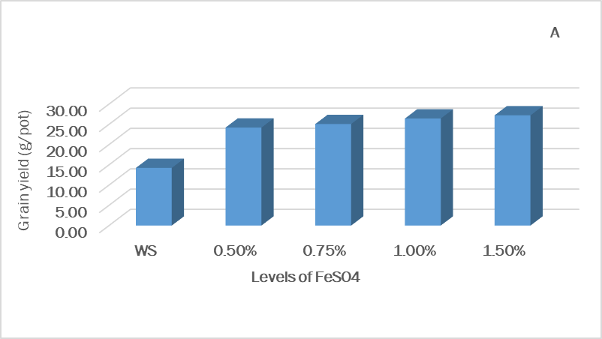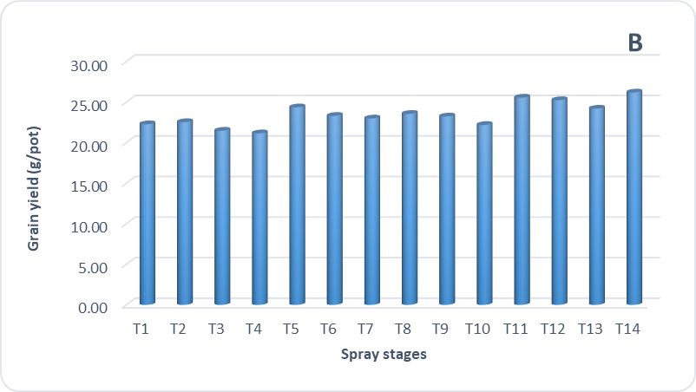

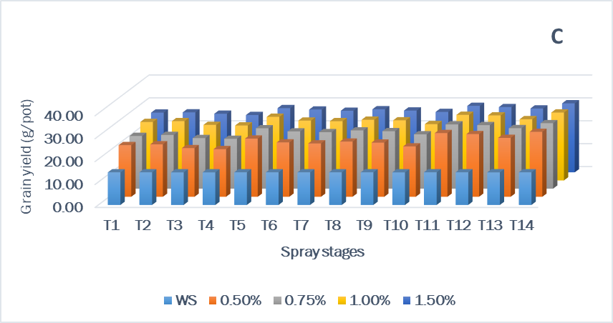

Figure 1. Effect of a) levels of FeSO₄ b) spray stages c) levels × spray stages on grain yield (g/pot)

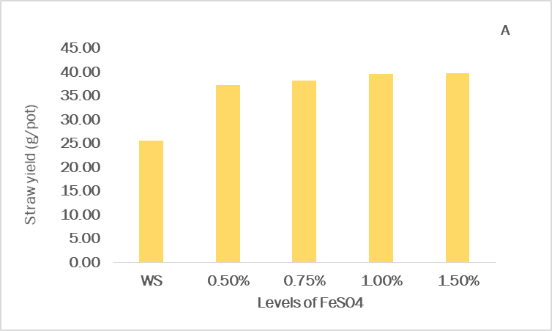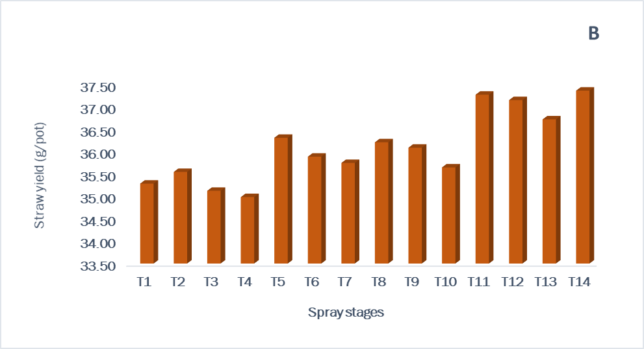

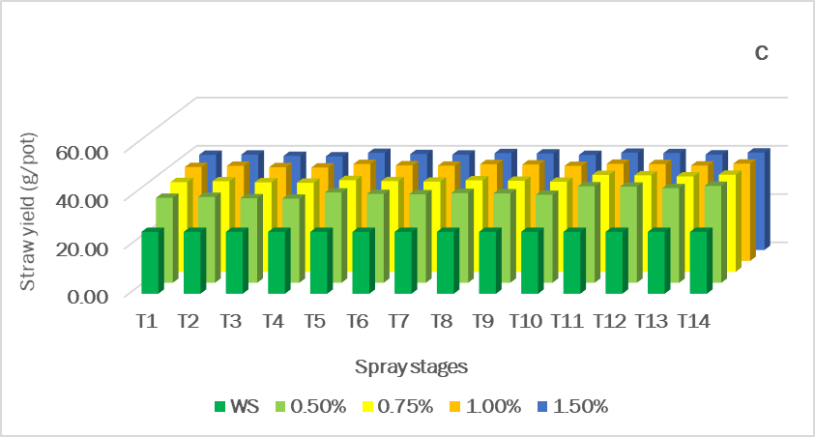

Figure 2. Effect of a) levels of FeSO₄ b) spray stages c) levels × spray stages on straw yield (g/pot)

