
Madras Agric.J., 2018; doi:xxxxxxxxx

RESEARCH ARTICLE
Standardization of Pellet size for Mechanized Sowing in Foxtail Millet
(Setaria italica L.)

ABSTRACT
The seeds of foxtail millet (Setaria italica L.) were circumscribed by small amount of filler materials and adhesive to produce a globular unit of systematized size and also supply nutrient to the plant. Pellet size in terms of seed size has been standardized by using TNAU pelleting powder as inert material and gum acacia as adhesive material to suite the requirement of air assisted seed drill for precision sowing with minimum seed rate. Results showed that the pellet size of 3.1 mm was found to be optimum for mechanized sowing with seed drill and 11 layers of coating increases the seed size to 3.1 mm. The seeds coated to 11 layers have also recorded maximum germination (87 %), root length (12.7 cm), shoot length (6.3 cm), vigour index (1656) with high speed of germination (6.5).

Keywords: Small millets, Mechanical sowing, Seed pelleting,Pellet size, Seed quality.

INTRODUCTION
Millets play a major role in food security and human nutrition by providing minerals and vitamins. Foxtail millet
(Setaria italica L.) is one of the important small millets mostly cultivated in arid and semi arid regions of Asia and other parts of the world. It is rich in thiamine,
calcium, dietary fiber and low in fat. However,
farmers mostly raise the crop under rainfed condition and marginal lands
with minimum care.
The main difficulty in millets is their seed size; because of small size, a large quantity of seeds are being wasted
during sowing and also needs a substantial number of labourers for sowing and thinning
. These problems can be addressed by mechanical sowing using
seed drills. Small seeds are not amenable for mechanical sowing and therefore, the size of the seeds has to be
increased to match with the hole size in the seed drill. Seed pelleting is one of the seed enhancement techniques
in which the seeds are coated with inert/ nutrient material with the help of adhesive which will increase the seed
size to the required level.

Pelleting is mostly practiced in small (Halmer,2003) and irregular shaped seeds for easy handling
and also helps in mechanized sowing. The pelleting material provides a
appropriate carrier for biofertilizers, insecticides, fungicides and nutrients (Dunning et al., 1985 and Chayadevi, 2017). Pelleting is also helps provide uniformity in plant spacing by
mechanized sowing. Sowing of pelleted seed offers protection from rodents, birds and insects
(Manjunath et al.,2009). Seeds pelleted with nutrients improve the initial growth and emergence of the
seedling (Roos et al., 1979).
Purpose / objective of the study?
32
MATERIAL AND METHODS
Foxtail millet CO (Te) 7 seed was obtained from Centre of Excellence, Athiyanthal, Thiruvannamalai. The experiment was conducted at Department of Seed Science and Technology, Coimbatore during 2019-
2020. The TNAU Pelleting mixture was used as inert material which consists of two parts of TNAU powder A and one part of TNAU powder B and other nutrients. The gum acacia with
appropriate viscosity, strength and water solubility was used as adhesive.

While pelleting, the seeds were spread in a thin layer and sprayed with adhesive (concentration?) over the seeds. Wet seeds
were transferred to a container and measured quantity of pelleting mixture was added as per the details given below.

Number of Steps | Quantity of pelleting material  (g)/each layer | No.of layers | Seed size (mm)
Control | - | - | 0.20
I step | 0.4 | 2 | 0.20
II step | 0.8 | 2 | 0.26
III step | 1.2 | 2 | 0.32
IV step | 2.0 | 3 | 2.13
V step | 2.5 | 2 | 3.12
VI step | 3.5 | 2 | 3.44
The container was rotated vigourously to avoid the multi and pseudo pellets and uniform distribution of pelleting mixture. Alternate wetting with adhesive and dusting of inert material process was repeated until getting the
required size of pellets by following different layers viz., 9 layers (S₁), 11 layers (S₂) and 13 layers (S₃). The process was repeated for
maximum of six steps. Unpelleted seeds served as control (S₀). The pelleted seeds w_{e}re dried in hot air oven at 40⁰C f_{o}r 2 h to have the compactness.
Different pellet s^{iz}es were made by using TNAU pelleting mixture and gum acacia
as per the details g.

The size of pelleted and unpelleted seeds was measured by using vernier calliper.

56
Germination test for pelleted and unpelleted seeds was carried out in paper medium using 100 seeds for each
treatment with four sub replicates in a germination room maintained at a temperature of 25 ± 1°C and RH
of 96 ± 2 percent with diffused light (approx. 10 h) during the day. Final count on normal seedlings was
recorded on tenth day and percent germination was computed. All normal seedling were measured for root
length ( between collar region and tip of primary root ), shoot length( from collar region to tip of leave) and
expressed in cm. The vigour index value was calculated and expressed in whole number. For determination
of dry weight, the seedlings were dried in a hot air oven maintained at 85°C for 48 h and kept in a
desiccator for 30 min and weighed in an electronic digital balance and mean of dry weight was arrived and
expressed as mg 10 seedlings -1.The speed of germination was calculated by the procedure given by
Maguire (1962). In which, the protrusion of plumule from pelleted seeds were counted daily from planting up to
final count day and calculated the speed of germination as per the formula,

69
70
X1- Number of seeds germinated at first count
X2- Number of seeds germinated at second count
Xn- Number of seeds germinated on nth day
Y1- Number of days from sowing to first count
Y2- Number of days from sowing to second count
Yn- Number of days from sowing to nth count 77

Dissolution rate of pelleted seeds was calculated as per method of Dogan et al.,(2005 ).In which, ten randomly selected pelleted seeds were
dropped in water and time taken to dissolve the pelleted material in water was recorded (Table.1)

Similarly, pelletization efficiency was calculated as per Baladhiya et al., (2011). In which, one
hundred pelleted seeds in two replication at 50 seeds per replication were soaked in water

and pelletization efficiency was calculated by the formula
87
88 Pelletization efficiency (%) = Number of pellets containing seed
89 --------------------------------------------------------------------- × 100
Number of pellets prepared
For fragmentation test, 100 pellets were taken in a plastic bag and was shackened manually for one
minute. After that, the number of broken and cracked pellets were noted (Tamilselvi, 2017)
94statistical analysis and methodoly used?

RESULTS AND DISCUSSION
Irrespective of size of pellets, significant difference was observed in speed of germination due
to pelleting over the unpelleted seeds
. Among the pellet size, 9 layers (S1 ) recorded maximum speed of germination (7.3) over 13 layers S3 (6.4) In case of seed germination, unpelleted seeds showed maximum germination
(89 %) followed by pelleted seeds with 9 layers (88 % ) and it was on par
with control. The maximum root length (12.7 cm) was observed in pellet size of 11 layers (S₂) which was on par with 9 layers (12.4 cm) and the minimum root length was observed in control (8.2 cm) . Shoot length results betrayed that considerable difference was observed in unpelleted and pelleted seeds. The unpelleted seeds and pellet size of 9 layers (S1 ) showed the same shoot length (6.0 cm) and the highest shoot length was observed in pellet size of 11 layers (6.3 cm). The pelleted seeds showed significant difference in vigour index than unpelleted seeds. The highest vigour index was observed in pellet size of 11 layers S₂ (1656) and minimum vigour index was observed in unpelleted seeds (1289) (Fig.2.). The maximum dry matter production was observed in pellet size of 11 layers S2 (0.05) over unpelleted seeds (Table 2.)
The hundred seed weight of pelleted seeds was maximum than unpelleted seeds because of adding filler
materials. Pellet size of 13 layers (S3 ) showed maximum 100 seed
weight (3.0) than other two layers (1.4 g and 2.5 g). The results for length of pellet also showed the
same trend. In which, the maximum length in pellet size of 11 layers (S2 ) was recorded (3.56 cm) over control (1.56
cm). The percentage increase in length of pellets in pellet size of 11 layers (S2 ) was higher ( 98 cm) than
pellet size of 9 layers. The maximum breadth of seed was recorded in pellet size of 13 layers (S3 )
(3.52 cm) followed by pellet size of 11 layers (S2 ) (3.30 cm)
and the least breadth was observed in unpelleted seeds (1.71 cm). The percentage increase in breadth of pelletes in pellet size of 13 layers (S3 ) was higher than pellet size of 9 layers (S1 ) (Table 1.)
Among the three different pellets, pellet size of 9 layers (S1 ) showed lesser time to dissolute (5.4 min)
when compared to pellet size of 13 layers (S3 ) (6.5 min) due to the more layers compared to other
pellets (Table 1b.) According to Dogan et al.,(2005) , pelleted seeds have massive diameter in size ,so it
take longer time to dissolute in water based on pelleting materials. Longer dissolution time take less
absorption of water and it stifle the germination (Table .1b)
In fragmentation test, the maximum broken and cracked pellets (6.1 %) was observed in pellet size of 13
layers (S3 ) followed by 11 layers (S2 ) (3.1 %) and least was observed in 9layers (S1 ) (2.0 %). No pseudo pellet was observed in all the three pellets which showed high pelleting efficiency in foxtail millet. The maximum number of double seeds was noticed in pellet size of 11 layers (S2 ) (1.0) and it was minimum in 13 layers (S3 ) (0.8) (Table .1b) Control seeds were earlier in days to intial germination because it easily imbibe water, and pelleting create a mechanical barrier to the protrusion of the radicle (Govinden-Soulange Joyce and Melissa Levantard, 2008). The TNAU pelleting powder also improved the yield of crop in germination percentage, Seedling length of a crop (Silambarasan,2015).The Gum acacia is derived from the plant of A.indica which have insecticidal property. In S3 more layer of filler materials also inhibit the germination.
The 11 layer coating (S2 ) is suitable for seed drill sowing (how? Field study data?) and it also have maximum root length, shoot
length, germination and vigour index .So this pellet size is suggested for mechanized sowing (whether studied under field condition?). Pelleting was also done in some other crops like redgram, blackgram and rice. In redgram, seeds pelleted with botanicals like thulasi followed by noni improved germination and field emergence (Anbarasan et al.,2015). Blackgram seeds were pelleted with botanicals followed by
biofertilizer,the seeds pelleted with pungam leaf powder enhance the germination and yield parameters
when compared to control(Vennila et al.,2018) whereas rice seeds were pelleted with arappu leaf
powder showed higher field emergence and plant growth at field over than to control ( Nagaraj ,1996)
- CONCLUSION
- It is concluded that the pellet size of 11 layers (3.1 mm) recorded maximum
- germination, root length, shoot length vigour index and pelletization efficiency with uniform pellet size and
- without pseudo pellets. Hence, the optimum pellet size of 3.1 mm with 11 layers can be recommended as
- the optimum pellet size for mechanized sowing in foxtail millet seeds.(field study data?)

REFERENCES (not in MAJ format)
- Abdul-Baki, A.A. and J.D. Anderson. 1973. Vigour determination in soybean seeds by multiple criteria. Crop 150 Sci., 13: 630 - 633.
- Angumuthu, R. "Studies on seed pelleting, physiological maturity, sowing quality and storage of small
- millets." M. Sc.(Agri.) Thesis (1991).
- Anbarasan, R., P. Srimathi and A.Vijayakumar. 2016. Influence of seed pelleting on seed quality
- improvement in redgram (Cajanus cajan L.). Legume Res., 39(4): 584 - 589.
- chaya devi, k. "studies on the influence of seed pelleting on crop performance, seed yield and quality in
- french bean (phaseolus vulgaris l.) cv.„arka anoop‟." phd diss., university of agricultural sciences
- gkvk, bangalore.
- Dunning, W., J. Byford and M.J. Durant. 1985. Sugar beet seed treatment. In: monograph, 2(Ed. Jeffs, K.
- A.). Collaborative.Int. Pesticide Analytical Council.
- Govinden Soulange Joyce and Melissa Levantard. 2008. Comparative studies of seed priming and pelleting
- on percentage and meantime to germination of seeds of tomato (Lycopersicon esculentum Mill.). 162 Afric. J. Agric. Res., 3(10): 725 - 731.
- Halmer,p.,2003 Enhancing seed performance for better yield and quality. Asian seeds plants Mater.10;4 -7
- Konstantinov, G. 1983. Transplantless growing of cv. Drouzhba tomatoes using pelleted seeds.
- Gradinarska Ii Lozarska Nauka, 20(4): 53 - 57.
- Kiran, S. P. "Influence of Seed Pelleting on Crop Growth, Seed Yield and Quality in Sunflower Hybrid KBSH-
- 53 (Helianthus Annuus L.)." PhD Thesis., University of Agricultural Sciences, GKVK, 2013.
- Krishnasamy, V. and J. Basaria Begam. 2003. Effect of seed hardening and pelleting on seed germination
- and vigour in blackgram. Seed Res., 31(2): 194 - 195.
- Manjunath, S.N., V.K. Deshpande, O. Sridevi, D.S. Uppar, H.B. Babalad and S.L.Rao. 2009. Influence of
- seed pelleting on crop growth, seed yield and quality of paprika chilli (Capsicum annuum L.). Kar. J.
172 Agric. Sci., 22 (4): 762 - 764.
- Pradip .et.al 2017 Farm Mechanization by using Seed Planting Machine International Advanced Research
- Journal in Science, Engineering and Technology: vol 4 issue 1
- Roos, E. 1979. Storage behaviour of pelleted, tabeleted taped lettuce seed. Hortic. Sci., 104(2): 283 - 288.
- Silambarasan, R. " Development of pelleting techniques for small seeded vegetable crops ." M. Sc.(Agri.)
177 Thesis (2015).
- Suma, N. "Studies of seed quality enhancement techniques in sesamum (Sesamum indicum L.) cv. Co 1 in
- sesamum." M. Sc.(Agriculture) Thesis (2005)
- Shashibhaskar, M. S., S. N. Vasudevan, M. B. Kurdikeri, R. L. Ravikumar, and N. Basavaraj. "Influence of
- seed pelleting on storability of tomato (Lycopersicum esculentum Mill.)." Karnataka Journal of
- Agricultural Sciences 22, no. 5 (2009): 1097-1103.
- Vennila, S., M. Pushpakaran, and K. Palaniraja. "Effect of presowing seed pelleting treatment using
- botanical leaf powders and biofertilizers on growth and yield characters in blackgram (Vigna mungo
- [L.] Hepper) variety VBN 5." Journal of Pharmacognosy and Phytochemistry 7, no. 4 (2018): 2923- 186 2925.
- Vigneshwari, R. 2002. Seed hardening and pelleting in ragi cv. CO 13 to induce drought resistance and to
- improve productivity under rainfed condition. M.Sc. (Agri.) Thesis, Tamil Nadu Agricultural University,
- Coimbatore, India. 190
191
192
193

194
195
196
197 | Table .1 (b) Effect of seed pelleting on Fragmentation, pelletization efficiency , double seeds | and
198 | Dissolution rate

199
200
201
202
203
204
205
206
Tables

Table 1a. Effect of pelleting on physical properties of Foxtail millet seeds

Pellet size | Increased 100 seed weight  (g) | Length(mm) | % of increase over control | Breadth (mm) | % of increase over control
Control | 0.23 | 1.56 | 0 | 1.71 | -
9 layers | 1.42 | 2.17 | 39 | 2.24 | 31
11 layers | 2.50 | 3.56 | 98 | 3.30 | 92
13 layers | 3.02 | 3.42 | 119 | 3.52 | 104
S Ed | 0.0041 | 0.0032 | 1.264 | 0.004  7 | 0.549
CD (P= 0.05) | 0.0087 | 0.0073 | 2.900 | 0.009  9 | 1.260

1b. title?
 |  |  | Foxtail millet
No.of layers | Fragmantation (%) | Pelletization efficiency (%) | Double seeds (%) | Time taken for dissolution
 | Fragmantation (%) | Pelletization efficiency (%) | Double seeds (%) | Initiation  (min) | Completion  (min)
Control | - | - | - | - | -
9 layers (S1 2.1) | 2.0 | 0 | 1.07 | 2.0 | 5.4
11 Layers (S23.1) | 3.1 | 0 | 1.0 | 3.1 | 6.3
13 Layers (S3 3.4) | 6.1 | 0 | 0.8 | 6.1 | 6.5
S Ed | 0.067 | - | 0.0024 | 0.0026 | 0.0022
CD (P= 0.05) | 0.167 | - | 0.0052 | 0.0056 | 0.0052

207
208 Table.2. Seed quality parameters of pelleted seeds in Foxtail millet

Pellet size (mm) | Speed of germination | Germination (%) | Root length (cm) | Shoot length (cm) | Vigour index | Dry matter production  (g/10 seedlings)
Control | 7.3 | 89 (70.60) | 8.2 | 6.0 | 1289 | 0.04
9 layers | 6.8 | 88 (69.71) | 12.4 | 6.0 | 1621 | 0.04
11 layers | 6.5 | 87 (68.84) | 12.7 | 6.3 | 1656 | 0.05
13 layers | 6.4 | 87 (68.84) | 11.4 | 5.5 | 1405 | 0.05
S Ed | 0.088 | 1.077 | 0.213 | 0.095 | 10.820 | 0.001
CD (P= 0.05) | 0.184 | 2.372 | 0.429 | 0.208 | 23.836 | 0.002

209
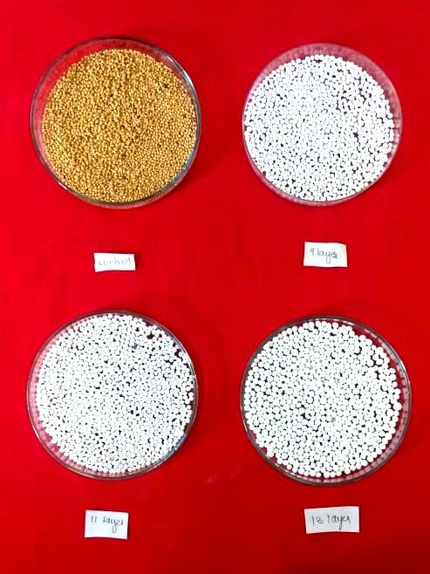
210 Figure.1 Different size of pelleted foxtail millet seeds (is it necessary? 211
control
9 layer
11 layer
13 layer
Foxtail millet
212
213
214
215
216
217
218
219
220
221
222
223
224
225
226
227
228
229
230
231
232
233
234

235
236
237

238

Figure 2.Seedling vigour of foxtail millet seeds

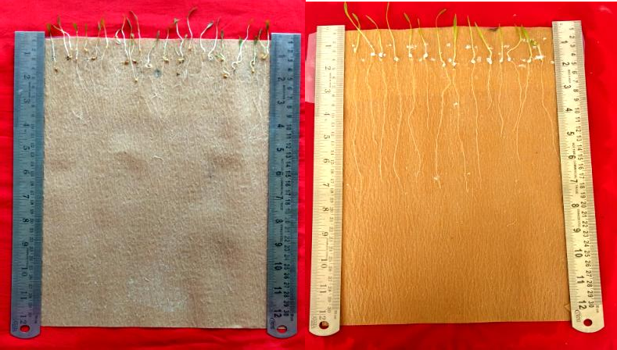

control
11 layer

