RESEARCH ARTICLE
Performance Analysis of the Farmer Producer Companies in Western Tamil Nadu, India using Altman’s Z-score

ABSTRACT
This study evaluated the financial performance of Farmer Producer Companies of western Tamil Nadu utilizing Altman Z' score model and sustainable growth rate. This analysis utilized secondary data gathered from the Ministry of Corporate Affairs, India. In this analysis, we concluded that the majority of the sample Farmer Producer Companies are in distress zone and if the present circumstance proceeded with these organizations will go to bankruptcy within next two years and all of the companies had negative growth rates, indicating that they would be unable to operate without external funding. As a result, there is an urgent need to concentrate on these companies in order to ensure their sustainable growth.

Keywords: Financial performance; Altman Z’ score; Sustainable growth; Farmer Producer Company; Distress zone

INTRODUCTION
India is witnessing a strategic policy shift from increasing productivity to increasing profitability. Doubling Farmers’ Income (DFI) by 2022-23 is the important policy thrust of Government of India (GOI).To achieve this, mobilization of farmers collective is an important strategy. Though there have been a number of models for group approaches were practiced in the forms of farmer cooperatives, farmer interest groups, farmer producer companies, commodity based organizations, etc. These experiments were plagued with issues and outcomes were short-lived. In recent years, the concept of farmer’s collectives has regained attention across the states. Both Union and State governments are providing special support for the promotion and formation of producer collectives (Farmer Producer Companies (FPCs)). Currently, the country has over 5000 FPCs, with 881 of them under the Small Farmers Agribusiness Consortium (SFAC), 2109 to the National Bank for Agriculture and Rural Development (NABARD), and the rest to various state governments. Tamil Nadu Government has been supporting FPCs since 2014, there are 500 FPCs registered in Tamil Nadu, 165 FPCs have been promoted through TNSFAC, more than 200 FPCs promoted by NABARD and 13 FPCs under central SFAC, besides self-promoted FPCs and by other agencies. But most of FPCs appear to limit their activities by providing farm inputs rather than implementing a comprehensive business program. Now as the number of FPCs has increased by orders of magnitude since 2014, their long-term viability is critical. Therefore, an investigation is required to determine if FPCs will continue to serve farmer-members with their activities in the near future. Hence, this study focuses to assess the present scenario of financial sustainability of FPCs in western Tamil Nadu. The general objective of this study is to evaluate the financial performance of FPC with the help of Altman’s Z score model. Results of the study provide a quantitative measure of FPCs financial performance. It will help to identify weaknesses early and plan to mitigate anticipated consequences. These research findings will also useful in formulating requisite policies to build confidence in FPCs.
Garg (2012) examined the performance of a Rewa crop producer company private Ltd. in Madhya Pradesh using 21 various financial ratios, and concluded that inefficiencies were occurred in financial management. In following year, Singh and Singh (2013) studied the overall performance of 25 FPCs from the states of Madhya Pradesh, Maharashtra, Gujarat and Rajasthan. Chauhan (2015) assessed the performance of the 18 FPCs in Madhya Pradesh and concluded that all FPCs under the study were below the desired standards. Saini (2018) used the Altman Z score model to assess the financial health of Chambal Fertilizers and Chemicals ltd over the last ten years (2007-08 to 2016-17).Swarankar and Jain (2020) measured financial performance of dairy cooperatives in Rajasthan using Altman Z score for past 5 years (2014-15 to 2018-19).
Fitzpatrick began using financial ratios to predict financial performance and distress in 1932. (Colak, 2019). Accounting ratios could be employed as financial distress indicators, according to Fitzpatrick's research. Beaver (1966) employed univariate analysis for prediction by using net cash flow to total liabilities as the most significant predictor to explain company distress (Affes and Hentati-Kaffel, 2019). To assess the possibility of a company's failure, Altman (1968) utilised multiple discriminant analysis (MDA) with five ratios, and this method became one of the first and most extensively used models for predicting financial distress. The revised Altman Z score was 83 percent and 67 percent accurate in predicting bankruptcy one and two years before filing for bankruptcy, respectively (Abdulkareem, 2015). Hence, in this study revised Altman Z score model was used to assess the financial performance of FPC in western Tamil Nadu.
MATERIAL AND METHODS
The primary objective of this study is to analyze the financial performance of FPCs in the western region of Tamil Nadu. To achieve this objective, Coimbatore, Tirupur, Erode districts has been purposefully chosen for the study. In Coimbatore district 16 FPCs, in Tirupur district 9 FPCs, in Erode district 22 FPCs are functioning. From this, 47 FPCs were formed as a universe of the study. At the time of data extraction, it was found that 29 FPCs were stroked-off by the Ministry of corporate affairs (MCA), India. It was further found that some of the FPCs have not filed their annual mandatory filings with RoC for one or more years. Hence, 25 FPCs were taken as samples for the study. The financial statements of 25 selected FPCs, form AOC-4 and MGT-7 were collected from MCA, India website from 2015- 2020 period.
There are different ways to define the financial sustainability of FPCs. According to Zietlow (2012), the best measure of a company's financial sustainability is its financial health. Soliwoda (2015) reported that economic, social and environmental aspects of sustainability of farms were well documented, but there is a gap in the assessment of the financial sustainability of the farms. Hence, the financial viability and financial health of companies have also been considered for measuring financial sustainability.
Financial Performance
Altman’s Z-score model (1968) is composed of five linear combinations of business ratios, which used a Multiple Discriminate Analyses (MDA) in order to measure the business performance of a firm. Altman’s Z-score model (1968) equation taken into consideration of five financial variables namely liquidity, profitability, leverage, solvency and sales activity. The Altman's formula was
Z = Cumulative Values
Based upon Altman's formula, the firms were classified into three categories according to the company's sustainability. Subsequently, Z-score technique was extended other industrial sectors such as private manufacturing companies. As a result, Altman updated the original Z-score formula in X4 to replace book value of equity with market value in order to match them with different parameters. This leads to change in the classification standards and Z-score results. Finally, the revised Altman Z'-score formula is shown as follows:
This model measures the financial health of the business. FPCs come under the purview of a private company and their shares are not traded freely in the open market. Hence, in this study the Altman Z’ Score (1983) is used instead of the Altman Z Score (1968) to evaluate the financial health of the FPCs.

X₁-Working Capital/Total Assets:
Working capital is the difference between the current assets of a company and its current liabilities. The value of a company’s working capital determines its short-term financial health. A positive working capital means that a company can meet its short-term financial debt, and still make funds available to invest and grow. In contrast, negative working capital means that a company will struggle to meet its short-term debt because there are insufficient current assets.
X₂-Retained Earnings/Total Assets
The retained profits to total assets ratio illustrates the amount of retained earnings or losses in a company. When a company's retained earnings to total assets ratio is low, it suggests the company is financing its expenditures with borrowed money rather than retained earnings. It raises the chances of a business going bankrupt. On the other hand, high retained earnings to total assets ratio, on the other hand, indicates that a firm uses its retained earnings to fund capital investment. It demonstrates that the company has attained profitability over time and does not require borrowings.
X₃-Earnings Before Interest and Tax/Total Assets:
EBIT, a measure of a company’s profitability, refers to the ability of a company to generate profits solely from its operations. The EBIT/Total Assets ratio indicates a company's ability to earn enough revenue to remain profitable, sustain ongoing operations, and pay debt.
X₄-Book Value of Equity/Total Liabilities:
The book value of the equity/total liabilities ratio shows the degree to which a company’s value would decline when it declares bankruptcy before the value of liabilities exceeds the value of assets in the balance sheet. A high value of equity to total liabilities ratio can be interpreted to mean high investor confidence in the company’s financial strength.
X₅-Sales/Total Assets:
The sales to total assets ratio shows how efficiently the management uses assets to generate revenues vis-à-vis the competition. High sales to total assets ratio is to mean that the management requires a small investment to generate sales, which increases the overall profitability of the company.
Altman’s Z-score that is lower than 1.23 means that the company is in financial distress and with a high probability of going bankrupt. On the other hand, a score of 2.9 and above means that the company is in a safe zone and is unlikely to file for bankruptcy. A score of 1.23 to 2.90 indicates that the company is in the grey region and has a moderate risk of bankruptcy.
Financial Sustainability:
Sustainable Growth Rate
Sustainable growth rate is the maximum growth rate that a company can sustain without having additional external funds or debt. SGR calculated as follows (Kakati and Roy, 2019)
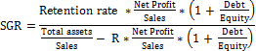
Retention rate computed as dividing retained earnings by net income

RESULTS AND DISCUSSION
The various financial ratios have been calculated and substituted into the Altman Z' score formula (1983), yielding a score for predicting each company's insolvency. Revised Altman’s Z- score of sample companies were further grouped into three categories as described above. The Details FPC comes under different categories of Altman Z’ score are presented in Table 1.

Table 1.The Details FPC comes under different categories of Altman Z’ score
 | 2015 | 2016 | 2017 | 2018 | 2019 | 2020
Below 1.23 | 3  (75.00) | 4  (57.14) | 11  (84.62) | 13  (76.47) | 13  (54.17) | 9  (52.94)
Between 1.23 to 2.90 | 1  (25.00) | 2  (28.57) | 1  (07.69) | 2  (11.77) | 5  (20.83) | 5  (29.41)
Above 2.90 | 0 | 1  (14.29) | 1  (07.69) | 2  (11.77) | 6  (25.00) | 3  17.65)
Total number of FPC  Reported | 4 | 7 | 13 | 17 | 24 | 17
*Values indicated in the parenthesis are percentage to the total
From the above table it revealed that the number of FPC in the distressed zone climbed until 2017, after which it decreased, and the number of companies in the safe zone increased in 2018-19 and decreased in 2019-20. The FPC comes grey area is an increasing trend and has a moderate chance of filing for bankruptcy. The details of Altman Z’ score for individual Farmer Producer Companies of western region of Tamil Nadu during 2015- 2020 is given below in figure 1.
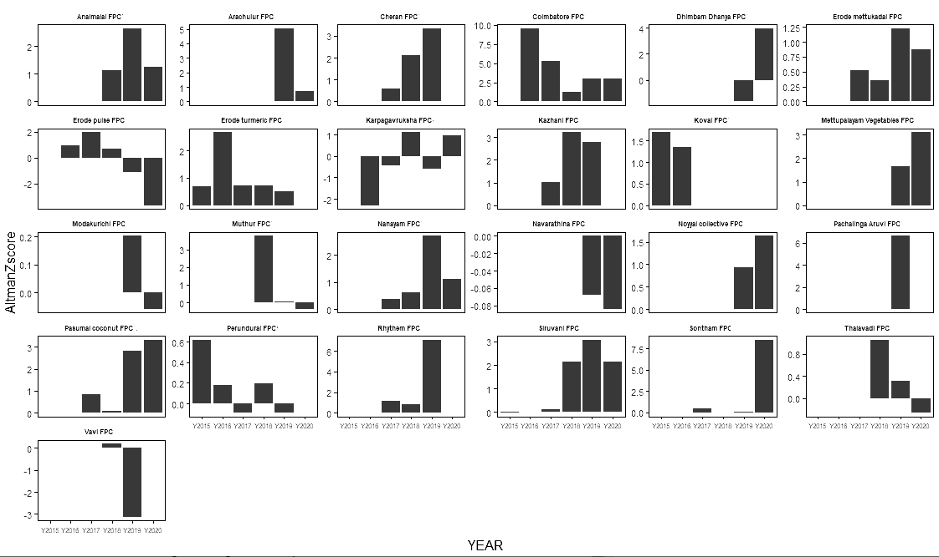
Figure. 1 Altman Z’ score for Farmer Producer Companies of western region of Tamil Nadu
From the figure 1, it is inferred that initially, Cheran FPC, Pasumai coconut FPC, Rhythem FPC, Sontham FPC, Siruvani FPC, Mettupalayam vegetable FPC, Dimbam dhaniya FPC, and Kazhani FPC has reported low performance and has proceeded to safe zone afterwards. These companies are in the state of fluctuation over the time and reach the safe zone. Coimbatore FPC had a better sales-to-assets ratio, putting them in a strong financial position over the years and Panchalinga Aruvi FPC has a greater book value of equity to total liability ratio, making them in a decent position for the financial year 2018-19. Noyyal collective FPC, Anaimalais FPC, and Siruvani FPC have been in the grey zone in the financial year 2019-20, with values ranging from 1.23 to 2.90.
The FPCs has Z’ score value below less than 1.23 value indicates that companies under distress zone, the probability of financial discomfiture is very high, this companies is at considerable risk of going to bankruptcy. Karpaga vruksham coconut FPC, Erode mettukadai FPC, Modakurichi FPC, Perundurai FPC and Navarathina FPC have been in the state of distressed condition over the years. Decreased sales, inadequate fund and inefficient management could be reason for this poor performance.

Sustainable growth rate
Sustainable growth rate has been worked out for selected FPCs in the western region of Tamil Nadu. Table 2 shows the sustainable growth rate of sample FPCs. From the results concluded that all of the companies had negative growth, and they cannot increase even 1 percent growth rate without additional financial resources. This is because the business does not have additional funds to reinvest, and these companies require the backing of investors and other lending companies in opportunity to expand their business.
Table 2. The details of Sustainable growth rate of selected Farmer Producer Companies of western region of Tamil Nadu
Name of FPC | 2015 | 2016 | 2017 | 2018 | 2019 | 2020
Erode turmeric FPC | 0.000 | -0.952 | -0.981 | -0.990 | 0.989
Thalavadi FPC |  |  |  | 0.000 | -0.668 | 0.987
Arachalur FPC |  |  |  |  | 0.623 | -0.826
Coimbatore coconut FPC |  | 0.279 | -2.167 | -7.370 | -1.431 | -1.162
Karpaga vruksham coconut FPC |  | 0.000 | 0.000 | -0.940 | -0.985 | -0.986
Kovai FPC | -0.647 | -0.647
Noyyal collective farming FPC |  |  |  |  | 0.000 | -0.856
Pasumai coconut FPC |  |  | 0.000 | 0.000 | -1.006 | -1.009
Rhythem FPC |  |  | 0.000 | 0.000 | -1.047
Siruvani FPC | -0.921 | -0.973 | -0.981 | -0.968 | -0.941 | -0.963
Sontham FPC |  |  | -0.833 | -0.977 | -0.988 | -0.991
Anaimalais coconut FPC |  |  |  | 0.000 | -1.293 | -1.645
Mettupalayam vegetable FPC |  |  |  |  | -1.110 | -1.086
Muthur FPC |  |  |  | -1.352 | -0.971 | -0.978
Cheran FPC |  |  |  | -0.961 | -0.815
Dhimbam dhaniya FPC |  |  |  |  | -0.991 | -0.990
Erode mettukadai FPC |  | 0.000 | 0.000 | -0.933 | -0.953 | -0.971
Erode pulse FPC |  | -0.932 | -0.877 | -0.957 | -0.989 | -0.996
Vavi FPC |  |  |  |  | -0.996
Kazhani FPC |  |  | 0.000 | -1.146 | -1.033 | -1.002
Modakurichi FPC |  |  |  |  |  | -0.980
Perundurai FPC | 0.000 | 0.000 | 0.000 | -0.975 | -0.987
Nanayam FPC |  |  | 0.000 | -0.925 | -0.957 | -0.978
Navarathina FPC |  |  |  |  |  | -0.974
Panchalinga aruvi collective farming FPC |  |  |  |  | -

In the financial year 2019, Arachulur and Erode turmeric FPC had a positive sustainable growth rate and Thalavadi FPC had a good value in the year 2020. Sustaining a firm with internal resources is a positive indicator. Panchalinga aruvi FPC does not have the MGT-07 form, which is needed to calculate the rate of sustainable growth rate.
CONCLUSION
Generally, FPCs go through ups and downs in terms of performance because of the impact of business cycles and other macro-economic variables. Measuring the financial health of FPCs has been an extremely important need for both managers as well as investors. Several tools have been developed to assess an FPC's financial strength based on its financial statements and balance sheet. Edward I. Altman's Z score, which employs a combination of various ratios to form an index of liquidity, profitability, sustainability and feasibility, has been highly accurate in analyzing the present state of financial health of a FPC as well as to enable one to predict the future, particularly in terms of probability of bankruptcy. In this research, we concluded that most of the sample FPCs are in the distressed zone and if this situation continued these companies would go to bankruptcy within next two years. Sustainable growth rate of sample FPCs also confirmed that most FPC required external funds to sustain their operations. Hence, there is an urgent need for financial support for those FPCs under Altman Z score grey and distress zone categories. The FPCs should invest in long-term capital, which means that the stakeholders are willing to spend in the company activity without expecting a quick return.

Funding and Acknowledgment

Not applicable for this study.

Ethics statement
Not applicable for this study.

Consent for publication

All the authors agreed to publish the content.

Competing interests
The authors Dhineshwari.S, Selavm. S, Amarnath. J.S., Prabakaran.K of the research article entitled “Performance Analysis of Farmer Producer Companies in Western Tamil Nadu, India using Altman’s Z score* declared that they have no conflict of interest.
Originality and plagiarism
Authors ensured that only totally original works were written and submitted, and that any work and/or words borrowed from others were properly cited.

Author contributions
Idea conceptualization– Dhineshwari. S, Selvam. S
Experiments- Dhineshwari. S
Guidance –Selvam. S ,
Writing original draft – Dhineshwari. S,
Writing- reviewing &editing - Selvam. S, Amarnath. J.S., Prabakaran. K

REFERENCES
Abdulkareem, H. 2015. The revised Altman Z’-score Model Verifying its Validity as a Predictor of Corporate Failure in the Case of UK Private Companies. In Conference. (January).
Altman, E. I. 1983. Exploring the road to bankruptcy. Journal of Business Strategy.
Chauhan, S. 2015. Producer companies in Madhya Pradesh: An evaluative study. Int. J. Recent Sci., 2(3), 66-77.
Çolak, M.S. 2019. A New Index Score for the Assessment of Firm Financial Risks (No. 1904).

Garg T. 2012. Business Performance of a Producer Company in Madhya Pradesh, Department of Agricultural Marketing, Co-Operation and Business Management University of Agricultural Sciences, Bangalore.

Kakati, S. and Roy, A. 2019. Financial Sustainability: A Study on the Current Status of Farmer Producer Companies in Northeast India. J. Manag. Res., 18(2).

Saini, V. 2018. Evaluating financial health of Gujarat state fertilizers through ‘Z’score model. Int. J. Res. Granthaalayah., 6(7), 115-120.
Singh, S., and Singh, T. 2013. Producer Companies in India: A study of organization and performance. CMA Publication., 246, 1-11
Soliwoda, M. 2015. Dilemmas in a financial dimension of sustainability of farms. Problems of Agricultural Economics., (3_2015).
Swarankar, J., and Jain, O. P. 2020. Measuring financial performance of dairy co-operatives in Rajasthan by revisiting Altman’s z score. Xi'an Univ. Archit. amp., 12(3), 2175-2181
Zietlow, J. 2012. A financial health index for achieving nonprofit financial sustainability. Available at SSRN 2049022.

