(Refer to reviewer comments)

RESEARCH ARTICLE
Studies on growth, Yield, Quality of Watermelon (Citrullus lanatus thunb.) and Soil Fertility by Organic Amendments and Fertigation in Theri Land (Red Sand Dune) of Southern Tamil Nadu.

ABSTRACT

The present investigation was carried out at Thirumaraiyur village, Sattankulam taluk, Thoothukudi district to study the effect of organic amendments with recommended dose of fertilizers on growth and yield of watermelon in Theri soil (red sand dunes) during the year 2017 and 2018. The experiment was laid out in Randomized Block Design with Factorial concept (FRBD). In all there were three factors as organic amendments with 6 treatment combinations for each factor, which were assigned at random in each plots with three replications. The recommended dose of fertilizers in treatments were two levels as 75 and 100 per cent. Among the treatment combinations, the tank silt application @ 100 t ha⁻¹ with 100 per cent recommended fertilizer as 200:100:100 kg of NPK ha⁻¹ through fertigation at 7 days interval (A1N5) produced maximum number of branches (10.67), longest vine (362.0 cm), number of fruits plant⁻¹ (2.57), weight of fruit (5.27 kg), fruit yield (68.77 t ha⁻¹), total soluble solid (TSS) 10.94%), ascorbic acid (8.08 (mg 100g⁻¹), gross return (4,09,320/ha), B:C ratio (2.45), uptake of NPK 41.51, 3.93 and 31.94 kg ha⁻¹, respectively) compared to other treatments. Significant built up of organic carbon (0.52%), available N (253.47 kg ha⁻¹ ), P (16.40 kg ha⁻¹) and K (218.40 kg ha⁻¹) were registered with the application of tank silt application @ 100 t ha⁻¹ with 100 per cent recommended fertilizer as 200:100:100 kg of NPK ha⁻¹ through fertigation at 7 days interval (A1N5).

Keywords: Organic amendments ; fertigation; yield ; watermelon and Theri land

INTRODUCTION
Watermelon (Citrullus lanatus Thunb.) is one of the important vegetable crops grown extensively in India. It is a major tropical crop in south Indian states of Karnataka, Andhra Pradesh and Tamil Nadu. India is the second largest producer of watermelon fruit among the Asian countries accounting 2.48 million tonnes from 1.01 lakh hectare with the productivity of 24.58 t ha⁻¹ (HSD, 2017. In Tamil Nadu, the production is 1.63 lakh tonnes from an area of 6930 ha with the average productivity of 23.52 t ha (DES, 2017.
The Theri lands (red sand dunes) are one of the major wastelands in Tirunelveli and Thoothukudi districts of Tamil Nadu. These theries are located (77º 49’ 44” to 78º 28’ 22” E and from 8º 15’13” to 9º 11’ 0” N) to an extent of 20,171 ha (Jawahar et al., 1999). The soils have low nutrient status, low water holding capacity, low organic carbon content and are susceptible to high wind erosion (Manikandan and Subramanian, 2010). The mean annual rainfall of the study area is between 610 and 700 mm.
A soil amendment is any material added to a soil to improve its physical properties, such as water retention, permeability, water infiltration, drainage, aeration and structure. In theri soils (red sand dune) organic amendments like tank silt, FYM, composted coir pith (CCP) etc. improve the physic-chemical properties of soil. Many organic amendments contain plant nutrients and act as organic fertilizers. Monitoring soil and plant nutrient status is an essential to ensure maximum crop productivity. It is well known that organic amendments and inorganic fertilizers are essential to increase the productivity of crops and fertility of soils.
The fertigation technology is the possible way to improve the crop production and soil productivity for profitable farming in constrained Theri soil. Fertigation within the rhizosphere matches with the physiological needs of the crop viz. root development, vegetative growth, flower and fruit development. Scientific information on fertigation in theri land (red sand dune), especially in watermelon, is very scanty. Hence, the present field experiment was conducted to determine influence of organic amendments combined with inorganic fertilizers through fertigation on growth, fruit yield of watermelon and soil fertility of Theri land.

MATERIAL AND METHODS
The experiment was conducted during kharif – winter seasons of 2016-2017 and 2017-2018 at Thirumaraiyur village, Sattankulam taluk, Thoothukudi district, Tamil Nadu. The sand dune ecosystem formed in isomegathermic and ustic regime from geogenic sand deposit under a semi arid climate. Soil at the experimental site was red sandy, with organic carbon 0.12%, electrical conductivity 0.13 dS/m, neutral pH (6.26), low available N (93.7 kg ha⁻¹), low available P (8.2 kg ha⁻¹) and low available K (88.5 kg ha⁻¹). Seeds of watermelon F1 hybrid Suprit were sown in rows of 2m width, with 60 cm plant-to-plant spacing, during the first week of November in both years. The experiment was laid out in Factorial Randomized Block Design (FRBD) with six treatments and three replications. Factor as three organic amendments viz., tank silt @ 100 t ha⁻¹, composted coir pith @ 12.5 t ha⁻¹ and farm yard manure @ 20 t ha⁻¹ were applied as basal doses before sowing. The treatments were T₁- 75 % recommended dose of fertilizers (RDF) (150:75:75 kg of NPK ha⁻¹) through soil application; T₂- 100 % recommended dose of fertilizers (RDF) (200:100:100 kg of NPK ha⁻¹) through soil application; T₃- 75 % recommended dose of fertilizers (RDF) (150:75:75 kg of NPK ha⁻¹) through fertigation at 7 days interval; T₄- 75 % recommended dose of fertilizers (RDF) (150:75:75 kg of NPK ha⁻¹) through fertigation at 15 days interval; T₅- 100 % recommended dose of fertilizers (RDF) (200:100:100 kg of NPK ha⁻¹) through fertigation at 7 days interval; T₆- 100 % recommended dose of fertilizers (RDF) (200:100:100 kg of NPK ha⁻¹) through fertigation at 15 days interval.
Conventional fertilizers used in the experiment were urea, single super phosphate, di-ammonium phosphate and muriate of potash; whereas, 19 each of N, P₂O₅, K₂O and KNO₃ used as the source of water soluble fertilizer. Fertilizer was applied at 7 and 15 days intervals through fertigation treatments. Soil treatments received the entire P₂O₅ and K₂O at sowing and N in two splits as basal during sowing and at 30 DAS. Irrigation was given through drippers to all the treatments. Growth observations were taken 60 days after sowing. All agronomic and plant protection measures were adopted as per the guide lines of crop production guide for Tamil Nadu (CPG, TNAU, 2015). The crop was harvested at 90 to 100 days after sowing, at fruit maturity as indicated by a dull sound of the fruit, or, when the fruit tendril turned to straw colour, or when the fruit base turned creamy-yellow in colour. The nutrient content and uptake by plants were analysed through prescribed laboratory procedures. Soil samples were analysed for organic carbon following Walkley and Black 1934, alkaline permanganate oxidizable N as described by Subbiah and Asija, 1956, 0.5 M NaHCO₃- extractable P (Olsen et al., 1954 and available potassium by flame photometry with extracting 1 N NH₄OAc (Schollenberger and Simon, 1945. Observations on crop growth, yield, yield parameters and quality were recorded and statistically analyzed as per Gomez and Gomez (1984). Economics of water melon cultivation as influenced by chemical fertilizer, drip fertigation and management practices were calculated by considering the prevailing market price of fruit and inputs used.

RESULTS AND DISCUSSION
Growth, yield and quality parameters
Effect of amendments
The growth and yield attributing characters such as number of branches, number of fruits plant⁻¹ and fruit yield were significantly influenced by various amendments (Figures 1-4).
Among the three amendments, the application of tank silt at the rate of 100 t ha⁻¹ significantly registered more number of branches (8.72), more fruits (2.22), higher fruit yield (55.49 t ha⁻¹), higher TSS (9.80%) and higher ascorbic acid content (7.41 mg 100g⁻¹) followed by composted coir pith applied at the rate of 12.5 t ha⁻¹, which registered higher number of branches (8.22), number of fruits (2.10), fruit yield (50.43 t ha⁻¹), TSS (9.79%) and ascorbic acid content (7.29 mg 100g⁻¹) . Tank silt contains all nutrients which is responsible for the enhanced growth and yield attributes in watermelon. Annadurai et al. 2005 noticed similar results that tank silt amendment enhanced the productivity of crops like sunflower, groundnut, cotton, sugarcane, soybean, gingili, tomato, cotton, onion, brinjal, turnip, cucumber, chilli etc.
Effect of nutrients
The growth and yield attributes of watermelon viz., number of branches, vine length, number of fruits and fruit weight were significantly influenced by the application of recommended dose of NPK as 200:100:100 kg ha⁻¹ through fertigation at 7 days interval (N5) (Figures 1 - 4) significantly registered maximum number of branches (10.0), longest vine (347.89 cm), highest number of fruits plant⁻¹ (2.38), more weight of fruit (5.33 kg) and higher fruit yield (63.32 t/ha), maximum TSS (10.75%) and highest ascorbic acid content (8.05 mg 100g⁻¹) followed by the application of 75 per cent NPK through fertigation at 7 days interval (N3) with the number of fruit (9.00), long vine (339.22 cm), more number of fruits plant⁻¹ (2.28), weight of fruit (5.04 kg), higher fruit yield (58.38 t ha⁻¹), higher TSS (10.63%) and higher ascorbic acid content (7.99 mg 100g⁻¹). However, among the two levels of NPK without fertigation, the minimum number of branches (6.78), shortest vein length (268.44 cm), minimum number of fruits per plant (1.75), lowest fruit weight (4.29 kg), minimum fruit yield (38.36 t ha⁻¹), low TSS (8.29%) and least ascorbic acid content (6.16 mg 100g⁻¹) were found in treatment applied with 75 per cent NPK ha⁻¹ through soil application (T₁). The present finding was supported by Kadam et al., 2009. The levels of tank silt at the rate of 20 t ha⁻¹ recorded higher number of pods, pod yield, haulm yield and shelling percentage in case of groundnut crop (Binitha, 2006).
Combined effect of amendment and nutrients
The interaction of amendments with fertilizers played an important role in increasing the production of watermelon. Though the interaction effect was non significant for all except fruit yield more number of branches (10.67), longer vine (362 cm), maximum number of fruits plant⁻¹ (2.57), heavy weight of fruit (5.27 kg), maximum fruit yield (68.77 t/ha), maximum TSS (10.94%) with maximum ascorbic acid content (8.08 mg 100g⁻¹) were registered by the application of tank silt @ 100 t ha⁻¹ along with 100 per cent NPK as 200:100:100 kg ha⁻¹ through fertigation at 7 days interval (A1N5) followed by the application of composted coir pith @ 12.5 t ha⁻¹ with 100 per cent NPK through fertigation at 7 days interval (A2N5) which recorded 10.33 number of branches, 350 cm longer vine, 2.33 number of fruits plant⁻¹, 5.29 kg of fruit, 61.73 t ha⁻¹ of fruit yield, 10.82% of TSS and 8.06 mg 100g⁻¹ of ascorbic acid. Among the two levels of NPK without fertigation the less number of branches (6.33), short vein length (259.33 cm), low number of fruits plant⁻¹ (1.67), low fruit weight (4.26 kg), minimum fruit yield (36.11 t ha⁻¹), low TSS (8.17% and minimum ascorbic acid content 6.08 mg 100g⁻¹ were found in treatment applied with FYM @ 20 t ha⁻¹ with 75 per cent NPK ha⁻¹ through soil application (A3N1). The result clearly indicated that only inorganic nutrients can not alone maintain instant flow of nutrients in increasing crop yield. There is a need to use organic and chemical fertilizers in combination with drip fertigation so as to increase crop productivity. The increase in the fruit yield might be due to the application of organic amendments in combination with inorganic fertilizers. This result is supported by the earlier findings of Ramesh (2001, (20), Umamaheshwarappa et al., 2005 and Castellanos et al., 2009.
Nutrient uptake
Effect of amendments
The uptake of N and K in watermelon was also significantly influenced by the organic amendments. The highest values of N and K uptake (32.90, and 24.09 kg ha⁻¹, respectively) by watermelon were recorded with the application of tank silt @ 100 t ha⁻¹(A1) followed by the treatment applied with composted coir pith @ 12.5 t ha⁻¹ (A2) which recorded the values of 31.69 and 21.88 kg ha⁻¹, where as the highest phosphorus uptake (3.17 kg ha⁻¹) was recorded in treatment applied with composted coir pith @ 12.5 t ha⁻¹(A2) followed by the treatment with tank silt @100 t ha⁻¹ (A1) by recording the value of 2.96 kg ha⁻¹. The minimum uptake of N, P and K (26.32, 2.78 and 19.49 kg ha⁻¹, respectively) were recorded in the treatment applied with FYM @ 20 t ha⁻¹(A3). The organic amendments contain all macro and micronutrients, which enhanced the steadily supply of nutrient at all critical stages of the crop resulted more nutrient uptake by the crop. The result confirms the findings of Vasantha Kumar et al., 2012 and Battilani and Solimando, 2006.
Effect of nutrients
The uptake of N, P and K in watermelon were also significantly influenced by various nutrient level and application methods. The highest values of N, P and K uptake (39.79, 4.04, and 30.49 kg ha⁻¹, respectively) by watermelon were recorded with the application of 100 per cent NPK as 200:100:100 kg ha⁻¹ through fertigation at 7 days interval (N5) followed by 75 per cent NPK through fertigation at 7 days interval (N3) with the N, P and K uptake values of 36.68, 3.71 and 28.30 kg ha⁻¹, respectively. The lowest uptake of N, P and K (20.13, 1.86 and 11.97 kg ha⁻¹, respectively) were observed in the treatment with soil application of 75 % recommended dose of NPK (N1). This could be ascribed to the increase in the available N, P and K contents in soil resulting from the increasing availability of nutrients which ultimately increased nutrient content in the plant tissue and also greater biomass production at higher rate of fertilizer application. Since the uptake of nutrient is a function of dry matter and nutrient content, the increased growth and yield attributes together with higher NPK content resulted in greater uptake of these elements. The result confirm the findings of Shyamaa et al., 2009 and Sajitha et al., 2016.
Combined effect of amendments and nutrients
The interaction of organic amendments with fertilizers played an important role in increasing the nutrient uptake of watermelon. Significantly maximum uptake of N and K (41.51 and 31.94 kg ha⁻¹) were recorded in treatment applied with tank silt @ 100 t ha⁻¹ with 100 per cent NPK as 200:100:100 kg ha⁻¹ through fertigation at 7 days interval (A1N5) where as the maximum P uptake (4.27 kg ha⁻¹) and higher uptake of N and K (40.37 and 30.00 kg ha⁻¹) were registered for the treatment applied with composted coir pith @ 12.5 t ha⁻¹ with 100 per cent NPK through fertigation at 7 days interval (A2N5). The minimum values of N, P and K uptake (18.35, 1.92 and 9.65 kg ha⁻¹) were recorded in the treatment applied with FYM @ 20 t ha⁻¹ with 75 per cent NPK ha⁻¹ through soil application (A3N1). The increased uptake of nutrients might be attributed to good growth and fruit yield of watermelon and may be due to application of tank silt with inorganic fertilizers, which help in improved plant growth and accumulation of greater biomass resulting in increased nutrient uptake. The increased uptake of N, P and K in watermelon may be ascribed to more availability of these nutrients from the added tank silt, fertilizer sources and the solubility action of organic acids produced during the decomposition of organic materials. Similar results were also reported by Ganeshappa (2000 and Tanwar el al. 2003.
Fertility status
Effect of amendments
The data presented in Figure 3 & 4 revealed that the highest organic carbon (0.38 %), available N, P and K (196.07, 13.41 and 193.17 kg ha⁻¹, respectively) were obtained by the application of tank silt @ 100 t ha⁻¹ (A1) followed by the treatment applied with composted coir pith @ 12.5 t ha⁻¹ (A2) which recorded the 0.27 % of organic carbon with available N, P and K (188.79,12.98 and 174.30 kg ha⁻¹, respectively). The tank silt and composted coir pith contain high level of organic carbon and all nutrients, which helped in sustaining the organic carbon and available N, P and K in the soil. Similar findings has been reported earlier by Ramesh, 2001 and Gonsalves et al. 20011.
Effect of Nutrients
The soil organic carbon and available NPK were significantly influenced by different levels and methods of nutrient application. The highest organic carbon (0.39 %), available N, P and K (242.23, 16.48 and 203.55 kg ha⁻¹, respectively) were obtained by the application of 100 per cent NPK through fertigation at 7 days interval (N5). The next superior values of organic carbon (0.34%), available N, P and K (216.62, 14.27 and 186.53 kg ha⁻¹, respectively) were recorded for the treatment which received 75 per cent NPK as 150:75:75 kg ha⁻¹ through fertigation at 7 days interval (N3). The lowest values of organic carbon (0.24%) and available N, P and K (139.71, 9.71 and 149.50 kg ha⁻¹, respectively) were noticed in the treatment received 75 per cent NPK as 150:75:75 kg ha⁻¹ through soil application (N1) (Table 2). The decline in the available N status of the soil might be attributed to the utilization of N, P and K for growth of watermelon. These results are in agreement with the findings of Kadam and Karthikeyan, 2006 and Kacha et al., 2017.
Combined effect of amendments and nutrients
It was observed from the data presented in table 2 that the combined application of amendments with fertilizers was significantly influenced the organic carbon and available nutrients. The highest organic carbon (0.52 %), available N, P and K (253.47, 16.40 and 218.40 kg ha⁻¹, respectively) were obtained from the treatment applied with tank silt @ 100 t ha⁻¹ with 100 per cent NPK as 200:100:100 kg ha⁻¹ through fertigation at 7 days interval (A1N5) followed by the treatment treatment applied with composted coir pith @ 12.5 t ha⁻¹ with 100 per cent NPK through fertigation at 7 days interval (A2N5), which recorded the next highest content of organic carbon (0.35%) and available N, P and K (242.73, 17.37 and 202.63 kg ha⁻¹, respectively). The higher content of organic carbon in soil might be due highly fertile tank silt and composted coir pith combined with inorganic nutrients is responsible for needed nutrient transformation besides providing favourable physico-chemical properties which help in the mineralization of soil nutrients leading to higher availability of N, P and K in soil. These results are in agreement with the findings of Kadam and Karthikeyan, 2006 and Kacha et al., 2017. The lowest organic carbon content (0.21%) and available N, P and K (132.27, 9.23 and 140.6 kg ha⁻¹, respectively)were observed for the treatment applied with FYM @ 20 t ha⁻¹ with 75 per cent NPK ha⁻¹ through soil application (A3N1). The decline in the available N status of the soil might be attributed to the utilization of N, P and K for growth of watermelon. These results are in agreement with the findings of Krishnappa et al. 1998 and Ramesh, 2001.
Economics
Details on economics and benefit:cost ratio in watermelon F1 hybrid Suprit in relation to various organic amendments with inorganic fertilizers with and without fertigation treatments tested are presented in Table 2.
Effect of amendments
The application of tank silt at the rate of 100 t ha⁻¹ (A1) significantly influenced economics of watermelon with the return (1,98,795) and benefit:cost ratio (1.88) followed by application of FYM @ 20 t ha⁻¹ (A3) which recorded the higher net return (1,55,355) and benefit:cost ratio (2.33).this might be due the cheap cost of manures reduced the cost of cultivation and increased the net return.
Effect of nutrients
The highest net return (2,48,090) with the benefit:cost ratio (2.61) were obtained by the application of 100 per cent NPK through fertigation at 7 days interval (N5). The next highest net return (2,25,860) with the benefit:cost ratio (2.52) were recorded for the treatment which received 75 per cent NPK as 150:75:75 kg ha⁻¹ through fertigation at 7 days interval (N3). The lowest net return (68,493) with the benefit:cost ratio (1.52) were recorded in the treatment received 75 per cent NPK as 150:75:75 kg ha⁻¹ through soil application (N1).
Combined effect of amendments and nutrients
The application of tank silt @ 100 t ha⁻¹ with 100 per cent NPK as 200:100:100 kg ha⁻¹ through fertigation at 7 days interval (A1N5) fetched significantly the highest net returns (2,90,570 and benefit : cost ratio (2.45) over the rest of the treatments. The better treatment was application of tank silt @ 100 t/ha with 75 per cent NPK as 150:75:75 kg ha⁻¹ through fertigation at 15 days interval (A1N3), which fetched a net return of 2,60, 560 and benefit : cost ratio of 2.31. The application of CCP@ 12.5 t ha⁻¹ with 100 per cent NPK as 200:100:100 kg ha⁻¹ through fertigation at 7days interval (A2N5) recorded the net return of 2,30, 790 and benefit : cost ratio of 2.66 which was higher than the application of FYM @ 20 t ha⁻¹ with 100 per cent NPK as 200:100:100 kg ha⁻¹ through fertigation at 7 days interval (A3N5) by fetching the net return of 2,22, 910 and benefit : cost ratio of 2.73. This might be due to increased higher productivity and lower cost of cultivation. The variation in the cost of cultivation under different treatments were recorded due to variable costs of fertilizers. Fruit yield was the major factor, which caused differences in net return. These results are in close conformity with the findings of Kumar et al., 2007 and Sajitha, 2013.

Tables
Table 1. Effect of organic amendment with inorganic fertilizers on nutrient uptake of hybrid watermelon and soil fertility
Treatments | Nutrient uptake (kg/ha) |  |  | Organic carbon (%) | Available nutrients (kg/ha)
Treatments | N | P | K | Organic carbon (%) | N | P | K
Treatments | Main factor (Amendments)
(A1) Tank silt @ 100 t ha⁻¹ | 32.90 | 2.96 | 24.09 | 0.38 | 196.07 | 13.41 | 193.17
(A2) Composted coir pith @ 12.5 t ha⁻¹ | 31.69 | 3.17 | 21.88 | 0.27 | 188.79 | 12.98 | 174.30
(A3) Farm yard manure (FYM) @ 20 t ha⁻¹ | 26.32 | 2.78 | 19.49 | 0.25 | 178.59 | 12.52 | 165.35
Mean | 30.47 | 2.97 | 21.82 | 0.30 | 187.82 | 12.97 | 177.61
SEd | 0.150 | 0.128 | 0.072 | 0.001 | 0.397 | 0.047 | 0.104
CD (P=0.05) | 0.417 | NS | 0.201 | 0.004 | 1.103 | 0.131 | 0.289
Main factor (Nutrients)
N₁- 75 % RDF (Soil application) | 20.13 | 1.86 | 11.97 | 0.24 | 139.71 | 9.71 | 149.50
N₂ -100 % RDF (Soil application) | 25.61 | 2.58 | 17.63 | 0.26 | 158.04 | 12.03 | 169.80
N₃ -75 % RDE at 7 days interval (Fertigation) | 36.68 | 3.71 | 28.30 | 0.34 | 216.62 | 14.27 | 186.53
N₄ -75 % RDF at 15 days interval (Fertigation) | 28.54 | 2.67 | 20.59 | 0.29 | 182.51 | 12.47 | 175.79
N₅-100 % RDF at 7 days interval (Fertigation) | 39.79 | 4.04 | 30.49 | 0.39 | 242.23 | 16.48 | 203.55
N₆ -100 % RDF at 15 days interval (Fertigation) | 32.08 | 2.97 | 21.94 | 0.27 | 187.79 | 12.85 | 180.47
Mean | 30.47 | 2.97 | 21.82 | 0.30 | 187.82 | 12.97 | 177.61
SEd | 0.204 | 0.078 | 0.099 | 0.002 | 0.668 | 0.084 | 0.110
CD (P=0.05) | 0.416 | 0.160 | 0.201 | 0.004 | 1.364 | 0.173 | 0.227
Interaction
A1N1 | 22.58 | 1.52 | 15.34 | 0.29 | 146.43 | 10.53 | 165.40
A1N2 | 27.34 | 2.77 | 20.61 | 0.32 | 175.20 | 12.63 | 182.47
A1N3 | 39.30 | 3.79 | 29.88 | 0.43 | 209.23 | 14.80 | 202.53
A1N4 | 31.47 | 2.88 | 23.55 | 0.36 | 198.70 | 12.53 | 193.77
A1N5 | 41.51 | 3.93 | 31.94 | 0.52 | 253.47 | 16.40 | 218.40
A1N6 | 35.21 | 2.91 | 23.22 | 0.34 | 193.37 | 13.57 | 196.47
A2N1 | 19.45 | 2.14 | 10.94 | 0.22 | 140.43 | 9.37 | 142.50
A2N2 | 26.22 | 2.71 | 17.63 | 0.24 | 155.47 | 11.90 | 168.43
A2N3 | 38.32 | 3.88 | 29.30 | 0.32 | 222.33 | 14.30 | 183.63
A2N4 | 30.22 | 2.84 | 19.99 | 0.24 | 183.47 | 12.50 | 172.03
A2N5 | 40.37 | 4.27 | 30.00 | 0.35 | 242.73 | 17.37 | 202.63
A2N6 | 35.58 | 3.17 | 23.43 | 0.23 | 188.33 | 12.43 | 176.37
A3N1 | 18.35 | 1.92 | 9.65 | 0.21 | 132.27 | 9.23 | 140.60
A3N2 | 23.29 | 2.26 | 14.67 | 0.23 | 143.47 | 11.57 | 158.50
A3N3 | 32.43 | 3.48 | 25.71 | 0.28 | 218.30 | 13.70 | 173.43
A3N4 | 23.92 | 2.29 | 18.24 | 0.26 | 165.37 | 12.37 | 161.57
A3N5 | 37.47 | 3.91 | 29.52 | 0.30 | 230.50 | 15.70 | 189.63
A3N6 | 25.46 | 2.85 | 19.18 | 0.24 | 181.67 | 12.57 | 168.37
Mean | 30.47 | 2.97 | 21.82 | 0.30 | 187.82 | 12.97 | 177.61
A@N
SEd | 0.356 | 0.179 | 0.172 | 0.003 | 1.128 | 0.142 | 0.204
CD (P=0.05) | 0.773 | 0.433 | 0.373 | 0.008 | 2.407 | 0.301 | 0.456
N@A
SEd | 0.353 | 0.135 | 0.171 | 0.003 | 1.157 | 0.146 | 0.192
CD (P=0.05) | 0.721 | 0.277 | 0.349 | 0.007 | 2.363 | 0.299 | 0.392

Table 2. Effect of organic amendment with inorganic fertilizers on economics of hybrid watermelon
Treatments | Cost of cultivation (/ha) | Gross return (/ha) | Net return  (/ha) | Benefit: cost ratio
Treatments | Main factor (Amendments)
(A1) Tank silt @ 100 t ha⁻¹ | 1,01,729 | 3,00,417 | 1,98,795 | 1.88
(A2) Composted coir pith @ 12.5 t ha⁻¹ | 1,21,618 | 2,74,307 | 1,52,688 | 2.20
(A3) Farm yard manure (FYM) @ 20 t ha⁻¹ | 1,11,618 | 2,66,973 | 1,55,355 | 2.33
Mean | 1,11,655 | 2,80,565 | 1,68,946 | 2.14
SEd | 90.72 | 10.88 | 8.16 | 0.004
CD (P=0.05) | 251.88 | 30.23 | 22.67 | 0.010
Main factor (Nutrients)
N₁- 75 % RDF (Soil application) | 82,820 | 1,51,300 | 68,493 | 1.52
N₂ -100 % RDF (Soil application) | 93,972 | 1,81,053 | 87,303 | 1.62
N₃ -75 % RDE at 7 days interval (Fertigation) | 1,22,820 | 3,48,680 | 2,25,860 | 2.52
N₄ -75 % RDF at 15 days interval (Fertigation) | 1,17,820 | 3,02,760 | 1,84,940 | 2.26
N₅-100 % RDF at 7 days interval (Fertigation) | 1,28,750 | 3,76,860 | 2,48,090 | 2.61
N₆ -100 % RDF at 15 days interval (Fertigation) | 1,23,750 | 3,22,740 | 1,98,990 | 2.29
Mean | 1,11,655 | 2,80,565 | 1,68,946 | 2.14
SEd | 128.30 | 11.41 | 11.55 | 0.003
CD (P=0.05) | 262.04 | 23.32 | 23.58 | 0.006
Interaction
A1N1 | 72,820 | 1,62,640 | 89,820 | 1.23
A1N2 | 83,750 | 1,88,560 | 1,04,810 | 1.25
A1N3 | 1,12,820 | 3,73,380 | 2,60,560 | 2.31
A1N4 | 1,07,820 | 3,22,440 | 2,14,620 | 1.99
A1N5 | 1,18,750 | 4,09,320 | 2,90,570 | 2.45
A1N6 | 1,13,750 | 3,46,080 | 2,32,330 | 2.04
A2N1 | 92,820 | 1,48,200 | 55,380 | 1.60
A2N2 | 1,03,750 | 1,79,200 | 75,450 | 1.73
A2N3 | 1,32,820 | 3,41,580 | 2,08,760 | 2.57
A2N4 | 1,27,820 | 2,95,140 | 1,67,320 | 2.31
A2N5 | 1,38,750 | 3,69,540 | 2,30,790 | 2.66
A2N6 | 1,33,750 | 3,12,180 | 1,78,430 | 2.33
A3N1 | 82,820 | 1,43,040 | 60,220 | 1.73
A3N2 | 93,750 | 1,75,400 | 81,650 | 1.87
A3N3 | 1,22,820 | 3,31,080 | 2,08,260 | 2.69
A3N4 | 1,17,820 | 2,90,700 | 1,72,880 | 2.47
A3N5 | 1,28,750 | 3,51,660 | 2,22,910 | 2.73
A3N6 | 1,23,750 | 3,09,960 | 1,86,210 | 2.50
Mean | 1,11,655 | 2,80,565 | 2,80,565 | 2.14
A@N
SEd | 222.22 | 21.08 | 20.00 | 0.006
CD (P=0.05) | NS | 47.18 | 43.29 | 0.014
N@A
SEd | 222.00 | 19.78 | 20.00 | 0.005
CD (P=0.05) | NS | 40.39 | 40.84 | 0.010

Figures and Structures

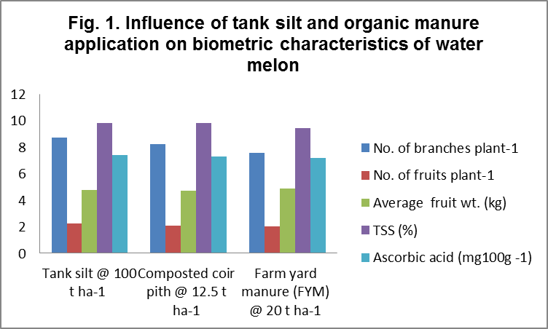

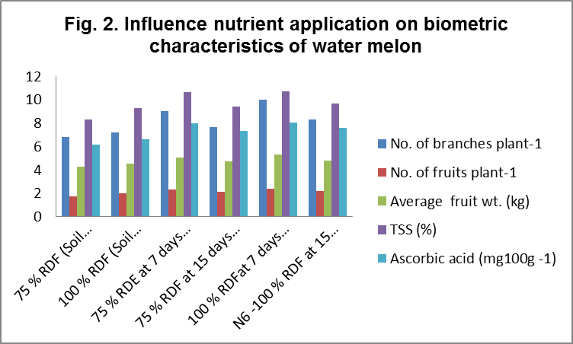

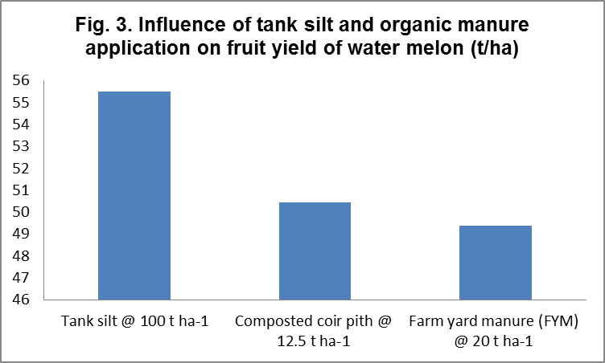

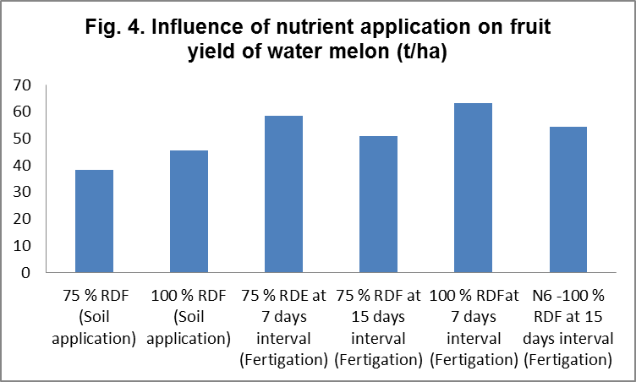

CONCLUSION
From the above data It can be concluded that application of tank silt @ 100 t ha⁻¹ with 100 per cent NPK as 200:100:100 kg ha⁻¹ through fertigation at 7 days interval (A1N5) could be recommended for increasing the fruit yield of hybrid watermelon, better net return and sustaining soil fertility in Theri land (Red sand dune) of Thoothukudi district of Tamil Nadu.

REFERENCES
Andrade Junior, A.S., De Dias, N. da S. Figueiredo Junior, L.G.M. Ribeiro, V.Q. and D.B. Sampaio, 2009. Response of watermelon to nitrogen fertigation. IRRIGA, 14:115-122.
Annadurai, B., Arunachalam, N. and K. Mahalingam. 2005. Effect of tank silt and press mud mixture amendment on the physical properties of Theri-soils. J. Soils and Crops., 15(1): 26- 29.
Battilani, A. and D. Solimando. 2006. Yield, quality and nitrogen use efficiency of fertigated watermelon. Acta Hort, 700:85-90
Binitha, N. K. 2006. Characterization of tank silts of North Karnataka and evaluation of its effect on the growth and yield of Groundnut. Ph.D. Thesis submitted to the Univ. Agric. Sci., Dharwad.
Castellanos M.T., Tarquis A.M., Ribas F., Cabello M.J., Arce A., and M.C. Cartagena. 2012. Nitrogen fertigation: An integrated agronomic and environmental study. Agricultural WaterManagement, http://dx.doi.org/10.1016/j.agwat.2012. 06.016.
CPG, TNAU. 2015. Crop Production Guide, Tamil Nadu Agricultural University, Coimbatore, Tamil Nadu.
DES. 2017. Department of Economics and Statistics. Tamil Nadu at a Glance. Statistical Hand Book of Tamil Nadu.
Ganeshappa, K..S. 2000. Integrated nutrient management in soybean and its residual effect on wheat under rainfed condition. Ph.D. Thesis, Univ. Agric. Sci, Dharwad.
Gomez K M and A. A. Gomez. 1984. Statistical Procedure for Agricultural Research. Edition 2, John Wiley, New York. p :574.
Gonsalves, M.V.I. Pavani, L.C., Fillho, A.B.C. and A.L. Feltrim. 2011. Leaf area index and fruit yield of seedless watermelon depending on spacing between plants and N and K applied by fertigation. Cientifica Jaboticabal 39:25-33
Horticulture Statistic Division. 2017. Ministry of Agriculture and Farmers Welfare. New Delhi. Available at www.agricoop.nic.in
Jawahar. D. Chandrasekaran. A and G. Arunachalam. 1999. Soil survey interpretation for land use planning in the Theries (red sand dunes) of coastal Tamil Nadu. Ph.D thesis submitted to Tamil Nadu Agricultural University, Coimbatore.
Kacha HL, Jethaloja B.P, Chovatiya, R.S and Jat Giriraj. 2017. Growth and yield of watermelon affected by chemical fertilizers. Int. J. Chemical Studies 5(4): 1701-1704.
Kadam, J. R and S. Karthikeyan. 2006. Effect of soluble NPK fertilizers on the nutrient balance, water use efficiency, fertilizer use efficiency of drip system in a tomato. Int. J. Plant. Sci., 1: 92-94.
Kadam, U.S., Deshmukh, A.D., Ingle, P.M. and R.G. Manjarekar. 2009. Effect of irrigation scheduling and fertigation levels on growth and yield of watermelon (Citrullus lanatus Thunb.). J. Maharashtra Agril. Univ., 34:319-321
Kumar M, Singh MK, Sunil M, Prakash, S and R. Baboo 2007. Studies on yield and economic returns of long melon as affected by nitrogen and phosphorus fertilization. Progressive Agriculture. 7(1/2):149-150.
Krismnappa, A. M., Ranganna, B.. Ramanagouda, P. and Y. S. Arun Kumar. 1998, Karnataka Rajyada Dakshnina Jillcgalalli kerehoolettuva karyakramada upayuktate mattu artliikathe; Kolar JilleyaAnubhava.
Manikandan, K and V. Subramanian. 2010. Integrated nutrient management for sustainable groundnut cultivation in Theri land. An Asian J. Soil Sci., 5(1): 134-137.
Olsen, S.R., Cole, C.V., Watanabe, F.S. and L.A. Dean, 1954. Estimation of available phosphorus in soils by extraction with sodium bicarbonate (NaHCO₃), U.S.D.A Circular, 939, 1-19.
Ramesh. N. R., 2001. Characterization of tank silts of Dharwad district. M.Sc. (Agri.) Thesis. Univ. of Agric. Sci., Dharwad.
Sajitha, J.P. 2013. Standardization of nutrient requirement through Fertigation for watermelon (citrullus lanatus thunb.) Hybrid kiran Ph.D thesis submitted to Tamil Nadu Agricultural University, Coimbatore
Sajitha, J.P., Vijayakumar, R.M., Pugalendhi, L., Devi, D. Durga and Jagadeeswaran 2016. Nutrient uptake pattern in various growth stages of watermelon. Asian J. Hort., 11(1) : 105-108, DOI : 10.15740/HAS/TAJH/11.1/105-108.
Schollenberger, C.J. and R.H. Simon. 1945. Determination of exchange capacity and exchangeable bases in soils: ammonium acetate method. Soil Science 59, 13- 24.
Shyamaa, I.S., Sahar, M.Z. and A.A. Yassen. 2009. Effect of method and rate of fertilizer application under drip irrigation on yield and nutrient uptake by tomato. Ocean J. Appl. Sci., 2 (2) :130-147.
Subbiah, B.U. and C.L. Asija. 1956. A rapid procedure for estimation of available nitrogen in soil. Curr. Sci. 25, 259-260.
Tanwar, S.P.S., Sharma, G.L. and M.S. Chahar. 2003. Effect of phosphorus and bio fertilizers on yield, nutrient content and uptake by black gram, Legume Res., 26(1): 39-41.
Umamaheswarappa P, Gowda VN, Murthy P.V and K.S. Krishnappa 2005. Growth, yield and quality of cucumber (Cucumis sativus L.) as influenced by varying levels of nitrogen, phosphorus and potassium. Karnataka J. Hort, 1(4):71-77.
Vasanth Kumar, Shirol, A.M., Ravindra Mulge, Thammaih, N and Prasad Kumar. 2012. Genotype x environmental interaction in watermelon (Citrullus lanatus Thunb.) genotypes for yield and quality traits. Karnataka J. Agril. Sci., 25:248-252
Walkley, A. and I.A. Black. 1934. An examination of soil organic carbon by chromic acid titration method. Soil Science 37, 29.

