Occurrence, Distribution and Molecular Characterization of Phytoplasma Infecting Chickpea
(Cicer arietinum L.) from Tamil Nadu

Abstract
Phytoplasma is an obligate prokaryote infecting wide array of crops such as urdbean, sesame, brinjal and many other vegetable crops in India. The recent outbreak of phytoplasma disease in several pulse crops has been noticed by several workers. A study was conducted to identify the phytoplasma infection in chickpea from Tamil Nadu. The average disease incidence due to phytoplasma was recorded with a rage of 5-20 per cent under field condition. The infected plants produced symptoms including stunting of plants, bushy appearance, reduced leaf size, chlorosis and reddening of infected leaves. The association of phytoplasma with these symptoms was confirmed by nested PCR assay using the universal primers P1/P7 and R16F2n/R16R2. The infected samples were amplified with an amplicon size of the 1.2 kb and sequence analysis showed more than 99% similarity with phytoplasma belongs to Candidatus Phytoplasma aurantifolia. Phylogenetic analysis of nucleotide sequences confirmed the chickpea phyllody phytoplasma forms single subgroup with other Indian isolates of various crops.

Keywords: Chickpea phytoplasma, Occurrence, Nested PCR; Phylogenetic analysis

Introduction
Chickpea (Cicer arietinum L.) one of the important pulse crops belongs to the family fabaceae grown in several countries accounting total share of 50% of the total pulse crops. India represents the largest producer of chickpea accounting for around 70% of the global production. It contains rich source of protein and consumed as dal by the people worldwide. The crop is cultivated with an area of 9.93 Mha and productivity of 935.34 kg/ha in India (Merga and Haji, 2019). The major chickpea growing states are Madhya Pradesh (MP), Rajasthan, Maharashtra, Uttar Pradesh (UP), Andhra Pradesh (AP), Karnataka, Chhattisgarh, Bihar, Tamil Nadu and Jharkhand. These states are contributing more than 95% of the chickpea production in India (Pradipa et al., 2018; Gurivi Reddy et al., 2021). In Tamil Nadu, crop is cultivated in districts viz., Coimbatore, Tiruppur, Dindigul, Thiruvallur, Kancheepuram, Erode, Salem, Namakkal, Perambalur, Tiruchirappali, Madurai, Virudhunagar, Ramanathapuram, Thoothukkudi and Tirunelveli and Dharmapuri (Pradipa et al., 2018). The crop loss due to biotic and abiotic stress have been reported for several years. Among the biotic factors, crop is known to be infected by several fungal and bacterial diseases including, dry root rot, Fusarium wilt, Colletotrichum stem blight and Botrytis grey mould. In addition, phytoplasma disease expressing symptoms of bushy appearance, reduced leaf size and reddening were found to be an emerging disease of chickpea in Tamil Nadu. Venkataraman (1959) reported the phyllody of chickpea for the first time in Tamil Nadu as a phytoplasma disease based on the symptomatology. In early 1990s, occurrence of phytoplasma disease in other pulses has also been reported from Tamil Nadu (Lakshmanan et al., 1988; Ghanekar et al., 1988). However, the occurrence and characterization of phytoplasmas in chickpea particularly has not been properly reported in Tamil Nadu. The major symptoms reported by different workers associated with phytoplasma disease include stunting of plants, bushy appearance and leaf reddening. The plants infected in the early stages, it produced severe stunting symptoms (Shreenath et al., 2020; Gurivi Reddy et al., 2021).
Phytoplasmas are intracellular obligate prokaryote that lack cell walls and their genome is very small (680-1,600 kb). Since the first report by Doi et al. (1967), phytoplasmas have been identified as pathogens in different plant genera and in some cases have caused severe epidemics in major crops such as grapevine, sugarcane and coconut (Weintraub and Beanland, 2006; Akram et al., 2016). In several plant species, phytoplasmas cause complex syndromes with symptoms such as stunting, proliferating auxiliary shoots, development of sterile deformed flowers, virescence, and phyllody (Lee et al., 2000; Bhaskara Reddy et al., 2014; Gurivi Reddy et al., 2021). Association of phytoplasma in chickpea has been reported from Pakistan, Australia, Myanmur and Sudan (Nasir et al., 2017). The phytoplasma disease is transmitted through leaf hopper under field condition as well as side wedge grafting under experimental plots (Lakshmanan et al., 1988). The association of phytoplasma disease in plants were recently identified using electron microscope, serological and molecular approaches such as PCR and restriction fragment analysis (T-RFLP) (Hodgetts et al., 2007; Oberhansli et al., 2011; Vijay Kumar Naik et al., 2018a). Gundersen et al. (1996) designed the new universal primer R16mF2 /R1 and R16mF2/R2 for the amplification of phytoplasma using nested PCR as a molecular tool for the detection of phytoplasma associated with plant tissue. The proper identification of phytoplasma disease in chickpea through molecular characterization and its proper genetic makeup, provides clues to develop management strategies for the betterment of farming community. In this study, we attempted to document the occurrence, distribution and molecular detection of phytoplasma in chickpea from Tamil Nadu.

Material and Methods
Sample collection
The survey was conducted in chickpea growing areas of Coimbatore, Dharapuram, Pollachi, Udumalpet and experimental plots of Pulse Department, TNAU, Coimbatore during the year 2018-2019. The incidence of phyllody was recorded and per cent disease incidence was calculated. Two fields were selected in each village and three plots were randomly selected in each field for calculating the mean disease incidence. The pathogen infection was expressed as per cent disease incidence for each field.
DNA extraction from chickpea leaf sample
The DNA was isolated from infected chickpea samples using the modified CTAB method for the detection of phytoplasma as per the protocol described by Warokka et al. (2006). Infected sample (0.4 g) was initially ground in liquid nitrogen using a precooled mortar and pestle and then incubated for 10 min in 2 ml of Phytoplasma Grinding Buffer, PGB in a centrifuge tube. The homogenate was centrifuged for 5 min at 420 g. The supernatant of each sample was transferred into clean tubes and centrifuged for 25 min at 1000 rpm. The pellet was dissolved in 1 ml CTAB buffer. After one-hour incubation at 65 °C, the nucleic acids were purified by chloroform-isoamyl alcohol (24:1) extraction and an equal volume of ice-cold isopropanol was added to the drawn aqueous phase and then incubated on ice for 1 h. After centrifugation at 1000 rpm for 10 min, the pellet was dissolved in 400 ml of TE (10 mM Tris-HCl pH 8.0,1 mM EDTA) to which 40 ml of 3M sodium acetate and 0.9 ml of 95 % ethanol were added. After incubation for 2 h at -20 °C, the mixture was centrifuged for 10 min at 10000 rpm. Once the supernatant was eliminated, the tubes were washed with 80 % ethanol, the pellet containing the DNA was dissolved in 35 μl of sterile distilled water and checked by 0.8 % agarose gel electrophoresis.
Amplification of 16S rRNA gene of phytoplasma by nested PCR
The nested PCR approach was followed to detect the phytoplasma present in the disease infected chickpea samples for the specificity in amplifying 16S rRNA gene of phytoplasma. One microlitre of DNA was used for first round amplification with primer pairs P1/P7 and 0.5 μl of first round product was used as template in nested-PCR without dilution with phytoplasma specific primers R16F2n/R16R2. The PCR assays were performed in a thermal cycler (Eppendorf, Germany) with the following thermal programme: initial denaturation at 94°C for 2 min, followed by 35 cycles of denaturation at 94°C for 1 min., annealing at 54°C for 1 min and extension at 72°C for 2 min and final extension of 72°C for 10 min. Aliquots of 10 μl PCR products were analyzed by horizontal gel electrophoresis (Bangalore Genei) on 1.5 % agarose with ethidium bromide (0.5 μg/ml) using TAE (Tris buffer, EDTA, Glacial acetic acid and water) as the running buffer. The sample was mixed with 2 μl of gel loading buffer then loaded with gel slots. The gel was visualized with a UV transilluminator and photographed in the gel documentation system (Alpha Innotech Corporation, USA).
Sequencing and analysis of 16S rRNA gene sequences of phytoplasma
The amplified PCR products were submitted to Barcode Biosciences Pvt. Ltd., Bangalore for sequencing. The resulted sequences were edited using BIOEDIT software to obtain full length sequence of 16S rRNA of phytoplasma. The nucleotide sequences were searched for sequence homology using BLAST search against Genbank database (http://www.ncbi.nih.gov/BLAST). The related phytoplasma 16S rRNA gene sequences retrieved from GenBank database was used for phylogenetic analysis. The phylogenetic tree was constructed with boot-strap for 1000 times using neighbour-joining method (Saitou and Nei, 1987; Tamura et al., 2011) and compared.

Results
Survey and symptomatology of phytoplasma
The field survey revealed the occurrence of phytoplasma incidence in farmer fields at Coimbatore, Dharapuram, Pollachi and Udumalpet. The phytoplasma incidence was recoded with range of 5-20% from chickpea growing areas of Tamil Nadu. The maximum incidence of phytoplasma was recoded in research plot of Pulse Department, TNAU, Coimbatore, which accounted for 20% infection. This was followed by Dharapuram area accounted 17% infection. The infected plants expressed the symptoms including stunting of plants, bushy appearance, reduced leaf size, chlorosis and reddening of infected leaves (Fig 1).
PCR amplification of phytoplasma based on 16S rRNA gene
Leaf samples showing the typical symptoms and suspected for phytoplasma collected from infected plants of chickpea were tested through nested PCR using phytoplasma specific primers. The first round of PCR was performed using the universal primers (p1/p7) and nested PCR was performed with specific primer (R16F2n/R16R2) to characterize 16S rRNA gene of chickpea phytoplasma. The samples were PCR amplified with an DNA fragment size of ~1.8 kb and ~1.2 kb from DNA extracted from infected plants but not from the DNA of healthy leaves (Fig 2). The Nested-PCR was repeated thrice using the same samples. The PCR products were sequenced on both the orientations and the consensus sequences of the study were deposited in GenBank and obtained with an accession number MW715055.
Comparative analysis of phytoplasma
The nucleotide sequences 16S rRNA region of phytoplasma infecting different crops were selected from GenBank using the tool NCBI BLAST for phylogenetic analysis. The analysis revealed that the nucleotide sequence of phytoplasma infecting chickpea had mor than 99% similarity with other isolates from NCBI, confirms the association of phytoplasma form chickpea. The chickpea nucleotide sequence also had 99.10% identity among the sequences from three host crops viz., Chrysanthemum morifolium, Tylophora indica and bamboo (Acc. Nos. MH547068; KY612250 and KF773149), especially with 16S rRNA gene sequences of 16SrI (Candidatus Phytoplasma aurantifolia) phytoplasmas infecting bamboo phytoplasma and chickpea from India (Table 1). The phylogenetic analysis of these sequences revealed that nucleotide sequences from chickpea isolate formed single cluster with other isolates confirmed the high sequence similarity with other isolates of various crops (Fig 3).

Discussion
Phytoplasma diseases in pulses have been reported by earlier workers using the nested PCR, RFLP and other molecular approaches. In our study, phytoplasma infected chickpea sample expressed the symptoms like stunting, bushy appearance with extremely small leaves, chlorosis and leaf reddening under field condition. Similar type of symptoms was observed by Akhtar et al. (2008) who reported that phytoplasma infected chickpea produced small leaves, bushy appearance and flowers modified into leaf like structure. The infected chickpea samples produced variety of symptoms including pale green leaves, bushy appearance and excessive axillary proliferation (Vijay Kumar Naik et al., 2018b). Gurupada Balol et al. (2019) observed the symptoms of phytoplasma infection in chickpea with change of leaves into pale green leaves, bushy appearance and excessive axillary proliferation. Similarly, Pallavi et al. (2012) reported the symptoms of phytoplasma associated with chickpea in India. The infected plants showed the phyllody symptoms such as pale green leaves, bushy appearance due to excessive stunting of shoots, reduced internodal length and excessive axillary proliferation.
In the present study, infected plant samples amplified for the 16sRNA specific primers using the nested PCR which confirmed the inevitable presence of phytoplasma in chickpea in Tamil Nadu. The nested PCR was performed with universal primer for first round amplification, yielded 1.8 kb amplicon size followed by second set of universal primer for specific amplification, which yielded 1.2 kb amplicon and sequence determined. The sequence analysis confirms the association of phytoplasma in chickpea collected from the field. Similar type of result was obtained by Pallavi et al. (2012) who isolated the DNA from infected chickpea samples and amplified the fragments with a size of 1.8 kb and 1.2 kb using phytoplasmas 16S rDNA primers P1/P7 and R16F2n/R16R2 respectively. The BLSAT analysis showed 99% similarity with 16SrII group belongs to Candidatus Phytoplasma aurantifolia. The present investigation of chickpea phytoplasma confirmed the high similarity with other isolates and formed a single subgroup with other Indian isolates in phylogenetic analysis (Fig 3). The Candidatus phytoplasma asteris and Candidatus phytoplasma aurantifolia are the major group belongs to 16SrI and 16SrII group of phytoplasmas associated with pulse crop in India (Vijay Kumar Naik et al., 2018a). Similarly, Gurivi Reddy et al. (2021) conducted the nested PCR using the DNA isolated from chickpea collected from Andhra Pradesh (AP), Telangana, Karnataka, Madhya Pradesh, Uttar Pradesh and New Delhi. The phytoplasma infected samples amplified the fragments corresponding to 16S rRNA gene and five multi locus genes, which confirmed the association of 16SrII-C and 16SrII-D subgroups of phytoplasmas strain with chickpea. Vijay Kumar Naik et al. (2018b) found the association of phytoplasma disease in chickpea collected from the fields in Kurnool district, Andhra Pradesh. The DNA isolated from infected chickpea produced amplicon size of 1.8 kb and 1.2 kb using the universal primers P1/P7 and R16F2n/R16R2 corresponding to 16S rRNA region. The sequence analysis showed that, nucleotide sequence shared the highest homology of 98% with Sesame phyllody phytoplasma 16SrII-D belongs to ‘Candidatus Phytoplasma aurantifolia’ of the 16SrII-D group infecting chickpea from Andhra Pradesh.
Hence, it is concluded that phytoplasma infecting chickpea was confirmed through symptomatology and molecular assay using nested PCR analysis. Further studies on the vector involved in transmission will help in developing management strategies.

Acknowledgements
Authors gratefully acknowledge the Tamil Nadu Agricultural University, Coimbatore - 641 003 for the financial support of the project under URP No.CPPS/CBE/PAT/CHP/2019/001. Also, acknowledge the DST-FIST, GOI, New Delhi for providing infrastructure facilities.

References
Akram, M., Naimuddin, Sachan, D. K., Patil, D. K., Chavan, R. A., Sontakke, R. A., Saifulla, M., and N. P. Singh. 2016. Characterization of phytoplasma associated with chickpea phyllody based on 16S rRNA gene sequence analysis. Journal of Food Legumes, 29(3&4): 232-236
Akhtar, K., Saha, T. M. and Atta, B. and M. Dickinson. 2008. Natural occurrence of phytoplasma associated with chickpea phyllody disease in Pakistan – a new record. Plant Pathology, 57(4):771 - 771
Bhaskara Reddy, B. V., Prasanthi, L., Sarada Jayalaxmi, R., Saisruthi, V., Shareef, S. M., and T. Giridhara Krishna. 2014. First report of 'Candidatus Phytoplasma aurantifolia' associated with phyllody of blackgram in India. New Disease Reports, 30: 25.
Doi, Y., Teranaka, M., Yora, K. and H. Asuyama. 1967. Mycoplasma or PLT group-like microorganisms found in the phloem elements of plants infected with mulberry dwarf, potato witches’ broom, aster yellows, or Paulownia witches’ broom. Annu. Phytopathol. Soc. Jpn., 33: 259-266
Ghanekar, A. M., Manohar, S. K., Reddy, S. V. and Y. L. Nene. 1988. Association of mycoplasma like organism with chickpea phyllody. Indian Phytopathology, 41: 462-464.
Gundersen, D. E., Lee, I. M., Schaff, D. A., Harrison, N. A., Chang, C. J., Davis, R. E. and D. T. Kingsbury. 1996. Genomic diversity and differentiation among phytoplasma strains in 16S rRNA groups I (aster yellows and related phytoplasmas) and III (X‐disease and related phytoplasmas). International Journal of Systematic Bacteriology, 46: 64-75.
Gurivi Reddy, M., Baranwa, V. K., Sagar, D. and G. P. Rao. 2021. Molecular characterization of Chickpea chlorotic dwarf virus and peanut witches’ broom phytoplasma associated with chickpea stunt disease and identification of new host crops and leafhopper vectors in India. 3 Biotech, 11: 112
Gurupada Balol, Channakeshava, C. and M. S. Patil. 2019. Molecular characterization of Candidatus Phytoplasma aurantifolia isolate infecting chickpea (Cicer arietinum) in Dharwad, Karnataka. Legume Research. doi.10.18805/LR-4156
Hodgetts, J., Ball, T., Boonham, N., Mumford, R. and M. Dickinson. 2007. Use of terminal restriction fragment length polymorphism (T-RFLP) for identification of phytoplasmas in plants. Plant Pathology, 56: 357-365.
Lakshmanan, P., Rabindran, R., Pillarswamy, K. and S. Mohan. 1988. Phyllody a new disease of green gram (Phaseolus aureus roxb) in Tamil Nadu. Current Science, 57: 14.
Lee, I. M., Davis, R. E. and D. E. Gundersen-Rindal. 2000. Phytoplasma: phytopathogenic mollicutes. Annu. Rev. Microbiol., 54: 221-255
Merga, B. and J. Haji, 2019. Economic importance of chickpea: production, value, and world trade. Cogent Food Agric., 5: 1-12
Nasir, F., Akhtar, K. P., Hameed, A., Yousaf, S., Gulzar, T., Sarwar, N., Shah, T. M. and Kiran, S. 2017. Biochemical alterations in the leaves of different Desi and Kabuli type chickpea genotypes infected by phytoplasma. Turk. J. Biochem., 42(4): 409-417
Oberhansli, T., Altenbach, D. and W. Bitterlin. 2011. Development of a duplex TaqMan real-time PCR for the general detection of phytoplasmas and 18S rRNA host genes in fruit trees and other plants. Bulletin of Insectology, 64: 37-38.
Pallavi, M. S., Ramappa, H. K., Shankarappa, K. S., Rangaswamy, K. T., Wickramaarachchi, W. A. R. T. and M. N. Maruthi. 2012. Detection and molecular characterization of phytoplasma associated with chickpea phyllody disease in south India. Phytoparasitica, 40: 279-286
Pradipa, C., Panneerselvam, S., Divya Bharathy, R., Dheebakaran, Ga, Geethalakshmi, V., Ragunath, K. P. and N. Kowshika. 2018. Status of bengal gram over Tamil Nadu. Agric. Sci. Digest., 38(3): 193-196
Shreenath, Y. S., Saritha, R. K., Basavaraj, Y. B., Pant, R. P., Sagar, D., Arya, M., Baranwal, V. K. and G. P. Rao. 2020. Evidence for the association of mastrevirus, cucumovirus and phytoplasma with chickpea stunt disease and their putative insect vectors in India. Eur. J. Plant Pathol., 157: 719-731
Venkataraman, K. 1959. Phyllody in Bengal gram (Cicer arietinum L.). Madras Agric. J., 46: 97
Vijay Kumar Naik, D., Bhaskara Reddy, B. V., Sarada Jayalaxmi, R., Sailaja Rani, J. and Hari Prasad, K. V. 2018a. A brief review on molecular detection and characterization of phytoplasma associated with pulses. Journal of Pharmacognosy and Phytochemistry, 7(3): 2023-2027
Vijay Kumar Naik, D., Bhaskara Reddy, B. V., Sailaja Rani, J., Sarada Jayalakshmi Devi, R., and K. V. Hari Prasad. 2018b. Natural occurrence of phytoplasma associated with chickpea Phyllody in Andhra Pradesh, India. Int. J. Curr. Microbiol. App. Sci., 7(7): 171-176
Weintraub, P. G. and L. Beanland. 2006. Insect vectors of phytoplasmas. Annu. Rev. Entomol., 51: 91-111.
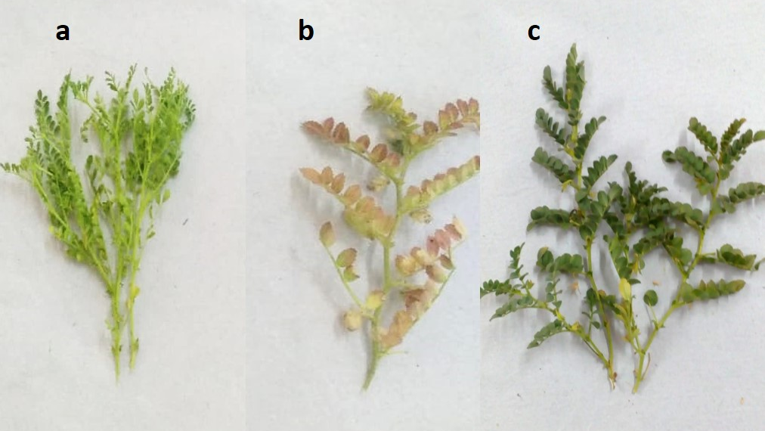
Figure 1. Symptoms of phytoplasma on chickpea with stunting and bushy appearance of infected plants (a), reddening of infected leaves (b) and healthy plants (c) under field cultivation.

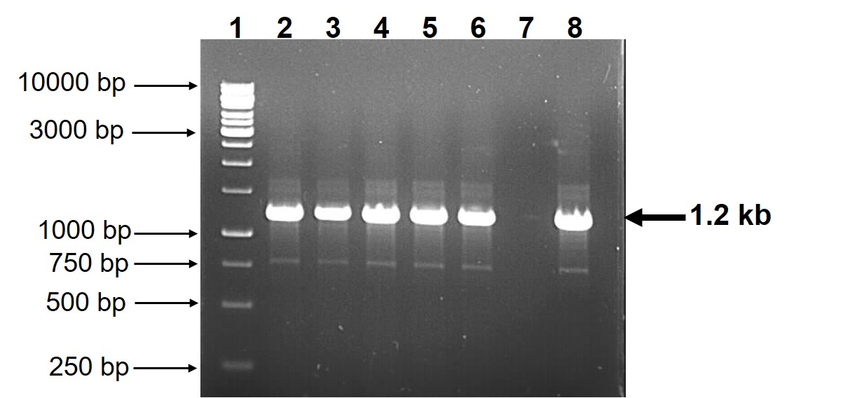
Figure 2. PCR amplification of 16S rRNA gene from phytoplasma naturally infected in chickpea. Lane 1 - 1 kb ladder; Lanes 2 to 6 - Amplified DNA fragment from infected samples; Lane 7- DNA from healthy sample; Lane - Positive control

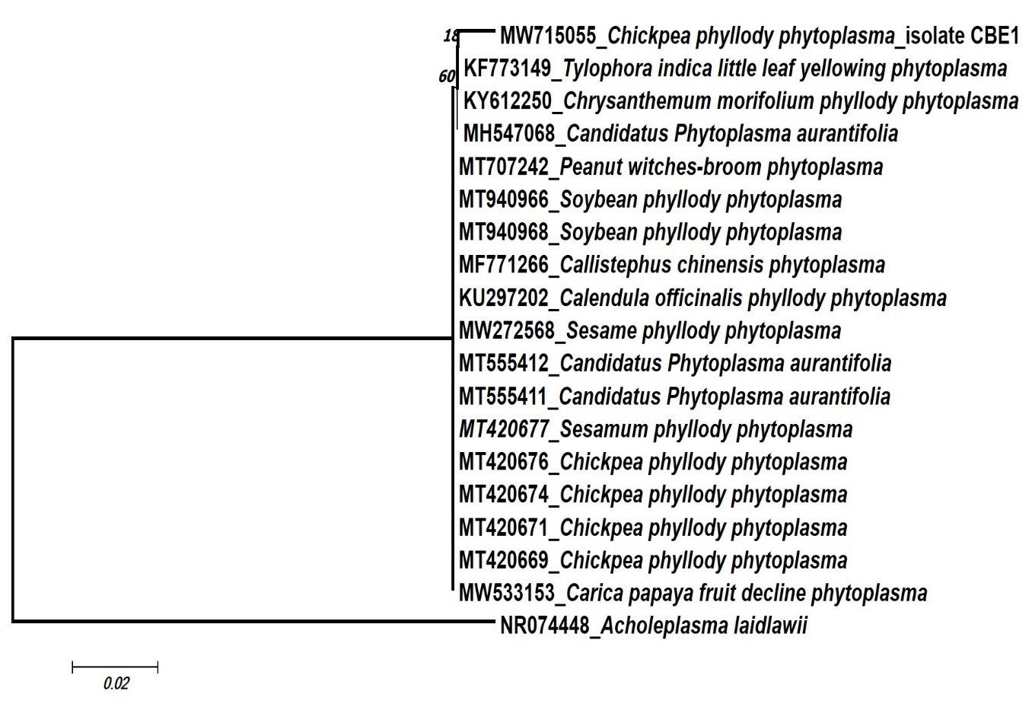
Figure 3. Neighbour joining phylogenetic tree based on the nucleotide sequences of 16S rRNA of Chickpea phyllody phytoplasma and Acholeplasma laidlawii is kept as out group.

Table 1. Nucleotide (nt) identities of 16S rRNA gene from phytoplasma from chickpea with corresponding sequences of selected isolates from NCBI.

S. No. | Crop/Isolate | Country | Per cent nucleotide similarity
1 | Bambusa vulgaris | India | 99.10
2 | Callistephus chinensis | India | 99.00
3 | Chrysanthemum morifolium | India | 99.10
4 | Tylophora indica | India | 99.10
5 | Calendula officinalis | Iran | 99.00
6 | Sesamum indicum | Iran | 99.00
7 | Croton bonplandianus | India | 99.00
8 | Croton bonplandianus | India | 99.00
9 | Sesamum indicum | India | 99.00
10 | Cicer arietinum | India | 99.00
11 | Cicer arietinum | India | 99.00
12 | Cicer arietinum | India | 99.00
13 | Cicer arietinum | India | 99.00
14 | Carica papaya | India | 99.00
15 | Glycine max | India | 99.00
16 | Glycine max | India | 99.00
17 | Crossandra | India | 99.00

