RESEARCH ARTICLE
Assessment of Farmer’s Perception on Pesticide Usage Pattern and Knowledge of Pest Management in Amaranthus at Coimbatore District

ABSTRACT
Pesticides are commonly used in agriculture and horticulture crops to control or manage pests and diseases in order to reduce or eliminate yield losses. Amaranthus is a protein rich grain that is commonly cultivated as a leafy vegetable. Pests of insects (63.2%), market (22.4%) and weather parameters (14.4%) acts as the major constraints of amaranthus production. Among which infestation of numerous insect pests that feed on plant parts such as stems, leaves, flowers and seeds have a greater negative impact on amaranthus production. A total of 92 insect pests from 11 different orders have been identified from cultivated amaranthus. Among which, leaf webber, Hymenia recurvalis Fab. (Lepidoptera: Pyralidae) and ash weevils, Myllocerus discolour and M. viridanus, (Curculionidae: Coleoptera) causes major threat to farmers. Leaf webber, H. recurvalis Fab. (Lepidoptera: Pyralidae) having the highest percentage of incidence on the foliage (8.8%). The borers group, curculionids, caused infestations of 12.6%, while the white grubs group infests 7.3% of the plants. Almost all the farmers relied on chemical pesticides for management of amaranthus pests. A field survey of pesticide usage pattern in amaranthus was undertaken in three amaranthus growing blocks of Coimbatore district viz., Sultanpet, Karamadai and Thondamuthur. Most of the farmers (73.3 %) used chlorantraniliprole for managing the insect pests infesting amaranthus. Around 66 per cent farmers used organic pesticide (exodus) as an option next to chlorantraniliprole. Percentage of farmers using imidacloprid, flubendiamide, panchakavya and jeevamrutham represent 53.3, 33.3 and 13.3 per cent, respectively.

Keywords: Amaranthus; Pesticides usage pattern; Chlorantraniliprole; Organic pesticide.

INTRODUCTION
Amaranthus (Amaranthus spp) belongs to Amaranthaceae family, is widely cultivated as a leafy vegetable in India grown during the summer and rainy seasons. New tender leaves and stems are used to make a delectable cooking preparation. Majority of amaranthus species are native to India or Indo-China region. In India, Amaranthus tricolour is the most widely cultivated as the leafy type. A. blitum and A. tristis are two other cultivated amaranthus species. It is more commonly cultivated in South India as a green leafy vegetable. Green leafy vegetables have gained general acceptance as a vital dietary component and they account for a significant amount of the diet in India's food preparation. It is an herbaceous annual plant. Amaranthus leaves are used as a vegetable and the seeds are used as a cereal (Ezeh et al., 2015). Vegetable amaranthus are popular because of their early maturity, palatability and nutritional content (Kamalanathan et al., 1973), as well as the fact that they may grow in urban garbage or compost (Dako et al., 2014). The leaves are rich source of calcium, iron and vitamins including vitamin A, vitamin K, vitamin B6, vitamin C and riboflavin (Akubugwo et al., 2007). On the other hand, grains are rich in dietary fibre, calcium and minerals like iron, magnesium, phosphorus, copper and manganese, as well good source of essential amino acids especially lysine. It aids in the reduction of blood pressure and cholesterol levels, as well the enhancement of antioxidant level and improves the immune systems (Martirosyan et al., 2007). As both vitamins and minerals are lacking in the diet of poor people, consumption of amaranthus helps in improving the health and livelihoods of rural and urban poor people (Kaaya et al., 2017). The diversity of insect pests is one of the limiting factors impacting amaranthus yield (Aderolu et al., 2013). Amaranthus is affected by other orders besides Lepidoptera, including as Coleoptera, Hemiptera and Orthoptera. Among the other orders of insect pests, the lepidopteran pest primarily targets amaranthus.
Despite its high potential in human health and nutrition, amaranth production is hindered by complex of insect pests of which amaranthus leaf webber and stem weevil are ranked as the most destructive pests (Kagali et al., 2013 and Othim et al., 2018). Sixty insect species associated with amaranthus crop were identified, among which H. recurvalis Fab. (Lepidoptera: Pyralidae) having the highest percentage of incidence on the foliage at 8.8%. This leaf webber causes severe losses to amaranthus species. The caterpillar webs the leaf into distinctive leaf shelter and voraciously feed on the green matter. The most voracious and damaging stage of H. recurvalis is the third instar larva which prefers tender leaf. Severe attack results in complete skeletonization and drying up of the leaves within a short time. This has necessitated the need to control the insect pest and other pests of amaranthus species. The borers group, curculionids, caused infestations of 12.6%, while the white grubs group infests 7.3% of the plants (Aderolu et al., 2013).
Chemical insecticides played significant role in plant protection against this pest, especially in commercial amaranthus cultivation. This scenario necessitated the development and application of new chemical insecticides that are more effective in pest control, safer to human and less harmful to the environment (Korrat et al., 2012). Hence, the study was undertaken with the objective to look into the various patterns of pesticide usage and farmers knowledge about pest management in amaranthus in different amaranthus growing blocks of Coimbatore district.

MATERIALS AND METHODS
Study area
Field survey on pesticide usage pattern in amaranthus was conducted in three amaranthus growing blocks of Coimbatore, viz., Sultanpet block (10.8771⁰N and 77.1974⁰E ) comprising of villages such as Pappampatti, Edayarpalayam, Kallapalayam, Kammalapatti, Kumarapalayam and Pachapalayam, Karamadai block (11.2428⁰N and 76.9587⁰E) comprising of villages such as Mongampalayam, Chinnakallipatti, S Pungampalayam and Mangalakaraiputhur and Thondamuthur block (10.9899⁰N and 76.8409⁰E) comprising of villages such as Narasipuram, Viraliyur, Vellimalaipatinam, Madvarayapuram and Theethipalayam) during 2020 - 2021 to study the scenario of pesticide usage in amaranthus growing farms (Table.1).
Research methods
Farmer surveys, focus group discussions of farmers and key informant interviews were used in amaranthus growing blocks of Coimbatore. Farmers represented various farm sizes (less than one acre to ten acres), levels of production experience and varied insect pest management practices. Female respondents completed the farmer survey in approximately 15 min. and male respondents in 20 min. A questionnaire was prepared and the data on pesticide usage pattern were collected from 15 farmers in each block comprising small to large farmers during the survey. The farmer's demographic details, area of cropping, varieties, amaranthus production, information on major pests, major pesticides, spray intervals, insecticide dosage and knowledge on eco-friendly pest management practices were collected. Despite the fact that the farmers in the study area did not maintain farm records, they were able to provide the required information through memory recall and experience. The data on pesticide usage were compiled and analyzed. The information gathered were entered in a MS-Excel worksheet, classified and used for further study. The results of analyzed data were represented in the form of tables and graphs.

RESULTS AND DISCUSSION
Demographics of farmers
A majority of the farmers in the survey were male (68.9%) compared to female (31.1%). Land holding of farmers broadly ranges from <1 acre to 10 acres. It was found that 48.9% respondents had ≤1 acre, while 40% and 11.1% had 2 – 5 acres and 5 – 10 acres respectivesly. Literacy rate of respondents was around 37.8% and rest of the respondents around 62.2% were uneducated.
Production
Survey reports revealed that majority of the respondents had obtained the yield ranging from 5 – 7 tonnes of leaf yield per acre and 300 – 350 kg of seed yield per acre. Among the survey participants, 91.1 % had raised amaranthus as monocrop. Whereas 2.2% grown it as intercrop and 6.7% of farmers used both monocrop and intercrop production systems. About 42.2% of respondents used seeds from previous harvest for sowing and 57.8% had obtained seed from agricultural supply stores. From the harvested produce, 32.8% was used for home consumption purpose and rest of the produce (67.2%) for sale purpose. Survey results reported that pests of insects (63.2%), market (22.4%) and weather parameters (14.4%) as the major constraints of amaranthus production.
Pest infestation
Based on the survey conducted, major variety grown was sengeerai followed by arun red, thandu keerai, arai keerai, CO1 and CO2. Reports revealed that pests such as leaf webber (Hymenia recurvalis), stem weevil (Hypolixus truncatulus), leaf miner (Liriomyza sp.), ash weevils (Myllocerus discolour and M. viridanus), flea beetle (Chaetocnema sp.) and coreid bug (Cletus sp.) were commonly observed in the three respective blocks. Among which leaf webber and ash weevils were found to be major threat to farmers. Due to its greater occurrence scoring based on percent damage was done. Incidence and intensity of leaf webber was scored using the score chart (Shahiba et al., 2020). Scores were given as 0 – no incidence, 1 – mild (25%), 2 – medium (50%), 3 – severe (75%) and 4 – very severe (100%). Based on the survey report, leaf webber incidence was observed in all the three blocks and based on scoring, high level of pest severity was observed.
Management practices
Pesticides commonly used by respondents in amaranthus were listed in Figure 1. Results from the survey revealed that many of the farmers used chlorantraniliprole (73.3 per cent farmer response), followed by the use of organic pesticide (exodus) (66.7 per cent). Muralikrishna et al. (2019) also reported that chlorantraniliprole (0.006%) was found to be the most effective insecticides against pests of amaranthus. Other farmers used imidacloprid (53.3 per cent) and flubendiamide (33.3 per cent). Muralikrishna et al. (2021) stated that among various insecticides used, flubendiamide (0.0096%) was found to produce promising results in management of amaranthus pests. Tohnishi et al. (2005) also reported that flubendiamide had greater efficacy in managing lepidopteran insect pests in amaranthus. Because of the specific mode of action of these diamides, all the treated larvae stopped feeding on amaranth leaves within six hours of exposure, despite the fact that flubendiamide (0.0096%) and chlorantraniliprole (0.006%) treated larvae took 36 hours to cause cent per cent mortality. This is due to diamides greater insecticidal efficacy against a variety of lepidopteran pests as well as many other insect orders, including Coleoptera, Diptera, Isoptera and Hemiptera (Sattelle et al., 2008; Lahm et al., 2009). Safety of diamides to spiders were also reported by Rajavel, 2011. Only 13.33 per cent of respondents had used panchakavya and jeevamrutham for managing the pests.
Farmer’s perception on seasonal abundance of amaranthus pests as recorded during the survey in three blocks of Coimbatore was given in Figure 2. The abundance of pest population was maximum during the month of November – December (73.3 per cent farmer response) followed by October – November (33.3 per cent). Aderolu et al. (2013) also reported that the pest population of amaranthus was abundant on dry season during the month of November and December. There was no significant difference in the abundance of leaf webbers and leaf worms between the dry and wet seasons (Othim et al., 2018). Pest population abundance was the lowest during January – February (66.7 per cent) followed by February – March (46.7 per cent). Majority of the respondents used power sprayers to apply pesticides in all the three blocks.
Farmer’s response on the frequency of pesticides usage in amaranthus was showed in Figure 3. It indicated that eighty per cent farmers applied pesticides at 10-15 days interval, whereas, 13.3 per cent of the farmers sprayed at 10 days interval and none of the farmers surveyed sprayed at weekly intervals. The remaining 6.7 percent of farmers apply pesticides based on insect infestation.
The insecticide dosage used by farmers in amaranthus was showed in Figure 4. Majority of the farmers had used insecticides at the dosage of 20-25 ml per tank (73.3 per cent) followed by 15-20 ml per tank (33.3 per cent) and 25-30 ml per tank (20.0 per cent) during the cropping period.
Most of the respondents were not aware of predators and parasitoids. Sourcing of information on pesticide usage in amaranthus pest management was obtained by the respondents from the pesticide dealers (60 per cent) followed by 33.3 per cent from TNAU and 6.7 per cent from State Department of Agriculture (Figure 5). The most important sources of knowledge for farmers about pesticide use were notifications from agrochemical stores, as well as sales representatives from various agrochemical firms.
CONCLUSION
The above findings confirmed that amaranthus growing farmers were facing a number of pest problems. Majority of the farmers used chlorantraniliprole at 10-15 days interval for controlling the pests. The results revealed that in order to increase the production and productivity, most of the farmers used chemical insecticides for managing the pests rather than employing bio-control agents. For the betterment of the consumers and to enhance the production and productivity of this green leafy vegetable, ecologically sustainable pest management practices could be recommended. Research on development of integrated pest management module for amaranthus could increase the production of amaranthus by proper identification of pests, use of pesticides at right time and dose and development of alternative eco-friendly pest management strategies.
Ethics statement
Specific permits were not required for the above field studies because no human or animal subjects were involved in this research.
Consent for publication
All the authors agreed to publish the content.
Competing interests
There was no conflict of interest in the publication of this content.
Data availability

All the data of this manuscript are included in the manuscript. No separate external data source is required. If anything is required from the manuscript, certainly, this will be extended by communicating with the corresponding author through corresponding official mail; kalaielakkiya98@gmail.com

REFERENCES
Akubugwo, I. E., Obasi, N. A., Chinyer, G. C. and A. E. Ugbogu. 2007. Nutritional and chemical value of Amaranthus hybridus L. leaves from Afikpo, Nigeria. Afr. J. Biotechnol., 6(24): 2833-2839.
Achigan-Dako, E. G., Sogbohossou, O. E. and P. Maundu. 2014. Current knowledge on Amaranthus spp.: research avenues for improved nutritional value and yield in leafy amaranths in sub-Saharan Africa. Euphytica., 197(3): 303-317.
Aderolu, I. A., Omooloye, A. A. and F. A. Okelana. 2013. Occurrence, abundance and control of the major insect pests associated with amaranths in Ibadan, Nigeria. Entomol Ornithol Herpetol., 2(112): 2161-0983.
Ezeh, A. E., Ogedegbe, A. B. O. and S. A. Ogedegbe. 2015. Insect pest occurrence on cultivated Amaranthus spp in Benin City, Edo State, Nigeria. J. Appl. Sci. Environ. Manage., 19(2): 335-339.
Kaaya, A., Kyamuhangire, W., Nakimbugwe, D., Chen, J. and R. Phillips. 2017. Efforts to promote amaranth production and consumption in Uganda to fight malnutrition. African J. Food, Agric. Nutr. Dev., 17: 12758-12774.
Kagali, R. N., Kioko, E. N., Osiemo, Z., Muya, S. and C. Wachera. 2013. Insect abundance and diversity on cultivated Amaranthus Sp. (Amaranthaceae) in Meru County, Kenya. Am. Int. J. Contemp. Res., 3(7).
Kamalanathan, S., Sunderajan, S., Thambura, J. S. and A. Shanmugam. 1973. Co I Amaranthus. A high yielding and delicious strain. Madras Agric. J., 60(6): 355-358.
Korrat, E. E. E., Abdelmonem, A. E., Helalia, A. A. R. and H. M. S. Khalifa. 2012. Toxicological study of some conventional and nonconventional insecticides and their mixtures against cotton leaf worm, Spodoptera littoralis (Boisd.) (Lepidoptera: Noectudae). Ann. Agric. Sci., 57(2): 145-152.
Lahm, G. P., Cordova, D. and J. D. Barry. 2009. New and selective ryanodine receptor activators for insect control. Bioorg. Med. Chem., 17(12): 4127-4133.
Martirosyan, D. M., Miroshnichenko, L. A., Kulakova, S. N., Pogojeva, A. V. and V. I. Zoloedov. 2007. Amaranth oil application for coronary heart disease and hypertension. Lipids Health Dis., 6(1): 1-12.
Muralikrishna, P., Mathew, T. B., Paul, A. and P. R. Nithya. 2019. Evaluation of bio-efficacy of new generation insecticides, botanicals and microbial insecticides on leaf webber of amaranth. J. Entomol. Zool. Stud., 7(5): 516-520.
Muralikrishna, P., Mathew, T. B., Nithya, P. R. and A. Paul. 2021. Bio-efficacy of new generation insecticides, botanicals, and microbial insecticides on Spodoptera litura. F (Lepidoptera: Noctuidae) in amaranth. J. Entomol. Zool. Stud., 9(3): 183-186.
Nampeera, E. L., Nonnecke, G. R., Blodgett, S. L., Tusiime, S. M., Masinde, D. M., Wesonga, J. M. and M. O. Abukutsa-Onyango. 2019. Farmers’ knowledge and practices in the management of insect pests of leafy amaranth in kenya. J. Integr. Pest Manag., 10(1): 1-12.
Othim, S. T. O., Kahuthia‐Gathu, R., Akutse, K. S., Foba, C. N. and K. K. M. Fiaboe. 2018. Seasonal occurrence of amaranth Lepidopteran defoliators and effect of attractants and amaranth lines in their management. J. Appl. Entomol., 142(7): 637-645.
Othim, S. T. O., Srinivasan, R., Kahuthia-Gathu, R., Dubois, T., Dinssa, F., Ekesi, S. and K. K. M. Fiaboe. 2018. Screening for resistance against major lepidopteran and stem weevil pests of amaranth in Tanzania. Euphytica., 214(10): 1-21.
Rajavel, D. S., Mohanraj, A. and K. Bharathi. 2011. Efficacy of chlorantraniliprole (Coragen 20SC) against brinjal shoot and fruit borer, Leucinodes orbonalis (Guen.). Pest Manag. Hort. Ecosyst., 17(1): 28-31.
Sattelle, D. B., Cordova, D. and T. R. Cheek. 2008. Insect ryanodine receptors: molecular targets for novel pest control chemicals. Invert. Neurosci., 8(3): 107-119.
Shahiba, A. M., Thomas, B., and A. Chacko. 2020. Evaluation of Thirty Amaranthus Genotypes (Amaranthus tricolor L.) for Different Biometric Characters. Int. J. Curr. Microbiol. App. Sci., 9(8): 1621-1631.
Tohnishi, M., Nakao, H., Furuya, T., Seo, A., Kodama, H., Tsubata, K., Fujioka, S., Kodama, H., Hirooka, T. and T. Nishimatsu. 2005. Flubendiamide, a novel insecticide highly active against lepidopterous insect pests. J. Pestic. Sci., 30(4): 354-360.
Table 1. List of villages surveyed in Coimbatore district
S.No | Block | Name of village
1 | Sultanpet | Pappampatti
1 | Sultanpet | Edayarpalayam
1 | Sultanpet | Kallapalayam
1 | Sultanpet | Kammalapatti
1 | Sultanpet | Kumarapalayam
1 | Sultanpet | Pachapalayam
2 | Karamadai | Mongampalayam
2 | Karamadai | Chinnakallipatti
2 | Karamadai | S Pungampalayam
2 | Karamadai | Mangalakaraiputhur
3 | Thondamuthur | Narasipuram
3 | Thondamuthur | Viraliyur
3 | Thondamuthur | Vellimalaipatinam
3 | Thondamuthur | Madvarayapuram
3 | Thondamuthur | Theethipalayam

Figure 1. Commonly used pesticides in amaranthus
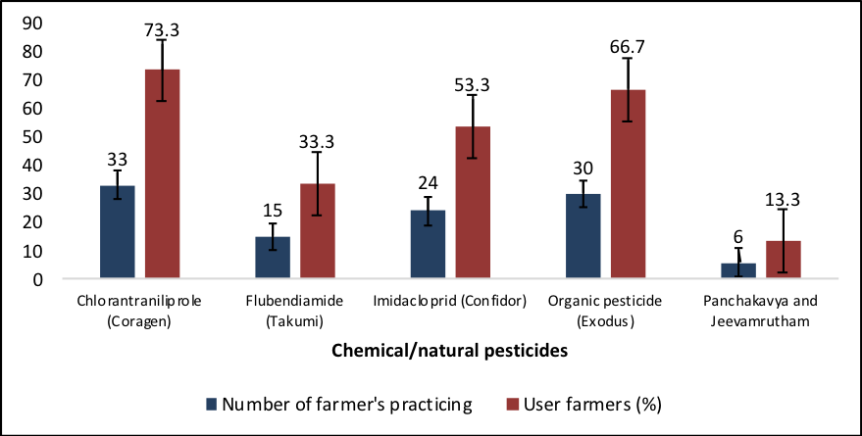
Figure 2. Seasonal abundance of amaranthus pests
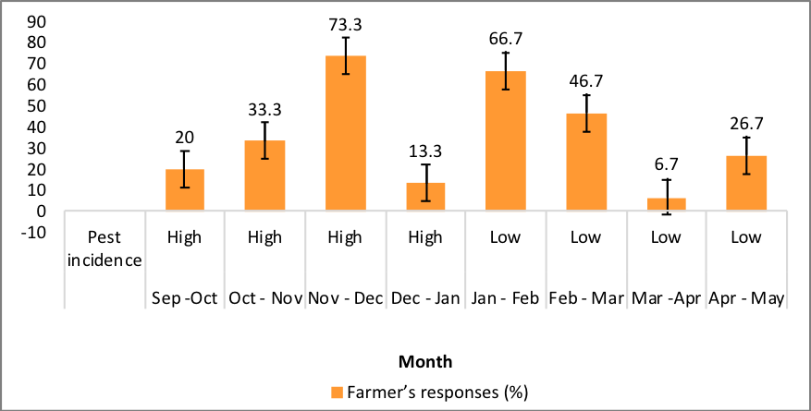
Figure 3. Frequency of pesticide usage in amaranthus
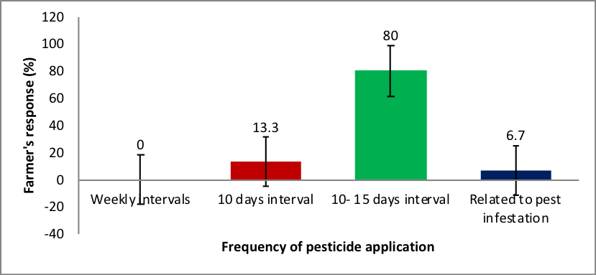

Figure 4. Dosage of insecticide used by farmers in amaranthus
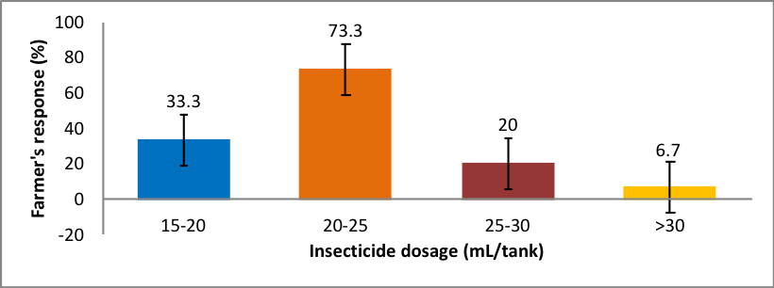
Figure 5. Sourcing of information on pesticide usage
