RESEARCH ARTICLE

Effects of Tillage Practices and Sources of nutrients on soil Microbial population and Grain yield of finger millet (Eleusine coracana L.)

ABSTRACT
A field experiment on ‘Effect of Tillage Practices and Sources of nutrients on soil Microbial population and Grain yield of finger millet (Eleusine coracana L.)’ conducted at Agricultural College and Research Institute, Tamil Nadu Agricultural University, Madurai during 2018-19 and 2019-20. The experiment laid out in a split-plot design with replicated thrice. The experiment consisted of three main plot treatments viz., Conventional tillage (T₁), Minimum tillage (T₂), and Plough sole tillage (T₃) and subplot has six treatments with different sources of nutrients viz., Farm Yard Manure + biofertilizer (O₁), Vermicompost + biofertilizer, (O₂), Goat manure + biofertilizer (O₃), Poultry manure + biofertilizer (O₄), Press mud + biofertilizer (O₅) and control (100% RDF) (O₆). The total microbial population viz., bacteria, fungi, and actinomycetes was found higher in the main plot treatment of minimum tillage (T₂) during first year and were comparable with conventional tillage (T₁) during second year. In the subplot, vermicompost + biofertilizer (O₂) recorded a higher microbial population followed by poultry manure + biofertilizer (O₄) during first year and was comparable with poultry manure + biofertilizer (O₄) during second year. Among the treatment combinations, the minimum tillage with vermicompost + biofertilizer (T₂O₂) recorded a higher microbial population during first year and was comparable with minimum tillage combination with poultry manure + biofertilizer (T₂O₄) during second year. Higher yield of finger millet recorded with conventional tillage with 100% RDF as control (T₁O₆) during first year and was comparable with minimum tillage combination with poultry manure + biofertilizer (T₂O₄) during second year. Even as the conventional tillage practice with 100% RDF as control recorded higher yield,the holistic approaches of minimum tillage combination with poultry manure + bio fertilizer (T₂O₄) can be recommended as best practice to the farmers why ? Pl. give reason.
Keywords: Finger millet yield, Microbial population, sources of nutrients, Tillage practices.

INTRODUCTION
Conservation tillage is a concept evolved to respond to the concerns of sustainability of agriculture (FAO, 2012). This resource-saving agricultural production system aims to achieve high and sustaining yields. It would enhance and maintain natural resource base through compliance of interrelated principles and with other good production management practices of plant nutrition (Abrol and Sangar, 2006). Traditional agriculture involves intensive tillages and responsible for soil erosion problems, surface and underground water pollution, and more consumption of irrigation water (Wolff and Stein, 1998). Moreover, implicated land resource degradation, low energy efficiency and contributes to global warming (Boatman et al., 1999). Hence, the conservation tillage is an effective alternative way to cultivate annual and perennial crop-based systems and with crop residue management to have a soil cover. This will precede way to increase the organic matter content in the surface soil horizons. Instantaneously, it also has beneficial impacts on the global environment as compared to traditional agriculture (Derpsch et al., 2010).
Soil harbors a dynamic population of microorganisms, which play a major role in the decomposition of organic matter and the transformation of plant nutrients. The availability of organically bound nitrogen through a transformation in the soil to the plant mainly depends on the population of microorganisms, which influenced by the application of organic manure. The microbial biomass, which is the total mass of bacteria, fungi, actinomycetes present in the soil, serves as a temporary sink for nutrients including nitrogen and it considered as an index of soil fertility. The factors like cropping system, manure application, etc., affect the soil microbial growth, activity, and diversity. Microbial biomass carbon and enzyme activity increases with the continuous application of organic manure (Zhao et al., 2016). Enzymes are important soil components involved in the dynamics of soil nutrient transformations and enzyme activity considered a major contributor to overall soil microbial activity. Microorganisms and their mediated processes can give an integrated measure of soil health. It also plays an important role in organic matter decomposition and the dynamics of nutrient transformations in the soil. The addition of organic manures significantly increases the urease, alkaline phosphatase and dehydrogenase activity in the soil as compared to chemical fertilizers. Hence, the present investigation was taken up to develop the soil microorganism and maintains soil quality for sustainable productivity of finger millet.

MATERIAL AND METHODS

A field experiment conducted at Department of Agronomy, Agricultural College and Research Institute, Tamil Nadu Agricultural University, Madurai to investigate the effect of tillage practice and sources of nutrients on the soil microbial population and grain yield of finger millet. The experimental field is located in the Southern agro-climatic zone of Tamil Nadu at 9º 54’ N latitude and 78º 54’ E longitude and an altitude of 147 m above MSL. A mean annual rainfall is 848 mm and distributed on 46 rainy days. The soil of the experimental site is clay loam in texture with 220.6:11.5: 308.4 kg available soil N: P₂O₅: K₂O ha⁻¹. The pH of the soil was 7.9 with EC of 0.52 dS m⁻¹ and with 0.48 per cent soil organic carbon. Initial soil microbial population of bacteria, fungi, and actinomycetes was 98.9 CFU g⁻¹, 16.7 CFU g⁻¹ and 80.6 CFU g⁻¹ of soil. The Tillage and nutrient sources formed as main and sub-plots. The experiment laid out in a split-plot design with three replications. The three tillage practices was consisted in main plot treatment viz., T₁- Conventional tillage (Mould board plough + cultivator + rotavator once each), T₂ - Minimum tillage (cultivator + rotavator once each) and T₃ - Plough sole tillage (using country plough once) and the subplot treatments consisted of six sources of nutrients viz., O₁ - FYM + biofertilizer, O₂-Vermicompost + biofertilizer, O₃- Goat manure + biofertilizer (S₃), O₄ -Poultry manure + biofertilizer, O₅ - Press mud + biofertilizer and O₆ - Control (100% RDF). Finger millet variety CO 15 was used for the study. Bacteria, fungi, and actinomycetes populations were observed at pre and post-harvest sowing of finger millet. Soil samples collected from each treatment after harvesting crop and stored at the temperature of 4º C for estimation of microbial population.One gram of soil was serial diluted to 10⁶, 10³ and 10⁴ for bacterial, fungi and actinomycetes, respectively. These data analyzed statistically by following Gomez and Gomez (2010). Treatment differences were found significant (F test), critical differences worked out at a five percent probability level and the values were furnished.
Table.1 Analytical methods employed in microbial analysis
Parameters | Method | Reference
Total bacteria | Serial dilution method using Nutrient Agar medium | Allen (1953)
Total fungi | Serial dilution method using Rose Bengal Agar medium | Martin (1950)
Total actinomycetes | Serial dilution method using Ken knights Agar medium | Allen (1953)
Table. 2 Composition of organic manures used in the experiment
Organic manure | 2018-2019 |  | 2019-2020
Organic manure | N (% ) | Quantity used(t/ha) | N (% ) | Quantity used(t/ha)
Farm yard manure | 0.50 | 12.00 | 0.51 | 12.00
Vermicompost | 1.50 | 4.00 | 1.52 | 4.00
Goat manure | 2.81 | 2.13 | 2.90 | 2.06
Poultry Manure | 2.96 | 2.02 | 2.98 | 2.01
Press mud | 2.35 | 4.13 | 2.30 | 4.08
100%RDF | 60:30:30 kg NPK ha⁻¹ |  | 60:30:30 kg NPK ha⁻¹

RESULTS AND DISCUSSION
Effect of tillage practices and sources of nutrients on post - harvest soil Bacterial population of finger millet (Figure. 1)
In the present study, the effect on tillage practices and sources of nutrients on the bacterial population of rhizosphere soil of finger millet assessed and the results are given in figure 1. How the results were drawn from the graph? Graph is made with two parameters such as tillage and nutrients. But, the results were splitted in to. How? Please provide tables to have more clarity. Lower total bacteria population of 41.42 x 10⁶ and 73.79 x 10⁶ CFU g⁻¹ was recorded under plough sole tillage (T₃) at post-harvest soil during 2018-19 and 2019-20, respectively. The favourable effect of reduced tillage on soil microbial population are mainly due to increased soil aeration, cooler and wetted condition, lower temperature and moisture, fluctuation and higher carbon contents in surface soil (Verhulst et al., 2011). Therefore, a shift in micro flora population significantly influences the maintenance of soil fertility and productivity owing to the faster rate of decomposition and mineralization of organic materials. Similar findings were reported by Biederbeck et al. (2005).
Regarding sources of nutrients, application of vermicompost + biofertilizer (O₂) recorded a higher total bacterial population of 64.23 x 10⁶ and 100.87x 10⁶ CFU g⁻¹ at post-harvest soil. This was followed by the application of poultry manure + biofertilizer (O₄) during 2018-19 and comparable during 2019-20. Significantly lower total bacterial population of 35.42 x 10⁶ and 66.35 x 10⁶ CFU g⁻¹ of soil noticed under application of 100% RDF as control (O₆) at post-harvest soil during both years. The bacterial populations were significant enhanced in the treatment irrespective of organic sources. Biswas et al. (2017) ascribed higher bacterial count to the positive effects of manure by providing nutrients for the growth of microbes directly or indirectly by stimulating plant growth and enhancing root carbon flow. Also, the organic manures show superiority in enriching the richness and diversity of soil bacteria (He et al., 2008) due to enhanced soil microbial biomass and activities of organic-treated soils (Islam et al., 2011).
The interaction effect between tillage practices and sources of nutrients found to be significant in post-harvest soil. The minimum tillage in combination with vermicompost + biofertilizer (T₂O₂) registered a higher total bacterial population of 70.65 x 10⁶ and 107.41 x 10⁶ CFU g⁻¹ at post-harvest soil during 2018-19 and 2019-20, respectively and this was followed by minimum tillage combination with poultry manure + biofertilizer (T₂O₄) during 2018-19 and was comparable with the above treatment during 2019-20. The lower total bacterial population of 28.95 x 10⁶ and 54.57 x 10⁶ CFU g⁻¹ of soil recorded under, plough sole tillage in combination with 100% RDF as control (T₃O₆) during 2018-19 and 2019-20, respectively. Please provide discussion here too.
Effect of tillage practices and sources of nutrients on post - harvest soil Fungi population of finger millet (Figure. 2)
Same sentances as above are used. Please re write the sentances Conservation tillage can also influence soil suitability for the growth of crops (Hewins et al., 2017), promoting the formation of fungal hyphal networks, and leading to higher soil fungal population sizes (Gottshall et al., 2017). Only references are mentioned here. Author must give the discussion here.
Repetition of sentances as above. Pl. rewrite. Ingle et al., (2014) reported an increase in fungal population with addition of organics since most of these organisms are chemoheterotrophs, which require organic source of carbon as food and oxidation of organic substances provides energy, thereby increasing their population.
Almost similar pattern of sentances are used. Pl. recast the sentances
Effect of tillage practices and sources of nutrients on post - harvest soil Actinomycetes population of finger millet (Figure.3)
Follow the previous paragraph comments. Similar to the present study, Li et al., (2020) reported an increase in soil bacteria, fungi, and actinomycets counts in conservation tillage practices, which created favourable environmental conditions for microbial growth. Conservation tillage practices can influence the soil microclimate, the distribution and decomposition of crop residues, and the transformation of nutrients (Cheng et al., 2017); those factors, in turn, can alter soil microbial population size and diversity (Li et al., 2018). Minimum tillage causes less disturbance of the soil, creating a better environment for microbial growth, leading to increased C use efficiency and elevated activity levels of various extracellular enzymes (Sauvadet et al., 2018).
Same sentances are followedThe increased microbial population may be due to the fact that organic manure provided necessary food and micro environment for their quicker multiplication and growth (Kumari and Kumari, 2002). This could be ascribed to the organic sources which supplied large amount of readily available carbon, resulting in more diverse and dynamic microbial system. Soil enzymatic activities increased as the soil microbes degrade organic matter through the production of diverse extracellular enzymes, after the application of vermicompost to soils (Tejada and Gonzalez, 2008). This may be attributed to higher amount of growth promoting substances, vitamins and enzymes which in turn increased the microbial population and root biomass production.
Repetition of sentances
Effect of tillage practices and sources of nutrients on grain yield of finger millet (Figure.4)
Tillage is an important management practice involving physical manipulation of soil for crop establishment. Optimization of tillage practices leads to improvement in soil health. Soil health is a dynamic and complex system, and its functions are mainly mediated by agricultural management practices (Doran and Zeiss, 2000). Among the tillage practices, the conventional tillage (T₁) registered significantly highest grain yield of 2337 and 2535 kg ha⁻¹ during 2018-19 and 2019-20, respectively. This was followed by minimum tillage (T₂) during 2018-19 and was on par with the above treatment during 2019-20. The lowest grain yield of 1648 and 1961 kg ha⁻¹ was recorded under plough sole tillage (T₃) during 2018-19 and 2019-20, respectively. Lacks discussion
Of the sources of nutrients, application of 100% RDF as control (O₆) recorded the highest grain yield of 2556 and 2679 kg ha⁻¹ during 2018-19 and 2019-20 respectively. This was followed by poultry manure + bio fertilizer (O₄) during 2018-19 and was comparable with the above treatment during 2019-20. Too lengthy sentence. Could not get the information Improvement in yield attributes could be due to higher quantity of macro and micronutrients added to soil in the form of organic sources resulting in increased availability of nutrients in root zone thus more uptake by crop resulting in higher values of yield attributing characters. These results are in conformity with the result of Poornesh et al., (2004). The lowest grain yield (1409 and 1763 kg ha⁻¹) was recorded under application FYM + bio fertilizer (O₁) during both year.
Interaction effect between tillage practices and sources of nutrients was not significant on grain yield with first year experiment during 2018-19 and was found significant during 2019-20. The combination of conventional tillage with 100% RDF as a control (T₁O₆) registered with highest grain yield of 2854 kg ha⁻¹ during 2019-20. This was comparable with minimum tillage in combination with poultry manure (T₂O₄) (2798 kg ha⁻¹).The lowest grain yield (1450 kg ha⁻¹) was recorded under plough sole tillage combined with FYM + bio fertilizer (T₃O₁) during 2019-20. Why this was happended. Pl. discuss. Similar to the present study, Mutonga et al., (2019) reported a higher grain yield in wheat under conservation tillage than conventional practices by conserving more moisture.

CONCLUSION
Pl. split the sentances Conclusion is not conveying the results out put. Needs revision.

Figures and Structures
Figure. 1 Effect of tillage practices and sources of nutrients on Bacterial population of finger millet during 2018-19 and 2019-20 Pl. do correct in the legend of figure too

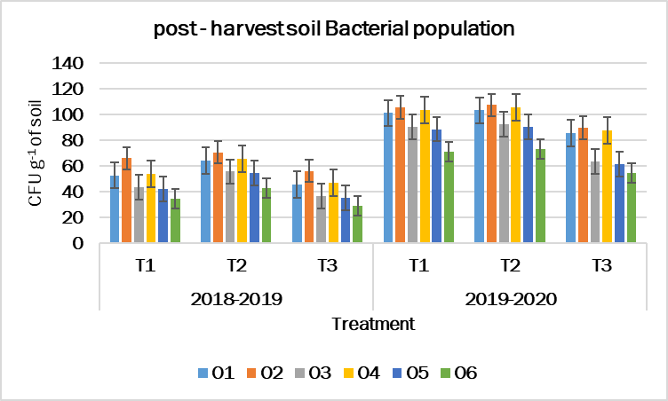

Figure. 2 Effect of tillage practices and sources of nutrients on Fungi population of finger millet during 2018-2019 and 2019-2020
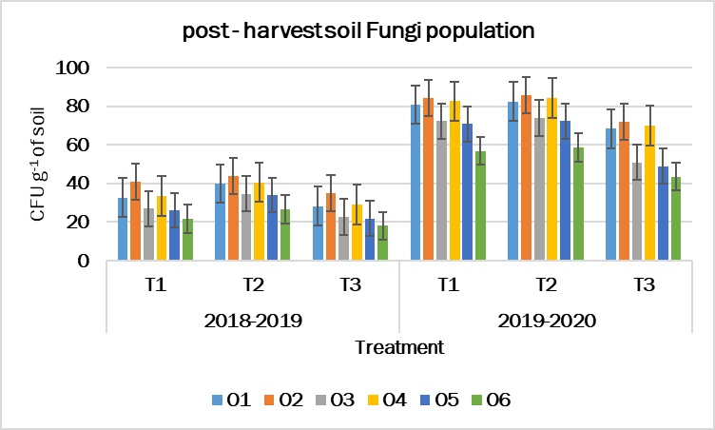

Figure. 3 Effect of tillage practices and sources of nutrients on actinomycetes population of finger millet during 2018-2019 and 2019-2020
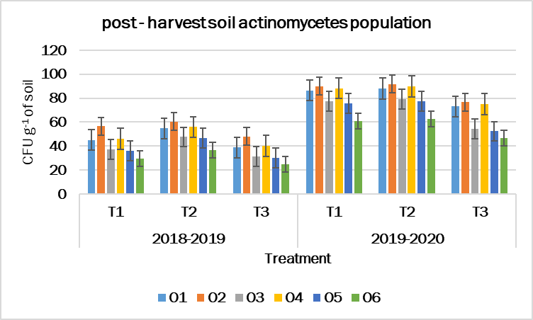

Figure.4 Effect of tillage practices and sources of nutrients on grain yield of finger millet during 2018-2019 and 2019-2020

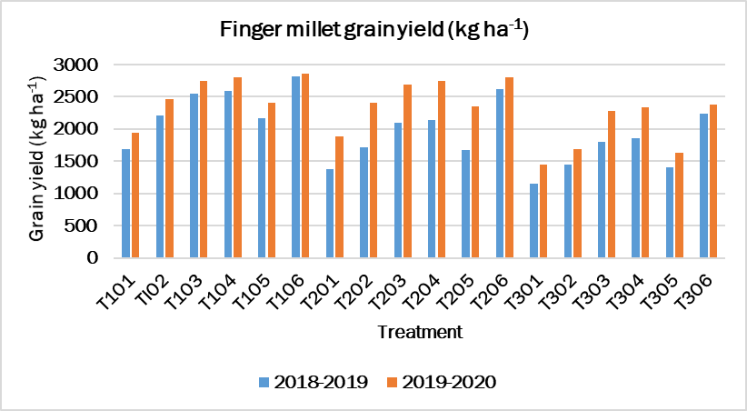

REFERENCES
Abrol, I.P. and Sangar, S. 2006. Sustaining Indian agriculture-conservation agriculture the way forward. Current Science, 91(8), 1020-2015.
Allen, M. B. (1953). The thermophilic aerobic sporeforming bacteria. Bacteriological reviews, 17(2), 125.
Font type?
Biswas, S., Hazra GC., Purakayastha TJ., Saha N., Mitran,T., Roy SS., Basak, N. and Mandal, B. 2017. Establishment of critical limits of indicators and indices of soil quality in rice-rice cropping systems under different soil orders. Geoderma 292: 34-48.
Boatman, N., Green, M. and Holland, J. 1999. Agri‐ environment schemes – what have they achieved and where do we go from here Aspects Appl. Biol., 100, 447.
Cheng, Y., Wang, J., Wang, J., Chang, S.X. and Wang, S. 2017. The quality and quantity of exogenous organic carbon input control microbial NO₃ − immobilization: a meta-analysis. Soil Biol. Biochem. 115, 357–363.
Derpsch, R. and Friedrich T. Global overview of Conservation Agriculture adoption. Invited Paper, 4th World Congress on Conservation Agriculture: Innovations for Improving Efficiency, Equity and Environment. 4 - 7 February 2010, New Delhi, ICAR.
Doran, J.W. and R. M. Zeiss. 2000. Soil health and sustainability: managing the biotic component of soil quality. Applied Soil Ecology. 15, 3–11.
FAO. (2012). Alive and kicking: why dormant soil microorganisms matter. Soil Biol. Biochem. 116, 419–430.
Gomez, K. A., Gomez, K. A and Gomez, A. A. 2010. Statistical procedures for agricultural research (2nd ed.) International Rice Research Institute, P.B. Box. Manila, Philippines and John Wiley and Sons, New York, USA, p. 680.
Gottshall, C.B., Cooper, M. and Emery, S.M. 2017. Activity, diversity and function of arbuscular mycorrhizae vary with changes in agricultural management intensity. Agric. Ecosyst. Environ. 241, 142–149.
He JZ, Zheng Y, Chen CR, He YQ and Zhang LM. 2008. Microbial composition and diversity of an upland red soil under long-term fertilization treatments as revealed by culture-dependent and culture-independent approaches. Journal of Soils Sediments 8: 349-358.
Hewins, D.B., Sinsabaugh, R.L., Archer, S.R. and Throop, H.L. 2017. Soil-litter mixing and microbial activity mediate decomposition and soil aggregate formation in a sandy shrub-invaded Chihuahuan Desert grassland. Plant Ecol. 218, 459–474.
Ingle SS, Jadhao SD, Kharche VK, Sonune BA and Mali DV. 2014. Soil biological properties as influenced by long-term manuring and fertilization under sorghum (Sorghum bicolor)-wheat (Triticum aestivum) sequence in Vertisols. Indian Journal of Agricultural Sciences 84: 452-457.
Islam MR, Chauhan PS, Kim Y, Kim M and Sa T. 2011. Community level functional diversity and enzyme activities in paddy soils under different long-term fertilizer management practices. Biology and Fertility of Soils 47: 599-604.
Kumari S and Kumari K. 2002. Effect of vermicompost enriched with rock phosphate on growth and yield of cowpea (Vigna unguilata L. walp). Journal of the Indian Society of Soil Science 50: 223-224.
Li, Y., Chang, S.X., Tian, L.H. and Zhang, Q.P. 2018. Conservation agriculture practices increase soil microbial biomass carbon and nitrogen in agricultural soils: a global meta-analysis. Soil Biol. Biochem. 121, 50–58.
Li, Y., Zhang, Q., Cai, Y., Yang, Q. and Chang, S. X. 2020. Minimum tillage and residue retention increase soil microbial population size and diversity: Implications for conservation tillage. Science of the Total Environment, 716, 137164.
Martin, J. P. (1950). Use of acid, rose bengal, and streptomycin in the plate method for estimating soil fungi. Soil science, 69(3), 215-232.
Martin, J. P. (1950). Use of acid, rose bengal, and streptomycin in the plate method for estimating soil fungi. Soil science, 69(3), 215-232.
Mutonga, M.W., Kipkorir, E.C. and Ng’etich, W.K. 2019. Assessment of Effects of Zero and Conventional Tillage Practices on Soil Moisture and Wheat Grain Yield in Arid and Semi-Arid Land of Laikipia, Kenya. Water Conservation Science and Engineering. 4 (1): 43-52.
Poornesh AS, Reddy VC and Kalyanamurthy KN. 2004. Effect of urban garbage compost and sewage sludge on yield of ragi, Eleusine coracana (L) Gaertn and soil properties. Environment and Ecology 22(3): 720- 723.
Sauvadet, M., Lashermes, G., Alavoine, G., Recous, S., Chauvat, M. and Maron, P.A. 2018. High carbon use efficiency and low priming effect promote soil C stabilization under reduced tillage. Soil Biol. Biochem. 123, 64–73.
Tejada, M and Gonzalez JL. 2008. Application of Two vermicomposts on a rice crop: Effects on soil biological properties and rice quality and yield. Agronomy Journal 10: 336-34.
Verhulst, N., Kienle, F., Sayre, K. D., Deckers, J., Raes, D., Limon-Ortega, A., Tijerina-Chavez, L and Govaerts, B. (2011). Soil quality as affected by tillage-residue management in a wheatmaize irrigated bed planting system. Plant and Soil, 340(1-2), 453-46.
Wolff, P. and Stein, T. M. 1998. Water efficiency and conservation in agriculture – opportunities and limitations. Agriculture and International Soil and Water Conservation Research, Vol. 2, No. 4, 2014, pp. 1-12.
Zhao, J., T. Ni., J. Li., Q. Lu., Z. Fang., Q. Huang., R. Zhang., R. Li., B. Shen and Q. Shen. 2016. Effects of organic– inorganic compound fertilizer with reduced chemical fertilizer application on crop yields, soil biological activity and bacterial community structure in a rice–wheat cropping system. Applied Soil Ecology 99: 1-12.

