RESEARCH ARTICLE
Influence of Seedling Age and Planting Pattern on Yield, Labour Productivity and Economics of Transplanted Finger Millet

ABSTRACT
The field experiment was conducted at Tamil Nadu Agricultural University, Coimbatore during Kharif, 2019 (July to November) to evaluate the influence of seedling age and planting pattern on grain and straw yield, labour productivity and economics of transplanted finger millet (Eleusine coracana L. Gaertn.). The experiment was laid out in split-plot design and each treatment was replicated thrice. It consisted of three seedling ages viz., 14, 17 and 20 days (old seedlings) as main plot factor and four planting pattern viz., rectangular (30 cm × 10 cm) and square (25 cm × 25 cm) planting with one and two number of seedlings per hill as sub plot factor. From the experimental results, yield, labour productivity and economics of finger millet were differed due to seedling age and planting pattern. Transplanting of 20 days old seedlings under rectangular planting (30 cm × 10 cm) with two seedlings per hill recorded higher grain yield, straw yield, labour productivity, gross return, net return and B:C ratio. Younger seedlings of 14 days old transplanted under rectangular planting (30 cm × 10 cm) with two seedlings per hill recorded higher cost of cultivation.
Keywords: Finger millet, labour productivity, ecomomics, seedling age and planting pattern

INTRODUCTION
Finger millet is a predominant dryland crop due to its resilience and ability to withstand aberrant weather conditions and majorly cultivated in the semiarid regions of Africa and Asia. The crop is well adapted to very poor and marginal uplands, where other crops cannot be grown successfully (AICSMIP, 2014). In India, finger millet is the third most important millet crop next to sorghum and pearl millet and accounts for nearly 60 percent of the global finger millet production. The area under finger millet cultivation in India was 1.19 million hectares with the average productivity of 1661 kg ha⁻¹ during 2017 (Chamoli et al., 2018). Nutritionally, finger millet is comparable with rice in terms of carbohydrate, protein and fat and has 8 to 10 times more calcium than rice (Chappalwar et al., 2013). With the several advantages, finger millet is considered as a crop for future, which secures food and nutrition for growing populations.
Besides its adaptability and nutritious quality, the crop has the highest productivity among the millets. However, the results of past decades revealed that the productivity was in declining trend due to cultivation of major food and commercial crops. To utilize its benefits, research should be made to increase the productivity without increasing the cultivated area. Among the several crop management strategies, altering the agronomic practices could increase the productivity and profitability. Considering the several agronomic practices, transplanting is a prime factor which tends to improve the yield by ensuring optimum crop stand in main field (Hebbal et al., 2018). Under transplanting, age of seedling, spacing and number of seedlings are the major yield limiting factors and optimization of these factors allows the plants to utilize the maximum resources leading to increase the productivity. Altering the above parameters may not much influence on cost of production but they contribute to higher return through improvement in yield.
Tillering is the important yield contributing character mainly depends on age of seedlings at the time of transplanting (Pasuquin et al., 2008). Beyond the optimum age of seedlings, the crop cannot attain its full growth and yield potential. Plant density is another important factor determined by crop spacing and number of seedlings per hill. They largely influence the interception of solar radiation, rate of photosynthesis, water and nutrient uptake and other physiological phenomena (Imran et al., 2015). If plant density exceeds an optimum, competition among plants for above and below ground resources becomes severe (Bayala et al., 2002). Keeping in view the above important points, the present research was conducted to find the optimum age of seedlings, spacing and number of seedlings per hill to get higher productivity and profitability under transplanted finger millet.

MATERIAL AND METHODS
The field experiment was carried out during Kharif season of 2019 (July to November) in field No. 37F at Eastern block farm, Department of Agronomy, Tamil Nadu Agricultural University, Coimbatore. The research farm is located in the Western Agro Climatic Zone of Tamil Nadu at 11°01’N latitude, 76°93’ E longitude and an altitude of 427 m above MSL. The experimental soil was sandy clay loam in texture and was slightly alkaline (pH-7.99) with low soluble salts (EC-1.2 dS m⁻¹). Irrigation water used for the experiment was slightly alkaline (pH-8) with high soluble salts (EC-5.7 dS m⁻¹).
The experiment was laid out in split-plot design with three replications. The main plot consisted three seedling ages viz., 14 (M₁), 17 (M₂) and 20 (M₃) days old seedlings and sub plot consisted of four planting pattern viz., rectangular planting (30 cm × 10 cm spacing) with one seedling per hill (S₁), square planting (25 cm × 25 cm spacing) with one seedling per hill (S₂), rectangular planting (30 cm × 10 cm spacing) with two seedlings per hill (S₃) and square planting (25 cm × 25 cm spacing) with two seedlings per hill (S₄).
Healthy seeds of finger millet variety CO 15 was selected for sowing. Seeds were sown in raised nursery beds with a seed rate of 7.5 kg ha⁻¹ and covered with vermicompost. For transplanting seedlings with different ages, nursery sowing was carried out in three different days with two days interval. In main field preparation, FYM @ 12.5 t ha⁻¹ was uniformly applied at last ploughing and at the time of transplanting TNAU MN mixture @12.5 kg ha⁻¹ blended with Azospirillum and Phosphobacteria each @ 2 kg ha⁻¹ were applied. The recommended fertilizer rate for finger millet is 60:30:30 kg ha⁻¹ of N, P₂O₅ and K₂O. For each treatment plot, half dose of N, full dose of P₂O₅ and K₂O were applied as basal and remaining half dose of N was top dressed at 30 DAT. Seedlings with the age of 14, 17 and 20 days old seedlings were separately uprooted from the respective nursery beds and transplanted in the main field. At the time of transplanting, all the treatment factors were carefully considered and incorporated as per the requirement. All the management practices followed above were based on CPG, 2019. Grain yield and straw yield were calculated based on the yields obtained from whole net plot area of treatment plot.
The labour requirement for different field operations in each treatment was recorded separately and the labour productivity was worked out by using the following formula (Pratten, 1976).
Labour productivity  (₹ man day⁻¹) | = | Output ( ₹ ha⁻¹)
Labour productivity  (₹ man day⁻¹) | = | Labour input (Man days ha⁻¹)

The cost of cultivation was worked out as per the input price followed in TNAU. The worked out cost of ₹ 32,678 ha⁻¹ was commonly considered irrespective of different treatments and added with individual treatment cost to get total cost of cultivation. The sale price of grain yield was calculated based on the MSP given by Government of India (MAFW, 2019) and income from straw yield was worked out based on current market prices for outputs followed in TNAU.

RESULTS AND DISCUSSION
The results on grain yield, straw yield, labour productivity and economics of finger millet as influenced by age of seedling and planting pattern are discussed below. The data on grain and straw yields were statistically analysed and presented in Figure 1, whereas labour productivity and economics were not statistically analysed but numerically worked out and presented in Table 1 and Figure 2, respectively.
Grain yield and straw yield as influenced by seedling age and planting pattern
In transplanting, seedling age and planting pattern had significant impact on grain and straw yields of finger millet, however the interaction effect was non significant.
Transplanting of seedlings with the age of 20 days old (M₃) recorded higher grain yield of 3748 kg ha⁻¹, which was followed by 17 days old seedlings (M₂). Better root establishment at transplanting in 20 days older seedlings tend to faster establishment and growth, which might increase the yield compared to younger seedlings. Comparatively, lower grain yield of 3393 kg ha⁻¹ was obtained from 14 days (M₁) seedlings. Grain yield decreased with deceasing age of seedlings as reported by Alam et al. (2002), Khatun et al. (2002) and Sarker et al. (2013). Among different planting pattern, rectangular planting (30 cm × 10 cm) with two seedlings per hill (S₃) recorded higher grain yield of 3853 kg ha⁻¹, which was comparable with square planting (25 cm × 25 cm) with two seedlings per hill (S₄). More number of tillers per unit area in rectangular planting favoured for higher grain yield, whereas increased yield attributes per hill in square planting encouraged the grain yield. Square planting (25 cm × 25 cm) with single seedling per hill (S₂) observed lower grain yield of 3344 kg ha⁻¹, which was statistically comparable with rectangular planting (30 cm × 10 cm) with single seedling per hill (S₁). This was mainly due to lesser number of tillers per unit area compared to other planting pattern. Thakur et al. (2010) reported that beyond optimum plant density, wider spacing does not give higher grain yield on an area basis compared to closer spacing. According to Paul et al. (2002) and Faruk et al. (2009) two seedlings per hill produced higher grain yield compared to single seedling per hill. The results were agreed by the findings of Rasool et al. (2012) and Vijayalaxmi et al. (2016).
Higher straw yield of 8427 kg ha⁻¹ was obtained from transplanting of 20 days old seedlings (M₃) followed by 17 days old seedlings (M₂). Seedlings with the age of 20 days exhibited better growth and development throughout the crop period resulted in higher straw yield than younger seedlings. The results are in agreement with the findings of El-Khoby and Shahein (2016). Significantly lower straw yield of 7989 kg ha⁻¹ was recorded with 14 days seedlings (M₁). Rectangular planting (30 cm × 10 cm) with two seedlings per hill (S₃) recorded higher straw yield of 8613 kg ha⁻¹. However, the treatment was statistically comparable with rectangular planting (30 cm × 10 cm) with single seedling per hill (S₁). Higher plant population in rectangular planting led to higher straw yield than square planting, which showed lower plant population. The results are in conformity with the findings of Hebbal et al. (2018) and Korir et al. (2018), who reported that closer spacing produced higher yield of straw than wider spacing. Significantly lower straw yield of 7777 kg ha⁻¹ was recorded under square planting (25 cm × 25 cm) with single seedling per hill (S₂). According to Faruk et al. (2009), Bhowmik et al. (2012) and Vijayalaxmi et al. (2016) single seedling per hill produced lower straw yield than more number of seedlings per hill.
Labour productivity as influenced by seedling age and planting pattern
Labour productivity is a measure to estimate the labour input, which would convert in to the output interms of economics. Seedlings of 20 days old transplanted under rectangular planting (30 cm × 10 cm) with two seedlings per hill (M₃S₃) recorded higher labour productivity (₹ 1908 man day⁻¹). Higher gross return along with added advantage of lower labour requirement clearly indicated the efficient conversion of input (labour) into output (yield), which might be the reason for higher labour productivity in older seedlings with rectangular planting with two seedlings per hill. Findings of Rakotomalala (1997) revealed that SCI in rice required more number of labours for transplanting than conventional planting. Comparatively, the lower labour productivity (₹ 1432 man day⁻¹) was obtained with 14 days old seedlings transplanted under rectangular planting (30 cm × 10 cm) with single seedling per hill (M₁S₁). Smaller seedling size with higher mortality rate in younger seedlings (14 days old) tend to higher labour requirement for transplanting and gap filling. At the same time younger seedlings under rectangular planting with single seedling per hill produced lesser grain yield (Kewat et al., 2002), which might reduce the labour productivity.
Economics as influenced by seedling age and planting pattern
The higher cost of cultivation (₹ 60,398 ha⁻¹) was recorded with transplanting of younger seedlings of 14 days old under rectangular planting (30 cm × 10 cm) with two seedlings per hill (M₁S₃). Younger seedlings of 14 days old required more labour input for transplanting and gap filling. Seed cost for gap filling also higher in younger seedlings, which might increase the cost. Similarly, rectangular planting with two seedlings per hill required more seed and labour due to higher plant population per unit area compared to square planting and single seedling per hill. Whereas, the lower cultivation cost (₹ 56,078 ha⁻¹) was recorded with the age of 20 days old seedlings transplanted under square planting (25 cm × 25 cm) with single seedling per hill (M₃S₂). Lengthier seedlings in 20 days old consumed lesser labour time for transplanting and quick faster establishment and plant stand took minimum seed and labour for gap filling. This might reduce the cost of cultivation in older seedlings. Similar results were recorded by Damodaran et al. (2012) and Hebbal et al. (2018), who reported that higher cost of cultivation was recorded under closer spacing. Similarly, transplanting of single seedling per hill recorded lower cost of cultivation compared to two seedlings per hill (Devi et al., 2019).
Transplanting of 20 days old seedlings under rectangular planting (30 cm × 10 cm) with two seedlings per hill (M₃S₃) recorded higher gross return of ₹ 129,772 ha⁻¹ compared to other treatments. Seedlings with the age of 20 days old transplanted under rectangular planting with two seedlings per hill attributed better plant establishment and higher population. This might have facilitated increased grain yield as well as straw yield and resulted in higher gross return. Transplanting of 14 days old seedlings under square planting (25 cm × 25 cm) with single seedling per hill (M₁S₂) recorded numerically the lower gross return of ₹ 104,618 ha⁻¹. Poor establishment and growth in younger seedlings coupled with lower plant population in square planting with single seedling per hill might have reduced gross return by lowering the yields. The results are in accordance with the finding of Ram et al. (2014) and Hebbal et al. (2018).
Comparatively highest net return of ₹ 72,614 ha⁻¹ was acquired with 20 days old seedlings under rectangular planting (30 cm × 10 cm) with two seedlings per hill (M₃S₃). Higher gross return along with lower cost of cultivation resulted in higher net return. Similar findings were reported by Ram et al. (2014) and Hebbal et al. (2018), who found that a spacing of 30×10 cm recorded higher net return compared to wider spacings. Transplanting of two seedlings per hill recorded higher net return compared to single seedling per hill as reported by Damodaran et al. (2012). Comparatively the lower net return of ₹ 46,020 ha⁻¹ was observed with 14 days old seedlings under square planting (25 cm × 25 cm) with single seedling per hill (M₁S₂).
The calculated value on benefit cost ratio was higher (2.27) in transplanting of 20 days old seedlings under rectangular planting (30 cm × 10 cm) with two seedlings per hill (M₃S₃). According to Ram et al. (2014) and Hebbal et al. (2018), closer spacing of 30 cm ×10 cm recorded higher B:C ratio. Whereas, younger seedlings of 14 days old transplanted under square planting (25 cm × 25 cm) with single seedling per hill (M₁S₂) recorded comparatively lower benefit cost ratio of 1.79.
CONCLUSION
Evident from the above results, it could be concluded that adoption of 20 days old seedlings transplanted under rectangular planting (30 cm × 10 cm) with two seedlings per hill was economically viable option to achieve higher yield and profit in transplanted finger millet under Western Agro Climatic zone of Tamil Nadu.
REFERENCES
AICSMIP (All India Co-ordinated Small Millets Improvement Project) Annual Report 2014. Report on compendium of released varieties in small millets. ICAR. GKVK, Bangalore.
Alam, M., Ahmed, M., Alam, M., Haque, M. and M. Hossin. 2002. Performance of seedling ages and seedling raising techniques on yield and yield components of transplant Aman rice. Pak. J. Biol. Sci., 5(11): 1214-1216.
Bayala, J., Teklehaimanot, Z. and S. Ouedraogo. 2002. Millet production under pruned tree crowns in a parkland system in Burkina Faso. Agrofor. Syst., 54(3): 203-214.
Bhowmik, S., Sarkar, M. and F. Zaman. 2012. Effect of spacing and number of seedlings per hill on the performance of aus rice cv. NERICA 1 under dry direct seeded rice (DDSR) system of cultivation. J. Bangladesh Agril. Univ., 10(2): 191-196.
Chamoli, V., Badoni, A., Bahuguna, N. and N. Joshi. 2018. Finger millet (Eluesine coracana) Nutritional status, health benefits and processing status-A review. SP5: 80-83
Chappalwar, V.M., Peter, D., Bobde, H. and S. M. John. 2013. Quality characteristics of cookies prepared from oats and finger millet based composite flour. Eng. Sci. Technol. 3 (4): 677-683.
CPG. 2019. Crop Production Guide. Department of Agriculture, Govt. of Tamil Nadu, Chennai and Tamil Nadu Agricultural University, Coimbatore.
Damodaran, V., Saren, B., Ravisankar, N. and N. Bommayasamy. 2012. Influence of time of planting, spacing, seedling number and nitrogen management practices on productivity, profitability and energetics of rice (Oryza sativa) in island ecosystem. Madras Agric. J., 99(7-9): 538-544.
Devi, K. N., Narayan, G., Singh, K. K., Devi, M. A., Athokpam, H. S. and A. D. Singh. 2019. Effect of Age and Number of Seedling per Hill on Growth and Yield of Black Scented Rice (Oryza sativa L.) Variety ‘Chakhao Poireiton’under Manipur Condition.Int. J. Curr. Microbiol. Appl. Sci., 8(7): 1738-1745.
El-Khoby, M. and A. M. Shahein. 2016. Effect of irrigation management and seedling age on the productivity and quality of two rice varieties using system of rice intensification (SRI). J. Sus. Agric. Sci., 42(3): 288-299
Faruk, M., Rahman, M. and M. Hasan. 2009. Effect of seedling age and number of seedling per hill on the yield and yield contributing characters of BRRI Dhan 33. Int. J. Sustain. 4 (1): 58-61.
Hebbal, N., Ramachandrappa, B. and M. Thimmegouda. 2018. Yield and economics of finger millet with establishment methods under different planting geometry and nutrient source. Indian J. Dryland Agric. Res. & Dev. 33 (1): 54-58.
Imran, A. A. K, Inamullah, F. A. S., Naeem, L. Z. M. and M. N. Khan. 2015. Phenological Traits of Rice as Influenced by Seedling Age and Number of Seedling Per Hill under Temperate Region. Journal of Biology, Agriculture and Healthcare 5(3): 145-149.
Khatun, A., Mollah, M., Rashid, I., Islam, M. and A. Khan. 2002. Seasonal effect of seedling age on the yield of rice. Pak. J. Biol. Sci., 5 (1): 40-42.
Kewat, M., Agrawal, S., Agrawal, K. and R. Sharma. 2002. Effect of divergent plant spacings and age of seedlings on yield and economics of hybrid rice (Oryza sativa). Indian J. Agron., 47 (3): 367-371.
Korir, A., Kamau, P. and D. Mushimiyimana. 2018. Effect of fertilization and spacing on growth and grain yields of finger millet (Eleusine Coracana L.) in Ainamoi, Kericho County, Kenya. Int. J. Adv. Res. Publ., 2(10): 34-44.
MAFW (Ministry of Agriculture and Farmers Welfare) 2019, Minumum Support Prise (MSP), Govt. of India, https://pib.gov.in/PressReleasePage.aspx?PRID=1576844
Pasuquin, E., Lafarge, T. and B. Tubana. 2008. Transplanting young seedlings in irrigated rice fields: early and high tiller production enhanced grain yield. Field Crops Res., 105 (1&2): 141-155.
Paul, S., Sarkar, M. and M. Ahmed. 2002. Effect of row arrangement and tiller separation on the yield and yield components of transplant aman rice. J. Agron., 1 (1): 9-11.
Pratten, C.F. 1976. Labour productivity differentials within international companies. Vol. 50: Cambridge University Press.
Rakotomalala, H. W. 1997. Comparison entre la Rizicullture Traditionnelle et le Systeme de Riziculture Intensive dans La Region de Ranomafana. Me´moire fin d’e´tudes, Thesis, Department of Agriculture, University of Antananarivo, Antananarivo.
Ram, H., Singh, J., Bohra, J., Singh, R. K. and J. Sutaliya. 2014. Effect of seedlings age and plant spacing on growth, yield, nutrient uptake and economics of rice (Oryza sativa) genotypes under system of rice intensification. Indian J. Agron. 59(2): 256-260.
Rasool, F., Habib, R. and M. Bhat. 2012. Evaluation of plant spacing and seedlings per hill on rice (Oryza sativa L.) productivity under temperate conditions. Pak. J. Biol. Sci., 49 (2): 169-172.
Sarker, T., Hossain, M., Salam, M. and M. Rabbani. 2013. Effect of seedling age and method of transplanting on the yield of Aman rice. Progress. Agric. 24(1&2): 9-16.
Thakur, A., Rath, S., Roychowdhury, S. and N. Uphoff. 2010. Comparative performance of rice with system of rice intensification (SRI) and conventional management using different plant spacings. J. Agron. Crop Sci. 196(2): 146-159.
Vijayalaxmi, G., Sreenivas, G., Rani, P. L. and A. Madhavi. 2016. Effect of plant densities and age of seedlings on growth and yield parameters of kharif rice. Int. J. Environ. Sci. Technol. 5(3): 1153-1162.

Table 1. Influence of seedling age and planting pattern on labour productivity (₹ man days⁻¹) of finger millet
Treatments |  | Labour input (man days) |  |  |  | Total labour  input  (man days) | Gross return  (₹ ha⁻¹) | Labour productivity  (₹ man days⁻¹)
 |  | Transplanting | Gap filling | Weeding | Harvesting | Total labour  input  (man days) | Gross return  (₹ ha⁻¹) | Labour productivity  (₹ man days⁻¹)
M₁ | S₁ | 27 | 3 | 23 | 22 | 75 | 107,408 | 1432
M₁ | S₂ | 31 | 2 | 20 | 19 | 72 | 104,618 | 1453
M₁ | S₃ | 26 | 3 | 23 | 25 | 77 | 119,434 | 1551
M₁ | S₄ | 30 | 2 | 20 | 20 | 72 | 112,068 | 1556
M₂ | S₁ | 22 | 2 | 23 | 22 | 69 | 116,395 | 1687
M₂ | S₂ | 29 | 1 | 20 | 19 | 69 | 109,068 | 1581
M₂ | S₃ | 20 | 2 | 23 | 25 | 70 | 127,886 | 1827
M₂ | S₄ | 29 | 1 | 20 | 20 | 70 | 122,165 | 1745
M₃ | S₁ | 22 | 2 | 23 | 22 | 69 | 118,577 | 1719
M₃ | S₂ | 25 | 1 | 20 | 19 | 65 | 113,957 | 1753
M₃ | S₃ | 18 | 2 | 23 | 25 | 68 | 129,772 | 1908
M₃ | S₄ | 27 | 1 | 20 | 20 | 68 | 126,765 | 1864
*Labour charges ₹ 360 man day⁻¹ for all the above mentioned operations (one man day - 8 hours)

Main plot: Seedling age | Sub plot: Planting pattern
M₁: Transplanting of 14 days old seedlings | S₁: Rectangular planting (30 × 10 cm) with one seedling per hill
M₂: Transplanting of 17 days old seedlings | S₂: Square planting (25 × 25 cm) with one seedling per hill
M₃: Transplanting of 20 days old seedlings | S₃: Rectangular planting (30 × 10 cm) with two seedlings per hill
 | S₄: Square planting (25 × 25 cm) with two seedlings per hill

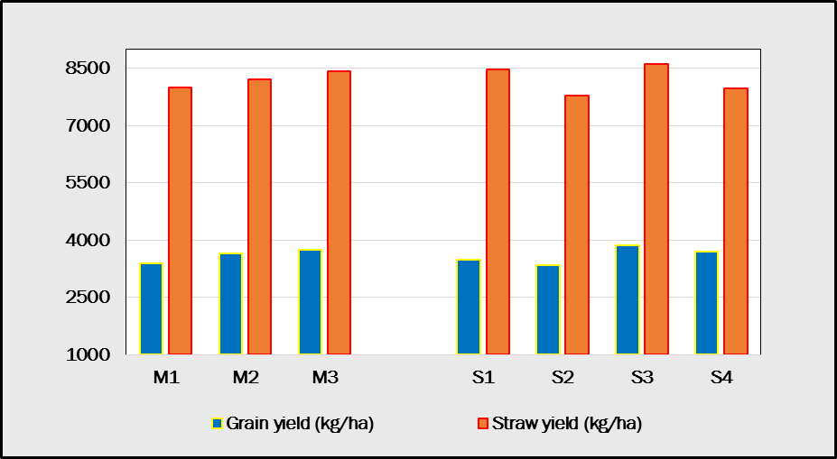
Fig 1. Influence of seedling age and planting pattern on grain yield (kg/ha) and straw yield (kg/ha) of finger millet

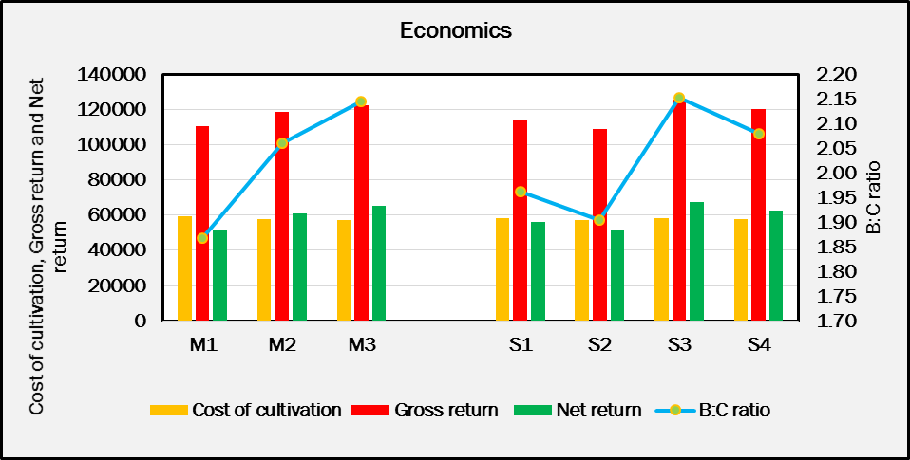
Fig 2. Influence of seedling age and planting pattern on economics of finger millet

