RESEARCH ARTICLE

Effects of Tillage Practices and Sources of nutrients on soil Microbial population and Grain yield of Finger millet (Eleusine coracana L.)

ABSTRACT
A field experiment on “Effect of Tillage practices and Sources of nutrients on soil Microbial population and Grain yield of Ragi (Eleusine coracana L.)” was conducted at Agricultural College and Research Institute, Department of Agronomy, Tamil Nadu Agricultural University, Madurai during 2018-19 and 2019-20. The experiment was laid out in a split plot design and replicated thrice. The experiment consisted of three main plot treatments viz., Conventional tillage (T₁), Minimum tillage (T₂) and Plough sole tillage (T₃) and sub plot has six treatments with different sources of nutrients viz., Farm Yard Manure + bio-fertilizer (Why sub plots are mentioned as O? Due to organic sources? If so, in title it can be mentioned) Vermi-compost + biofertilizerSImilarly correct inall places (O₂), Goat manure + bio fertilizer (O₃), Poultry manure + bio fertilizer (O₄), Press mud + bio fertilizer (O₅) and control (100% RDF) (O₆). The total microbial population viz., bacteria, fungi and actinomycetes were found higher in in the main plot treatment of minimum tillage (T₂) during 2018-19 and was comparable with conventional tillage (T₁) during 2019-20. Of the sub plot, vermicompost + bio fertilizer (O₂) recorded higher microbial population followed by poultry manure + bio fertilizer (O₄) during 2018-19 and was comparable with poultry manure + bio fertilizer (O₄) during 2019--20. Among the treatment combination, minimum tillage with vermicompost + bio fertilizer (T₂O₂) recorded higher microbial population during 2018-19Rather mentioning year, it can be mentioned as first and second year and was comparable with minimum tillage combination with poultry manure + bio fertilizer (T₂O₄) during 2019-20. Higher yield of ragi were recorded with conventional tillage with 100% RDF as control (T₁O₆) during 2018-2019 and was comparable with minimum tillage combination with poultry manure + bio fertilizer (T₂O₄) during 2019-2020.

Keywords: Finger millet, Grain yield, Microbial population, sources of nutrients, Tillage practices.

INTRODUCTION
Conservation tillage is a concept evolved to respond to the concerns of sustainability of agriculture (FAO, 2012). This is a resource-saving agricultural production system aims to achieve high and sustaining yields and also will be able to enhance and maintain natural resource base through compliance of interrelated principles and with other good production management practices of plant nutrition (Abrol and Sangar, 2006). Traditional agriculture involves intensive tillages and held responsible for soil erosion problems, surface and underground water pollution and more consumption of irrigation water (Wolff and Stein, 1998). Moreover, it is implicated in land resource degradation and low energy efficiency and contributes to global warming (Boatman et al., 1999). Hence, the conservation tillage is an effective alternative way to cultivate annual and perennial crop-based systems and with crop residue management to have a soil cover. This will precede way to increase the organic matter content in the surface soil horizons. Instantaneously, it also has the beneficial impacts on the global environment as compared to traditional agriculture (Derpsch et al., 2010).
Soil harbors dynamic population of microorganisms, which play major role in decomposition of organic matter and transformation of plant nutrients. The availability of organically bound nitrogen through transformation in soil to the plant mainly depends on the population of microorganisms, which is influenced by the application of organic manure. The microbial biomass, which is the total mass of bacteria, fungi, actinomycetes present in soil, serves as a temporary sink for nutrients including nitrogen and can be considered as an index of soil fertility. The factors like cropping system, manure application etc., affects the soil microbial growth, activity and diversity. Microbial biomass carbon and enzyme activity increases with continuous application of organic manure (Zhao et al., 2016). Enzymes are important soil components involved in dynamics of soil nutrient transformations and enzyme activity is considered to be a major contributor of overall soil microbial activity. Microorganisms and their mediated processes can give an integrated measure of soil health. It also plays an important role in organic matter decomposition and in the dynamics of nutrient transformations in the soil. Addition of organic manures significantly increases the urease, alkaline phosphatase and dehydrogenase activity in the soil as compared to chemical fertilizers. Hence, experiment was planned to study the effect of tillage practices and sources of nutrients on the soil microbial population and grain yield of ragi.

MATERIAL AND METHODS

A field experiment was conducted at Agricultural College and Research Institute, Tamil Nadu Agricultural University, Madurai to investigate the effect of tillage practice and sources of nutrients on the soil microbial population and grain yield of ragiPlease avoid use of local name. The experimental field was located in the Southern agro climatic zone of Tamil Nadu at 9º 54’ N latitude and 78º 54’ E longitude and at an altitude of 147 m above MSL. A mean annual rainfall of 848 mm was distributed in 46 rainy days. The soil of the experimental site is clay loam with 220.6, 11.5, 308.4 kg available soil N, P₂O₅, K₂O ha⁻¹. The pH of the soil was 7.9 with EC of 0.52 dS m⁻¹ and with 0.48 per cent soil organic carbon and initial soil microbial population of bacteria, fungi and actinomycetes was 98.9 cfu g⁻¹, 16.7 cfu g⁻¹ and 80.6 cfu g⁻¹ of soil.Is the values are same in bothe the years of experiments? The Tillage and nutrient sources formed as main and sub-plots. The experiment wwas laid out in split plot design with three replications. The main plot treatment consisted of three tillage practices viz.,T₁- Conventional tillage (Mould board plough + cultivator + rotavator once each), T₂ - Minimum tillage (cultivator + rotavator once each) and T₃ - Plough sole tillage (using country plough once) and the sub plot treatments consisted of six sources of nutrients viz., O₁ - FYM + bio fertilizer, O₂-Vermicompost + bio fertilizer, O₃- Goat manure + bio fertilizer (S₃), O₄ -Poultry manure + bio fertilizer, O₅ - Press mud + bio fertilizer and O₆ - Control (100% RDF).What basis the nutrients were applied? On N equivalent? What is the quantity? What is nutrient content of manures in both the years? Ragi variety CO 15 was used for the study. Bacteria, fungi and actinomycetes populations were observed at pre and post-harvest sowing of ragi. How sampling was done? How it was analysed? These data were analysed statistically by following Gomez and Gomez (2010). Treatment differences found significant (F test), critical differences worked out at five per cent probability level and the values were furnished. Treatment differences that were not significant were denoted as “NS”.No were NS was found in the article.

RESULTS AND DISCUSSION
Effect of tillage practices and sources of nutrients on post-harvest soil Bacterial population of Ragi (Figure. 1)
In the present study, the effect on the tillage practices and sources of nutrients on the bacterial population of ragi rhizosphereWhat is it? No mentioning about it in MM part. soil was assessed and the results are given in figure 1. Among tillage practices, minimum tillage (T₂) recorded higher total bacterial population (58.74 x 10⁻⁶ and 95.37 x 10⁻⁶ CFU g⁻¹) at post-harvest soil during 2018-2019 and 2019-2020 respectively.There is no separate Fig. to know about your statement. Fig. are not having SE bars or any other statistical indications. This was followed by conventional tillage (T₁) during 2018-2019 and was on par with the above treatment during 2019-2020. The lower total bacteria population of 41.42 x 10⁻⁶ and 73.79 x 10⁻⁶ CFU g⁻¹was recorded under plough sole tillage (T₃) at post-harvest soil during 2018-2019 and 2019-2020. Where is the discussion?
Regarding sources of nutrients, application of vermicompost + bio fertilizer (O₂) recorded higher total bacterial population of 64.23 x 10⁻⁶ and 100.87x 10⁻⁶ CFU g⁻¹ of soil at post-harvest soil. This was followed by application of poultry manure + bio fertilizer (O₄) during 2018-2019 and comparable during 2019-2020. The lower total bacterial population of 35.42 x 10⁻⁶ and 66.35 x 10⁻⁶ CFU g⁻¹ of soil was noticed under application of 100% RDF as control (O₆) at post-harvest soil during both year. The bacterial population was significantly enhanced in the treatment irrespective of organic sources. Biswas et al. (2017) ascribed the higher bacterial count to the positive effects of manure by providing nutrients for the growth of microbes directly or indirectly by stimulating plant growth and enhancing root carbon flow. Also, the organic manures show superiority in enriching the richness and diversity of soil bacteria (He et al., 2008) due to enhanced soil microbial biomass and activities of organic treated soils (Islam et al., 2011).
Interaction effect between tillage practices and sources of nutrients was found to be significant at post-harvest soil. The minimum tillage in combination with vermicompost + bio fertilizer (T₂O₂) registered higher total bacterial population of 70.65 x 10⁻⁶ and 107.41 x 10⁻⁶ CFU g⁻¹ of soil at post-harvest soil during 2018-2019 and 2019-2020 respectively. This was followed by minimum tillage combination with poultry manure + bio fertilizer (T₂O₄) during 2018-2019 and was comparable with the above treatment during 2019-2020. The lower total bacterial population of 28.95 x 10⁻⁶ and 54.57 x 10⁻⁶ CFU g⁻¹ of soil was recorded under plough sole tillage in combination with 100% RDF as control (T₃O₆) during 2018-2019 and 2019-2020 respectively.

Effect of tillage practices and sources of nutrients on post - harvest soil Fungi population of Ragi (Figure. 2)
Among tillage practices, minimum tillage (T₂) recorded higher total fungi population (36.58 x 10⁻⁵ and 76.17 x 10⁻⁵ CFU g⁻¹) at post-harvest soil during 2018-2019 and 2019-2020 respectively. This was followed by conventional tillage (T₁) during 2018-2019 and was on par with the above treatment during 2019-2020. The lower total fungi population of 25.79 x 10⁻⁵ and 58.93 x 10⁻⁵ CFU g⁻¹was recorded under plough sole tillage (T₃) at post-harvest soil during both year. Conservation tillage can also influence soil suitability for the growth of crops (Hewins et al., 2017), promoting the formation of fungal hyphal networks, and leading to higher soil fungal population sizes (Gottshall et al., 2017).
Regarding source of nutrients, application of vermicompost + bio fertilizer (O₂) recorded higher total fungi population of 39.99 x 10⁻⁵ and 80.56 x 10⁻⁵ CFU g⁻¹ of soil at post-harvest soil during 2018-2019 and 2019-2020 respectively. This was followed by application of poultry manure + bio fertilizer (O₄) during 2018-2019 and comparable during 2019-2020. The lower total fungi population of 22.06 x 10⁻⁵ and 52.99 x 10⁻⁵ CFU g⁻¹ of soil was noticed under 100% RDF as control (O₆) at post-harvest soil during both year. Ingle et al., (2014) reported an increase in fungal population with addition of organics since most of these organisms are chemoheterotrophs, which require organic source of carbon as food and oxidation of organic substances provides energy, thereby increasing their population.
Interaction effect between tillage practices and sources of nutrients was found to be significant in influencing fungi population at post-harvest soil. The minimum tillage in combination with application of vermicompost + bio fertilizer (T₂O₂) registered higher total fungi population of 43.99 x 10⁻⁵, and 85.78 x 10⁻⁵ CFU g⁻¹ of soil at post-harvest soil during 2018-2019 and 2019-2020 respectively. This was followed by minimum tillage combination with poultry manure + bio fertilizer (T₂O₄) during 2018-2019 and was comparable with the above treatment during 2019-2020. The lower total fungi population of 18.03 x 10⁻⁵and 43.58 x 10⁻⁵ CFU g⁻¹ of soil was recorded under plough sole tillage combination with 100% RDF as control (T₃O₆) during 2018-2019 and 2019-2020 respectively.
Effect of tillage practices and sources of nutrients on post - harvest soil Actinomycetes population of Ragi (Figure.3)
Among tillage practices, minimum tillage (T₂) recorded higher total actinomycetes population (50.36 x 10⁻³ and 81.51 x 10⁻³ CFU g⁻¹) at post-harvest soil during 2018-2019 and 2019-2020 respectively. This was followed by conventional tillage (T₁) during 2018-2019 and was on par with the above treatment during 2019-2020. The lower total actinomycetes population of 35.51 x 10⁻³ and 63.07 x 10⁻³ CFU g⁻¹was recorded under plough sole tillage (T₃) at post-harvest soil during 2018-2019 and 2019-2020. Similar to the present study, Li et al., (2020) reported an increase in soil bacteria, fungi, and actinomycets counts in conservation tillage practices, which created favourable environmental conditions for microbial growth. Conservation tillage practices can influence the soil microclimate, the distribution and decomposition of crop residues, and the transformation of nutrients (Cheng et al., 2017); those factors, in turn, can alter soil microbial population size and diversity (Li et al., 2018). Minimum tillage causes less disturbance of the soil, creating a better environment for microbial growth, leading to increased C use efficiency and elevated activity levels of various extracellular enzymes (Sauvadet et al., 2018).
Regarding source of nutrients, application of vermicompost + bio fertilizer (O₂) recorded higher total actinomycetes population of 55.07 x 10⁻³ and 86.21 x 10⁻³ CFU g⁻¹ of soil at post-harvest soil. This was followed by application of poultry manure + bio fertilizer (O₄). The lower total actinomycetes population of 30.37 x 10⁻³ and 56.71 x 10⁻³ CFU g⁻¹ of soil was recorded noticeably under 100% RDF as control (O₆) at post-harvest soil during both year. The increased microbial population may be due to the fact that organic manure provided necessary food and micro environment for their quicker multiplication and growth (Kumari and Kumari, 2002). This could be ascribed to the organic sources which supplied large amount of readily available carbon, resulting in more diverse and dynamic microbial system. Soil enzymatic activities increased as the soil microbes degrade organic matter through the production of diverse extracellular enzymes, after the application of vermicompost to soils (Tejada and Gonzalez, 2008). This may be attributed to higher amount of growth promoting substances, vitamins and enzymes which in turn increased the microbial population and root biomass production.
Interaction effect between tillage practices and sources of nutrients was found to be significant in enhancing at post-harvest soil. The minimum tillage in combination with application of vermicompost + bio fertilizer (T₂O₂) registered higher total actinomycets population of 60.57 x 10⁻³ and 91.80 x 10⁻³ CFU g⁻¹ of soil at post-harvest soil during 2018-2019 and 2019-2020 respectively. This was followed by minimum tillage combination with poultry manure + bio fertilizer (T₂O₄) during 2018-2019 and was comparable with the above treatment during 2019-2020. The lower total actinomycets population of 24.82 x 10⁻³ and 46.64 x 10⁻³ CFU g⁻¹ of soil was recorded under plough sole tillage combination with 100% RDF as control (T₃O₆) during 2018-2019 and 2019-2020 respectively.
Effect of tillage practices and sources of nutrients on grain yield of Ragi (Figure.4)
Tillage is an important management practice involving physical manipulation of soil for crop establishment. Optimization of tillage practices leads to improvement in soil health. Soil health is a dynamic and complex system, and its functions are mainly mediated by agricultural management practices (Doran and Zeiss, 2000). Among the tillage practices, the conventional tillage (T₁) registered significantly highest grain yield of 2337 and 2535 kg ha⁻¹ during 2018-2019 and 2019-2020 respectively. This was followed by minimum tillage (T₂) during 2018-2019 and was on par with the above treatment during 2019-2020. The lowest grain yield of 1648 and 1961kg ha⁻¹ was recorded under plough sole tillage (T₃) during 2018-2019 and 2019-2020 respectively.
Of the sources of nutrients, application of 100% RDF as control (O₆) recorded the highest grain yield of 2556 and 2679 kg ha⁻¹ during 2018-2019 and 2019-2020 respectively. This was followed by poultry manure + bio fertilizer (O₄) during 2018-2019 and was comparable with the above treatment during 2019-2020. Even as there was increased grain yield in 100% RDF, it was found to give reduced microbial population than poultry manure + bio fertilizer (O₄), that will not give a long term effect in improving soil health which is essential for sustaining the production and productivity of crops that can be accomplished by the poultry manure + bio fertilizer it ranked next to 100% RDF in record yield. Improvement in yield attributes could be due to higher quantity of macro and micronutrients added to soil in the form of organic sources resulting in increased availability of nutrients in root zone thus more uptake by crop resulting in higher values of yield attributing characters. These results are in conformity with the result of Poornesh et al., (2004). The lowest grain yield (1409 and 1763 kg ha⁻¹) was recorded under application FYM + bio fertilizer (O₁) during both year.

Interaction effect between tillage practices and sources of nutrients was not significant on grain yield with first year experiment during 2018-2019 and was found significant during 2019-2020. The combination of conventional tillage with 100% RDF as a control (T₁O₆) were registered with highest grain yield of 2854 kg ha⁻¹ during 2019-2020. This was comparable with minimum tillage in combination with poultry manure (T₂O₄) (2798 kg ha⁻¹).The lowest grain yield (1450 kg ha⁻¹) was recorded under plough sole tillage combined with FYM + bio fertilizer (T₃O₁) during 2019-2020. Similar to the present study, Mutonga et al., (2019) reported a higher grain yield in wheat under conservation tillage than conventional practices by conserving more moisture.

Figures and Structures
Figure. 1 Effect of tillage practices and sources of nutrients on Bacterial population of Ragi during 2018-2019 and 2019-2020

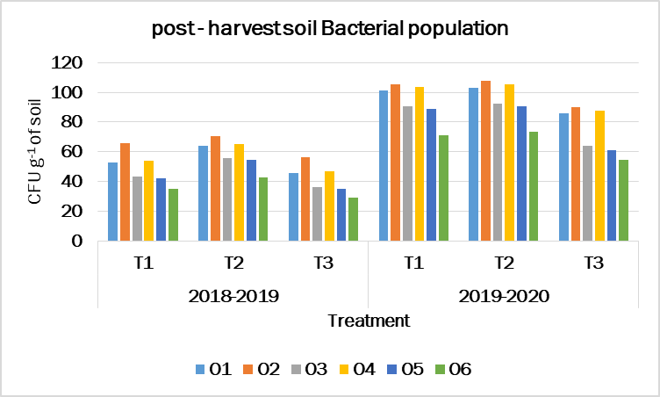

Figure. 2 Effect of tillage practices and sources of nutrients on Fungi population of Ragi during 2018-2019 and 2019-2020
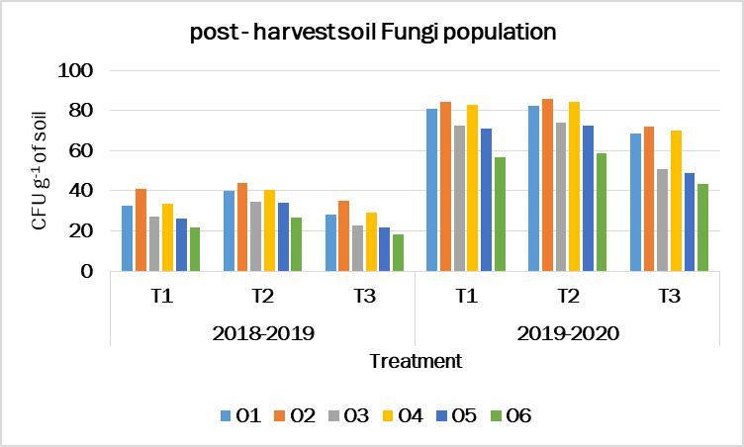

2018-2019
2019-2020

Figure. 3 Effect of tillage practices and sources of nutrients on actinomycetes population of Ragi during 2018-2019 and 2019-2020
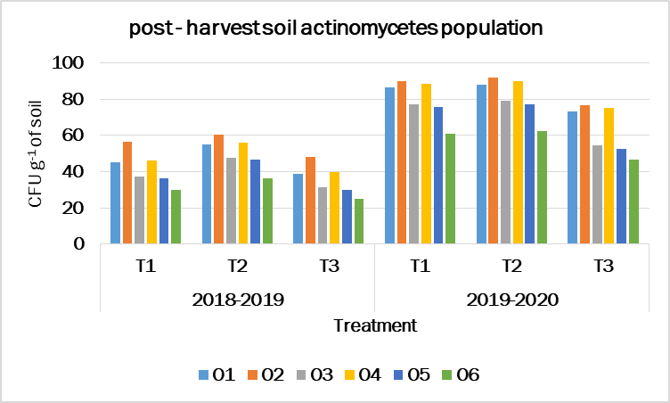

Figure.4 Effect of tillage practices and sources of nutrients on grain yield of Ragi during 2018-2019 and 2019-2020

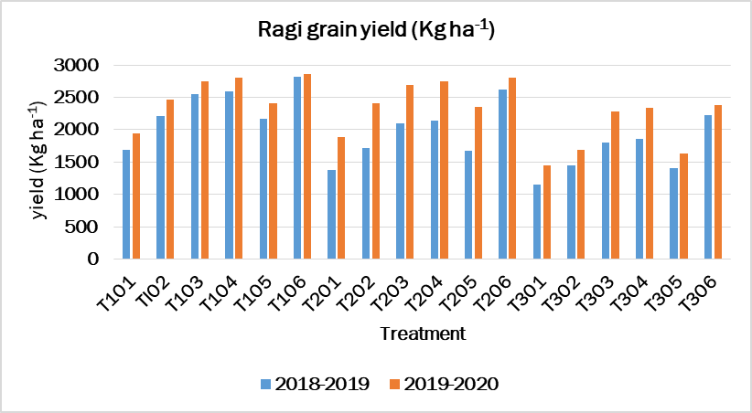

CONCLUSION
As per the results obtained from the experiment it could be concluded that the practice of minimum tillage is best management is enhancing the microbial population compare to conventional tillage even though it registered higher yield which cannot be sustained with long term effect due to reduced microbial population recoded in this practice. As for as, different sources of nutrients, the organic sources of vermicompost recorded with more microbial population. However, it was recorded with lesser grain yield over poultry manure. It was found to be next best source in recording the microbial population. Take in to account of above results, the combination of minimum tillage and poultry manure + bio fertilizer by the organic source will be the best option to sustain the grain yield with long term effect besides improve soil health in ragi.

REFERENCES
Abrol, I.P. and Sangar, S. 2006. Sustaining Indian agriculture-conservation agriculture the way forward. Current Science, 91(8), 1020-2015.
Biswas, S., Hazra GC., Purakayastha TJ., Saha N., Mitran,T., Roy SS., Basak, N. and Mandal, B. 2017. Establishment of critical limits of indicators and indices of soil quality in rice-rice cropping systems under different soil orders. Geoderma 292: 34-48.
Boatman, N., Green, M. and Holland, J. 1999. Agri‐ environment schemes – what have they achieved and where do we go from here Aspects Appl. Biol., 100, 447.
Cheng, Y., Wang, J., Wang, J., Chang, S.X. and Wang, S. 2017. The quality and quantity of exogenous organic carbon input control microbial NO₃ − immobilization: a meta-analysis. Soil Biol. Biochem. 115, 357–363.
Derpsch, R. and Friedrich T. Global overview of Conservation Agriculture adoption. Invited Paper, 4th World Congress on Conservation Agriculture: Innovations for Improving Efficiency, Equity and Environment. 4 - 7 February 2010, New Delhi, ICAR.
Doran, J.W. and R. M. Zeiss. 2000. Soil health and sustainability: managing the biotic component of soil quality. Applied Soil Ecology. 15, 3–11.
FAO. (2012). Alive and kicking: why dormant soil microorganisms matter. Soil Biol. Biochem. 116, 419–430.
Gomez, K. A., Gomez, K. A and Gomez, A. A. 2010. Statistical procedures for agricultural research (2nd ed.) International Rice Research Institute, P.B. Box. Manila, Philippines and John Wiley and Sons, New York, USA, p. 680.
Gottshall, C.B., Cooper, M. and Emery, S.M. 2017. Activity, diversity and function of arbuscular mycorrhizae vary with changes in agricultural management intensity. Agric. Ecosyst. Environ. 241, 142–149.
He JZ, Zheng Y, Chen CR, He YQ and Zhang LM. 2008. Microbial composition and diversity of an upland red soil under long-term fertilization treatments as revealed by culture-dependent and culture-independent approaches. Journal of Soils Sediments 8: 349-358.
Hewins, D.B., Sinsabaugh, R.L., Archer, S.R. and Throop, H.L. 2017. Soil-litter mixing and microbial activity mediate decomposition and soil aggregate formation in a sandy shrub-invaded Chihuahuan Desert grassland. Plant Ecol. 218, 459–474.
Ingle SS, Jadhao SD, Kharche VK, Sonune BA and Mali DV. 2014. Soil biological properties as influenced by long-term manuring and fertilization under sorghum (Sorghum bicolor)-wheat (Triticum aestivum) sequence in Vertisols. Indian Journal of Agricultural Sciences 84: 452-457.
Islam MR, Chauhan PS, Kim Y, Kim M and Sa T. 2011. Community level functional diversity and enzyme activities in paddy soils under different long-term fertilizer management practices. Biology and Fertility of Soils 47: 599-604.
Kumari S and Kumari K. 2002. Effect of vermicompost enriched with rock phosphate on growth and yield of cowpea (Vigna unguilata L. walp). Journal of the Indian Society of Soil Science 50: 223-224.
Li, Y., Chang, S.X., Tian, L.H. and Zhang, Q.P. 2018. Conservation agriculture practices increase soil microbial biomass carbon and nitrogen in agricultural soils: a global meta-analysis. Soil Biol. Biochem. 121, 50–58.
Li, Y., Zhang, Q., Cai, Y., Yang, Q. and Chang, S. X. 2020. Minimum tillage and residue retention increase soil microbial population size and diversity: Implications for conservation tillage. Science of the Total Environment, 716, 137164.
Mutonga, M.W., Kipkorir, E.C. and Ng’etich, W.K. 2019. Assessment of Effects of Zero and Conventional Tillage Practices on Soil Moisture and Wheat Grain Yield in Arid and Semi-Arid Land of Laikipia, Kenya. Water Conservation Science and Engineering. 4 (1): 43-52.
Poornesh AS, Reddy VC and Kalyanamurthy KN. 2004. Effect of urban garbage compost and sewage sludge on yield of ragi, Eleusine coracana (L) Gaertn and soil properties. Environment and Ecology 22(3): 720- 723.
Sauvadet, M., Lashermes, G., Alavoine, G., Recous, S., Chauvat, M. and Maron, P.A. 2018. High carbon use efficiency and low priming effect promote soil C stabilization under reduced tillage. Soil Biol. Biochem. 123, 64–73.
Tejada, M and Gonzalez JL. 2008. Application of Two vermicomposts on a rice crop: Effects on soil biological properties and rice quality and yield. Agronomy Journal 10: 336-34.
Wolff, P. and Stein, T. M. 1998. Water efficiency and conservation in agriculture – opportunities and limitations. Agriculture and International Soil and Water Conservation Research, Vol. 2, No. 4, 2014, pp. 1-12.
Zhao, J., T. Ni., J. Li., Q. Lu., Z. Fang., Q. Huang., R. Zhang., R. Li., B. Shen and Q. Shen. 2016. Effects of organic– inorganic compound fertilizer with reduced chemical fertilizer application on crop yields, soil biological activity and bacterial community structure in a rice–wheat cropping system. Applied Soil Ecology 99: 1-12.

