IMPACT OF HIGH TEMPERATURE STRESS ON MORPHO PHYSIOLOGICAL AND YIELD OF RICE (Oryza sativa L.) GENOTYPES

ABSTRACT
The present experiment was conducted to understand the morpho-physiological parameters of rice genotypes under high temperature conditions. Ten rice genotypes were used in this study viz, N22, ADT 36, ADT 37, ADT 43, ADT 45, CO 51, ASD 16, MDU 6, TPS 5 and Anna (R) 4. Plants were grown under OTC (Open Top Chamber) with the treatments of ambient, Ambient+2^{O} C and Ambient+4^{O} C. Stress was imposed during anthesis period. High temperature stress resulted in significant changes in morpho-physiological parameters such as plant height, no. of tillers, leaf area, SPAD chlorophyll index, and grain yield of rice genotypes. High temperature stress affected Leaf area, SPAD chlorophyll index and grain yield. But amazingly N22 and Anna (R) 4 maintained higher SPAD chlorophyll index and leaf area which indirectly leads to higher grain yield under high temperature conditions.
Keywords: Rice, High temperature, Leaf area, SPAD chlorophyll index, Yield
INTRODUCTION
Climate change is a current trend that has started to have adverse impact on agriculture. Among the abiotic stresses high temperature is a major stress which cruelly affects plants growth and productivity. The global temperature is predicted to rise by 2.5 to 4.3^{O} C by the end of the century 2100 (IPCC 2007). Rice (Oryza sativa L.) is the most widely consumed staple food, feeding about a half of the world’s population. Worldwide rice is grown in 114 countries on 116 million hectares (M ha) to produce more than 650 million tons (FAO, 2012). Generally rice is adversely affected by high temperature in the lower elevation of tropics and by lower temperature in the temperate regions (Dubey et al., 2018).
All plants species have an optimum temperature range for efficient physiological functions such as growth, developmental and reproduction. Temperatures above or below that range will have a negative impact on plant performance leading to loss in economic yield. High temperature affects morphological, physiological, and biochemical characters which serve as a base for yield reduction (Wang et al, 2003). With the rising temperature, plant height, and the number of tillers increased in rice (Oh-e et al, 2007). High temperature reduced leaf area due to early senescence (Anil Sebastian and Selvaraju, 2017) and lowers SPAD values that contribute to reduced dry matter accumulation and yield (Kurniawan et al, 2019 and Vinitha et al, 2020).

Rice is highly sensitive to high temperature particularly at flowering and grain filling stage. Even 1º C increase in daytime maximum/nighttime minimum will severely affects rice yield by 10% (Dubey et al., 2018). Yield losses under high temperature were attributed to spikelet sterility and reduction of grain weight (Prasad et al., 2006; Shi et al., 2013). High temperatures at flowering and during grain-filling phase reduce yield by causing spikelet sterility and shortening the duration of grain-filling phase (Tian et al, 2007 and Xie et al, 2009). Dubey et al., 2018 confirmed that temperature during ripening affects the weight per grain, also the 1000 grain weight in rice. With this background this experiment was conducted to study the morphophysiological characters and yield of rice genotypes under high temperature conditions.

MATERIAL AND METHODS
Ten short duration rice genotypes namely, N22, ADT 36, ADT 37, ADT 43, ADT 45, CO 51, ASD 16, MDU 6, TPS 5 and Anna (R) 4 were chosen for this study. Seeds were collected from various rice research stations of Tamil Nadu. This experiment was conducted during January to April 2019, using Open Top Chambers , in the Department of Crop Physiology, Tamil Nadu Agricultural University, Coimbatore. OTC is made of a polycarbonate sheet of 4m×4m×4m. Three chambers were used for this study, one for control (Ambient temperature) and others for exposing high temperature (+2 °C and +4 °C from ambient). By using infrared source, humidifiers and wireless signal transmission with SCADA integration facility, temperature and relative humidity (RH) were maintained inside the chambers. Two plants per pots were maintained and with three replications. Stress was imposed at anthesis stage to grain filling stage from morning 9 am to evening 5 pm. The maximum air temperature for Ambient, Ambient+2^{O} C and Ambient+4^{O} C ranged from 36.79°C – 40.88°C, with high RH (85.6%) was recorded at ambient chamber (75.2%) (Figure 1). Observations were recorded after the stress imposition and stress imposed plants were compared with plants which grown under ambient condition.
Plant height was measured from the base of the shoot to the tip of the growing point and mean plant height was calculated and expressed in cm. Leaf area per plant was measured using a Leaf Area Meter (LICOR, Model LI 3000) and expressed as cm2 plant-1. SPAD readings were recorded using chlorophyll meter (SPAD 502) designed by the Soil Plant Analytical Development (SPAD) section, Minolta, Japan. Grain yield was calculated after harvesting, five plants were taken to assess the grain yield and average was calculated and expressed in g plant-1. For statistical analysis, the data collected from this experiment were statistically analyzed in a CRD (Completely Randomized Design) through SPSS software. The critical difference (CD) was computed at 0.05 probability level.
RESULTS AND DISCUSSION
Plant height (cm plant⁻¹) and No. of tillers
Plant height increased significantly under high temperature conditions. Plant height was varied significantly among the rice genotypes. Among the genotypes, N22 (77.4,79.1,79.9 cm) recorded more plant height followed by Anna (R) 4 (72.5 73.6, 74.1 cm) in ambient, ambient+2ºC and ambient+4ºC respectively (Table 1.) Plant height is an important trait for growth, since increased plant height would allow greater biomass production and yield potential in crops (Zhang et al., 2004). Sandeep et al. (2020), who reported that high temperature causes an increment in plant height, and it acts as an important factor for genetic differentiation in rice genotypes. Vinitha et al. (2020) suggested that heat stress generally causes increment in plant height, this might be an adaptive nature of the rice plants to escape heat this might be an adaptive nature of the rice plants to escape heat. They try to quicken their phenophases, hence irrespective of heat tolerant ability plant height generally increases. Therefore, plant height can be considered as one of the important trait for determining tolerance under stress conditions. Active tiller number is very much important for grain yield of rice, generally stress affects tiller number of rice. No significant variation observed among the genotypes, plants maintained same no of tillers in Ambient, Ambient+2^{O} C and Ambient+4^{O} C treatments, because stress was imposed after the completion of active tillering phase. So there is no such variation in the tiller numbers. CO 51 (14,13 and14) recorded more tiller numbers followed by Anna (R) 4 (72.5 73.6, 74.1 cm) in ambient, ambient+2º C and ambient+4º C respectively (Table 2).
Leaf area (cm² plant⁻¹)
The time trend of leaf area revealed a gradual increase from vegetative to grain filling stage. Decreased leaf area was observed under high temperature condition in rice varieties. Irrespective of the genotypes there was a decrease in the leaf area during amb+2º C and amb+4º C compared to control. Higher leaf area reduction was observed in ADT 36, ADT 37 and CO 51 in amb+2º C (19%, 15% and 15%) and CO 51, ADT 36 and ADT 37 (35%, 33% and 25%) in amb+4º C (Fig. 2). Leaf area is a fundamental determinant of the total photosynthesis of a plant. Leaf area always shows a positive relationship with net photosynthetic activity, because leaf enlargement is attributed to increase in number and width of grana and also high degree of stacking of grana (Fortun et al., 1985). Gupta and Guhey (2011) reported a significant reduction in leaf area in susceptible genotypes than tolerant genotypes under HTS, similar result was observed in this study. Thus, an optimum leaf area of 0.33 m² to 0.89 m² is required to maintain photosynthesis and grain yield under heat stress (Sabine Stuerz and Folkard Asch, 2019).

SPAD chlorophyll Index
SPAD chlorophyll value is expressed as cholorophyll index. In all the stress treatments, all the genotypes recorded less chlorophyll index than control. Compared to all the treatments Amb+4ºC had higher SPAD chlorophyll reduction percentage in all the genotypes. Among the genotypes, ADT 36, ADT 37 and CO 51 (21%, 18.8% and 18%) had higher reduction percentage in Amb+4ºC. Fig 3. shows N22 ASD 16 and Anna (R) 4 (6.8%, 6.1%, and 6.4%) had lesser reduction percentage in Amb+4º C. Lower reduction in chlorophyll content under heat is a good indicator of tolerance, which has been proved in rice varieties. Nirmal Kumar et al. (2018) reported that, decreased chlorophyll content was observed in rice under high temperature condition. According to Tafesse et al. (2020), SPAD chlorophyll index was reduced upto 14.67 % at high temperatures over control. These results were confirmed with this present study.

Grain weight
Irrespective of the genotypes, higher reduction in grain yield was observed under amb+2º C and amb+4º C showing significant difference from each other. More reduction was observed in ADT 43 followed by CO 51 and ADT 37 (53% 46% and 44%) in amb+2º C over control. In amb+4º C recorded more yield reduction in CO 51 followed by ADT 37 and ADT 43 (78%, 71% and 69%) in amb+2º C. Among the genotypes, N22 and Anna (R) 4 recorded less yield reduction (10% and 12%) in amb+2º C and (19% and 22%) in amb+4º C respectively. (Fig. 4). Also, Vivitha et al (2017), who reported a less percent reduction of yield in N22 upto 6.94% under heat stress condition. The study proved N22 as a heat-tolerant cultivar (Ye et al 2012). During ripening, the panicle is a highly sensitive organ to high-temperature stress (Morita et al, 2004). According to Gaballah and Abu (2019) high temperature stress reduced panicle length and panicle weight of rice genotypes. These results were found similar to this present study.

CONCLUSION
This study concluded that, morphophysiological parameters were essential for grain yield of rice genotypes under high temperature conditions. N22 and Anna (R) 4 recorded higher yield under high temperature conditions. CO 51, ADT 37 and ADT 43 recorded lesser yield under amb+2º C and amb+4º C than other genotypes. These genotypes showed a decreased leaf area and SPAD chlorophyll values. CO 51 has highest tiller number, higher Leaf area and SPAD chlorophyll index than all genotypes under ambient condition, but higher reduction percent was observed in leaf area, SPAD chlorophyll index under amb+2º C and amb+4º C. Therefore, leaf area and SPAD chlorophyll index are important parameters which contributing higher to grain yield of rice genotypes.
REFERENCES
- Anil Sebastian and P. Selvaraju. 2017. Crop phenology and seed yield as influenced by high-temperature stress in rice. International J. of Agricultural Science and Research., 7(6): 419-426.
- FAO, 2008. Food and Agriculture Statistics Global Outlook. Food and Agricultural Organization of the United Nations. Available from: http://faostat.fao.org/Portals/_Faostat/documents/pdf/world.pdf
- Fortun, C., Rapsch, S. and Ascaso. C. 1985. Action of humic acid preparations on leaf development, mineral elements contents and chloroplast ultrastructure of ryegrass plants. Photosynthetica, 19: 294-299.
- Gaballah, M.M. and Abu. A.F. 2019. Genetic behavior of some rice genotypes under normal and high-temperature stress. Alexandria Science Exchange J., 40(2): 370-384.
- Gupta, R. and Guy. A. 2011. Responses of rice genotypes to water stress imposed at the early seedling stage. Oryza., 48(4): 366-369.
- IPCC (Intergovernmental Panel on Climate Change (2007). Climate Change 2007: Impacts, adaptation and vulnerability. (M. L. Parry, O. F. Canziani, J. P. Palutikof, P. J. van der Linden, and C. E. Hanson, Eds.), In “Contribution of Working Group II to Fourth Assessment Report of the Intergovernmental Panel on Climate Change”. Cambridge University Press, Cambridge, United Kingdom, 1000pp.
- Kurniawan, D.Y., Junaedi, A., Lubis, I. and Sunarti. T.C. 2019. Evaluation of growth and physiological responses of three rice (Oryza sativa L.) varieties to elevated temperatures. Indian J. of Tropical Sci., 6(1): 17-23.
- Minolta, C. 1989. Manual for Chlorophyll meter SPAD-502. Minolta Cameraco., Osaka, Japan.
- Morita, S., Shiratsuchi, H., Takanashi, J.-I., and Fujita, K. (2004). Effect of high temperature on grain ripening in rice plants: Analysis of the effects of high night and high day temperatures applied to the panicle and other parts of the plant. Jpn. J. Crop Sci. 73, 77–83.
- Nirmal-Kumar, A.R., Vijayalakshmi, C. and Vijayalakshmi. D. 2018. Combined effects of drought and moderately high temperature on the photosynthesis, PS II photochemistry and yield traits in rice (Oryza sativa L.). Indain Journal of Plant Physiology., 23(3): 408–415.
- Oh-e, I., Saitoh, K. and Kuroda. T. 2007. Effects of high temperature on growth, yield and dry-matter production of rice grown in the paddy field. Plant Production Sci., 10 (4): 412-422.
- Prasad, P.V.V., Boote, K.J., Allen, L.H., Sheehy, J.E.,and Thomas, J.M.G. (2006). Species, ecotype and cultivar differences in spikelet fertility and harvest index of rice in response to high temperature stress. Field Crops Research, 95: 398–411
- Sabine Stuerz and Folkard Asch. 2019. Responses of Rice Growth to Day and Night Temperature and Relative Air Humidity—Dry Matter, Leaf Area, and Partitioning. Plants., 8(521): 1-12.
- Sandeep, S., Sujatha, M., Subbarao, L. V. and C. N. Neeraja. 2020. Assessment of morphometric diversity for yield and yield attributing traits in rice (Oryza sativa L.) for tolerance to heat stress. Current Journal of Applied Science and Technology., 39(10): 29-49.
- Shi, W.,Muthurajan, R., Rahman, H., Selvam, J., Peng, S. and Zou, Y. 2013. Source-sink dynamics and proteomic reprogramming under elevated night temperature and their impact on rice yield and grain quality. New Phytol., 197: 825-837.
- Tafesse, E.G., Gali, K. K., Lachagari, V. B. R., Bueckert, R. and T. D. Warkentin. 2020. Genome- wide association mapping for heat stress responsive traits in field pea. Int. J. Mol. Sci., 21(2043): 1-26.
- Tian X H, Matsui T, Li S H, Lin J C. 2007. High temperature stress on rice anthesis: Research progress and prospects. Chin J Appl Ecol., 18(11): 2632–2636.
- Vinitha, A., Raveendran, M., Babu Rajendra Prasad, V, and Vijayalakshmi, D. 2020. Rice Yield under High-Temperature Stress is Influenced by Morpho-Physiological Traits. Madras Agric. J., 2020; doi:10.29321
- Vivitha, P., Raveendran, M. and D. Vijayalakshmi. 2017. Introgression of QTLs controlling spikelet fertility maintains membrane integrity and grain yield in improved white Ponni derived progenies exposed to heat stress. Rice Science., 24(1): 32-40.
- Wang, W., Vinocur, B. and Altman. A. 2003. Plant responses to drought, salinity and extreme temperatures: Towards genetic engineering for stress tolerance. Planta., 218: 1-14.
- Xie, X.J., Li., Y.X. and Shen, S.H., 2009. High temperature harm at flowering in Yangtze river basin in recent 55 years. Jiangsu J. Agric. Sci. 25: 28-32.
- Ye, C.R., Argayoso, M.A., Redona, E.D., Sierra, S.N., Laza, M.A., Dilla, C.J., Mo, Y.J., Thomson, M.J., Chin, J., Delavina, C.B., Diaz, G.Q. and Hernandez. J.E. 2012. Mapping QTL for heat tolerance at flowering stage in rice using SNP markers. Plant Breeding, 131(1): 33–41.
- Zhang, H.Y., Huang, Y.J., Wang, D.H., Qi, Y.X., Zhong, P.G., Li, G.H., Liu, K., Kuang. H.Y. 2004. A study on developing near isogenic lines of heat tolerance at grain filling stage in rice. Acta Agric Univ Jiangxi, 26 (6): 847-853.

Genotypes | Ambient | Ambient+2º C | Ambient+4º C
N22 | 113.7 | 115.3 | 116.1
ADT 36 | 95.1 | 96.8 | 97.7
ADT 36 | 95.7 | 97.3 | 97.8
ADT 36 | 98.1 | 99.9 | 99.5
ADT 36 | 93.2 | 92.6 | 95.2
CO 51 | 96.6 | 97.6 | 98.8
ASD 16 | 107.2 | 109.3 | 108.6
MDU 6 | 101.1 | 102.5 | 103.9
TPS 5 | 93.8 | 94.2 | 95.3
Anna (R) 4 | 110.3 | 111.2 | 113.2
Mean | 100.48 | 101.67 | 102.61
 | G | T | G*T
SEd | 2.194 | 1.202 | 3.800
CD (0.05) | 4.366 | NS | 7.562
Table 1. Effect of high temperature stress on plant height (cm) and leaf area of rice genotypes

Table 2. Effect of high temperature stress on No.of tillers in rice genotypes

Genotypes | Ambient | Ambient+2º C | Ambient+4º C
N22 | 11 | 12 | 12
ADT 36 | 11 | 12 | 12
ADT 37 | 12 | 12 | 13
ADT 43 | 11 | 12 | 13
ADT 45 | 13 | 12 | 13
CO 51 | 14 | 13 | 14
ASD 16 | 13 | 13 | 12
MDU 6 | 11 | 12 | 11
TPS 5 | 12 | 12 | 11
Anna (R) 4 | 13 | 14 | 13
Mean | 12.1 | 12.9 | 12.4
 | G | T | G*T
SEd | 0.236 | 0.129 | 0.408
CD (0.05) | 0.469 | 0.258 | 0.813

Figure 1. Weather data of maximum air temperature (ºC) and relative humidity (%)

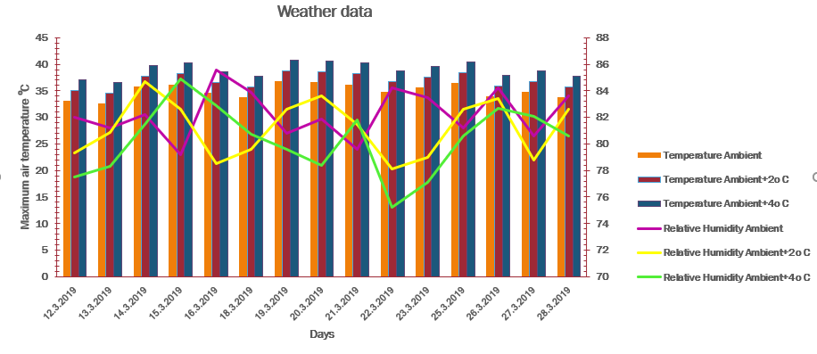

Figure 2. Effect of high temperature stress on Leaf area (cm²) of rice genotypes
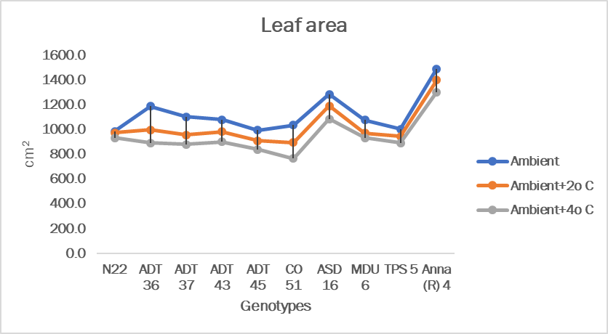

Figure 3. Effect of high temperature stress on SPAD chlorophyll index of rice genotypes

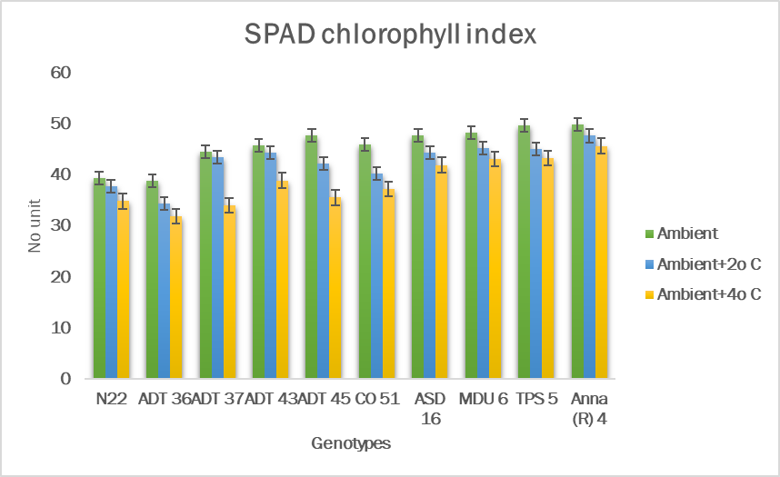

Fig 4. Effect of high temperature stress on Grain yield (g plant⁻¹) of rice genotypes

